Online materials for: Artificial freshwater mudflats temporarily provide substantial feeding habitat for threatened waders such as Pied Avocets
Yvonne I. Verkuil, Camilla Dreef, Peter van Horssen & Jan van der Winden
Supplement 1
Habitat assessment: remote versus on-the-ground imagery
The vegetated surface areas of the basins as estimated with satellite images (proportion of pixels) correlated with the surface areas estimated with on-the-ground photography (proportion of points) (Figure S1A). Correlations were significant for three categories: >90% cover (R² = 0.56, t₈₈ = 6.3, p < 0.001), 50-90% cover (R² = 0.47, t₈₈ = 5.0, p < 0.001), and 5-20% cover (R² = -0.32, t₈₈ = -3.1, p = 0.002). The sum of the B1 and B2 categories (called Open Vegetation), and C-E categories (called Dense Vegetation) were used for further analyses.
The water surfaces of the basins as estimated with satellite images correlated significantly with on-the-ground category “dry surface”, which is the inverse of wet area (R² = -0.47, t₈₉ = -4.9, p < 0.001) (Figure S1B). The other three categories specify water levels invisible on satellite images, and as expected did not correlated with general wetness. All water categories were used as model predictors, where the DM and WM categories were summed to one water-mud mosaic category.

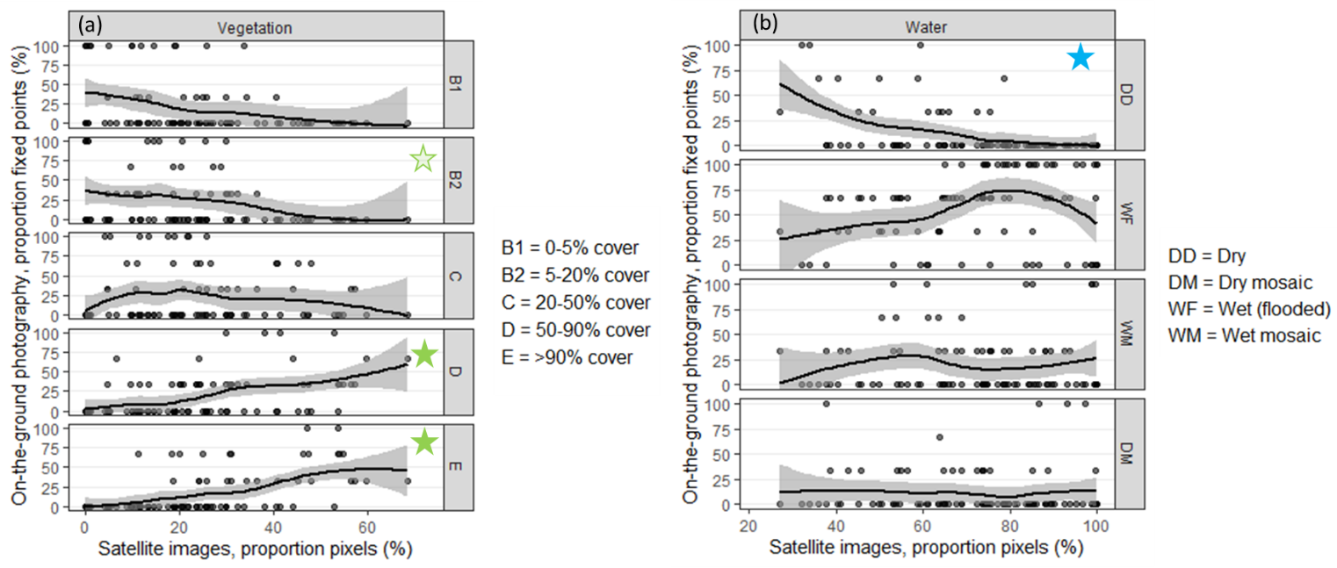
Figure S1. Correlation between relative surface estimates of habitat categories as scored with satellite imagery and with on-the-ground fixed-location photography. Two satellite remote-sensing categories are shown: A. Vegetation, B. Water. Up to three points per basin at fixed locations were scored in five vegetation categories, and four water categories; see legend. Average surface estimates were compared for each month (May-July) in the three years (2020-2022) the data sets overlapped; Vegetation n = 89, Water n = 90. Stars indicate significant correlations (details in text).

Supplement 2
Residual plots and coefficients (tables and plots)
Details for modelling step A
Pairs plot
Pairs plot for covariates in the models using satellite image data are shown in Figure S2-1. The highest correlation was between water cover (proportion pixels, RS_water) and vegetation (proportion pixels, RS_Vegetation) (Figure S2-1). Also note high correlation between basin age (AgeCompartment) and vegetation cover (RS_vegetation); see next section.
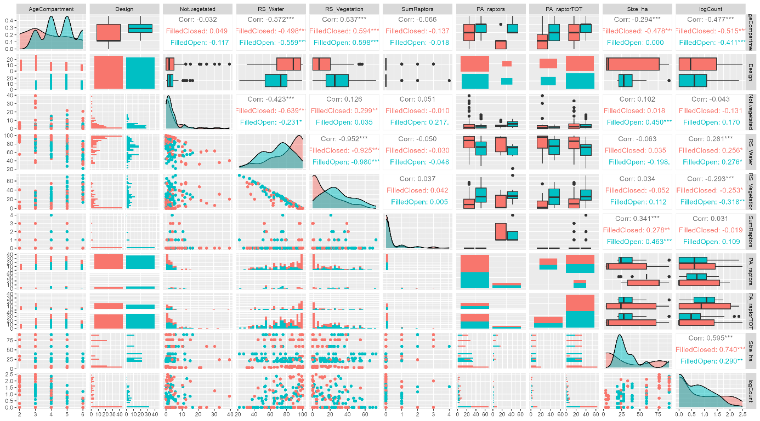
Figure S2-1. Pairs plot for all relevant covariates using satellite image date (pixels). AgeCompartment = age of basin (years); Design = basin design (FilledOpen = open basins, FilledClosed = closed basins); Not_vegetated = proportion pixels not vegetated; RS_water = proportion pixels covered with water; RS_vegetation = proportion pixels with terrestrial vegetation; SumRaptors = sum raptors per basin (n); PA_raptors = presence/absence of raptors per basin (0/1); PA_raptorTOT = presence/absence of raptors on entire archipelago (0/1); Size_ha = size basin (ha); logCount= number of Pied Avocets (log10).

Variance inflation factors (checking for multicollinearity) and residuals final model
Variance inflation factors (VIF), using satellite image data, were checked with intercept in the model. After dropping vegetation cover (RS-vegetation), VIFs for other covariates were below 5 (Table S2-1). The residuals of the final model are shown in Figure S2-2.
Table S2-1. Generalized variance inflation factors (GVIF) for selected model for satellite image date, shown in Table 1: glmer.nb.zi_S0. Basin design: open to greater lake or levees stay closed.
Variable | GVIF | df | GVIF^(1/(2*ff))
Basin size (ha) | 1.594678 | 1 | 1.262805
Age of basin (years) | 3.541356 | 1 | 1.881849
Basin design (Open or Closed) | 4.242042 | 2 | 1.435138
Absence/presence raptors (0/1) | 1.925266 | 1 | 1.387539

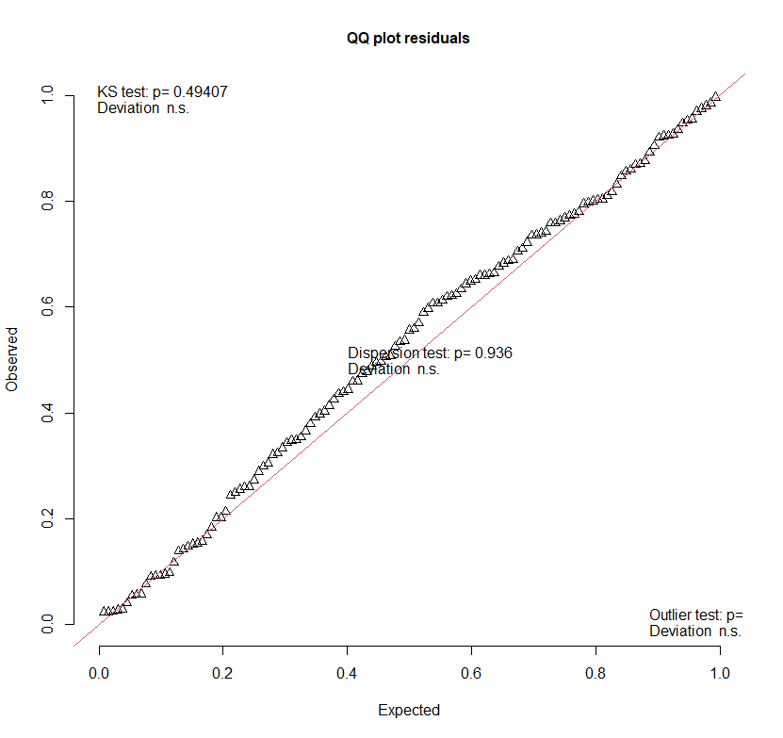
Figure S2-2. Residuals final model for satellite image data (glmer.nb.zi_S0, Table 1).
Coefficients final model
Coefficients for the final model using satellite image data are shown in Table S2-2 and Figure S2-3. Note: the final model had no intercept.
Table S2-2. Coefficients final model selected model in Table 1: glmer.nb.zi_S0. Basin design: open to greater lake or levees stay closed.
Estimate | std.error | statistic | p.value | conf.low | conf.high | term
-0.737 | 0.193 | -3.818 | 0 | -1.115 | -0.358 | Age of basin (years)
0.026 | 0.007 | 3.644 | 0 | 0.012 | 0.039 | Basin size (ha)
0.113 | 0.555 | 0.204 | 0.838 | -0.975 | 1.201 | Absence/presence raptors (0/1)
4.126 | 1.219 | 3.384 | 0.001 | 1.736 | 6.515 | Open basin design
4.434 | 1.092 | 4.06 | 0 | 2.294 | 6.575 | Closed basin design

Details for modelling step B
Pairs plot
Pairs plot for covariates in the models using on-the-ground fixed-location photography data, are shown in Figure S2-4.
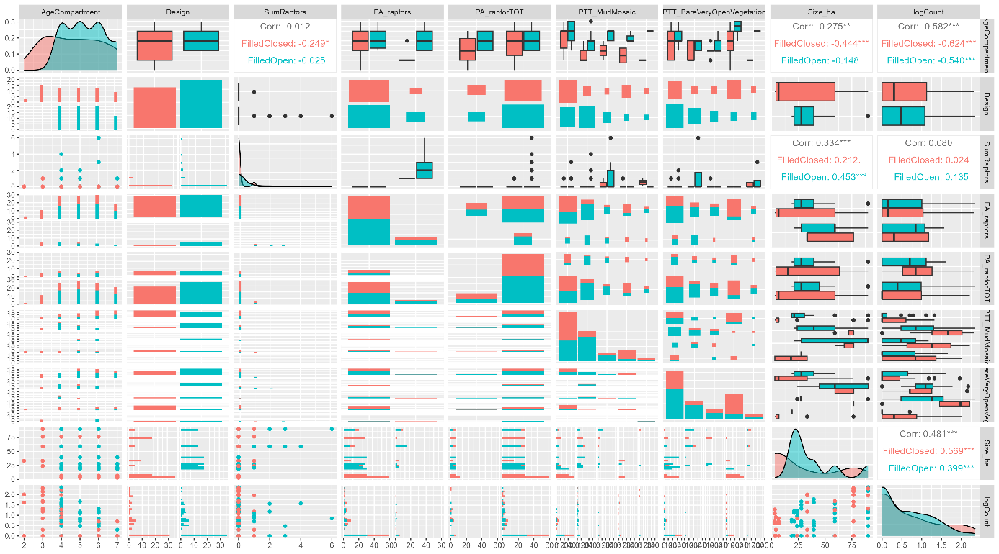
Figure S2-4. Pairs plot for all relevant covariates for on-the-ground fixed-location photography data. AgeCompartment = Age of basin (years); Design = basin design (FilledOpen = open basins, FilledClosed = closed basins); SumRaptors = sum raptors per basin (n); PA_raptors = presence/absence of raptors per basin (0/1); PA_raptorTOT = presence/absence of raptors on entire archipelago (0/1); PTT_MudMosaic = proportion of basin area with water-mud mosaics; PTT_BareVeryOpenVegetation = proportion of basin area with bare mud of very open vegetation; Size_ha = size basin (ha); number of Pied Avocets (log10).
Variance inflation factors (checking for multicollinearity) and residuals final model
Variance inflation factors (VIF), for models using on-the-ground fixed-location photography data, were checked with intercept in the model. All VIFs were below 5 (Table S2-3). The residuals of the final model are shown in Figure S2-5.
Table S2-3. Generalized variance inflation factors (GVIF) for selected model for satellite image date, shown in Table 1: glmer.nb_zi. Basin design: open to greater lake or levees stay closed. Mosaic water/mudflat = proportion of basin area with water-mud mosaics; Bare/open vegetation = proportion of basin area with bare mud of very open vegetation.
Variable | GVIF | Df | GVIF^(1/(2*Df))
Basin size (ha) | 2.718 | 1 | 1.649
Age of basin (years) | 1.957 | 1 | 1.399
Basin design (Open or Closed) | 1.869 | 1 | 1.367
Absence/presence raptors (0/1) | 1.450 | 1 | 1.204
Mosaic water/mudflat | 3.494 | 3 | 1.232
Bare/open vegetation | 3.384 | 3 | 1.225

Figure S2-5. Residuals of final model for on-the-ground fixed-location photography data: glmer.nb_zi, in Table 1.
Coefficients final model
Coefficients for the final model using on-the-ground fixed-location photography data, are shown in Table S2-4 and Figure S2-6. Note: the final model had no intercept.
Table S2-4. Coefficients of final model for on-the-ground fixed-location photography data: glmer.nb_zi, in Table 1. Basin design: open to greater lake or levees stay closed. Mosaic water/mudflat = proportion of basin area with water-mud mosaics; Bare/open vegetation = proportion of basin area with bare mud of very open vegetation.
Estimate | std.error | statistic | p.value | conf.low | conf.high | term
0.011 | 0.007 | 1.729 | 0.084 | -0.002 | 0.024 | Age of basin (years)
-0.756 | 0.148 | -5.102 | 0 | -1.047 | -0.466 | Basin size (ha)
3.743 | 0.909 | 4.119 | 0 | 1.962 | 5.524 | Absence/presence raptors (0/1)
3.595 | 1.001 | 3.591 | 0 | 1.633 | 5.557 | Open basin design
0.556 | 0.472 | 1.179 | 0.238 | -0.368 | 1.481 | Closed basin design
1.281 | 0.373 | 3.435 | 0.001 | 0.55 | 2.012 | Mosaic water/mudflat_1/3
0.786 | 0.491 | 1.602 | 0.109 | -0.176 | 1.748 | Mosaic water/mudflat_2/3
0.821 | 0.465 | 1.765 | 0.078 | -0.091 | 1.732 | Mosaic water/mudflat_3/3
0.385 | 0.363 | 1.06 | 0.289 | -0.327 | 1.097 | Bare/open vegetation_1/3
1.116 | 0.397 | 2.81 | 0.005 | 0.338 | 1.894 | Bare/open vegetation_2/3
0.623 | 0.407 | 1.529 | 0.126 | -0.176 | 1.422 | Bare/open vegetation_3/3

