Supplementary Materials
First-ever data on space use by breeding Whiskered Terns Chlidonias hybrida using bio-logging

Jean-Marc Paillisson, Alexandre Corbeau, Rémi Chambon, Françoise Amélineau, Christophe de Franceschi, Océane Bégassat and Laura Beau

Contents
Appendix S1. Bird capture and transmitter attachment.
Appendix S2. Daily foraging distance (in km) from the nest by individual Whiskered Terns throughout the breeding season.
Appendix S3. Proportion of foraging locations (in %) within the colony pond, nearby ponds, and grasslands for the four Whiskered Terns across the breeding season.
Appendix S4. Density plots of recorded and random foraging locations in ponds according to their distance from the nest (in km).
Appendix S5. Proportions of visually identified prey (%) brought back by Whiskered Terns to the nests during the chick-rearing period in La Brenne in 2023.
Appendix S1. Bird capture and transmitter attachment.
Whiskered Terns were captured while incubating using tent traps (TW45, 45×45cm, Moudry®, Czech Republic). Whenever possible, trapping occurred during the second half of the incubation period (which lasts, on average, 21 days; Gochfeld and Burger 1996) to reduce the risk of nest abandonment following capture. Traps were deployed on accessible nests, either centrally located within the colony or at its periphery, for quick intervention. Additionally, traps were only set when both parents were at the nest, ensuring that the second bird would promptly return to incubate after capture. To minimize disturbance, traps were set simultaneously on two nearby nests and removed once one individual was caught in one of them.
A camouflaged floating carriage was used to reduce disturbance during colony visits. This also facilitated the transport of traps and storage of eggs removed during capture (which were replaced with dummy eggs). Egg age was initially estimated by testing buoyancy in water (fresh eggs sink, whereas older eggs float), and further measurements (egg size with a Vernier calliper to the nearest 0.01 mm, and mass with an electronic balance to the nearest 0.1 g) were taken shortly after trap deployment in the camouflaged floating. Egg age was calculated using Paillisson’s equation (Paillisson et al. 2007).
Once captured, the birds were transported to the shore to have transmitters attached. Each bird was measured, weighted, banded with an aluminium National Natural History Museum ring, and individually marked with a colour-ring. Three body feathers were collected for molecular sexing. Birds were equipped with solar-powered GPS-UHF transmitters (nanoFix GEO+RF, Pathtrack®, Figure S1).
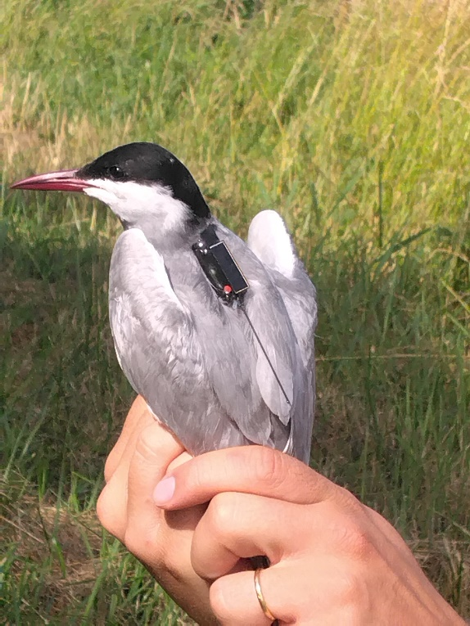
Figure S1. Whiskered Tern with an attached GPS transmitter (Pathtrack®) using a wing-loop harness.

In the absence of prior feedback on device deployment in marsh terns during this study, we tested two attachment methods: a wing-loop and a leg-loop harness (both have been successfully used in terns, e.g., Soanes et al. 2015; Martinović et al. 2019; Pratte et al. 2021; Morten et al. 2022). We focused on a silicon harness suitable for short-term studies but also tested a teflon harness for potential year-round monitoring (details in Table S1).
Table S1. Summary of device features (including attachment type) and birds equipped. The time required to equip birds includes the time to reach the shoreline of ponds, bird measurements, banding, and device attachment.
Device |  |  | Bird |  |  |  | Time
Number | Features (l×w×h, mass) | Attachment | Sex | Body mass  (% of the equipment) | Colony | Breeding success | Capture | Equipment
45756 | 34×11×9 mm, 3.17 g | Silicon wing-loop | F | 84.2 g (4.60%) | Ex-Chèvres | Yes | 7 min | 32 min
47524 | 34×11×8 mm, 2.52 g | Silicon leg-loop | F | 95.8 g (3.36%) | Ex-Chèvres | Yes | 4 min | 22 min
47420 | 33×12×8 mm, 2.75 g | Silicon wing-loop | M | 89.9 g (3.95%) | Grand Riau | No | 15 min | 27 min
47816 | 34×11×9 mm, 3.27 g | Teflon wing-loop | M | 101.8 g (4.00%) | Bignotoi | No | 8 min | 42 min

We observed early signs of battery depletion in the device attached with a leg-loop harness, likely due to the solar panel being obscured by the bird’s wings when at rest. No such issue was found with the wing-loop harness (Video S1). Therefore, we recommend using the wing-loop harness for equipping Whiskered Terns. A loop of 39-40 mm is required. Furthermore, no negative effects on the birds’ behaviour at the nest were detected following the attachment of the devices. Based on specific reviews on the impacts of bio-logging (Barron et al. 2010; Bodey et al. 2017), up to 80% of Whiskered Tern individuals can be safely equipped with nanoFix GEO+RF (>84 g (<5% of body mass), unpublished data, n = 131 adults captured).

References

Barron, D.G., Brawn, J.D. and Weatherhead, P.J. (2010). Meta-analysis of transmitter effects on avian behaviour and ecology. Methods in Ecology and Evolution 1(2): 180–187. doi: 10.1111/j.2041-210X.2010.00013.x.

Bodey, T., Cleasby, I., Bell, F., Parr, N., Schultz, A., Votier, S. and Bearhop, S. (2017). A phylogenetically controlled meta-analysis of biologging device effects on birds: deleterious effects and a call for more standardized reporting of study data. Methods in Ecology and Evolution 9. doi: 10.1111/2041-210X.12934.

Gochfeld, M. and Burger, J. (1996). Family Sternidae (Terns). Pp. 624–667 in J. del Hoyo,A. Elliott and J. Sargatal eds. Handbook of the birds of the world, Vol 3: Hoatzin to auks. Barcelona, Spain: Lynx Edicions.
Martinović, M., Galov, A., Svetličić, I., Tome, D., Jurinović, L., Ječmenica, B., Basle, T., Božič, L. and Kralj, J. (2019). Prospecting of breeding adult Common terns in an unstable environment. Ethology Ecology & Evolution 31(5): 457–468. doi: 10.1080/03949370.2019.1625952.

Morten, J.M., Burgos, J.M., Collins, L., Maxwell, S.M., Morin, E.-J., Parr, N., Thurston, W., Vigfúsdóttir, F., Witt, M.J. and Hawkes, L.A. (2022). Foraging behaviours of breeding Arctic Terns Sterna paradisaea and the impact of local weather and fisheries. Frontiers in Marine Science 8: 760670. doi: 10.3389/fmars.2021.760670.

Paillisson, J.-M., Reeber, S., Carpentier, A. and Marion, L. (2007). Reproductive parameters in relation to food supply in the whiskered tern (Chlidonias hybrida). Journal of Ornithology 148(1): 69–77. doi: 10.1007/s10336-006-0102-4.

Pratte, I., Ronconi, R., Craik, S. and McKnight, J. (2021). Spatial ecology of endangered roseate terns and foraging habitat suitability around a colony in the western North Atlantic. Endangered Species Research 44: 339–350. doi: 10.3354/esr01108.

Soanes, L.M., Bright, J.A., Brodin, G., Mukhida, F. and Green, J.A. (2015). Tracking a small seabird: first records of foraging movements in the sooty tern Onychoprion fuscatus. Marine Ornithology 43(2): 235–239.
http://www.marineornithology.org/PDF/43_2/43_2_235-239.pdf
Appendix S2. Daily foraging distance (km) from the nest by individual Whiskered Terns throughout the breeding season. Pre-incubation (orange), incubation (green), rearing (blue) and post-breeding (red) periods. Locations within the colony pond are excluded.
Appendix S3. Proportion of foraging locations (in %) within the colony pond (light blue), nearby ponds (dark blue), and grasslands (green) for the four Whiskered Terns across the breeding season.
Appendix S4. Density plots of recorded and random foraging locations in ponds according to their distance from the nest (in km).
Recorded foraging locations are shown in black, while randomly generated foraging locations in buffer areas centered on the nest, are shown in grey. The radius of these buffer areas corresponds to the maximum observed distance from the nest location for each period (values in Table 1). The results show a preference for ponds near the nest. Similar trends were observed for grasslands (data not shown).

Appendix S5. Proportions of visually identified prey (%) brought back by Whiskered Terns to the nests during the chick-rearing period in La Brenne in 2023 (9 colonies, 63 pairs, 371 one-hour observation bouts). Identified prey accounted for 56% of the 1332 prey recorded (many prey being too small to be identified). Most of the larger prey items were fish and amphibians, with aquatic invertebrates (primarily dragonflies and water beetles) making up 96% of identified items. Note that, on average, 91% of all foraging positions recorded via bio-logging occurred within ponds.
Video S1. Video of an equipped Whiskered Tern (with a wing-loop harness) at the nest, captured by a drone. The device is visible and not obscured by the wings.

https://drive.google.com/file/d/1lky_4FJV_VfaO23TIqCuun5WZWf9NFV6/view?usp=sharing

