Supplemental Material

Tables

Supplemental Table 1. Pairs used by season and population of origin.
 | Number of Pairs per Population
Yr | Rio Abajo Captive | Rio Abajo Wild
2015 | 0 | 1
2016 | 0 | 2
2017 | 4 | 0
2018 | 3 | 5

Supplemental Table 2. Spearman Rank correlation coefficient of each scorer to the master scorer. Total bouts had 14 of 17 (82.4%) scorers’ agreement. Average bout duration showed 11 of 17 (64.7%) scorers’ agreement. The time inside only 16 of 17 (94.1%) scorers’ agreement. Statistically significant *, excluded from analysis **.
Scorer | Pair Id | Number of Chicks Fed | Total Bouts | Average Bout Duration | Time Inside
1 | RAW Bonding A 2018 | 0.6482 | 1* | 0.9747* | 1*
2 | RAW 4A 2015 | 0.9037* | 0.9429* | 1.000* | 1*
3 | RAW Area I 2018 | 0.6325 | 0.9429* | 0.7537 | 1*
4 | RAW Chalet 2018** | 0 | 0.8000 | 0.8000 | 0.2722
5 | RAW Chalet 2018** | 0 | 0 | 0 | 1*
6 | RAW Comederos 2017 | 0.5774 | 0.9487 | 1.0000* | 1*
7 | RAW Cuarentena 2016 | 0.7454 | 1* | 1.0000* | 1*
8 | RAW 4B 2018 | 0.9037* | 0.9412* | 0.6471 | 1*
9 | RAW 4B 2018 | 0.5000 | 1* | 1.0000* | 1*
10 | RAW Espino 2018 | 0 | 0.9211* | 0.7000 | 1*
11 | RAW Maria Nueva 2016 | 0.7906 | 1* | 1.000* | 1*
12 | RAC G 2017 | 1* | 1* | 0.9545* | 1*
13 | RAC K 2018 | 1* | 1* | 0.8426* | 1*
14 | RAC O 2018 | 0.5 | 0.9276* | 0.4414 | 1*
15 | RAC L 2017 | 1* | 1* | 1* | 1*
16 | RAC O 2017 March 21 | 1* | 1* | 0.8986* | 1*
17 | RAC O 2017 March 23 | 0.7071 | 0.9856* | 0.9852* | 1*

Supplemental Table 3. Raw reproductive information of the pairs and parental care data per pair. All values reported are mean values.
Population | Pair_ID | Total bouts | Mean bout duration (s) | Duration inside (min) | Pair Duration | Total eggs | Fertile eggs | Added fertile eggs | Dead eggs | Hatchlings | Nestlings dead/removed | Fledglings
RAC | B 2017 | 14.187 | 4.937 | 19.575 | 3 | 4 | 3 | 0 | 0 | 3 | 1 | 2
RAC | G 2017 | 5.121 | 3.158 | 15.880 | 12 | 3 | 2 | 0 | 0 | 2 | 0 | 2
RAC | G 2018 | 4.381 | 3.313 | 24.918 | 13 | 3 | 2 | 0 | 0 | 2 | 0 | 2
RAC | K 2018 | 6.643 | 3.499 | 14.427 | 2 | 4 | 4 | 0 | 3 | 1 | 0 | 1
RAC | L 2017 | 6.225 | 3.715 | 25.148 | 1 | 3 | 1 | 0 | 0 | 1 | 0 | 1
RAC | O 2017 | 8.632 | 8.370 | 26.575 | 3 | 4 | 2 | 0 | 0 | 2 | 0 | 2
RAC | O 2018 | 6.813 | 5.354 | 17.438 | 4 | 4 | 4 | 0 | 1 | 3 | 1 | 2
RAW | 4A 2015 | 17.559 | 16.957 | 24.852 | 1 | 3 | 3 | 0 | 0 | 3 | 0 | 3
RAW | 4B 2018 | 9.821 | 4.140 | 11.132 | 2 | 3 | 3 | 0 | 0 | 3 | 1 | 2
RAW | Area I 2018 | 30.428 | 12.188 | 25.228 | 5 | 3 | 2 | 1 | 0 | 3 | 0 | 3
RAW | Bonding A 2018 | 20.438 | 7.101 | 19.952 | 4 | 3 | 2 | 1 | 0 | 3 | 1 | 2
RAW | Cuarentena 2016 | 9.396 | 12.738 | 68.040 | 3 | 3 | 1 | 2 | 0 | 3 | 1 | 2
RAW | Espino 2018 | 17.868 | 9.701 | 28.263 | 3 | 3 | 3 | 0 | 0 | 3 | 0 | 3
RAW | Maria Nueva 2016 | 21.324 | 3.808 | 31.386 | 1 | 3 | 2 | 0 | 0 | 2 | 0 | 2

Supplemental Table 4. Summary statistics of pooled populations.
Statistic | Total eggs | Fertile eggs | Nestlings | Fledglings | Total bouts | Mean Bout duration | Duration inside
Mean | 3.286 | 2.429 | 2.429 | 2.071 | 12.774 | 7.070 | 25.201
Std Dev | 0.469 | 0.938 | 0.756 | 0.616 | 7.729 | 4.340 | 13.602
Std Err Mean | 0.125 | 0.251 | 0.202 | 0.165 | 2.066 | 1.160 | 3.635
Upper 95% Mean | 3.556 | 2.970 | 2.865 | 2.427 | 17.237 | 9.575 | 33.055
Lower 95% Mean | 3.015 | 1.887 | 1.992 | 1.716 | 8.311 | 4.564 | 17.347
N | 14 | 14 | 14 | 14 | 14 | 14 | 14
Variance | 0.220 | 0.879 | 0.571 | 0.379 | 59.743 | 18.832 | 185.022
CV | 14.268 | 38.608 | 31.126 | 29.725 | 60.509 | 61.381 | 53.975
Minimum | 3 | 1 | 1 | 1 | 4.381 | 3.158 | 11.132
Maximum | 4 | 4 | 3 | 3 | 30.428 | 16.957 | 68.040
Median | 3 | 2 | 3 | 2 | 9.608 | 5.145 | 24.885

Supplemental Table 5. Summary statistics by captive and wild populations.
 | Total eggs |  | Fertile eggs |  | Nestlings |  | Fledglings |  | Total bouts |  | Mean bout duration |  | Duration inside
Statistic | Captive | Wild | Captive | Wild | Captive | Wild | Captive | Wild | Captive | Wild | Captive | Wild | Captive | Wild
Mean | 3.571 | 3 | 2.571 | 2.286 | 2.000 | 2.857 | 1.714 | 2.429 | 7.429 | 18.119 | 4.621 | 9.519 | 20.566 | 29.836
Std Dev | 0.535 | 0 | 1.134 | 0.756 | 0.816 | 0.378 | 0.488 | 0.535 | 3.271 | 7.217 | 1.854 | 4.834 | 4.940 | 18.065
Std Err Mean | 0.202 | 0 | 0.429 | 0.286 | 0.309 | 0.143 | 0.184 | 0.202 | 1.236 | 2.728 | 0.701 | 1.827 | 1.867 | 6.828
Upper 95% Mean | 4.066 | 3 | 3.620 | 2.985 | 2.755 | 3.207 | 2.166 | 2.923 | 10.454 | 24.793 | 6.335 | 13.990 | 25.135 | 46.543
Lower 95% Mean | 3.077 | 3 | 1.523 | 1.587 | 1.245 | 2.508 | 1.263 | 1.934 | 4.404 | 11.445 | 2.906 | 5.048 | 15.996 | 13.129
N | 7 | 7 | 7 | 7 | 7 | 7 | 7 | 7 | 7 | 7 | 7 | 7 | 7 | 7
Variance | 0.286 | 0 | 1.286 | 0.571 | 0.667 | 0.143 | 0.238 | 0.286 | 10.698 | 52.081 | 3.436 | 23.371 | 24.407 | 326.340
CV | 14.967 | 0 | 44.096 | 33.072 | 40.825 | 13.229 | 28.464 | 22.010 | 44.029 | 39.830 | 40.116 | 50.787 | 24.023 | 60.547
Minimum | 3 | 3 | 1 | 1 | 1 | 2 | 1 | 2 | 4.381 | 9.396 | 3.158 | 3.808 | 14.427 | 11.132
Maximum | 4 | 3 | 4 | 3 | 3 | 3 | 2 | 3 | 14.187 | 30.428 | 8.370 | 16.957 | 26.575 | 68.040
Median | 4 | 3 | 2 | 2 | 2 | 3 | 2 | 2 | 6.643 | 17.868 | 3.715 | 9.701 | 19.575 | 25.228

Supplemental Material
Figures
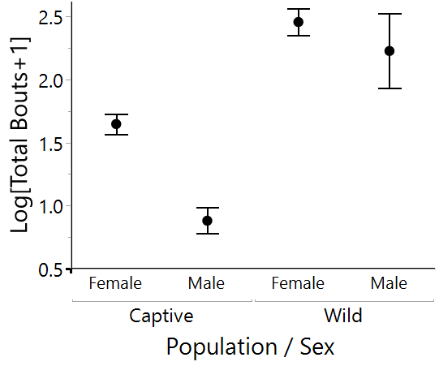
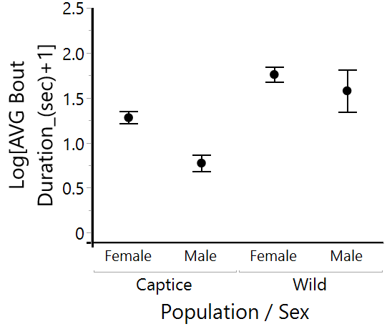
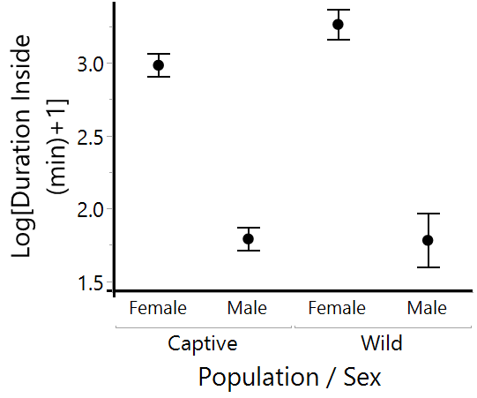

Supplemental Figure 1. Includes the log + 1 transformation results for the mixed model analysis.

