SUPPLEMENTARY INFORMATION
Research Article
Breeding biology of the “Critically Endangered” Cherry-throated Tanager Nemosia rourei

DIEGO HOFFMANN^{1*}, GUSTAVO RODRIGUES MAGNAGO², MARCELO RENAN DE DEUS SANTOS³, CARLOS HARTUR RIBEIRO NOIA⁴, ATHOS JOSÉ RODRIGUES DE SOUZA⁵, VICTÓRIA CAROLINA COSTA FARIA⁶, THIERES DALEPRANE FIOROTTI⁷, GABRIEL SCALDAFERRO BONFA⁸, TOMÁS GONÇALVES CAPDEVILLE⁹, GABRIEL AUGUSTO LEITE¹⁰, FABIO SCHUNCK¹¹, FÁBIO RAPOSO DO AMARAL¹², BENJAMIN TIMOTHY PHALAN¹³

Table S1. Information on the incubation phase, such as start date, number of incubation days, number of eggs, number of incubation sessions (time intervals in which an adult individual was with the eggs), average duration of incubation sessions (h:mm:ss), average interval between incubation sessions (h:mm:ss), and number of feedings of the incubator while it was incubating. Monitoring of ten nests of two groups of the Cherry-throated Tanager Nemosia rourei in Mata dos Caetés (MC) and Santa Teresa (ST). (-) absence of information; (?) impossibility to determine precisely; (*) the value does not represent a complete period of incubation or nestlings.
Nest | Local | Incubation Start (date) | Incubation period (days) | Eggs (n) | Incubation sessions (n) | Average incubation duration (n) | Average interval between incubation sessions (n) | N of incubator feeds (n sessions)
N1 | MC | - | 11* | ? | 19 | 0:54:15 (8) | ? | 1 (1)
N2 | MC | - | 10* | 3 | 94 | 0:51:07 (67) | 0:19:40 (73) | 38 (30)
N3 | MC | - | - | ? | - | - | - | -
N4 | ST | - | 13* | ? | 86 | 1:21:13 (71) | 0:25:15 (76) | 194 (75)
N5 | ST | 2021/10/26 | 16 | 4 | 99 | 1:20:37 (75) | 0:27:24 (82) | 92 (52)
N6 | MC | - | - | ? | - | - | - | -
N7 | MC | 2022/09/25 | 16 | ? | 137 | 0:50:16 (96) | 0:23:26 (100) | 97 (57)
N8 | ST | 2022/11/05 | 10* | ? | 62 | 0:47:41 (41) | 0:28:39 (35) | 104 (36)
N9 | MC | - | - | ? | - | - | - | -
N10 | ST | 2023/09/17 | 15* | 4 | ? | ? | ? | ?
Total/mean |  |  | 16 | 3.7 | 497 | 1:00:52 (358) | 0:24:53 (366) | 526 (251)

Table S2. Information on the nestling phase, such as the hatching date of the eggs, the number of days of the nestling period, the number of nestlings (when possible to determine), the number of brooding sessions (time intervals in which an adult individual was with the nestlings), the average duration of brooding sessions (h:mm:ss), the average interval between brooding sessions (h:mm:ss), the number of feeding sessions (time interval, with the arrival of an individual or group to offer one or multiple food items), the number of food items offered to the nestlings. Some food offerings to the nestlings occurred before the start of a brooding session and even during brooding sessions, with the brooder moving aside to allow other individuals of the group to offer food to the nestlings. After feeding sessions, fecal sac removal was recorded, and after the nestling phase, the nest status and the number of fledglings were verified in ten nests of two groups of the Cherry-throated Tanager Nemosia rourei in Mata dos Caetés (MC) and Santa Teresa (ST). (-) absence of information; (?) impossibility to determine precisely; (*) the value does not represent a complete period of incubation or nestlings.
Nest | Local | Nestling start | Nestlings period (days) | Nestlings (n) | Brooding sessions (n) | Average brooding duration (n) |  | Average interval between brooding sessions (n) |  | Feeding sessions (n) | Food items (n) |  | Food items upon arrival to brood (n sessions) |  | Food items during brooding (n sessions) |  | Fecal sacs removal (n) |  | Nest status |  | Fledlings (n)
N1 | MC | ? | 4* | ≥2 | 21 | 0:45:30(14) |  | 0:19:17 (14) |  | 24 | 32 |  | 21 (14) |  | 5 (5) |  | 5 |  | Failure |  | 0
N2 | MC | 11/11/2020 | 16 | 2 | 132 | 0:31:01(102) |  | 0:28:18(101) |  | 503 | 1319 |  | 296 (116) |  | 223 (117) |  | 141 |  | Success |  | 2
N3 | MC | ? | 15* | 3 | 109 | 0:15:42 (88) |  | 0:39:36 (86) |  | 984 | 3281 |  | 285 (95) |  | 205 (97) |  | 169 |  | Success |  | 3
N4 | ST | 07/10/2021 | 6* | 3 | 58 | 0:41:17 (48) |  | 0:17:25 (48) |  | 129 | 264 |  | 116 (47) |  | 126 (73) |  | 13 |  | Failure |  | 0
N5 | ST | 12/11/2021 | 17 | 2 | 110 | 0:30:28 (78) |  | 0:50:48 (78) |  | 451 | 1461 |  | 300 (113) |  | 175 (85) |  | 76 |  | Success |  | 2
N6 | MC | ? | 7* | 2 | 6 | 0:11:30 (4) |  | 1:51:40 (3) |  | 212 | 769 |  | 16 (4) |  | 9 (5) |  | 32 |  | Success |  | 2
N7 | MC | 11/10/2022 | 15 | 3 | 106 | 0:18:52 (73) |  | 0:45:50 (73) |  | 543 | 2105 |  | 338 (87) |  | 134 (52) |  | 111 |  | Success |  | 3
N8 | ST | - | - | - | - | - |  | - |  | - | - |  | - |  | - |  | - |  | Failure |  | 0
N9 | MC | ? | 4* | ? | - | - |  | - |  | - | - |  | - |  | - |  | - |  | Failure |  | 0
N10 | ST | - | - | - | - | - |  | - |  | - | - |  | - |  | - |  | - |  | Failure |  | 0
Total / mean |  |  | 16.0 | 17 | 542 | 0:27:46 (407) | 0:44:42 (403) |  | 2846 |  |  | 9231 |  | 1372 (476) |  | 877 (434) |  | 547 |  | 50% |  | 12

Table S3. Table S3. List of types of food items offered to the nestlings of ten nests of two groups of the Cherry-throated Tanager Nemosia rourei in Mata dos Caetés (MC) and Santa Teresa (ST). (-) absence of information.
Item | N1 | N2 | N3 | N4 | N5 | N6 | N7 | N8 | N9 | N10 | Total
Undetermined | 28 | 1267 | 3269 | 239 | 1426 | 755 | 2073 | - | - | - | 9057
Caterpillars of moths or butterflies (Lepidoptera) | 2 | 37 | 10 | 13 | 7 | 9 | 17 | - | - | - | 95
Crickets and katydids (Orthoptera) |  | 5 |  | 8 | 2 | 1 | 6 | - | - | - | 22
Insect larvae and chrysalis | 1 | 7 |  | 2 |  | 2 | 1 | - | - | - | 13
Adult Lepidoptera |  |  |  |  |  |  | 5 | - | - | - | 5
winged termites (Blattodea) | 1 | 1 |  |  | 1 |  | 1 | - | - | - | 4
Spiders (Araneae) |  |  |  |  |  | 1 | 2 | - | - | - | 3
Fruits |  |  | 2 |  |  | 1 |  | - | - | - | 3
Bees (Hymenoptera) |  | 1 |  |  |  |  |  | - | - | - | 1
Beetles (Coleoptera) |  |  |  | 1 |  |  |  | - | - | - | 1
Stick insects (Phasmida) |  |  |  |  | 1 |  |  | - | - | - | 1
Total | 32 | 1318 | 3281 | 263 | 1437 | 769 | 2105 | - | - | - | 9205

Table S4. List of species that provoked agonistic reactions in individuals of the Cherry-throated Tanager Nemosia rourei during the monitoring of ten nests of two groups, in Mata dos Caetés (MC) and Santa Teresa (ST).
Species | Family / Group | Construction phase |  |  | Incubation phase |  |  |  |  |  | Nestling phase |  |  |  |  |  | Nestlings fledged | Total
Species | Family / Group | N5 | N7 | N8 | N2 | N4 | N5 | N7 | N8 | N10 | N2 | N3 | N4 | N5 | N6 | N7 | N2 | Total
Indefinite | INDETERMINATE | 1 | 1 | 1 | 1 | 3 | 8 | 2 | 1 |  |  | 29 | 1 | 7 | 3 | 6 |  | 64
Selenidera maculirostris | RAMPHASTIDAE |  |  | 1 |  | 4 | 6 |  | 3 |  |  | 10 | 6 | 2 | 4 | 3 |  | 39
Mixed flock | MIXED FLOCK | 1 |  |  | 2 |  | 1 |  | 3 |  |  | 4 |  | 3 | 1 |  |  | 15
Sapajus nigritus | MAMMALIA |  | 1 |  | 2 |  |  |  |  |  |  |  |  | 2 | 1 | 2 |  | 8
Dendrocolaptidae | DENDROCOLAPTIDAE |  |  |  |  | 1 | 1 |  |  |  |  | 1 |  | 3 |  | 1 |  | 7
Tangara cyanoventris | THRAUPIDAE |  |  |  | 1 |  | 1 |  |  |  |  | 4 |  | 1 |  |  |  | 7
Tangara desmaresti | THRAUPIDAE |  |  |  |  |  |  |  |  |  |  | 7 |  |  |  |  |  | 7
Thraupis ornata | THRAUPIDAE |  |  |  |  |  |  |  |  |  |  | 6 |  |  |  |  |  | 6
Accipitridae | ACCIPITRIDAE |  | 1 |  |  | 1 |  |  |  |  |  | 2 |  |  |  |  | 1 | 5
Elanoides forficatus | ACCIPITRIDAE |  |  |  | 2 |  |  |  |  |  | 2 |  |  |  |  |  | 1 | 5
Anabacerthia lichtensteini | FURNARIIDAE |  |  |  |  | 3 |  |  |  |  | 1 |  |  | 1 |  |  |  | 5
Melanerpes flavifrons | PICIDAE |  |  |  |  |  |  |  |  |  |  | 4 |  |  |  |  |  | 4
Ramphastos vitellinus | RAMPHASTIDAE |  |  |  |  | 2 |  |  |  |  | 1 |  |  |  |  | 1 |  | 4
Dacnis cayana | THRAUPIDAE |  |  |  |  |  |  | 1 | 1 |  |  | 2 |  |  |  |  |  | 4
Hemithraupis ruficapilla | THRAUPIDAE |  |  |  |  | 1 |  |  |  |  |  | 1 | 1 |  |  | 1 |  | 4
Leptodon cayanensis | ACCIPITRIDAE |  |  |  |  |  |  |  |  |  | 1 |  |  |  |  |  | 2 | 3
Lepidocolaptes squamatus | DENDROCOLAPTIDAE |  |  |  |  |  | 1 |  |  |  |  |  |  | 2 |  |  |  | 3
Myiodynastes maculatus | TYRANNIDAE |  | 1 |  |  |  |  |  |  |  | 1 |  |  | 1 |  |  |  | 3
Amadonastur lacernulatus | ACCIPITRIDAE |  |  |  |  |  | 1 |  | 1 |  |  |  |  |  |  |  |  | 2
Caryothraustes brasiliensis | CARDINALIDAE |  |  |  |  |  | 1 |  |  |  |  |  |  | 1 |  |  |  | 2
Sittasomus griseicapillus | DENDROCOLAPTIDAE |  |  |  |  |  | 1 | 1 |  |  |  |  |  |  |  |  |  | 2
Xiphocolaptes albicollis | DENDROCOLAPTIDAE |  |  |  |  |  |  |  |  |  |  |  |  | 2 |  |  |  | 2
Micrastur ruficollis | FALCONIDAE |  |  |  |  |  |  |  |  |  |  |  |  |  | 2 |  |  | 2
Oxyruncus cristatus | OXYRUNCIDAE |  |  |  |  |  |  |  |  |  |  | 1 |  |  | 1 |  |  | 2
Picidae | PICIDAE |  |  |  |  |  |  |  |  |  |  | 2 |  |  |  |  |  | 2
Veniliornis maculifrons | PICIDAE |  |  |  |  | 2 |  |  |  |  |  |  |  |  |  |  |  | 2
Pyrrhura frontalis | PSITTACIDAE |  |  |  |  |  |  |  |  |  |  | 2 |  |  |  |  |  | 2
Tangara cyanocephala | THRAUPIDAE |  |  |  |  | 2 |  |  |  |  |  |  |  |  |  |  |  | 2
Thraupis cyanoptera | THRAUPIDAE |  |  |  |  |  |  |  |  |  |  | 2 |  |  |  |  |  | 2
Harpagus diodon | ACCIPITRIDAE |  |  |  |  | 1 |  |  |  |  |  |  |  |  |  |  |  | 1
Rupornis magnirostris | ACCIPITRIDAE |  |  |  |  |  |  |  |  |  | 1 |  |  |  |  |  |  | 1
Cathartes burrovianus | CATHARTIDAE |  |  |  |  |  |  |  |  |  |  | 1 |  |  |  |  |  | 1
Milvago chimachima | FALCONIDAE |  |  |  |  |  |  |  | 1 |  |  |  |  |  |  |  |  | 1
Euphonia pectoralis | FRINGILLIDAE |  |  |  |  |  | 1 |  |  |  |  |  |  |  |  |  |  | 1
Dendroma rufa | FURNARIIDAE |  |  |  |  | 1 |  |  |  |  |  |  |  |  |  |  |  | 1
Philydor rufum | FURNARIIDAE |  |  |  |  | 1 |  |  |  |  |  |  |  |  |  |  |  | 1
Callithrix flaviceps | MAMMALIA |  |  |  |  |  |  |  |  |  |  |  |  |  | 1 |  |  | 1
Dryocopus lineatus | PICIDAE |  |  |  |  |  |  |  |  |  |  | 1 |  |  |  |  |  | 1
Piculus aurulentus | PICIDAE |  | 1 |  |  |  |  |  |  |  |  |  |  |  |  |  |  | 1
Pteroglossus aracari | RAMPHASTIDAE |  |  |  |  |  |  |  |  | 1 |  |  |  |  |  |  |  | 1
Pteroglossus bailloni | RAMPHASTIDAE |  |  |  |  |  |  |  |  |  |  | 1 |  |  |  |  |  | 1
Ramphastos dicolorus | RAMPHASTIDAE |  |  |  |  |  |  |  |  |  |  | 1 |  |  |  |  |  | 1
Sclerurus scansor | SCLERURIDAE |  |  |  |  |  | 1 |  |  |  |  |  |  |  |  |  |  | 1
Chlorophanes spiza | THRAUPIDAE |  |  |  |  |  |  |  |  |  |  | 1 |  |  |  |  |  | 1
Coereba flaveola | THRAUPIDAE |  |  |  |  |  |  |  |  |  |  |  |  | 1 |  |  |  | 1
Pachyramphus castaneus | TITYRIDAE |  |  |  |  |  | 1 |  |  |  |  |  |  |  |  |  |  | 1
Tityra inquisitor | TITYRIDAE |  |  |  |  |  | 1 |  |  |  |  |  |  |  |  |  |  | 1
Phyllomyias griseocapilla | TYRANNIDAE |  |  |  |  |  |  |  |  |  | 1 |  |  |  |  |  |  | 1
Sirystes sibilator | TYRANNIDAE |  | 1 |  |  |  |  |  |  |  |  |  |  |  |  |  |  | 1
Total |  | 2 | 6 | 2 | 8 | 22 | 25 | 4 | 10 | 1 | 8 | 82 | 8 | 26 | 13 | 14 | 4 | 235

Figure S1. Researchers in the field, with binoculars and cameras, monitoring individuals of the Cherry-throated Tanager Nemosia rourei (A), near the platform used for nest monitoring (B). Photos by G. Magnago (A) e D. Hoffmann (B).

Figure S2. During the monitoring of the nests of the Cherry-throated Tanager Nemosia rourei, it was observed that group individuals fed the incubator (N5) (A) and that the species has nest helpers (N5) (B). After the chicks leave the nest, they are closely monitored by adults, remaining alone for only a few minutes (N3) (C, D). Photos by C.H.R. Noia (A), G.S. Bonfa (B) e T.D. Fiorotti (C, D).

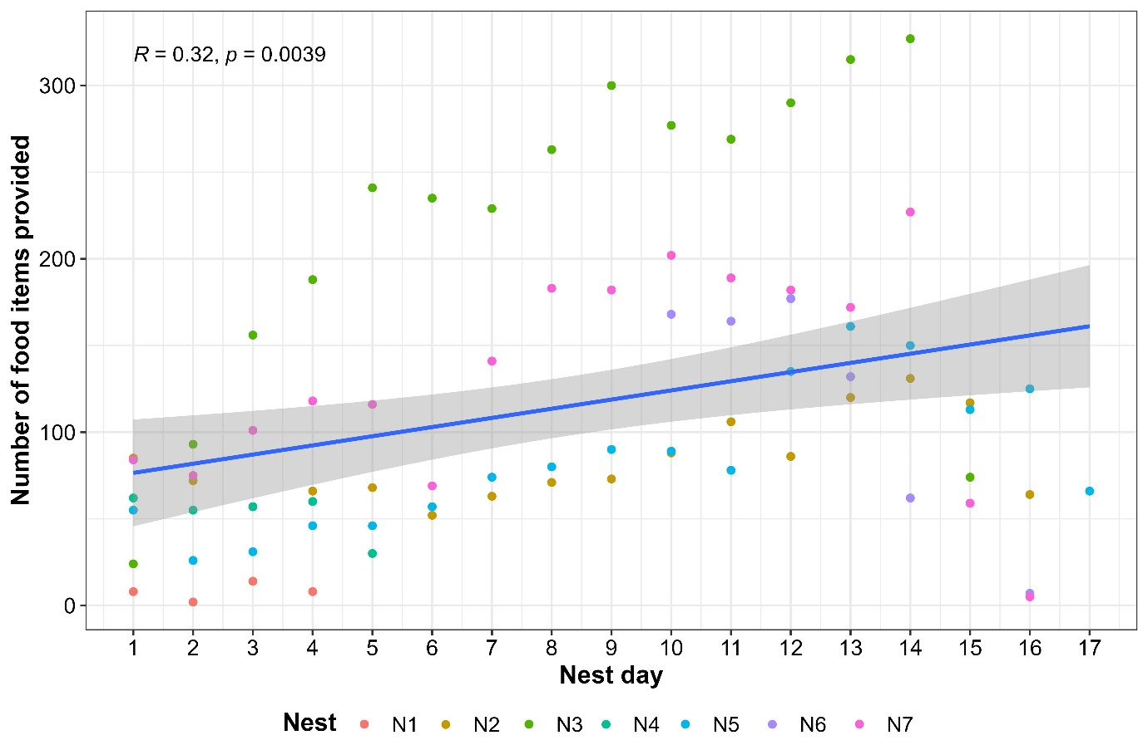
Figure S3. Relation of Number of food items provided by adults of Cherry-throated Tanager to nestling by nest day, for seven nests that have reached the nestling phase. The blue line represent the linear trend with the 95 percent confidence interval. At the top left is the result of the Pearson correlation.

Figure S4. During the monitoring of the nests of the Cherry-throated Tanager Nemosia rourei, it was observed that some chicks were parasitized by botfly larvae (N2) (A), which affected their flight ability in the first days after leaving the nest. The individuals became agitated when hawks, toucans, and monkeys were near the nests (N2) (B). On one occasion, the approach (C) and attempt to pluck feathers from the nestlings (D) by a Gray-capped Tyrannulet Phyllomyias griseocapilla were filmed (N2). On another occasion, a Black-necked Aracari Pteroglossus aracari was filmed removing (E) and eating four eggs (N10) (F). Images C-F are stills taken from video footage. Photos by G. Magnago (A, C, D), D. Hoffmann (B) e A.J.R Souza (E, F).

