**Supplementary material**

**Table S1**: **Variables measured in the field.** All proportions were estimated visually in plots that were delimited in the field. For the tree, shrub, regeneration and crawling bush strata, an estimation was made for all woody or coniferous species separately, then summed to obtain the total coverage for each species.

|  |  |  |  |
| --- | --- | --- | --- |
| **Scale** | **Variable** | **Description** |  |
| 10 m | Grazing evidence [Y/N] | Evidence of grazing by livestock: movable/ fixes fenceposts, cow dung, presence of livestock |  |
|  | Grass height [cm] | Estimation of the mean grass height of the plot |  |
|  | Grass coverage [%] | Estimation of the proportion of ground covered by non-woody vegetation |  |
|  | Mineral ground [%] | Estimation of the proportion of ground covered by gravel (>10cm2), stones ( < 1 m2) and rock (> 1 m2). |  |
|  | Litter [%] | Proportion of dead leaves and needles |  |
|  | Woody litter [%] | Proportion of ground covered by twigs (Ø < 1cm), branches (Ø < 10cm), wood chips and pinecones |  |
|  | Bare ground [%] | Proportion of humus, sand, and other bare ground |  |
| 40 m | Intensive managed grasslands [%] | Grassland poor in grass species |  |
|  | Intensive pasture [%] | Grassland submitted to frequent grazing by livestock |  |
|  | Extensive grassland [%] | Species-rich grassland, corresponding to *Arrhenaterion* or *Mesobromion* |  |
|  | Extensive pasture [%] | Species-rich grassland showing recent signs of grazing |  |
|  | Unmanaged grassland [%] | Grassland showing no signs of use by man; mostly *Stipo-poion* |  |
|  | Hedge/ wooded hems [%] | Linear wooded structures |  |
|  | Forest [%] | Proportion of plot that was part of an extended wooded surface |  |
|  | Other land-use types [%] | Rarely encountered habitat types, such as orchards or vegetable gardens |  |
| 40 & 10 m | Lying dead wood coverage [%] | Coverage of fallen dead trees (Ø > 10 cm, height > 1.3 m) |  |
|  | Snag coverage [%] | Coverage of standing dead trees (Ø > 10 cm, height > 1.3 m) |  |
|  | Number of snags [n] | Number of snags per plot |  |
|  | Tree coverage [%] | Canopy cover (height > 5m) |  |
|  | Shrub coverage [%] | Shrub cover (5m > height > 1.3m) of each species separately |  |
|  | Crawling bush coverage [%] | Crawling bush coverage |  |
|  | Crawling bush diversity | Diversity of crawling bushes (Shannon) |  |
|  | Total Regeneration [%] | Cover of woody vegetation regrowth (height < 1.3m) |  |
|  | Shrub diversity | Diversity of shrubs |  |
|  | Tree diversity | Diversity of trees |  |
|  | Total diversity | Diversity of woody vegetation |  |

|  |  |  |  |
| --- | --- | --- | --- |
|  | Vegetation structure diverstiy | Diversity of different types of vegetation structures |  |
|  | Crawling bush diversity | Diversity of crawling bushes |  |
|  | Crawling bush coverage [%] | Cover of low-growing woody bushes |  |
|  | Road [%] | Cover of concrete/ dirt roads |  |
|  | Building [%] | Cover of Human habitations |  |
|  | Water [%] | Proportion of plot covered by standing or running water |  |
| Only for foraging in Vineyards: | Wooden posts [n] | Number of wooden posts with a flat top (Ø > 5 cm) |  |
|  | Metal vine-posts [n] | Number of metal vine-posts in vineyards |  |
|  | Concrete vine-posts [n] | Differ from metal vine-posts by height, width, and a flat surface at the top |  |
|  | Jets [n] | Number of visible jets used to irrigate grassland/ vineyard |  |
|  | Other artificial perches [n] | Movable plastic posts, hollow metal tubes, fences, etc. |  |
|  | Vineyard [%] | Proportion of plot used for viticulture |  |
|  | Vineyard grass cover [%] | Proportion of ground covered by grass within vineyards |  |

**Table S2**: List of removed variables due to high number of zeros (light brown) and then correlation with other variables (blue).

|  |  |  |  |  |  |
| --- | --- | --- | --- | --- | --- |
| **Breeding 10m** | **Breeding 40m** | **Foraging 10m** | **Foraging 40m** | **Vineyards 10m** | **Vineyards 40m** |
| Grazing evidence | Coniferous tree coverage | Tree diversity | Intensive pasture | Grazing evidence | Grazing evidence |
| Tree coverage | Deciduous tree coverage | Wooden posts | Buildings | Grass height | Grass height |
| Number of snags | Tree diversity | Number of snags | Intensive grassland | Intensive grasslands | Intensive grasslands |
| Coniferous coverage | Number of snags | Crawling bush diversity | Coniferous regeneration coverage | Intensive pasture | Intensive pasture |
| Coniferous shrub coverage | Deciduous regeneration | Snag coverage | Lying dead wood | Extensive grassland | Extensive grassland |
| Deciduous tree coverage | Vegetation structure diversity | Roads | Crawling bush diversity | Extensive pasture | Extensive pasture |
| Tree diversity |  | Artificial perches | Wooden posts | Unmanaged grassland | Unmanaged grassland |
| Snag coverage |  | Coniferous regenation coverage | Extensive pasture | Hedges | Hedges |
| Crawling bush diversity |  | Decidous tree coverage | Roads | Forest | Forest |
| Regeneration coverage |  | Lying dead wood | Jets | Other land use types | Other land use types |
| Shrub diversity |  | Coniferous tree coverage | Coniferous tree diversity | Lying desd wood coverage | Lying desd wood coverage |
| Deciduous regeneration |  | Jets | Coniferous shrub diversity | Snag coverage | Snag coverage |
|  |  | Coniferous shrub coverage | Other artificial perches | Number of snags | Number of snags |
|  |  | Tree coverage | Extensive grasslands | Tree coverage | Tree coverage |
|  |  | Shrub diversity | Number of snags | Shrub | Crawling bush coverage |
|  |  | Regeneration diversity | Landuse diversity | Shrub diversity | Crawling bush diversity |
|  |  | Woody litter | Tree diversity | Regeneration coverage | Regeneration coverage |
|  |  | Grazing evidence | Deciduous regeneration | Shrub diversity | Tree diversity |
|  |  | Crawling bush coverage | Shrub diversity | Tree diversity | Roads |
|  |  | Deciduous shrub | Structure diversity | Total diversity | Buildings |
|  |  | Rocky ground | Regeneration diversity | Vegetation structure diversity | Water |
|  |  |  | Shrub coverage | Crawling bush diversity | Wooden posts |
|  |  |  |  | Crawling bush coverage | Concrete vine-posts |
|  |  |  |  | Roads | Jets |
|  |  |  |  | Buildings | Other artificial perches |
|  |  |  |  | Water | Deciduous regeneration |
|  |  |  |  | Wooden posts | Shrub diversity |
|  |  |  |  | Concrete vine-posts |  |
|  |  |  |  | Jets |  |
|  |  |  |  | Other artificial perches |  |

**Figure S1:** GPS data from 2018 and 2019 across the entire study area from the 42 tracked nightjars. Each colour represents the data from one individual nightjar. GPS points collected between the five study sites were mostly from floater male birds that visited different sights. Scale: 1:156000; basemap: Swisstopo (res.= 0.25 x   
0.25 m).

**Figure S2:** 50 and 95% kernels of the nightjar with the ring number I20. The nightjar left its breeding area to forage in three different zones. The area near the Rhône River where the nightjar foraged is ~2.5 km away from the center of the 50% kernel. Scale: 1:17’500; basemap: Swisstopo (res.= 0,25 x 0.25 m).

**Figure S3:** Example of a foraging plot. The points in light blue represent the GPS data corresponding to foraging events collected for the nightjar I08 in one of the sites it favoured for hunting. Notice how the points are clustered; the point in green corresponds to the center of the study plot. Scale: 1:700; basemap: Swisstopo (res.= 0.25 x 0,25m).

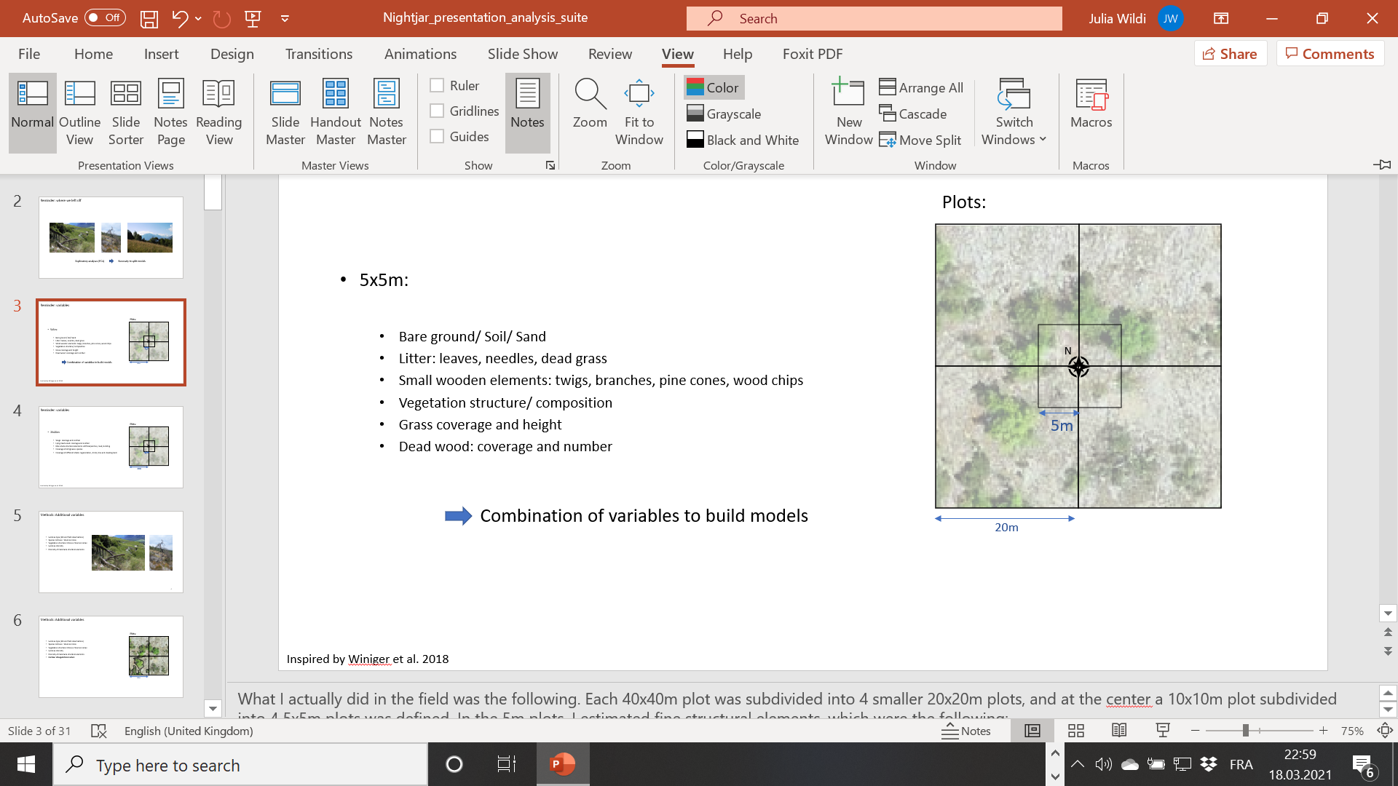

**Figure S4:** **Schema of a vegetation plot that was sampled within nightjar breeding habitat.** At the center of the 40 x 40 m plot, the corresponding 10 x 10 m plot was separated into four 5 x 5 m subplots, in which finer structural elements at ground level were measured in addition to vegetation structure. Vegetation within breeding plots often showed a scattered appearance, with ground that is visibly devoid of vegetation on the aerial photographs.

**Figure S5: Available habitats in the surrounding of the nightjars breeding territories (1.3km).** Forest and Wine are extracted from the land cover vector of the Canton of Valais available online (https://sit.vs.ch/). The meadow data are extracted from Huber *et al*. (2022) modeling the permanent grasslands of Switzerland.

**Figure S6: PCA for the foraging habitat using the 4 variables of the clogit model.** Vineyards and grasslands are represented in red (vineyards) and yellow (grasslands). Individuals are represented by the different colors. Only 1 individual, the blue, is restricted to vineyards.

References:

Huber, N., Ginzler, C., Pazur, R., Descombes, P., Baltensweiler, A., Ecker, K., Meier, E., & Price, B. 2022. Countrywide classification of permanent grassland habitats at high spatial resolution. - Remote Sensing in Ecology and Conservation. https://doi.org/10.1002/rse2.298