**Supplementary Material**

**Appendix S1. Study site details for long-term monitoring sites in the Arctic.**

Table S1. Major monitoring sites in the Arctic studying snowy owls during the breeding period.

|  |  |  |  |  |  |  |  |  |
| --- | --- | --- | --- | --- | --- | --- | --- | --- |
| Monitoring site | Arctic zone | Location | Country | Coordinates | Study area (km2) | Monitoring period | Field work season | Fluctuating prey populationa |
| Karupelv Valley | High | North-East | Greenland | 72°N, 24°W | 75 | 1988-ongoing | 25 Jun-5 Aug | strong |
| Hochstetter Forland | High | North-East | Greenland | 75°N, 19°W | 100 | 2010-ongoing | 30 Jun-10 Aug | strong |
| Bylot Island | High | Nunavut | Canada | 73°N, 80°W | 105 [480]b | 1993-ongoing | 1 Jun-20 Aug | strong |
| Utqiagvik | Low | Alaska | USA | 71°N, 157°W | 214 | 1992-ongoing | June-Aug | strong |
| Wrangel Island | High | Chukotka | Russia | 71°N, 179°E | 45 | 1990-2010 | May-Sep | strong |
| Fennoscandia | Sub | Norway, Sweden, Finland | Norway | 69°N, 22°E | NA | 2005-ongoing | 15 May-1 Aug | strong |
| Igloolik | High | Nunavut | Canada | 69°N, 81°W | 114 | 2011-ongoing | 01 Jun-8 Aug | weak |

aFluctuations in prey population categorized as strong or weak.

bCore study area intensively monitored each year is 105 km2 but an additional area covering 480 km2 (Bylot Island Secondary) is also monitored since 2000 but less intensively. Only data from the Core study area is used in our analysis.

**Appendix S2. Simulation study to evaluate the ability of generalized linear models to recover population trends while ignoring cyclical patterns.**

We used simulations to test whether models used here could recover population trend estimates from abundance of nests of an irruptive species having characteristics similar to populations of snowy owl while ignoring cyclical patterns induced by predator-prey interactions. We simulated abundance data that coarsely mimicked those of the snowy owl and recovered estimates with regression models to compare with true (i.e., simulated) values.

**Methods**

To simulate counts ($y$) of an irruptive species, we used a zero-inflated distribution: $y_{t}\sim Poisson(λ_{t}z_{t})$ where $z_{t}\sim Bernoulli(ψ_{t})$. We simulated abundance ($μ$) so it remained stable or changed linearly over time (*t*) depending on the scenario. A 30-year temporal trend of abundance (hereafter population trend) was controlled by the parameter $δ_{1}$ as $μ_{t}=\exp\left(δ_{0}+δ_{1}{year}_{t}\right)$ where year was a temporal covariate for breeding season scaled to range between -1 and 1. To mimic cycles from predator-prey interactions, we simulated cyclical changes of habitat suitability using a zero-inflation parameter ($ψ$) that accounted for an excess number of zeroes within counts compared to a standard Poisson distribution.

$$ψ_{t}=ilogit\left(ω_{0}+ω_{1}sin⁡(2π\left(\frac{{year}_{t}}{period}\right))+ω_{2}cos⁡(2π\left(\frac{{year}_{t}}{period}\right))\right)$$

For all simulations we set $ω_{1}=ω_{2}=2$ and $period=4$ time steps to approximate cycle duration typical of lemmings across the circumpolar region (Gauthier et al. 2024). For each scenario, we simulated 1,000 time series data sets. We considered three scenarios, each with three to five sets of parameters (Table A2) where we varied mean abundance, population trend, and duration of monitoring period. Examples of simulated data are depicted in Fig A1.

Table S2. Parameter sets used during three simulation scenarios. We assessed relative bias and coverage in the estimation by models of temporal population trends from 1,000 simulations for each set of parameters. A negative binomial distribution was used to estimate population trends in all simulations.

|  |  |  |  |  |  |
| --- | --- | --- | --- | --- | --- |
| Scenario name | Mean abundance ($δ_{0}$) | Population trend ($δ_{1}$) | Duration of monitoring (time steps) | Relative bias | Coverage |
| Population trend | 10 | -0.70 | 30 | -0.11 (0.68) | 0.98 |
|  | 10 | -0.35 | 30 | -0.18 (1.36) | 0.98 |
|  | 10 | 0 | 30 | 0.03 (0.49) | 0.97 |
|  | 10 | 0.35 | 30 | 0.07 (1.32) | 0.98 |
|  | 10 | 0.70 | 30 | 0.02 (0.70) | 0.98 |
| Low mean abundance | 0.5 | -0.70 | 30 | 0.02 (1.93) | 0.93 |
|  | 1 | -0.70 | 30 | -0.10 (1.27) | 0.96 |
|  | 2 | -0.70 | 30 | -0.09 (0.92) | 0.97 |
|  | 3 | -0.70 | 30 | -0.15 (0.76) | 0.98 |
| Duration of monitoring | 10 | -0.70 | 5 | -1.92 (5.21) | 0.95 |
|  | 10 | -0.70 | 10 | -0.02 (1.71) | 0.96 |
|  | 10 | -0.70 | 15 | 0.25 (1.18) | 0.96 |

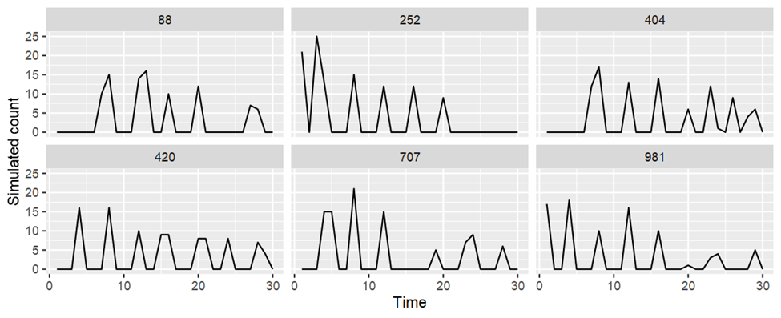

Figure S1. Six randomly selected simulations among a total of 1,000 for one scenario (mean abundance = 10, duration = 30-years and temporal trend of abundance = -0.7) designed to resemble counts from an irruptive species.

For each simulation, we used generalized linear models to estimate the population trend in a frequentist framework for increased computational speed. We attempted to recover population trend estimates using generalized linear models with a negative binomial distribution (R package ‘MASS’, Venables and Ripley 2002). We implemented simulations and models in R version 4.2.3. We calculated relative bias of population trend estimates ($δ_{1}$) as $Rel. bias=\frac{estimate-truth}{truth}$ (Amundson et al. 2014). We calculated coverage as the proportion of estimates where 95% confidence intervals overlapped the true value (Amundson et al. 2014). Note that although data were simulated from a zero-inflated Poisson distribution, we used a negative binomial distribution in our main analysis. Although the negative binomial distribution does not explicitly account for population cycles, it does account for extra zeroes as typically observed in our time series (Fig. 1). Also, a negative binomial distribution provided the best fit for snowy owl (Appendix S3). The zero-inflated Poisson distribution merely provided a convenient method to incorporate population cycles into simulated data.

**Results**

Generalized linear models generally recovered population trend estimates well even though they ignored cyclical pattern of fluctuations (Table A2). These estimates had little bias and excellent coverage in most scenarios considered here except for short-duration monitoring (5-time steps) and low mean abundance (0.5), which tended to have high relative bias (Fig. A2). Therefore, data sets with short-duration monitoring of <10-time steps and low abundance (<0.5) should be excluded from analyses.

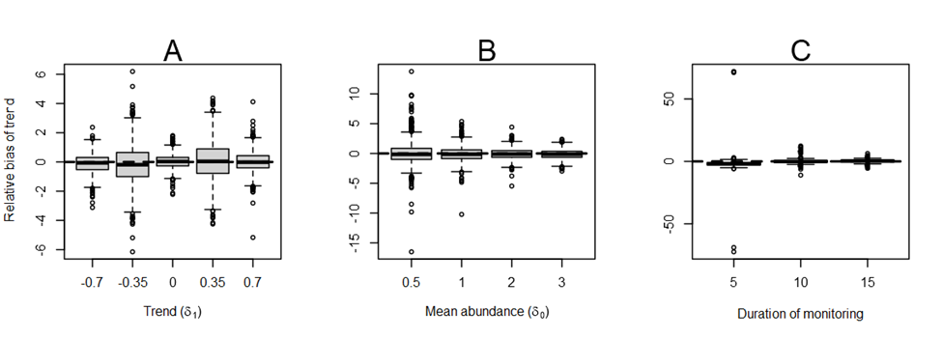

Figure S2. Relative bias of population trends estimated by generalized linear models with a negative binomial distribution according to: (A) magnitude of 30-year temporal trend of abundance, (B) mean abundance, and (C) duration of monitoring. The dashed line depicts unbiased estimates. Solid horizontal lines within each box depict medians (50th percentile); boxes depict the 25th and 75th percentiles; whiskers depict the largest and smallest values within 1.5 times the interquartile range; outlier data are depicted as open circles; and a dashed line at no bias (zero) is provided for reference. For each scenario, we simulated 1,000 time series data sets.

**Literature Cited**

**Amundson C.L., Royle J.A. and Handel C.M.** (2014) A hierarchical model combining distance sampling and time removal to estimate detection probability during avian point counts. *The Auk* **131**, 476–494. <https://doi.org/10.1642/AUK-14-11.1>

**Gauthier G., Ehrich D., Belke-Brea M., Domine F., Alisauskas R., Clark K., Ecke F., Eide N., Framstad E., Frandsen J., Gilg O., Henttonen H., Hörnfeldt B., Kataev G.D., Menyushina I.E., Oksanen L., Oksanen T., Olofsson J., Samelius G., Sittler B., Smith P.A., Sokolov A.A., Sokolova N.A. and Schmidt N.M.** (2024) Taking the beat of the Arctic: are lemming population cycles changing due to winter climate? *Proceedings of the Royal Society B* **291**, 20232361. <https://doi.org/10.1098/rspb.2023.2361>

**Venables W.N. and Ripley B.D.** (2002) Modern Applied Statistics with S. Fourth Edition. Springer, New York. ISBN 0-387-95457-0**.**

**Appendix S3. Methods and results for breeding population trend analysis.**

We used hierarchical generalized linear models (Gelman and Hill 2007) to estimate trends in relative abundance over time and derive population growth rates (Sauer and Link 2011). We used count data ($y$) collected during 1988–2020 from five sites (Fig. 1, Appendix S1) to estimate population trends. We omitted data from Hochstetter Forland and Igloolik because too few owl nests were monitored. We also omitted data from Bylot Island Secondary because preliminary analyses suggested that these data placed too much weight on the Bylot Island study region when estimating overall population trends.

We fit models using count data (*y*) as a response variable with $y_{t,j}\sim g(μ_{t,j})$ where indices represent site (*j*) and year (*t*) and $g(μ_{t,j})$ represents a best-fitting statistical distribution determined from a goodness-of fit test (described below) having a mean ($μ_{t,j}$) and some variance. We used the log-link function to specify the mean as a function of some covariates that included a site-specific intercept ($α_{j}$), a site-specific linear trend over time for counts ($β_{j}$) with a covariate (${YEAR}_{t}$) as $\log{(μ_{t,j})}\sim α_{j}+β_{j}×{YEAR}_{t}+ε_{t}$, where $ε_{t}\sim normal(0, σ)$. Year of monitoring (1988–2020) was included as a covariate (${YEAR}_{t}$) that was scaled and centered to have a minimum = -1, maximum = 1, and mean = 0. Some sites included data of area of survey, but Fennoscandia did not include these data. Therefore, we were unable to include area as an offset to correct for the area surveyed at each site.

We selected the best-fitting distribution (either Poisson, zero-inflated Poisson, or negative binomial) for count data by implementing global models that included the aforementioned covariate of a linear trend over time. We checked goodness-of-fit of each distribution using posterior predictive checks and Bayesian *P*-values calculated using mean absolute percentage discrepancy statistic (Kéry and Schaub 2022). We retained the distribution that provided the best fit for further analysis when its Bayesian *P*-value was nearest to 0.5 compared to other distributions. A negative binomial distribution provided best fit (Bayesian *P*-value = 0.45) while Poisson and zero-inflated Poisson distributions provided poorer fit (Bayesian *P*-values = 0.05 and 0.98, respectively); therefore, we used the negative binomial distribution for inference.

We used Bayesian inference using Hamilton Monte Carlo samplers (hereafter HMC) in R version 4.2.1 (R Core Team 2021) and NIMBLE version 0.13.0 (NIMBLE Development Team 2019) and NIMBLEHMC version 0.2.0 (Turek et al. 2023). One distribution (i.e., zero-inflated Poisson) could not be fit using HMC because of limitations with discrete parameters; therefore, we switched to Markov Chain Monte Carlo (MCMC) methods for model implementation. We fit each model using four chains with each chain having 10,000 burn-in iterations, 20,000 posterior iterations, thinned by retaining one in 10 iterations, thereby totaling 4,000 posterior draws (1,000 for each chain). We assigned adequate convergence when $\hat{R}$ ≤ 1.1 (Gelman and Rubin 1992) and traceplots did not appear to drift.

We provide pseudocode describing how we converted abundance estimates from models to percent change of snowy owl populations over three generations, consistent with IUCN Red List Criteria A2:

Step 1) Run model.

Step 2) Derive population growth rates for each site and each year from posterior draws of predicted abundance.

Step 3) Calculate a weighted mean of population growth rates among sites where each monitored site contributes proportional to its population size (count) each year.

Step 4) Set three generations from the end of the data set as a reference year (reference year = 1996 and 1988 using 8-year and 10.7-year generations, respectively) when all posterior iterations equal one to calculate percent change from this baseline.

Step 5) Multiply posterior iterations of the reference year (all equal to one) by subsequent population growth rates to estimate an overall population growth rate for each year.

Step 6) Convert population growth rates relative to percent change since 1996.

Here, we describe these steps in greater detail. First (Step 1), we extracted estimated abundance for each site and year from the model. Second (Step 2), we derived parameters to calculate population growth rates for each site from posterior distributions of relative abundance as $λ_{t,j}={(μ}_{t,j})/{(μ}_{t-1,j})$. Third (Step 3), we used mean counts from surveys at each site to weight population growth rates ($λ_{t,j}^{weighted}$) so that each site contributes proportionally to the count at each site that was monitored. We assigned no weight (i.e., zero) to population growth rates during years when a site was not monitored for two consecutive years. Fourth, (Step 4) we subtracted three generations from the last year (2020) to determine the reference year as a baseline year to ensure consistency with IUCN Red List Criteria A2. Therefore, we set the posterior draws of this reference year to a value of one. We assumed an approximate generation time of 8 years based on the equation of Lande et al. (2003) and using the estimates from Therrien et al. 2012, and 10.7 based on the maximum generation time from which we could estimate three generations given the data. We included the longer generation time (i.e., 10.7 years) because members of the working group suspected that 8 years might be the lower boundary of generation time given the methods used elsewhere for estimation, and this was the longest generation time for which we could estimate percent change over three generations. Fifth (Step 5), we started with the posterior of the reference year (1996 and 1988) equal to one and multiplied each year by the weighted population growth rate among sites during the following year. These values now represented the population growth rates compared to the reference year (e.g., $λ_{t,j}^{1996}$). Sixth (Step 6), we converted these values to percent change after three generations (Step 6), e.g., percent change = ($λ_{t,j}^{1996}$-1) ×100 (Sauer et al. 2017). Percent change after three generations can be directly interpreted under the IUCN Red List Criteria A2 and propagates uncertainty in these values.

We attempted to fit more complex models using a multivariate normal distribution that allowed parameters to include correlations among sites; however, these models did not adequately converge and were discarded from further consideration. We also attempted to fit a model that included site and time as random factors; however, these results included several sites that did not meet our criteria from simulations (online supplementary Figs. S8 and S9). This analysis yielded similar results to those presented in the methods of this manuscript.

**Literature Cited**

**BirdLife International** (2020) Species factsheet: *Bubo scandiacus*, IUCN Red List for Birds. <http://www.birdlife.org> on 12/04/2020.

**Gelman A. and Hill J.** (2007) Data Analysis Using Regression and Multilevel/Hierarchical Models. Cambridge University Press.

**Gelman A. and Rubin D.B.** (1992) Inference from iterative simulation using multiple sequences. *Statistical Science* **7**, 457–472.

**Lande R., Engen S. and Saether B.E.** (2003) Stochastic population dynamics in ecology and conservation. Oxford University Press, USA.

**NIMBLE Development Team** (2019) NIMBLE: MCMC, Particle Filtering, and Programmable Hierarchical Modeling.

**R Core Team** (2022) R: A language and environment for statistical computing. R Foundation for Statistical Computing, Vienna, Austria.

**Sauer J.R. and Link W.A.** (2011) Analysis of the North American Breeding Bird Survey Using Hierarchical Models. *The Auk* **128**, 87–98. Doi:10.1525/auk.2010.09220

**Sauer J.R., Pardieck K.L., Ziolkowski Jr D.J., Smith A.C., Hudson M.R., Rodriguez V., Berlanga H., Niven D.K. and Link W.A.** (2017) The first 50 years of the North American breeding bird survey. *The Condor: Ornithological Applications* **119**, 576–593.

**Schaub M. and Kery M.** (2021) Integrated population models: theory and ecological applications with R and JAGS. Academic Press.

**Therrien J.F., Gauthier G. and Bêty J.** (2012) Survival and reproduction of adult snowy owls tracked by satellite. *The Journal of Wildlife Management* **76**, 1562­–1567.

**Turek D., de Valpine P. and Paciorek C.** (2023) _nimbleHMC: Hamiltonian Monte Carlo and Other Gradient-Based MCMC Sampling Algorithms for 'nimble'_. R package version 0.2.0.

**Appendix S4. Parameter estimates from analyses of population trends at five sites where snowy owls were monitored between 1988­–2020.**

We provided parameter estimates for trends at each site using both 80% and 95% highest density intervals (hereafter ‘HDIs’). We chose these levels because they are commonly used for management purposes (Miller et al. 2016, 2019; McClure et al. 2023b). We considered parameter estimates to be biologically relevant when 80% HDIs excluded zero. We calculated the probability of direction (Makowski et al. 2019) as the proportion of iterations that were less than the null value (λ = 1 or percent change = 0) to determine the probability that the population was declining. We designated the probability of decline (hereafter ‘pd’) to indicate a negative trend with values > 0.90 (McClure et al. 2023b). Data, metadata, and code for implementation are archived at <https://github.com/The-Peregrine-Fund/Snowy-Owl-Population-Trends> and accompanied by a full workflow at <https://the-peregrine-fund.github.io/Snowy-Owl-Population-Trends/>.

Table S3. Abundance trends of snowy owls at five sites. Parameter estimates are presented on the log scale for a random factor of time among sites, mean abundance of each site (mu) in 2004 (i.e., the median year of time interval), linear trend over time (beta) of each site, and a parameter for the negative binomial distribution estimating the number of successes (r.nb) of each site. We provide median estimates along with 80% and 95% highest density intervals (HDIs). We considered sites to have potentially significant population trends when probability of direction (pd) was greater than 0.90.

|  |  |  |  |  |  |  |  |
| --- | --- | --- | --- | --- | --- | --- | --- |
| Site | Parameter | Median | 95% HDIs | | 80% HDIs | | pd |
| All sites | sigma.time | 1.92 | 0.79 | 3.43 | 1.08 | 2.73 |  |
| Bylot Island Core | mu | 1.46 | 0.28 | 2.73 | 0.76 | 2.22 |  |
|  | beta | 0.12 | -1.93 | 2.13 | -1.23 | 1.33 | 0.55 |
|  | r.nb | 0.46 | 0.21 | 0.77 | 0.28 | 0.63 |  |
| Fennoscandia | mu | 2.78 | 2.04 | 3.69 | 2.25 | 3.27 |  |
|  | beta | 0.66 | -0.48 | 1.81 | -0.06 | 1.36 | 0.88 |
|  | r.nb | 0.14 | 0.04 | 0.28 | 0.05 | 0.21 |  |
| Karupelv Valley | mu | 0.58 | -0.49 | 1.86 | -0.12 | 1.32 |  |
|  | beta | -0.56 | -2.19 | 1.03 | -1.56 | 0.41 | 0.77 |
|  | r.nb | 0.15 | 0.04 | 0.29 | 0.07 | 0.22 |  |
| Utqiagvik | mu | 2.51 | 1.94 | 3.16 | 2.10 | 2.89 |  |
|  | beta | -0.74 | -1.86 | 0.41 | -1.50 | -0.04 | 0.91 |
|  | r.nb | 0.17 | 0.01 | 0.52 | 0.02 | 0.34 |  |
| Wrangel Island | mu | 4.10 | 3.71 | 4.57 | 3.83 | 4.39 |  |
|  | beta | -0.04 | -0.93 | 0.89 | -0.60 | 0.56 | 0.53 |
|  | r.nb | 0.61 | 0.24 | 1.21 | 0.30 | 0.90 |  |
|  |  |  |  | |  | |  |

**Literature Cited**

**Makowski D., Ben-Shachar M.S. and Lüdecke D.** (2019) bayestestR: Describing effects and their uncertainty, existence and significance within the Bayesian framework. *Journal of Open-Source Software* **4**, 1541.

**McClure C.J.W., Rolek B.W. and Fleischer J.** (2023b) Composite population trends reveal status of wintering diurnal raptors in the Northwestern USA. *Biological Conservation* **277**, 109861

**Miller R.A., Paprocki N., Stuber M.J., Moulton C.E. and Carlisle J.D.** (2016) Short-eared owl (*Asio flammeus*) surveys in the North American intermountain west: utilizing citizen scientists to conduct monitoring across a broad geographic scale. *Avian Conservation Ecology* **11**, 3–10. <http://dx.doi.org/10.5751/ACE-00819-110103>

**Miller R.A., Carlisle J.D., Barnes J.G., Haley R.D. and Jeffress M.R.** (2019) Winter distributions and habitat associations of raptors across Nevada. *Western Birds* **50**, 114–141.