**The effect of small-scale agro-environmental initiatives on avian diversity in agricultural landscapes**

Examples of initiatives

1. Grass strip in the edge of arable field along existing hedgerow.

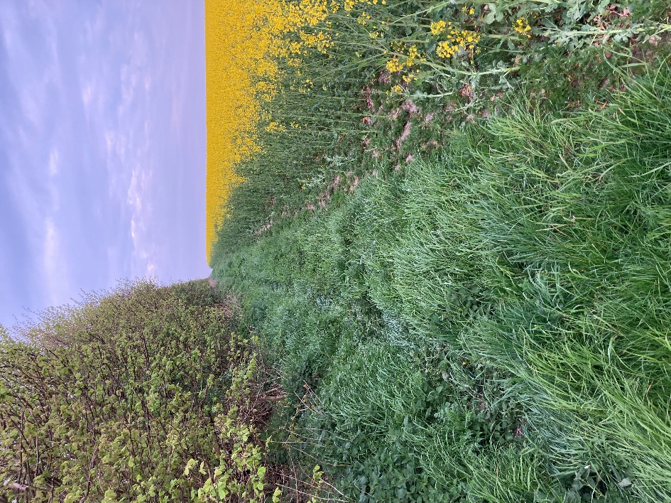

1. Sown vegetation strip in the edge of arable field boardering scrubland.

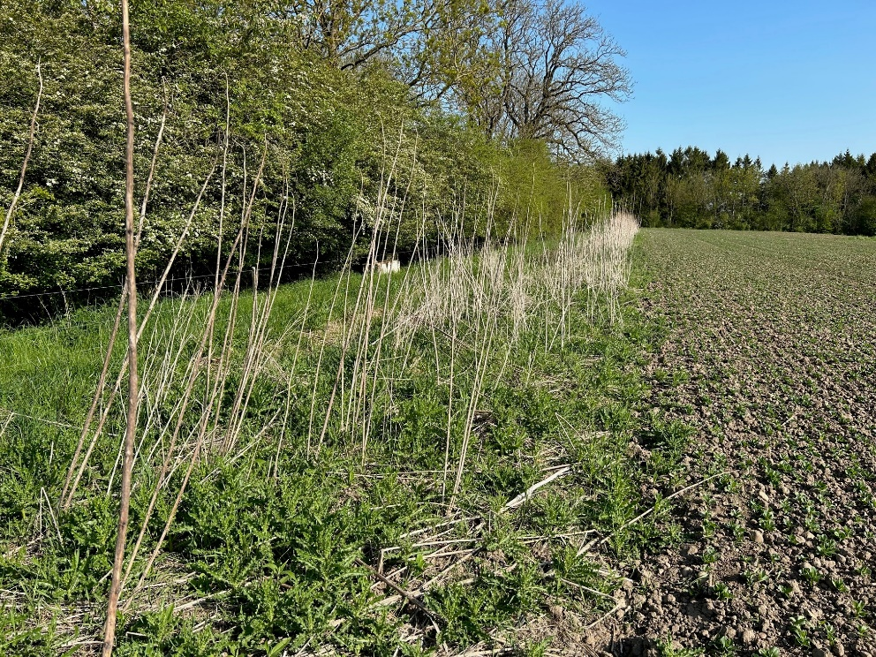

1. Combination strip with grass, natural vegetation and bare soil boardering a forest.

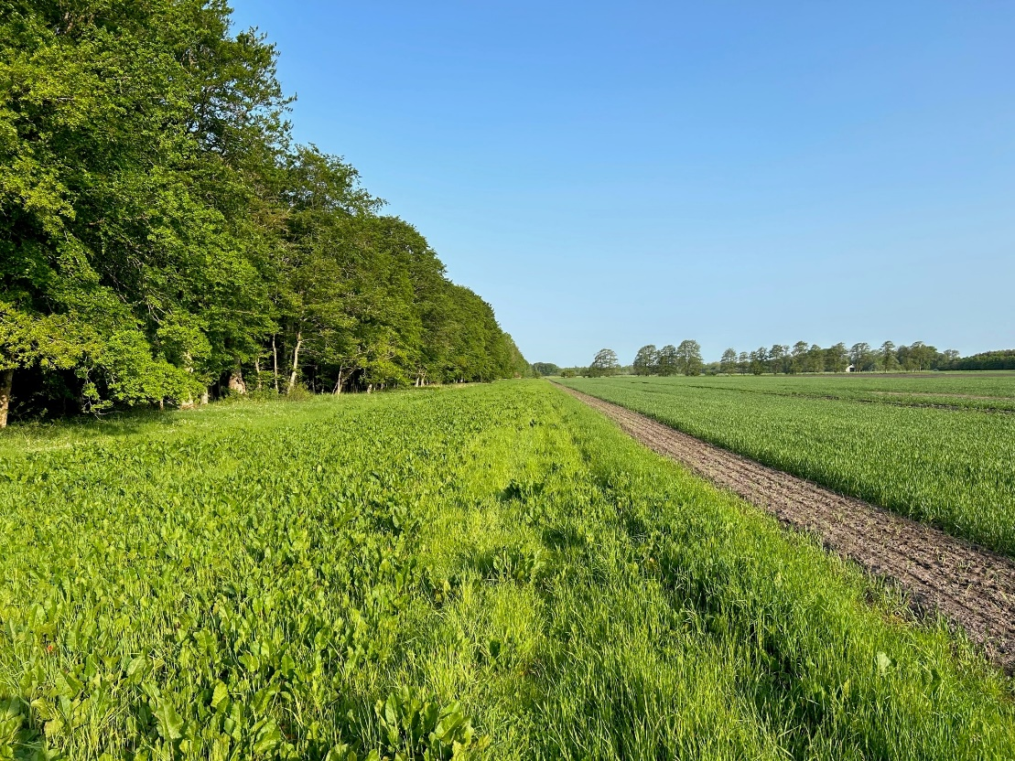

1. Established hedgerow in the middle of arable field

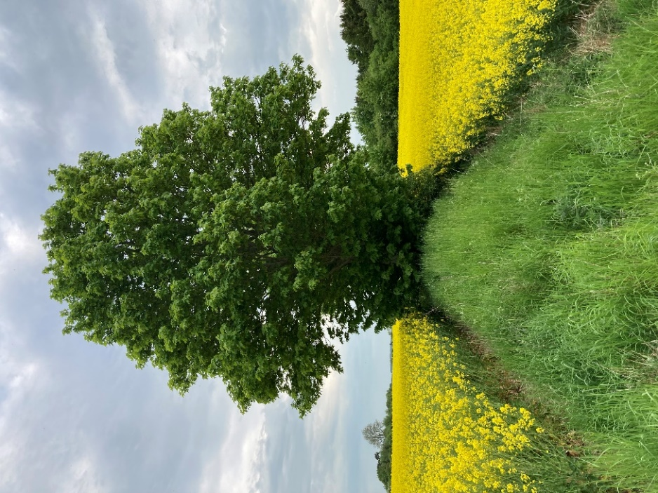

1. Established lake in the corner of an arable field.

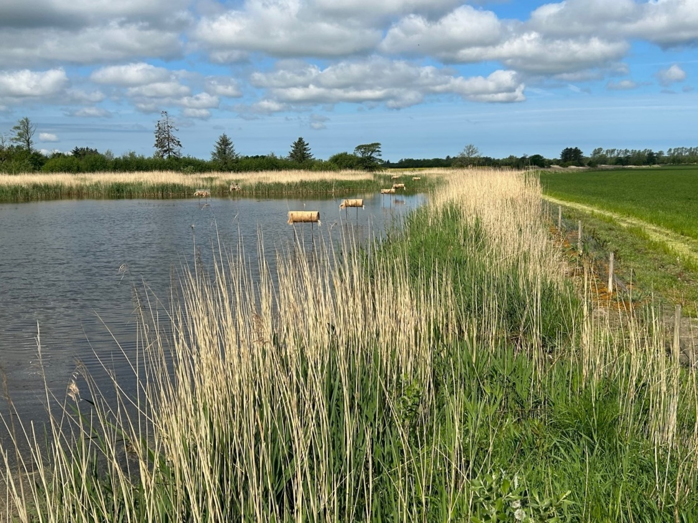

1. Area of open vegetation in one end of an arable field.

