Power line density and habitat quality: key factors in Canarian houbara bustard decline
Alberto Ucero ^{a,*}, Juan C. Alonso ª, Carlos Palacín ª, Inmaculada Abril-Colón ª , José M. Álvarez-Martínez^{b}
ª Departamento de Ecología Evolutiva, Museo Nacional de Ciencias Naturales (CSIC), José Gutiérrez Abascal 2, E-28006 Madrid, Spain
^{b} IHCantabria, Instituto de Hidráulica Ambiental de la Universidad de Cantabria. PCTCAN, C/Isabel Torres, 15, 39011, Santander, Spain
* Address correspondence to A. Ucero. E-mail: albertucero@mncn.csic.es
Museo Nacional de Ciencias Naturales (CSIC), José Gutiérrez Abascal 2, E-28006 Madrid, Spain. Telephone: (+34) 914111328

Table S1. Published estimates of the Canarian houbara bustard population in Fuerteventura.
Year of census | Houbaras counted | Surface surveyed (km²) | Houbaras estimated in the island |  |  | Census method | Reference
 |  |  | minimum | maximum | mean
1979 | 42 | 58 | 80 | 100 | 80-100 | Multiple line transects on food, plus continuous transects and some visits to side difficult to survey by transects, extrapolation | Lack 1983
1984 | -¹ | - | 59 | 90 | 59-90 | Author’s estimate | Collins 1984
1984 | 24 | 49.3 | 69 | 86 | 69-86 | Multiple line transects on foot, extrapolation | Osborne 1986
1988 | 127 | - | 262 | 318 | 262-318 | Multiple line transects on foot, extrapolation | Emmerson et al. 1989a
1989 | 125 | - | - | - | - | Multiple line transects on foot, extrapolation | Emmerson et al. 1989b
1989 | 153 | - | 153 | 378 | 153-378 | Multiple line transects on foot, extrapolation | Emmerson et al. 1990
1992 | 137 | - | 300 | 350 | 300-350 | Multiple line transects on foot, extrapolation | Emmerson et al. 1992
1994 | 189 | - | - | - | 241 | Author’s estimate | Martín et al., 1997
1998 | 87² |  |  |  | 199² | Direct counting of males from vantage points over the entire houbara distribution range, and population estimate² | Hellmich 1998
2005 | 216 | - | - | - | 431 | Multiple line transects on foot, compound extrapolation, additional observations 9 | Lorenzo et al. 2007
2005 | 22 | - | 44 | 246 | 147 | Transects on foot, detectability estimates, bootstrapping to estimate confidence intervals | Carrascal & Alonso 2005
2005 | 36+ | 121.4 | 98 | 274 | 177 | Multiple line transects on foot, extrapolation | Carrascal. et al 2008
2005 | - | - | 46 | 258 | 154 | Multiple line transects on foot, extrapolation | Carrascal. et al 2012
2006 | 218 | - | - | - | 384 | Multiple line transects on foot, compound extrapolation, additional observations 12 | Lorenzo et al. 2007
2006 | 233-236 | - | - | - | 421 | Multiple line transects on foot, compound extrapolation, additional observations 13 | Lorenzo et al. 2007; see also Hernández & Lorenzo, 2012 14
2011 | 117 | 104.3 | -15 | - | - | Multiple line transects on foot, delectability estimates, bootstrapping | Schuster et al. 2012
2012 | 41 | 137.5 | 105 | 295 | 193 | Transects on foot following stratified sampling criteria, detectability estimates, bootstrapping to estimate confidence intervals | Carrascal 2012
2016 | 94 | 111.3 | 15 | - | - | Multiple line transects on foot, delectability estimates, bootstrapping | De Colsa & Carrascal 2017
2020 | 72 | 110.34 | - | - | 160 | Multiple line transects on foot, delectability estimates, bootstrapping | De Colsa & Carrascal 2020
2021 | 67 | 312.5 | 85 | 109 | 97 | Direct counting of individuals from vehicles and vantage points over the entire known area, and population estimate | Ucero et al. 2021

¹ A hyphen means that the authors do not provide the data
² The author counted 83 adult males, estimated a proportion of 1 immature male per 5 adult males (i.e., 16.6 immature males) and multiplied the sum by two, assuming a sex ratio of 1:1 ([83 + 16.6] x 2 = 199.2 individuals in the population; see Hellmich 1998, pages 47-48).
Table S2. Census areas defined in 1998 and 2021 (Hellmich, 1998; Ucero et al., 2021) and their location in Fuerteventura. Includes values for the percentage decrease in the number of display sites occupied in 1998 in each of the areas compared to the sites currently occupied and the percentage decrease in males in each of the areas from 1998 to 2021.
Census areas (Hellmich 1998) | Census areas (Ucero. et al 2021) | Location in Fuerteventura | Numbers of display sites active in each area in 2021 / 1998 (% abandonment) | Numbers of males detected in each area in 2021 / 1998 (% reduction) | Protected status⁹
El Jable de Corralejo | North-east of Fuerteventura | Parque Natural de Corralejo | 1/2 (50) | 1/2 (50) | SPA, 1987; Natural Park, 1982
Majanicho | North West Fuerteventura | Cotillo - Majanicho | 2/9 (77.8) | 2/10¹ (80) | SPA, 1989 (El Cotillo - Jable de Taca¹⁰); 2006 (Majanicho)
El Cotillo-Jable de Taca
Llanos de Tostón | Centre - North of Fuerteventura | Lajares- La Oliva | 3/8 (62.5) | 4²/9³ (50) | SPA, 1989
Jable de Lajares
Montañeta de la Cebada
Monta alta-Rosa de Frasquita
Montaña Bermeja W (Llano de la Laguna) | Centre of Fuerteventura | Tefía- Triquivijate - Tesjuate | 8/27 (70.4) | 10⁴/28⁵ (64.3) | NP, except Montaña Bermeja W, Triquivijate E and El Saladar-Mafasca-Montañeta de los Alares (SPA, 2001)
Montaña Bermeja S (Montañeta de Tao)
Rosa de Ocalia – Llano de Muchichafe
Alto de Matías-Triquivijate W
Triquivijate E
El saladar-Mafasca-Montañeta de los Alares
Tesjuates
Llanos de Tindaya-Lomos de Esquinzo | Centre - West of Fuerteventura | Tindaya - Esquinzo | 7/12 (41.7) | 7/12 (41.7) | SPA, 1989
Llanos de Tindaya-Laderas de Tebeto
Llanos de Guisguey-Laderas del Time | Centre - East of Fuerteventura | Guisguey-Filmapaire-Aeropuerto-Las Salinas | 2/17 (88.2) | 7⁶/17 (58.8) | NP
Valle de Fimapaire - Las Llanadas
Llanos de Lezque-Llanos y Rosa de la Mareta
Montañeta de Osarda-Vista del Castillo
Llanos de las Salinas
Llano Grande | Centre - South of Fuerteventura | Tiscamanita - Tuineje | 2/4 (50) | 2/5⁷ (60) | NP
Rosa de Catalina García Sur
Granillo-Alto de Agua Oveja | South of Fuerteventura | Parque Natural de Jandia | 4/4 (0) | 4/4 (0) | SPA and Natural Park, 1987
TOTALS |  |  | 29/83 (65.1) | 37/87⁸ (57.5)
Newly occupied display sites in 2020-21 |  |  |  | 4
Males without confirmed display site in 2020-21 |  |  |  | 3

¹Includes 1 male aged as subadult (Majanicho)
²Includes 1 displaced male
³Includes 1 male aged as subadult (Llanos de Tostón)
⁴Includes 1 young male and includes 1 displaced male
⁵Includes 1 male aged as subadult (Tesjuate)
⁶Includes 3 males with no confirmed display location and 2 displaced male display sites
⁷Includes 1 male aged as subadult (Llano Grande)
⁸Includes 4 males aged as subadults and 1 young male in the 2020 census
⁹SPA = Special Protection Areas for Birds, NP = Not protected
¹⁰ In this area, despite having been declared a SPA in 1987, protection was not very effective, due to the large number of scattered constructions that were built after it was declared a protected area and the high level of tourist use. This has probably resulted in a high number of extinct display sites here

Table S3. A value of 2 was assigned to the presence of a steppe species at high density and a value of 1 to the presence of a steppe species at low density. The sum of this value (1 or 2) for each of the three steppe species present in the different census areas defined by Hellmich (1998) and Carrascal and Colsa (2020) on Fuerteventura provided the final value used in our analyses. A value of zero was assigned to a viewing site when none of the three steppe species were present in that area. Data on the number of species and densities by area were obtained from Hellmich (1998) and Carrascal & Colsa (2020). See Methods for more details.
 |  | Abundance of other steppe birds  in 1997-98 (Hellmich 1998) |  |  |  | Abundance of other steppe birds  in 2020-21 (Carrascal and Colsa, 2020)
ID male display location | Zones Hellmich | Burhinus oedicnemus insularum | Pterocles orientalis | Cursorius cursor | Final value used in our analyses | Burhinus oedicnemus insularum | Pterocles orientalis | Cursorius cursor | Final value used in our analyses
1 | El Jable de Corralejo | 1 | 0 | 1 | 2 | 1 | 0 | 2 | 3
2 | El Jable de Corralejo | 1 | 0 | 1 | 2 | 1 | 0 | 2 | 3
3 | Majanicho | 2 | 0 | 0 | 2 | 1 | 0 | 1 | 2
4 | El Cotillo-Jable de Taca | 2 | 1 | 2 | 5 | 1 | 1 | 1 | 3
5 | El Cotillo-Jable de Taca | 2 | 1 | 2 | 5 | 1 | 1 | 1 | 3
6 | El Cotillo-Jable de Taca | 2 | 1 | 2 | 5 | 1 | 1 | 1 | 3
7 | El Cotillo-Jable de Taca | 2 | 1 | 2 | 5 | 1 | 1 | 1 | 3
8 | El Cotillo-Jable de Taca | 2 | 1 | 2 | 5 | 1 | 1 | 1 | 3
9 | El Cotillo-Jable de Taca | 2 | 1 | 2 | 5 | 1 | 1 | 1 | 3
10 | El Cotillo-Jable de Taca | 2 | 1 | 2 | 5 | 1 | 1 | 1 | 3
11 | El Cotillo-Jable de Taca | 2 | 1 | 2 | 5 | 1 | 1 | 1 | 3
12 | Jable de Lajares | 1 | 2 | 1 | 4 | 0 | 2 | 1 | 3
13 | Jable de Lajares | 1 | 2 | 1 | 4 | 0 | 2 | 1 | 3
14 | Montañeta de la Cebada | 1 | 2 | 1 | 4 | 1 | 1 | 1 | 3
15 | Montañeta de la Cebada | 1 | 2 | 1 | 4 | 1 | 1 | 1 | 3
16 | Montañeta de la Cebada | 1 | 2 | 1 | 4 | 1 | 1 | 1 | 3
17 | Montaña alta-Rosa de Frasquita | 1 | 2 | 1 | 4 | 1 | 1 | 1 | 3
18 | Montaña alta-Rosa de Frasquita | 1 | 2 | 1 | 4 | 1 | 1 | 1 | 3
19 | Montaña alta-Rosa de Frasquita | 1 | 2 | 1 | 4 | 1 | 1 | 1 | 3
20 | Llanos de Tindaya-Lomos de Esquinzo | 2 | 2 | 2 | 6 | 1 | 1 | 1 | 3
21 | Llanos de Tindaya-Lomos de Esquinzo | 2 | 2 | 2 | 6 | 1 | 1 | 1 | 3
22 | Llanos de Tindaya-Lomos de Esquinzo | 2 | 2 | 2 | 6 | 1 | 1 | 1 | 3
23 | Llanos de Tindaya-Lomos de Esquinzo | 2 | 2 | 2 | 6 | 1 | 1 | 1 | 3
24 | Llanos de Tindaya-Laderas de Tebeto | 2 | 2 | 2 | 6 | 1 | 1 | 1 | 3
25 | Llanos de Tindaya-Laderas de Tebeto | 2 | 2 | 2 | 6 | 1 | 1 | 1 | 3
26 | Llanos de Tindaya-Laderas de Tebeto | 2 | 2 | 2 | 6 | 1 | 1 | 1 | 3
27 | Llanos de Tindaya-Laderas de Tebeto | 2 | 2 | 2 | 6 | 1 | 1 | 1 | 3
28 | Llanos de Tindaya-Laderas de Tebeto | 2 | 2 | 2 | 6 | 1 | 1 | 1 | 3
29 | Llanos de Tindaya-Laderas de Tebeto | 2 | 2 | 2 | 6 | 1 | 1 | 1 | 3
30 | Llanos de Tindaya-Laderas de Tebeto | 2 | 2 | 2 | 6 | 1 | 1 | 1 | 3
31 | Llanos de Tindaya-Laderas de Tebeto | 2 | 2 | 2 | 6 | 1 | 1 | 1 | 3
32 | Llanos de Guisguey-Laderas del Time | 0 | 1 | 1 | 2 | 0 | 0 | 1 | 1
33 | Llanos de Guisguey-Laderas del Time | 0 | 1 | 1 | 2 | 0 | 0 | 1 | 1
34 | Llanos de Guisguey-Laderas del Time | 0 | 1 | 1 | 2 | 0 | 0 | 1 | 1
35 | Llanos de Guisguey-Laderas del Time | 0 | 1 | 1 | 2 | 0 | 0 | 1 | 1
36 | Llanos de Guisguey-Laderas del Time | 0 | 1 | 1 | 2 | 0 | 0 | 1 | 1
37 | Llanos de Guisguey-Laderas del Time | 0 | 1 | 1 | 2 | 0 | 0 | 1 | 1
38 | Valle de Fimapaire - Las Llanadas | 1 | 1 | 1 | 3 | 0 | 1 | 0 | 1
39 | Valle de Fimapaire - Las Llanadas | 1 | 1 | 1 | 3 | 0 | 1 | 0 | 1
40 | Valle de Fimapaire - Las Llanadas | 1 | 1 | 1 | 3 | 0 | 1 | 0 | 1
41 | Valle de Fimapaire - Las Llanadas | 1 | 1 | 1 | 3 | 0 | 1 | 0 | 1
42 | Valle de Fimapaire - Las Llanadas | 1 | 1 | 1 | 3 | 0 | 1 | 0 | 1
43 | Valle de Fimapaire - Las Llanadas | 1 | 1 | 1 | 3 | 0 | 1 | 0 | 1
44 | Montaña Bermeja Oeste | 0 | 0 | 2 | 2 | 0 | 0 | 2 | 2
45 | Montaña Bermeja Oeste | 0 | 0 | 2 | 2 | 0 | 0 | 2 | 2
46 | Montaña Bermeja Oeste | 0 | 0 | 2 | 2 | 0 | 0 | 2 | 2
47 | Montaña Bermeja Oeste | 0 | 0 | 2 | 2 | 0 | 0 | 2 | 2
48 | Montaña Bermeja Oeste | 0 | 0 | 2 | 2 | 0 | 0 | 2 | 2
49 | Monataña Bermeja Sur | 0 | 0 | 2 | 2 | 0 | 0 | 2 | 2
50 | Monataña Bermeja Sur | 0 | 0 | 2 | 2 | 0 | 0 | 2 | 2
51 | Rosa de Ocalia | 0 | 0 | 0 | 0 | 0 | 0 | 2 | 2
52 | Rosa de Ocalia | 0 | 0 | 0 | 0 | 0 | 0 | 2 | 2
53 | Alto de Matías-Triquivitaje Oeste | 1 | 1 | 1 | 3 | 1 | 1 | 1 | 3
54 | Alto de Matías-Triquivitaje Oeste | 1 | 1 | 1 | 3 | 1 | 1 | 1 | 3
55 | Triquivitaje Este | 0 | 1 | 1 | 2 | 0 | 1 | 1 | 2
56 | Triquivitaje Este | 0 | 1 | 1 | 2 | 0 | 1 | 1 | 2
57 | Triquivitaje Este | 0 | 1 | 1 | 2 | 0 | 1 | 1 | 2
58 | Triquivitaje Este | 0 | 1 | 1 | 2 | 0 | 1 | 1 | 2
59 | Triquivitaje Este | 0 | 1 | 1 | 2 | 0 | 1 | 1 | 2
60 | Triquivitaje Este | 0 | 1 | 1 | 2 | 0 | 1 | 1 | 2
61 | Triquivitaje Este | 0 | 1 | 1 | 2 | 0 | 1 | 1 | 2
62 | El saladar-Mafasca-Montañeta de los Alares | 0 | 0 | 0 | 0 | 1 | 2 | 1 | 4
63 | El saladar-Mafasca-Montañeta de los Alares | 0 | 0 | 0 | 0 | 1 | 2 | 1 | 4
64 | El saladar-Mafasca-Montañeta de los Alares | 0 | 0 | 0 | 0 | 1 | 2 | 1 | 4
65 | El saladar-Mafasca-Montañeta de los Alares | 0 | 0 | 0 | 0 | 1 | 2 | 1 | 4
66 | El saladar-Mafasca-Montañeta de los Alares | 0 | 0 | 0 | 0 | 1 | 2 | 1 | 4
67 | El saladar-Mafasca-Montañeta de los Alares | 0 | 0 | 0 | 0 | 1 | 2 | 1 | 4
68 | El saladar-Mafasca-Montañeta de los Alares | 0 | 0 | 0 | 0 | 1 | 2 | 1 | 4
69 | Tesjuate | 0 | 1 | 0 | 1 | 0 | 0 | 0 | 0
70 | Tesjuate | 0 | 1 | 0 | 1 |  |  |  | 0
71 | Llanos de Lezque-Llanos y Rosa de la Mareta | 0 | 0 | 1 | 1 | 0 | 0 | 0 | 0
72 | Llanos de Lezque-Llanos y Rosa de la Mareta | 0 | 0 | 1 | 1 | 0 | 0 | 0 | 0
73 | Monatañeta de Osarda-Vista del Castillo | 0 | 0 | 0 | 0 | 0 | 0 | 0 | 0
74 | Monatañeta de Osarda-Vista del Castillo | 0 | 0 | 0 | 0 | 0 | 0 | 0 | 0
75 | Llanos de las Salinas | 1 | 1 | 1 | 3 | 0 | 0 | 0 | 0
76 | Llano Grande | 0 | 1 | 1 | 2 | 0 | 1 | 1 | 2
77 | Llano Grande | 0 | 1 | 1 | 2 | 0 | 1 | 1 | 2
78 | Rosa de Catalina García Sur | 0 | 0 | 1 | 1 | 0 | 0 | 2 | 2
79 | Rosa de Catalina García Sur | 0 | 0 | 1 | 1 | 0 | 0 | 2 | 2
80 | Granillo-Alto de Agua Oveja | 1 | 2 | 1 | 4 | 1 | 2 | 2 | 5
81 | Granillo-Alto de Agua Oveja | 1 | 2 | 1 | 4 | 1 | 2 | 2 | 5
82 | Granillo-Alto de Agua Oveja | 1 | 2 | 1 | 4 | 1 | 2 | 2 | 5
83 | Granillo-Alto de Agua Oveja | 1 | 2 | 1 | 4 | 1 | 2 | 2 | 5

Table S4. Generalised Linear Models (GLM) explaining permanence/abandonment of display sites in houbara bustard males on Fuerteventura island. Model-averaged estimates, confidence intervals (CI), adjusted error, Z-value (Z) and significance of predictor variables selected in the four best models according to ΔAICc (AICc ≤ 2) (see models and definitions of variables in Table 2).
Covariate | Model | Parameter estimate | Lower CI | Upper CI | Adjusted SE | Z | p-value
INTERCEPT | NDVIfinal + DensPowLin | -4.755 | -8.116 | -1.881 | 1.570 | -3.027 | 0.003
 | NDVIfinal + DensPowLin + DensBuild | -4.138 | -7.639 | -1.052 | 1.659 | -2.493 | 0.012
 | NDVIfinal + DensPowLin + DensHoub | -5.121 | -8.682 | -2.120 | 1.652 | -3.099 | 0.002
 | NDVIfinal + DensPowLin + DensRoad | -4.280 | -8.063 | -0.9872 | 1.780 | -2.404 | 0.016
NDVIfinal | NDVIfinal + DensPowLin | 55.478 | 20.581 | 95.685 | 18.943 | 2.929 | 0.003
 | NDVIfinal + DensPowLin + DensBuild | 50.960 | 14.506 | 92.302 | 19.619 | 2.597 | 0.009
 | NDVIfinal + DensPowLin + DensHoub | 54.497 | 19.112 | 95.175 | 19.173 | 2.842 | 0.005
 | NDVIfinal + DensPowLin + DensRoad | 50.724 | 12.398 | 90.448 | 20.677 | 2.453 | 0.014
DensPowLin | NDVIfinal + DensPowLin | -0.089 | -0.181 | -0.019 | 0.040 | -2.229 | 0.025
 | NDVIfinal + DensPowLin + DensBuild | -0.076 | -0.169 | -0.004 | 0.041 | -1.868 | 0.061
 | NDVIfinal + DensPowLin + DensHoub | -0.075 | -0.16954 | 0.0005 | 0.042 | -1.771 | 0.077
 | NDVIfinal + DensPowLin + DensRoad | -0.078 | -0.178 | -2.622x10⁻⁵ | 0.044 | -1.767 | 0.077
DensHoub | NDVIfinal + DensPowLin + DensHoub | 3.548 | -3.289 | 10.635 | 3.507 | 1.012 | 0.312
DensRoad | NDVIfinal + DensPowLin + DensRoad | -0.489 | -2.367 | 1.279 | 0.916 | -0.534 | 0.593

Fig.S1 Areas defined for the 1998 census (Hellmich, 1998)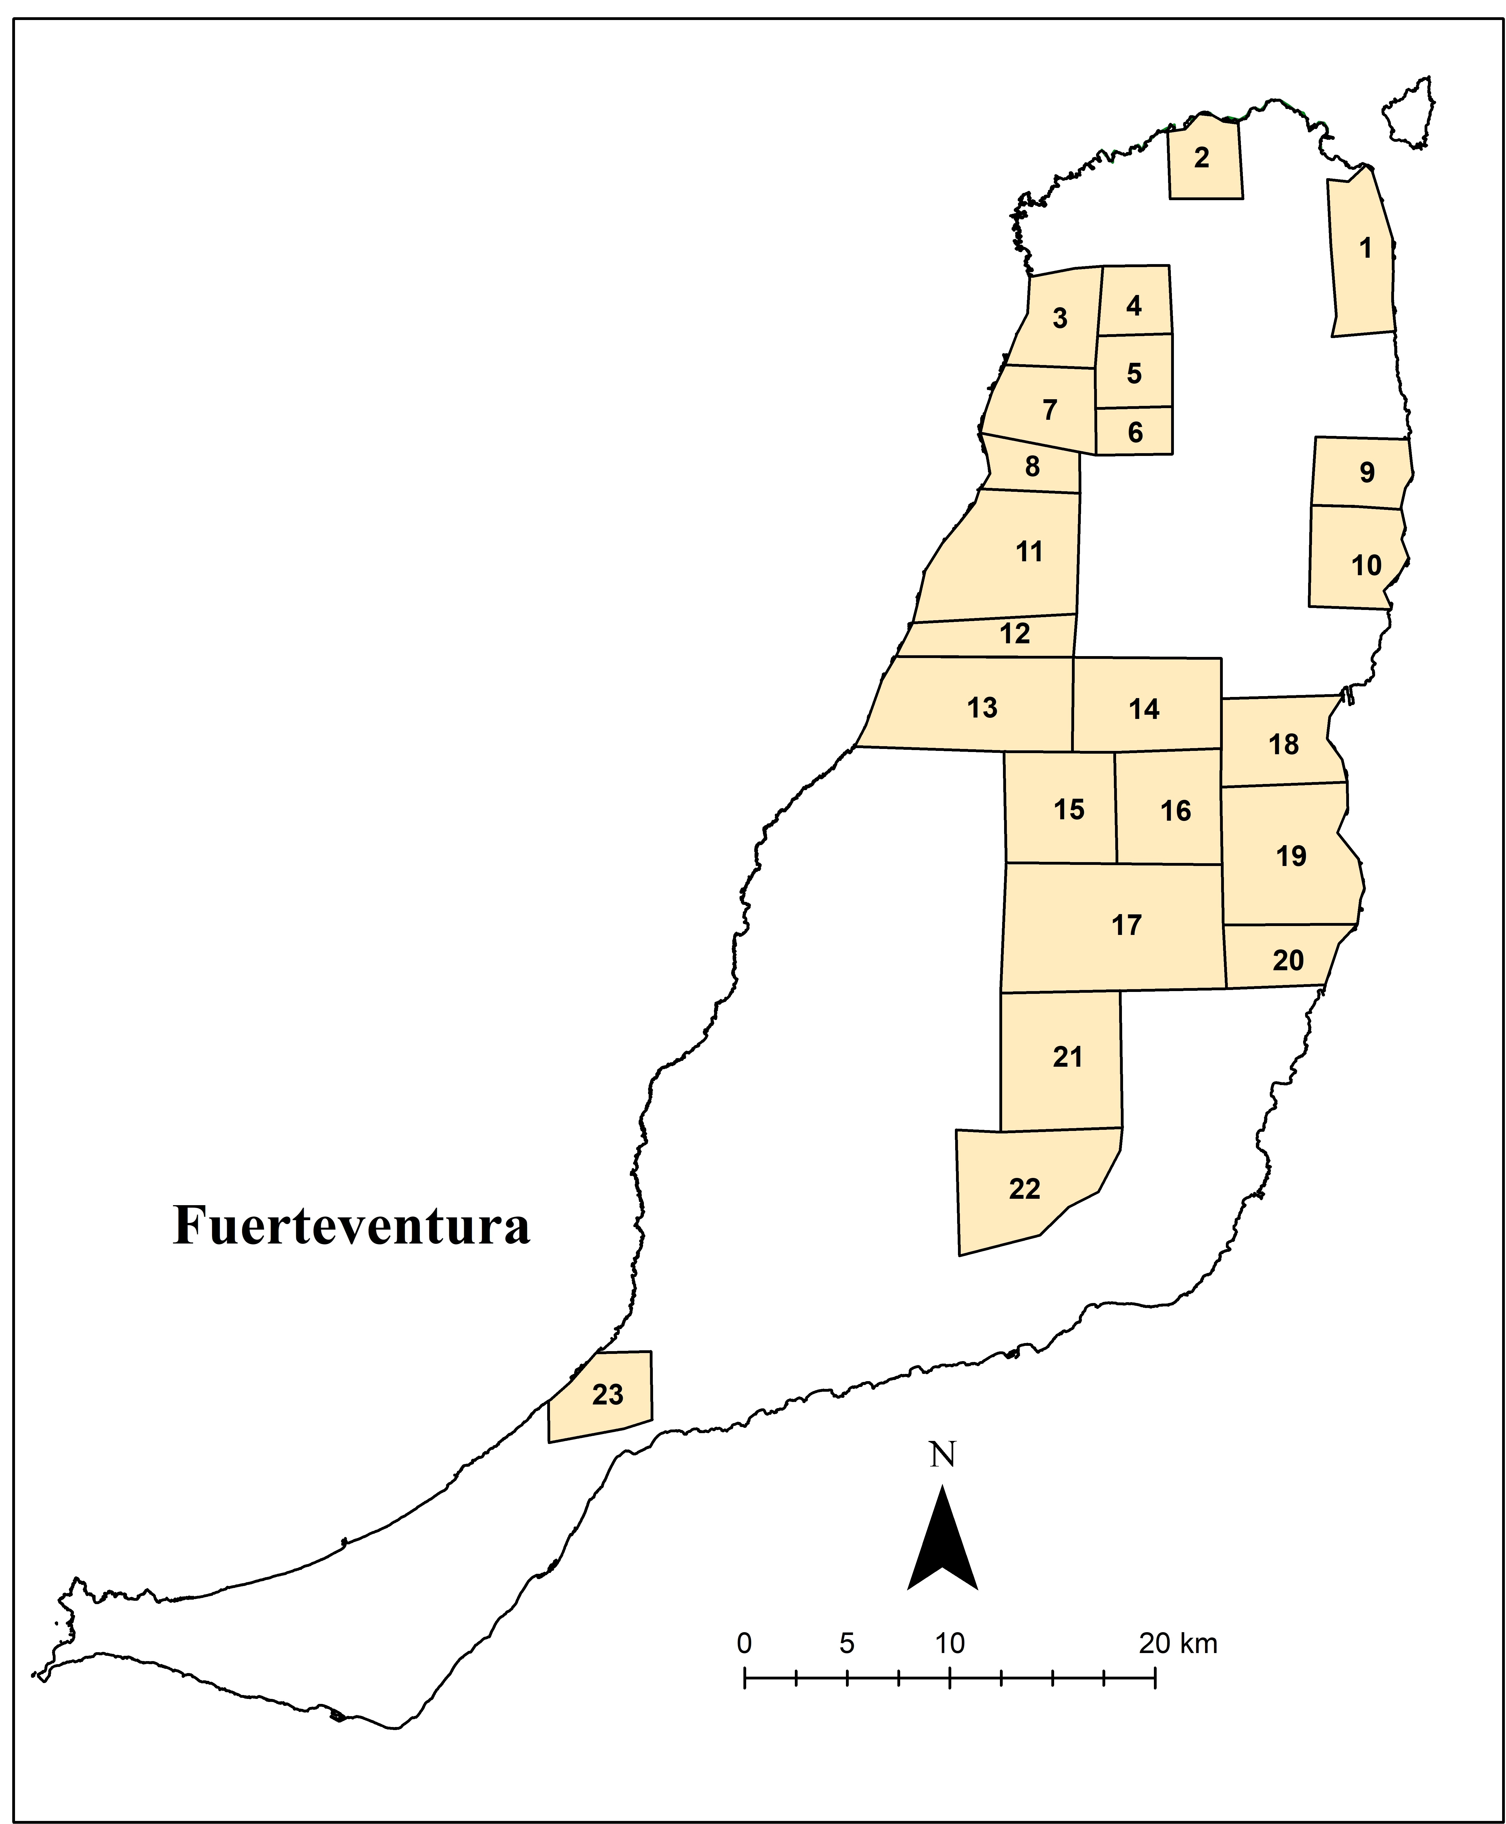
Legend: (1) El Jable de Corralejo (2) Majanicho (3) El Cotillo – Jable de Taca (4) Jable de Lajares (5) Montañeta de la Cebada (6) Montaña Alta – Rosa de Frasquita (7) Llanos de Tindaya – Lomos de Esquinzo (8) Llanos de Tindaya – Laderas de Tebeto (9) Llanos de Guisguey – Laderas del Time (10) Valle de Fimapaire – Las Llanadas (11) Montaña Bermeja Sur (12) Montaña Bermeja Oeste (13) Rosa de Ocalia (14) Tesjuastes (15) Alto de Matías – Triquivitaje Oeste (16) Triquivitaje Este (17) El Saladar – Mafasca – Montañeta de los Alares (18) Llanos de Lezque – Llanos y Rosa de la Mareta (19) Montañeta de Osarda – Vista del Castillo (20) Llanos de las Salinas (21) Llano Grande (22) Rosa de Catalina García Sur (23) Granillo – Alto de Agua Oveja

