Supplementary Material:

Recent distribution and population trends for Secretarybirds Sagittarius serpentarius in South Africa, Lesotho and Eswatini from citizen science data

Christiaan Willem Brink 1,2, Alan Tristram Kenneth Lee 1,2,3, Dinusha Priyadarshani 4, Wen-Han Hwang 5, Ernst Retief 1, Kishaylin Chetty 6 and Melissa Andrea Whitecross1,7

1 BirdLife South Africa, Isdell House, Dunkeld West 2196, South Africa

2 FitzPatrick Institute of African Ornithology, Department of Biological Sciences, University of Cape Town, Rondebosch 7701, South Africa

3 Centre for Functional Biodiversity, School of Life Sciences, University of KwaZulu-Natal, Private Bag X01, Scottsville 3209, South Africa

4 Institute of Statistics, National Chung Hsing University, Taichung, Taiwan

5 Institute of Statistics, National Tsing Hua University, Hsinchu, Taiwan

6 Biodiversity Centre of Excellence, Eskom Holdings SOC Ltd, Megawatt Park, Maxwell Dr, Sunninghill 2157, South Africa

7 School of Animal Plant and Environmental Sciences, University of the Witwatersrand, Johannesburg, 1 Jan Smuts Ave, Braamfontein 2050, South Africa.

ORCIDs:

Christiaan Willem Brink: <https://orcid.org/0000-0001-8488-5560>

Alan Lee: <https://orcid.org/0000-0002-5858-9351>

Dinusha Priyadarshani: <https://orcid.org/0000-0002-1667-8276>

Wen-Han Hwang: <https://orcid.org/0000-0003-4141-0498>

Kishaylin Chetty: https://orcid.org/0000-0003-1374-1206

Melissa Whitecross: <https://orcid.org/0000-0001-5267-8137>

## Appendix

**Appendix Description A1:** Mixed exponential time-to-detection model

Under the Mixed exponential time-to-detection model, the probability density of t is

$$f\left(t\right)= \left\{\begin{aligned}\frac{μκ^{κ+1}}{{\left(κ+μt\right)}^{κ+1}}, 0<t<1 \\ {\left(1+\frac{μ}{κ}\right)}^{-κ}, t=1, \\ \end{aligned}\right.$$

Where $κ=$ aggregration index and the $μ=$ mean detection intensity. If there $n$ number of site and $τ$ number of visits, for the multiple visits occupancy model for single season, the likelihood function is,

$L_{TTD}=\prod_{i=1}^{n}{[\left(1-ψ\right)I\left(y_{i}=0\right)+ψ\prod_{j=1}^{τ}{f(t_{ij}})]}$,

Where $y_{i}$ is the frequency of the detections in the site $i$, $ψ$ is the occupancy probability. As we have hourly data (the species is detected whether in the 1st, 2nd, 3rd, or in the 4th hour) than the continuous data for the $t$, we modified the mixed exponential time-to-detection model to discretized version and pmf of $t$ is as follows,

$$p_{1}=\int_{t=0}^{0.25}{f\left(t\right)dt, t=1, } p_{2}=\int_{t=0.25}^{0.5}{f\left(t\right)dt,t=2 } p_{3}=\int_{t=0.5}^{0.75}{f\left(t\right)dt,t=3 }$$

$$p_{4}=\int_{t=0.75}^{1}{f\left(t\right)dt,t=4, } p_{0}=1-\int_{t=0}^{1}{f\left(t\right)dt, } if species is not detected$$

We computed the full likelihood by summing the likelihoods from each year. The occupancy probability and mean detection rate were modeled as a function of year in both urban and non-urban areas as follows;

,

**Figure A1:** Secretarybird reporting rate (S2RR) as per SABAP2 website, May 2022. Black indicates either no records or no data. Grey indicates a low SABAP2 reporting rate (S2RR), with red indicating pentads with high reporting rate.

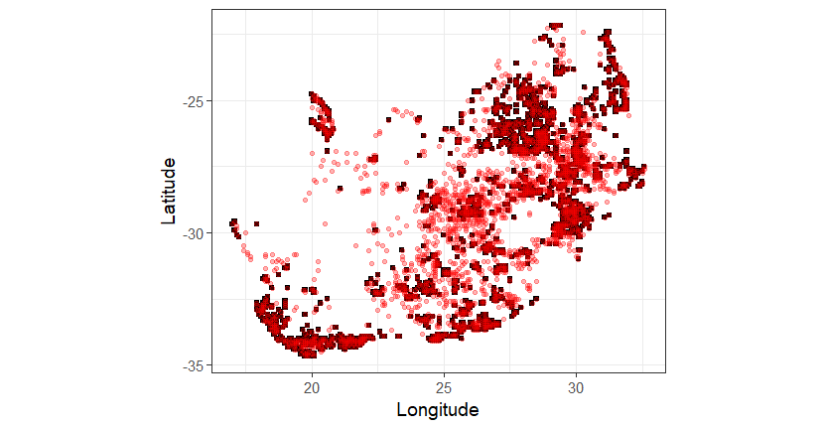

**Figure A2:** The sample area for Dynamic occupancy models (black squares = pentads with >10 records) in relation to presence of Secretarybird distribution (red dots, pentads with at least one Secretarybird record).

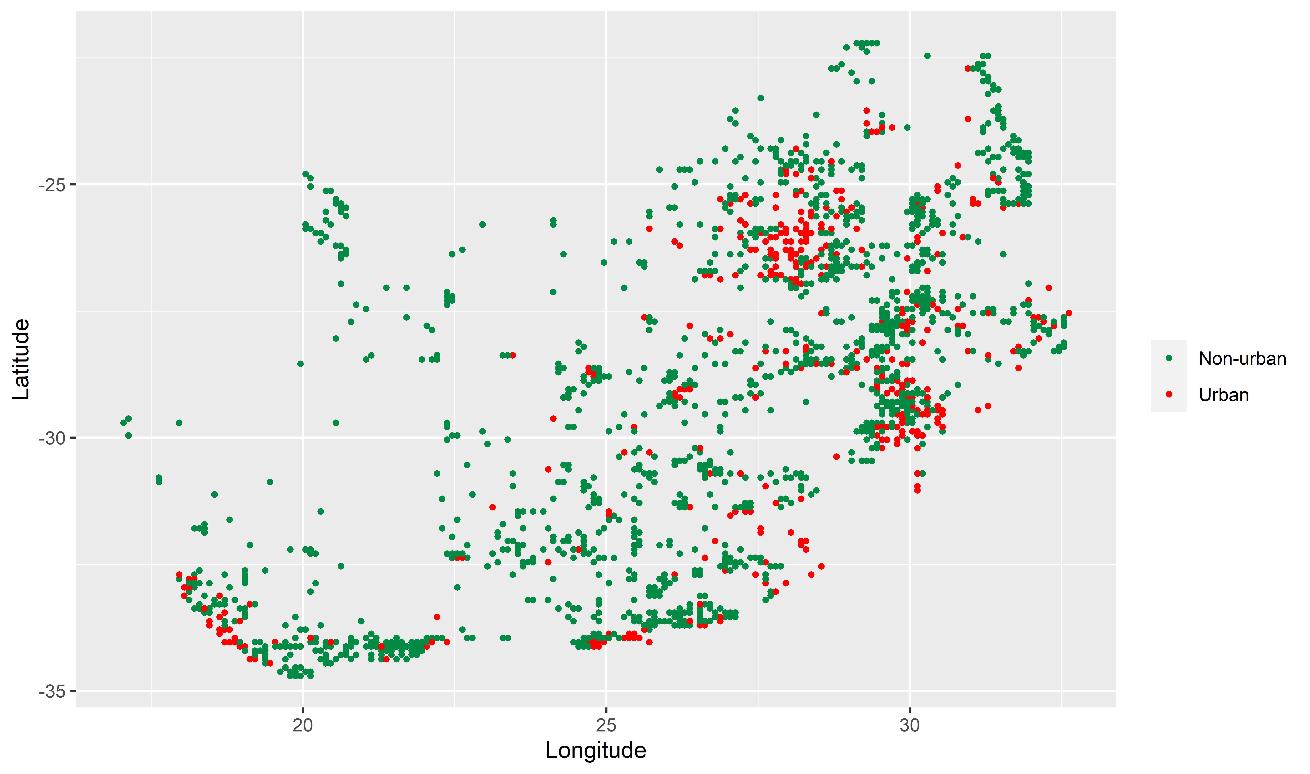

Figure A3: The locations of the urban and non-urban sites from the survey used in the time-to-detection models. Note that the surveyed sites may differ each year.

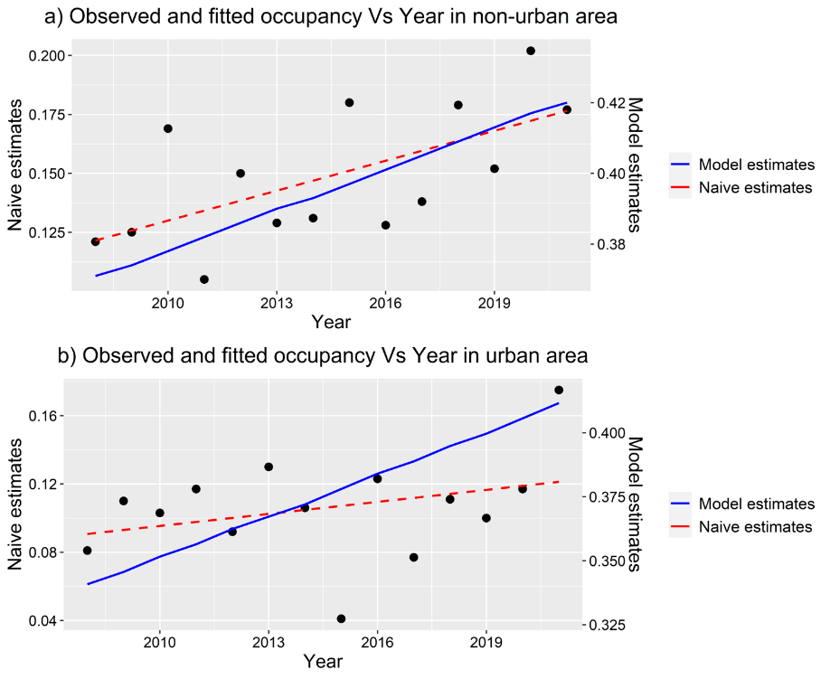

Figure A4: The observed and the fitted occupancy probability in non-urban (a) and urban (b) areas for the time-to-detection models. This is not a robust measure of abundance (for that see Figure A5) but provides a measure of within how much of the species’ range it was recorded.

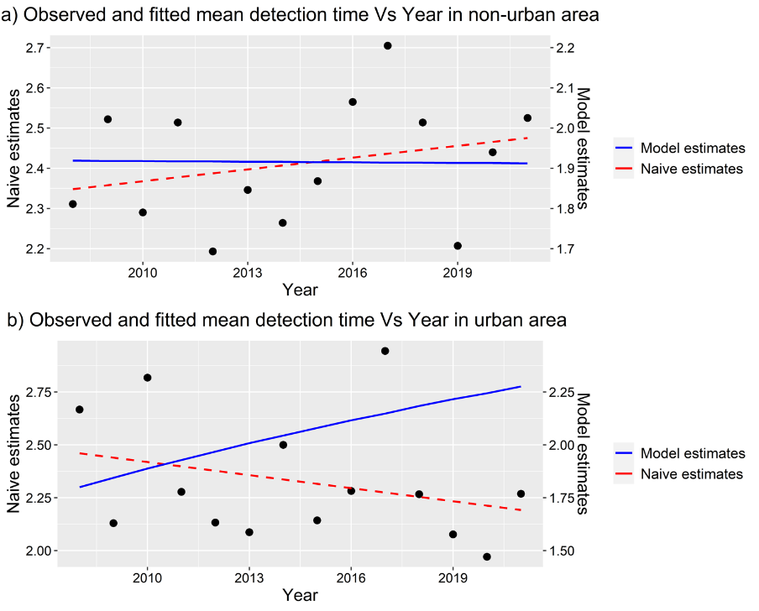

Figure A5: The observed and the fitted mean detection time (used as a proxy for abundance) in non-urban (a) and urban (b) areas for the time-to-detection models.

Table A1: Descriptive statistics of the bootstrapped values of change, for the SABAP1 to early SABAP2 period (2007 – 2014). Reporting rate change is the difference in reporting rate between periods relative to SABAP1 normalized to a value between -1 and 1, with 0 being no change and negative values lower reporting rate for SABAP2. Range change is similarly bounded between -1 and 1. Z is a measure of statistical confidence in change, and C is a log transformed measure of reporting rate change that better accounts for the non-linear relationship between density and reporting rate (see text for details). SD = standard deviation of the mean; L_CL and U_CL are the 95% confidence intervals, which for the median were calculated using bootstrapping. Q1 and Q3 are the 25% and 75% quartiles respectively.

|  |  |  |  |  |  |  |  |  |  |
| --- | --- | --- | --- | --- | --- | --- | --- | --- | --- |
| **Statistic** | **Mean** | **SD** | **L_CI** | **U_CI** | **Median** | **L_CI** | **U_CI** | **Q1** | **Q3** |
| Reporting rate change | -0.182 | 0.031 | -0.184 | -0.18 | -0.184 | -0.186 | -0.181 | -0.204 | -0.161 |
| Range change | -0.266 | 0.06 | -0.269 | -0.262 | -0.267 | -0.272 | -0.262 | -0.308 | -0.225 |
| Z | -1.212 | 0.192 | -1.223 | -1.201 | -1.212 | -1.227 | -1.199 | -1.343 | -1.086 |
| C | -1.403 | 0.25 | -1.419 | -1.388 | -1.41 | -1.43 | -1.385 | -1.576 | -1.231 |

Table A2: Descriptive statistics of the bootstrapped values of change, for the within SABAP2 change (2007 – 2014 and January 2015 to April 2023). Values as per Table A1.

|  |  |  |  |  |  |  |  |  |  |
| --- | --- | --- | --- | --- | --- | --- | --- | --- | --- |
| **Statistic** | **Mean** | **SD** | **L_CI** | **U_CI** | **Median** | **L_CI** | **U_CI** | **Q1** | **Q3** |
| Reporting rate change | 0.005 | 0.035 | 0.003 | 0.007 | 0.005 | 0.003 | 0.008 | -0.019 | 0.028 |
| Range change | 0.057 | 0.098 | 0.051 | 0.063 | 0.056 | 0.046 | 0.059 | -0.011 | 0.122 |
| Z | -0.132 | 0.11 | -0.139 | -0.125 | -0.132 | -0.141 | -0.126 | -0.209 | -0.061 |
| C | 0.08 | 0.291 | 0.062 | 0.097 | 0.079 | 0.064 | 0.105 | -0.124 | 0.274 |

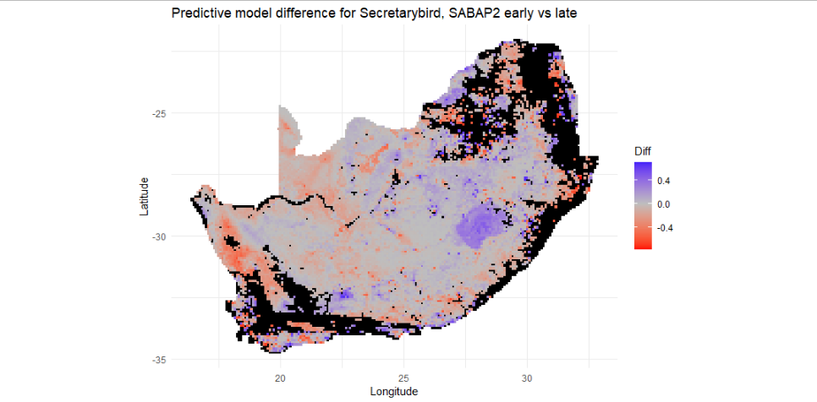

**Figure A6:** The difference in random forest model predictive surfaces for probability of occurrence between early and late SABAP2 periods (2008-2014, 2015 - 2022) for the South Africa, Lesotho and Eswatini domain, using pentads as the sampling unit. Blue indicates a predicted increased probability of recording a species for the more recent time period, while red indicates decreased probability of recording a species. Black areas of the map were not predicted to be suitable in either model.

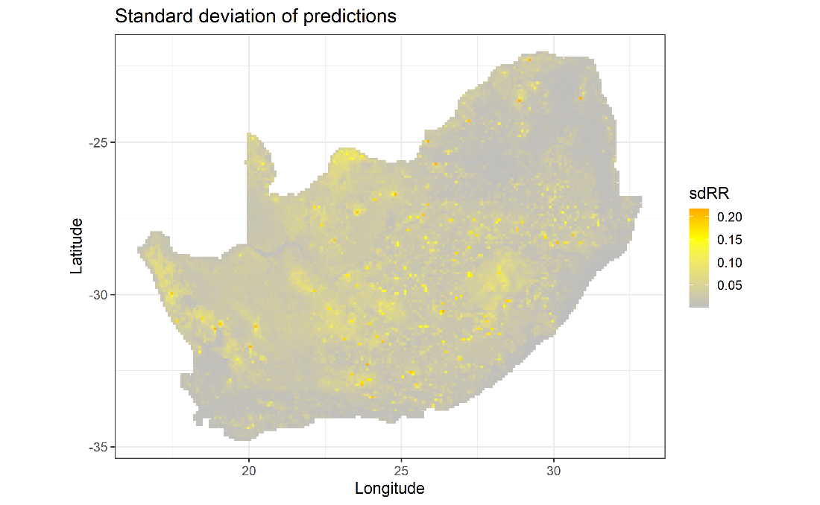

**Figure A7:** Standard deviation of the random forest model predicting reporting rate for Secretarybird across South Africa, Lesotho and Eswatini, in Figure 6.