Supplementary materials for:

Monitoring bird migration using nocturnal flight calls on the East Asian-Australasian Flyway: a case from Beijing

Shuangqi Liu, Terry Townshend, Andrew Farnsworth, Danny Alexander, Hua Tian, Fangyuan Hua

This file includes:
Figures S1 – S5
Tables S1 – S2

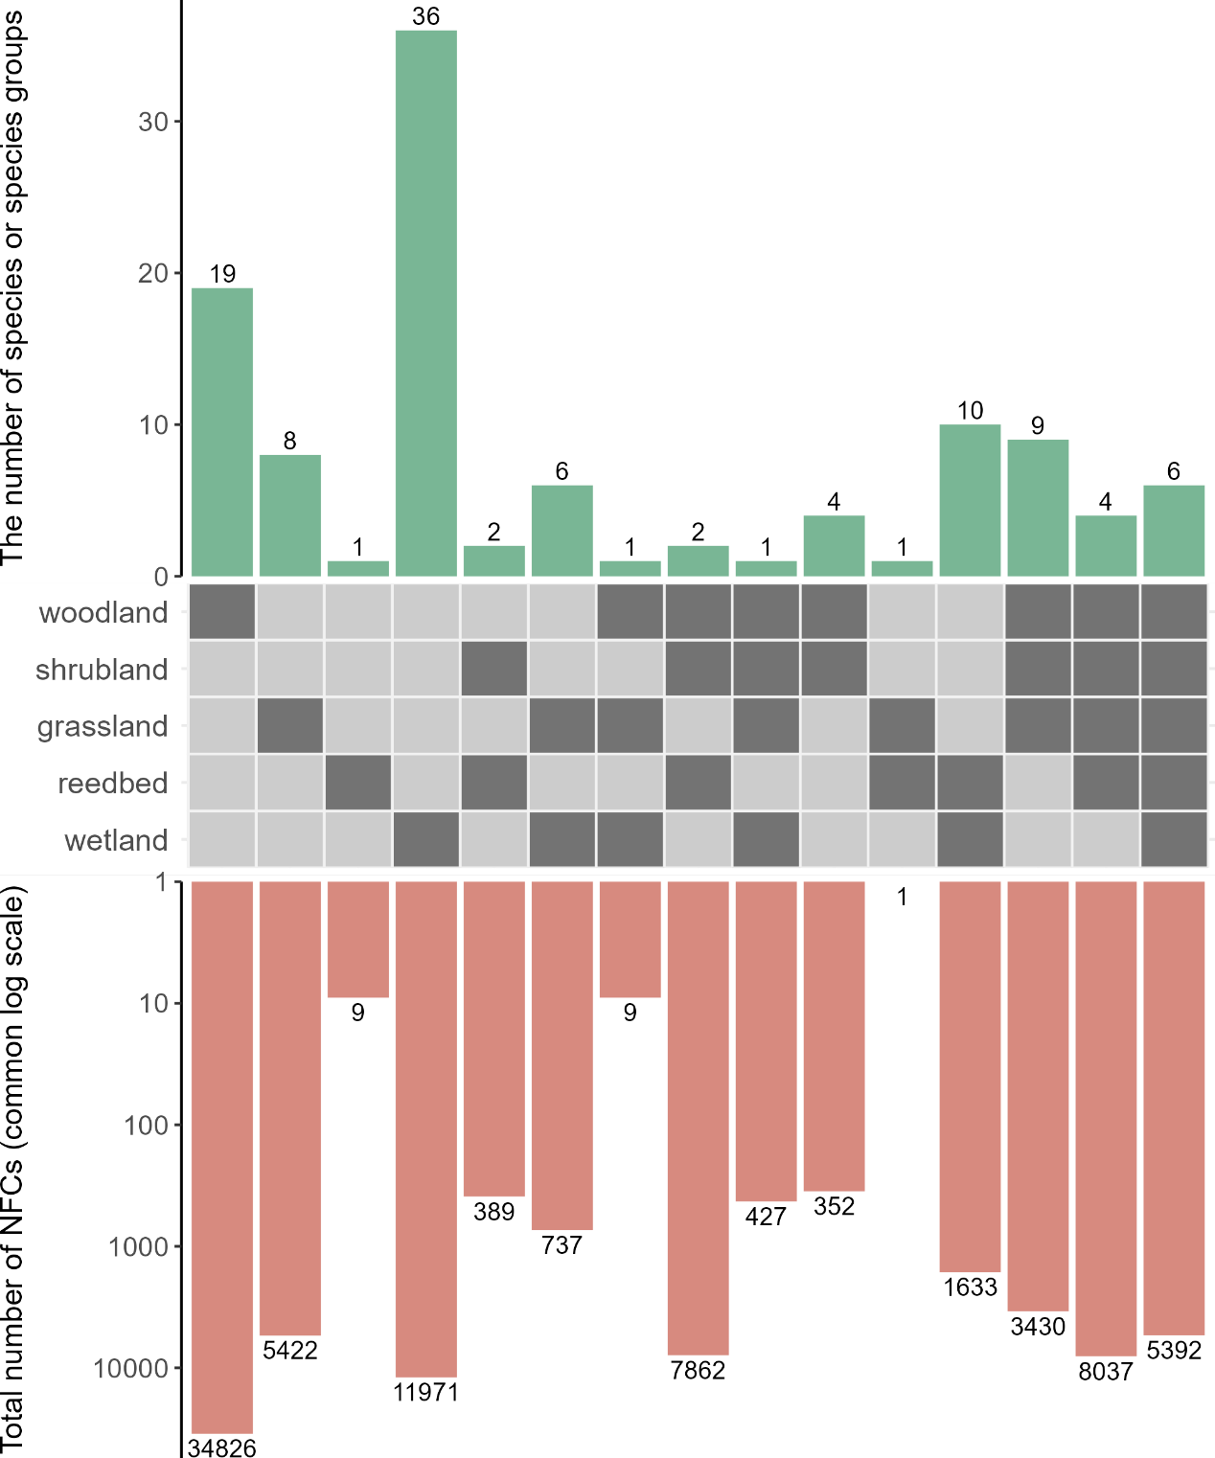
Figure S1 Habitat associations of migratory birds recorded in this study. Each column corresponds to a ‘habitat association guild’, with the dark-coloured cells in the middle matrix indicating the habitats with which species or species groups in a given guild are associated. Bars above the matrix represent the numbers of species or species groups that fall within each habitat association guild, while bars below the matrix represent the total numbers of NFCs recorded for all the species or species groups in each habitat association guild.
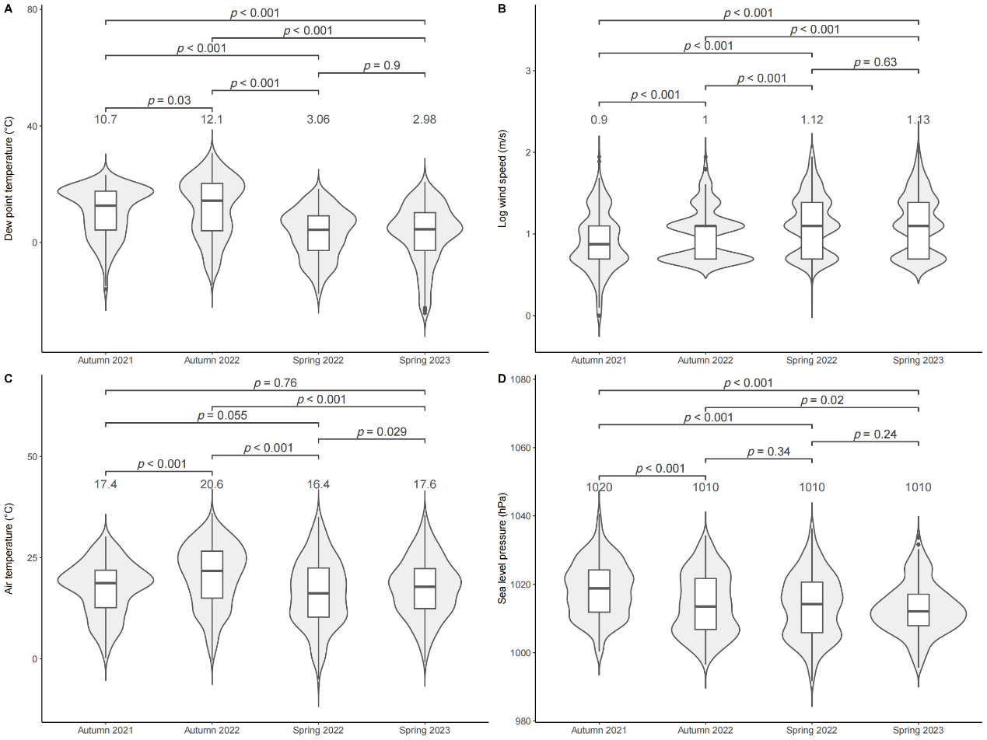
Figure S2 Comparison of weather features among the four study seasons, including (A) dew point temperature (℃), (B) wind speed (m/s; on natural log scale), (C) air temperature (℃), and (D) sea level pressure (hPa). The numbers above the violin plots indicate the mean values of each weather feature within a given migration season. The significance level of each pair-wise comparison (after Bonferroni correction) of the weather features is presented above the lines connecting each pair of violin plots.

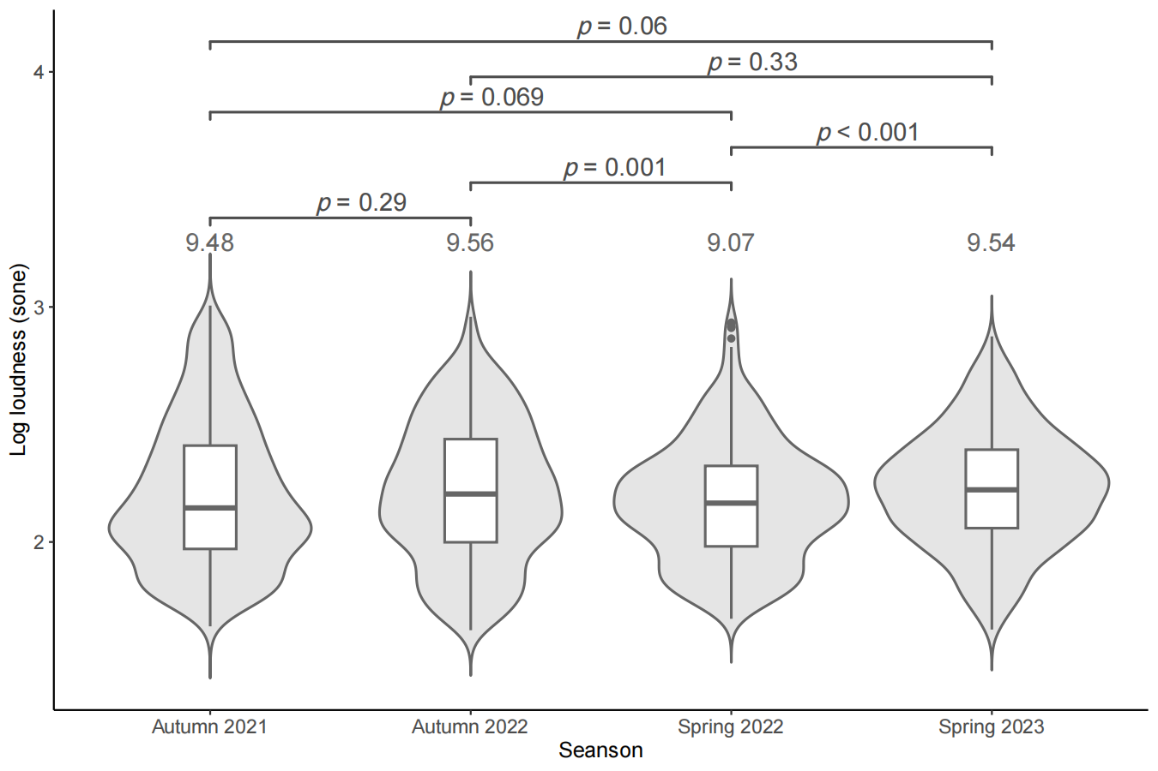
Figure S3 Comparison of the mean loudness (measured in sone; on natural log scale) among the four study seasons. The numbers above the violin plots indicate the mean values within a given migration season. The significance level of each pair-wise comparison (after Bonferroni correction) of the loudness measures is presented above the lines connecting each pair of violin plots.

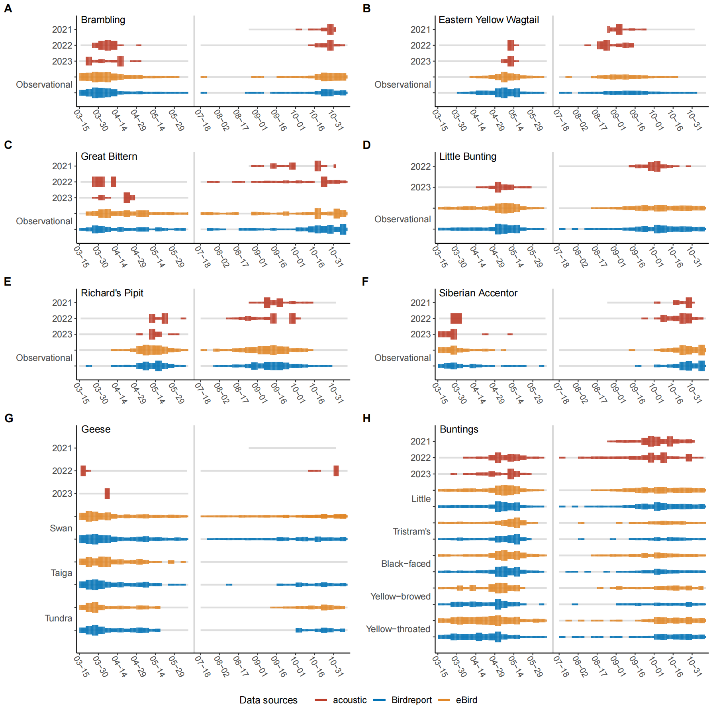Figure S4 Temporal patterns of migratory phenology of additional species or species groups that had ≥150 NFCs over at least one migration season (not including common local breeders or the Siberian Rubythroat Calliope calliope), based on the number of records from NFC monitoring and citizen science observations, including (A) Brambling Fringilla montifringilla, (B) Eastern Yellow Wagtail Motacilla tschutschensis, (C) Great Bittern Botaurus stellaris, (D) Little Bunting Emberiza pusilla, (E) Richard’s Pipit Anthus richardi, (F) Siberian Accentor Prunella montanella, (G) Anser spp. (geese) and (H) Emberiza spp. (buntings). Line width indicates the rescaled number of calls or checklists, aggregated over five-day periods. Line colour indicates data resource, with grey colour representing zero counts. For Little Bunting, we grouped calls together with other bunting calls in autumn 2021 and spring 2022; we thus had data only for autumn 2022 and spring 2023.
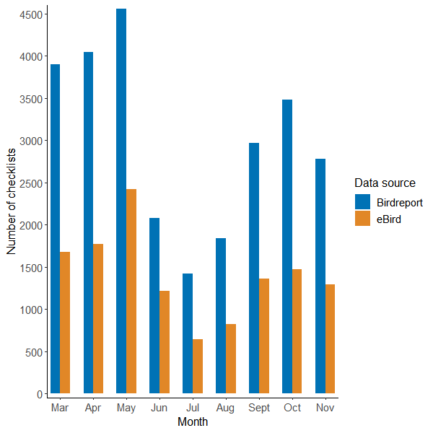
Figure S5 Total number of bird observation checklists (including incomplete checklists) by month between 2002 and 2022, from two main citizen science databases.

Table S1 Call counts from all recording hours and bona fide night during each migration season for each species or species group. List of species or species groups follows a descending order based on the total number of calls across the four study seasons.
Common name | Scientific name | 2021 autumn |  |  | 2022 spring | 2022 autumn |  | 2023 spring |  | Total
 |  | All | Night | Adjusted† | All | All | Night | All | Night | All | Night
Species
Olive-backed Pipit | Anthus hodgsoni | 12468 | 11547 | 10054 | 393 | 12689 | 12402 | 608 | 407 | 26158 | 24749
Black-crowned Night-Heron | Nycticorax nycticorax | 5358 | 4550 | 1836 | 425 | 2152 | 1608 | 529 | 467 | 8464 | 7050
Common Rosefinch | Carpodacus erythrinus | 2124 | 1591 | 1375 | 486 | 2137 | 1921 | 3096 | 2730 | 7843 | 6728
Eurasian Skylark | Alauda arvensis | 2614 | 2568 | 2351 | 5 | 1354 | 1323 | 843 | 808 | 4816 | 4704
Red-rumped Swallow | Cecropis daurica | 252 | 0 | 0 | 0 | 4451 | 1 | 0 | 0 | 4703 | 1
Little Bunting | Emberiza pusilla | 0 | 0 | 0 | 0 | 1204 | 1175 | 488 | 278 | 1692 | 1453
Brambling | Fringilla montifringilla | 328 | 314 | 208 | 21 | 1069 | 967 | 147 | 142 | 1565 | 1444
Yellow-bellied Tit | Periparus venustulus | 549 | 354 | 237 | 2 | 29 | 19 | 162 | 104 | 742 | 479
Indian Cuckoo | Cuculus micropterus | 0 | 0 | 0 | 428 | 20 | 18 | 293 | 253 | 741 | 699
Grey Heron | Ardea cinerea | 108 | 95 | 74 | 77 | 369 | 364 | 118 | 109 | 672 | 645
Little Grebe | Tachybaptus ruficollis | 6 | 6 | 5 | 178 | 171 | 158 | 202 | 198 | 557 | 540
Richard’s Pipit | Anthus richardi | 266 | 228 | 224 | 25 | 98 | 83 | 51 | 18 | 440 | 354
Eastern Yellow Wagtail | Motacilla tschutschensis | 261 | 118 | 26 | 11 | 76 | 23 | 22 | 0 | 370 | 152
White Wagtail | Motacilla alba | 204 | 41 | 12 | 4 | 22 | 3 | 94 | 1 | 324 | 49
Siberian Rubythroat‡ | Calliope calliope | 85 | 85 | 85 | 1 | 236 | 236 | 0 | 0 | 322 | 322
Siberian Accentor | Prunella montanella | 123 | 101 | 48 | 2 | 171 | 101 | 9 | 9 | 305 | 213
Eurasian Coot | Fulica atra | 0 | 0 | 0 | 36 | 17 | 15 | 208 | 208 | 261 | 259
Silver-throated Tit | Aegithalos glaucogularis | 248 | 241 | 1 | 0 | 0 | 0 | 0 | 0 | 248 | 241
Common Swift | Apus apus | 0 | 0 | 0 | 0 | 0 | 0 | 246 | 0 | 246 | 0
Black-winged Stilt | Himantopus himantopus | 0 | 0 | 0 | 7 | 2 | 2 | 229 | 229 | 238 | 238
Great Bittern | Botaurus stellaris | 20 | 19 | 16 | 3 | 175 | 174 | 14 | 14 | 212 | 210
Striated Heron | Butorides striata | 48 | 48 | 42 | 55 | 56 | 55 | 51 | 50 | 210 | 208
Common Moorhen | Gallinula chloropus | 0 | 0 | 0 | 60 | 11 | 11 | 132 | 132 | 203 | 203
Pine Bunting | Emberiza leucocephalos | 37 | 24 | 11 | 0 | 109 | 84 | 0 | 0 | 146 | 108
Wood Sandpiper | Tringa glareola | 1 | 1 | 1 | 2 | 117 | 115 | 6 | 6 | 126 | 124
Common Sandpiper | Actitis hypoleucos | 10 | 10 | 9 | 13 | 43 | 43 | 59 | 59 | 125 | 125
Green Sandpiper | Tringa ochropus | 42 | 39 | 37 | 12 | 23 | 20 | 39 | 34 | 116 | 105
Buff-bellied Pipit | Anthus rubescens | 18 | 9 | 0 | 1 | 19 | 8 | 49 | 0 | 87 | 18
Little Ringed Plover | Charadrius dubius | 1 | 1 | 1 | 17 | 17 | 17 | 51 | 51 | 86 | 86
Yellow-throated Bunting | Emberiza elegans | 29 | 0 | 0 | 0 | 54 | 8 | 0 | 0 | 83 | 8
Carrion Crow | Corvus corone | 18 | 0 | 0 | 0 | 0 | 0 | 64 | 0 | 82 | 0
Pallas’s Reed Bunting | Emberiza pallasi | 28 | 17 | 10 | 0 | 39 | 37 | 0 | 0 | 67 | 54
Forest Wagtail | Dendronanthus indicus | 23 | 0 | 0 | 3 | 12 | 0 | 0 | 0 | 38 | 3
Daurian Jackdaw | Corvus dauuricus | 33 | 0 | 0 | 0 | 0 | 0 | 0 | 0 | 33 | 0
Asian Koel | Eudynamys scolopaceus | 0 | 0 | 0 | 9 | 0 | 0 | 20 | 20 | 29 | 29
Red-throated Pipit | Anthus cervinus | 3 | 0 | 0 | 0 | 24 | 4 | 1 | 0 | 28 | 4
Spotted Redshank | Tringa erythropus | 7 | 7 | 3 | 0 | 10 | 10 | 10 | 10 | 27 | 27
Long-billed Plover | Charadrius placidus | 25 | 25 | 25 | 0 | 0 | 0 | 0 | 0 | 25 | 25
Tristram’s Bunting | Emberiza tristrami | 0 | 0 | 0 | 0 | 25 | 13 | 0 | 0 | 25 | 13
Lapland Bunting | Calcarius lapponicus | 9 | 9 | 9 | 0 | 14 | 14 | 0 | 0 | 23 | 23
Blyth’s Pipit | Anthus godlewskii | 3 | 3 | 3 | 0 | 18 | 15 | 1 | 0 | 22 | 18
Purple Heron | Ardea purpurea | 13 | 13 | 12 | 1 | 8 | 8 | 0 | 0 | 22 | 22
Black-capped Kingfisher | Halcyon pileata | 0 | 0 | 0 | 9 | 5 | 5 | 7 | 7 | 21 | 21
Caspian Tern | Hydroprogne caspia | 0 | 0 | 0 | 0 | 0 | 0 | 19 | 19 | 19 | 19
Chinese Penduline Tit | Remiz consobrinus | 0 | 0 | 0 | 0 | 0 | 0 | 19 | 0 | 19 | 0
Brown Shrike | Lanius cristatus | 4 | 4 | 4 | 2 | 4 | 4 | 4 | 4 | 14 | 14
Barn Swallow | Hirundo rustica | 10 | 0 | 0 | 0 | 3 | 0 | 0 | 0 | 13 | 0
Grey Plover | Pluvialis squatarola | 3 | 3 | 0 | 8 | 0 | 0 | 0 | 0 | 11 | 11
Grey-headed Lapwing | Vanellus cinereus | 8 | 8 | 8 | 0 | 0 | 0 | 3 | 3 | 11 | 11
White’s Thrush | Zoothera aurea | 0 | 0 | 0 | 10 | 1 | 1 | 0 | 0 | 11 | 11
Bewick’s Swan | Cygnus columbianus | 0 | 0 | 0 | 0 | 10 | 10 | 0 | 0 | 10 | 10
Grey Wagtail | Motacilla cinerea | 10 | 0 | 0 | 0 | 0 | 0 | 0 | 0 | 10 | 0
Oriental Reed Warbler | Acrocephalus orientalis | 0 | 0 | 0 | 5 | 0 | 0 | 4 | 3 | 9 | 8
Large Hawk-Cuckoo | Hierococcyx sparverioides | 0 | 0 | 0 | 8 | 0 | 0 | 34 | 19 | 42 | 27
Large-billed Crow | Corvus macrorhynchos | 8 | 0 | 0 | 0 | 0 | 0 | 0 | 0 | 8 | 0
Rustic Bunting | Emberiza rustica | 0 | 0 | 0 | 0 | 8 | 6 | 0 | 0 | 8 | 6
Black-faced Bunting | Emberiza spodocephala | 7 | 7 | 7 | 0 | 0 | 0 | 0 | 0 | 7 | 7
Garganey | Spatula querquedula | 0 | 0 | 0 | 7 | 0 | 0 | 0 | 0 | 7 | 7
Yellow-billed Grosbeak | Eophona migratoria | 7 | 7 | 7 | 0 | 0 | 0 | 0 | 0 | 7 | 7
Common Cuckoo | Cuculus canorus | 0 | 0 | 0 | 3 | 0 | 0 | 3 | 3 | 6 | 6
Ashy Minivet | Pericrocotus divaricatus | 0 | 0 | 0 | 0 | 0 | 0 | 5 | 0 | 5 | 0
Common Greenshank | Tringa nebularia | 1 | 1 | 1 | 3 | 0 | 0 | 1 | 1 | 5 | 5
Little Whimbrel | Numenius minutus | 5 | 5 | 5 | 0 | 0 | 0 | 0 | 0 | 5 | 5
Mallard | Anas platyrhynchos | 0 | 0 | 0 | 5 | 0 | 0 | 0 | 0 | 5 | 5
Common Redshank | Tringa totanus | 1 | 1 | 1 | 2 | 1 | 1 | 0 | 0 | 4 | 4
Pacific Golden Plover | Pluvialis fulva | 0 | 0 | 0 | 1 | 3 | 1 | 0 | 0 | 4 | 2
Peregrine Falcon | Falco peregrinus | 0 | 0 | 0 | 0 | 4 | 0 | 0 | 0 | 4 | 0
Siberian Thrush§ | Geokichla sibirica | 0 | 0 | 0 | 0 | 4 | 4 | 0 | 0 | 4 | 4
Brown-cheeked Rail | Rallus indicus | 0 | 0 | 0 | 0 | 0 | 0 | 3 | 3 | 3 | 3
Far Eastern Curlew§ | Numenius madagascariensis | 0 | 0 | 0 | 0 | 3 | 0 | 0 | 0 | 3 | 0
Oriental Scops Owl | Otus sunia | 0 | 0 | 0 | 3 | 0 | 0 | 0 | 0 | 3 | 3
Pied Avocet | Recurvirostra avosetta | 0 | 0 | 0 | 0 | 0 | 0 | 3 | 3 | 3 | 3
Water Pipit | Anthus spinoletta | 1 | 0 | 0 | 0 | 2 | 2 | 0 | 0 | 3 | 2
Eurasian Curlew | Numenius arquata | 1 | 1 | 1 | 0 | 1 | 1 | 0 | 0 | 2 | 2
Grey Nightjar | Caprimulgus jotaka | 0 | 0 | 0 | 2 | 0 | 0 | 0 | 0 | 2 | 2
Grey-tailed Tattler | Tringa brevipes | 2 | 2 | 2 | 0 | 0 | 0 | 0 | 0 | 2 | 2
Whimbrel | Numenius phaeopus | 0 | 0 | 0 | 1 | 0 | 0 | 1 | 1 | 2 | 2
Black-naped Oriole | Oriolus chinensis | 0 | 0 | 0 | 1 | 0 | 0 | 0 | 0 | 1 | 1
Citrine Wagtail | Motacilla citreola | 0 | 0 | 0 | 0 | 1 | 1 | 0 | 0 | 1 | 1
Common Snipe | Gallinago gallinago | 0 | 0 | 0 | 1 | 0 | 0 | 0 | 0 | 1 | 1
Common Tern | Sterna hirundo | 0 | 0 | 0 | 0 | 0 | 0 | 1 | 1 | 1 | 1
Kentish Plover | Charadrius alexandrinus | 0 | 0 | 0 | 0 | 1 | 1 | 0 | 0 | 1 | 1
Northern Shoveler | Spatula clypeata | 1 | 1 | 1 | 0 | 0 | 0 | 0 | 0 | 1 | 1
Relict Gull | Ichthyaetus relictus | 0 | 0 | 0 | 1 | 0 | 0 | 0 | 0 | 1 | 1
Rosy Pipit | Anthus roseatus | 1 | 1 | 1 | 0 | 0 | 0 | 0 | 0 | 1 | 1
Ruddy Shelduck | Tadorna ferruginea | 0 | 0 | 0 | 1 | 0 | 0 | 0 | 0 | 1 | 1
Taiga Flycatcher | Ficedula albicilla | 1 | 1 | 1 | 0 | 0 | 0 | 0 | 0 | 1 | 1
Two-barred Warbler | Phylloscopus plumbeitarsus | 0 | 0 | 0 | 0 | 1 | 1 | 0 | 0 | 1 | 1
White-breasted Waterhen | Amaurornis phoenicurus | 0 | 0 | 0 | 1 | 0 | 0 | 0 | 0 | 1 | 1
Yellow-breasted Bunting | Emberiza aureola | 0 | 0 | 0 | 1 | 0 | 0 | 0 | 0 | 1 | 1
Species group
Buntings†† | Emberiza spp. | 4243 | 2858 | 2257 | 559 | 966 | 673 | 487 | 336 | 6255 | 4426
Flycatchers‡‡ | Muscicapidae spp. | 857 | 855 | 827 | 0 | 2282 | 2278 | 963 | 955 | 4102 | 4088
White-eyes | Zosterops spp. | 1566 | 1351 | 367 | 122 | 712 | 631 | 293 | 150 | 2693 | 2254
Thrushes | Turdidae spp. | 908 | 905 | 888 | 49 | 380 | 379 | 81 | 81 | 1418 | 1414
Geese | Anser spp. | 0 | 0 | 0 | 43 | 1086 | 1086 | 19 | 19 | 1148 | 1148
Herons or bitterns | Ardeidae spp. | 7 | 7 | 7 | 154 | 543 | 491 | 201 | 191 | 905 | 843
Wagtails or pipits§§ | Motacillidae spp. | 0 | 0 | 0 | 18 | 284 | 115 | 125 | 6 | 427 | 139
Songbirds | Passeriformes spp. | 0 | 0 | 0 | 0 | 0 | 0 | 417 | 356 | 417 | 356
Winter thrushes | Turdus spp. | 59 | 58 | 56 | 1 | 98 | 98 | 1 | 1 | 159 | 158
Snipes | Gallinago spp. | 2 | 2 | 2 | 1 | 12 | 12 | 42 | 42 | 57 | 57
Wagtails | Motacilla spp. | 13 | 6 | 1 | 0 | 0 | 0 | 16 | 0 | 29 | 6
Rails or crakes | Rallidae spp. | 0 | 0 | 0 | 0 | 1 | 1 | 18 | 18 | 19 | 19
Pipits | Anthus spp. | 8 | 1 | 1 | 0 | 0 | 0 | 0 | 0 | 8 | 1
Swifts | Apus spp. | 0 | 0 | 0 | 0 | 0 | 0 | 9 | 0 | 9 | 0
Crows | Corvidae spp. | 1 | 0 | 0 | 0 | 0 | 0 | 7 | 0 | 8 | 0
Larks | Alaudidae spp. | 0 | 0 | 0 | 0 | 5 | 5 | 0 | 0 | 5 | 5
Shorebirds | Charadriiformes spp. | 0 | 0 | 0 | 0 | 0 | 0 | 5 | 5 | 5 | 5
Cuckoos | Cuculus spp. | 0 | 0 | 0 | 1 | 0 | 0 | 2 | 2 | 3 | 3
Ducks | Anas spp. | 0 | 0 | 0 | 1 | 0 | 0 | 0 | 0 | 1 | 1
Ducks or geese | Anseriformes spp. | 0 | 0 | 0 | 0 | 0 | 0 | 1 | 1 | 1 | 1
Richard’s or Blyth’s Pipit | Anthus richardi/godlewskii | 0 | 0 | 0 | 0 | 0 | 0 | 1 | 1 | 1 | 1
Unidentified calls |  | 1557 | 1334 | 1274 | 1101 | 938 | 898 | 42 | 41 | 3638 | 3374
Total |  | 34654 | 29483 | 22434 | 4402 | 34400 | 27760 | 10679 | 8609 | 84135 | 70254
Note: † – Recording time during the autumn of 2021 was two hours longer than the spring of 2022. This column presents the adjusted numbers of calls from autumn 2021 after removing calls recorded during those two extra hours, such that the numbers were comparable with those in spring 2022. ‡ – Some calls of this species may have been misidentified because of the incomplete understanding of its full variation of NFCs. § – Identification of these species based on NFCs may be uncertain. †† – Buntings were grouped together in autumn 2021 and spring 2022, but some were identified to species since autumn 2022. ‡‡ – For flycatchers, we did not count the number of their calls in autumn 2021 and spring 2022 (they were counted toward unidentified calls instead), thus had data only for autumn 2022 and spring 2023. §§ – Since autumn 2022, we adopted a more conservative approach to identifying calls of wagtails and pipits to species (i.e. where in doubt, we identified calls to the “wagtails and pipits” group rather than to individual species); hence the much higher number of calls for this group in autumn 2022 and spring 2023 compared with previous seasons.

Table S2 The counts of bird observation checklists used to generate temporal patterns for 14 selected species or species groups recorded by NFC.
Common name |  | Scientific name | Birdreport | eBird | NFCs
Species
Olive-backed Pipit |  | Anthus hodgsoni | 2019 | 1683 | 26158
Common Rosefinch |  | Carpodacus erythrinus | 353 | 448 | 7843
Eurasian Skylark |  | Alauda arvensis | 818 | 809 | 4816
Little Bunting† |  | Emberiza pusilla | 3227 | 2361 | 1692
Brambling |  | Fringilla montifringilla | 2203 | 1636 | 1565
Richard’s Pipit |  | Anthus richardi | 636 | 731 | 440
Eastern Yellow Wagtail |  | Motacilla tschutschensis | 1158 | 1023 | 370
Siberian Accentor |  | Prunella montanella | 416 | 327 | 305
Great Bittern |  | Botaurus stellaris | 280 | 287 | 212
Species group
Buntings‡ | Yellow-throated Bunting | Emberiza elegans | 2353 | 1423 | 6255
 | Black-faced Bunting | Emberiza spodocephala | 983 | 891
 | Tristram’s Bunting | Emberiza tristrami | 562 | 376
 | Yellow-browed Bunting | Emberiza chrysophrys | 396 | 218
 | Little Bunting | Emberiza pusilla | 3227 | 2361
Flycatchers§ | Yellow-rumped Flycatcher | Ficedula zanthopygia | 593 | 474 | 4102
 | Taiga Flycatcher | Ficedula albicilla | 3392 | 2193
 | Dark-sided Flycatcher | Muscicapa sibirica | 917 | 509
 | Asian Brown Flycatcher | Muscicapa dauurica | 722 | 473
White-eyes | Swinhoe’s White-eye | Zosterops simplex | 1033 | 443 | 2693
 | Chestnut-flanked White-eye | Zosterops erythropleurus | 425 | 223
Thrushes | Eye-browed Thrush | Turdus obscurus | 304 | 171 | 1418
Geese | Taiga Bean Goose | Anser fabalis | 735 | 261 | 1148
 | Tundra Bean Goose | Anser serrirostris | 324 | 196
 | Swan Goose | Anser cygnoides | 1296 | 680

