Habitat restoration to conserve the Little Vermilion Flycatcher on Santa Cruz Island, Galapagos

SUPPLEMENTARY INFORMATION

Table S1. Comparison of logistic regression models fitted to daily nest failure data for Little Vermilion Flycatchers. Each row of the table reports the AIC_{c} value for each of five models fitted to the data (see main text and Table 1). The model specification columns show which of the two independent variables Season and Treatment and their two-way interaction term were included in the model. All models also included the stage of nesting (egg-stage; nestling stage) as an additional binary independent variable (see main text).

Model specification
__________________________________________
________________________________________
Model code | Season | Treatment | Season.Treatment | Number of fitted parameters | AIC_{c}
0 | 0 | 0 | 0 | 2 | 87.522
1 | 1 | 0 | 0 | 3 | 88.503
2 | 0 | 1 | 0 | 3 | 86.278
3 | 1 | 1 | 0 | 4 | 88.014
4 | 1 | 1 | 1 | 5 | 85.807

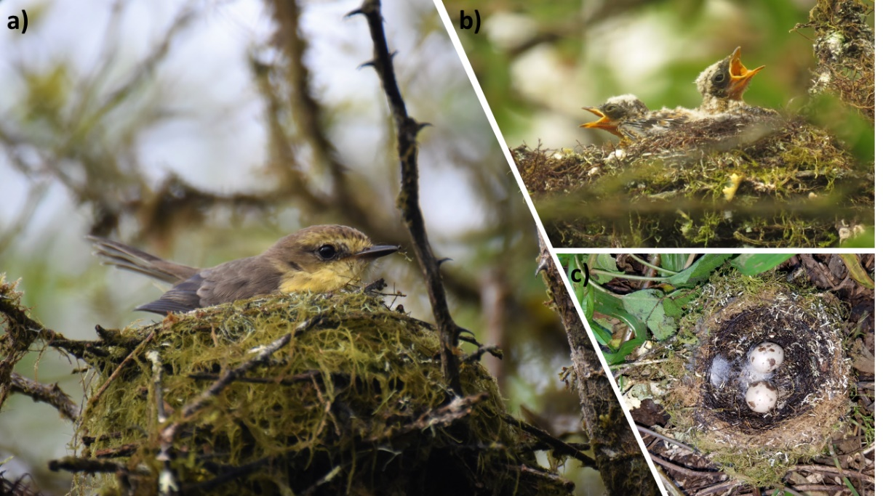
Figure S1. a) Female sitting on a cup nest incubating the eggs. The nest is built by the female and comprised of moss, twigs, dry leaves, and sometimes feathers, hair and plant fiber are incorporated, b) nest with nestlings inside, and c) a nest with eggs inside. Photos by David Anchundia and George Gutiérrez.

