|  |  |  |  |  |  |  |  |
| --- | --- | --- | --- | --- | --- | --- | --- |
| Regional sector | Surveyed UTMs | Transects | Repeated transects | Visits | Km per UTM | Total Kms | Survey dates |
| Ebro valley | 145 | 315 | 10 | 333 | 9.4 ± 5.4 | 1369 | 11 May ± 19 days |
| Northern plateau | 141 | 325 | 69 | 451 | 9.6 ± 8.3 | 1359 | 14 May ± 29 days |
| IS paramos | 71 | 199 | 33 | 254 | 12.0 ± 8.2 | 849 | 5 June ± 25 days |
| Southern plateau | 141 | 565 | 78 | 712 | 13.6 ± 10.4 | 1916 | 15 May ± 13 days |
| Extremadura | 94 | 252 | 64 | 360 | 11.1 ± 8.4 | 1039 | 11 May ± 21 days |
| South | 68 | 94 | 28 | 147 | 7.8 ± 3.2 | 468 | 22 May ± 29 days |

Table S1. Survey coverage, effort, and dates in each regional sector.

|  |  |  |  |  |  |  |
| --- | --- | --- | --- | --- | --- | --- |
| Model | nPar | AIC | delta | AICwt | cWt | |
| Detection function | | | | | |
| **1 Exponential** | **2** | **12580.1** | **0.0** | **1.0** | **1.00** | |
| 2 Hazard rate | 3 | 12589.8 | 9.75 | 0.0 | 1.00 | |
| 3 Halfnormal | 2 | 12713.6 | 133.5 | 0.0 | 1.00 | |
| Detection sub-model | | | | | |
| **1 DF + Neg.Bin lambda(.)phi(.)**RegSec **\*JD+ RegSec +H* JD + JD 2)** | **19** | **4428.7** | **0.0** | **1.0** | **1.00** | |
| 1 DF+ Neg.Bin lambda(.)phi(.)p(RegSec * JD +H* JD) | 18 | 4458.2 | 29.5 | 0.0 | 1.00 | |
| 1 DF+ Neg.Bin lambda(.)phi(.)p(RegSec * JD +H) | 17 | 4475.0 | 46.3 | 0.0 | 1.00 | |
| 1 DF+ Neg.Bin lambda(.)phi(.)p(RegSec * JD) | 16 | 4478.7 | 50.1 | 0.0 | 1.00 | |
| Abundance submodel | | | | | |
| **1 DET+ lambda(**RegSec**)** | **25** | **4415.7** | **0.0** | **0.6** | **0.58** | |
| 1 DET+ lambda(RegSec +ac) | 26 | 4417.0 | 1.3 | 0.3 | 0.88 | |
| 1 DET+ lambda(RegSec +ac+ac2) | 27 | 4418.9 | 3.3 | 0.1 | 1.00 | |

Table S2. Results of the Hierarchical Distance Sampling (HDS)model selection. Selected function and variables are highlighted in bold. nPars: number of parameters; AIC: Akaike information criterion; AICwt: model weights; and cWt, cumulative model weights. Covariates considered: H: hour; JD: Julian date; ac: spatial autocorrelation; RegSec: regional sector.

|  |  |  |
| --- | --- | --- |
| Regional sector | Individuals in surveyed areas [90% CI] | Individuals in areas that were not surveyed [90% CI] |
| Ebro valley | 715 [292 – 1439] | 188 [120 – 294] |
| Northern plateau | 225 [88 – 529] | 37 [24 – 55] |
| IS paramos | 945 [433 – 1714] | 28 [17 – 48] |
| Southern plateau | 737 [302 – 1479] | 293 [212 – 404] |
| Extremadura | 725 [370 – 1268] | 130 [82 – 206] |
| South | 679 [355 – 1180] | 21 [6 – 68] |
| Total | 4025 [1840 – 7609] | 697 [461 – 1075] |

Table S3. Estimates of the BBS population size (number of birds) in the sampled and unsampled areas of each regional sector in 2019. Abundances were obtained from the best HDS model (Table S2).

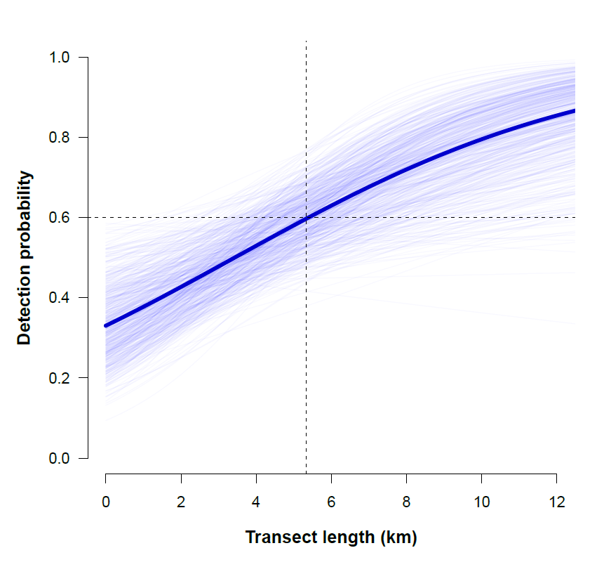

Figure S1 Relationship between the probability of detection and the sampling effort (transect length, in km). A minimum of 5.3 km of walked transect is needed to ensure a detection probability > 0.60 (dashed lines).



Figure S2. Relationship between the probability of detection and the time of day. Surveys conducted between 6 and 11 a.m. ensure a probability of detection > 0.60.

Distance (m)

Frequency

Figure S3. BBS observation frequencies (grey bars) according to distance to the transect line (grouped into 50 m classes) and detection function (black line). The black stripes at the base of the X-axis indicate BBS observations.