Supplementary material

Supp 1. Estimation and parameters of sun angles. LD = Loosdrecht, ZM = Zwarte Meer

Logger ID | location | Start year | SAE | threshold | remarks
V3948 004 | LD | 2016 | -3,75 | 500
V3948 005 | LD | 2016 | -4,50 | 500
V3948 006 | LD | 2016 | -3,00 | 500
V3948 003 | LD | 2016 | -0,50 | 500
V7408 004 | LD | 2018 | -0,75 | 500
V7408 006 | LD | 2018 | 4,25 | 500
V7408 009 | ZM | 2018 |  |  | time adjusted , sites manual
V7408 010 | ZM | 2018 | -1,50 | 500
V7408 012 | ZM | 2018 | -4,00 | 500
V7408 014 | ZM | 2018 | -5,50 | 500

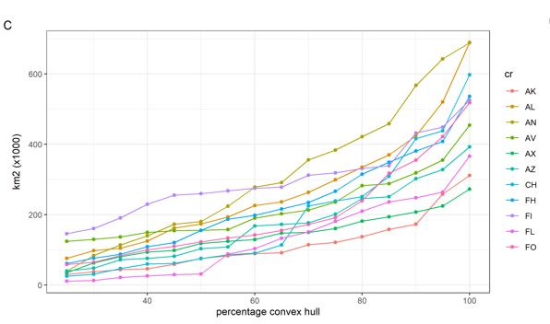

Supp 2. Estimates of minimum convex polygon sizes Adehabitat R-package (Calenge 2006) (polygon around LLpoints) of the staging area south of the Sahara between 1 November and 31 January as a relation of the percentage of datapoints included within the polygon. Above 80% of all datapoints the influence of outliers disproportionately adds to the calculated surface of the staging area. With these selected LLpoints we calculated the 80% minimum convex polygon size for each individual with the 80% threshold is visually chosen based on likelihood patterns

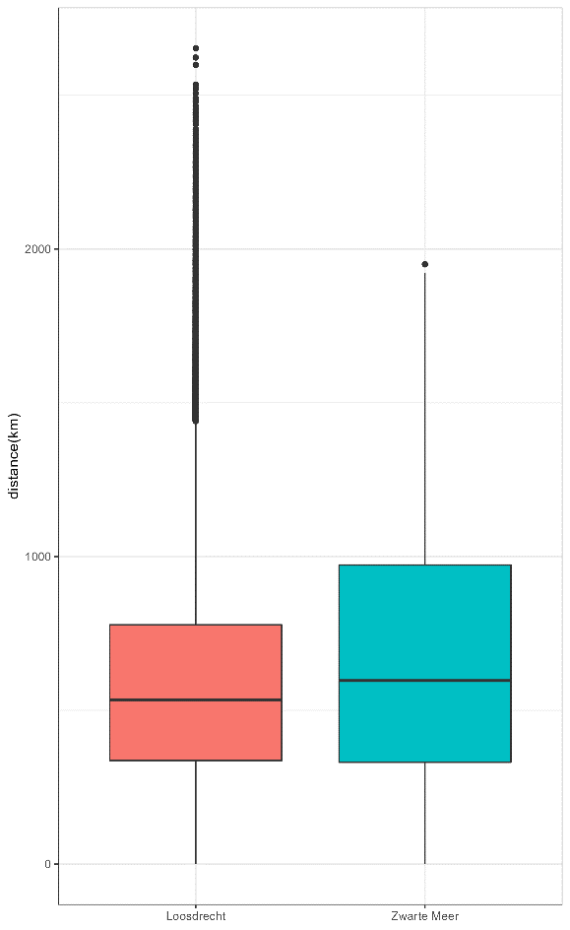

Supp 3. Estimation of migratory spread (cf Burgess et al. 2020), expressed as median distances between all LLpoints in the non-breeding period for two Dutch breeding populations of Great Reed Warbler, between 1 November to 31 January for 10 individuals tagged with light level loggers.

