Supplementary material for Northward migration of Red Knots Calidris canutus rufa and environment connectivity of Southern Brazil to Canada

Antônio Coimbra de Brum¹; Júlia Victória Grohmann Finger¹; Richard G. Lathrop Jr²; Stephanie Feigin³; Joseph Smith³; Lawrence Joseph Niles³; and Maria Virginia Petry¹,*.

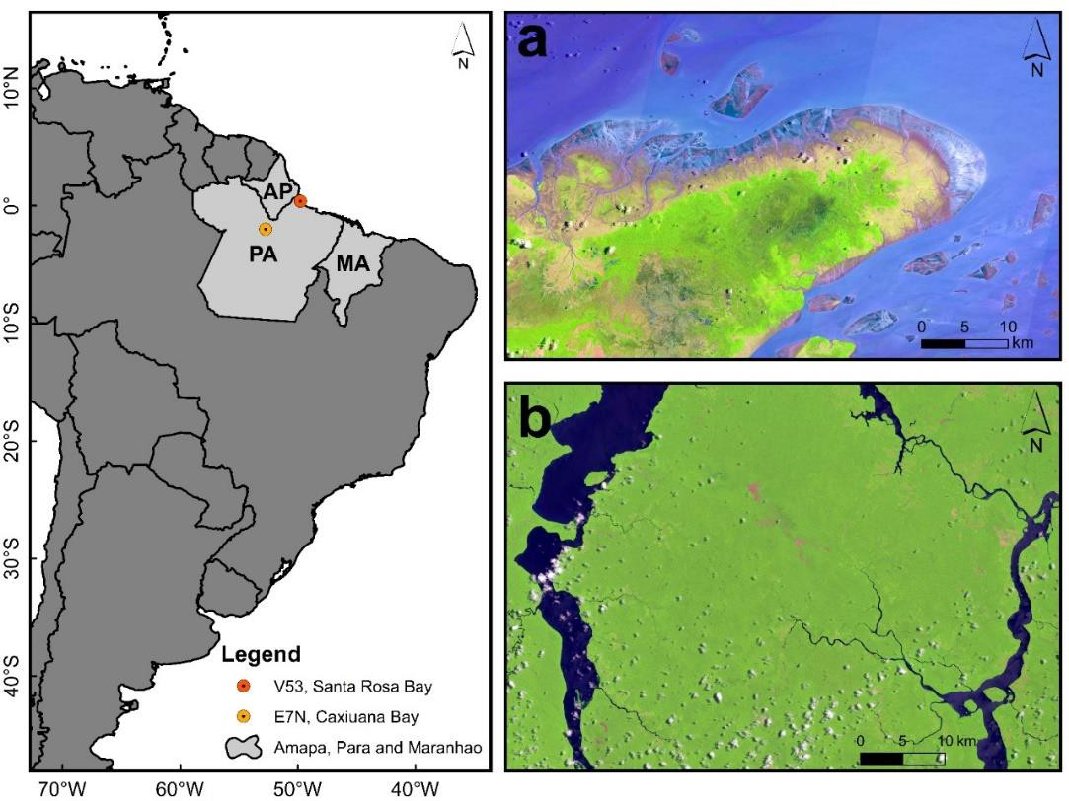
Figure S1. Areas in the state of Pará used by Red Knots V53 and E7N. a) Santa Rosa Bay, mouth of the Amazonas River), b) Xingu River and Caxiuanã Bay. AP = Amapá, PA = Pará, MA = Maranhão.

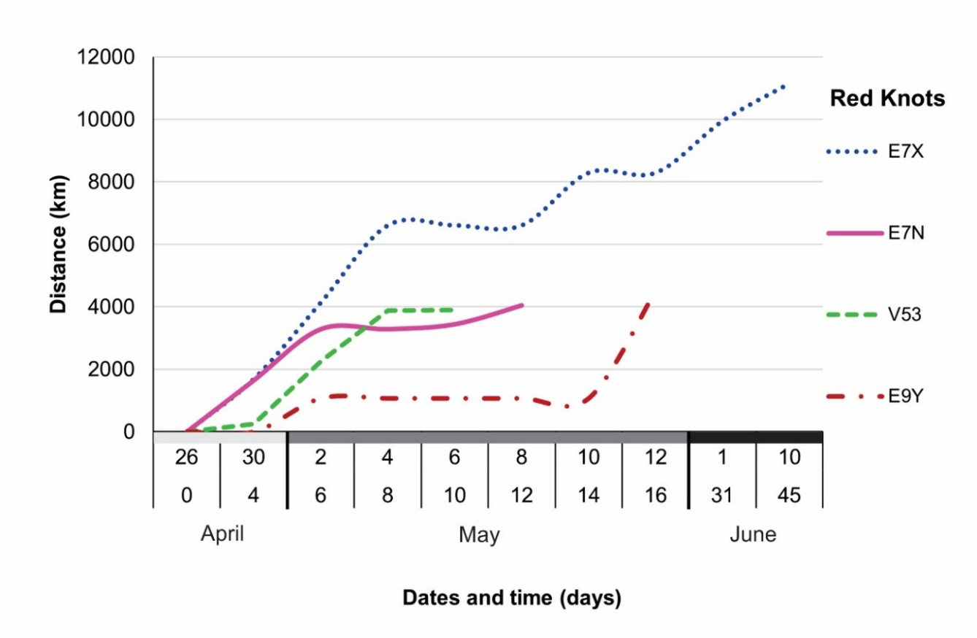
Figure S2. Cumulative distances (km), dates and cumulative travel days of migrating Red Knots tracked between April and June 2019
Table S1. Positions fixes of Red Knots (Calidris canutus rufa) tracked from Lagoa do Peixe National Park between April and July 2019. Distances and times between fixes, flight speed, number of fixes for each bird and locations for recording the position

Bird | Date |  | Position |  | Nº of fixes | Days | Relative distance (km) | Migration speed (km/d) | Flight speed (km/h) | Geographical References
E7X | 30 Apr | 4 May | -16º55 S, -55º08 W | 27º03 N, -63,93 W | 2 | 4 | 4,916 | 1.229 | 51 | Pantanal (MT, BR) → Sargasso Sea (Central America)
 | 4 May | 10 May | 27º03 N, -63,93 W | 39º33 N, -74º88 W | 2 | 6 | 1,683 | 280 | - | Sargasso Sea → Middle Township (NJ, USA)
 | 10 May | 16 May | 39º33 N, -74º88 W | 39º01 N, -74º83 W | 3 | 6 | - | - | - | Middle Township → West Wildwood (NJ, USA)
 | 16 May | 1 June | 39º01 N, -74º83 W | 53º06 N, -82º13 W | 1 | 16 | 1,685 | 105 | - | West Wildwood → James Bay (ON, CA)
 | 1 June | 10 June | 53º06 N, -82º13 W | 63º72 N, -85º75 W | 1 | 9 | 1,206 | 134 | - | James Bay → Southampton Island (NU, CA)
E7N | 26 Apr | 30 Apr | -31º35 S, -51º05 W | -16º71 S, -53º85 W | 2 | 4 | 1,646 | 411 | - | Lagoa do Peixe (RS, BR) → Pantanal (MT, BR)
 | 30 Apr | 2 May | -16º71 S, -53º85 W | -1º98 S, -52º72 W | 1 | 2 | 1,634 | 817 | 34 | Pantanal → Porto de Moz (PA, BR)
 | 2 May | 6 May | -1º98 S, -52º72 W | -2º39 S, -51º38 W | 1 | 4 | - | - | - | Porto de Moz → Baía de Caxiuana (PA, BR)
 | 6 May | 8 May | -2º39 S, -51º38 W | -1º21 S, -52º72 W | 1 | 2 | 614 | 307 | - | Baía de Caxiuana → Baía do Iririmirim (MA, BR)
 | 8 May | 20 May | -1º21 S, -52º72 W | -0º89 S, -46º32 W | 3 | 12 | - | - | - | Baía do Iririmirim → Baía do Chum (PA, BR)
V53 | 26 Apr | 30 Apr | -31º15 S, -50º79 W | -29º39 S, -49º85 W | 2 | 4 | 214 | 53 | - | Lagoa do Peixe (RS, BR) → Lagoa de Itapeva (RS , BR)
 | 30 Apr | 2 May | -29º39 S, -49º85 W | -12º38 S, -42º59 W | 1 | 2 | 2,028 | 1014 | 42 | Lagoa de Itapeva → Várzea da Pedra (BA, BR)
 | 2 May | 4 May | -12º38 S, -42º59 W | 0º39 N, -49º76 W | 1 | 2 | 1,619 | 809 | - | Várzea da Pedra → Baía Santa Rosa (AM, BR)
 | 4 May | 6 May | 0º39 N, -49º76 W | 0º39 N, -49º86 W | 1 | 2 | - | - | - | Baía Santa Rosa (AM, BR)
E9Y | 2 May | 12 May | -22º48 S, -46º51 W | 7º27 N, -56º13 W | 2 | 10 | 3,454 | 345 | - | Sertãozinho (MG, BR) → Atlantic Ocean (SR)
E8A | 26 Apr | 23 July | -31º35 S, -51º04 W | -31º35 S, -51º04 W | 20 | 90 | - |  | - | Lagoa do Peixe
MT: Mato Grosso, BR: Brazil, NJ: New Jersey, USA: United States of America, ON: Ontario, CA: Canada, NU: Nunavut, RS: Rio Grande do Sul, PA: Pará, MA: Maranhão, BA: Bahia, AM: Amapá, MG: Minas Gerais, SR: Suriname.

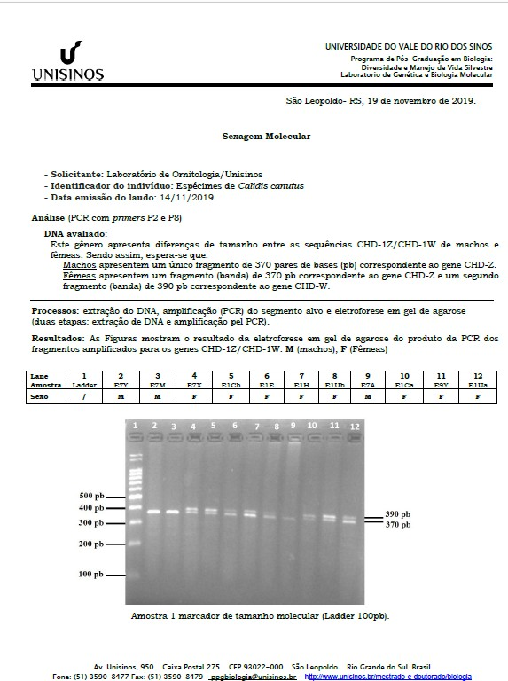
Figure S3 – Molecular sexing results for birds E7X, E9Y, V53, E7N and E8A.

Legend: The Birds E7X and E9Y are shown in columns (lame) 4 and 11 respectively. M = male and F = Female.

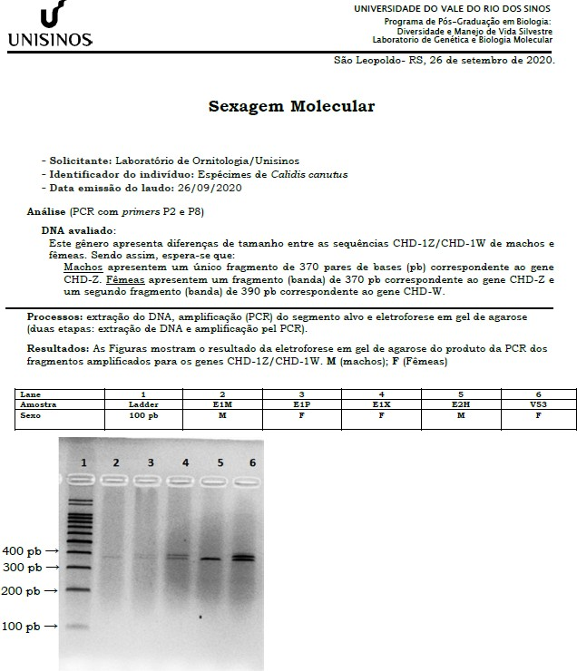

Legend: The bird V53 is shown in column (lame) 6. M = male and F = Female.

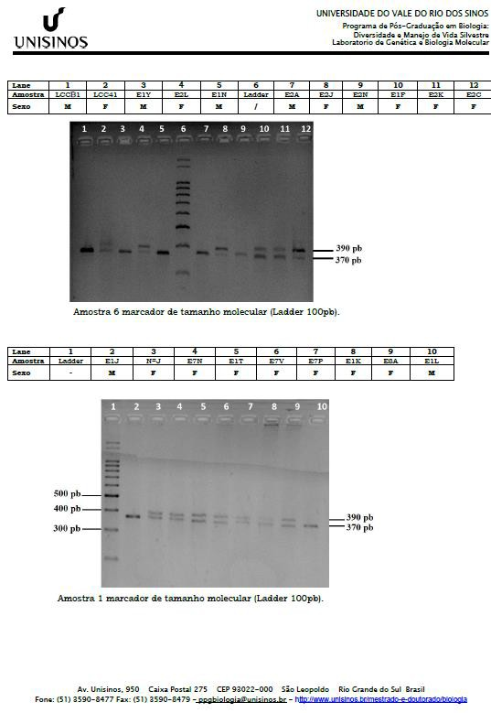
Legend: The birds E7N and E8A are shown in the second table column (lame) 4 and 9 respectively. M = male and F = Female.

