Impact of prompt sophistication on ChatGPT’s output for automatic written corrective feedback
Na Luo*
Lanzhou University, China (luona@lzu.edu.cn)
Yifan Wang
Lanzhou University, China (wangyifan2024@lzu.edu.cn)
Zhe (Victor) Zhang
Macao Polytechnic University, Macao SAR, China (victorzhang@mpu.edu.mo)
Yile Zhou
Freelancer, China (zhou952412@163.com)
Rongfu Zhao
Lanzhou University, China (zhaorf2024@lzu.edu.cn)
Luo, N., Wang, Y., Zhang, Z.V., Zhou, Y. & Zhao, R. (2025) Impact of prompt sophistication on ChatGPT’s output for automatic written corrective feedback. ReCALL.
Appendixes
Appendix 1: Error categories, definitions and examples
Error category | Definition | Example
1. Article/determiner | Errors involving unnecessary or missing article or determiner, wrong article or determiner, or a determiner that does not agree in number with the noun it modifies | Developing effective communication skills can help students cope with the various challenges.
2. Colloquialism | Use of informal words or expressions reflecting an inappropriately casual register | Maybe students can become excellent lecturers or qualified candidates.
3. Connective | Errors of wrong, unclear, unnecessary or missing conjunctions and other connectives | Above all, the ability to communicate effectively not only raises working efficiency, but also can exercise our way of thinking.  (This is the penultimate sentence of the entire essay)
4. Direct translation | Direct translation of Chinese into English, which leads to awkward word choice, expressions or sentence structures | ...students should learn how to be human while learning cultural knowledge.
5. Noun ending | Missing, unnecessary or incorrect plural or possessive marker/ confusion about singular or plural noun ending | ...effective communication skills contribute to students physical and mental health
6. Preposition | Wrong, unnecessary or missing preposition | First of all, students who enter into a new environment need to introduce themselves.
7. Pronoun | A personal pronoun that does not agree in number or case with the referent or that has no apparent antecedent. | It is necessary for students to develop our communication skills.
8. Punctuation | All punctuation and capitalization errors, correctable by merely changing the punctuation and/or capitalization | Effective communication is a lifelong benefit, we should pay attention to it.
9. Sentence structure | Obvious missing or redundancy of one or more sentence element(s), use of wrong sentence pattern, and other complicated disorders which affect two or more sentence constituents | When students cooperate in a team, effective communication can express what they think.
10. Spelling | Incorrect spelling | Students should foster effective communication skills for to reasons.
11. SV agreement | Errors in either noun or verb form resulting in lack of agreement between the subject and the verb of a clause | Everyone need to communication with other people.
12.Verb form | Errors in formation of the verb including time or tense markings | I will analysis reasons about it.
13. Word choice or expression | Use of wrong words or multiple-word expressions, the missing or redundancy of such words or expressions which only affects one sentence element | When friends suffer setbacks, students with effective communication skills know how to praise them properly.
14. Word form | Wrong form of the word, i.e., the word is in the wrong lexical category for the context | An increase number of people are now concerned about communication skills
15. Word order | Errors related to incorrect arrangement or sequence of words in a sentence | These skills include both the management of body language and facial expressions.
Appendix 2: The three prompts for ChatGPT
Prompt 1 | Please act as a writing tutor to provide corrective feedback to the following essay written by a Chinese undergraduate who learns English as a foreign language. Make sure to provide specific feedback on language errors to help the student improve writing accuracy. Essay: < >
Prompt 2 | Please act as a writing tutor to provide detailed and comprehensive corrective feedback to the following essay written by a Chinese undergraduate who learns English as a foreign language. Make sure your feedback is specific so that the student writer can use it to improve writing accuracy. Please provide feedback on language issues based on the following 15 error categories and their definitions:  [1. Article/determiner error: Errors involving unnecessary or missing article or determiner, wrong article or determiner, or a determiner that does not agree in number with the noun it modifies. ...]  Label all errors you find with the abovementioned categories.  Please present your feedback sentence by sentence in a table, with the first column being the original sentence, the second column being the error category, and the third column the explanation for the error and suggestions for improvement.  Essay: < >
Prompt 3 | Please act as a writing tutor to provide detailed and comprehensive corrective feedback to the following essay written by a Chinese undergraduate who learns English as a foreign language. Make sure your feedback is specific so that the student writer can use it to improve writing accuracy. Please provide feedback on language issues based on the following 15 error categories and their definitions. One example of each error category, together with one possible correction, is provided. The error and its correction in each example are underlined.  [1. Article/determiner error: Errors involving unnecessary or missing article or determiner, wrong article or determiner, or a determiner that does not agree in number with the noun it modifies.  Example: In order to cope with the difficulties in life, students need to develop effective communication skills.  Possible correction: In order to cope with difficulties in life, students need to develop effective communication skills.  ...  13. Word choice or expression error: Use of wrong words or multiple-word expressions, the missing or redundancy of such words or expressions which only affects one sentence element.  Example: When friends suffer setbacks, students with effective communication skills know how to praise them properly.  Possible correction: When friends suffer setbacks, students with effective communication skills know how to comfort them properly.  ...]  Label all errors you find with the abovementioned categories.  Please present your feedback sentence by sentence in a table, with the first column being the original sentence, the second column being the error category, and the third column the explanation for the error and suggestions for improvement.  Essay: < >
Appendix 3: An essay in the corpus and its AWCF outputs from ChatGPT across prompts and Grammarly
The essay:
An increase number of people are now concerning about the communication skills in contemporary social. I consider that students have to develop effective communication skills too. Next, I will analysis reasons about it.
The primary reason of my view is that communication skills is not only an ability of socializing, but also a part of comprehensive quality as well. As a human, we have to communicate with others in our daily life. If we try to construct a harmonious connection with ourselves and people around us, we must express what we want others know clearly. And then, It is believe that students have to master communication skills to earn a living no matter which kind of work they do and whatever they at any stage. And we can realize that doing well in socializing have become a regulation to success.
To sum up, students must develop effective communication skills to overcome many difficulties in the society.
AWCF generated by ChatGPT with Prompt 1:
Essay 1 argues for the importance of effective communication skills for students, highlighting their significance in daily life and professional success. Here's a critique and suggestions for improvement:
- Introduction and Context:
  - The introduction acknowledges the growing concern about communication skills in modern society but could benefit from a more precise framing of why these skills are increasingly valued today. Clarifying the link between communication skills and the demands of a globalized, interconnected world could provide a stronger context.
- Communication as a Comprehensive Quality:
  - The assertion that communication is part of comprehensive quality is valid. Expanding on this by detailing how communication skills intersect with emotional intelligence, problem-solving, and teamwork could provide a fuller picture of their importance.
- Importance in Professional Life:
  - The point about the necessity of communication skills for professional success is well-made. Illustrating this with specific examples, such as how effective communication can influence career advancement or entrepreneurial success, would add depth to the argument.
- Clarity and Cohesion:
  - The essay's flow could be improved by better structuring the argument, ensuring each point logically leads to the next. Additionally, clarifying the connection between individual well-being and effective communication could enhance coherence.
- Grammar and Sentence Structure:
  - There are several grammatical errors and awkward phrasings ("An increase number of people," "I will analysis reasons about it," "It is believe that") that need to be corrected for clarity and professionalism.
  - The essay should maintain a consistent and formal tone throughout, suitable for an academic or persuasive text.
- Conclusion and Call to Action:
  - The conclusion succinctly summarizes the argument but could be strengthened by reinforcing the broader implications of effective communication skills, perhaps suggesting how students can develop these skills.
By addressing these points, the essay will offer a more comprehensive, detailed, and persuasive argument for the importance of developing effective communication skills in students, enhancing its clarity, depth, and impact.
AWCF generated by ChatGPT with Prompt 2:
Original Text | Error Categories | Explanation
An increase number of people are now concerning about the communication skills in contemporary social. | 1. Article/determiner, 6. Preposition, 13. Word choice or expression | "An increase number" should be "An increasing number." The phrase "concerning about" should be "concerned about," and "in contemporary social" is missing a noun, such as "society."
I consider that students have to develop effective communication skills too. | None | No errors detected; the sentence is grammatically correct.
Next, I will analysis reasons about it. | 14. Word form | "analysis" should be "analyze." "Reasons about it" could be more directly stated as "the reasons for this view."
The primary reason of my view is that communication skills is not only an ability of socializing, but also a part of comprehensive quality as well. | 11. SV agreement, 13. Word choice or expression | "skills is" should be "skills are." "Ability of socializing" should be "ability to socialize."
As a human, we have to communicate with others in our daily life. | None | No errors detected; the sentence is grammatically correct.
If we try to construct a harmonious connection with ourselves and people around us, we must express what we want others know clearly. | 13. Word choice or expression | "What we want others know" should be "what we want others to know."
And then, It is believe that students have to master communication skills to earn a living no matter which kind of work they do and whatever they at any stage. | 12. Verb form, 13. Word choice or expression | "It is believe" should be "It is believed." The phrase "whatever they at any stage" is unclear and grammatically incorrect; it might be intended to say "at any stage in their careers."
And we can realize that doing well in socializing have become a regulation to success. | 11. SV agreement, 13. Word choice or expression | "have become" should be "has become." "A regulation to success" is awkward; "a prerequisite for success" would be clearer.
To sum up, students must develop effective communication skills to overcome many difficulties in the society. | None | No errors detected; the sentence is grammatically correct.
AWCF generated by ChatGPT with Prompt 3:
Original Text | Error Categories | Explanation for Error Identification
An increase number of people are now concerning about the communication skills in contemporary social. | 14. Word form, 13. Word choice or expression, 12. Verb form | "increase" should be "increasing". The word "concerning" should be replaced with "concerned". "in contemporary social" should be "in contemporary society".
I consider that students have to develop effective communication skills too. | - | No errors identified in this sentence.
Next, I will analysis reasons about it. | 12. Verb form, 4. Direct translation | "analysis" should be "analyze". "reasons about it" is a direct translation error and should be "reasons for it".
The primary reason of my view is that communication skills is not only an ability of socializing, but also a part of comprehensive quality as well. | 11. SV agreement, 13. Word choice or expression, 4. Direct translation | "skills is" should be "skills are". "an ability of socializing" is a direct translation error and should be "an ability for socializing". "as well" at the end is redundant.
As a human, we have to communicate with others in our daily life. | 5.Noun ending | "As a human" doesn't align with the plural pronoun "we". It should be "As humans, we..."
If we try to construct a harmonious connection with ourselves and people around us, we must express what we want others know clearly. | 12. Verb form | "what we want others know" should be "what we want others to know".
And then, It is believe that students have to master communication skills to earn a living no matter which kind of work they do and whatever they at any stage. | 12. Verb form, 9. Sentence structure, 8. Punctuation, 4. Direct translation | "It is believe" should be "It is believed". "whatever they at any stage" is a direct translation error and is missing a verb; it should be "at which stage they are". "And then," should have a lowercase "it" following it.
And we can realize that doing well in socializing have become a regulation to success. | 11. SV agreement, 13. Word choice or expression | "socializing have" should be "socializing has". "a regulation to success" is not idiomatic; it should be "a key to success" or "a requirement for success".
To sum up, students must develop effective communication skills to overcome many difficulties in the society. | 1. Article/determiner | "difficulties in the society" should be "difficulties in society".
Feedback generated by Grammarly
Screenshot of Grammarly’s error flagging of the essay from the downloaded report:
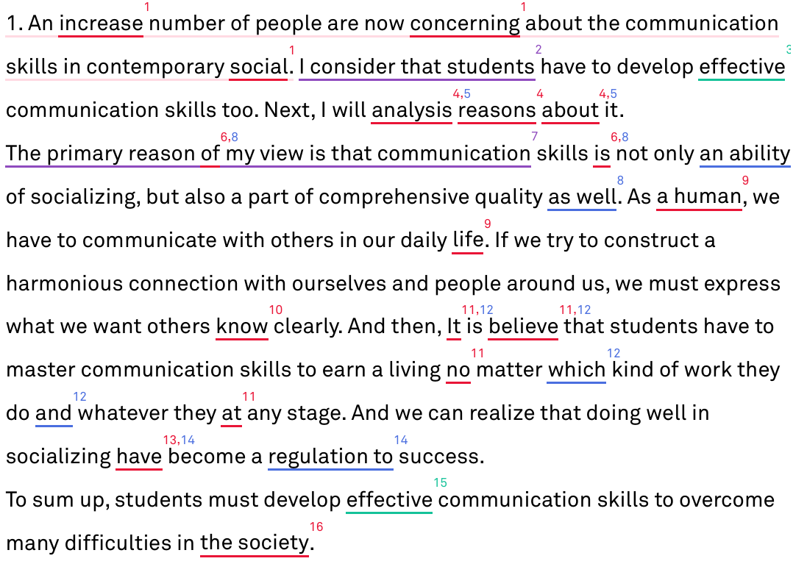

Screenshot of analysis by Grammarly for errors 1–6 in the essay from the downloaded report: 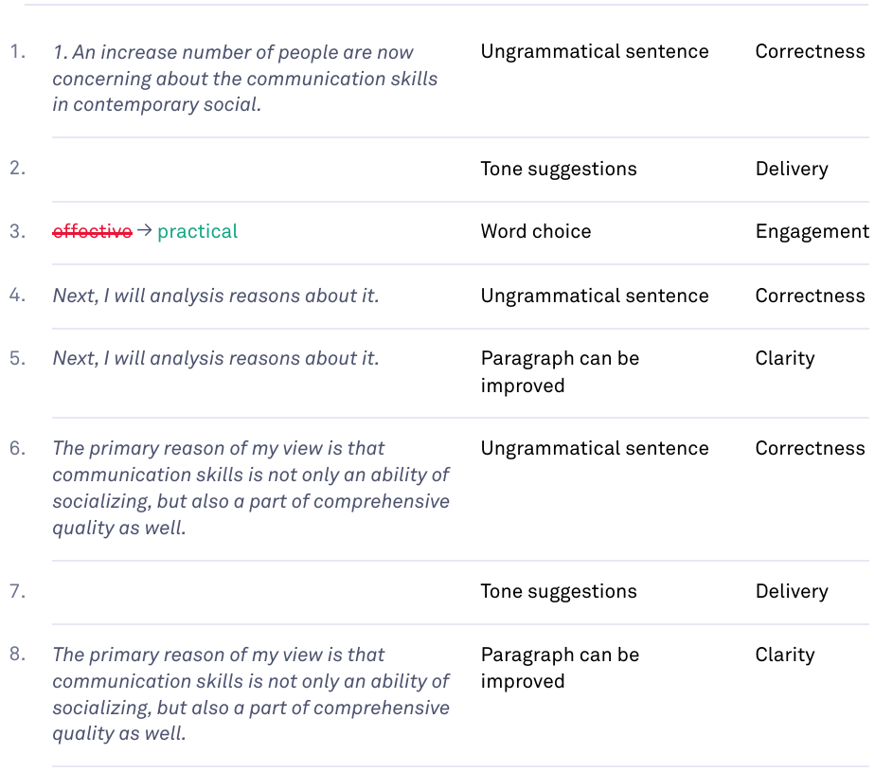

Screenshots of suggestions for revision by Grammarly for errors 1–6 in the essay (non-downloadable, available only in the interactive interface from Grammarly’s website):
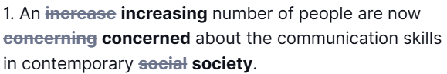
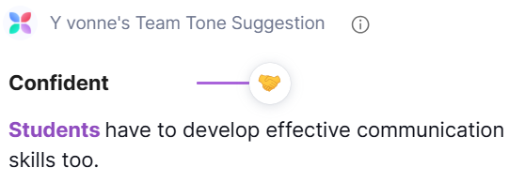
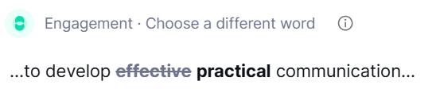
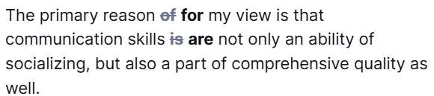

The original prompt included a subject–verb agreement error (‘who learn’). We believe this copyediting change did not affect any model outputs reported.

