Supplementary Material Table A
Table A. The articles in the dataset
Authors | Article Title | Source Title | Publication  Year
Veivo, O; Mutta, M | Dialogue breakdowns in robot-assisted L2 learning | COMPUTER ASSISTED LANGUAGE LEARNING | 2022
Martin, JL; Wright, KE | Bias in Automatic Speech Recognition: The Case of African American Language | APPLIED LINGUISTICS | 2022
Cheng, YW; Wang, YP; Cheng, YJ; Chen, NS | The impact of learning support facilitated by a robot and IoT-based tangible objects on children's game-based language learning | COMPUTER ASSISTED LANGUAGE LEARNING | 2022
An, X; Chai, CS; Li, YS; Zhou, Y; Shen, X; Zheng, CP; Chen, MY | Modeling English teachers' behavioral intention to use artificial intelligence in middle schools | EDUCATION AND INFORMATION TECHNOLOGIES | 2022
Yagi, S; Elnagar, A; Fareh, S | A benchmark for evaluating Arabic word embedding models | NATURAL LANGUAGE ENGINEERING | 2022
Zhang, Z; Xu, L | Student engagement with automated feedback on academic writing: a study on Uyghur ethnic minority students in China | JOURNAL OF MULTILINGUAL AND MULTICULTURAL DEVELOPMENT | 2022
Hwang, H; Kim, H | Automatic Analysis of Constructional Diversity as a Predictor of EFL Students' Writing Proficiency | APPLIED LINGUISTICS | 2022
Chen, F; Xia, QS; Feng, Y; Wang, L; Peng, G | Learning challenging L2 sounds via computer-assisted training: Audiovisual training with an airflow model | JOURNAL OF COMPUTER ASSISTED LEARNING | 2022
Mizumoto, A | Calculating the Relative Importance of Multiple Regression Predictor Variables Using Dominance Analysis and Random Forests | LANGUAGE LEARNING | 2022
Jiang, MYC; Jong, MSY; Lau, WWF; Chai, CS; Wu, N | Exploring the effects of automatic speech recognition technology on oral accuracy and fluency in a flipped classroom | JOURNAL OF COMPUTER ASSISTED LEARNING | 2022
Guo, K; Wang, J; Chu, SKW | Using chatbots to scaffold EFL students? argumentative writing | ASSESSING WRITING | 2022
Ling, L; Chen, WY | Integrating an ASR-based translator into individualized L2 vocabulary learning for young children | EDUCATION AND INFORMATION TECHNOLOGIES | 2022
Ebadi, S; Amini, A | Examining the roles of social presence and human-likeness on Iranian EFL learners' motivation using artificial intelligence technology: a case of CSIEC chatbot | INTERACTIVE LEARNING ENVIRONMENTS | 2022
Zhang, XP | The relationship between lexical use and L2 writing quality: A case of two genres | INTERNATIONAL JOURNAL OF APPLIED LINGUISTICS | 2022
Lim, K; Song, J; Park, J | Neural automated writing evaluation for Korean L2 writing | NATURAL LANGUAGE ENGINEERING | 2022
Liu, J; Fan, L; Tian, LY; Li, C; Feng, WS | The neural mechanisms of explicit and implicit processing of Chinese emotion-label and emotion-laden words: evidence from emotional categorisation and emotional Stroop tasks | LANGUAGE COGNITION AND NEUROSCIENCE | 2022
Godwin-Jones, R | Partnering with AI: Intelligent writing assistance and instructed language learning | LANGUAGE LEARNING & TECHNOLOGY | 2022
Hsieh, JC | Multimodal Digital Storytelling Presentations among Middle-School Learners of English as a Foreign Language: Emotions, Grit and Perceptions | RELC JOURNAL | 2022
Zammit, J | Application of 'Gabra' online dictionary for international adults learning maltese | COMPUTER ASSISTED LANGUAGE LEARNING | 2022
Chasetareh, F; Barabadi, E; Khajavy, GH; Flett, G | Perfectionism and L2 Achievement: The Mediating Roles of Motivation and Self-Regulated Learning Among Iranian High School Students | JOURNAL OF PSYCHOEDUCATIONAL ASSESSMENT | 2022
Awada, G | Robotics and Weblog integration into EFL curriculum of middle and secondary schools: Exploratory study | LANGUAGE TEACHING RESEARCH | 2022
Gaillat, T; Simpkin, A; Ballier, N; Stearns, B; Sousa, A; Bouye, M; Zarrouk, M | Predicting CEFR levels in learners of English: The use of microsystem criterial features in a machine learning approach | RECALL | 2022
Engwall, O; Lopes, J; Cumbal, R; Berndtson, G; Lindstrom, R; Ekman, P; Hartmanis, E; Jin, E; Johnston, E; Tahir, G; Mekonnen, M | Learner and teacher perspectives on robot-led L2 conversation practice | RECALL | 2022
Liu, YG; Hintz, F; Liang, JY; Huettig, F | Prediction in challenging situations: Most bilinguals can predict upcoming semantically-related words in their L1 source language when interpreting | BILINGUALISM-LANGUAGE AND COGNITION | 2022
Tai, TY; Chen, HHJ | The impact of intelligent personal assistants on adolescent EFL learners' speaking proficiency | COMPUTER ASSISTED LANGUAGE LEARNING | 2022
Xu, JJ; Kang, H | Salience-simplification strategy for markedness of causal subordinators: ?Because? and ?since? in argumentative essays | LINGUA | 2022
Yang, H; Kim, H; Lee, JH; Shin, D | Implementation of an AI chatbot as an English conversation partner in EFL speaking classes | RECALL | 2022
Du, YF; Gao, H | Determinants affecting teachers' adoption of AI-based applications in EFL context: An analysis of analytic hierarchy process | EDUCATION AND INFORMATION TECHNOLOGIES | 2022
Jakonen, T; Jauni, H | Managing activity transitions in robot-mediated hybrid language classrooms | COMPUTER ASSISTED LANGUAGE LEARNING | 2022
Spring, R; Johnson, M | The possibility of improving automated calculation of measures of lexical richness for EFL writing: A comparison of the LCA, NLTK and SpaCy tools | SYSTEM | 2022
Wang, XH; Pang, H; Wallace, MP; Wang, QY; Chen, WL | Learners' perceived AI presences in AI-supported language learning: a study of AI as a humanized agent from community of inquiry | COMPUTER ASSISTED LANGUAGE LEARNING | 2022
Chen, YC | Effects of technology-enhanced language learning on reducing EFL learners' public speaking anxiety | COMPUTER ASSISTED LANGUAGE LEARNING | 2022
Wang, J; Zhang, Y; Hung, CY; Wang, QY; Zheng, Y | Exploring the characteristics of an optimal design of non-programming plugged learning for developing primary school students' computational thinking in mathematics | ETR&D-EDUCATIONAL TECHNOLOGY RESEARCH AND DEVELOPMENT | 2022
Ranalli, J; Yamashita, T | Automated written corrective feedback: Error-correction performance and timing of delivery | LANGUAGE LEARNING & TECHNOLOGY | 2022
Al Hakim, VG; Yang, SH; Liyanawatta, M; Wang, JH; Chen, GD | Robots in situated learning classrooms with immediate feedback mechanisms to improve students' learning performance | COMPUTERS & EDUCATION | 2022
Kim, H; Yang, H; Shin, D; Lee, JH | Design principles and architecture of a second language learning chatbot | LANGUAGE LEARNING & TECHNOLOGY | 2022
Tantucci, V; Wang, AQ | Resonance as an Applied Predictor of Cross-Cultural Interaction: Constructional Priming in Mandarin and American English Interaction | APPLIED LINGUISTICS | 2022
Quint, N; Allassonniere-Tang, M | Inferring case paradigms in Koalib with computational classifiers | CORPUS LINGUISTICS AND LINGUISTIC THEORY | 2022
Eryigit, G; Sentas, A; Monti, J | Gamified crowdsourcing for idiom corpora construction | NATURAL LANGUAGE ENGINEERING | 2022
Jeon, J | Exploring a self-directed interactive app for informal EFL learning: a self-determination theory perspective | EDUCATION AND INFORMATION TECHNOLOGIES | 2022
Lee, H; Lee, JH | Social robots for English language teaching | ELT JOURNAL | 2022
Lin, V; Yeh, HC; Huang, HH; Chen, NS | Enhancing EFL vocabulary learning with multimodal cues supported by an educational robot and an IoT-Based 3D book | SYSTEM | 2022
Chen, CH; Koong, CS; Liao, C | Influences of Integrating Dynamic Assessment into a Speech Recognition Learning Design to Support Students' English Speaking Skills, Learning Anxiety and Cognitive Load | EDUCATIONAL TECHNOLOGY & SOCIETY | 2022
Hu, CC; Yeh, HC; Chen, NS | Teacher development in robot and IoT knowledge, skills, and attitudes with the use of the TPACK-based Support-Stimulate-Seek approach | INTERACTIVE LEARNING ENVIRONMENTS | 2021
Jeon, J | Exploring AI chatbot affordances in the EFL classroom: young learners' experiences and perspectives | COMPUTER ASSISTED LANGUAGE LEARNING | 2021
Liu, CC; Hou, JR; Tu, YF; Wang, YM; Hwang, GJ | Incorporating a reflective thinking promoting mechanism into artificial intelligence-supported English writing environments | INTERACTIVE LEARNING ENVIRONMENTS | 2021
Xu, JJ; Li, JL | A syntactic complexity analysis of translational English across genres | ACROSS LANGUAGES AND CULTURES | 2021
Tian, Y; Kim, M; Crossley, S; Wan, Q | Cohesive devices as an indicator of L2 students' writing fluency | READING AND WRITING | 2021
Huang, TH; Wang, LZ | Artificial intelligence learning approach through total physical response embodiment teaching on French vocabulary learning retention | COMPUTER ASSISTED LANGUAGE LEARNING | 2021
Crossley, S; Wan, Q; Allen, L; McNamara, D | Source inclusion in synthesis writing: an NLP approach to understanding argumentation, sourcing, and essay quality | READING AND WRITING | 2021
Wu, JW | An overview of less commonly taught languages education in China: historical perspectives and practical concerns | ONOMAZEIN | 2021
Katushemererwe, F; Caines, A; Buttery, P | Building natural language processing tools for Runyakitara | APPLIED LINGUISTICS REVIEW | 2021
Eryigit, G; Bektas, F; Ali, U; Dereli, B | Gamification of complex morphology learning: the case of Turkish | COMPUTER ASSISTED LANGUAGE LEARNING | 2021
Lin, CJ; Mubarok, H | Learning Analytics for Investigating the Mind Map-Guided AI Chatbot Approach in an EFL Flipped Speaking Classroom | EDUCATIONAL TECHNOLOGY & SOCIETY | 2021
Jeon, J | Chatbot-assisted dynamic assessment (CA-DA) for L2 vocabulary learning and diagnosis | COMPUTER ASSISTED LANGUAGE LEARNING | 2021
Zubanova, S; Didenko, E; Karabulatova, I | Location-based mobile learning system facilitating English learning | INTERACTIVE LEARNING ENVIRONMENTS | 2021
Xu, J; Jones, E; Laxton, V; Galaczi, E | Assessing L2 English speaking using automated scoring technology: examining automarker reliability | ASSESSMENT IN EDUCATION-PRINCIPLES POLICY & PRACTICE | 2021
Kang, X; Matthews, S; Yip, V; Wong, PCM | Language and nonlanguage factors in foreign language learning: evidence for the learning condition hypothesis | NPJ SCIENCE OF LEARNING | 2021
Hu, H; Amaral, P; Kubler, S | Word embeddings and semantic shifts in historical Spanish: Methodological considerations | DIGITAL SCHOLARSHIP IN THE HUMANITIES | 2022
Pi, ZL; Zhu, FF; Zhang, Y; Yang, JM | An instructor's beat gestures facilitate second language vocabulary learning from instructional videos: Behavioral and neural evidence | LANGUAGE TEACHING RESEARCH | 2021
Hsieh, JC; Lee, JS | Digital storytelling outcomes, emotions, grit, and perceptions among EFL middle school learners: robot-assisted versus PowerPoint-assisted presentations | COMPUTER ASSISTED LANGUAGE LEARNING | 2021
Nahatame, S | Text Readability and Processing Effort in Second Language Reading: A Computational and Eye-Tracking Investigation | LANGUAGE LEARNING | 2021
Huang, XY; Zou, D; Cheng, GR; Chen, XL; Xie, HR | Trends, Research Issues and Applications of Artificial Intelligence in Language Education | EDUCATIONAL TECHNOLOGY & SOCIETY | 2021
Hsieh, JC | Digital Storytelling Outcomes and Emotional Experience among Middle School EFL Learners: Robot-Assisted versus PowerPoint-Assisted Mode | TESOL QUARTERLY | 2021
Lyashevskaya, O; Panteleeva, I; Vinogradova, O | Automated assessment of learner text complexity | ASSESSING WRITING | 2021
McPhedran, MJ; Lupker, SJ | L2-L1 noncognate masked translation priming as a task-specific phenomenon | BILINGUALISM-LANGUAGE AND COGNITION | 2021
Zhang, XP; Li, WW | Effects of n-grams on the rated L2 writing quality of expository essays: A conceptual replication and extension | SYSTEM | 2021
Hsu, TC; Liang, YS | Simultaneously Improving Computational Thinking and Foreign Language Learning: Interdisciplinary Media With Plugged and Unplugged Approaches | JOURNAL OF EDUCATIONAL COMPUTING RESEARCH | 2021
Divekar, RR; Drozdal, J; Chabot, S; Zhou, YL; Su, H; Chen, Y; Zhu, HM; Hendler, JA; Braasch, J | Foreign language acquisition via artificial intelligence and extended reality: design and evaluation | COMPUTER ASSISTED LANGUAGE LEARNING | 2022
Nasseri, M; Thompson, P | Lexical density and diversity in dissertation abstracts: Revisiting English L1 vs. L2 text differences | ASSESSING WRITING | 2021
Banaeian, H; Gilanlioglu, I | Influence of the NAO robot as a teaching assistant on university students' vocabulary learning and attitudes | AUSTRALASIAN JOURNAL OF EDUCATIONAL TECHNOLOGY | 2021
Huang, Y; Murakami, A; Alexopoulou, T; Korhonen, A | Subcategorization frame identification for learner English | INTERNATIONAL JOURNAL OF CORPUS LINGUISTICS | 2021
Tang, XR | How metaphoremes emerge Case studies of Chinese verb metaphors | REVIEW OF COGNITIVE LINGUISTICS | 2021
Nasseri, M | Is postgraduate English academic writing more clausal or phrasal? Syntactic complexification at the crossroads of genre, proficiency, and statistical modelling | JOURNAL OF ENGLISH FOR ACADEMIC PURPOSES | 2021
Tsai, Y | Diachronic observation of lexical and syntactic patterns in English translations of Taiwan patent texts | PERSPECTIVES-STUDIES IN TRANSLATION THEORY AND PRACTICE | 2021
Leeuwestein, H; Barking, M; Sodaci, H; Oudgenoeg-Paz, O; Verhagen, J; Vogt, P; Aarts, R; Spit, S; de Haas, M; de Wit, J; Leseman, P | Teaching Turkish-Dutch kindergartners Dutch vocabulary with a social robot: Does the robot's use of Turkish translations benefit children's Dutch vocabulary learning? | JOURNAL OF COMPUTER ASSISTED LEARNING | 2021
Fulton, L; Hoffman, DL; Paek, S | Language learning in an era of datafication and personalized learning | ETR&D-EDUCATIONAL TECHNOLOGY RESEARCH AND DEVELOPMENT | 2021
Monteiro, K; Kim, Y | The effect of input characteristics and individual differences on L2 comprehension of authentic and modified listening tasks | SYSTEM | 2020
Al-Hoorie, AH; Hiver, P; Kim, TY; De Costa, PI | The Identity Crisis in Language Motivation Research | JOURNAL OF LANGUAGE AND SOCIAL PSYCHOLOGY | 2021
van den Berghe, R; de Haas, M; Oudgenoeg-Paz, O; Krahmer, E; Verhagen, J; Vogt, P; Willemsen, B; de Wit, J; Leseman, P | A toy or a friend? Children's anthropomorphic beliefs about robots and how these relate to second-language word learning | JOURNAL OF COMPUTER ASSISTED LEARNING | 2021
Yoon, HJ | Interactions in EFL argumentative writing: effects of topic, L1 background, and L2 proficiency on interactional metadiscourse | READING AND WRITING | 2021
Cheng, YW; Wang, YP; Yang, YF; Yang, ZK; Chen, NS | Designing an authoring system of robots and IoT-based toys for EFL teaching and learning | COMPUTER ASSISTED LANGUAGE LEARNING | 2020
Engwall, O; Lopes, J | Interaction and collaboration in robot-assisted language learning for adults | COMPUTER ASSISTED LANGUAGE LEARNING | 2022
Abbas, MA; Hammad, S; Hwang, GJ; Khan, S; Gilani, SMM | An assistive environment for EAL academic writing using formulaic sequences classification | INTERACTIVE LEARNING ENVIRONMENTS | 2020
Fu, SX; Gu, HM; Yang, B | The affordances of AI-enabled automatic scoring applications on learners' continuous learning intention: An empirical study in China | BRITISH JOURNAL OF EDUCATIONAL TECHNOLOGY | 2020
Timpe-Laughlin, V; Sydorenko, T; Daurio, P | Using spoken dialogue technology for L2 speaking practice: what do teachers think? | COMPUTER ASSISTED LANGUAGE LEARNING | 2022
Vazquez, R; Raganato, A; Creutz, M; Tiedemann, J | A Systematic Study of Inner-Attention-Based Sentence Representations in Multilingual Neural Machine Translation | COMPUTATIONAL LINGUISTICS | 2020
Alemi, M; Haeri, NS | Robot-assisted instruction of L2 pragmatics: Effects on young EFL learners' speech act performance | LANGUAGE LEARNING & TECHNOLOGY | 2020
Ulum, G | A critical deconstruction of computer-based test application in Turkish State University | EDUCATION AND INFORMATION TECHNOLOGIES | 2020
Eguchi, M; Kyle, K | Continuing to Explore the Multidimensional Nature of Lexical Sophistication: The Case of Oral Proficiency Interviews | MODERN LANGUAGE JOURNAL | 2020
Goh, TT; Sun, H; Yang, B | Microfeatures influencing writing quality: the case of Chinese students' SAT essays | COMPUTER ASSISTED LANGUAGE LEARNING | 2020
Delgado-Crespo, V; Gil, V; Mur-Duenas, P; Pellicer-Ortin, S | Developing communication and thinking skills in English as a Foreign Language Education undergraduate students: a proposal for a syllabus model | ONOMAZEIN | 2020
Nagy, IT; Racz, A; Vincze, V | Detecting light verb constructions across languages | NATURAL LANGUAGE ENGINEERING | 2020
Hsu, LW | To CALL or not to CALL: empirical evidence from neuroscience | COMPUTER ASSISTED LANGUAGE LEARNING | 2022
Ou, J; Li, WL; Yang, Y; Wang, NZ; Xu, M | Earlier second language acquisition is associated with greater neural pattern dissimilarity between the first and second languages | BRAIN AND LANGUAGE | 2020
Chew, CS; Wu, WCV; Idris, N; Loh, EF; Chua, YP | Enhancing Summary Writing of ESL Learners via a Theory-Based Online Tool: System Development and Evaluation | JOURNAL OF EDUCATIONAL COMPUTING RESEARCH | 2020
Kang, H; Xu, JJ | A Multifactorial Analysis of Concessive Clause Positioning | JOURNAL OF QUANTITATIVE LINGUISTICS | 2021
Al-Thwaib, E; Hammo, BH; Yagi, S | An academic Arabic corpus for plagiarism detection: design, construction and experimentation | INTERNATIONAL JOURNAL OF EDUCATIONAL TECHNOLOGY IN HIGHER EDUCATION | 2020
Liao, J; Lu, XF; Masters, KA; Dudek, J; Zhou, Z | Telepresence-place-based foreign language learning and its design principles | COMPUTER ASSISTED LANGUAGE LEARNING | 2022
Wan, MY; Fang, AC; Huang, CR | The Discriminativeness of Internal Syntactic Representations in Automatic Genre Classification | JOURNAL OF QUANTITATIVE LINGUISTICS | 2021
Crossley, SA; Skalicky, S; Dascalu, M | Moving beyond classic readability formulas: new methods and new models | JOURNAL OF RESEARCH IN READING | 2019
Zarco-Tejada, MA | Automatic profiling of L2-simplified texts: Identifying discriminate features of linguistic proficiency | DIGITAL SCHOLARSHIP IN THE HUMANITIES | 2019
Zhane, H; Su, IF; Chen, F; Ng, ML; Wang, L; Yan, N | The time course of orthographic and semantic activation in Chinese character recognition: evidence from anERP study | LANGUAGE COGNITION AND NEUROSCIENCE | 2020
Xie, Q | Error analysis and diagnosis of ESL linguistic accuracy: Construct specification and empirical validation | ASSESSING WRITING | 2019
Law, AS; Stock, R | Learning approach and its relationship to type of media use and frequency of media-multitasking | ACTIVE LEARNING IN HIGHER EDUCATION | 2019
Chew, CS; Idris, N; Loh, EF; Wu, WCV; Chua, YP; Bimba, AT | The effects of a theory-based summary writing tool on students' summary writing | JOURNAL OF COMPUTER ASSISTED LEARNING | 2019
Huang, PY; Tsao, NL | Using collocation clusters to detect and correct English L2 learners' collocation errors | COMPUTER ASSISTED LANGUAGE LEARNING | 2021
Moussalli, S; Cardoso, W | Intelligent personal assistants: can they understand and be understood by accented L2 learners? | COMPUTER ASSISTED LANGUAGE LEARNING | 2020
Godwin-Jones, R | In a World of SMART Technology, Why Learn Another Language? | EDUCATIONAL TECHNOLOGY & SOCIETY | 2019
Yao, CL | A case study of Chinese adult learners' English acquisition in a blended learning environment | AUSTRALIAN JOURNAL OF ADULT LEARNING | 2019
Iio, T; Maeda, R; Ogawa, K; Yoshikawa, Y; Ishiguro, H; Suzuki, K; Aoki, T; Maesaki, M; Hama, M | Improvement of Japanese adults' English speaking skills via experiences speaking to a robot | JOURNAL OF COMPUTER ASSISTED LEARNING | 2019
Liu, R; Stamper, J; Davenport, J; Crossley, S; McNamara, D; Nzinga, K; Sherin, B | Learning linkages: Integrating data streams of multiple modalities and timescales | JOURNAL OF COMPUTER ASSISTED LEARNING | 2019
Sisman, B; Gunay, D; Kucuk, S | Development and validation of an educational robot attitude scale (ERAS) for secondary school students | INTERACTIVE LEARNING ENVIRONMENTS | 2019
Sun, K; Yu, DA; Chen, JS; Yu, D; Choi, YJ; Cardie, C | DREAM: A Challenge Data Set and Models for Dialogue-Based Reading Comprehension | TRANSACTIONS OF THE ASSOCIATION FOR COMPUTATIONAL LINGUISTICS | 2019
Sun, YG | Construction and Effect Evaluation of Russian Wisdom Classroom Teaching Model under the Background of the Belt and Road | EDUCATIONAL SCIENCES-THEORY & PRACTICE | 2018
Yao, CL | How a blended learning environment in adult education promotes sustainable development in China | AUSTRALIAN JOURNAL OF ADULT LEARNING | 2018
Cheng, YW; Sun, PC; Chen, NS | The essential applications of educational robot: Requirement analysis from the perspectives of experts, researchers and instructors | COMPUTERS & EDUCATION | 2018
Crossley, SA; Kyle, K | Assessing writing with the tool for the automatic analysis of lexical sophistication (TAALES) | ASSESSING WRITING | 2018
Liao, J; Lu, XF | Exploring the affordances of telepresence robots in foreign language learning | LANGUAGE LEARNING & TECHNOLOGY | 2018
Kyle, K; Crossley, SA | Measuring Syntactic Complexity in L2 Writing Using Fine-Grained Clausal and Phrasal Indices | MODERN LANGUAGE JOURNAL | 2018
Kessler, G | Technology and the future of language teaching | FOREIGN LANGUAGE ANNALS | 2018
Kannan, J; Munday, P | New Trends in Second Language Learning and Teaching through the lens of ICT, Networked Learning, and Artificial Intelligence | CIRCULO DE LINGUISTICA APLICADA A LA COMUNICACION | 2018
Perez-Paredes, P; Guillamon, CO; Jimenez, PA | Language teachers' perceptions on the use of OER language processing technologies in MALL | COMPUTER ASSISTED LANGUAGE LEARNING | 2018
Yannakoudakis, H; Andersen, OE; Geranpayeh, A; Briscoe, T; Nicholls, D | Developing an automated writing placement system for ESL learners | APPLIED MEASUREMENT IN EDUCATION | 2018
Perinan-Pascual, C; Mairal-Uson, R | A framework of analysis for the evaluation of automatic term extractors | VIAL-VIGO INTERNATIONAL JOURNAL OF APPLIED LINGUISTICS | 2018
Rozovskaya, A; Roth, D; Sammons, M | Adapting to Learner Errors with Minimal Supervision | COMPUTATIONAL LINGUISTICS | 2017
Liu, M; Li, Y; Xu, WW; Liu, L | Automated Essay Feedback Generation and Its Impact on Revision | IEEE TRANSACTIONS ON LEARNING TECHNOLOGIES | 2017
Kyle, K; Crossley, S | Assessing syntactic sophistication in L2 writing: A usage-based approach | LANGUAGE TESTING | 2017
Macintyre, PD; Baker, SC; Sparling, H | Heritage Passions, Heritage Convictions, and the Rooted L2 Self: Music and Gaelic Language Learning in Cape Breton, Nova Scotia | MODERN LANGUAGE JOURNAL | 2017
Reyes, A | Inventing Postcolonial Elites: Race, Language, Mix, Excess | JOURNAL OF LINGUISTIC ANTHROPOLOGY | 2017
Alexopoulou, T; Michel, M; Murakami, A; Meurers, D | Task Effects on Linguistic Complexity and Accuracy: A Large-Scale Learner Corpus Analysis Employing Natural Language Processing Techniques | LANGUAGE LEARNING | 2017
Ziegler, N; Meurers, D; Rebuschat, P; Ruiz, S; Moreno-Vega, JL; Chinkina, M; Li, WJ; Grey, S | Interdisciplinary Research at the Intersection of CALL, NLP, and SLA: Methodological Implications From an Input Enhancement Project | LANGUAGE LEARNING | 2017
Yoon, HJ | Textual voice elements and voice strength in EFL argumentative writing | ASSESSING WRITING | 2017
Berger, CM; Crossley, SA; Kyle, K | Using Novel Word Context Measures to Predict Human Ratings of Lexical Proficiency | EDUCATIONAL TECHNOLOGY & SOCIETY | 2017
Morch, AI; Engeness, I; Cheng, VC; Cheung, WK; Wong, KC | EssayCritic: Writing to Learn with a Knowledge-Based Design Critiquing System | EDUCATIONAL TECHNOLOGY & SOCIETY | 2017
Skalicky, S; Crossley, SA; McNamara, DS; Muldner, K | Identifying Creativity During Problem Solving Using Linguistic Features | CREATIVITY RESEARCH JOURNAL | 2017
Crossley, SA; Skalicky, S; Dascalu, M; McNamara, DS; Kyle, K | Predicting Text Comprehension, Processing, and Familiarity in Adult Readers: New Approaches to Readability Formulas | DISCOURSE PROCESSES | 2017
Kyle, K; Crossley, S | The relationship between lexical sophistication and independent and source-based writing | JOURNAL OF SECOND LANGUAGE WRITING | 2016
Kerz, E; Wiechmann, D | Second language construction learning: investigating domain-specific adaptation in advanced L2 production | LANGUAGE AND COGNITION | 2016
Chen, GH; Cheng, LX | Criteria for new inclusions in the OED - A case study of informatization | ENGLISH TODAY | 2016
Kyle, K; Crossley, SA; McNamara, DS | Construct validity in TOEFL iBT speaking tasks: Insights from natural language processing | LANGUAGE TESTING | 2016
Lucas, RIG; Bernardo, ABI; Rojo-Laurilla, MA | Amotivation in Filipino ESL Learners: Exploring Some Correlates | PORTA LINGUARUM | 2016
Crossley, SA; Kyle, K; McNamara, DS | The development and use of cohesive devices in L2 writing and their relations to judgments of essay quality | JOURNAL OF SECOND LANGUAGE WRITING | 2016
Hong, ZW; Huang, YM; Hsu, M; Shen, WW | Authoring Robot-Assisted Instructional Materials for Improving Learning Performance and Motivation in EFL Classrooms | EDUCATIONAL TECHNOLOGY & SOCIETY | 2016
Francois, T | When readability meets computational linguistics: a new paradigm in readability | REVUE FRANCAISE DE LINGUISTIQUE APPLIQUEE | 2015
Wu, WCV; Wang, RJ; Chen, NS | Instructional design using an in-house built teaching assistant robot to enhance elementary school English-as-a-foreign-language learning | INTERACTIVE LEARNING ENVIRONMENTS | 2015
Lei, MM; Akama, H; Murphy, B | Neural basis of language switching in the brain: fMRI evidence from Korean-Chinese early bilinguals | BRAIN AND LANGUAGE | 2014
Wiechmann, D; Kerz, E | Cue Reliance in L2 Written Production | LANGUAGE LEARNING | 2014
de St Leger, D; Mullan, K | A good all-round French workout or a massive stress?: Perceptions of group work among tertiary learners of French | SYSTEM | 2014
Beuls, K | Grammatical error diagnosis in fluid construction grammar: a case study in L2 Spanish verb morphology | COMPUTER ASSISTED LANGUAGE LEARNING | 2014
Tono, Y; Satake, Y; Miura, A | The effects of using corpora on revision tasks in L2 writing with coded error feedback | RECALL | 2014
Aslan, BG; Ozturk, O; Inceoglu, MM | Effect of Bayesian Student Modeling on Academic Achievement in Foreign Language Teaching (University Level English Preparatory School Example) | KURAM VE UYGULAMADA EGITIM BILIMLERI | 2014
Fleming, DH | Affective Teaching for Effective Learning: A Deleuzian pedagogy for the (corporate era and) Chinese context | EDUCATIONAL PHILOSOPHY AND THEORY | 2014
Crossley, SA; Allen, LK; Kyle, K; McNamara, DS | Analyzing Discourse Processing Using a Simple Natural Language Processing Tool | DISCOURSE PROCESSES | 2014
Chen, MH; Huang, CC; Huang, ST; Chang, JS; Liou, HC | An Automatic Reference Aid for Improving EFL Learners' Formulaic Expressions in Productive Language Use | IEEE TRANSACTIONS ON LEARNING TECHNOLOGIES | 2014
Crossley, SA; Cobb, T; McNamara, DS | Comparing count-based and band-based indices of word frequency: Implications for active vocabulary research and pedagogical applications | SYSTEM | 2013
Crossley, SA; Subtirelu, N; Salsbury, T | FREQUENCY EFFECTS OR CONTEXT EFFECTS IN SECOND LANGUAGE WORD LEARNING What Predicts Early Lexical Production? | STUDIES IN SECOND LANGUAGE ACQUISITION | 2013
Karlstrom, P; Lundin, E | CALL in the zone of proximal development: novelty effects and teacher guidance | COMPUTER ASSISTED LANGUAGE LEARNING | 2013
Sonu, M; Kato, H; Tajima, K; Akahane-Yamada, R; Sagisaka, Y | Non-native perception and learning of the phonemic length contrast in spoken Japanese: training Korean listeners using words with geminate and singleton phonemes | JOURNAL OF EAST ASIAN LINGUISTICS | 2013
Crossley, S; McNamara, D | APPLICATIONS OF TEXT ANALYSIS TOOLS FOR SPOKEN RESPONSE GRADING | LANGUAGE LEARNING & TECHNOLOGY | 2013
Chen, GD; Nurkhamid; Wang, CY; Yang, SH; Lu, WY; Chang, CK | Digital Learning Playground: supporting authentic learning experiences in the classroom | INTERACTIVE LEARNING ENVIRONMENTS | 2013
Crossley, SA | Advancing research in second language writing through computational tools and machine learning techniques: A research agenda | LANGUAGE TEACHING | 2013
Tragant, E; Thompson, MS; Victori, M | Understanding foreign language learning strategies: A validation study | SYSTEM | 2013
Wei, NX; Li, JJ | A new computing method for extracting contiguous phraseological sequences from academic text corpora | INTERNATIONAL JOURNAL OF CORPUS LINGUISTICS | 2013
Liou, HC; Yang, PC; Chang, JS | Language supports for journal abstract writing across disciplines | JOURNAL OF COMPUTER ASSISTED LEARNING | 2012
Lin, PMS | Sound Evidence: The Missing Piece of the Jigsaw in Formulaic Language Research | APPLIED LINGUISTICS | 2012
Wible, D; Liu, ALE; Tsao, NL | A browser-based approach to incidental individualization of vocabulary learning | JOURNAL OF COMPUTER ASSISTED LEARNING | 2011
Chen, CM; Lee, TH | Emotion recognition and communication for reducing second-language speaking anxiety in a web-based one-to-one synchronous learning environment | BRITISH JOURNAL OF EDUCATIONAL TECHNOLOGY | 2011
Amaral, L; Meurers, D; Ziai, R | Analyzing learner language: towards a flexible natural language processing architecture for intelligent language tutors | COMPUTER ASSISTED LANGUAGE LEARNING | 2011
Amaral, LA; Meurers, D | On using intelligent computer-assisted language learning in real-life foreign language teaching and learning | RECALL | 2011
Chen, NS; Quadir, B; Teng, DC | Integrating book, digital content and robot for enhancing elementary school students' learning of English | AUSTRALASIAN JOURNAL OF EDUCATIONAL TECHNOLOGY | 2011
Lee, S; Noh, H; Lee, J; Lee, K; Lee, GG; Sagong, S; Kim, M | On the effectiveness of Robot-Assisted Language Learning | RECALL | 2011
Enright, MK; Quinlan, T | Complementing human judgment of essays written by English language learners with e-rater (R) scoring | LANGUAGE TESTING | 2010
Chodorow, M; Gamon, M; Tetreault, J | The utility of article and preposition error correction systems for English language learners: Feedback and assessment | LANGUAGE TESTING | 2010
Yang, YF; Tsai, CC | Conceptions of and approaches to learning through online peer assessment | LEARNING AND INSTRUCTION | 2010
Chang, CW; Lee, JH; Chao, PY; Wang, CY; Chen, GD | Exploring the Possibility of Using Humanoid Robots as Instructional Tools for Teaching a Second Language in Primary School | EDUCATIONAL TECHNOLOGY & SOCIETY | 2010
Yang, YF; Wong, WK; Yeh, HC | Investigating readers' mental maps of references in an online system | COMPUTERS & EDUCATION | 2009
Kaalep, HJ; Mikk, J | CREATING SPECIALISED DICTIONARIES FOR FOREIGN LANGUAGE LEARNERS: A CASE STUDY | INTERNATIONAL JOURNAL OF LEXICOGRAPHY | 2008
Chang, YC; Chang, JS; Chen, HJ; Liou, HC | An automatic collocation writing assistant for Taiwanese EFL learners: A case of corpus-based NLP technology | COMPUTER ASSISTED LANGUAGE LEARNING | 2008
Schulze, M; Penner, N | Construction grammar in ICALL | COMPUTER ASSISTED LANGUAGE LEARNING | 2008
Fernandez, C; Roca, X; Gonzalez, J | Providing Automatic Multilingual Text Generation to Artificial Cognitive Systems | VIAL-VIGO INTERNATIONAL JOURNAL OF APPLIED LINGUISTICS | 2008
Li, YY | Negotiating knowledge contribution to multiple discourse communities: A doctoral student of computer science writing for publication | JOURNAL OF SECOND LANGUAGE WRITING | 2006
McShane, M | Redefining paradigm for computer-aided language instruction | FOREIGN LANGUAGE ANNALS | 2003
Micarelli, A; Boylan, P | Conversation rebuilding: From the foreign language classroom to implementation in an intelligent tutoring system | COMPUTERS & EDUCATION | 1997
NAGATA, N; SWISHER, MV | STUDY OF CONSCIOUSNES-RAISING BY COMPUTER - THE EFFECT OF METALINGUISTIC FEEDBACK ON 2ND-LANGUAGE-LEARNING | FOREIGN LANGUAGE ANNALS | 1995
Note: Some articles may appear in the early view year in Web of Science, despite having a low article count, due to the potential variation between the early access and regular publishing years.

Supplementary Material Figure A
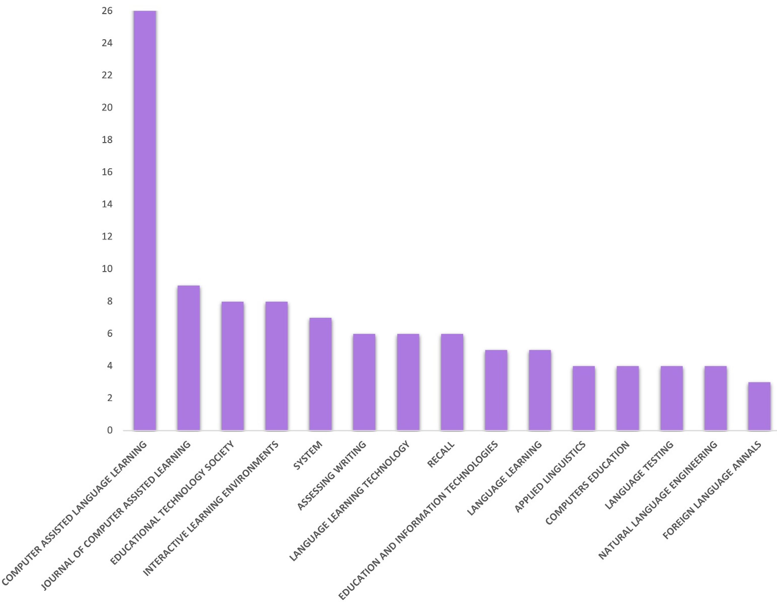
Figure A. Number of articles published in the 15 most prolific journals
Supplementary Material Figure B
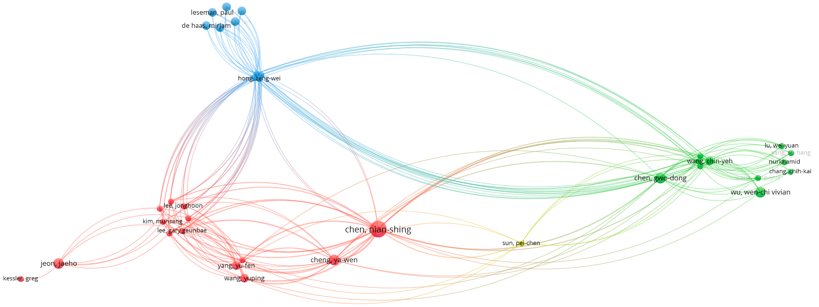
Figure B. Citation analysis of authors

Supplementary Material Figure C
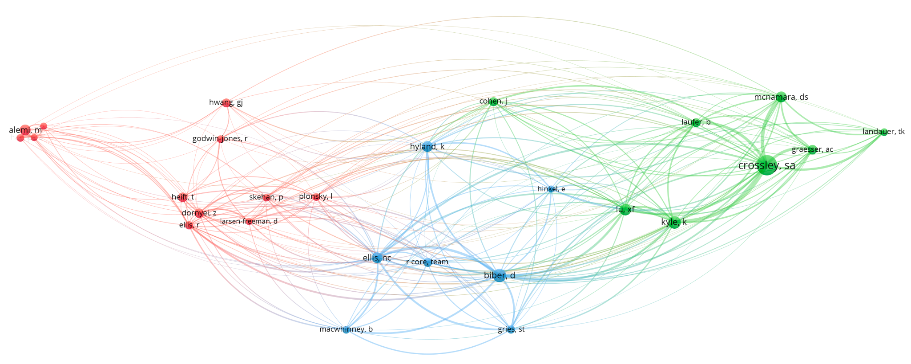
Figure C. Co-authorship

Supplementary Material Figure D
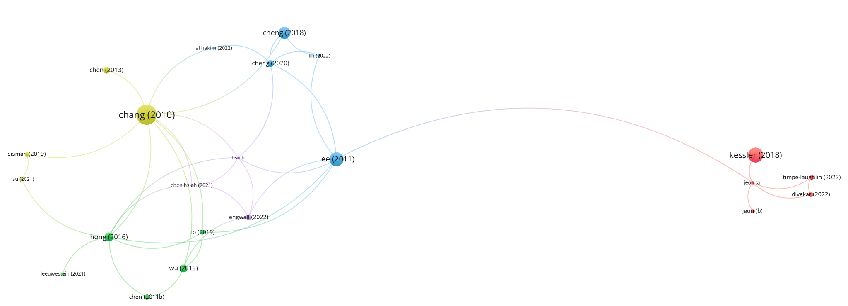
Figure D. Most frequently cited articles

Supplementary Material Figure E
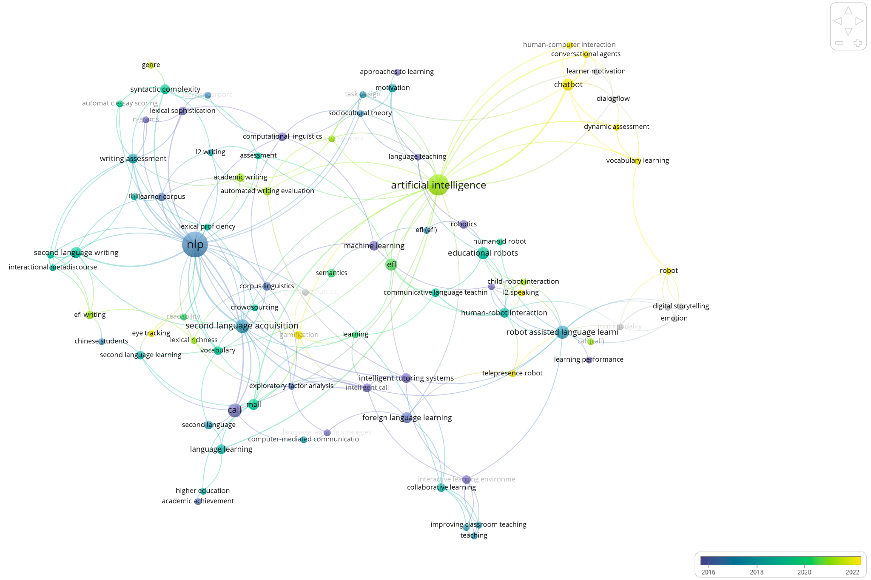
Figure E. A historical intellectual development: A co-occurrence analysis of author keywords

