Literature search
The search query for each of the 12 streams of literature is listed in Table 4. The first search term being the research area’s name as title words. For the keyword query, we used the keywords ‘government’ and ‘community OR citizens’. For both, we included synonyms and spelling variations. Reflecting the integrative approach of our review, we added keywords related to conceptualization to the search query. This is not to exclude empirical papers, but rather capture those articles that foreground conceptual insights, be they theoretical or empirical. The search queries were entered in Google Scholar using Publish or Perish, an open-access software program that retrieves and analyzes bibliometric information (Harzing, 2007).
Table 4: search queries as performed in Google Scholar through Publish or Perish.
Title words query | Keywords query | Results
"public encounter" OR "public encounters" AND perspective OR theory OR theoretical OR theories OR framework OR concept OR concepts OR conceptual OR heuristic OR review | ~government AND ~citizen OR ~community | 99
"Sustainability initiatives" AND perspective OR theory OR theoretical OR theories OR framework OR concept OR concepts OR conceptual OR heuristic OR review | ~government AND ~citizen OR ~community | 41
"grassroots initiatives" OR "grassroots innovations" AND perspective OR theory OR theoretical OR theories OR framework OR concept OR concepts OR conceptual OR heuristic OR review | ~government AND ~citizen OR ~community | 20
"citizen initiatives" OR "community-based initiatives" OR "citizen collectives" AND perspective OR theory OR theoretical OR theories OR framework OR concept OR concepts OR conceptual OR heuristic OR review | ~government AND ~citizen OR ~community | 27
"coproduction" OR "co-production" AND perspective OR theory OR theoretical OR theories OR framework OR concept OR concepts OR conceptual OR heuristic OR review | ~government AND ~citizen OR ~community | 249
"self-organization" OR "self-organisation" AND perspective OR theory OR theoretical OR theories OR framework OR concept OR concepts OR conceptual OR heuristic OR review | ~government AND ~citizen OR ~community | 76
"Collaborative governance" AND perspective OR theory OR theoretical OR theories OR framework OR concept OR concepts OR conceptual OR heuristic OR review | ~government AND ~citizen OR ~community | 187
“democratic innovation” AND perspective OR theory OR theoretical OR theories OR framework OR concept OR concepts OR conceptual OR heuristic OR review | ~government AND ~citizen OR ~community | 165
"interactive governance" AND perspective OR theory OR theoretical OR theories OR framework OR concept OR concepts OR conceptual OR heuristic OR review | ~government AND ~citizen OR ~community | 13
“experimental governance” AND perspective OR theory OR theoretical OR theories OR framework OR concept OR concepts OR conceptual OR heuristic OR review | ~government AND ~citizen OR ~community | 139
“living labs” AND perspective OR theory OR theoretical OR theories OR framework OR concept OR concepts OR conceptual OR heuristic OR review | ~government AND ~citizen OR ~community | 60
“environmental governance” AND perspective OR theory OR theoretical OR theories OR framework OR concept OR concepts OR conceptual OR heuristic OR review | ~government AND ~citizen OR ~community | 304
“commons governance” AND theory OR theoretical OR theories OR concept OR concepts OR conceptual OR heuristic OR review | ~government AND ~citizen OR ~community | 15

Selection process
The literature search produced a total of 1444 records (Figure 1). Duplicate records (57), records that were undated (64), and records without a source (254) were removed by automation. Based on a manual screening of the title, source and publisher, records that were non-English (20), book chapters (137), theses (2), grey literature (37), conference papers (69), and additional duplicate records (4) were excluded. Based on a screening of the abstract, records that did not mention communities or citizens (269), did not mention government (164), or concerned law enforcement (32) were excluded. The remaining records were sought for retrieval, with 317 records retrieved.
Figure 4: PRISMA flow diagram. Adapted from Page et al. (2021)
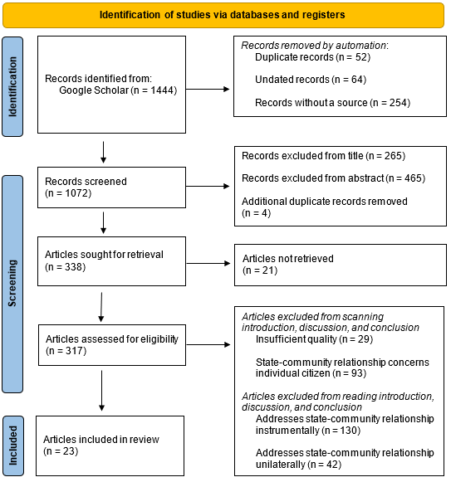
First, articles with incoherent language or minimal references were excluded (29). Second, articles focusing on interactions between the state and individual citizens (93) were removed. We classified the remained articles into instrumental (130), unilateral (42), and interactive (23) approaches (Figure 2). Instrumental analyses use state-community interactions as a vehicle to study an external phenomenon such as outcomes. Unilateral analyses do concern themselves with state-community interactions an sich, but do so from the perspective of either the state or the community. Interactive analyses place the interaction between state and community central to its analysis. This makes interactive articles particularly suitable for this research’s aim of developing a framework for a relational understanding of state-CBI encounters. Therefore, this last group of articles was selected as the final sample for in-depth analysis, while the insights from the instrumental and unilateral articles were also kept in mind for constructing our typology.
Figure 5: Types of state-community analyses identified in the literature.
