Figure S1
Actor-Partner Interdependence Model
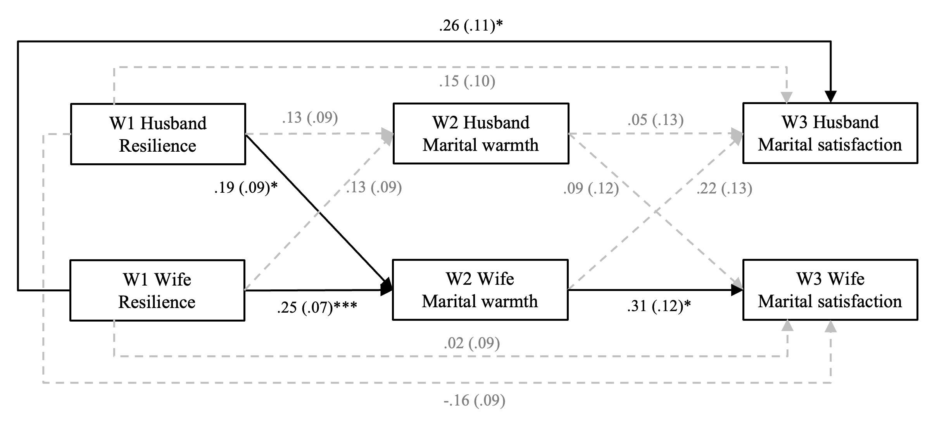
Note. * p < .05, *** p < .001. Bold paths denote significant coefficients; gray and dashed paths denote nonsignificant coefficients. W1 = Wave 1, W2 = Wave 2, W3 = Wave 3.

Figure S2
Mediation Model of Spillover Positivity After Controlling for Baseline Level with Standardized Coefficients
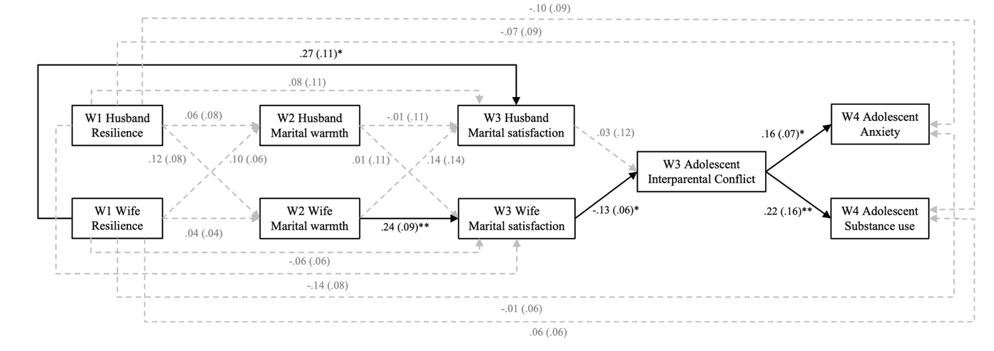
Note. * p < .05, ** p < .01, *** p < .001. Bold paths denote significant coefficients; gray and dashed paths denote nonsignificant coefficients. W1 = Wave 1, W2 = Wave 2, W3 = Wave 3, W4 = Wave 4.

Table S1
Standardized Direct, Indirect, and Total Effects for the Actor-Partner Interdependence Model
Mediational Pathway |  | Indirect |  |  | Direct |  |  | Total
 |  | Estimate | 95% CI |  | Estimate | 95% CI |  | Estimate | 95% CI
W1 H Resilience → W3 H Marital satisfaction |  | .048 | [-.006, .153] |  | .154 | [-.053, .340] |  | .203 | [-.007, .395]
 | W2 H Marital warmth | .007 | [-.020, .073]
 | W2 W Marital warmth | .042 | [-.002, .147]
W1 W Resilience → W3 W Marital satisfaction |  | .087 | [.020, .188] |  | .024 | [-.134, .171] |  | .111 | [-.046, .254]
 | W2 H Marital warmth | .012 | [-.009, .072]
 | W2 W Marital warmth | .075 | [.019, .174]
W1 H Resilience → W3 W Marital satisfaction |  | .070 | [.010, .161] |  | -.156 | [-.312, .015] |  | -.087 | [-.244, .062]
 | W2 H Marital warmth | .012 | [-.010, .070]
 | W2 W Marital warmth | .058 | [.010, .131]
W1 W Resilience → W3 H Marital satisfaction |  | .061 | [-.004, .158] |  | .262 | [.047, .476] |  | .323 | [.120, .505]
 | W2 H Marital warmth | .007 | [-.018, .070]
 | W2 W Marital warmth | .262 | [-.006, .133]
Note. Bold denotes significant indirect effects. W = Wife, H = Husband. W1 = Wave 1, W2 = Wave 2, W3 = Wave 3.

Table S2
Direct, Indirect, and Total Effects for the Mediation Model of Positivity Spillover from Husbands’ Resilience
Mediational Pathway |  | Indirect |  |  | Direct |  |  | Total
 |  | Estimate | 95% CI |  | Estimate | 95% CI |  | Estimate | 95% CI
W1 H Resilience → W4 Adolescent Anxiety |  | -.001 | [-.026, .013] |  | -.134 | [-.310, .039] |  | -.135 | [-.311, .035]
 | W3 W Mar satisfaction → W3 Interparental conflict | .006 | [.000, .021]
 | W3 H Mar satisfaction → W3 Interparental conflict | -.003 | [-.029, .004]
 | W2 W Mar warmth → W3 W Mar satisfaction → W3 Interparental conflict | -.003 | [-.010, .000]
 | W2 H Mar warmth → W3 W Mar satisfaction → W3 Interparental conflict | .000 | [-.004, .001]
 | W2 W Mar warmth → W3 H Mar satisfaction → W3 Interparental conflict | -.001 | [-.012, .001]
 | W2 H Mar warmth → W3 H Mar satisfaction → W3 Interparental conflict | .000 | [-.004, .001]
W1 H Resilience → W4 Adolescent Substance use |  | -.003 | [-.068, .032] |  | -.215 | [-.647, .201] |  | -.219 | [-.648, .209]
 | W3 W Mar satisfaction → W3 Interparental conflict | .015 | [.000, .058]
 | W3 H Mar satisfaction → W3 Interparental conflict | -.008 | [-.076, .010]
 | W2 W Mar warmth → W3 W Mar satisfaction → W3 Interparental conflict | -.007 | [-.029, .000]
 | W2 H Mar warmth → W3 W Mar satisfaction → W3 Interparental conflict | .000 | [-.010, .002]
 | W2 W Mar warmth → W3 H Mar satisfaction → W3 Interparental conflict | -.002 | [-.036, .001]
 | W2 H Mar warmth → W3 H Mar satisfaction → W3 Interparental conflict | .000 | [-.009, .002]
Note. Bold denotes significant indirect effects. W = Wife, H = Husband, Mar = Marital.
W1 = Wave 1, W2 = Wave 2, W3 = Wave 3, W4 = Wave 4.

