Investigating the interplay of loneliness and social isolation across adolescence:
Findings from a nationally representative longitudinal study

Supplementary material
Supplement A. Description of sample socioeconomic status 2
Supplement B: Loneliness and social isolation measures at age 12 and age 18 3
Supplement C: Sex and reporter differences in cross-lagged panel models (CLPM) 4
Supplement D: Sex and reporter differences in interaction effects of age 12 loneliness and
social isolation on age 18 social isolation 5
Supplement E: Sensitivity analyses using a top 25% cut off to define “lonely” or “isolated”
individuals 6
Supplement F: Sensitivity analyses using age 12 social isolation measure excluding ‘complains
of loneliness’ item for all analyses 8

Supplement A. Description of sample socioeconomic status
Families were recruited to represent the UK population with new-borns in the 1990s on the basis of residential location throughout England and Wales and mother’s age. Teenage mothers with twins were over-selected to replace high-risk families selectively lost to the register through non-response. Older mothers having twins via assisted reproduction were under-selected to avoid an excess of well-educated older mothers. The study sample represented the full range of socioeconomic conditions in the UK, as reflected in families’ distribution on a neighbourhood-level socioeconomic index: 25.6% of E-Risk families live in “wealthy achiever” neighbourhoods compared to 25.3% nationwide; 5.3% vs. 11.6% live in “urban prosperity” neighbourhoods; 29.6% vs. 26.9% live in “comfortably off” neighbourhoods; 13.4% vs. 13.9% live in “moderate means” neighbourhoods, and 26.1% vs. 20.7% live in “hard-pressed” neighbourhoods [ACORN: A Classification of Residential Neighbourhoods, CACI Ltd.]. E-Risk underrepresents “urban prosperity” households because they are likely to be childless. Figure S1 shows that E-Risk families’ addresses closely mirror the deciles of the UK’s 2015 Lower-layer Super Output Area (LSOA) Index of Multiple Deprivation (IMD) which averages 1,500 residents. Approximately 10% (dotted red line) of the E-Risk cohort fills each of the IMD’s 10 bands, indicating that the sample accurately represents the distribution of deprivation in the UK.

Figure S1. Proportion of E-Risk Study family addresses in each decile of the UK Government’s Index of Multiple Deprivation.
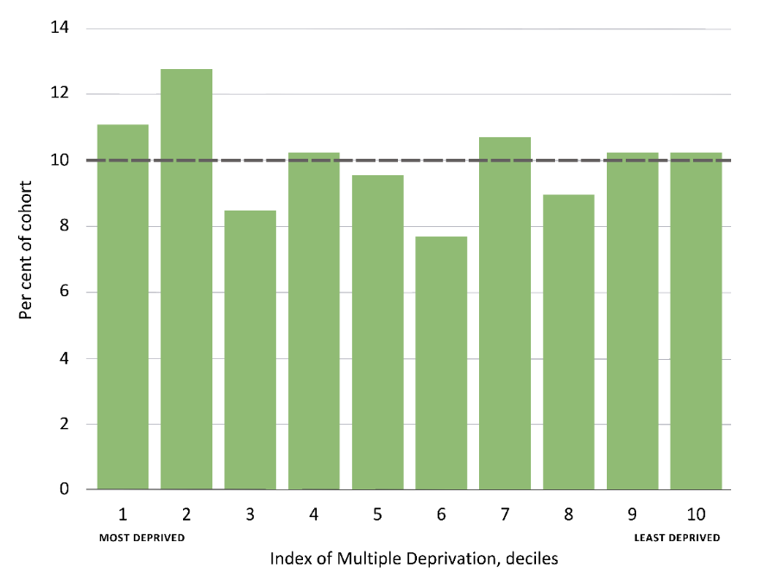
Note: The UK Ministry of Housing, Communities and Local Government Index of Multiple Deprivation is an official measure of relative deprivation for every LSOA small area (approximately 1,500 residents or 650 households in England).

Supplement B: Loneliness and social isolation measures at age 12 and age 18

Table S1. Cross-sectional associations of age 12 and 18 loneliness and social isolation measures with important correlates.
Measure | Loneliness | Female sex | Neuroticism | Anxiety | Depression
Social isolation
CBCL selected items (age 12) | 0.31*** | *-0.05* | 0.09** | 0.12*** | 0.31***
MSPSS reverse coded (age 18) | 0.43*** | *-0.10*** | 0.08** | 0.16*** | 0.22***
Loneliness | Social isolation
CDI selected items (age 12) | 0.31*** | -0.02 | 0.17*** | 0.23*** | 0.22***
UCLA Loneliness Scale (age 18) | 0.43*** | 0.03 | 0.27*** | 0.36*** | 0.41***

* p<0.05, **p<0.01, ***p<0.001

Supplement C: Sex and reporter differences in cross-lagged panel models (CLPM)

Figure S2. Cross-lag model for the longitudinal association between loneliness and social isolation at across ages 12 and 18 for male participants (A) and female participants (B).
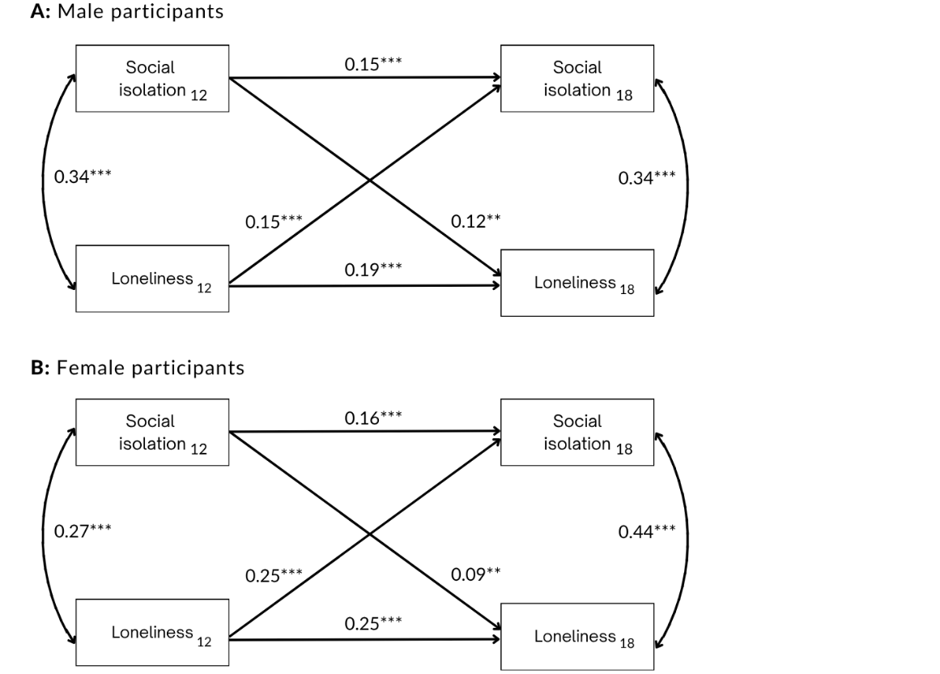
Values on single-headed arrows are standardised partial regression coefficients. Values on double-headed arrows between variables at the same time-point are correlation coefficients. In Model A, N = 952; in Model B, N = 1,051.

Figure S3. Cross-lag model for the longitudinal association between loneliness and social isolation at across ages 12 and 18 using mother reported (A) and teacher reported (B) age 12 social isolation.
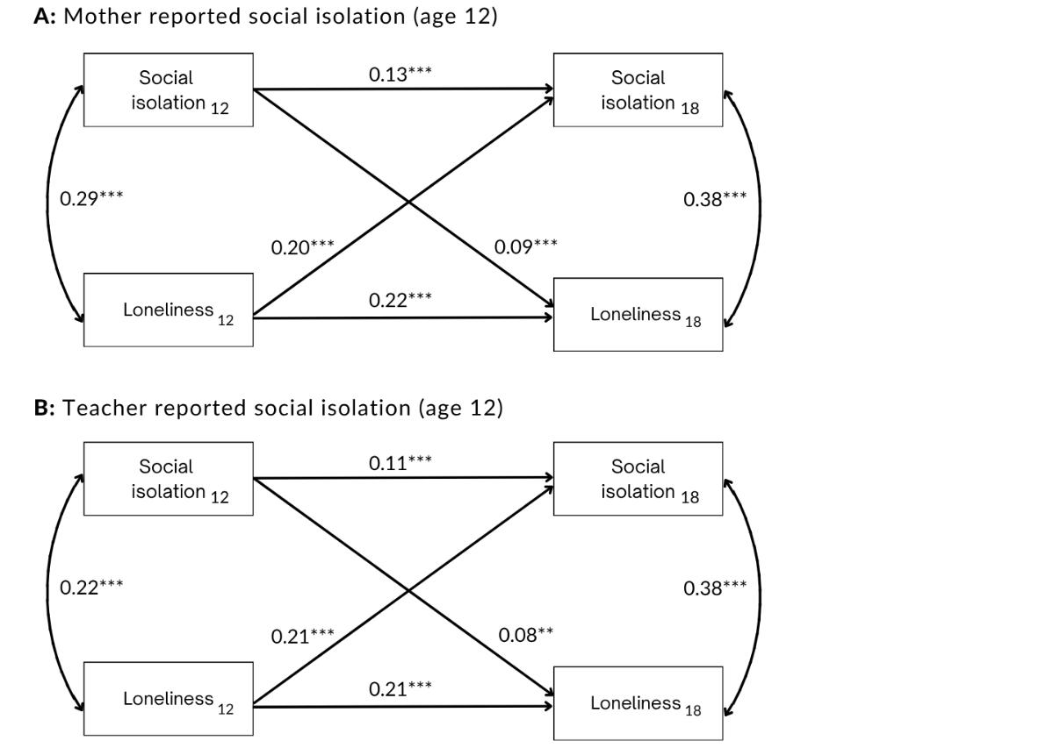
Values on single-headed arrows are standardised partial regression coefficients. Values on double-headed arrows between variables at the same time-point are correlation coefficients. In Model A, N = 1,987; in Model B, N = 1,665.

Supplement D: Sex and reporter differences in interaction effects of age 12 loneliness and social isolation on age 18 social isolation
Sex differences
The association between social isolation at age 12 and age 18 did not vary by sex. The association between loneliness at age 12 and isolation at age 18 was stronger for girls (B = 0.25, p = <0.001) than boys (B = 0.15, p = 0.001).

Reporter differences

Table S2. Associations between age 12 loneliness and social isolation and age 18 social isolation using combined and separate mother and teacher reports of age 12 social isolation.
 | Combined report |  | Mother report |  | Teacher report
 | b | p | b | p | b | p
Model 1
Loneliness | 0.99 | <0.001 | 1.03 | <0.001 | 1.03 | <0.001
Social isolation | 0.44 | <0.001 | 0.31 | <0.001 | 0.27 | <0.01
Model 2
Loneliness | 1.2 | <0.001 | 1.18 | <0.001 | 1.29 | <0.001
Social isolation | 0.57 | <0.001 | 0.39 | <0.001 | 0.42 | <0.001
Loneliness x isolation | -0.12 | 0.083 | -0.08 | 0.24 | -0.17 | 0.02

Supplement E: Sensitivity analyses using a top 25% cut off to define “lonely” or “isolated” individuals
Table S3. Proportion of participants classified as lonely or socially isolated for the creation of a cumulative measure of loneliness and social isolation at ages 12 and 18.
 | Age 12 |  |  | Age 18
 | Not isolated | Socially isolated | Total | Not isolated | Socially isolated | Total
 | N (%) | N (%) | N (%) | N (%) | N (%) | N (%)
Not lonely | 1,167 (54.8) | 309 (14.5) | 1,476 (69.3) | 1,209 (59.0) | 299 (14.6) | 1,508 (73.6)
Lonely | 405 (19.0) | 248 (11.6) | 653 (30.7) | 264 (12.9) | 276 (13.5) | 540 (26.4)
Total | 1,572 (73.8) | 557 (26.2) | 2,129 (100.0) | 1,473 (71.9) | 575 (28.1) | 2,048 (100.0)
For sensitivity analyses, at age 12, participants with a loneliness score greater than or equal to 1 were coded as lonely and participants with a social isolation score greater than 1 were coded as isolated. At age 18, participants who scored higher than 2 on loneliness were classified as lonely and participants with social isolation scores greater than 4 were classified as isolated.

Figure S4. Associations between age social isolation and loneliness at age 12 and age 18 mental health, coping and wellbeing, risky health behaviors and socioeconomic outcomes using a top 25% cut off score.
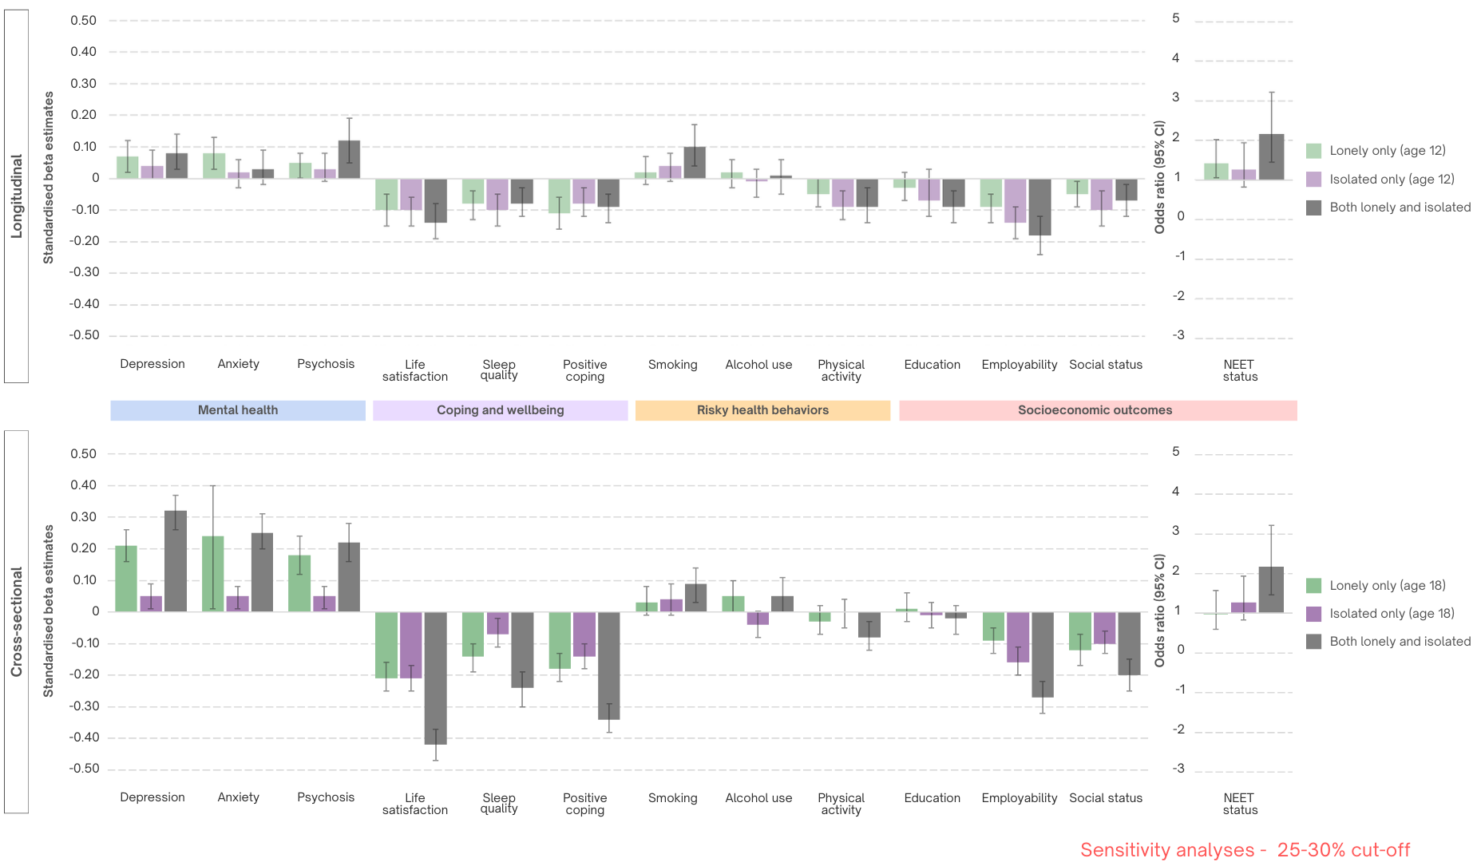
Beta estimates and 95% confidence intervals (CI) are shown for all associations aside from not in employment, education or training (NEET) status. For NEET status, odds ratios (OR) and 95% confidence intervals are shown. All models compare to the neither lonely nor isolated group. All models adjust for age-12 mental health and personality, parental socioeconomic status and sex.

Supplement F: Sensitivity analyses using age 12 social isolation measure excluding ‘complains of loneliness’ item for all analyses
Figure S5. Cross-lag model for the longitudinal association between loneliness and social isolation across ages 12 and 18.
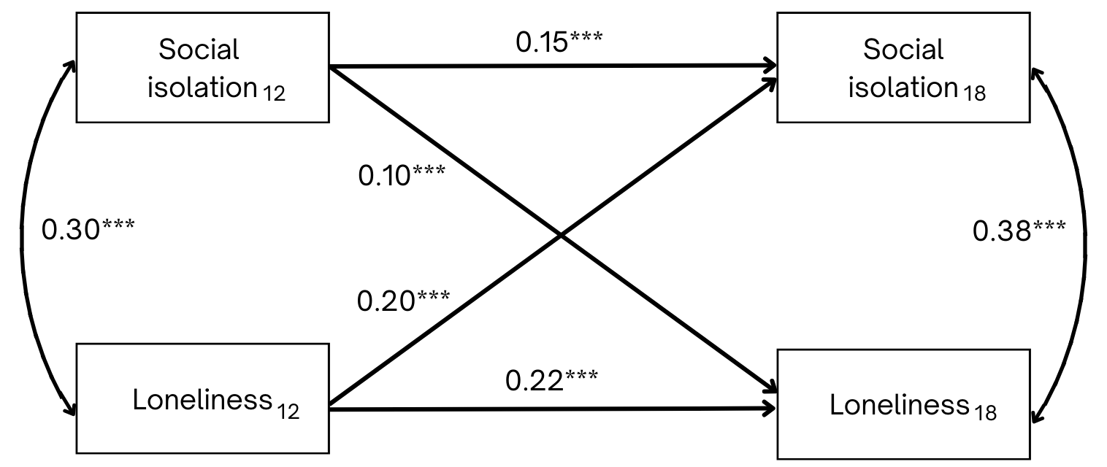
Values on single-headed arrows are standardized partial regression coefficients. Values on double-headed arrows between variables at the same time-point are correlation coefficients. Age 12 social isolation measure excluded ‘complains of loneliness’ item. N = 2,195. *** p < 0.001

Table S4. Associations between age 12 loneliness and social isolation and age 18 social isolation using combined and separate mother and teacher reports of age 12 social isolation.
 | Combined report |  |  | Mother report |  |  | Teacher report
 | b | β | p | b | β | p | b | β | p
Model 1
Loneliness | 0.99 | 0.20 | <0.001 | 1.04 | 0.21 | <0.001 | 1.04 | 0.2 | <0.001
Social isolation | 0.51 | 0.14 | <0.001 | 0.35 | 0.12 | <0.001 | 0.30 | 0.09 | <0.01
Model 2
Loneliness | 1.20 | 0.24 | <0.001 | 1.18 | 0.23 | <0.001 | 1.27 | 0.025 | <0.001
Social isolation | 0.64 | 0.18 | <0.001 | 0.44 | 0.14 | <0.001 | 0.45 | 0.14 | <0.01
Loneliness x isolation | -0.14 | -0.08 | 0.10 | -0.09 | -0.06 | 0.28 | -0.17 | -0.09 | 0.04
b indicates unstandardized regression coefficients, β indicates standardized regression coefficients. All models adjust for parental socioeconomic status and sex. Age 12 social isolation measure excluded ‘complains of loneliness’ item.

Figure S6. Associations between age-12 and age-18 social isolation according to age-12 loneliness.
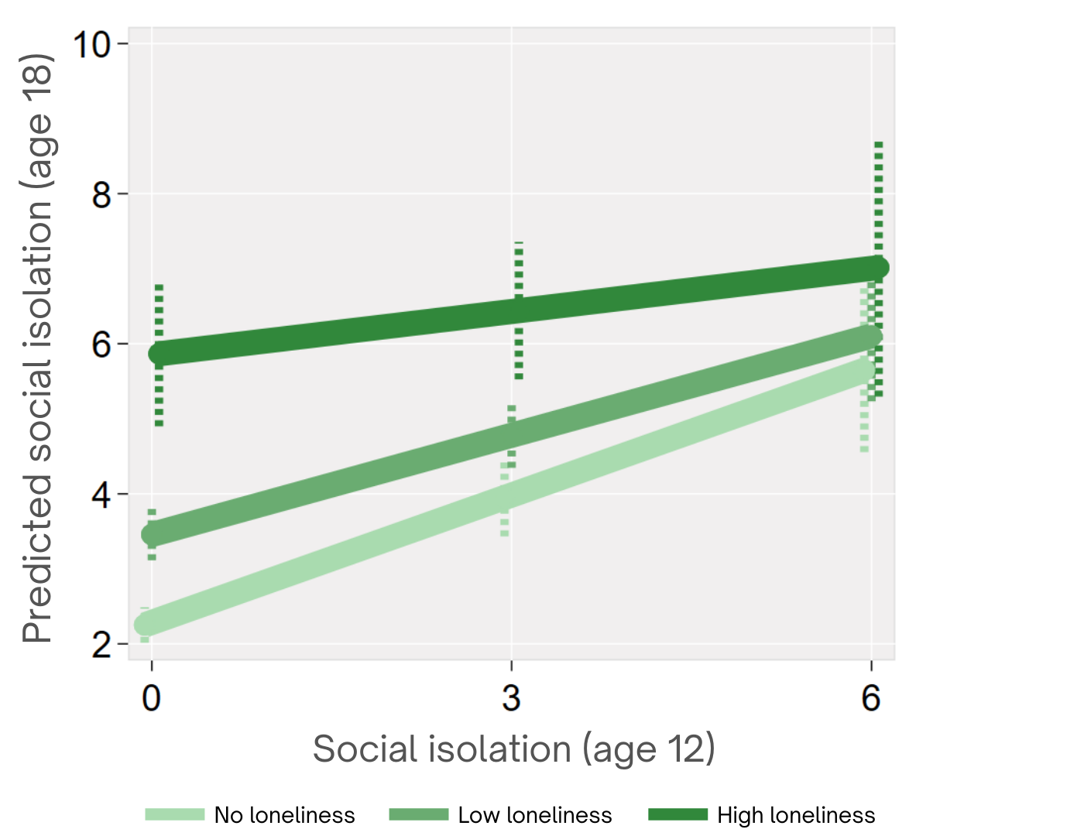
For illustrative purposes, at age 12, no loneliness reflects a score of 0, low loneliness represents a score of 1, high loneliness reflects a score of 3. Age 12 social isolation measure excluded ‘complains of loneliness’ item. Model adjusts for parental socioeconomic status and sex.

Table S5: Hierarchical regression analyses modelling the association between loneliness and social isolation and age-18 outcomes.
 | Mental health |  |  |  |  |  | Coping and wellbeing |  |  |  |  |  | Risky health behavior |  |  |  |  |  | Socioeconomic outcomes
 | Depression |  | Anxiety |  | Psychosis |  | Life satisfaction |  | Sleep quality |  | Positive coping |  | Smoking |  | Alcohol use |  | Physical activity |  | Education |  | Employability |  | Social status |  | NEET
 | β | p | β | p | β | p | β | p | β | p | β | p | β | p | β | p | β | p | β | p | β | p | β | p | OR | p
Longitudinal models: Age 12 loneliness and social isolation
1A. Loneliness model
Loneliness | 0.16 | <0.001 | 0.12 | <0.001 | 0.17 | <0.001 | -0.18 | <0.001 | -0.12 | <0.001 | -0.16 | <0.001 | 0.13 | <0.001 | 0.03 | 0.20 | -0.08 | <0.001 | -0.14 | <0.001 | -0.20 | <0.001 | -0.09 | <0.001 | 1.28 | <0.001
1B. Social isolation model
Social isolation | 0.10 | <0.001 | 0.05 | 0.04 | 0.15 | <0.001 | -0.15 | <0.001 | -0.09 | <0.001 | -0.14 | <0.001 | 0.13 | <0.001 | -0.01 | 0.58 | -0.14 | <0.001 | -0.15 | <0.001 | -0.24 | <0.001 | -0.14 | <0.001 | 1.32 | <0.001
2. Independent main effects
Loneliness | 0.14 | <0.001 | 0.11 | <0.001 | 0.14 | <0.001 | -0.15 | <0.001 | -0.10 | <0.001 | -0.13 | <0.001 | 0.10 | <0.01 | 0.04 | 0.13 | -0.04 | 0.07 | -0.10 | <0.001 | -0.15 | <0.001 | -0.06 | 0.04 | 1.14 | 0.10
Social isolation | 0.06 | 0.02 | 0.02 | 0.43 | 0.10 | <0.01 | -0.11 | <0.001 | -0.07 | <0.001 | -0.11 | <0.001 | 0.10 | 0.01 | -0.02 | 0.36 | -0.13 | <0.001 | -0.12 | <0.001 | -0.20 | <0.001 | -0.12 | <0.001 | 1.29 | <0.001
Age 12 social isolation measure excluded ‘complains of loneliness’ item. All models adjust for parental socioeconomic status and sex.

Figure S7. Independent associations between age-12 loneliness, social isolation and age-18 outcomes, adjusted for age-12 mental health and personality.
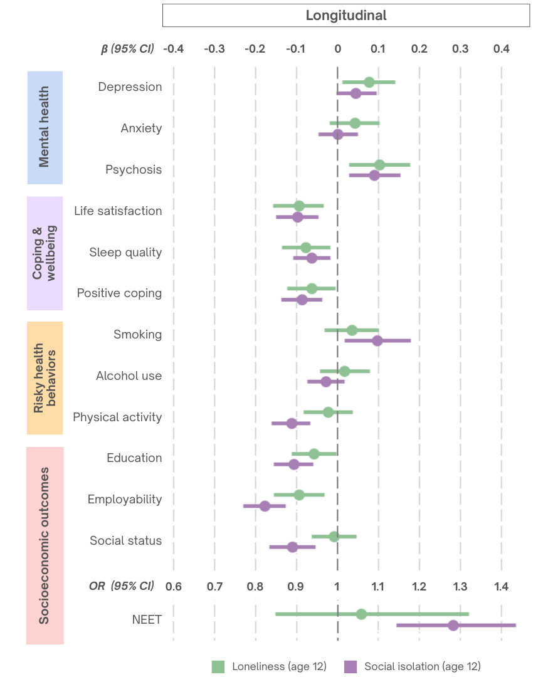
Beta estimates and 95% confidence intervals (CI) are shown for all associations aside from not in employment, education or training (NEET) status. For NEET status, odds ratios (OR) and 95% confidence intervals are shown. Age 12 social isolation measure excluded ‘complains of loneliness’ item. All models adjust for age-12 mental health, parental socioeconomic status and sex.

Figure S8. Associations between age social isolation and loneliness at age 12 and age 18 mental health, coping and wellbeing, risky health behaviors and socioeconomic outcomes.
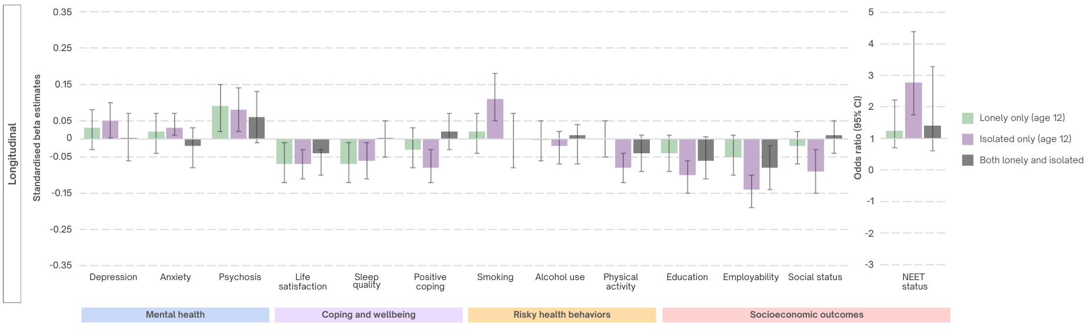
Beta estimates and 95% confidence intervals (CI) are shown for all associations aside from not in employment, education or training (NEET) status. For NEET status, odds ratios (OR) and 95% confidence intervals are shown. All models compare to the neither lonely nor isolated group. All models adjust for age-12 mental health and personality, parental socioeconomic status and sex.

Table S6. Main and interaction effects of loneliness and social isolation at age 12 on age 18 outcomes.
 |  | Longitudinal models
 |  | Loneliness (age 12) |  | Social isolation (age 12) |  | Loneliness x isolation
 |  | β | p | β | p | β | p
Mental  health | Depression | 0.09 | 0.013 | 0.06 | 0.04 | -0.04 | 0.39
Mental  health | Anxiety | 0.07 | 0.06 | 0.03 | 0.28 | -0.06 | 0.20
Mental  health | Psychosis | 0.11 | 0.02 | 0.11 | <0.01 | -0.02 | 0.77
Coping & wellbeing | Life satisfaction | -0.15 | <0.001 | -0.15 | <0.001 | 0.12 | <0.01
Coping & wellbeing | Sleep quality | -0.12 | <0.001 | -0.11 | <0.001 | 0.10 | 0.01
Coping & wellbeing | Positive coping | -0.12 | <0.001 | -0.15 | <0.001 | 0.13 | <0.01
Physical health behavior | Smoking | 0.07 | 0.07 | 0.12 | 0.01 | -0.07 | 0.13
Physical health behavior | Alcohol use | 0.02 | 0.59 | -0.02 | 0.36 | -0.01 | 0.97
Physical health behavior | Physical activity | -0.03 | 0.32 | -0.13 | <0.001 | 0.02 | 0.48
Socioeconomic  outcomes | Education | -0.08 | 0.01 | -0.13 | <0.001 | 0.05 | 0.17
Socioeconomic  outcomes | Employability | -0.13 | <0.001 | -0.22 | <0.001 | 0.09 | 0.05
Socioeconomic  outcomes | Social status | -0.04 | 0.17 | -0.14 | <0.001 | 0.07 | 0.06
Socioeconomic  outcomes |  | OR | p | OR | p | OR | p
Socioeconomic  outcomes | NEET | 1.24 | 0.08 | 1.40 | <0.001 | 0.92 | 0.02
All models adjust for sex, childhood socioeconomic status and childhood mental health. Age 12 social isolation measure excluded ‘complains of loneliness’ item.

Table S7. Associations between social isolation at age 12 and coping and wellbeing and socioeconomic outcomes at age 18 at low, medium and high loneliness
 |  | No loneliness |  |  | Low loneliness |  |  | High loneliness
 |  | b | (95% CI) | p | b | 95% CI | p | b | 95% CI | p
Coping & wellbeing | Life satisfaction | -0.09 | (-0.12, -0.05) | <0.001 | -0.06 | (-0.09, -0.02) | 0.001 | 0.02 | (-0.05, 0.08) | 0.64
Coping & wellbeing | Sleep quality | -0.28 | (-0.44, -0.13) | <0.001 | -0.15 | (-0.27, -0.03) | 0.01 | 0.11 | (-0.08, 0.30) | 0.26
Coping & wellbeing | Positive coping | -0.32 | (0.45, -0.19) | <0.001 | -0.19 | (-0.29, -0.08) | 0.001 | 0.08 | (-0.12, -0.28) | 0.43
Socioeconomic status | Employability | -0.15 | (-0.19, -0.08) | <0.001 | -0.12 | (-0.15, -0.08) | <0.001 | -0.06 | (-0.13, 0.01) | 0.06
Socioeconomic status | Subjective social status | -0.1 | (-0.15 -0.05) | <0.001 | -0.07 | (-0.11, -0.03) | <0.001 | -0.02 | (-0.08, 0.04) | 0.46
Socioeconomic status |  | OR | (95% CI) | p | OR | (95% CI) | p | OR | (95% CI) | p
Socioeconomic status | NEET status | 1.41 | (1.23, 1.61) | <0.001 | 1.28 | (1.47, 1.43) | <0.001 | 1.07 | (0.88, 1.30) | 0.50
No loneliness is indicated by a score of 0, low loneliness is indicated by a score of 1 and high loneliness by a score of 3 at age 12. Age 12 social isolation measure excluded ‘complains of loneliness’ item.

Figure S9. Associations between social isolation and coping, wellbeing and socioeconomic outcomes according to loneliness severity.
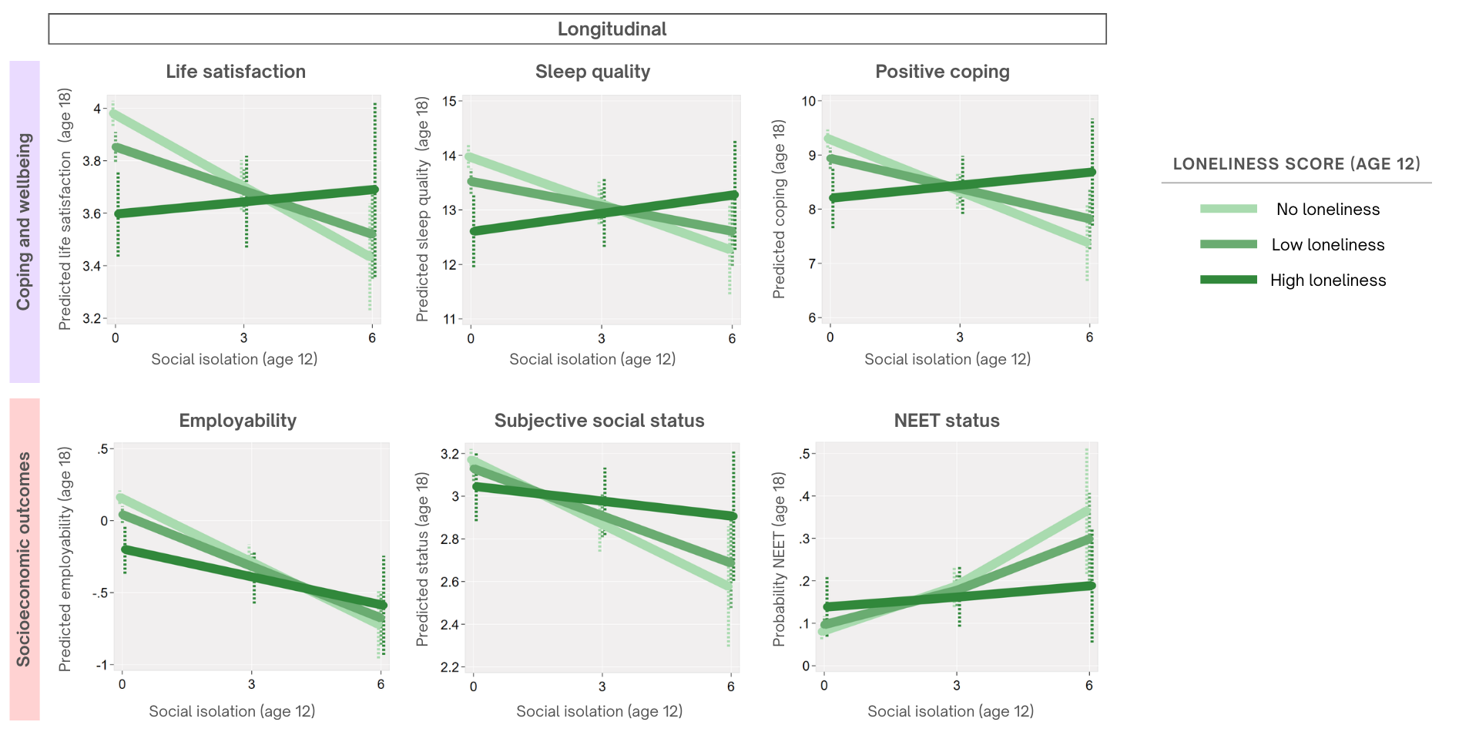
No loneliness indicated by a score of 0 at age 12, low loneliness indicated by a score of 1 and high loneliness by a score of 3 at age 12. NEET indicates not in education, employment or training. Age 12 social isolation measure excluded ‘complains of loneliness’ item. All models adjust for age-12 mental health and personality, parental socioeconomic status and sex.

