Supplementary Material
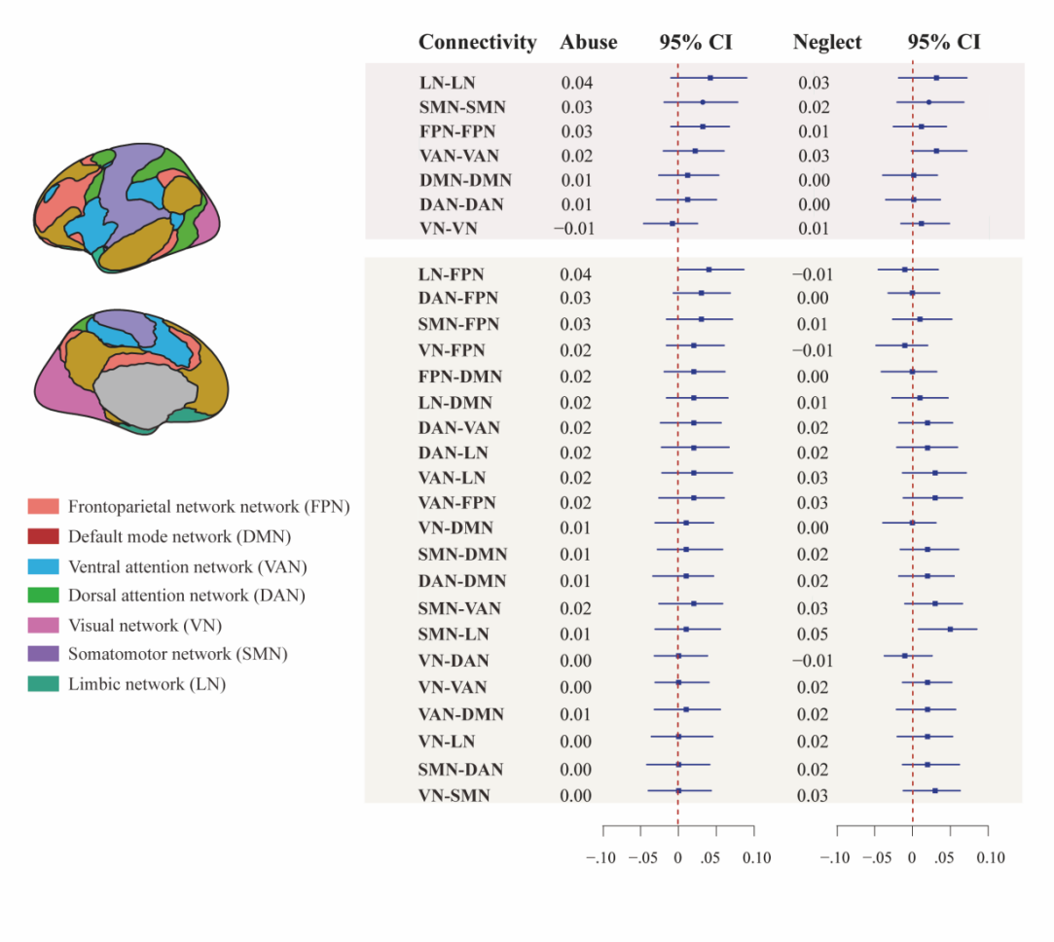
Figure S1. The association between abuse/neglect experience and brain network connectivity. After correction for multiple comparisons, no significant associations were observed between abuse experience and specific network connectivity (left panel), nor between neglect experience and network connectivity (right panel), controlling for age, gender, subjective SES, the other dimension of experience (e.g., neglect or abuse). FPN, frontoparietal network; DMN, default mode network; VAN, ventral attention network; DAN, dorsal attention network; VN, visual network; SMN, somatomotor network; LN, limbic network.

AVA analysis
Cross-sectional mediation analyses lack temporal difference, which warrants caution when interpreting causal directionality. To avoid assumptions of causal directionality, we conducted additional exploratory analyses using the associational variable analysis (AVA) framework, which provides an alternative approach for interpreting associations in nonexperimental cross-sectional data (Weems, 2025). Because the present study included a moderation component (i.e., the interaction between psychological resilience and childhood threat), the AVA framework was applied in an exploratory manner. Specifically, the interaction term (psychological resilience × childhood threat) was treated as the independent variable, resting-state SMN-LN connectivity as the associational variable (AV), and mental health outcomes (i.e., depressive and somatic symptoms) as dependent variables. The R² effect sizes were interpreted using conventional thresholds for small (0.0225), medium (0.059), and large (0.138) effects.
Following the AVA framework, the analysis was conducted in three steps (see Table S1 for depressive symptoms and Table S2 for somatic symptoms). Step 1: Pearson correlations indicated that SMN-LN connectivity was significantly associated with both the psychological resilience × childhood threat interaction and depression, with R² ranging from medium to large. This indicated that the resting-state connectivity was meaningfully associated with the psychological resilience × childhood threat interaction and depression. Step 2: Regression analyses examined whether SMN-LN connectivity explains the association between the resilience × threat interaction and depression. Results showed that, although SMN-LN connectivity remained significantly associated with depression, the variance it explained decreased by 2% after controlling for the interaction term. SMN-LN accounted for medium amounts of variance in depression, with semi-partial R² values of 0.06. Step 3: A moderated mediation analysis (SPSS Model 8) tested whether the indirect path from the resilience × threat interaction to depression via SMN-LN connectivity was significant. We used Model 8 rather than Model 4 (as in Weems, 2025) because our analysis involves moderation, in which the indirect effect may vary as a function of psychological resilience. Results showed a significant indirect effect at low levels of psychological resilience (coefficient = 0.08, SE = 0.05, 95% CI [0.01, 0.21]). Together, the AVA results indicated that SMN-LN explained a significant portion of the variance in the relationship between the resilience × threat interaction and depressive symptoms. A similar pattern of results was observed for somatic symptoms (see Table S2). In summary, these results indicated that when psychological resilience was low, SMN-LN served as an associational variable in the relationship between childhood threat and depression as well as somatization.

TABLE S1. Associational variable analysis for Depression.
 | SMN-LN | Depression | Interaction between Threat and Psychological resilience | Mean | SD
SMN-LN |  | R ² = 0.08 | R ² = 0.11 | 0.29 | 0.18
Depression | 0.29** |  | R ² = 0.001 | 0.59 | 0.49
Interaction between Threat and Psychological resilience | -0.33** | -0.04 |  | 4.80 | 2.10

Dependent: Depression |  | Unstandardized coefficients
Dependent: Depression |  | B | Std. error |  | t |  | Semi-partial | Semi-partial squared | VIF
Intercept |  | -0.18 | 0.19 |  | -0.90
Interaction between Threat and Psychological resilience |  | -0.04 | 0.09 |  | -0.44 |  | -0.05 | 0.002 | 1.29
SMN-LN |  | 1.14 | 0.52 |  | 2.22* |  | 0.24 | 0.06 | 1.33

 |  | Indirect effects
Psychological resilience |  | Effect | BootSE | BootLLCI | BootLLCI
Low (M-1SD) | Threat → SMN-LN → Depression | 0.08 | 0.05 | 0.01 | 0.21
Mean | Threat → SMN-LN → Depression | 0.01 | 0.03 | -0.03 | 0.09
High (M+1SD) | Threat → SMN-LN → Depression | -0.06 | 0.05 | -0.18 | 0.02
Note. *p < .05, **p < .01.

TABLE S2. Associational variable analysis for Somatization.
 | SMN-LN | Somatization | Interaction between Threat and Psychological resilience | Mean | SD
SMN-LN |  | R ² = 0.08 | R ² = 0.11 | 0.29 | 0.18
Somatization | 0.29** |  | R ² = 0.01 | 0.72 | 0.63
Interaction between Threat and Psychological resilience | -0.33** | -0.08 |  | 4.80 | 2.10

Dependent: Somatization |  | Unstandardized coefficients
Dependent: Somatization |  | B | Std. error |  | t |  | Semi-partial | Semi-partial squared | VIF
Intercept |  | -0.20 | 0.23 |  | -0.87
Interaction between Threat and Psychological resilience |  | -0.09 | 0.11 |  | -0.82 |  | -0.09 | 0.01 | 1.32
SMN-LN |  | 1.55 | 0.61 |  | 2.56* |  | 0.27 | 0.08 | 1.34

 |  | Indirect effects
Psychological resilience |  | Effect | BootSE | BootLLCI | BootLLCI
Low (M-1SD) | Threat → SMN-LN → Somatization | .12 | .07 | .02 | .29
Mean | Threat → SMN-LN → Somatization | .02 | .04 | -.04 | .12
High (M+1SD) | Threat → SMN-LN → Somatization | -.08 | .07 | -.24 | .03
Note. *p < .05, **p < .01.

