Loneliness and Depressive Symptoms in Adolescents: A Multi-Timescale Examination

Tak Tsun Lo, J. Loes Pouwels, Jacqueline M. Vink, Nina van den Broek, Hend Eltanamly, Dominique F. Maciejewski, and Maaike Verhagen

Supplemental Material 1: Equivalence Testing Between the Two Subsamples And The Rest of The Sample ……………………………………………………………………………………2

Supplemental Material 2: Suitability of Analyzing Trait Loneliness and Depressive Symptoms Across Waves ..……………………………………………………………………5

Supplemental Material 3: Full Model Specifications………….………………………………8

Supplemental Material 4: Full Model Results and Inspections of the Stability of Parameter Estimates …………………………………………………...………………………………..19

Supplemental Material 5: Sensitivity Analysis for Hypothesis 2 .…………………………..31

References...…….……………………………………………………………………………34

Supplementary Material 1: Equivalence Testing
1.1 Equivalence Between Adolescents Who Dropped-Out Before Wave 6 and Those Who Remained
In our study, there were more drop-outs since the COVID-19 pandemic. Specifically, the number of participating adolescents dropped from 667 in Wave 1 to 129 in Wave 6. To assess whether these subsamples were reasonably representative of the full sample in terms of their levels of loneliness and depressive symptoms, we conducted equivalence tests comparing Wave 1 scores of loneliness and depressive symptoms between adolescents who dropped-out before Wave 6 and those who remained. Two one-sided t-tests were used with an equivalence bound determined following Simonsohn (2015)’s “small telescope” approach, which was the smallest effect size that the sample had 33% power to detect.
Among the adolescents who dropped out, n = 565 had Wave 1 measurements of loneliness, and n = 558 had completed Wave 1 measurements of depressive symptoms. For the rest of the sample, n = 94 had completed these Wave 1 measurements. Using G*power (Faul et al., 2009), by specifying 33% power and a 0.05 significance level, we obtained that an appropriate equivalence bound is d = ±0.16 for the equivalence test between drop-out sample versus the non-drop-out sample.
Descriptive statistics on Wave 1 levels of loneliness and depressive symptoms in these samples are shown in Table S1. Results from two one-sided t-tests indicated that, within the specified equivalence bounds, the drop-out and non-drop-out samples were statistically equivalent on Wave 1 loneliness and depressive symptoms: Loneliness and depressive symptoms were equivalent with t(115.4) = 1.73, p = .043, and t(118.9) = –2.99, p = .002, respectively.

Table S1
Descriptive Statistics of Subsamples that Underwent Equivalence Tests
 |  | Drop-out  Throughout  Six Waves |  | H1a subsample that participated  the ESM study |  | H2 subsample that participated  Wave 5, ESM, or Wave 6
Wave 1 Measurements |  | Drop-out | Non  Drop-Out | H1a subsample | The rest of the sample | H2 subsample | The rest of the sample
Loneliness | n | 565 | 94 | 71 | 588 | 140 | 519
Loneliness | M (SD) | 0.37 (0.44) | 0.43 (0.53) | 0.40 (0.50) | 0.38 (0.45) | 0.37 (0.48) | 0.39 (0.45)
Depressive Symptoms | n | 558 | 94 | 71 | 581 | 140 | 512
Depressive Symptoms | M (SD) | 0.48 (0.39) | 0.50 (0.44) | 0.46 (0.42) | 0.49 (0.39) | 0.48 (0.41) | 0.49 (0.39)

1.2 The Representativeness of Subsamples in Analyzing Hypothesis 1a (N = 84) and Hypothesis 2 (N=181)
The experience sampling method (ESM) study design required us to recruit adolescents and parents as dyads. This, together with participant drop-outs throughout the six waves of longitudinal study, resulted in relatively small subsamples out of the full sample (N = 774). Specifically, Hypothesis 1a (H1a, hourly feedback loop between loneliness and depressive symptoms) included n = 84 adolescents who participated in the ESM study; Hypothesis 2 (H2, across-time-scale influence) included n = 181 adolescents who provided data at Wave 5, the ESM study, or Wave 6.
To assess whether these subsamples were reasonably representative of the full sample in terms of their levels of loneliness and depressive symptoms, we conducted equivalence tests comparing Wave 1 scores of loneliness and depressive symptoms between each subsample and the remainder of the sample. Two one-sided t-tests were used with equivalence bounds determined following Simonsohn (2015)’s recommendation, which was the smallest effect size that the sample had 33% power to detect.
Among the H1a subsample (n = 84), n = 71 had completed Wave 1 measurements of loneliness and depressive symptoms. For the rest of the sample, n = 588 had provided Wave 1 loneliness, and n = 581 had provided Wave 1 depressive symptoms. Using G*power, by specifying 33% power and a 0.05 significance level, we obtained that an appropriate equivalence bound is d = ±0.19 for the equivalence test between H1a subsample versus the rest the sample.
Among the H1b subsample (N = 181), n = 140 had completed Wave 1 measurements of loneliness and depressive symptoms. For the rest of the sample, n = 519 had provided Wave 1 loneliness, and n = 512 had provided Wave 1 depressive symptoms. Using G*power, by specifying 33% power and a 0.05 significance level, we obtained that an appropriate equivalence bound is d = ±0.14 for the equivalence test between the H2 subsample versus the rest the sample.
Descriptive statistics on Wave 1 levels of loneliness and depressive symptoms in these subsamples are shown in Table S1. Results from two one-sided t-tests indicated that, within the specified equivalence bounds, both the H1a and H2 subsamples were statistically equivalent to the remainder of the sample on Wave 1 loneliness and depressive symptoms. For the H1a subsample, loneliness and depressive symptoms were equivalent with t(84.33) = 2.71, p = .004, and t(85.48) = –2.98, p = .002, respectively. For the H2 subsample, equivalence was also supported with t(209.7) = –2.83, p = .003 for loneliness, and t(214.8) = –3.38, p < .001 for depressive symptoms.
These findings suggested that the subsamples used to test Hypotheses 1a and 2 did not differ meaningfully from the rest of the sample in their initial levels of loneliness and depressive symptoms.
Supplementary Material 2:
Suitability of Analyzing Trait Loneliness and Depressive Symptoms Across Waves
To ensure the suitability of analyzing trait loneliness and depressive symptoms across five waves (Waves 1, 3, 4, 5, and 6), we conducted two sets of analyses: (1) multilevel confirmatory factor analysis (MCFA) to assess factor structure stability between and within adolescents, as pre-registered, and (2) a longitudinal invariance test encompassing all waves, to assess if factor structures at different waves are comparable.
2.1. Multilevel Confirmatory Factor Analysis
Consistent with procedures commonly used in experience sampling research (e.g., Eisele et al., 2021), we conducted MCFA separately for loneliness and depressive symptoms items, clustering data within individuals. This approach assessed the factor structure at both the within-adolescent and between-adolescent levels. Each set of items (e.g., 10 CES-D items for depressive symptoms, 12 LEKA items for loneliness) loaded onto a single respective latent factor.
Model fit was evaluated using conventional cut-off criteria: RMSEA < .08, CFI > .95, and TLI > .90 (Bentler & Bonett, 1980; Schermelleh-Engel et al., 2003). As the within-adolescent model for loneliness initially failed to meet the TLI threshold, we checked the modification indices to identify overlapping items. We then allowed residuals of overlapping items to correlate (items 9 and 10, and items 11 and 12), improving model fit. Final fit indices (see Table S2.1) were satisfactory, supporting the unidimensionality of both scales. Thus, using mean scores of the respective scales for main analyses was considered appropriate, as pre-registered.
Table S2.1
Multilevel Confirmatory Factor Analysis of Loneliness and Depressive Symptoms
 | Standardized factor loading
Variable | Min | Max | Median | χ2 | RMSEA | CFI | TLI
Loneliness
Within-adolescent model* | 0.46 | 0.67 | 0.61 | 404.99 | 0.06 | 0.97 | 0.91
Between-adolescent model | 0.72 | 0.98 | 0.92 | 151.97 | 0.03 | 0.99 | 0.98
Depressive symptoms
Within-adolescent model | 0.20 | 0.69 | 0.50 | 220.78 | 0.05 | 0.96 | 0.91
Between-adolescent model | 0.52 | 1.00 | 0.81 | 113.19 | 0.03 | 0.98 | 0.96
Note. *We included correlations between residual variances of two pairs of overlapping loneliness items: item 9 (“I feel abandoned by my friends”) and 10 (“I feel pushed aside by my friends”), and item 11 (“I’m sad because no one wants to join me”) and 12 (“I’m sad because I don’t have any friends”).

2.2. Longitudinal Invariance Between the First and Last Measurement
We conducted longitudinal invariance testing to check whether the factor structures of LEKA (loneliness) and CES-D (depressive symptoms) were held across waves. For loneliness, we ran the test twice: one including all 12 items, and another excluding item 7 (“I feel alone at school”), which was omitted for two participants at Wave 6 who were no longer in school. For depressive symptoms, we ran just one test, because the same items were used across all participants across waves. We applied conventional change thresholds (Δ) in fit indices: ΔRMSEA < .015, ΔCFI > -.01, and ΔSRMR < .015 (Chen, 2007).
Results are reported in Table S2.2. Changes in all fit indices supported metric invariance (equal factor loadings) and scalar invariance (equal factor loadings and intercepts). This indicated that we could compare the mean score of the two scales of loneliness and depressive symptoms across time.

Table S2.2
Change of Fit Indices in Increasingly Constrained Models that Implied Increasing Degrees of Measurement Invariance
Change (Δ) of Fit Indices | Metric Invariance | Scalar Invariance | Strict Invariance
Loneliness (all items)
ΔRMSEA | 0.000 | 0.000 | 0.003
ΔSRMR | 0.002 | 0.000 | 0.005
ΔCFI | -0.005 | -0.01 | -0.037
Loneliness (item 7 excluded)
ΔRMSEA | 0.000 | 0.000 | 0.003
ΔSRMR | 0.003 | 0.001 | 0.006
ΔCFI | -0.006 | -0.009 | -0.036
Depressive Symptoms
ΔRMSEA | 0.000 | 0.000 | 0.003
ΔSRMR | 0.004 | 0.002 | 0.004
ΔCFI | -0.006 | -0.007 | -0.033
Note. In evaluating a model, higher values of CFI are better, whereas lower values of RMSEA and SRMR are better. Fit indices changes in line of conventional thresholds of ΔRMSEA < .015, ΔCFI > -.01, and ΔSRMR < .015 (Chen, 2007) are denoted in bold.

Supplemental Material 3: Full Model Specifications
In our preregistration, we have stated the steps in determining: (1) whether there are substantial time trends in outcome variables, which affected our choice of analyzing the data with either dynamic structural equation modeling (DSEM) or residual dynamic structural equation modeling (RDSEM), and (2) how to proceed when models did not converge with the default option of unconstrained covariance structure where all random effects covariate in pairs. For clarity, we first present our full model specifications (Section 3.1), before we show the steps we have taken to arrive at our final model specifications with regards to the two issues of time trend (Section 3.2.1) and model convergence (Section 3.2.2).
3.1. Final Model Specifications
In Figure S3.1.1a (Model 1a: hourly relations), S3.1.1b (Model 1b: half-yearly relations), and S3.1.2 (Model 2: across-timescale effects), we graphically illustrate the final model specifications in the Mplus analysis scripts we have used.

Figure S3.1.1a
Full Specifications of Model 1a (Hourly Relations Controlled for the time trend throughout the ESM study).
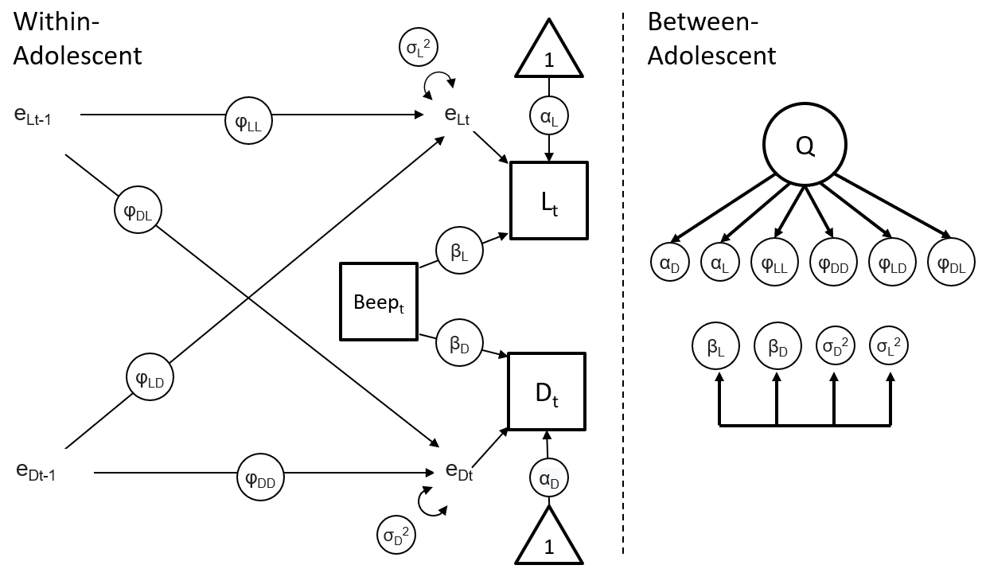
Note. D: Depressive Symptoms; L: Loneliness; e: Residual; α, β, φ: person-specific estimates of within-person paths (i.e., random intercepts and random slopes); σ: person-specific estimates of residual variances; Q: common factor of person-specific estimates (random effects); Beep: The number of the current ESM observation (1, 2, …70); t: current observation; t-1: previous observation; Subscripts LL, LD, DL, DD that followed φ: combinations of temporal relations within and between loneliness and depressive symptoms. Unidirectional arrows in the between-adolescent side: factor analytic covariance structure. Bidirectional and overlapping arrows in the between-adolescent side: pairs of covariance.

Figure S3.1.1b
Full Specifications of Model 1b (Half-Yearly Relations Controlling for the Time Trend Throughout the Longitudinal Study and the COVID-19 Related Time Trend.
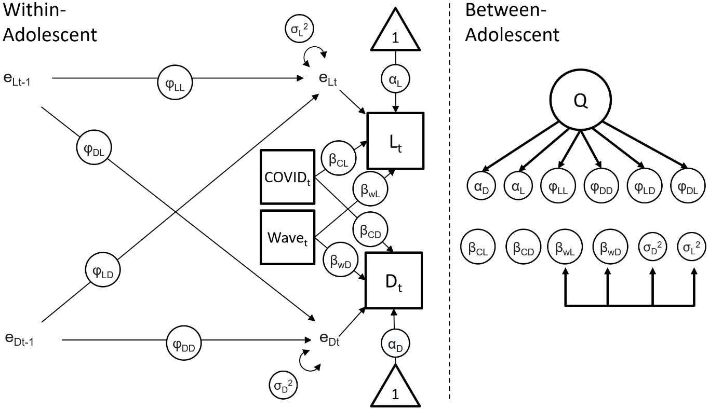
Note. D: Depressive Symptoms; L: Loneliness; e: Residual; α, β, φ: person-specific estimates of within-person paths (i.e., random intercepts and random slopes); σ: person-specific estimates of residual variances; Q: common factor of person-specific estimates (random effects); t: current observation; t-1: previous observation; Subscripts LL, LD, DL, DD that followed φ: combinations of temporal relations between loneliness and depressive symptoms. Subscripts wL, wD, CL, CD that followed β: wave-specific (w) or COVID-specific (C) time trends to loneliness (L) or depressive symptoms (D); Unidirectional arrows in the between-adolescent side: factor analytic covariance structure. Bidirectional and overlapping arrows in the between-adolescent side: pairs of covariance.

Figure S3.1.2
Full Specifications of Model 2 (Across-Timescale Effects).
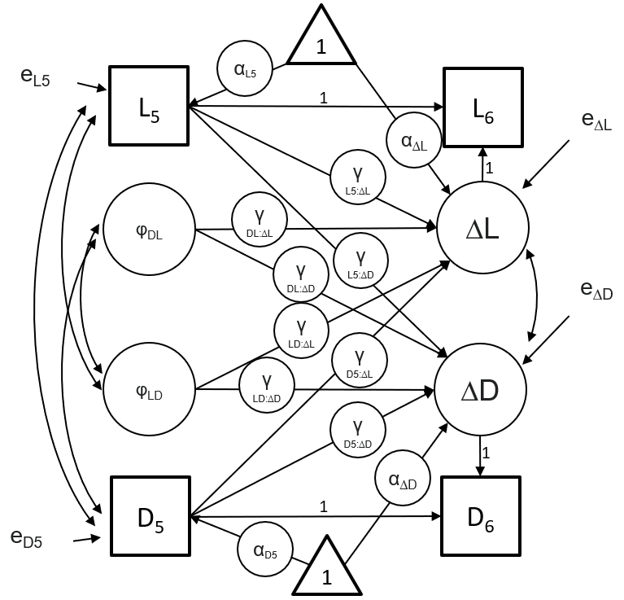
Note. D: Depressive Symptoms; L: Loneliness; ∆D: Latent change in Depressive Symptoms; ∆L Latent change in Loneliness; e: Residual; α: mean/intercept; φ: person-specific estimates of within-person temporal relations extracted from Model 1a; γ: path estimate (“:” denotes an effect, e.g., γ_{D5:∆D} denotes the path estimate of the effect from D₅ to ∆D); Subscript 5, 6: Measured at Wave 5 or Wave 6.

3.2. Specifications of Model 1a and 1b
3.2.1. Within-Adolescent Level Specifications of Model 1a and 1b in View of Time Trends
To test the hourly and half-yearly feedback loops (H1a and H1b), we used experience sampling method (ESM) data, up to 70 beeps per adolescent, and panel data, spanning up to 5 waves of measurement per participant. Loneliness and depressive symptoms, our key variables, may systematically change over time with increasing beeps or waves. To assess whether within-person variance in these variables was attributable to time trends, we estimated models with only the intercept and time variables (beeps or waves) as predictors (e.g., beep number 1 to 70 in predicting momentary loneliness). We ran four such models, one for each measure of trait and state loneliness and depressive symptoms, allowing for random intercepts and random slopes of time. This approach captured both baseline levels of loneliness/depressive symptoms and individual differences in time trends of loneliness and depressive symptoms.
Using the r2mlm R package (Shaw et al., 2022), we calculated the proportion of within-person variance explained by time trends. Time trends accounted for substantial proportions of within-adolescent variance in loneliness (5% in half-yearly data and 9% in hourly data) and depressive symptoms (14% in half-yearly data and 13% in hourly data). These proportions exceeded the 5% pre-registered threshold. Accordingly, we used residual dynamic structural equation modeling (RDSEM) instead of DSEM to account for these time trends.
In RDSEM, time trend variables were included so that residuals represented deviations from modelled trends in loneliness and depressive symptoms. To visualize these trends, we plotted time series for loneliness and depressive symptoms in hourly and half-yearly time scales (Figures S3.2.1 and S3.2.2). Most trends were approximately linear, except trait loneliness, which appeared stable or declining initially but began to rise from Wave 4 onward.
For Model 1a (hourly relations; ESM data), we conducted RDSEM using ESM beep as the time trend variable. In Model 1b (half-yearly relations, panel data), Wave 4, the time point which trait loneliness began to rise, coincided with the COVID-19 pandemic. Prior studies have documented the impact of the COVID-19 pandemic on adolescent social and mental health (van den Boom et al., 2023). To account for this, we applied a piecewise growth modeling approach (Pouwels et al., 2021) with two time variables: WaveR_{t}, indexing time since study started, and COVID_{t}, indexing time since the pandemic began. Using WaveR_{t} and COVID_{t}, we could model the time trends of loneliness and depressive symptoms as a function of time elapsed since the study has started (WaveR_{t}) and since the COVID-19 pandemic has come in place (COVID_{t}).
For WaveR_{t}, we coded t = -4 at Wave 1 (fall 2017), then increment it every half a year so that t = 0 right before the COVID-19 pandemic (fall 2019) and t = 4 at Wave 6 (fall 2021). To represent the full nine half-yearly points from fall 2017 to fall 2021, we inserted empty rows with missing values for intermediate points so that WaveR_{t} was indexed as (-4, -3, -2, -1, 0, 1, 2, 3, 4). For COVID_{t}, we coded 0 for all pre-pandemic observations (up to fall 2019) and 1–4 for post-pandemic half-years, so that it was indexed as (0, 0, 0, 0, 0, 1, 2, 3, 4). COVID_{t} = 1 at the measurement at spring 2021, when COVID-19 restrictions first came in place. This way of coding ensured that the COVID-19 time variable had no influence on loneliness and depressive symptoms before the COVID-19 pandemic happened.
In RDSEM, loneliness and depressive symptoms were regressed on both WaveR_{t} and COVID_{t}. The intercepts of loneliness and depressive symptoms (t = 0 for both time trend variables) reflected mean levels right before the COVID-19 pandemic. The slopes of WaveR_{t} (β_{wL}, β_{wD}, Figure S3.1.b) captured normative half-yearly change, and the slopes of COVID_{t} (β_{CL}, β_{CD}) represented COVID-specific changes above and beyond those trends. Both slopes were modeled as random effects, allowing for individual differences in the slopes between adolescents.
Figure S3.2.1
Time Trend of Loneliness and Depressive Symptoms in the ESM Study
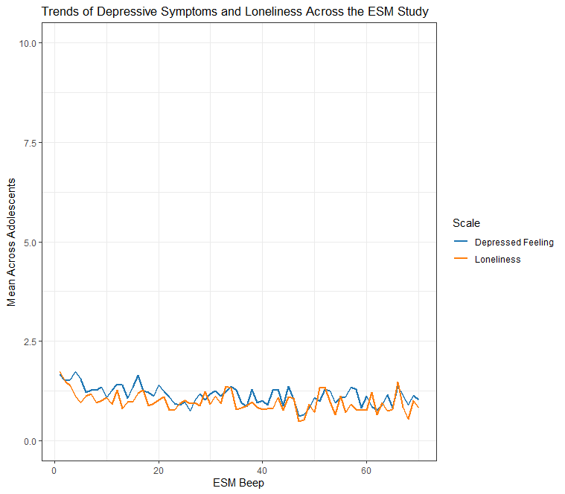

Figure S3.2.2
Time Trend of Loneliness and Depressive Symptoms in the Longitudinal Study
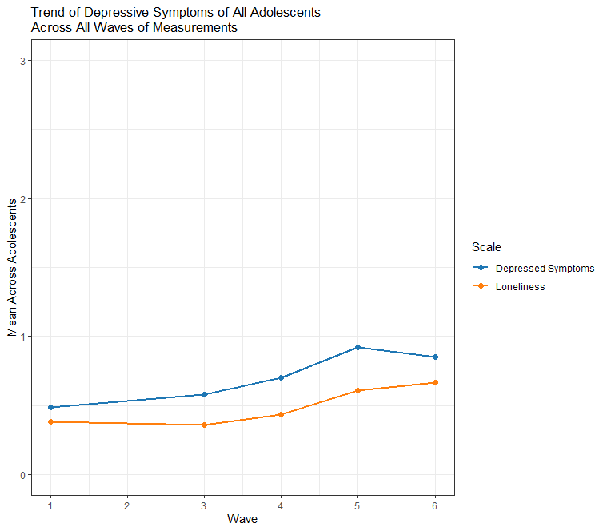
Note. Data from Wave 4 to 6 were collected during the COVID-19 pandemic.

We adapted the pre-registered bivariate multilevel vector autoregressive model (p. 626, McNeish & Hamaker, 2020) using RDSEM specifications (p. 629, McNeish & Hamaker, 2020). The within-adolescent structures for Model 1a and Model 1b are shown in Figures S3.1.1a and S3.1.1b. Model 1a included the ESM beep number as the sole time trend predictor; Model 1b included both the wave number and the COVID-19-time variable.

3.2.2. Between-Adolescent Level Specifications of Model 1a and 1b That Enabled Stable Model Convergence
Our pre-registration specified that person-specific parameters (i.e., random effects) should be freely estimated with all possible covariances (e.g., between the random intercepts of loneliness and depressive symptoms). However, this full covariance structure led to non-convergence in both Model 1a and 1b. To address this, we followed two pre-registered principles for simplifying the covariance structure: (1) applying a factor analytic covariance structure, and (2) progressively removing covariances between person-specific parameters starting with those not central to our hypotheses (e.g., covariances with person-specific residual variances). The factor analytic structure is an approach that decomposes random effect covariance matrices into loadings and uniquenesses, so as to improve numerical stability and avoiding nonpositive definiteness during model estimation (McNeish & Bauer, 2022).
Following these principles, we simplified Model 1a and 1b step-by-step (see Table S3) until stable convergence was achieved. Stable convergence was confirmed by doubling the number of iterations of the first convergence, inspecting the smoothness of posterior density plots, and examining trace plots of the Bayesian posterior estimates.

Table S3
Stepwise Simplification Of Model Covariance Structure Before Reaching Model Convergence
 | Model 1a |  | Model 1b
Covariance Structure Between Person-Specific Estimates | Main  Analysis | Sex  Difference | Main  Analysis | Sex  Difference
Unrestricted covariance structure (i.e., having covariance between every possible pairs of person-specific estimates) | N | - | N | -
Factor analytic structure covering all random effects | N | - | N | -
Factor analytic structure covering α, β, and φ, then allowing a pair of σ to covary | N | - | N | -
Factor analytic structure covering α, β, and φ (the remaining pair of σ does not covary) | N | - | N | -
Factor analytic structure covering α and φ, and unrestricted covariance structure between all possible pairs between β and σ | Y | Y | Y | N
Factor analytic structure covering α and φ, then allowing a pair of β to covary and a pair of σ to covary (but β and σ do not covary) | - | - | - | N
Factor analytic structure covering α and φ, then allowing a pair of σ to covary (but the pair of β does not covary nor does it covary with σ) | - | - | - | N
Factor analytic structure covering α and φ, then allowing pairs of β to covary (but the pair of σ does not covary nor does it covary with β) | - | - | - | Y
Note. α: intercepts, β: time trends, φ: temporal relations (e.g., lonely->depressed), σ: residual variances N: Non-convergence. Y: Convergence. -: Did not estimate because either (i) the model converged in earlier steps or (ii) exploratory models including sex variables were more complicated than their main models, so the covariance structures with which the main model did not converge were not attempted.

3.3. Specifications of Model 2
Model 2 specifications largely followed our pre-registration, with one minor deviation: we set starting values, rather than fixed values, for the covariances between predictor variables (i.e., between φ_{LD} and φ_{DL}, and between L₅ and D₅, Figure S3.1.2). This adjustment was necessary to enable Mplus’s default estimation algorithm (ALGORITHM = GIBBS(PX1)). This adjustment also allowed the covariances in the Hypothesis 2 subsample (n = 181) to differ from those estimated in Model 1a (n = 84) and Model 1b (n = 774), which was conceptually appropriate given the different (sub)samples used.

Supplemental Material 4: Full Model Results and Inspections of the Stability of Parameter Estimates
In this Supplemental Material, we first present standardized estimates of model results. Then, we present trace plots and density plots on the key parameters or paths we have estimated (e.g., the hourly Lonely→Depressed temporal relation in Model 1a).

4.1. Standardized Estimates of Model 1a, Model 1b, Model 2, and Their Corresponding Exploratory Models on Potential Sex Differences
Table S4.1.a
Standardized Estimates in Model 1a (Hourly): Main, Pre-registered Analysis and Exploratory Analysis on Potential Sex Differences
Standardized Estimates
(95% Credibility Interval)
 | Pre-registered Analysis | Exploratory  Analysis  (Sex Differences)
 | n = 84 | n_{boys} = 36, n_{girls} = 48
Within-adolescent
Lonely→Depressed (φ_{LD}) | 0.094 (0.049, 0.139) | 0.101 (0.056, 0.144)
Depressed→Lonely (φ_{DL)} | 0.072 (0.031, 0.113) | 0.065 (0.017, 0.110)
Lonely→Lonely (φ_{LL}) | 0.197 (0.142, 0.243) | 0.196 (0.145, 0.248)
Depressed→Depressed (φ_{DD}) | 0.231 (0.184, 0.277) | 0.205 (0.157, 0.253)
Time Trend: Loneliness (β_{L}) | -0.150 (-0.238, -0.096) | -0.197 (-0.315, -0.132)
Time Trend: Depressive Symptoms (β_{D}) | -0.144 (-0.294, -0.085) | -0.188 (-0.464, -0.103)
Residual Variance: Loneliness (σ_{L}) | 0.822 (0.792, 0.856) | 0.795 (0.764, 0.830)
Residual Variance: Depressive Symptoms (σ_{D}) | 0.781 (0.751, 0.811) | 0.747 (0.712, 0.780)
Between-adolescent
Factor analytic covariance structure
Factor loading: Intercept (Lonely) | 0.942 (0.814, 0.998) | 0.000 (-0.974, 0.944)
Factor loading: Intercept (Depressed) | 0.927 (0.797, 0.995) | 0.000 (-0.989, 0.930)
Factor loading: Lonely→Lonely | 0.178 (-0.213, 0.544) | 0.000 (0.000, 0.000)
Factor loading: Depressed→Depressed | 0.090 (-0.277, 0.441) | 0.000 (-0.977, 0.984)
Factor loading: Lonely→Depressed | 0.319 (-0.115, 0.688) | 0.000 (-0.293, 0.318)
Factor loading: Depressed→Lonely | 0.567 (-0.280, 0.972) | 0.011 (-0.964, 0.970)
Sex differences: female-specific estimates of
Lonely→Depressed (φ_{LD}) | - | 0.138 (-0.113, 0.368)
Depressed→Lonely (φ_{DL)} | - | 0.006 (-0.373, 0.487)
Residual variance (loneliness), covary with
Residual variance (depressed) | 0.382 (0.161, 0.566) | 0.398 (0.170, 0.582)
Time trend (loneliness) | -0.074 (-0.378, 0.226) | -0.011 (-0.333, 0.292)
Time trend (depressed) | 0.040 (-0.271, 0.345) | 0.296 (-0.105, 0.566)
Residual variance (depressed), covary with
Time trend (loneliness) | -0.077 (-0.372, 0.246) | 0.101 (-0.237, 0.425)
Time trend (depressed) | 0.027 (-0.275, 0.316) | 0.147 (-0.271, 0.458)
Time trend (loneliness), covary with
Time trend (depressed) | 0.857 (0.551, 0.965) | 0.609 (0.247, 0.883)
Means or Intercepts,
Lonely | 1.074 (0.792, 1.367) | 1.110 (0.804, 1.416)
Depressed | 1.132 (0.847, 1.429) | 1.162 (0.854, 1.476)
Lonely→Lonely | 0.714 (0.397, 1.066) | 0.607 (0.290, 0.948)
Depressed→Depressed | 0.896 (0.547, 1.288) | 0.830 (0.473, 1.244)
Lonely→Depressed | 0.518 (0.143, 0.920) | 0.097 (-0.263, 0.476)
Depressed→Lonely | 0.760 (0.222, 1.437) | 0.366 (-0.386, 1.113)
Time trend (loneliness) | -0.538 (-1.010, -0.160) | -0.472 (-0.938, -0.108)
Time trend (depressed) | -0.482 (-0.886, -0.111) | -0.300 (-0.719, 0.036)
Log Residual Variance (Loneliness) | -0.179 (-0.397, 0.038) | -0.187 (-0.407, 0.036)
Log Residual Variance (Depressed) | -0.154 (-0.372, 0.064) | -0.180 (-0.399, 0.039)
Unexplained Variance,
Lonely | 0.113 (0.003, 0.337) | 1.000 (0.033, 1.000)
Depressed | 0.141 (0.009, 0.365) | 1.000 (0.017, 1.000)
Lonely→Lonely | 0.963 (0.704, 1.000) | 1.000 (1.000, 1.000)
Depressed→Depressed | 0.980 (0.802, 1.000) | 0.426 (0.020, 1.000)
Lonely→Depressed | 0.897 (0.526, 1.000) | 0.969 (0.798, 1.000)
Depressed→Lonely | 0.677 (0.055, 0.999) | 0.369 (0.017, 0.988)
Note. -: paths not included in the analysis model, hence no estimates.
Table S4.1.b
Standardized Estimates in Model 1b (Half-yearly): Main, Pre-registered Analysis and Exploratory Analysis on Potential Sex Differences
Standardized Estimates
(95% Credibility Interval)
 | Pre-registered Analysis | Exploratory Analysis  (Sex Differences)
 | N = 774 | N_{boys} = 364, N_{girls} = 410
Within-adolescent
Lonely→Depressed (φ_{LD}) | 0.028 (0.013, 0.044) | 0.029 (0.019, 0.043)
Depressed→Lonely (φ_{DL)} | 0.023 (0.012, 0.038) | 0.029 (0.014, 0.045)
Lonely→Lonely (φ_{LL}) | 0.925 (0.907, 0.938) | 0.916 (0.895, 0.933)
Depressed→Depressed (φ_{DD}) | 0.922 (0.906, 0.935) | 0.919 (0.903, 0.934)
Time Trend: Loneliness (β_{L}) | -0.452 (-0.548, -0.345) | -0.408 (-0.507, -0.312)
Time Trend: Depressive Symptoms (β_{D}) | 0.040 (-0.067, 0.150) | 0.084 (-0.042, 0.179)
COVID-19 Trend: Loneliness (β_{CL}) | 0.669 (0.509, 0.797) | 0.586 (0.447, 0.730)
COVID-19 Trend: Depressive Symptoms (β_{CL}) | 0.182 (-0.010, 0.337) | 0.118 (-0.025, 0.323)
Residual Variance: Loneliness (σ_{L}) | 0.101 (0.085, 0.119) | 0.108 (0.091, 0.126)
Residual Variance: Depressive Symptoms (σ_{D}) | 0.095 (0.080, 0.117) | 0.097 (0.085, 0.110)
Between-adolescent
Factor analytic covariance structure
Factor loading: Intercept (Lonely) | 0.000 (0.000, 0.000) | 0.000 (0.000, 0.000)
Factor loading: Intercept (Depressed) | 0.000 (-0.969, 0.717) | 0.000 (-0.567, 0.821)
Factor loading: Lonely→Lonely | 0.000 (-1.212, 1.102) | 0.000 (-0.975, 1.523)
Factor loading: Depressed→Depressed | 0.000 (-1.283, 1.098) | 0.000 (-1.035, 2.467)
Factor loading: Lonely→Depressed | 0.000 (-1.252, 1.198) | 0.000 (-1.456, 1.252)
Factor loading: Depressed→Lonely | 0.000 (-1.026, 1.493) | 0.000 (-1.269, 1.108)
Sex differences: female-specific estimates of
Lonely→Depressed (φ_{LD}) | - | 0.010 (-0.460, 0.429)
Depressed→Lonely (φ_{DL)} | - | 0.100 (-0.287, 0.539)
Residual variance (loneliness), covary with
Residual variance (depressed) | 0.795 (0.676, 0.910) | -
Time trend (loneliness) | 0.398 (0.286, 0.503) | -
Time trend (depressed) | 0.266 (0.122, 0.391) | -
Residual variance (depressed), covary with
Time trend (loneliness) | 0.299 (0.172, 0.410) | -
Time trend (depressed) | 0.360 (0.223, 0.478) | -
Time trend (loneliness), covary with
Time trend (depressed) | 0.370 (0.252, 0.484) | 0.391 (0.266, 0.507)
COVID-19 trend (loneliness), covary with
COVID-19 trend (depressed) | - | 0.564 (0.052, 0.892)
Means or Intercepts,
Lonely | 2.967 (1.476, 4.825) | 3.466 (1.845, 5.721)
Depressed | 9.083 (5.028, 13.898) | 9.839 (5.632, 14.490)
Lonely→Lonely | 28.249 (23.101, 31.262) | 27.958 (22.045, 31.092)
Depressed→Depressed | 28.702 (24.008, 31.517) | 28.518 (23.656, 31.376)
Lonely→Depressed | 0.862 (0.425, 1.367) | 0.881 (0.321, 1.665)
Depressed→Lonely | 0.796 (0.399, 1.196) | 0.671 (0.084, 1.269)
Time trend (loneliness) | -0.288 (-0.404, -0.176) | -0.348 (-0.473, -0.225)
Time trend (depressed) | 0.175 (0.058, 0.292) | 0.170 (0.043, 0.295)
COVID-19 trend (loneliness) | 1.597 (0.934, 3.427) | 1.160 (0.730, 1.841)
COVID-19 trend (depressed) | 0.385 (0.102, 0.726) | 0.283 (0.050, 0.557)
Log Residual Variance (Loneliness) | -2.801 (-3.041, -2.570) | -2.804 (-3.050, -2.566)
Log Residual Variance (Depressed) | -2.838 (-3.076, -2.621) | -2.895 (-3.151, -2.670)
Unexplained Variance,
Lonely | 0.998 (0.214, 1.000) | 1.000 (0.679, 1.000)
Depressed | 1.000 (1.000, 1.000) | 1.000 (1.000, 1.000)
Lonely→Lonely | 0.975 (0.413, 1.000) | 0.989 (0.336, 1.000)
Depressed→Depressed | 0.955 (0.411, 1.000) | 0.985 (0.031, 1.000)
Lonely→Depressed | 0.933 (0.371, 1.000) | 0.918 (0.350, 1.000)
Depressed→Lonely | 0.972 (0.508, 1.000) | 0.923 (0.437, 1.000)
Note. -: paths or parameters not included in the analysis model, hence no estimates.
Table S4.2
Standardized Estimates in Model 2: Pre-registered Analysis and Exploratory Analysis on Potential Sex Differences
Path | Pre-registered  Analysis  n = 181 | Exploratory Analysis  (Sex Differences)  n_{boys} = 72, n_{girls} = 109
φ_{LD} →ΔL | -0.284 (-0.520, -0.014) | -0.381 (-0.712, 0.183)
φ_{DL} →ΔL | 0.089 (-0.192, 0.352) | -0.175 (-0.546, 0.283)
φ_{LD} →ΔD | 0.178 (-0.045, 0.385) | 0.182 (-0.370, 0.593)
φ_{DL} →ΔD | 0.152 (-0.069, 0.351) | -0.145 (-0.511, 0.398)
Female specific effects
φ_{LD} →ΔL | - | 0.196 (-0.315, 0.528)
φ_{DL} →ΔL | - | 0.287 (-0.182, 0.629)
φ_{LD} →ΔD | - | 0.032 (-0.370, 0.514)
φ_{DL} →ΔD | - | 0.339 (-0.198, 0.653)
Female →ΔL | - | -0.231 (-0.529, 0.125)
Female →ΔD | - | -0.256 (-0.563, 0.098)
L₅→ΔL | -0.261 (-0.466, -0.040) | -0.065 (-0.345, 0.202)
D₅→ΔL | 0.157 (-0.032, 0.336) | 0.005 (-0.255, 0.267)
L₅→ΔD | 0.129 (-0.088, 0.331) | 0.084 (-0.185, 0.356)
D₅→ΔD | -0.393 (-0.558, -0.212) | -0.274 (-0.551, -0.020)
ΔL→L₆ | 0.859 (0.747, 0.995) | 0.871 (0.674, 1.075)
ΔD→D₆ | 0.794 (0.683, 0.926) | 0.888 (0.698, 1.085)
L₅→L₆ | 0.442 (0.251, 0.598) | 0.511 (0.223, 0.710)
D₅→D₆ | 0.328 (0.166, 0.474) | 0.416 (0.155, 0.623)
Covariance (ΔD & ΔL) | 0.859 (0.747, 0.995) | 0.871 (0.674, 1.075)
Covariance (L₅ & D₅) | 0.794 (0.683, 0.926) | 0.888 (0.698, 1.085)
φ_{LD} covary with
φ_{DL} | 0.024 (-0.212, 0.252) | 0.039 (-0.185, 0.259)
L₅ | 0.388 (0.139, 0.576) | 0.324 (0.054, 0.541)
D₅ | 0.009 (-0.225, 0.231) | 0.055 (-0.226, 0.328)
φ_{DL} covary with
L₅ | 0.097 (-0.194, 0.369) | 0.121 (-0.171, 0.385)
D₅ | 0.225 (-0.047, 0.447) | 0.225 (-0.068, 0.480)
Means or Intercepts of
L₅ | 1.134 (0.919, 1.346) | 1.138 (0.790, 1.498)
D₅ | 1.591 (1.339, 1.842) | 1.454 (1.053, 1.862)
φ_{LD} | 0.564 (0.344, 0.789) | 0.591 (0.360, 0.826)
φ_{DL} | 0.956 (0.698, 1.227) | 0.956 (0.694, 1.223)
ΔL | 0.101 (-0.242, 0.446) | 0.350 (-0.251, 0.796)
ΔD | 0.198 (-0.182, 0.572) | 0.431 (-0.106, 0.917)
Residual Variance
ΔL | 0.752 (0.591, 0.889) | 0.544 (0.230, 0.872)
ΔD | 0.788 (0.638, 0.909) | 0.581 (0.264, 0.859)
Note. -: paths not included in the analysis model, hence no estimates.
4.2. Inspecting the Stability of Parameter Estimates
After confirming model convergence by doubling the number of iterations, we additionally inspected the trace plots and density plots of the key parameters to ensure the stability of their estimates. In the trace plots of the half-yearly temporal relations (Figure S4.2.2.1), initial estimates were high, but they quickly stabilized around the final estimate values for the rest of the iterations. In Mplus, the first half of each estimation chain is discarded as burn-in (see https://www.statmodel.com/HTML_UG/chapter16V8.htm). Accordingly, the early fluctuations were not included in the estimation of the parameters central to our hypotheses. As an additional robustness check, we further doubled the number of iterations of the half-yearly model to 25,600. The trace plots from iterations 12,800 to 25,600 showed well-overlapping chains, providing further evidence of stable estimation. This indicated stability in the final estimates as there were no further change trends. All other trace plots we examined showed that chains mixed well with no trends upon increasing number of iterations. All density plots were smooth and unimodal. Overall, they indicated estimates of the parameters were stable.

4.2.1 Hourly Temporal Relations in Model 1a
Figure S4.2.1.1
Trace Plots of Hourly Temporal Relations
Lonely→Depressed
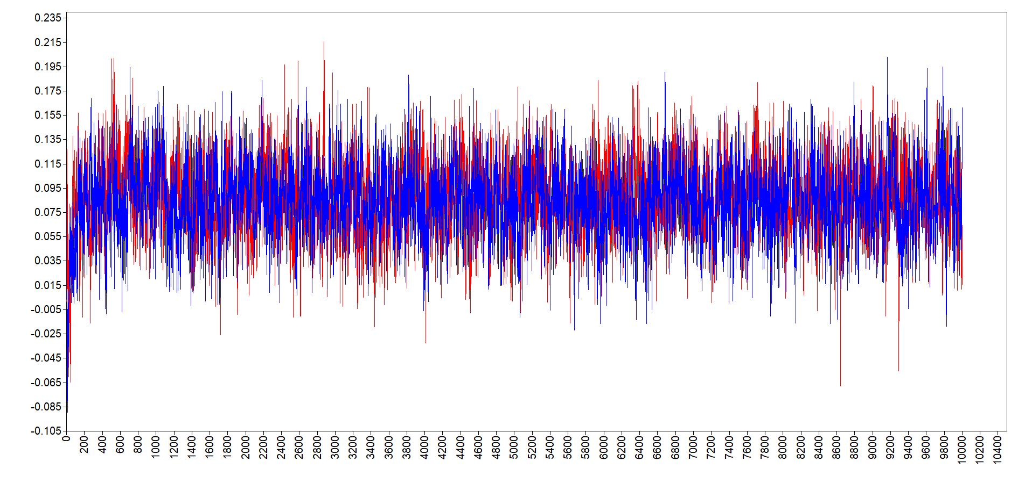
Depressed→Lonely
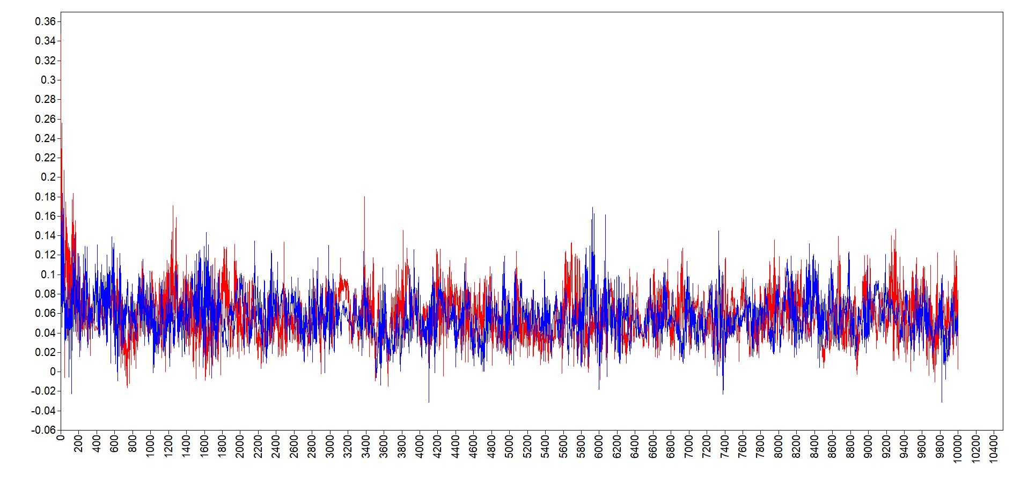
Figure S4.2.1.2
Density Plots of Hourly Temporal Relations
Lonely→Depressed
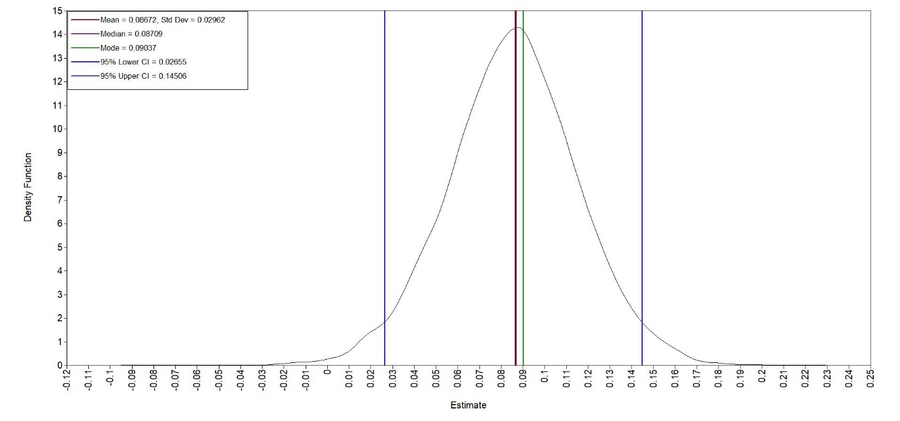
Depressed→Lonely
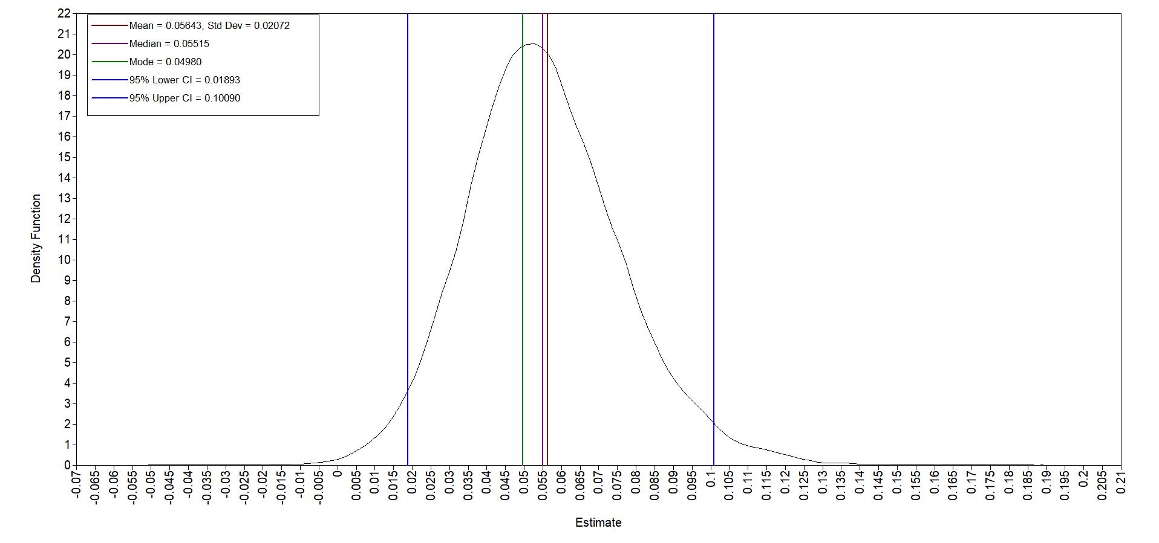

4.2.2 Half-yearly Temporal Relations in Model 1b
Figure S4.2.2.1
Trace Plots of Half-Yearly Temporal Relations (12800 iterations)
Lonely→Depressed
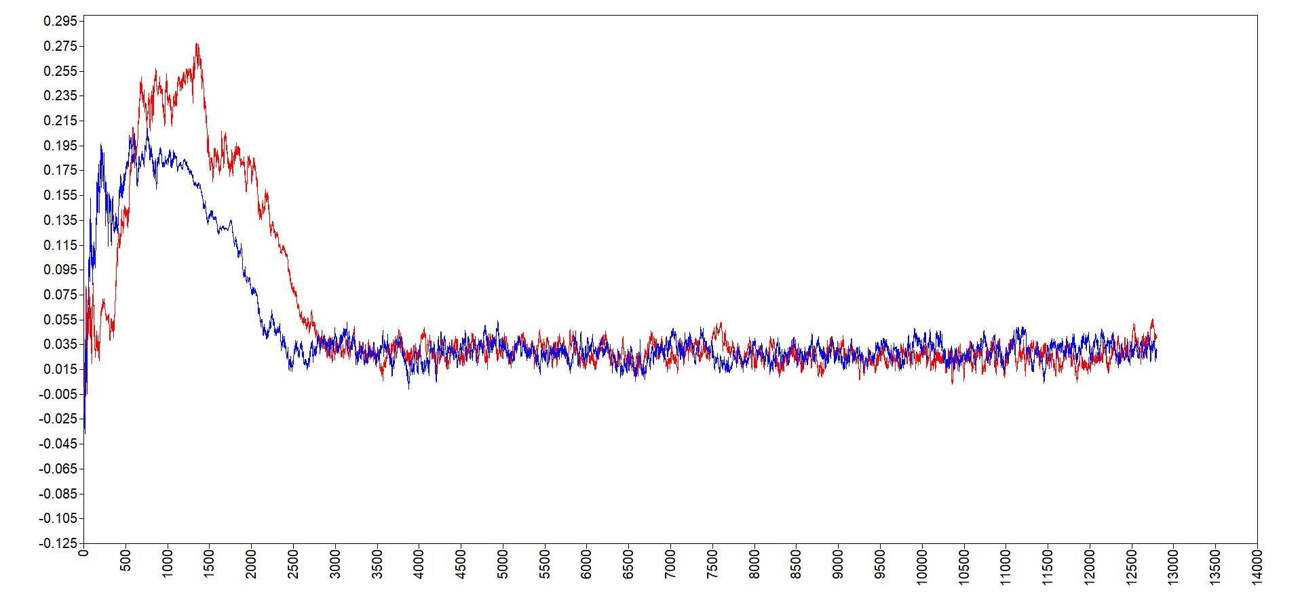
Depressed→Lonely
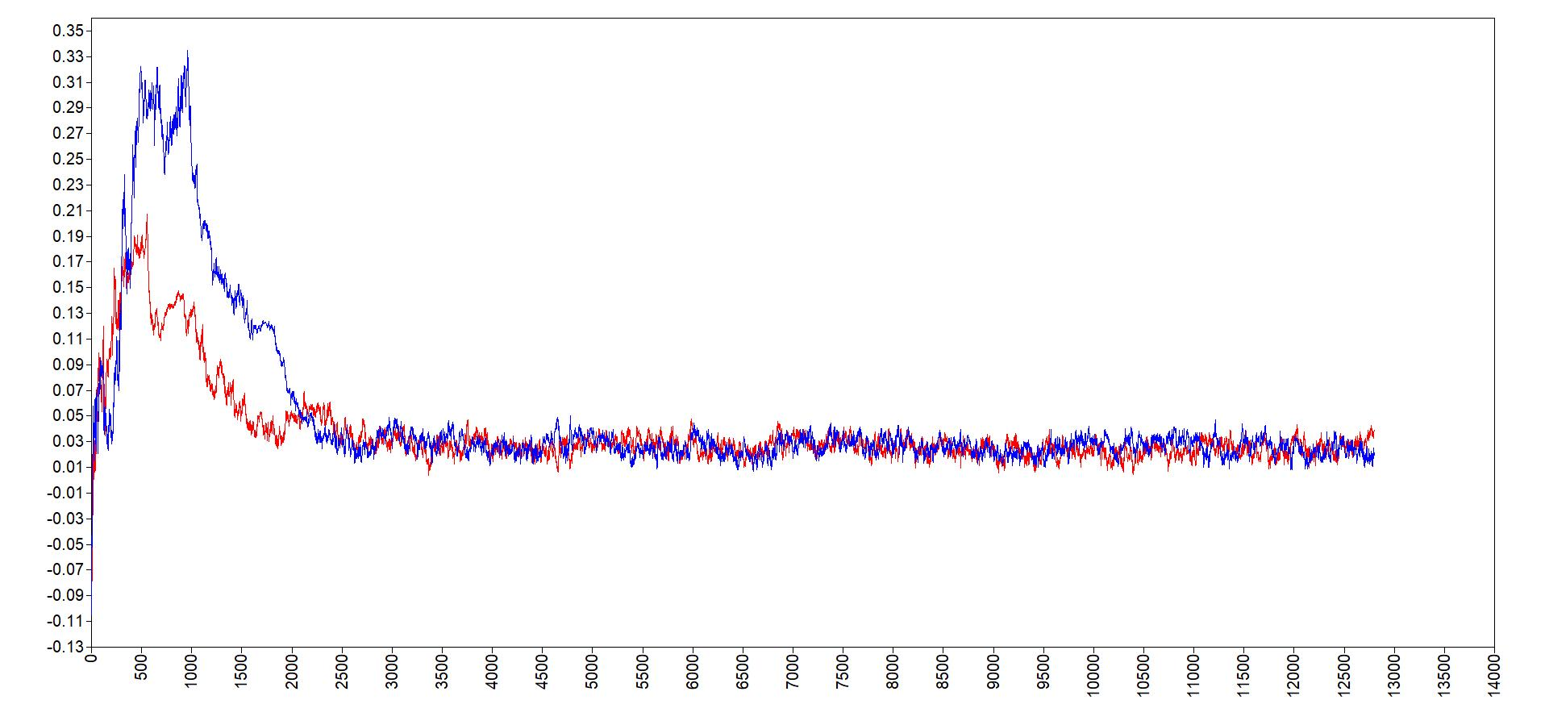
Figure S4.2.2.2
Trace Plots of Half-Yearly Temporal Relations (25600 iterations)
Lonely→Depressed
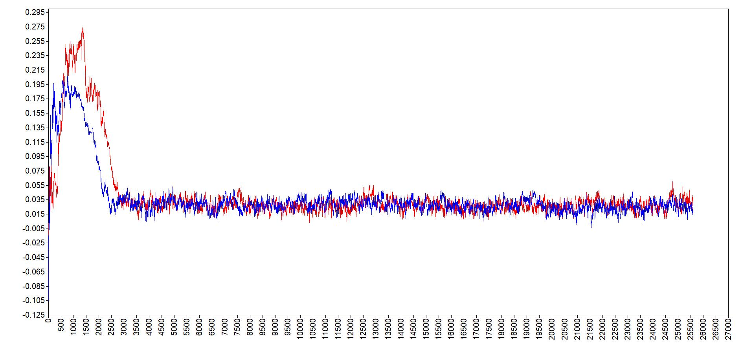
Depressed→Lonely
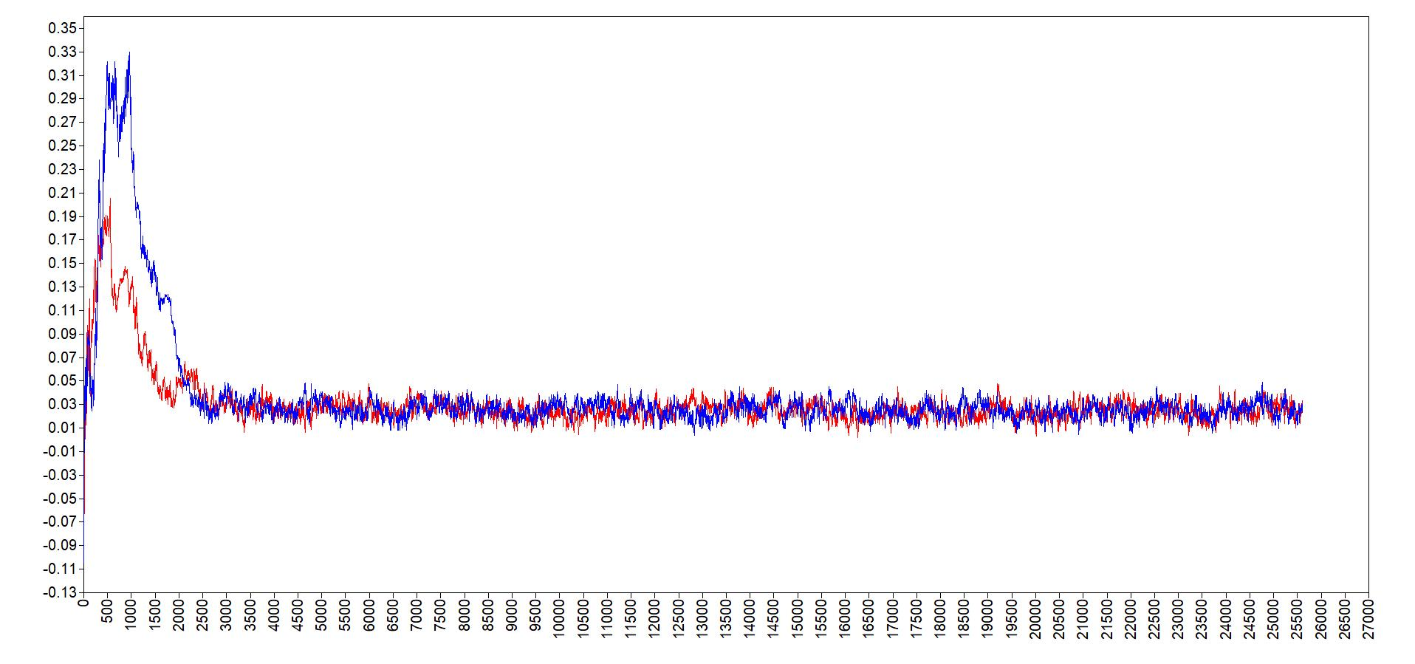
Figure S4.2.2.3
Density Plots of Half-Yearly Temporal Relations
Lonely→Depressed
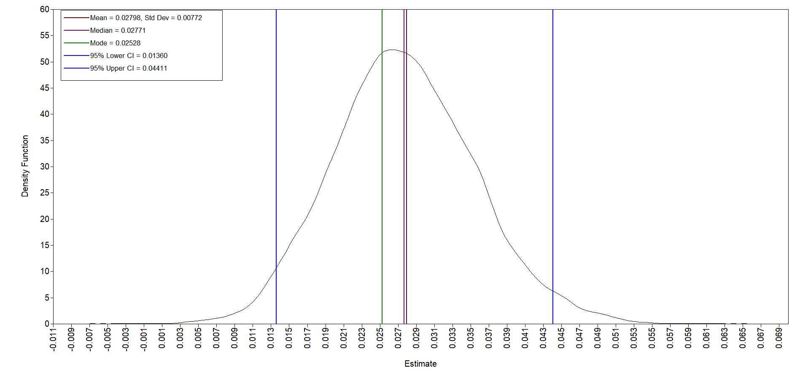
Depressed→Lonely
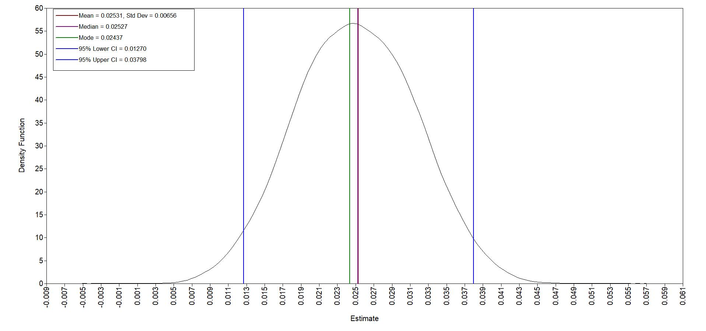

4.2.3 Across-time-scale Influence in Model 2
Figure S4.2.3.1
Trace Plots of the Across-time-scale Influence From Hourly Lonely→Depressed Temporal Relation to Half-Yearly Changes in Loneliness
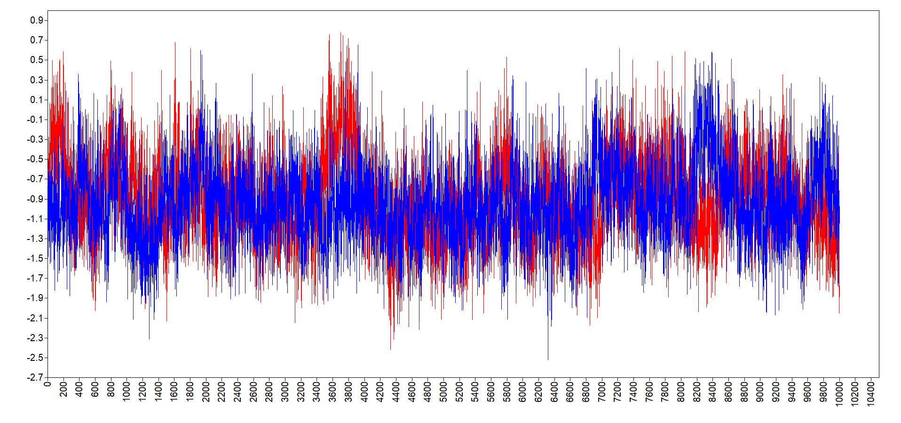
Figure S4.2.3.2
Density Plot of the Across-time-scale Influence From Hourly Lonely→Depressed Temporal Relation to Half-Yearly Changes in Loneliness
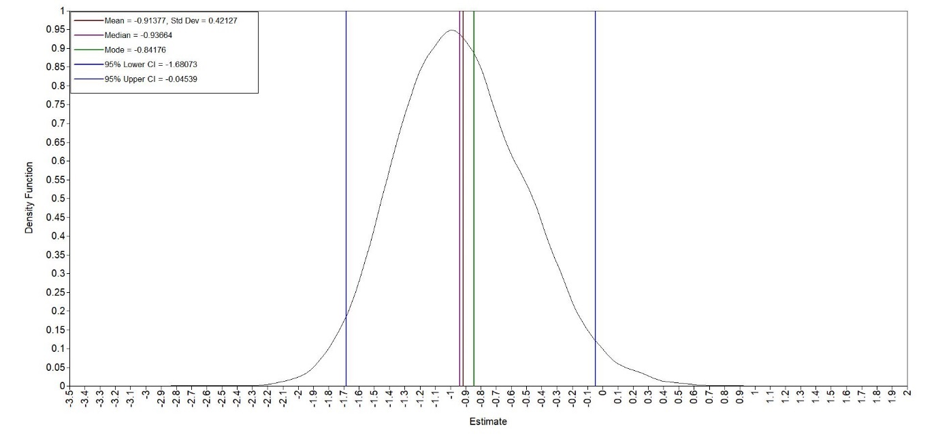

Supplemental Material 5: Sensitivity Analysis for Hypothesis 2
5.1. One-Step Model to Test Hypothesis 1a and Hypothesis 2 Altogether
In our pre-registration, we test Hypothesis 1a and Hypothesis 2 separately in Model 1a and Model 2. Technically, it is possible to embed the latent change score model specification from Model 2 directly in the between-person level of Model 1a (R)DSEM so that Hypothesis 1a and Hypothesis 2 are tested together in a one-step approach (Hamaker et al., 2018). We ran a sensitivity analysis with this one-step approach. However, the one-step model did not converge. This nonconvergence is not surprising because our specification was more complex while supported by less data: we modeled two between-person outcomes with an average of 42 repeated measurements per participant (n=84), whereas the published one-step example (Hamaker et al., 2018) used a single between-person outcome with roughly 100 repeated measurements per participant (N=101).
5.2. Additional Regression Paths From Wave 5 Measurements to ESM Estimates
The ESM study occurred not at W5, but three months after W5 and three months before W6. Therefore, analytically, it was possible to specify additional regression paths in Model 2 in which person-specific ESM estimates of hourly loneliness and depressed feelings were temporally predicted by W5 measurements of loneliness and depressive symptoms. Accordingly, we conducted a sensitivity analysis that added these additional paths to the H2 model (paths in bold, Figure S5.2). The results for H2 were unchanged, as the values of the key estimates that tested H2 were very close to the estimates in the preregistered model and are similarly (non)significant (Table S5.2). The standardized residual variance of ESM estimates are .829 and .924 for φ_{LD} and φ_{DL} respectively. These variances indicate the proportion of unexplained variance between adolescents. In other words, in this sensitivity analysis, W5 loneliness and depressive symptoms could only account for less than 20% of the variance of the ESM estimates. This means that that person-specific hourly relations were mostly explained by factors other than W5 loneliness and depressive symptoms.
Figure S5.2
Full Specifications of Model 2 (Across-Timescale Effects) Sensitivity Analysis.
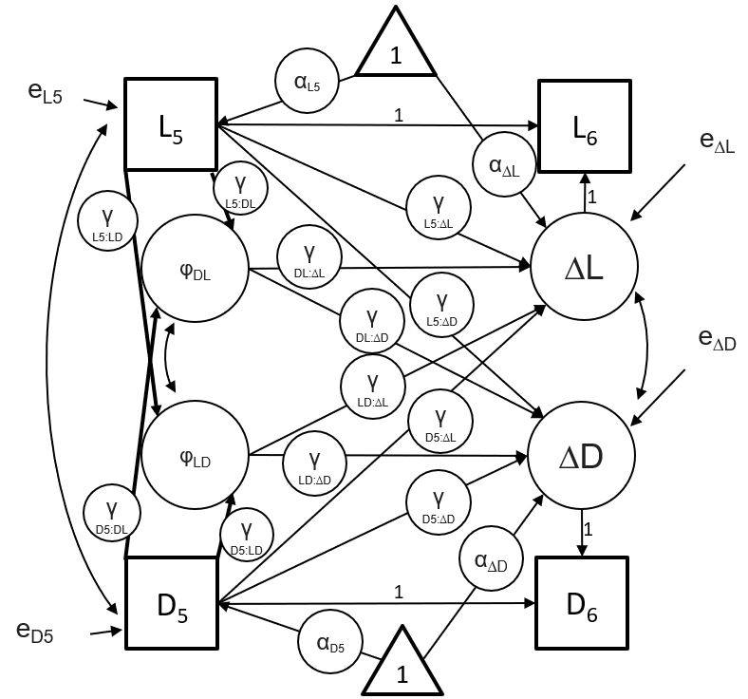
Note. D: Depressive Symptoms; L: Loneliness; ∆D: Latent change in Depressive Symptoms; ∆L Latent change in Loneliness; e: Residual; α: mean/intercept; φ: person-specific estimates of within-person temporal relations extracted from Model 1a; γ: path estimate (“:” denotes an effect, e.g., γ_{D5:∆D} denotes the path estimate of the effect from D₅ to ∆D); Subscript 5, 6: Measured at Wave 5 or Wave 6. This model is built on the pre-registered Model 2 (Figure S3.1.2). The changes in this sensitivity analysis model are that Wave 5 measurements of loneliness and depressive symptoms predict person-specific ESM estimates, as denoted by bold arrows.
Table S5.2
Standardized Estimates in Model 2: Sensitivity Analysis on Modeling the Temporal Relations From Wave 5 Measurements to ESM Person-Specific Estimates
Path | Sensitivity Analysis  n = 181
φ_{LD} →ΔL | -0.302 (-0.524, -0.048)
φ_{DL} →ΔL | 0.050 (-0.219, 0.333)
φ_{LD} →ΔD | 0.163 (-0.061, 0.369)
φ_{DL} →ΔD | 0.140 (-0.089, 0.362)
L₅→ΔL | -0.249 (-0.456, -0.023)
D₅→ΔL | 0.162 (-0.023, 0.345)
L₅→ΔD | 0.128 (-0.078, 0.331)
D₅→ΔD | -0.380 (-0.557, -0.183)
L₅→ φ_{LD} | 0.422 (0.158, 0.628)
D₅→ φ_{LD} | -0.151 (-0.367, 0.099)
L₅→ φ_{LD} | 0.072 (-0.220, 0.361)
D₅→ φ_{DL} | 0.199 (-0.075, 0.441)
ΔL→L₆ | 0.858 (0.745, 0.988)
ΔD→D₆ | 0.788 (0.673, 0.924)
L₅→L₆ | 0.831 (0.720, 0.956)
D₅→D₆ | 0.900 (0.784, 1.033)
Covariance (ΔD & ΔL) | 0.444 (0.259, 0.601)
Covariance (L₅ & D₅) | 0.335 (0.185, 0.473)
Covariance (φ_{LD} & φ_{DL}) | -0.002 (-0.231, 0.232)
Means or Intercepts of
L₅ | 1.151 (0.941, 1.362)
D₅ | 1.597 (1.324, 1.853)
ΔL | 0.103 (-0.286, 0.436)
ΔD | 0.215 (-0.147, 0.586)
Residual Variance
ΔL | 0.750 (0.586, 0.889)
ΔD | 0.800 (0.647, 0.920)
φ_{LD} | 0.829 (0.640, 0.964)
φ_{DL} | 0.924 (0.774, 0.996)
5.3. Excluding an Outlier in ESM Person-Specific Estimates
Our preregistration specified that exclusions would be limited to potential careless responding, indicated by very short response times or invariant responding across items that included reverse-coded items. One participant showed an unusually high person specific ESM estimate for the hourly association between feeling lonely and feeling depressed (see Figure 2 in the main text). However, this participant did not appear to provide problematic data: they completed 80% of ESM assessments and showed within-person variation in both loneliness and depressed feelings, meaning they would not qualify for exclusion under our preregistered criteria. We therefore retained this case in the main analyses. Still, in the interest of transparency and robustness, we also ran a sensitivity analysis excluding this participant. The overall pattern of results remained unchanged in terms of the directions of the key path estimates (Table S5.3).
One path, however, became significant: person-specific estimates for the hourly association from feeling lonely to feeling depressed significantly predicted half yearly increases in depressive symptoms. This suggests that although adolescents who showed stronger hourly increases in depressed feelings following heightened loneliness appeared protected against half yearly increases in loneliness (results from our preregistered analysis), they may also have been at greater risk for increases in depressive symptoms over the same period (results from this outlier-excluding sensitivity analysis). However, this new finding should be interpreted with caution. Because it emerged only after excluding an outlying case, it may reflect an inflated risk of a Type I error rather than a stable effect (André, 2022; Bakker & Wicherts, 2014). Further research is needed before drawing substantive conclusions from this result.
In the main text, we report and interpret the preregistered analyses. Future studies with larger samples are needed to determine whether this additional significant association is replicable or instead reflects an unstable result that emerged after departing from the preregistered plan.

Table S5.3
Key Standardized Estimates in Model 2: Sensitivity Analysis of Excluding an Outlier
Path | Sensitivity Analysis  n = 180
φ_{LD} →ΔL | -0.299 (-0.533, -0.031)
φ_{DL} →ΔL | 0.086 (-0.171, 0.354)
φ_{LD} →ΔD | 0.271 (0.050, 0.466)
φ_{DL} →ΔD | 0.125 (-0.087, 0.328)

References
André, Q. (2022). Outlier exclusion procedures must be blind to the researcher’s hypothesis. Journal of Experimental Psychology: General, 151(1), 213.
Bakker, M., & Wicherts, J. M. (2014). Outlier removal, sum scores, and the inflation of the Type I error rate in independent samples t tests: The power of alternatives and recommendations. Psychological Methods, 19(3), 409.
Bentler, P. M., & Bonett, D. G. (1980). Significance tests and goodness of fit in the analysis of covariance structures. Psychological Bulletin, 88(3), 588.
Chen, F. F. (2007). Sensitivity of goodness of fit indexes to lack of measurement invariance. Structural Equation Modeling: A Multidisciplinary Journal, 14(3), 464–504.
Eisele, G., Lafit, G., Vachon, H., Kuppens, P., Houben, M., Myin-Germeys, I., & Viechtbauer, W. (2021). Affective structure, measurement invariance, and reliability across different experience sampling protocols. Journal of Research in Personality, 92, 104094. https://doi.org/10.1016/j.jrp.2021.104094
Faul, F., Erdfelder, E., Buchner, A., & Lang, A.-G. (2009). Statistical power analyses using G* Power 3.1: Tests for correlation and regression analyses. Behavior Research Methods, 41(4), 1149–1160.
Hamaker, E. L., Asparouhov, T., Brose, A., Schmiedek, F., & Muthén, B. (2018). At the frontiers of modeling intensive longitudinal data: Dynamic structural equation models for the affective measurements from the COGITO study. Multivariate Behavioral Research, 53(6), 820–841.
McNeish, D., & Bauer, D. J. (2022). Reducing incidence of nonpositive definite covariance matrices in mixed effect models. Multivariate Behavioral Research, 57(2–3), 318–340.
McNeish, D., & Hamaker, E. L. (2020). A primer on two-level dynamic structural equation models for intensive longitudinal data in Mplus. Psychological Methods, 25(5), 610–635. https://doi.org/10.1037/met0000250
Pouwels, J. L., Valkenburg, P. M., Beyens, I., Van Driel, I. I., & Keijsers, L. (2021). Some socially poor but also some socially rich adolescents feel closer to their friends after using social media. Scientific Reports, 11(1), 21176. https://doi.org/10.1038/s41598-021-99034-0
Schermelleh-Engel, K., Moosbrugger, H., Müller, H., & others. (2003). Evaluating the fit of structural equation models: Tests of significance and descriptive goodness-of-fit measures. Methods of Psychological Research Online, 8(2), 23–74.
Shaw, M., Rights, J. D., Sterba, S. S., & Flake, J. K. (2022). r2mlm: An R package calculating R-squared measures for multilevel models. Behavior Research Methods. https://doi.org/10.3758/s13428-022-01841-4
Simonsohn, U. (2015). Small telescopes: Detectability and the evaluation of replication results. Psychological Science, 26(5), 559–569.
van den Boom, W., Marra, E., van der Vliet, N., Elberse, J., van Dijken, S., van Dijk, M., Euser, S., Derks, M., Leurs, M., Albers, C., & others. (2023). General mental health, loneliness, and life satisfaction in the context of COVID-19 policies: A 2-year cohort study in the netherlands, april 2020–january 2022. Public Health Reports, 138(5), 812–821.

