Supplemental materials
Table 1. BRIEF-2 factor analysis residual covariance modifications
Residual covariances added | Domain | Modification indices value | Theoretical justification | Model improvement
Item 14 with 6 | Emotional control | 50 | Overlap in wording
Item 43 with 6 | Working memory | 50 | Overlap in wording
Item 63 with 37 | Organization of Materials | 50 | Overlap in wording
Model improvement |  |  |  | ΔCFI = +0.02, ΔRMSEA = 0.00
Item 40 with 17 | Shift | 40 | Overlap in wording
Model improvement |  |  |  | ΔCFI = +0.004, ΔRMSEA = -0.001
Item 31 with 11 | Shift | 30 | Overlap in wording
Item 35 with 23 | Plan/Organize | 30 | Overlap in wording
Model improvement |  |  |  | ΔCFI = +0.006, ΔRMSEA = -0.001
Item 33 with 21 | Task-Monitor | 20 | Overlap in wording
Item 43 with 6 | Emotional Control | 20 | Overlap in wording
Item 60 with 31 | Shift | 20 | Overlap in wording
Model improvement |  |  |  | ΔCFI = +0.006, ΔRMSEA = -0.001
Item 43 with 14 | Emotional Control | 20 | Overlap in wording
Model improvement |  |  |  | ΔCFI = +0.003, ΔRMSEA = 0.00
Item 28 with 3 | Working memory | 15 | Overlap in wording
Item 59 with 52 | Plan/Organize | 15 | Overlap in wording
Item 41 with 28 | Working memory | 15 | Overlap in wording
Model improvement |  |  |  | ΔCFI = +0.004, ΔRMSEA = -0.001
Item 29 with 5 | Task-Monitor | 10 | Overlap in wording
Item 24 with 16 | Inhibit | 10 | Overlap in wording
Model improvement |  |  |  | ΔCFI = +0.002, ΔRMSEA = 0.00

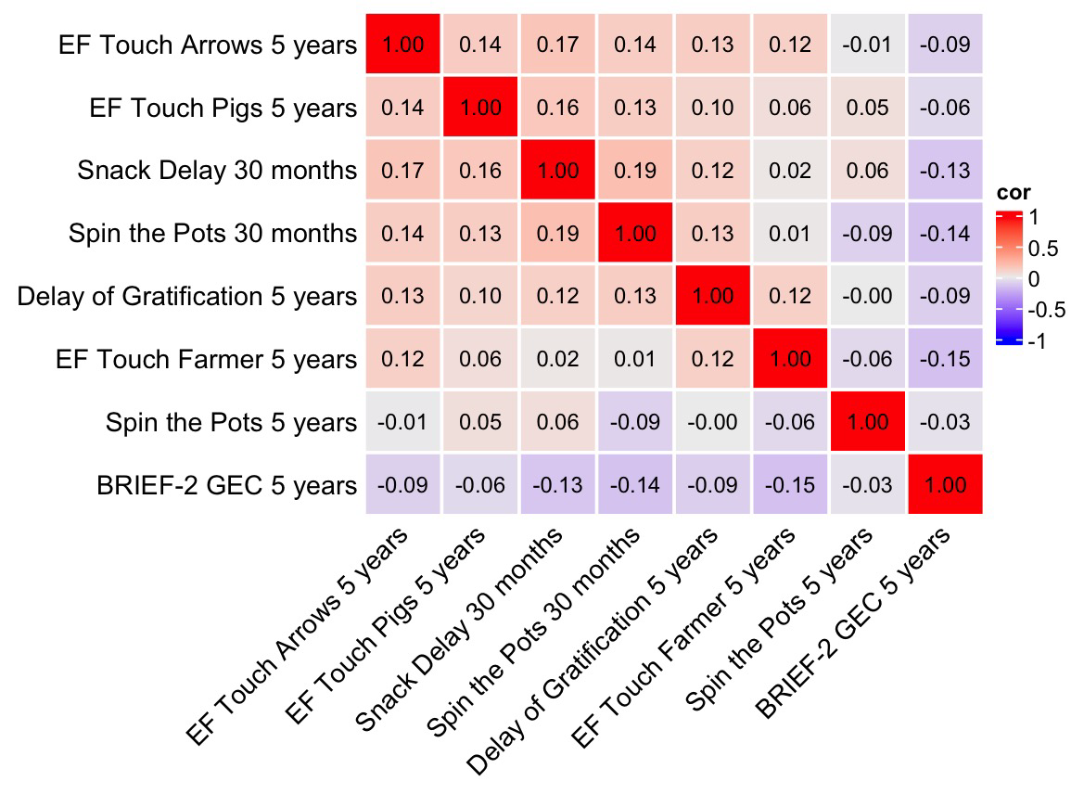
Figure 1. Cross-correlation heatmap for each pair of EF scores. Correlations between EF scores were measured in terms of Kendall's tau correlation coefficients.
Table 2. Differential abundance analyses adjusted for time from sample collection to freezing in 30 month stool samples
 | Timepoint | EF task | Associated genus | df | Baseline Mean Abundance | Log2 Fold −Change | Adjusted p-value
All | 30 months | Spin the pots 2.5 years | Escherichia  Ruminococcus | 140  140 | 168 319.10  23.02 | 0.94  0.95 | .04  .04
 |  | EF Touch Farmer 5 year | Lachnospiraceae_Unidentified_Genus_2 | 81 | 362.40 | -0.76 | .01

Sensitivity analyses accounting for the delay between sample collection and freezing were conducted for the 30-month gut microbiota samples but not for the 2.5-month samples. At the 2.5-month time point, information on the time from collection to freezing was not systematically recorded, as this occurred at the initiation of the cohort and sample handling variables were not yet routinely documented. Consequently, freezing delay data were available only for a substantially smaller subset of participants (n = 101) that differed markedly from the original study population (n = 277) in both size and composition. Sensitivity analyses at this time point were therefore considered unreliable and potentially biased and were not performed.
For the 30-month samples, information on the time from collection to freezing was available for a substantially larger proportion of participants (n = 197, original n = 204), allowing sensitivity analyses to be conducted. Differential abundance analyses were first performed without adjustment for freezing delay. In these analyses, performance on the Spin the Pots task at 2.5 years was positively associated with the genera Escherichia and Ruminococcus, and performance on the EF Touch Farmer task at 5 years was negatively associated with an unidentified genus belonging to the family Lachnospiraceae. No sex-stratified associations were observed at the 30-month time point. The differential abundance analyses were then repeated with adjustment for the time from sample collection to freezing. The results were highly consistent with the primary analyses: Escherichia and Ruminococcus remained positively associated with Spin the Pots performance at 2.5 years, and the unidentified Lachnospiraceae genus remained negatively associated with EF Touch Farmer performance at 5 years. Effect directions and magnitudes were comparable across models, and all associations remained statistically significant after correction for multiple testing (see Supplementary Table 2.)
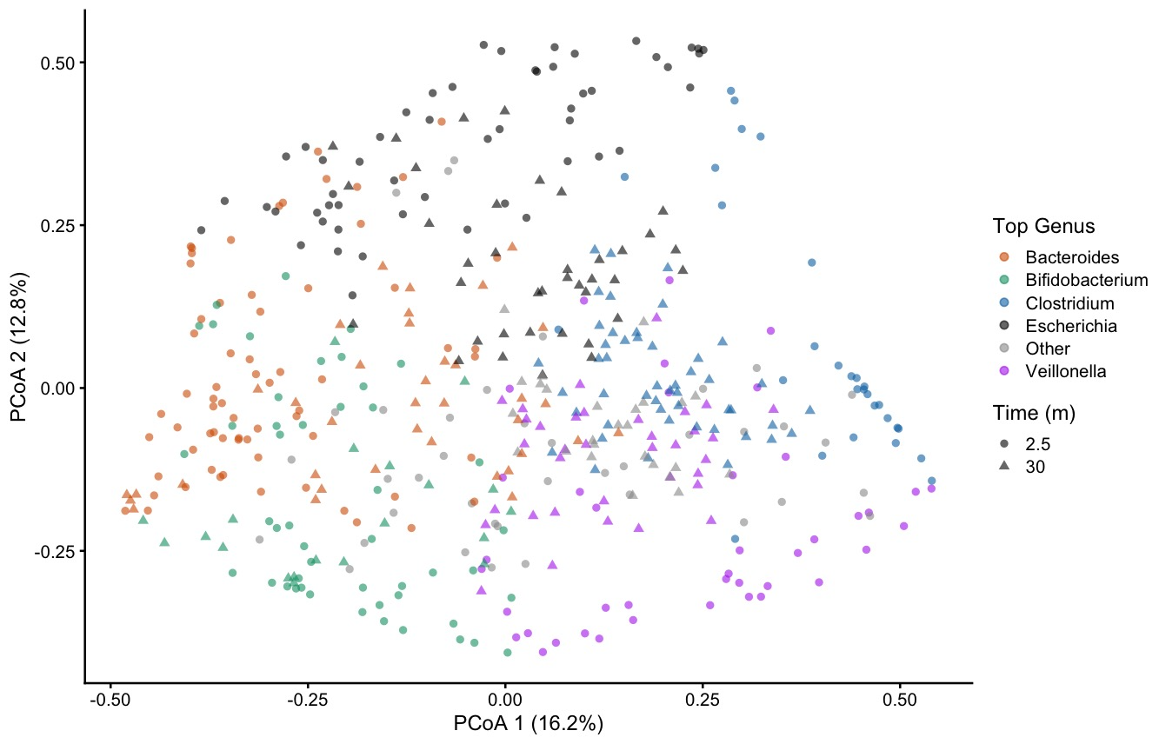
Figure 2. Ordination plots of microbial samples by Bray-Curtis dissimilarity. Points are coloured by top genus and shaped by time point.

Table 3. BileAcid and SCFAs EF correlations
GMC timepoint | EF variable | metabolite | Spearman cor | p-value | adj. p-value
2.5 months | Snack Delay task 30 months | 7-oxo-DCA | -0.28 | .003 | .62
 | Spin the Pots task 30 months | GCA | -0.28 | .003 | .62
 | BRIEF-2 GEC 5 years | Propionic acid | -0.22 | .02 | .95
 | Delay of gratification 5 years | Valeric acid | -0.23 | .01 | .95
 | Spin the Pots task 5 years | Propionic acid | -0.19 | .04 | .95
 |  | Isovaleric acid | -0.21 | .02 | .95
30 months | Spin the Pots 30 months | 7-oxo-DCA | -0.17 | .05 | .95
 | Delay of gratification 5 years | aMCA | -0.22 | .03 | .95
 | EF Touch Arrows task 5 years | 7-oxo-DCA | 0.22 | .03 | .95
 |  | CA | 0.21 | .04 | .95
 | EF Touch Pigs task 5 years | aMCA | -0.25 | .01 | .95
 |  | CA | -0.21 | .05 | .95

Table 4. BileAcid and SCFAs EF correlations for boys and girls separately.
GMC timepoint | sex | EF variable | metabolite | Spearman cor | p-value | adj. p-value
2.5 months | boy | Snack Delay task 30 months | CA | 0.31 | .01 | .92
 |  |  | 7-oxo-DCA | -0.27 | .03 | .92
 |  |  | TUDCA | -0.24 | .05 | .92
 |  | Spin the Pots task 30 months | GCA | -0.32 | .01 | .92
 |  |  | THCA | -0.25 | .04 | .92
 |  | BRIEF-2 GEC | TUDCA | 0.28 | .02 | .92
 |  | Delay of gratification task 5 years | TCA | -0.31 | .01 | .92
 |  | EF Touch Farmer task 5 years | bMCA | -0.29 | .03 | .92
 |  |  | CA | -0.32 | .02 | .92
 |  | Spin the Pots task 5 years | Isovaleric acid | -0.27 | .02 | .92
 | Girls | Snack Delay task 30 months | bMCA | -0.32 | .04 | .92
 |  |  | Valeric acid | -0.43 | .01 | .82
 |  | Spin the Pots task 30 months | aMCA | 0.35 | .03 | .92
 |  | Spin the Pots task 5 years | GUDCA | 0.31 | .05 | .92
30 months | Boys | Delay of gratification task 5 years | DCA | -0.29 | .03 | .92
 |  | EF Touch Arrows task 5 years | 7-oxo-DCA | 0.31 | .02 | .92
 |  | EF Touch Pigs task 5 years | aMCA | -0.33 | .02 | .92
 |  |  | CA | -0.39 | .01 | .82
 |  | Spin the Pots task 5 years | aMCA | 0.41 | .003 | .82
 |  |  | Butyric acid | 0.30 | .03 | .92
 |  |  | HCA | 0.39 | .01 | .82
 |  |  | UDCA | 0.28 | .04 | .92
 |  |  | wMCA | 0.39 | .004 | .82
 | Girls | Delay of gratification task 5 years | aMCA | -0.34 | .02 | .92
 |  | EF Touch Farmer task 5 years | Isovaleric acid | -0.31 | .04 | .92
 |  | Spin the Pots task 30 months | 7-oxo-DCA | -0.27 | .04 | .92

Table 5. Polar Metabolite EF correlations
GMC timepoint | EF variable | Metabolite | Spearman cor | p-value | adj.p-value
2.5 months | Spin the Pots task 2.5 years | P.hydroxylphenyllactic.acid | 0.24 | .01 | .90
 | BRIEF-2 GEC | Lauric.acid | 0.19 | .05 | .90
 |  | Succinic.acid | 0.20 | .04 | .90
 |  | Unknown | 0.21 | .02 | .90
 | Delay of Gratification task 5 years | X2.ketoadipic.acid. | 0.25 | .01 | .90
 |  | Melibiose | -0.21 | .03 | .90
 |  | Unknown | 0.20 | .04 | .90
 | EF Touch Arrows task 5 years | X3.4.Dihydroxyphenylacetic.acid | -0.20 | .04 | .90
 |  | Unknown | 0.20 | .04 | .90
 | EF Touch Farmer task 5 years | N.Acetyl.D.glucosamine | -0.25 | .02 | .90
 |  | Unknown | -0.21 | .04 | .90
 | EF Touch Pigs task 5 years | Oleic.acid.18.1n.9. | -0.27 | .01 | .90
 |  | Unknown | -0.20 | .04 | .90
 | Spin the Pots task 5 years | Palmitoleic.acid | 0.20 | .04 | .90
 |  | X1.Monostearin. | -0.19 | .04 | .90
 |  | Sophorose. | -0.20 | .04 | .90
 |  | Unknown | 0.20 | .04 | .90
 |  | Unknown | -0.19 | .05 | .90
30 months | Snack Delay task 2.5 years | Glycine | -0.20 | .03 | .90
 |  | Ribitol.1 | 0.18 | .04 | .90
 |  | Unknown | 0.19 | .03 | .90
 |  | Unknown | 0.22 | .01 | .90
 | Spin the Pots 2.5 years | Shikimic.acid | -0.23 | .01 | .90
 |  | Lauric.acid | -0.22 | .01 | .90
 |  | X4.Hydroxyphenylacetic.acid | -0.22 | .01 | .90
 |  | X2.Methylpentadecanoic.acid.  .trimethylsilyl.ester | -0.21 | .01 | .90
 |  | X3.phosphoglycerate | -0.21 | .02 | .90
 |  | P.hydroxylphenyllactic.acid | -0.20 | .02 | .90
 |  | DFucose | -0.19 | .02 | .90
 |  | L.Arginine | -0.19 | .03 | .90
 |  | N.Acetyl.D.glucosamine | -0.19 | .03 | .90
 |  | Putrescine | -0.18 | .03 | .90
 |  | Unknown | -0.28 | .001 | .90
 |  | Unknown | -0.21 | .01 | .90
 | BRIEF-2 GEC | Unknown | 0.24 | .02 | .90
 |  | Unknown | 0.23 | .02 | .90
 | Delay of Gratification task 5 years | Stearic.acid | -0.27 | .01 | .90
 |  | L.5.Oxoproline | -0.22 | .03 | .90
 |  | Succinic.acid | -0.22 | .03 | .90
 |  | Hexose. | -0.21 | .04 | .90
 |  | Galactonic.acid | -0.20 | .04 | .90
 |  | Plamitic.acid.16.0. | -0.20 | .05 | .90
 |  | Unknown | -0.29 | .004 | .90
 | EF Touch Arrows task 5 years | Quinolinic.acid | -0.21 | .03 | .90
 | EF Touch Farmer task 5 years | Altrose | 0.22 | .05 | .90
 |  | Oleic.acid.18.1n.9. | -0.25 | .02 | .90
 | Spin the Pots 5 years | Unknown | 0.31 | .002§ | .90
 |  | Unknown | 0.21 | .04 | .90

Table 6. Polar Metabolite EF correlations for boys and girls separately.
GMC timepoint |  | sex | EF variable |  |  | metabolite |  | Spearman cor |  | p-value |  | adj. p-value
2.5 months | Boys |  |  | Spin the Pots 2.5 years | Succinic.acid |  | -0.37 |  | .002 |  | .70
 |  |  |  |  | Unknown |  | -0.25 |  | .04 |  | .95
 |  |  |  | Delay of Gratification task 5 years | Unknown |  | 0.25 |  | .04 |  | .95
 |  |  |  | BRIEF-2 GEC | Maltose |  | 0.27 |  | .03 |  | .95
 |  |  |  | EF Touch Arrows task 5 years | X4.Hydroxyphenylacetic.acid |  | -0.32 |  | .01 |  | .91
 |  |  |  |  | X3.4.Dihydroxyphenylacetic.acid |  | -0.32 |  | .01 |  | .91
 |  |  |  |  | Unknown |  | -0.31 |  | .02 |  | .95
 |  |  |  | EF Touch Pigs task 5 years | Succinic.acid |  | -0.39 |  | .002 |  | .70
 |  |  |  |  | Oleic.acid.18.1n.9. |  | -0.36 |  | .005 |  | .70
 |  |  |  |  | Lauric.acid |  | -0.27 |  | .04 |  | .95
 |  |  |  | Spin the Pots 5 years | Unknown |  | 0.25 |  | .04 |  | .95
 | Girls |  |  | Snack Delay task 2.5 years | Pentadecanoic.acid.15.0. |  | -0.35 |  | .02 |  | .95
 |  |  |  |  | X4.Hydroxyphenylacetic.acid |  | -0.34 |  | .03 |  | .95
 |  |  |  | Spin the Pots task 2.5 years | Quinolinic.acid |  | -0.33 |  | .03 |  | .95
 |  |  |  |  | X3..3.hydroxyphenyl.propionic.acid |  | -0.33 |  | .03 |  | .95
 |  |  |  |  | D.Fructose |  | 0.33 |  | .04 |  | .95
 |  |  |  |  | X3.4.dihydroxyhydrocinnamic.acid. |  | -0.31 |  | .04 |  | .95
 |  |  |  |  | Unknown |  | 0.35 |  | .02 |  | .95
 |  |  |  | BRIEF-2 GEC | Plamitic.acid.16.0. |  | 0.46 |  | .002 |  | .70
 |  |  |  |  | C16. |  | 0.45 |  | .002 |  | .70
 |  |  |  |  | Sinapic.acid |  | 0.44 |  | .003 |  | .70
 |  |  |  |  | D.Ribose |  | 0.43 |  | .004 |  | .70
 |  |  |  |  | Minoxidil |  | 0.41 |  | .01 |  | .70
 |  |  |  |  | Stearic.acid |  | 0.39 |  | .01 |  | .76
 |  |  |  |  | Unknown18 |  | 0.39 |  | .01 |  | .77
 |  |  |  |  | Succinic.acid |  | 0.38 |  | .01 |  | .91
 |  |  |  |  | L.Ascorbic.acid |  | 0.37 |  | .01 |  | .93
 |  |  |  |  | Lauric.acid |  | 0.36 |  | .02 |  | .95
 |  |  |  |  | Unknown15 |  | 0.36 |  | .02 |  | .95
 |  |  |  |  | X3.indoleacetonitrile |  | 0.30 |  | .05 |  | .95
 |  |  |  |  | Unknown26 |  | 0.30 |  | .05 |  | .95
 |  |  |  |  | Unknown |  | 0.49 |  | .001 |  | .70
 |  |  |  | Delay of Gratification task 5 years | X2.ketoadipic.acid. |  | 0.42 |  | .01 |  | .70
 |  |  |  | EF Touch Arrows task 5 years | Unknown |  | 0.41 |  | .01 |  | .70
 |  |  |  |  | Unknown |  | 0.39 |  | .01 |  | .76
 |  |  |  |  | Threitol |  | 0.36 |  | .02 |  | .70
 |  |  |  |  | Unknown |  | 0.36 |  | .02 |  | .76
 |  |  |  |  | Arachidonic.acid |  | 0.36 |  | .02 |  | .95
 |  |  |  |  | Unknown19 |  | 0.35 |  | 0.2 |  | .95
 |  |  |  |  | X1.Pentadecanol |  | 0.34 |  | .03 |  | .95
 |  |  |  |  | Unknown |  | 0.33 |  | .03 |  | .95
 |  |  |  |  | Fucose_2 |  | -0.31 |  | .04 |  | .95
 |  |  |  | EF Touch Farmer task 5 years | Quinolinic.acid |  | -0.44 |  | .01 |  | .70
 |  |  |  |  | Pantothenic.acid |  | -0.44 |  | .01 |  | .70
 |  |  |  |  | N.Acetyl.D.glucosamine |  | -0.44 |  | .01 |  | .70
 |  |  |  |  | X3..3.hydroxyphenyl.propionic.acid |  | -0.39 |  | .01 |  | .93
 |  |  |  |  | Putrescine |  | -0.37 |  | .02 |  | .95
 |  |  |  |  | aconitic.acid.delta |  | -0.37 |  | .02 |  | .95
 |  |  |  |  | DFucose |  | -0.33 |  | .04 |  | .95
 |  |  |  | EF Touch Pigs task 5 years | Pentadecanoic.acid.15.0. |  | -0.31 |  | .04 |  | .95
 |  |  |  | Spin the Pots task 5 years | Palmitoleic.acid |  | 0.30 |  | .05 |  | .95
30 months | Boys |  |  | Snack Delay task 2.5 years | C16. |  | -0.26 |  | .02 |  | .95
 |  |  |  |  | X3..3.hydroxyphenyl.propionic.acid |  | 0.24 |  | .04 |  | .95
 |  |  |  | Spin the Pots task 2.5 years | Lauric.acid |  | -0.33 |  | .004 |  | .70
 |  |  |  |  | X2.Methylpentadecanoic.acid.  .trimethylsilyl.ester |  | -0.33 |  | .003 |  | .70
 |  |  |  |  | P.hydroxylphenyllactic.acid |  | -0.31 |  | .01 |  | .70
 |  |  |  |  | Unknown |  | -0.27 |  | .02 |  | .95
 |  |  |  |  | Unknown |  | -0.27 |  | .02 |  | .95
 |  |  |  |  | Unknown |  | -0.27 |  | .02 |  | .95
 |  |  |  |  | Asparagine |  | -0.27 |  | .02 |  | .95
 |  |  |  |  | L.Arginine |  | -0.26 |  | .02 |  | .95
 |  |  |  |  | Putrescine |  | -0.25 |  | .03 |  | .95
 |  |  |  |  | N.Acetyl.D.glucosamine |  | -0.25 |  | .03 |  | .95
 |  |  |  |  | D.Fructose |  | -0.24 |  | .04 |  | .95
 |  |  |  |  | Unknown |  | -0.24 |  | .04 |  | .95
 |  |  |  | BRIEF-2 GEC | X4.Hydroxyphenylacetic.acid |  | 0.31 |  | .03 |  | .95
 |  |  |  |  | Plamitic.acid.16.0. |  | 0.31 |  | .03 |  | .95
 |  |  |  |  | L.Ascorbic.acid |  | -0.30 |  | .03 |  | .95
 |  |  |  |  | Unknown14 |  | 0.30 |  | .03 |  | .95
 |  |  |  |  | Palmitoleic.acid |  | 0.28 |  | .04 |  | .95
 |  |  |  | Delay of Gratification task 5 years | X3.4.dihydroxyhydrocinnamic.acid. |  | -0.29 |  | .04 |  | .95
 |  |  |  |  | Succinic.acid |  | -0.28 |  | .04 |  | .95
 |  |  |  |  | Unknown |  | 0.28 |  | .04 |  | .95
 |  |  |  | EF Touch Arrows task 5 years | Sinapic.acid |  | -0.41 |  | .002 |  | .70
 |  |  |  |  | C16. |  | -0.40 |  | .003 |  | .70
 |  |  |  |  | Ribonic.acid. |  | -0.37 |  | .01 |  | .75
 |  |  |  |  | Plamitic.acid.16.0. |  | -0.36 |  | .01 |  | .84
 |  |  |  |  | Unknown |  | -0.31 |  | .03 |  | .95
 |  |  |  |  | L.Iditol |  | -0.30 |  | .03 |  | .95
 |  |  |  |  | Unknown |  | -0.30 |  | .03 |  | .95
 |  |  |  | EF Touch Farmer task 5 years | Unknown |  | -0.36 |  | .02 |  | .95
 |  |  |  |  | X2.Methylpentadecanoic.acid.  .trimethylsilyl.ester |  | 0.34 |  | .03 |  | .95
 |  |  |  | Spin the Pots task 5 years | Unknown |  | 0.53 |  | 0.0001 |  | .20
 |  |  |  |  | Hexose. |  | 0.34 |  | .01 |  | .93
 |  |  |  |  | X3.4.dihydroxyhydrocinnamic.acid. |  | 0.29 |  | .04 |  | .95
 |  |  |  |  | Galactonic.acid |  | 0.28 |  | .04 |  | .95
30 months | Girls |  |  | Snack Delay task 2.5 years | Unknown |  | 0.40 |  | .002 |  | .70
 |  |  |  |  | Glycine |  | -0.38 |  | .004 |  | .70
 |  |  |  |  | Unknown |  | 0.37 |  | .004 |  | .70
 |  |  |  |  | Unknown |  | -0.36 |  | .01 |  | .75
 |  |  |  |  | Unknown |  | 0.34 |  | .01 |  | .85
 |  |  |  |  | L.Arginine |  | 0.29 |  | .03 |  | .95
 |  |  |  |  | X1...Trimethylsilylmethyl..3.  cyclohexenyl..5.Methyl.4.hexen.1.ol |  | 0.29 |  | .03 |  | .95
 |  |  |  |  | Unknown |  | 0.27 |  | .05 |  | .95
 |  |  |  | Spin the Pots 2.5 years | Unknown |  | -0.32 |  | .01 |  | .93
 |  |  |  |  | Shikimic.acid |  | -0.29 |  | .03 |  | .95
 |  |  |  |  | X4.Hydroxyphenylacetic.acid |  | -0.27 |  | .04 |  | .95
 |  |  |  |  | X3.4.Dihydroxyphenylacetic.acid |  | -0.26 |  | .04 |  | .95
 |  |  |  | Delay of Gratification task 5 years | Unknown |  | -0.39 |  | .01 |  | .75
 |  |  |  |  | Stearic.acid |  | -0.37 |  | .01 |  | .93
 |  |  |  |  | Glycine |  | -0.32 |  | .03 |  | .95
 |  |  |  |  | L.5.Oxoproline |  | -0.31 |  | .04 |  | .95
 |  |  |  |  | X3.indoleacetonitrile |  | -0.31 |  | .04 |  | .95
 |  |  |  | EF Touch Arrows task 5 years | Unknown |  | 0.32 |  | .03 |  | .95
 |  |  |  | EF Touch Farmer task 5 years | Altrose |  | 0.40 |  | .01 |  | .75
 |  |  |  |  | P.hydroxylphenyllactic.acid |  | -0.35 |  | .02 |  | .95
 |  |  |  |  | X3..3.hydroxyphenyl.propionic.acid |  | 0.34 |  | .02 |  | .95
 |  |  |  | EF Touch Pigs task 5 years | Unknown |  | 0.32 |  | .03 |  | .95

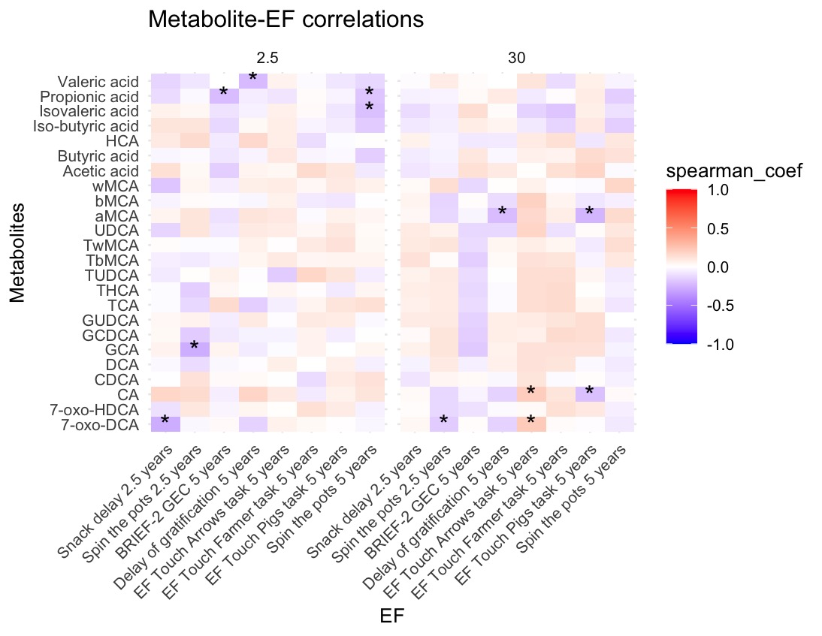
Figure 3. Heatmaps showing nominally significant correlations between BileAcids, SCFAs and EF. *nominal p<.05

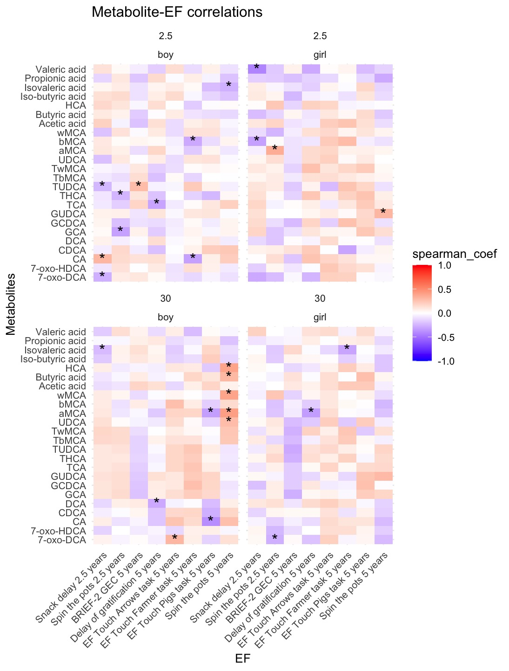
Figure 4. Heatmaps showing nominally significant correlations between BileAcids, SCFAs and EF for boys and girls separately. *nominal p<.05

