Supplementary Materials
Table S1
Parents’ Reports: Frequencies
Lie Rating | age 6 | age 7 | age 8 | age 10 | age 11 | age 12 | age 15 | age 19
0 | 905 | 670 | 669 | 454 | 765 | 851 | 917 | 855
1 | 1864 | 1350 | 1392 | 951 | 1276 | 1188 | 1030 | 844
2 | 234 | 145 | 172 | 101 | 129 | 96 | 96 | 79
Total | 3003 | 2165 | 2233 | 1506 | 2170 | 2135 | 2043 | 1778
Girls | age 6 | age 7 | age 8 | age 10 | age 11 | age 12 | age 15 | age 19
0 | 463 | 349 | 350 | 364 | 435 | 470 | 509 | 468
1 | 857 | 656 | 703 | 703 | 600 | 533 | 462 | 381
2 | 97 | 57 | 61 | 61 | 45 | 32 | 31 | 28
Total | 1417 | 1062 | 1128 | 1128 | 1080 | 1035 | 1002 | 877
Boys | age 6 | age 7 | age 8 | age 10 | age 11 | age 12 | age 15 | age 19
0 | 442 | 321 | 319 | 90 | 330 | 381 | 408 | 387
1 | 1007 | 694 | 699 | 248 | 676 | 655 | 568 | 463
2 | 137 | 88 | 102 | 40 | 84 | 64 | 65 | 51
Total | 1586 | 1103 | 1120 | 378 | 1090 | 1100 | 1041 | 901

Table S2
Teachers’ Reports: Frequencies
Lie Rating | 7 years | 8 years | 10 years | 11 years | 12 years | 15 years
0 | 1526 | 1703 | 1258 | 1788 | 1845 | 1841
1 | 549 | 587 | 382 | 579 | 521 | 497
2 | 114 | 130 | 76 | 119 | 94 | 79
Total | 2189 | 2420 | 1716 | 2486 | 2460 | 2417
Girls | 7 years | 8 years | 10 years | 11 years | 12 years | 15 years
0 | 810 | 878 | 975 | 963 | 952 | 959
1 | 197 | 238 | 231 | 201 | 191 | 182
2 | 37 | 36 | 39 | 39 | 18 | 22
Total | 1044 | 1152 | 1245 | 1203 | 1161 | 1163
Boys | 7 years | 8 years | 10 years | 11 years | 12 years | 15 years
0 | 716 | 825 | 283 | 825 | 893 | 882
1 | 352 | 349 | 151 | 378 | 330 | 315
2 | 77 | 94 | 37 | 80 | 76 | 57
Total | 1145 | 1268 | 471 | 1283 | 1299 | 1254

Table S3

Correlations and Descriptive Statistics for Variables Used in Parent Reports Analyses

 | 1 | 2 | 3 | 4 | 5 | 6 | 7 | 8 | 9 | 10 | 11 | 12 | 13 | 14 | 15
1. lies at 6 years
2. lies at 7 years | .47***
3. lies at 8 years | .45*** | .54***
4. lies at 10 years | .40*** | .45*** | .55***
5. lies at 11 years | .38*** | .45*** | .52*** | .54***
6. lies at 12 years | .39*** | .42*** | .47*** | .49*** | .57***
7. lies at 15 years | .34*** | .39*** | .41*** | .45*** | .52*** | .56***
8. lies at 19 years | .35*** | .36*** | .44*** | .45*** | .48*** | .51*** | .55***
9. sex (0 = girl, 1 = boy) | .06** | .06** | .05* | .11*** | .12*** | .12*** | .13*** | .11***
10. aggressiveness, age 6 | .55*** | .36*** | .40*** | .40*** | .36*** | .36*** | .33*** | .32*** | .17***
11. # violent crime (incl. w/ weapon) | .06** | .06** | .05* | .06* | .06** | .05* | .09*** | .08** | .11*** | .02
12. # violent crime (excl. w/ weapon) | .06** | .05* | .05* | .06* | .05* | .05* | .09*** | .07** | .11*** | .02 | .98***
13. # non-violent crime | .08*** | .05* | .07** | .07** | .10*** | .09*** | .13*** | .13*** | .14*** | .01 | .35*** | .34***
14. DSM-III-R antisocial personality | .12*** | .09** | .06* | .10** | .06* | .10*** | .07* | .13*** | .09*** | .14*** | .05 | .05* | .22***
15. aggressiveness, age 19 | .33*** | .35*** | .42*** | .39*** | .46*** | .60*** | .44*** | .43*** | .17*** | .57*** | .12*** | .12*** | .12*** | .15***
N | 3003 | 2165 | 2233 | 1506 | 2170 | 2135 | 2043 | 1778 | 3017 | 3007 | 3017 | 3017 | 3017 | 1674 | 2142
M | 0.78 | 0.76 | 0.78 | 0.77 | 0.71 | 0.65 | 0.60 | 0.56 | 0.53 | 7.88 | 0.06 | 0.05 | 0.45 | 1.04 | 5.40
SD | 0.57 | 0.56 | 0.57 | 0.56 | 0.57 | 0.56 | 0.58 | 0.58 | 0.50 | 4.38 | 0.35 | 0.32 | 2.46 | 0.30 | 4.05
Min | 0 | 0 | 0 | 0 | 0 | 0 | 0 | 0 | 0 | 0 | 0 | 0 | 0 | 1 | 0
Max | 2 | 2 | 2 | 2 | 2 | 2 | 2 | 2 | 1 | 25 | 7 | 5 | 69 | 5 | 24

*p < .05, **p < .01, ***p < .001

Table S4

Correlations and Descriptive Statistics for Variables Used in Teacher Reports Analyses

 | 1 | 2 | 3 | 4 | 5 | 6 | 7 | 8 | 9 | 10 | 11 | 12 | 13
1. lies at 7 years
2. lies at 8 years | .38***
3. lies at 10 years | .33*** | .37***
4. lies at 11 years | .30*** | .35*** | .35***
5. lies at 12 years | .34*** | .29*** | .31*** | .36***
6. lies at 15 years | .28*** | .32*** | .27*** | .31*** | .33***
7. sex | .16*** | .13*** | .19*** | .17*** | .17*** | .14***
8. agressiveness, age 6 | .26*** | .26*** | .28*** | .23*** | .21*** | .21*** | .17***
9. # violent crime (incl. w/ weapon) | .17*** | .15*** | .15*** | .12*** | .16*** | .15*** | .11*** | .02
10. # violent crime (excl. w/ weapon) | .17*** | .15*** | .13*** | .12*** | .15*** | .15*** | .11*** | .02 | .98***
11. # non-violent crime | .14*** | .19*** | .10*** | .21*** | .15*** | .17*** | .14*** | .01 | .35*** | .34***
12. antisocial personality | .17*** | .06* | .09** | .10*** | .05 | .12*** | .09*** | .14*** | .05 | .05* | .22***
13. aggressiveness, age 19 | .23*** | .26*** | .23*** | .26*** | .25*** | .26*** | .17*** | .57*** | .12*** | .12*** | .12*** | .15***
N | 2189 | 2420 | 1716 | 2486 | 2460 | 2417 | 3017 | 3007 | 3017 | 3017 | 3017 | 1674 | 2142
M | 0.35 | 0.35 | 0.31 | 0.33 | 0.29 | 0.27 | 0.53 | 7.88 | 0.06 | 0.05 | 0.45 | 1.04 | 5.40
SD | 0.58 | 0.58 | 0.55 | 0.56 | 0.53 | 0.51 | 0.50 | 4.38 | 0.35 | 0.32 | 2.46 | 0.30 | 4.05
Min | 0 | 0 | 0 | 0 | 0 | 0 | 0 | 0 | 0 | 0 | 0 | 1 | 0
Max | 2 | 2 | 2 | 2 | 2 | 2 | 1 | 25 | 7 | 5 | 69 | 5 | 24

*p < .05, **p < .01, ***p < .001

Supplementary Figures

Figure Captions
Figure S1
Observed Means of Teachers’ and Parents’ Reports of Lying
Note. Parents and teachers indicated how often the child told lies on a 3-point Likert-type scale with 0 = does not apply, 1 = occasional, and 2 = frequent.

Figure S2
Model-Implied Latent Growth Trajectory for Overall Sample of Teachers’ Reports of Lie-Telling
Note. No actual measurements were taken at 9 years, 13 years, or 14 years of age; the figure displays model-implied means assuming constant linear growth across these occasions. Teachers reported at each time point how often the child told lies on a 3-point Likert-type scale with 0 = does not apply, 1 = occasional, and 2 = frequent.

Figure S3
Model-Implied Latent Growth Trajectory for Overall Sample of Parents’ Reports of Lying
Note. Parents reported at each time point how often the child told lies on a 3-point Likert-type scale with 0 = does not apply, 1 = occasional, and 2 = frequent.
Figure S1
Observed Means of Teachers’ and Parents’ Reports of Lying

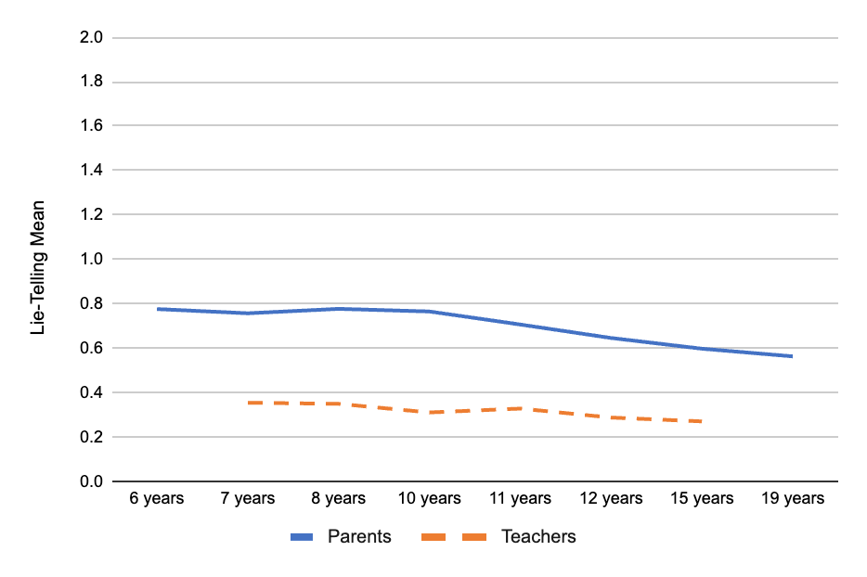

Figure S2
Model-Implied Latent Growth Trajectory for Overall Sample of Teachers’ Reports of Lie-Telling

Figure S3
Model-Implied Latent Growth Trajectory for Overall Sample of Parents’ Reports of Lying

