Appendices

Depressive Symptoms Amplify the Impact of Feeling Supported or Ignored by Friends Online on Adolescents’ Well- and Ill-Being

Janssen, L.H.C.^{1,2}, van der Wal, A.², & Beyens, I.²

¹ Department of Developmental Psychology, Utrecht University, Utrecht, the Netherlands.
² Amsterdam School of Communication Research, University of Amsterdam, Amsterdam, The Netherlands.

* Corresponding author. Email: l.h.c.janssen@uu.nl
Appendix A
DSEM Estimates and 95% Bayesian Credible Intervals for the Within-Person Effects, Between-Person Associations, Random Effects and Moderation of Gender of Time Spent Communicating Online, Feeling Supported by Friends Online, and Feeling Ignored by Friends Online on Well-being and Ill-being
In response to a reviewer’s suggestion, we explored gender as potential moderator of the effects of online communication with friends on well- and ill-being. These analyses were exploratory in nature and we focused on adolescents who indicated that they identified as boy or girl (n = 475), excluding 4 non-binary adolescents. Our main conclusions remained the same. Adolescents’ gender explained the differences in the effects of time spent communicating online on ill-being (β = .164, p = .016) and the effects of feeling ignored by friends online on ill-being (β = .134, p = .006). Simple slope analyses (see Figures A1 and A2) indicated that on days when girls reported spending more time communicating online with friends, they experienced higher ill-being while for boys there was no effect of time spent communicating online on ill-being. With regard to feeling ignored by friends online, both girls and boys experienced higher ill-being on days when they reported feeling more ignored by their friends online, but the effect was stronger for girls than boys. The full model results can be found in Table A1 below.

Figure A1
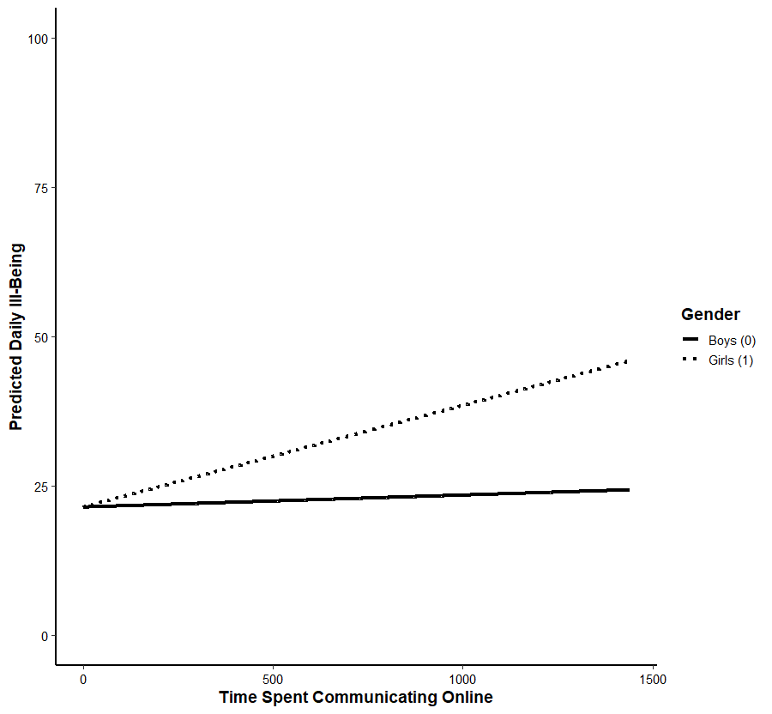
Simple Slopes of the Moderating Role of Gender in the Effect of Time Spent Communicating Online on Ill-being
Note. Lines represent predicted values for boys and girls.
Figure A2
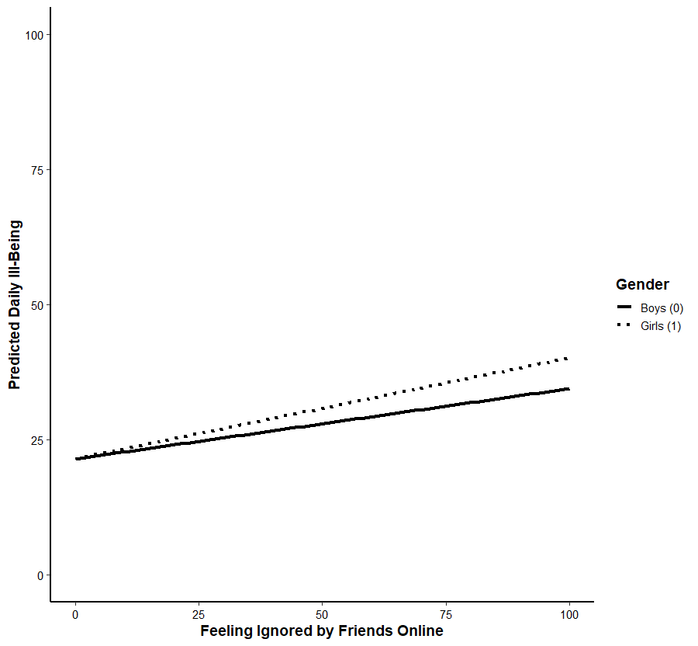
Simple Slopes of the Moderating Role of Gender in the Effect of Feeling Ignored by Friends Online on Ill-being
Note. Lines represent predicted values for boys and girls.
Table A1
DSEM Estimates and 95% Bayesian Credible Intervals for the Within-Person Effects, Between-Person Associations, Random Effects and Moderation of Gender of Time Spent Communicating Online, Feeling Supported by Friends Online, and Feeling Ignored by Friends Online on Well-being and Ill-being
 |  | Time spent communicating online (H1)ª |  |  |  |  |  | Feeling supported by friends online (H2) |  |  |  |  | Feeling ignored by friends online (H3)^{b}
 |  | b | β | p | 95% CI |  | b |  | β | p | 95% CI |  |  | b | β | p | 95% CI
Well-being (H1a, H2a, H3a)
Fixed effects
Within-person
Well-being (t-1) à Well-being (t) |  | 0.264 | .264 | < .001 | [0.252, 0.275] |  | 0.245 |  | .245 | < .001 | [0.234, 0.257] |  |  | 0.261 | .260 | < .001 | [0.248, 0.273]
Predictor àWell-being |  | 0.006 | .020 | .015 | [0.002, 0.036] |  | 0.201 |  | .199 | < .001 | [0.187, 0.210] |  |  | -0.055 | -.083 | < .001 | [-0.097, -0.071]
Between-person
Predictor & Well-being |  | 29.437 | .052 | .132 | [-0.042, 0.146] |  | 105.643 |  | .641 | < .001 | [0.580, 0.694] |  |  | -64.728 | -.366 | < .001 | [-0.446, -0.282]
Gender Well-being |  | -3.491 | -.102 | .002 | [-0.166, -0.038] |  | -3.463 |  | -.102 | .001 | [-0.166, -0.037] |  |  | -3.259 | -.104 | .001 | [-0.167, -0.098]
Gender Predictor |  | 2.850 | .021 | .252 | [-0.045, 0.086] |  | 1.015 |  | .026 | .217 | [-0.039, 0.091] |  |  | 1.525 | .036 | .136 | [-0.028, -0.098]
Gender Beta |  | -0.001 | -.003 | .473 | [-0.079, 0.073] |  | 0.015 |  | .020 | .303 | [-0.053, 0.090] |  |  | -0.045 | -.063 | .050 | [-0.139, 0.012]
Random effect |  | σ² |  | p | 95% CI |  | σ² |  |  | p | 95% CI |  |  | σ² |  | p | 95% CI
Predictor Well-being |  | .009 |  | < .001 | [0.007 0.011] |  | .072 |  |  | < .001 | [0.062, 0.085] |  |  | .064 |  | < .001 | [0.055, 0.076]
Ill-being (H1b, H2b, H3b)
Fixed effects
Within-person
Ill-being (t-1)  Ill-being (t) |  | 0.235 | .235 | < .001 | [0.221, 0.250] |  | 0.230 |  | .231 | < .001 | [0.219, 0.243] |  |  | 0.223 | .223 | < .001 | [0.209, 0.237]
Predictor à Ill-being |  | 0.002 | .028 | < .001 | [0.011, 0.046] |  | -0.136 |  | -.108 | < .001 | [-0.121, -0.094] |  |  | 0.130 | .142 | < .001 | [0.128, 0.156]
Between-person
Predictor & Ill-being |  | 5.727 | .009 | .435 | [-0.102, 0.115] |  | -64.937 |  | -.321 | < .001 | [-0.402, -0.235] |  |  | 162.406 | .779 | < .001 | [0.730, 0.820]
Gender Ill-being |  | 7.731 | .183 | <.001 | [0.108, 0.256] |  | 7.238 |  | .173 | < .001 | [0.110, -0.233] |  |  | 7.620 | .182 | < .001 | [0.106, 0.255]
Gender Predictor |  | 4.739 | .037 | .179 | [-0.043, 0.110] |  | 0.924 |  | .023 | .244 | [-0.044, 0.090] |  |  | 0.378 | .009 | .413 | [-0.071, 0.085]
Gender Beta |  | 0.015 | .164 | .016 | [0.015, 0.321] |  | 0.001 |  | .001 | .489 | [-0.079, 0.078] |  |  | 0.057 | .134 | .006 | [0.030, 0.242]
Random effect |  | σ² |  | p | 95% CI |  | σ² |  |  | p | 95% CI |  |  | σ² |  | p | 95% CI
Predictor Ill-being |  | .001 |  | < .001 | [0.001 0.002] |  | .074 |  |  | < .001 | [0.062, 0.089] |  |  | .021 |  | < .001 | [0.016, 0.028]
Note. Bolded values indicate significant results with regard to gender.
ª With regard to ill-being, model did not converge, results are reported of model including minimum of 50 observations, n = 326
^{b} With regard to ill-being, model did not converge, results are reported of model including minimum of 50 observations, n = 326

Appendix B
Person-Specific Effects of Time Spent Communicating Online With Friends on Well-being and Ill-being
The person-specific effects of time spent communicating online with friends and well-being ranged from β = -.815 to β = .838 for well-being and from β = -.821 to β = .656 for ill-being. See Figure B1a-b for overview of range.

Figure B1
Distribution of the Person-Specific Standardized Effects Across the Sample for the Effects of Time Spent Communicating Online with Friends on Well-Being (B1a) and Ill-being (B1b).
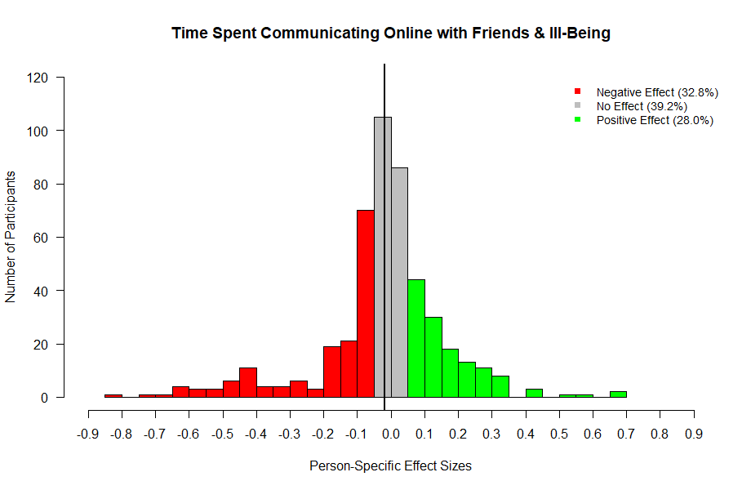
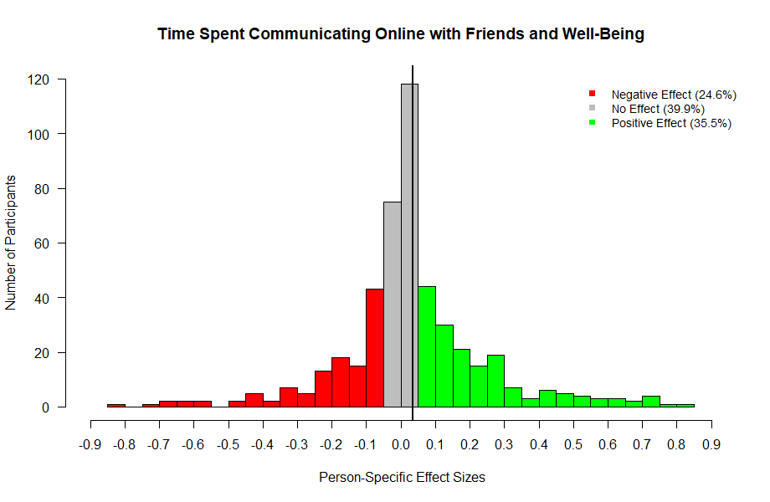
B1b
B1a
Note. The x-axes display standardized effect sizes, the y-axes display the number of participants.

Appendix C
Simple Slope Analysis to Visually Depict Moderation of Depressive Symptoms of Feeling Supported or Ignored by Friends Online on Well-being and Ill-being

Figure C1
Simple Slopes of the Moderating Role of Depressive Symptoms in the Effect of Feeling Supported by Friends Online on Well-being
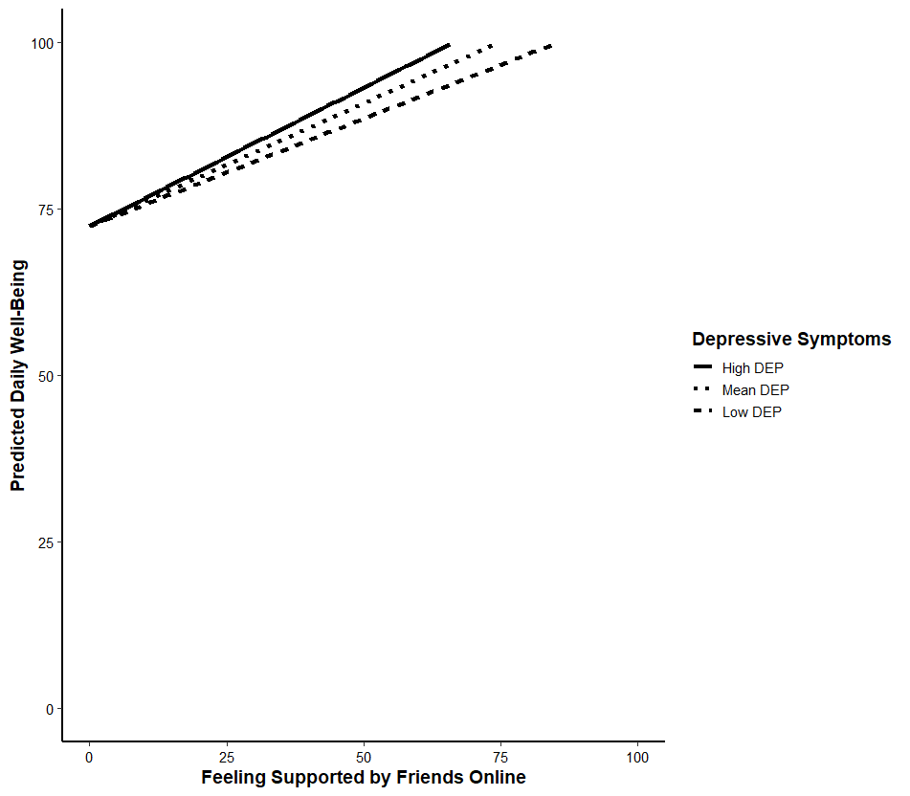
Note. Lines represent predicted values at low (−1 SD), mean, and high (+1 SD) levels of depressive symptoms.

Figure C2
Simple Slopes of the Moderating Role of Depressive Symptoms in the Effect of Feeling Ignored by Friends Online on Well-being
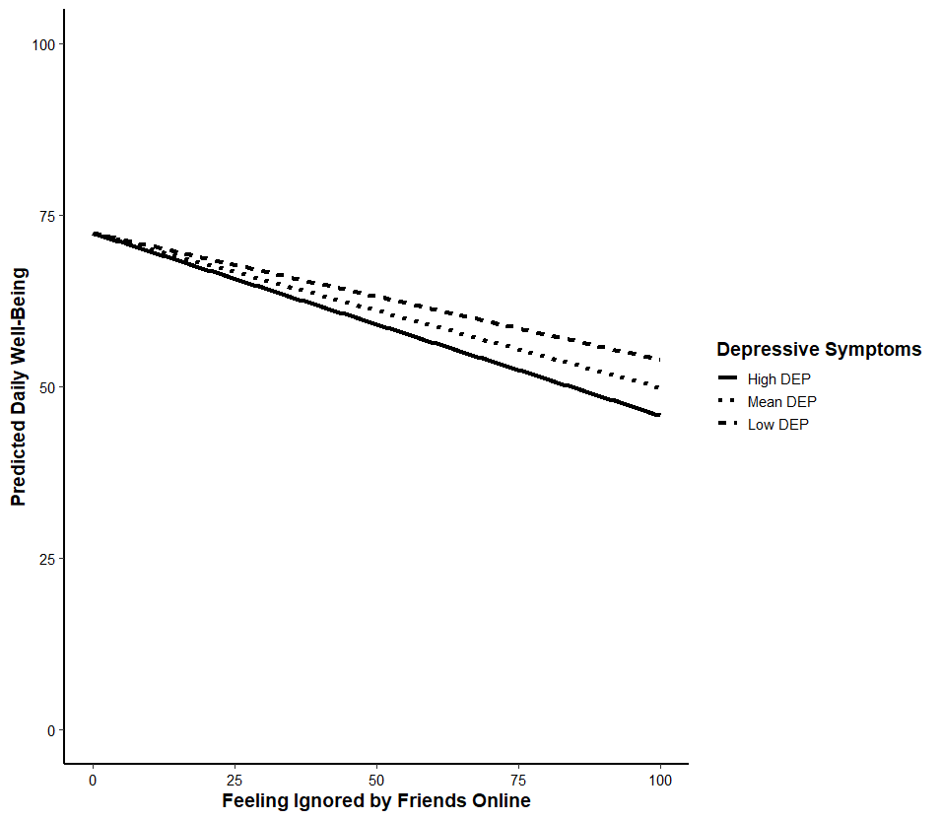
Note. Lines represent predicted values at low (−1 SD), mean, and high (+1 SD) levels of depressive symptoms.

Figure C3
Simple Slopes of the Moderating Role of Depressive Symptoms in the Effect of Feeling Supported by Friends Online on Ill-being
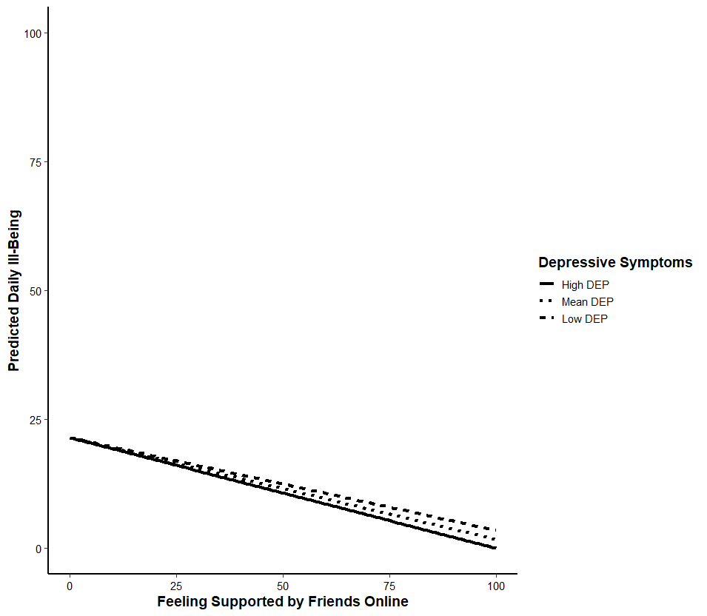
Note. Lines represent predicted values at low (−1 SD), mean, and high (+1 SD) levels of depressive symptoms.
Figure C4
Simple Slopes of the Moderating Role of Depressive Symptoms in the Effect of Feeling Ignored by Friends Online on Ill-being
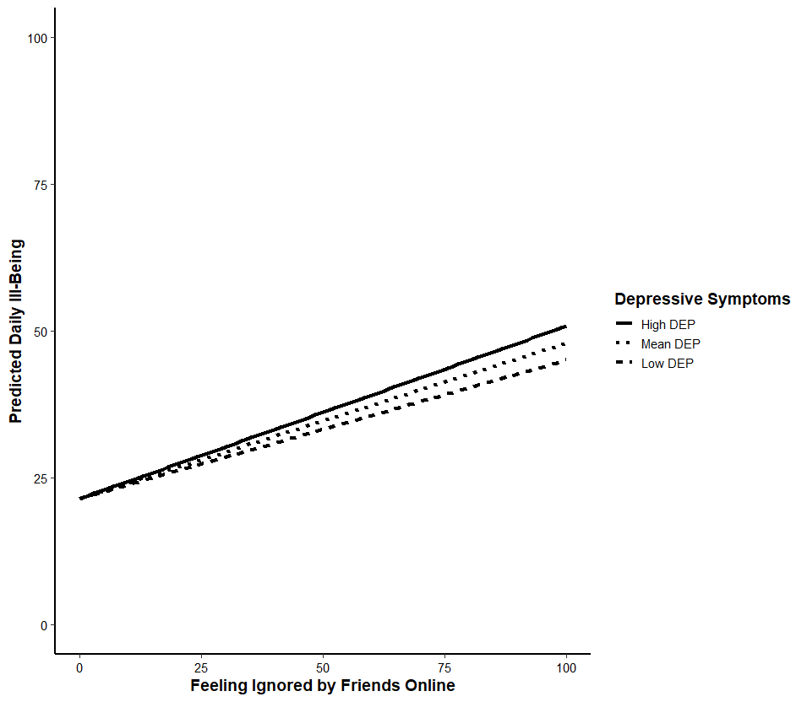
Note. Lines represent predicted values at low (−1 SD), mean, and high (+1 SD) levels of depressive symptoms.

Appendix D
DSEM Analyses for the Effects of Time Spent Communicating Online, Feeling Supported by Friends Online, and Feeling Ignored by Friends Online on Well-being and Ill-being on Sample of Adolescents with a Minimum of 50 Observations of Communicating Online With Friends

Table D1
DSEM Estimates and 95% Bayesian Credible Intervals for the Within-Person Effects, Between-Person Associations, Random Effects of Time Spent Communicating Online, Feeling Supported by Friends Online, and Feeling Ignored by Friends Online on Well-being and Ill-being on Sample of Adolescents with a Minimum of 50 Observations of Communicating Online With Friends (N = 339)
 |  | Time spent communicating online (H1) |  |  |  |  |  | Feeling supported  by friends online (H2) |  |  |  |  | Feeling ignored by friends online (H3)
 |  | b | β | p | 95% CI |  | b |  | β | p | 95% CI |  |  | b | β | p | 95% CI
Well-being (H1a, H2a, H3a)
Fixed effects
Within-person
Well-being (t-1) Well-being (t) |  | 0.265 | .265 | < .001 | [0.251, 0.277] |  | 0.245 |  | .244 | < .001 | [0.231, 0.257] |  |  | 0.258 | .259 | < .001 | [0.245, 0.271]
Predictor Well-being |  | 0.001 | .003 | .382 | [-0.016, 0.022] |  | 0.199 |  | .196 | < .001 | [0.183, 0.210] |  |  | -0.089 | -.093 | < .001 | [-0.108, -0.078]
Between-person
Predictor & Well-being |  | 49.293 | .091 | .055 | [-0.021, 0.198] |  | 114.452 |  | .674 | < .001 | [0.608, 0.730] |  |  | -72.500 | -.408 | < .001 | [-0.498, -0.315]
Random effect |  | σ² |  | p | 95% CI |  | σ² |  |  | p | 95% CI |  |  | σ² |  | p | 95% CI
Predictor Well-being |  | .002 |  | < .001 | [0.002, 0.003] |  | .033 |  |  | < .001 | [0.026, 0.042] |  |  | .025 |  | < .001 | [0.020, 0.032]
Ill-being (H1b, H2b, H3b)
Fixed effects
Within-person
Ill-being (t-1)  Ill-being (t) |  | 0.234 | .234 | < .001 | [0.219, 0.248] |  | 0.225 |  | .225 | < .001 | [0.211, 0.239] |  |  | 0.220 | .220 | < .001 | [0.206, 0.234]
Predictor Ill-being |  | 0.010 | .026 | .007 | [0.006, 0.045] |  | -0.132 |  | -.107 | < .001 | [-0.122, -0.093] |  |  | 0.169 | .146 | < .001 | [0.131, 0.160]
Between-person
Predictor & Ill-being |  | 5.618 | .008 | 0.439 | [-0.270, 0.111] |  | -69.372 |  | -.333 | < .001 | [-0.430, -0.234] |  |  | 166.968 | .764 | < .001 | [0.714, 0.809]
Random effect |  | σ² |  | p | 95% CI |  | σ² |  |  | p | 95% CI |  |  | σ² |  | p | 95% CI
Predictor Ill-being |  | .001 |  | < .001 | [0.001, 0.002] |  | .039 |  |  | < .001 | [0.030, 0.049] |  |  | .023 |  | < .001 | [0.017, 0.029]
Note. Bolded values indicate difference in comparison to initial results.

Table D2
 |  | Feeling supported  by friends online (RQ1) |  |  |  |  | Feeling ignored  by friends online (RQ2)ª
 |  | b | β | p | 95% CI |  | b | β | p | 95% CI
Well-being (RQ1a, RQ2a)
Fixed effects
Within-person
Well-being (t-1) Well-being (t) |  | 0.245 | .245 | < .001 | [0.232, 0.257]
Predictor Well-being |  | 0.193 | .191 | < .001 | [0.176, 0.207]
Between-person
Predictor & Well-being |  | 96.712 | .665 | < .001 | [0.598, 0.724]
Depressive symptoms Well-being |  | -1.020 | -.363 | < .001 | [-0.427, -0.293]
Depressive symptoms Predictor |  | -0.548 | -.156 | < .001 | [-0.228, -0.081]
Depressive symptoms Beta |  | 0.007 | .146 | < .001 | [0.052, 0.232]
Random effect |  | σ² |  | p | 95% CI
Predictor & Well-being |  | 0.033 |  | < .001 | [0.026, 0.042]
Ill-being (RQ1b, RQ2b)
Fixed effects
Within-person
Ill-being (t-1) Ill-being (t) |  | 0.227 | .227 | < .001 | [0.213, 0.240] |  | 0.222 | .222 | < .001 | [0.208, 0.235]
Predictor Ill-being |  | -0.131 | -.107 | < .001 | [-0.120, -0.093] |  | 0.169 | .146 | < .001 | [0.132, 0.160]
Between-person
Predictor & Ill-being |  | -42.077 | -.255 | < .001 | [-0.356, -0.151] |  | 118.625 | .723 | < .001 | [0.662, 0.772]
Depressive symptoms Ill-being |  | 1.475 | .444 | < .001 | [0.381, 0.504] |  | 1.478 | .445 | < .001 | [0.380, 0.505]
Depressive symptoms Predictor |  | -0.540 | -.155 | < .001 | [-0.225, -0.080] |  | 0.997 | .279 | < .001 | [0.207, 0.346]
Depressive symptoms Beta |  | -0.005 | -.100 | .018 | [-.191, -0.006] |  | 0.005 | .124 | .012 | [0.018, 0.224]
Random effect |  | σ² |  | p | 95% CI |  | σ² |  | p
Predictor & Ill-being |  | 0.038 |  | < .001 | [0.030, 0.048] |  | 0.022 |  | < .001 | [0.017, 0.029]
DSEM Estimates and 95% Bayesian Credible Intervals for the Within-Person Effects, Between-Person Associations, Random Effects, and Moderation of Depressive Symptoms of Feeling Supported by Friends Online, and Feeling Ignored by Friends Online on Well-being and Ill-being on Sample of Adolescents with a Minimum of 50 Observations of Communicating Online With Friends (N = 339)
Note. Bolded values indicate difference in comparison to initial results.
ªInitial results reported on feeling ignored by friends online and well-being were already on adolescents with more than 50 observations.
Appendix E
DSEM Analyses for the Effects of Time Spent Communicating Online, Feeling Supported by Friends Online, and Feeling Ignored by Friends Online on Well-being and Ill-being on Sample Excluding Untrustworthy Observations

Table E1
DSEM Estimates and 95% Bayesian Credible Intervals for the Within-Person Effects, Between-Person Associations, Random Effects of Time Spent Communicating Online, Feeling Supported by Friends Online, and Feeling Ignored by Friends Online on Well-being and Ill-being on Sample Excluding Untrustworthy Observations

 |  | Time spent communicating online (H1)ª |  |  |  |  |  | Feeling supported by friends online (H2) |  |  |  |  | Feeling ignored by friends online (H3)^{b}
 |  | b | β | p | 95% CI |  | b |  | β | p | 95% CI |  |  | b | β | p | 95% CI
Well-being (H1a, H2a, H3a)
Fixed effects
Within-person
Well-being (t-1) Well-being (t) |  | 0.262 | .262 | < .001 | [0.249, 0.275] |  | 0.245 |  | .245 | < .001 | [0.233, 0.257] |  |  | 0.259 | .259 | < .001 | [0.246, 0.270]
Predictor Well-being |  | 0.001 | .006 | .262 | [0.011, 0.023] |  | 0.211 |  | .199 | < .001 | [0.187, 0.212] |  |  | -0.080 | -.082 | < .001 | [-0.096, -0.068]
Between-person
Predictor & Well-being |  | 43.233 | .080 | .086 | [-0.034, 0.189] |  | 103.397 |  | .626 | < .001 | [0.565, 0.682] |  |  | -64.196 | -.370 | < .001 | [-0.446, -0.284]
Random effect |  | σ² |  | p | 95% CI |  | σ² |  |  | p | 95% CI |  |  | σ² |  | p | 95% CI
Predictor Well-being |  | .002 |  | < .001 | [0.001, 0.003] |  | .070 |  |  | < .001 | [0.060, 0.082] |  |  | .068 |  | < .001 | [0.057, 0.080]
Ill-being (H1b, H2b, H3b)
Fixed effects
Within-person
Ill-being (t-1)  Ill-being (t) |  | 0.239 | .238 | < .001 | [0.226, 0.251] |  | 0.232 |  | .231 | < .001 | [0.217, 0.244] |  |  | 0.222 | .222 | < .001 | [0.208, 0.235]
Predictor Ill-being |  | -0.007 | -.013 | .139 | [-0.036, 0.008] |  | -0.149 |  | -.119 | < .001 | [-0.132, -0.106] |  |  | 0.166 | .143 | < .001 | [0.128, 0.156]
Between-person
Predictor & Ill-being |  | 42.316 | .060 | .103 | [-0.032, 0.154] |  | -61.136 |  | -.299 | < .001 | [-0.380, -0.210] |  |  | 163.523 | .759 | < .001 | [0.706, 0.803]
Random effect |  | σ² |  | p | 95% CI |  | σ² |  |  | p | 95% CI |  |  | σ² |  | p | 95% CI
Predictor Ill-being |  | .011 |  | < .001 | [0.009, 0.013] |  | .072 |  |  | < .001 | [0.060, 0.087] |  |  | .023 |  | < .001 | [0.017, 0.030]
Note. Bolded values indicate difference in comparison to initial results.
ªWhen doubling iterations of time spent & well-being, there was no convergence. Therefore results are reported of model that did converge, including minimum of 50 observations. n = 328 instead of n = 479
^{b}No convergence on full dataset, results on model data including adolescents with more than 50 observations. n = 328 instead of n = 479
Table E2
DSEM Estimates and 95% Bayesian Credible Intervals for the Within-Person Effects, Between-Person Associations, Random Effects and Moderation of Depressive Symptoms of Feeling Supported by Friends Online, and Feeling Ignored by Friends Online on Well-being and Ill-being on Sample Excluding Untrustworthy Observations
 |  | Feeling supported  by friends online (RQ1) |  |  |  |  | Feeling ignored  by friends online (RQ2)ª
 |  | b | β | p | 95% CI |  | b | β | p | 95% CI
Well-being (RQ1a, RQ2a)
Fixed effects
Within-person
Well-being (t-1) Well-being (t) |  | 0.245 | .246 | < .001 | [0.234, 0.257] |  | 0.259 | .259 | < .001 | [0.247, 0.270]
Predictor Well-being |  | 0.211 | .198 | < .001 | [0.186, 0.214] |  | -0.081 | -.083 | < .001 | [-0.097, -0.069]
Between-person
Predictor & Well-being |  | 86.510 | .606 | < .001 | [0.545, 0.663] |  | -30.633 | -.219 | < .001 | [-0.305, -0.127]
Depressive symptoms Well-being |  | -0.954 | -.347 | < .001 | [-0.401, -0.285] |  | -0.953 | -.346 | < .001 | [-0.401, -0.286]
Depressive symptoms Predictor |  | -0.520 | -.155 | < .001 | [-0.217, -0.091] |  | 1.049 | .308 | < .001 | [0.248, 0.364]
Depressive symptoms Beta |  | 0.009 | .133 | < .001 | [0.062, 0.200] |  | -0.005 | -.081 | .018 | [-0.157, -0.006]
Random effect |  | σ² |  | p | 95% CI |  | σ² |  | p | 95% CI
Predictor Well-being |  | 0.068 |  | < .001 | [0.058, 0.080] |  | 0.066 |  | < .001 | [0.056, 0.078]
Ill-being (RQ1b, RQ2b)
Fixed effects
Within-person
Ill-being (t-1) Ill-being (t) |  | 0.235 | .235 | < .001 | [0.222, 0.247] |  | 0.223 | .223 | < .001 | [0.210, 0.237]
Predictor Ill-being |  | -0.148 | -.117 | < .001 | [-0.130, -0.106] |  | 0.166 | .142 | < .001 | [0.127, 0.156]
Between-person
Predictor & Ill-being |  | -34.316 | -.214 | < .001 | [-0.301, -0.122] |  | 112.489 | .710 | < .001 | [0.647, 0.763]
Depressive symptoms Ill-being |  | 1.483 | .454 | < .001 | [0.394, 0.499] |  | 1.522 | .460 | < .001 | [0.395, 0.518]
Depressive symptoms Predictor |  | -0.510 | -.152 | < .001 | [-0.212, -0.086] |  | 1.033 | .290 | < .001 | [0.220, 0.358]
Depressive symptoms Beta |  | -0.006 | .-084 | .018 | [-.160, -0.006] |  | 0.005 | .138 | .005 | [0.033, 0.243]
Random effect |  | σ² |  | p | 95% CI |  | σ² |  | p | 95% CI
Predictor Ill-being |  | 0.071 |  | < .001 | [0.060, 0.086] |  | 0.022 |  | < .001 | [0.016, 0.029]
Note. Bolded values indicate difference in comparison to initial results.
ª With regard to well-being, convergence reached after 23,100 iterations (doubling iterations resulted in similar findings), results of 23,100 iteration-model are reported. With regard to ill-being, model did not converge, results are reported of model including minimum of 50 observations, n = 328

