Supplementary Tables

Table S1

Range, Means (M), and Standard Deviations (SD) of Unstandardized Study Variables for both the Control and Experimental Groups
 | Range | Experimental Group (n = 315) |  |  |  |  |  |  | Control Group (n = 140)
 | Range | Rejection condition |  |  | Acceptance condition |  |  |  | Neutral condition ^{rej} |  |  | Neutral condition ^{acc}
 | Range | n | M | SD | n | M | SD |  | n | M | SD | n | M | SD
Gender | 0.00/1.00 | 315 | 0.50 | 0.50 | 315 | 0.50 | 0.50 |  | 140 | 0.49 | 0.50 | 140 | 0.49 | 0.50
Age | 10.00–12.17 | 303 | 10.86 | 0.39 | 303 | 10.86 | 0.39 |  | 135 | 10.87 | 0.38 | 135 | 10.87 | 0.38
SPS | 2.00–6.14 | 315 | 4.21 | 0.79 | 315 | 4.21 | 0.79 |  | 140 | 4.30 | 0.83 | 140 | 4.30 | 0.83
Positive mood-Pre | 1.00–5.00 | 313 | 4.23 | 0.75 | 314 | 4.14 | 0.77 |  | 139 | 4.10 | 0.80 | 139 | 4.10 | 0.73
Negative mood-Pre | 1.00–5.00 | 313 | 1.24 | 0.53 | 314 | 1.25 | 0.50 |  | 139 | 1.29 | 0.67 | 139 | 1.33 | 0.74
Positive SSE-Pre | 1.00–5.00 | 313 | 3.80 | 0.92 | 314 | 3.77 | 0.88 |  | 139 | 3.66 | 0.92 | 139 | 3.72 | 0.88
Negative SSE-Pre | 1.00–5.00 | 313 | 1.36 | 0.75 | 314 | 1.37 | 0.72 |  | 139 | 1.38 | 0.77 | 139 | 1.47 | 0.84
Positive mood-Post | 1.00–5.00 | 293 | 2.87 | 1.28 | 300 | 4.57 | 0.7 |  | 125 | 3.94 | 1.06 | 125 | 4.01 | 1.01
Negative mood-Post | 1.00–5.00 | 293 | 2.47 | 1.16 | 300 | 1.20 | 0.51 |  | 125 | 1.46 | 0.92 | 125 | 1.49 | 0.82
Positive SSE-Post | 1.00–5.00 | 293 | 2.76 | 1.32 | 300 | 4.26 | 0.87 |  | 125 | 3.66 | 1.09 | 125 | 3.73 | 1.02
Negative SSE-Post | 1.00–5.00 | 293 | 2.55 | 1.33 | 300 | 1.26 | 0.65 |  | 125 | 1.48 | 0.88 | 125 | 1.59 | 1.02
Benign IA-Post | 1.00–5.00 | 293 | 2.28 | 1.29 | 300 | 4.55 | 0.75 |  | 125 | 3.77 | 1.19 | 125 | 3.91 | 1.03
Hostile IA-Post | 1.00–5.00 | 293 | 2.84 | 1.40 | 300 | 1.22 | 0.62 |  | 125 | 1.67 | 1.03 | 125 | 1.63 | 1.00
Prosocial behavior-Post | 0.00-152 | 292 | 26.14 | 33.29 | 300 | 57.69 | 30.43 |  | 125 | 48.33 | 31.96 | 125 | 49.54 | 31.26
Aggressive behavior-Post | 0.00-109 | 292 | 34.72 | 36.25 | 300 | 7.26 | 21.15 |  | 125 | 11.14 | 23.82 | 125 | 8.42 | 21.87
Note. SPS = Sensory Processing Sensitivity. SSE = State Self-esteem. IA = Intent Attribution.
^{rej} Children in the neutral condition matched to the rejection condition. ^{acc} Children in the neutral condition matched to the acceptance condition.
Five participants were absent for one of the two experimental sessions, leading to missing pretest and posttest scores (rejection condition: n = 2; acceptance condition: n = 1; neutral condition: n = 2). Additional posttest data was missing due to internet or software issues after the 3-minute interaction (rejection condition: n = 21; acceptance condition: n = 14; neutral condition: n = 28).

Table S2

Zero-order Correlations of Study Variables for the Rejection Condition (Above Diagonal) and Acceptance Condition (Below Diagonal) Across the Experimental and Control Group
 | n | 1 | 2 | 3 | 4 | 5 | 6 | 7 | 8 | 9 | 10 | 11 | 12 | 13
n |  | 452 | 452 | 452 | 452 | 418 | 418 | 418 | 418 | 418 | 418 | 417 | 417 | 455
1. PM-Pre | 453 |  | -0.43*** | 0.58*** | -0.29*** | 0.41*** | -0.18*** | 0.23*** | -0.07 | 0.15** | -0.14** | 0.11* | -0.07 | -0.03
2. NM-Pre | 453 | -0.40*** |  | -0.31*** | 0.62*** | -0.13*** | 0.29*** | -0.05 | 0.23*** | -0.03 | 0.18*** | -0.04 | 0.04 | 0.04
3. PSSE-Pre | 453 | 0.60*** | -0.21*** |  | -0.39*** | 0.37*** | -0.17*** | 0.44*** | -0.20*** | 0.11* | -0.05 | 0.07 | 0.02 | 0.04
4. NSSE-Pre | 453 | -0.37*** | 0.54*** | -0.37*** |  | -0.13*** | 0.31*** | -0.16** | 0.35*** | -0.07 | 0.16** | -0.08 | 0.03 | 0.05
5. PM-Post | 425 | 0.54*** | -0.32*** | 0.46*** | -0.32*** |  | -0.69*** | 0.71*** | -0.55*** | 0.53*** | -0.39*** | 0.30*** | -0.31*** | -0.01
6. NM-Post | 425 | -0.25*** | 0.60*** | -0.06 | 0.38*** | -0.48*** |  | -0.55*** | 0.68*** | -0.45*** | 0.51*** | -0.25*** | 0.25*** | 0.02
7. PSSE-Post | 425 | 0.48*** | -0.25*** | 0.61*** | -0.37*** | 0.68*** | -0.29*** |  | -0.63*** | 0.42*** | -0.27*** | 0.21*** | -0.18** | 0.03
8. NSSE-Post | 425 | -0.30*** | 0.50*** | -0.26*** | 0.60*** | -0.48*** | 0.55*** | -0.39*** |  | -0.35*** | 0.39*** | -0.20*** | 0.18*** | -0.03
9. BIA-Post | 425 | 0.34*** | -0.21*** | 0.28*** | -0.29*** | 0.42*** | -0.29*** | 0.43*** | -0.29*** |  | -0.64*** | 0.51*** | -0.49*** | 0.06
10. HIA-Post | 425 | -0.17*** | 0.27*** | -0.11* | 0.30*** | -0.26*** | 0.36*** | -0.24*** | 0.35*** | -0.65*** |  | -0.42*** | 0.46*** | -0.02
11. PB-Post | 425 | 0.15** | -0.14** | 0.07 | -0.17** | 0.21*** | -0.18*** | 0.14** | -0.20*** | 0.34*** | -0.23*** |  | -0.71*** | 0.03
12. AB-Post | 425 | -0.07 | 0.15** | 0.03 | 0.10* | -0.14** | 0.23*** | -0.06 | 0.09 | -0.28*** | 0.28*** | -0.60*** |  | 0.00
13. SPS | 455 | -0.02 | 0.04 | 0.04 | 0.09 | 0.02 | -0.01 | 0.04 | 0.02 | -0.03 | -0.01 | 0.03 | -0.04
Note. PM = Positive Mood. NM = Negative Mood. PSSE = Positive State Self-esteem. NSSE = Negative State Self-esteem. BIA = Benign Intent Attribution. HIA = Hostile Intent Attribution. PB = Prosocial behavior. AB = Aggressive behavior. SPS = Sensory Processing Sensitivity.
*p < .05, **p < .01, ***p < .001

Table S3

Parameter Estimates of Unconditional Latent Change Score Models of Standardized Mood and State Self-esteem for Experimental Group Children (n =315).
Dependent variable | Rejection Condition |  |  |  |  | Acceptance Condition
Dependent variable | Mean |  | Variance |  |  | Mean |  | Variance
Dependent variable | Est. (SD) | 95%PPI | Est. (SD) | 95%PPI |  | Est. (SD) | 95%PPI | Est. (SD) | 95%PPI
Δ Positive mood | -1.78 (0.09) | [-1.96, -1.61]* | 1.63 (0.24) | [1.18, 2.12]* |  | 0.58 (0.04) | [0.49, 0.66]* | 0.10 (0.08) | [0.00, 0.27]*
Δ Negative mood | 2.12 (0.12) | [1.90, 2.36]* | 3.62 (0.34) | [2.98, 4.32]* |  | -0.12 (0.04) | [-0.20, -0.04]* | 0.09 (0.09) | [0.00, 0.29]*
Δ Positive SSE | -1.12 (0.08) | [-1.27, -0.97]* | 1.23 (0.16) | [0.94, 1.56]* |  | 0.55 (0.05) | [0.46, 0.64]* | 0.14 (0.08) | [0.02, 0.31]*
Δ Negative SSE | 1.58 (0.1) | [1.38, 1.77]* | 2.58 (0.25) | [2.13, 3.11]* |  | -0.15 (0.04) | [-0.23, -0.07]* | 0.05 (0.05) | [0.00, 0.15]*
Note. Δ = Latent Changes. SSE = State Self-esteem. Est. = unstandardized parameter estimate. SD = standard deviation.
We used the Bayes estimator due to negative residual variance warnings.
* The 95% posterior credible interval does not include zero. This suggests there is a 95% probability that the true effect lies outside zero, given the data and the prior model assumptions.

Table S4

Parameter Estimates of Unconditional Regression Models of Intent Attribution and Behavior for Experimental Group Children (n = 314 ª).
Dependent variable | Rejection Condition |  |  |  |  |  | Acceptance Condition
Dependent variable | Mean |  |  | Variance |  |  | Mean |  |  | Variance
Dependent variable | Estimate (SE) | p |  | Estimate (SE) | p |  | Estimate (SE) | p |  | Estimate (SE) | p
Benign IA-Post | 2.28 (0.08) | < .001 |  | 1.66 (0.11) | < .001 |  | 4.55 (0.04) | < .001 |  | 0.56 (0.09) | < .001
Hostile IA-Post | 2.85 (0.08) | < .001 |  | 1.96 (0.1) | < .001 |  | 1.22 (0.04) | < .001 |  | 0.39 (0.09) | < .001
Prosocial behavior-Post | 26.14 (1.95) | < .001 |  | 1104.61 (85.47) | < .001 |  | 57.69 (1.75) | < .001 |  | 922.79 (71.48) | < .001
Aggressive behavior-Post | 34.72 (2.12) | < .001 |  | 1309.27 (69.58) | < .001 |  | 7.26 (1.22) | < .001 |  | 445.76 (82.97) | < .001
Note. IA = Intent Attribution. Estimate = unstandardized parameter estimate. SE = standard error.
ª One participants was excluded due to missing all intent attribution and behavior data for both sessions. Such missing data could not be handled by the FIML method in Mplus as these cases had no available information on outcome variables.

Table S5

Good to Excellent Model Fit Across Outcomes of Unconditional Latent Change Score Models for Experimental Group Children (n = 315)
Dependent variable | PPP value | 95% CI Lower Bound | 95% CI Upper Bound
Positive mood | 0.36 | -12.13 | 16.90
Negative mood | 0.60 | -16.47 | 12.83
Positive state self-esteem | 0.41 | -13.14 | 15.86
Positive state self-esteem | 0.18 | -8.41 | 21.13
Note. Model fit was assessed using posterior predictive checking and a Posterior Predictive P-value (PPP value) was computed (Kaplan & Depaoli, 2012). Generally, PPP values of less than .05 indicate poor model fit, PPP values between .05 and .10 indicate borderline fit, PPP values of more than .10 indicate good fit, and PPP values of .50 indicate excellent fit.
The 95% posterior predictive credibility interval reflects the distribution of differences between observed and replicated χ² values. It should include zero, suggesting that the model reproduces the observed data well (Kaplan & Depaoli, 2012).
Unconditional regression model fit for posttest-only outcomes (i.e., positive and negative intent attribution and behavioral responses) was omitted because fit statistics such as CFI and RMSEA are not applicable in simple analyses of mean and variance without a structural model.

Table S6

Main Effects of Group (0 = Control, 1 = Experimental) on Children’s Standardized Latent Changes (Δ) in Mood and State Self-esteem (N = 455) and Posttest Levels of Intent Attribution and Behavior (n = 449 ª)
Dependent variable | Outcome responses in control group |  |  | Outcome responses in experimental group |  |  | Main effects of Group
 | Estimate (SE) | p |  | Estimate (SE) | p |  | Estimate (SE) | p
Rejection condition
Δ Positive mood | -0.24 (0.10) | .017 |  | -1.77 (0.09) | < .001 |  | -1.53 (0.13) | < .001
Δ Negative mood | 0.27 (0.11) | .014 |  | 2.13 (0.12) | < .001 |  | 1.86 (0.16) | < .001
Δ Positive SSE | -0.03 (0.08) | .699 |  | -1.12 (0.08) | < .001 |  | -1.09 (0.11) | < .001
Δ Negative SSE | 0.11 (0.08) | .137 |  | 1.58 (0.10) | < .001 |  | 1.47 (0.12) | < .001
Benign IA-Post | 0.73 (0.07) | < .001 |  | -0.31 (0.05) | < .001 |  | -1.04 (0.09) | < .001
Hostile IA-Post | -0.58 (0.07) | < .001 |  | 0.25 (0.06) | < .001 |  | 0.83 (0.09) | < .001
Prosocial behavior-Post | 0.46 (0.08) | < .001 |  | -0.19 (0.06) | .001 |  | -0.66 (0.10) | < .001
Aggressive behavior-Post | -0.48 (0.06) | < .001 |  | 0.20 (0.06) | < .001 |  | 0.68 (0.09) | < .001
Acceptance condition
Δ Positive mood | -0.11 (0.10) | .287 |  | 0.58 (0.04) | < .001 |  | 0.69 (0.11) | < .001
Δ Negative mood | 0.28 (0.10) | .005 |  | -0.12 (0.04) | .003 |  | -0.41 (0.11) | < .001
Δ Positive SSE | 0.02 (0.08) | .844 |  | 0.55 (0.05) | < .001 |  | 0.54 (0.09) | < .001
Δ Negative SSE | 0.19 (0.10) | .042 ^{b} |  | -0.15 (0.04) | < .001 |  | -0.34 (0.10) | .001
Benign IA-Post | -0.51 (0.10) | < .001 |  | 0.21 (0.05) | < .001 |  | 0.72 (0.11) | < .001
Hostile IA-Post | 0.37 (0.11) | .001 |  | -0.15 (0.05) | .001 |  | -0.52 (0.12) | < .001
Prosocial behavior-Post | -0.20 (0.09) | .028 ^{b} |  | 0.08 (0.06) | .156 |  | 0.28 (0.11) | .010
Aggressive behavior-Post | 0.04 (0.09) | .677 |  | -0.02 (0.06) | .778 |  | -0.05 (0.11) | .614
Note. For each outcome, main effects were estimated for both the Rejection and Acceptance conditions compared to the control group in a single latent change score model (see Figure 3).
SSE = State Self-esteem. IA = Intent Attribution. Estimate = unstandardized parameter estimate derived from standardized scores. SE = standard error.
ª Six participants were excluded because they missed all intent attribution and behavior data for both sessions. Such missing data could not be handled by the FIML method in Mplus as these cases had no available information on outcome variables.
^{b} According to the FDR procedure this estimate is not significant.

Table S7

Interaction Effects of Group (0 = Control, 1 = Experimental) and Manipulation Order or Profile Order on Children’s Standardized Latent Changes (Δ) in Mood and State Self-esteem (N = 455) and Posttest Levels of Intent Attribution and Behavior (n = 449 ª)
Dependent variable | Group × manipulation order effect |  |  | Group × profile version order effect
 | Estimate (SE) | p |  | Estimate (SE) | p
Rejection Condition
Δ Positive mood | 0.53 (0.26) | .044 ^{b} |  | -0.18 (0.26) | .501
Δ Negative mood | -0.16 (0.32) | .624 |  | -0.20 (0.32) | .539
Δ Positive SSE | 0.51 (0.22) | .018 ^{b} |  | 0.16 (0.22) | .476
Δ Negative SSE | -0.27 (0.25) | .280 |  | -0.17 (0.25) | .509
Benign IA-Post | 0.20 (0.18) | .269 |  | -0.13 (0.18) | .476
Hostile IA-Post | 0.10 (0.17) | .562 |  | 0.05 (0.18) | .795
Prosocial behavior-Post | 0.02 (0.20) | .908 |  | -0.26 (0.20) | .181
Aggressive behavior-Post | 0.33 (0.16) | .040 ^{b} |  | 0.10 (0.17) | .557
Acceptance Condition
Δ Positive mood | -0.15 (0.23) | .514 |  | -0.24 (0.22) | .279
Δ Negative mood | 0.51 (0.21) | .017 ^{b} |  | -0.04 (0.21) | .864
Δ Positive SSE | -0.26 (0.18) | .156 |  | 0.12 (0.18) | .515
Δ Negative SSE | 0.47 (0.20) | .019 ^{b} |  | -0.11 (0.21) | .605
Benign IA-Post | -0.24 (0.23) | .300 |  | -0.08 (0.23) | .732
Hostile IA-Post | 0.58 (0.25) | .019 ^{b} |  | -0.02 (0.25) | .934
Prosocial behavior-Post | 0.16 (0.21) | .449 |  | -0.26 (0.21) | .217
Aggressive behavior-Post | 0.37 (0.21) | .074 |  | 0.010 (0.21) | .647
Note. For each outcome, interaction effects were estimated for both the Rejection and Acceptance conditions compared to the control group in a single latent change score model (see Figure 3).
Estimate = unstandardized parameter estimate. SE = standard error. SSE = State Self-esteem. IA = Intent Attribution.
ª Six participants were excluded because they missed all intent attribution and behavior data for both sessions. Such missing data could not be handled by the FIML method in Mplus as these cases had no available information on outcome variables.
^{b} According to the FDR procedure this estimate is not significant.

Table S8

Descriptive Model Testing Significance of Indicator Means Against Zero For Each Goal 2 Reactivity Subgroup
Means | Mood reactivity  (n = 28) |  |  |  | High reactivity  (n = 141) |  |  |  | Low reactivity  (n = 146)
Means | Estimate | SE | p |  | Estimate | SE | p |  | Estimate | SE | p
Rejection Condition
Δ Positive mood | -1.80 | 0.14 | < .001 |  | -2.55 | 0.07 | < .001 |  | -1.02 | 0.07 | < .001
Δ Negative mood | 2.15 | 0.23 | < .001 |  | 3.34 | 0.13 | < .001 |  | 0.96 | 0.10 | < .001
Δ Positive SSE | -0.74 | 0.17 | < .001 |  | -1.80 | 0.06 | < .001 |  | -0.54 | 0.05 | < .001
Δ Negative SSE | 0.54 | 0.22 | .016 |  | 2.64 | 0.11 | < .001 |  | 0.77 | 0.07 | < .001
Acceptance Condition
Δ Positive mood | 0.69 | 0.03 | < .001 |  | 0.66 | 0.02 | < .001 |  | 0.47 | 0.01 | < .001
Δ Negative mood | -0.26 | 0.04 | < .001 |  | -0.13 | 0.01 | < .001 |  | -0.07 | 0.01 | < .001
Δ Positive SSE | 0.56 | 0.05 | < .001 |  | 0.69 | 0.02 | < .001 |  | 0.40 | 0.01 | < .001
Δ Negative SSE | -0.46 | 0.02 | < .001 |  | -0.13 | 0.01 | < .001 |  | -0.10 | 0.01 | < .001
Note. Δ = Latent change. SSE = State Self-esteem. Estimate = unstandardized parameter estimate derived from standardized scores. SE = standard error.

Table S9

Descriptive Statistics and Univariate Analyses of Variance for Goal 2 Reactivity Subgroups Indicators
Indicators | Mood reactivity  (n = 28) |  |  | High reactivity  (n = 141) |  |  | Low reactivity  (n = 146) |  |  | Subgroup differences
Indicators | M | SD |  | M | SD |  | M | SD |  | F | η²
Rejection Condition
Δ Positive mood | -1.80^{b} | 0.76 |  | -2.55^{c} | 0.84 |  | -1.02ª | 0.79 |  | 128.53*** | 0.45
Δ Positive SSE | -0.74ª | 0.93 |  | -1.80^{b} | 0.68 |  | -0.54ª | 0.60 |  | 131.27*** | 0.46
Δ Negative mood | 2.15^{b} | 1.25 |  | 3.34ª | 1.50 |  | 0.96^{c} | 1.15 |  | 115.37*** | 0.43
Δ Negative SSE | 0.54^{b} | 1.20 |  | 2.64ª | 1.26 |  | 0.77^{b} | 0.87 |  | 119.73*** | 0.43
Acceptance Condition
Δ Positive mood | 0.69ª | 0.18 |  | 0.66ª | 0.19 |  | 0.47^{b} | 0.16 |  | 50.67*** | 0.25
Δ Positive SSE | 0.56^{b} | 0.26 |  | 0.69ª | 0.19 |  | 0.40^{c} | 0.15 |  | 90.24*** | 0.37
Δ Negative mood | -0.26^{c} | 0.20 |  | -0.13^{b} | 0.15 |  | -0.07ª | 0.14 |  | 22.10*** | 0.12
Δ Negative SSE | -0.46^{c} | 0.11 |  | -0.13^{b} | 0.07 |  | -0.10ª | 0.06 |  | 320.88*** | 0.67
Note. Δ = Latent change. SSE = State Self-esteem. Indicator means with different superscripts differ at the p = .05 level in the Games-Howell post hoc test.
For each indicator, we applied a False Discovery Rate (FDR) procedure across post hoc pairwise comparisons to control for inflated Type I errors (Benjamini & Hochberg, 1995).
***p < .001

Table S10

Fit Statistics for Goal 3 SPS Subgroup LPA in the Whole Sample (N = 455)
Number of profiles | AIC | BIC | aBIC | Entropy | p LMR | p BLRT | LT 5%
2 Profiles | 2545.346 | 2574.188 | 2551.972 | 0.420 | 0.0038 | <0.001 | 0
3 Profiles | 2535.828 | 2577.031 | 2545.295 | 0.603 | 0.0162 | 0.0128 | 0
4 Profiles | 2534.228 | 2587.792 | 2546.534 | 0.626 | 0.4664 | 0.3636 | 1
5 Profiles | 2529.099 | 2595.023 | 2544.245 | 0.783 | 0.0892 | 0.0200 | 0
6 Profiles | 2530.430 | 2608.716 | 2548.416 | 0.745 | 0.5211 | 0.6667 | 0
Note. AIC = Akaike’s Information Criterion. BIC = Bayesian Information Criterion. aBIC = sample-size-adjusted BIC. P LMR = p-value for the Lo-Mendel-Rubin adjusted likelihood ratio test for K versus K-1 classes. P BLRT = p-value for the Bootstrapped likelihood ratio test for K versus K-1 classes. LT5% Number of profiles containing less than 5% of cases.

Table S11

Descriptive Statistics and Univariate Analyses of Variance for Goal 3 SPS Subgroup Indicators
 | Low sensitivity  (n = 22) |  |  | Average sensitivity  (n = 106) |  |  | Low aesthetic sensitivity  (n = 64) |  |  | Moderate sensitivity  (n = 100) |  |  | High sensitivity  (n = 23) |  |  | Subgroup differences
Indicators | M | SD |  | M | SD |  | M | SD |  | M | SD |  | M | SD |  | F | η²
EOE-LST | -0.93^{d} | 1.14 |  | -0.22^{c} | 0.86 |  | -0.03^{bc} | 1.05 |  | 0.29^{ab} | 0.85 |  | 0.76ª | 0.99 |  | 13.17*** | 0.15
AES | -2.00e | 0.27 |  | -0.13^{c} | 0.25 |  | -0.98^{d} | 0.26 |  | 0.77^{b} | 0.3 |  | 1.89ª | 0.25 |  | 1002.12*** | 0.93
Note. Indicator means with different superscripts differ at the p = .05 level in the Tukey’s HSD post hoc test.
For each indicator, we applied a False Discovery Rate (FDR) procedure across post hoc pairwise comparisons to control for inflated Type I errors (Benjamini & Hochberg, 1995).
***p < .001

Table S12

Goal 1 Robustness Check Regarding Interaction Effects of Group (0 = Control, 1 = Experimental) × SPS on Children’s Standardized Latent Changes (Δ) in Mood and State Self-esteem and Posttest Levels of Intent Attribution and Behavior
Dependent variable | Condition check succeeded  (ns ª = 359 and 365) |  |  | Susception check succeeded  (ns ª = 433 and 439) |  |  | No manipulation technical issues  (ns ª = 402 and 405) |  |  | No compliance issues  (ns ª =402 and 407) |  |  | Outliers replaced by missing values  (ns ª = 449 - 455) |  |  | Good IA translation  (for IA only)  (n =357)
 | Est. (SE) | p |  | Est. (SE) | p |  | Est. (SE) | p |  | Est. (SE) | p |  | Est. (SE) | p |  | Est. (SE) | p
Rej. Con.
Δ PM | -0.01 (0.15) | .970 |  | -0.03 (0.13) | .817 |  | 0.01 (0.14) | .946 |  | -0.03 (0.14) | .809 |  | 0.02 (0.14) | .907 |  | / | /
Δ NM | 0.1 (0.15) | .522 |  | 0.11 (0.15) | .476 |  | 0.15 (0.15) | .323 |  | 0.16 (0.16) | .328 |  | 0.04 (0.21) | .866 |  | / | /
Δ PSSE | -0.01 (0.16) | .928 |  | -0.01 (0.12) | .906 |  | 0.00 (0.12) | .970 |  | -0.06 (0.12) | .608 |  | -0.02 (0.12) | .895 |  | / | /
Δ NSSE | -0.17 (0.14) | .227 |  | -0.15 (0.12) | .229 |  | -0.23 (0.13) | .084 |  | -0.11 (0.13) | .430 |  | -0.26 (0.17) | .126 |  | / | /
BIA-Post | -0.09 (0.12) | .443 |  | -0.07 (0.09) | .418 |  | -0.11 (0.09) | .218 |  | -0.15 (0.09) | .118 |  | -0.05 (0.09) | .537 |  | -0.10 (0.10) | .324
HIA-Post | 0.03 (0.08) | .706 |  | 0.00 (0.08) | .964 |  | 0.03 (0.08) | .717 |  | 0.07 (0.08) | .408 |  | 0.00 (0.08) | .997 |  | 0.08 (0.09) | .360
PB-Post | -0.12 (0.12) | .297 |  | -0.03 (0.09) | .763 |  | -0.02 (0.10) | .838 |  | 0.02 (0.10) | .855 |  | -0.05 (0.09) | .612 |  | / | /
AB-Post | 0.08 (0.09) | .388 |  | 0.02 (0.08) | .825 |  | 0.05 (0.09) | .568 |  | 0.03 (0.09) | .773 |  | 0.04 (0.08) | .646 |  | / | /
Acc. Con.
Δ PM | -0.22 (0.13) | .085 |  | -0.15 (0.13) | .233 |  | -0.05 (0.11) | .661 |  | -0.02 (0.11) | .860 |  | -0.14 (0.13) | .270 |  | / | /
Δ NM | 0.15 (0.12) | .228 |  | 0.10 (0.11) | .365 |  | 0.10 (0.11) | .371 |  | 0.08 (0.10) | .417 |  | 0.03 (0.16) | .829 |  | / | /
Δ PSSE | -0.28 (0.11) | .007 ^{b} |  | -0.10 (0.10) | .337 |  | -0.17 (0.09) | .047 ^{b} |  | -0.11 (0.09) | .211 |  | -0.11 (0.10) | .280 |  | / | /
Δ NSSE | -0.16 (0.09) | .064 |  | -0.01 (0.13) | .942 |  | -0.14 (0.10) | .155 |  | -0.07 (0.09) | .424 |  | -0.18 (0.11) | .103 |  | / | /
BIA-Post | -0.24 (0.17) | .158 |  | -0.04 (0.11) | .761 |  | -0.05 (0.13) | .690 |  | -0.11 (0.12) | .391 |  | -0.03 (0.12) | .786 |  | -0.14 (0.13) | .257
HIA-Post | 0.05 (0.20) | .803 |  | 0.06 (0.13) | .662 |  | 0.04 (0.15) | .779 |  | 0.10 (0.15) | .507 |  | 0.13 (0.13) | .312 |  | 0.10 (0.15) | .493
PB-Post | -0.20 (0.14) | .150 |  | -0.09 (0.10) | .368 |  | -0.06 (0.12) | .588 |  | -0.09 (0.12) | .436 |  | -0.10 (0.10) | .354 |  | / | /
AB-Post | 0.14 (0.16) | .393 |  | 0.19 (0.12) | .106 |  | 0.20 (0.14) | .130 |  | 0.22 (0.14) | .114 |  | 0.25 (0.15) | .098 |  | / | /
Note. For each outcome, interaction effects were estimated for both the Rejection and Acceptance conditions compared to the control group in a single latent change score model (see Figure 3).
Est. = unstandardized parameter estimate. SE = standard error. Rej. Con. = Rejection condition. Acc. Con. = Acceptance condition. PM = Positive mood. NM = Negative mood. PSSE = Positive state self-esteem. NSSE = Negative state self-esteem. BIA = Benign intent attribution. HIA = Hostile intent attribution. PB = Prosocial behavior. AB = Aggressive behavior.
ª Sample sizes varied between outcomes with both pretests and posttests and those only with posttests. For outcomes with both, missing data were handled using the FIML method in Mplus, as no participants lacked all pretest and posttest data across both sessions. However, for analyses involving posttest-only outcomes, participants with missing data in both sessions were excluded, as the FIML method requires at least some data on the outcomes.
^{b} According to the FDR procedure this estimate is not significant.

Table S13

Goal 2 Reactivity Subgroup: Robustness Check Regarding Latent profile Analyses Fit Statistics
Number of profiles | AIC | BIC | aBIC | Entropy | p LMR | p BLRT | LT 5%
Condition check succeeded (n =295)
2 Profiles | 2535.734 | 2627.908 | 2548.626 | 0.821 | < .001 | < .001 | 0
3 Profiles | 2339.399 | 2464.756 | 2356.932 | 0.886 | 0.0121 | < .001 | 0
4 Profiles | 2218.754 | 2377.294 | 2240.928 | 0.859 | 0.2596 | < .001 | 0
5 Profiles * | 2155.944 | 2347.667 | 2182.759 | 0.880 | 0.4031 | < .001 | 1
6 Profiles * | 2111.209 | 2336.114 | 2142.665 | 0.899 | 0.1913 | < .001 | 2
Susception check succeeded (n = 301)
2 Profiles | 2647.907 | 2740.585 | 2661.299 | 0.822 | < .001 | < .001 | 0
3 Profiles | 2424.090 | 2550.131 | 2442.303 | 0.891 | 0.0012 | < .001 | 0
4 Profiles | 2289.188 | 2448.593 | 2312.222 | 0.869 | 0.2176 | < .001 | 0
5 Profiles | 2240.390 | 2433.160 | 2268.245 | 0.882 | 0.4284 | < .001 | 1
6 Profiles* | 2192.081 | 2418.215 | 2224.758 | 0.901 | 0.1597 | < .001 | 2
No manipulation technical issues (n = 285)
2 Profiles | 2360.894 | 2452.206 | 2372.929 | 0.816 | 0.0002 | < .001 | 0
3 Profiles | 2176.394 | 2300.579 | 2192.763 | 0.883 | 0.1152 | < .001 | 0
4 Profiles | 2035.393 | 2192.450 | 2056.095 | 0.869 | 0.1287 | < .001 | 0
5 Profiles | 1977.428 | 2167.357 | 2002.462 | 0.885 | 0.4603 | < .001 | 1
6 Profiles * | 1930.937 | 2153.739 | 1960.304 | 0.903 | 0.1456 | < .001 | 2
No compliance issues (n = 281)
2 Profiles | 2333.133 | 2424.092 | 2344.818 | 0.827 | 0.0002 | < .001 | 0
3 Profiles | 2115.926 | 2239.631 | 2131.818 | 0.893 | 0.0036 | < .001 | 0
4 Profiles | 1973.206 | 2129.655 | 1993.303 | 0.874 | 0.0368 | < .001 | 0
5 Profiles | 1930.470 | 2119.665 | 1954.775 | 0.895 | 0.3309 | < .001 | 1
6 Profiles* | 1879.522 | 2101.462 | 1908.033 | 0.907 | 0.2709 | < .001 | 2
Outliers replaced by missing values (n = 315)
2 Profiles | 4810.058 | 4903.872 | 4824.579 | 0.794 | < .001 | < .001 | 0
3 Profiles | 4594.257 | 4721.845 | 4614.006 | 0.857 | 0.0328 | < .001 | 0
4 Profiles | 4472.913 | 4634.273 | 4497.889 | 0.851 | 0.1940 | < .001 | 0
5 Profiles | 4421.840 | 4616.974 | 4452.044 | 0.868 | 0.1659 | < .001 | 0
6 Profiles | 4373.788 | 4602.695 | 4409.220 | 0.886 | 0.3179 | < .001 | 2
Note. AIC = Akaike’s Information Criterion. BIC = Bayesian Information Criterion. aBIC = sample-size-adjusted BIC. p LMR = p-value for the Lo-Mendel-Rubin adjusted likelihood ratio test for K versus K-1 classes. p BLRT = p-value for the Bootstrapped likelihood ratio test for K versus K-1 classes. LT5% Number of profiles containing less than 5% of cases.
* Warning about p-value not being trustworthy due to local maxima, even with 2,000 random starts.

Table S14

Goal 2 Reactivity Subgroup: Robustness Check Regarding Differences on SPS

 | Est. | SE | p
Full experimental group sample (n = 315)
DIFF High Reactivity – Low Reactivity | 0.04 | 0.10 | .728
DIFF High Reactivity – Mood Reactivity | -0.35 | 0.18 | .055
DIFF Low Reactivity – Mood Reactivity | -0.38 | 0.18 | .032 ª
Condition check succeeded (n =295)
DIFF Low Reactivity – Mood Reactivity | -0.38 | 0.19 | .053
DIFF Low Reactivity – High Reactivity | -0.05 | 0.11 | .627
DIFF Mood Reactivity – High Reactivity | 0.32 | 0.20 | .101
Susception check succeeded (n = 301)
DIFF Low Reactivity – Mood Reactivity | -0.44 | 0.18 | .011
DIFF Low Reactivity – High Reactivity | -0.08 | 0.11 | .429
DIFF Mood Reactivity – High Reactivity | 0.36 | 0.18 | .041 ª
No manipulation technical issues (n = 285)
DIFF Low Reactivity – Mood Reactivity | -0.46 | 0.18 | .013
DIFF Low Reactivity – High Reactivity | 0.02 | 0.11 | .856
DIFF Mood Reactivity – High Reactivity | 0.48 | 0.19 | .011
No compliance issues (n = 281)
DIFF Mood Reactivity – Low Reactivity | 0.52 | 0.17 | .003
DIFF Mood Reactivity – High Reactivity | 0.46 | 0.18 | .008
DIFF Low Reactivity – High Reactivity | -0.06 | 0.11 | .610
Outliers replaced by missing values (n = 315)
DIFF Mood Reactivity – Low Reactivity | 0.29 | 0.15 | .059
DIFF Mood Reactivity – High Reactivity | 0.33 | 0.16 | .035 ª
DIFF Low Reactivity – High Reactivity | 0.04 | 0.11 | .688
Note. Est. = unstandardized parameter estimate derived from standardized scores. SE = standard error. The notation ‘DIFF High Reactivity – Low Reactivity’ denotes the estimated difference in SPS scores between the High Reactivity and Low Reactivity subgroups, calculated by subtracting the Low Reactivity score from the High Reactivity score. This notation is consistently used for all subgroup comparisons.
ª According to the FDR procedure this estimate is not significant.

Table S15

Goal 3 SPS Subgroup: Robustness Check Regarding Differences on Outcome Reactivity Scores Following Peer Rejection
Dependent  variable | Full experimental group sample  (n _{ΔPM, NM, PSSE, NSSE} = 315,  n _{BIA- , HIA-Post} = 293,  n _{AB-, BP-Post} = 292) |  |  | Condition check succeeded  (n _{Δ PM, NM, PSSE, NSSE} = 295,  n _{BIA- , HIA-Post} = 274,  n _{AB-, BP-Post} = 273) |  |  | Susception check succeeded  (n _{Δ PM, NM, PSSE, NSSE} = 315,  n _{BIA- , HIA-Post} = 280,  n _{AB-, BP-Post} = 279) |  |  | No manipulation technical issues  (n _{Δ PM, NM, PSSE, NSSE} = 285,  n _{BIA- , HIA-Post} = 267,  n _{AB-, BP-Post} = 266) |  |  | No compliance issues  (n _{Δ PM, NM, PSSE, NSSE} = 281,  n _{BIA- , HIA-Post} = 262,  n _{AB-, BP-Post} = 261) |  |  | Outliers replaced by missing values  (n _{Δ PM, NM, PSSE, NSSE} = 315,  n _{BIA- , HIA-Post} = 293,  n _{AB-, BP-Post} = 292) |  |  | Good translation of intent attribution items  (n _{BIA- , HIA-Post} = 232)
 | Est. | SE | p | Est. | SE | p | Est. | SE | p | Est. | SE | p | Est. | SE | p | Est. | SE | p | Est. | SE | p
Δ PM
DIFF _{Low – Ave} | 0.01 | 0.279 | .962 | 0.01 | 0.30 | .981 | 0.00 | 0.29 | .999 | 0.09 | 0.31 | .760 | 0.01 | 0.29 | .972 | -0.01 | 0.34 | .981
DIFF _{Low – Low Aes} | 0.04 | 0.31 | .910 | 0.03 | 0.33 | .933 | 0.09 | 0.31 | .774 | 0.07 | 0.34 | .830 | 0.13 | 0.32 | .690 | -0.06 | 0.37 | .873
DIFF _{Low – Mod} | -0.19 | 0.28 | .501 | -0.15 | 0.30 | .625 | -0.14 | 0.29 | .629 | -0.18 | 0.31 | .568 | -0.18 | 0.29 | .535 | -0.31 | 0.34 | .361
DIFF _{Low – High} | 0.20 | 0.36 | .582 | 0.33 | 0.39 | .394 | 0.23 | 0.36 | .523 | 0.13 | 0.38 | .728 | 0.20 | 0.36 | .577 | 0.13 | 0.43 | .763
DIFF _{Ave – Low Aes} | 0.02 | 0.23 | .926 | 0.02 | 0.23 | .931 | 0.09 | 0.23 | .696 | -0.02 | 0.24 | .933 | 0.12 | 0.24 | .634 | -0.05 | 0.28 | .853
DIFF _{Ave – Mod} | -0.20 | 0.20 | .321 | -0.16 | 0.21 | .461 | -0.14 | 0.21 | .503 | -0.27 | 0.21 | .186 | -0.19 | 0.22 | .381 | -0.30 | 0.25 | .223
DIFF _{Ave – High} | 0.18 | 0.29 | .524 | 0.32 | 0.31 | .293 | 0.23 | 0.29 | .420 | 0.04 | 0.28 | .896 | 0.19 | 0.29 | .511 | 0.14 | 0.35 | .692
DIFF _{Low Aes – Mod} | -0.22 | 0.20 | .261 | -0.18 | 0.20 | .386 | -0.23 | 0.20 | .247 | -0.25 | 0.21 | .237 | -0.30 | 0.21 | .143 | -0.25 | 0.24 | .293
DIFF _{Low Aes – High} | 0.16 | 0.30 | .590 | 0.30 | 0.32 | .342 | 0.14 | 0.30 | .635 | 0.06 | 0.30 | .851 | 0.08 | 0.30 | .804 | 0.19 | 0.36 | .602
DIFF _{Mod – High} | 0.39 | 0.30 | .196 | 0.48 | 0.32 | .134 | 0.37 | 0.30 | .213 | 0.31 | 0.30 | .296 | 0.38 | 0.30 | .206 | 0.44 | 0.36 | .226
Δ NM
DIFF _{Low – Ave} | -0.29 | 0.36 | .419 | -0.22 | 0.38 | .563 | -0.25 | 0.38 | .510 | -0.38 | 0.39 | .330 | -0.19 | 0.44 | .669 | -0.45 | 0.55 | .411
DIFF _{Low – Low Aes} | -0.89 | 0.42 | .031 ª | -0.83 | 0.43 | .055 | -0.91 | 0.43 | .035 ª | -0.88 | 0.46 | .056 | -0.67 | 0.50 | .184 | -1.36 | 0.62 | .03 ª
DIFF _{Low – Mod} | -0.25 | 0.37 | .491 | -0.31 | 0.38 | .417 | -0.23 | 0.38 | .545 | -0.28 | 0.41 | .496 | 0.01 | 0.45 | .976 | -0.35 | 0.56 | .534
DIFF _{Low – High} | -0.43 | 0.41 | .287 | -0.57 | 0.43 | .180 | -0.43 | 0.42 | .305 | -0.38 | 0.44 | .390 | -0.23 | 0.47 | .626 | -0.71 | 0.60 | .240
DIFF _{Ave – Low Aes} | -0.60 | 0.38 | .114 | -0.61 | 0.39 | .118 | -0.66 | 0.40 | .095 | -0.49 | 0.39 | .206 | -0.48 | 0.41 | .239 | -0.91 | 0.57 | .111
DIFF _{Ave – Mod} | 0.04 | 0.34 | .913 | -0.09 | 0.34 | .787 | 0.02 | 0.35 | .964 | 0.10 | 0.34 | .761 | 0.20 | 0.35 | .561 | 0.11 | 0.50 | .835
DIFF _{Ave – High} | -0.14 | 0.35 | .687 | -0.36 | 0.36 | .328 | -0.18 | 0.35 | .615 | 0.00 | 0.36 | .999 | -0.04 | 0.35 | .903 | -0.26 | 0.51 | .615
DIFF _{Low Aes – Mod} | 0.64 | 0.34 | .060 | 0.52 | 0.34 | .131 | 0.68 | 0.35 | .052 | 0.60 | 0.36 | .093 | 0.68 | 0.36 | .057 | 1.01 | 0.50 | .043 ª
DIFF _{Low Aes – High} | 0.46 | 0.39 | .231 | 0.26 | 0.40 | .522 | 0.49 | 0.39 | .217 | 0.49 | 0.40 | .221 | 0.44 | 0.40 | .275 | 0.65 | 0.56 | .250
DIFF _{Mod – High} | -0.18 | 0.37 | .632 | -0.26 | 0.38 | .491 | -0.19 | 0.37 | .604 | -0.10 | 0.39 | .788 | -0.24 | 0.37 | .510 | -0.36 | 0.54 | .502
Δ PSSE
DIFF _{Low – Ave} | -0.26 | 0.24 | .278 | -0.28 | 0.25 | .264 | -0.23 | 0.24 | .338 | -0.04 | 0.25 | .874 | -0.36 | 0.29 | .207 | -0.26 | 0.25 | .302
DIFF _{Low – Low Aes} | -0.42 | 0.26 | .112 | -0.45 | 0.28 | .103 | -0.37 | 0.26 | .164 | -0.23 | 0.27 | .401 | -0.39 | 0.30 | .198 | -0.45 | 0.28 | .101
DIFF _{Low – Mod} | -0.51 | 0.23 | .027 ª | -0.54 | 0.25 | .029 ª | -0.45 | 0.24 | .057 | -0.42 | 0.25 | .091 | -0.59 | 0.28 | .033 ª | -0.54 | 0.25 | .029 ª
DIFF _{Low – High} | -0.17 | 0.30 | .568 | -0.06 | 0.32 | .859 | -0.12 | 0.31 | .684 | -0.12 | 0.32 | .705 | -0.24 | 0.34 | .471 | -0.18 | 0.32 | .583
DIFF _{Ave – Low Aes} | -0.16 | 0.20 | .433 | -0.17 | 0.21 | .412 | -0.14 | 0.20 | .508 | -0.19 | 0.19 | .319 | -0.02 | 0.20 | .903 | -0.19 | 0.21 | .363
DIFF _{Ave – Mod} | -0.25 | 0.17 | .128 | -0.26 | 0.17 | .129 | -0.22 | 0.17 | .210 | -0.38 | 0.17 | .022 ª | -0.23 | 0.17 | .184 | -0.28 | 0.18 | .118
DIFF _{Ave – High} | 0.09 | 0.25 | .732 | 0.23 | 0.25 | .373 | 0.11 | 0.25 | .662 | -0.08 | 0.25 | .744 | 0.12 | 0.25 | .639 | 0.09 | 0.26 | .747
DIFF _{Low Aes – Mod} | -0.10 | 0.16 | .555 | -0.09 | 0.16 | .594 | -0.08 | 0.17 | .621 | -0.19 | 0.16 | .240 | -0.21 | 0.16 | .182 | -0.08 | 0.17 | .627
DIFF _{Low Aes – High} | 0.24 | 0.26 | .348 | 0.39 | 0.27 | .137 | 0.24 | 0.26 | .343 | 0.11 | 0.26 | .675 | 0.14 | 0.25 | .574 | 0.28 | 0.27 | .309
DIFF _{Mod – High} | 0.34 | 0.25 | .173 | 0.48 | 0.25 | .058 | 0.33 | 0.25 | .192 | 0.30 | 0.26 | .242 | 0.35 | 0.25 | .160 | 0.36 | 0.26 | .170
Δ NSSE
DIFF _{Low – Ave} | 0.12 | 0.37 | .739 | 0.19 | 0.39 | .622 | 0.09 | 0.37 | .813 | -0.08 | 0.39 | .843 | 0.08 | 0.46 | .863 | 0.34 | 0.57 | .553
DIFF _{Low – Low Aes} | -0.09 | 0.42 | .836 | -0.07 | 0.44 | .881 | -0.29 | 0.42 | .493 | -0.33 | 0.45 | .463 | -0.28 | 0.51 | .584 | -0.02 | 0.65 | .970
DIFF _{Low – Mod} | 0.55 | 0.36 | .128 | 0.56 | 0.38 | .137 | 0.46 | 0.36 | .206 | 0.45 | 0.39 | .247 | 0.49 | 0.45 | .286 | 1.00 | 0.56 | .076
DIFF _{Low – High} | 0.39 | 0.44 | .369 | 0.32 | 0.48 | .495 | 0.30 | 0.44 | .500 | 0.20 | 0.46 | .668 | 0.36 | 0.52 | .488 | 0.71 | 0.66 | .284
DIFF _{Ave – Low Aes} | -0.21 | 0.34 | .534 | -0.26 | 0.34 | .455 | -0.38 | 0.34 | .264 | -0.26 | 0.35 | .462 | -0.36 | 0.34 | .293 | -0.36 | 0.50 | .471
DIFF _{Ave – Mod} | 0.42 | 0.26 | .105 | 0.37 | 0.27 | .161 | 0.37 | 0.27 | .169 | 0.53 | 0.27 | .049 ª | 0.41 | 0.27 | .138 | 0.66 | 0.40 | .100
DIFF _{Ave – High} | 0.27 | 0.35 | .431 | 0.13 | 0.37 | .721 | 0.21 | 0.35 | .549 | 0.28 | 0.35 | .428 | 0.28 | 0.35 | .423 | 0.37 | 0.50 | .463
DIFF _{Low Aes – Mod} | 0.63 | 0.28 | .024 ª | 0.63 | 0.28 | .027 ª | 0.75 | 0.28 | .007 ª | 0.78 | 0.30 | .008 ª | 0.76 | 0.28 | .007 ª | 1.02 | 0.42 | .015 ª
DIFF _{Low Aes – High} | 0.48 | 0.38 | .207 | 0.39 | 0.41 | .340 | 0.58 | 0.38 | .122 | 0.53 | 0.39 | .177 | 0.64 | 0.38 | .094 | 0.73 | 0.55 | .187
DIFF _{Mod – High} | -0.15 | 0.35 | .662 | -0.24 | 0.38 | .526 | -0.16 | 0.35 | .644 | -0.25 | 0.36 | .482 | -0.13 | 0.35 | .717 | -0.29 | 0.51 | .567
BIA-Post
DIFF _{Low – Ave} | 0.31 | 0.31 | .309 | 0.20 | 0.33 | .552 | 0.27 | 0.32 | .391 | 0.28 | 0.33 | .387 | 0.27 | 0.37 | .460 | 0.31 | 0.31 | .309 | 0.40 | 0.39 | .304
DIFF _{Low – Low Aes} | 0.50 | 0.35 | .147 | 0.51 | 0.37 | .168 | 0.45 | 0.36 | .217 | 0.47 | 0.38 | .210 | 0.33 | 0.41 | .428 | 0.50 | 0.35 | .147 | 0.41 | 0.45 | .360
DIFF _{Low – Mod} | 0.31 | 0.31 | .324 | 0.38 | 0.34 | .254 | 0.27 | 0.33 | .402 | 0.24 | 0.34 | .484 | 0.30 | 0.37 | .415 | 0.31 | 0.31 | .324 | 0.39 | 0.40 | .328
DIFF _{Low – High} | 0.22 | 0.40 | .572 | 0.32 | 0.41 | .442 | 0.20 | 0.40 | .622 | 0.16 | 0.42 | .705 | 0.22 | 0.44 | .613 | 0.22 | 0.40 | .572 | 0.23 | 0.52 | .662
DIFF _{Ave – Low Aes} | 0.19 | 0.29 | .499 | 0.32 | 0.29 | .280 | 0.18 | 0.30 | .561 | 0.19 | 0.30 | .525 | 0.06 | 0.30 | .858 | 0.19 | 0.29 | .499 | 0.01 | 0.34 | .970
DIFF _{Ave – Mod} | 0.00 | 0.25 | .995 | 0.19 | 0.26 | .465 | 0.00 | 0.26 | .995 | -0.05 | 0.26 | .860 | 0.03 | 0.26 | .904 | 0.00 | 0.25 | .995 | -0.01 | 0.29 | .982
DIFF _{Ave – High} | -0.09 | 0.33 | .795 | 0.12 | 0.33 | .719 | -0.08 | 0.34 | .822 | -0.13 | 0.34 | .710 | -0.05 | 0.34 | .888 | -0.09 | 0.33 | .795 | -0.17 | 0.42 | .692
DIFF _{Low Aes – Mod} | -0.20 | 0.26 | .447 | -0.13 | 0.26 | .614 | -0.18 | 0.27 | .507 | -0.24 | 0.27 | .387 | -0.02 | 0.27 | .931 | -0.20 | 0.26 | .447 | -0.02 | 0.31 | .951
DIFF _{Low Aes – High} | -0.28 | 0.36 | .432 | -0.20 | 0.36 | .581 | -0.25 | 0.36 | .489 | -0.31 | 0.37 | .393 | -0.10 | 0.36 | .779 | -0.28 | 0.36 | .432 | -0.18 | 0.46 | .696
DIFF _{Mod – High} | -0.09 | 0.35 | .809 | -0.07 | 0.35 | .847 | -0.07 | 0.35 | .834 | -0.08 | 0.36 | .825 | -0.08 | 0.35 | .823 | -0.09 | 0.35 | .809 | -0.16 | 0.45 | .719
HIA-Post
DIFF _{Low – Ave} | 0.11 | 0.35 | .749 | 0.22 | 0.38 | .560 | 0.11 | 0.37 | .760 | 0.10 | 0.35 | .779 | 0.11 | 0.40 | .785 | 0.11 | 0.35 | .749 | 0.02 | 0.43 | .967
DIFF _{Low – Low Aes} | -0.48 | 0.40 | .232 | -0.37 | 0.42 | .380 | -0.47 | 0.42 | .263 | -0.53 | 0.41 | .196 | -0.33 | 0.45 | .457 | -0.48 | 0.40 | .232 | -0.19 | 0.49 | .695
DIFF _{Low – Mod} | -0.21 | 0.35 | .559 | -0.25 | 0.38 | .513 | -0.19 | 0.37 | .608 | -0.27 | 0.36 | .455 | -0.31 | 0.40 | .445 | -0.21 | 0.35 | .559 | -0.28 | 0.43 | .519
DIFF _{Low – High} | 0.01 | 0.42 | .981 | -0.09 | 0.47 | .848 | 0.00 | 0.44 | .992 | 0.05 | 0.42 | .906 | -0.09 | 0.47 | .856 | 0.01 | 0.42 | .981 | -0.18 | 0.55 | .740
DIFF _{Ave – Low Aes} | -0.59 | 0.32 | .066 | -0.59 | 0.33 | .070 | -0.58 | 0.33 | .082 | -0.63 | 0.34 | .060 | -0.44 | 0.33 | .177 | -0.59 | 0.32 | .066 | -0.21 | 0.36 | .564
DIFF _{Ave – Mod} | -0.32 | 0.27 | .241 | -0.47 | 0.27 | .090 | -0.30 | 0.28 | .280 | -0.37 | 0.28 | .186 | -0.42 | 0.28 | .134 | -0.32 | 0.27 | .241 | -0.30 | 0.30 | .323
DIFF _{Ave – High} | -0.10 | 0.34 | .766 | -0.31 | 0.37 | .403 | -0.12 | 0.34 | .734 | -0.05 | 0.33 | .880 | -0.19 | 0.34 | .571 | -0.10 | 0.34 | .766 | -0.20 | 0.44 | .645
DIFF _{Low Aes – Mod} | 0.27 | 0.28 | .334 | 0.13 | 0.28 | .658 | 0.28 | 0.29 | .334 | 0.26 | 0.29 | .367 | 0.03 | 0.29 | .931 | 0.27 | 0.28 | .334 | -0.09 | 0.32 | .782
DIFF _{Low Aes – High} | 0.49 | 0.37 | .189 | 0.28 | 0.40 | .478 | 0.46 | 0.38 | .218 | 0.58 | 0.37 | .117 | 0.25 | 0.37 | .505 | 0.49 | 0.37 | .189 | 0.01 | 0.47 | .987
DIFF _{Mod – High} | 0.22 | 0.36 | .541 | 0.16 | 0.38 | .680 | 0.19 | 0.36 | .604 | 0.32 | 0.34 | .359 | 0.22 | 0.36 | .530 | 0.22 | 0.36 | .541 | 0.10 | 0.46 | .832
PB-Post
DIFF _{Low – Ave} | 4.04 | 9.38 | .666 | 3.73 | 10.20 | .715 | 7.53 | 9.63 | .434 | 2.85 | 10.09 | .778 | 2.16 | 11.06 | .845 | 4.04 | 9.38 | .666
DIFF _{Low – Low Aes} | 3.86 | 10.26 | .707 | 4.98 | 11.04 | .652 | 4.79 | 10.62 | .652 | 2.23 | 11.10 | .841 | -0.78 | 11.92 | .948 | 3.86 | 10.26 | .707
DIFF _{Low – Mod} | 6.95 | 9.58 | .468 | 9.27 | 10.31 | .369 | 8.27 | 9.89 | .403 | 5.79 | 10.30 | .574 | 7.07 | 11.13 | .525 | 6.95 | 9.58 | .468
DIFF _{Low – High} | -10.14 | 11.95 | .396 | -2.61 | 12.47 | .834 | -8.49 | 12.15 | .485 | -12.02 | 12.53 | .337 | -10.85 | 13.20 | .411 | -10.14 | 11.95 | .396
DIFF _{Ave – Low Aes} | -0.19 | 7.02 | .979 | 1.26 | 7.24 | .862 | -2.75 | 7.15 | .701 | -0.62 | 7.59 | .935 | -2.94 | 7.52 | .696 | -0.19 | 7.02 | .979
DIFF _{Ave – Mod} | 2.91 | 6.45 | .652 | 5.54 | 6.59 | .400 | 0.74 | 6.50 | .910 | 2.94 | 6.87 | .669 | 4.91 | 6.71 | .464 | 2.91 | 6.45 | .652
DIFF _{Ave – High} | -14.18 | 9.21 | .123 | -6.34 | 9.19 | .491 | -16.02 | 9.18 | .081 | -14.87 | 9.45 | .116 | -13.01 | 9.32 | .163 | -14.18 | 9.21 | .123
DIFF _{Low Aes – Mod} | 3.10 | 6.32 | .624 | 4.29 | 6.37 | .501 | 3.48 | 6.51 | .593 | 3.56 | 6.82 | .602 | 7.85 | 6.54 | .230 | 3.10 | 6.32 | .624
DIFF _{Low Aes – High} | -13.99 | 9.63 | .146 | -7.59 | 9.59 | .428 | -13.28 | 9.71 | .172 | -14.25 | 9.98 | .153 | -10.06 | 9.76 | .303 | -13.99 | 9.63 | .146
DIFF _{Mod – High} | -17.09 | 9.73 | .079 | -11.88 | 9.61 | .216 | -16.76 | 9.77 | .086 | -17.81 | 10.00 | .075 | -17.92 | 9.72 | .065 | -17.09 | 9.73 | .079
AB-Post
DIFF _{Low – Ave} | -3.22 | 9.08 | .723 | -0.24 | 9.79 | .980 | -7.29 | 9.34 | .435 | -2.84 | 9.13 | .755 | -4.91 | 10.81 | .650 | -3.22 | 9.08 | .723
DIFF _{Low – Low Aes} | -0.76 | 10.19 | .941 | 0.60 | 10.87 | .956 | -0.87 | 10.41 | .934 | -1.06 | 10.35 | .919 | 0.08 | 11.86 | .994 | -0.76 | 10.19 | .941
DIFF _{Low – Mod} | -7.53 | 9.21 | .414 | -6.07 | 9.93 | .541 | -9.86 | 9.42 | .295 | -6.80 | 9.31 | .465 | -11.08 | 10.88 | .308 | -7.53 | 9.21 | .414
DIFF _{Low – High} | 1.34 | 11.88 | .910 | -2.50 | 13.15 | .849 | -0.43 | 12.00 | .972 | 1.53 | 12.08 | .899 | -2.53 | 13.14 | .847 | 1.34 | 11.88 | .910
DIFF _{Ave – Low Aes} | 2.46 | 8.05 | .760 | 0.84 | 8.18 | .918 | 6.43 | 8.26 | .436 | 1.79 | 8.34 | .830 | 4.99 | 8.43 | .554 | 2.46 | 8.05 | .760
DIFF _{Ave – Mod} | -4.31 | 7.07 | .542 | -5.83 | 7.24 | .421 | -2.57 | 7.29 | .724 | -3.96 | 7.31 | .588 | -6.17 | 7.38 | .403 | -4.31 | 7.07 | .542
DIFF _{Ave – High} | 4.55 | 9.84 | .644 | -2.26 | 10.81 | .834 | 6.87 | 9.91 | .488 | 4.38 | 10.13 | .666 | 2.38 | 9.94 | .811 | 4.55 | 9.84 | .644
DIFF _{Low Aes – Mod} | -6.77 | 7.08 | .339 | -6.67 | 7.21 | .355 | -9.00 | 7.20 | .211 | -5.74 | 7.41 | .438 | -11.16 | 7.33 | .128 | -6.77 | 7.08 | .339
DIFF _{Low Aes – High} | 2.09 | 10.44 | .841 | -3.10 | 11.35 | .785 | 0.44 | 10.47 | .967 | 2.59 | 10.80 | .810 | -2.62 | 10.53 | .804 | 2.09 | 10.44 | .841
DIFF _{Mod – High} | 8.86 | 10.30 | .390 | 3.57 | 11.29 | .752 | 9.44 | 10.34 | .361 | 8.34 | 10.66 | .434 | 8.55 | 10.35 | .409 | 8.86 | 10.30 | .390
Note. Est. = unstandardized parameter estimate. SE = standard error. Δ = Latent change. PM = Positive mood. NM = Negative mood. PSSE = Positive state self-esteem. NSSE = Negative state self-esteem. BIA = Benign intent attribution. HIA = Hostile intent attribution. PB = Prosocial behavior. AB = Aggressive behavior. Low = Low Sensitivity. Ave = Average Sensitivity. Low Aes = Low Aesthetic Sensitivity. Mod = Moderate Sensitivity. High = High Sensitivity.
The notation ‘DIFF _{Low – Ave}’ denotes the estimated difference in outcome reactivity scores between the Low Sensitivity and Average Sensitivity subgroups, calculated by subtracting the Average Sensitivity score from Low Sensitivity score. This notation is consistently applied for all subgroup comparisons.
Sample sizes varied between outcomes with both pretests and posttests and those only with posttests. For outcomes with both, missing data were handled using the FIML method in Mplus, as no participants lacked all pretest and posttest data across both sessions. However, for analyses involving posttest-only outcomes, participants with missing data in both sessions were excluded, as the FIML method requires at least some data on the outcomes.
ª According to the FDR procedure this estimate is not significant.

Table S16

Goal 3 SPS Subgroup: Robustness Check Regarding Differences on Outcome Reactivity Scores Following Peer Acceptance

Dependent variable | Full experimental group sample  (n _{Δ PM, NM, PSSE, NSSE} = 315,  n _{BIA- , HIA-, AB-, BP-Post} = 300) |  |  | Condition check succeeded  (n _{Δ PM, NM, PSSE, NSSE} = 295,  n _{BIA- , HIA-, AB-, BP-Post} = 282) |  |  | Susception check succeeded  (n _{Δ PM, NM, PSSE, NSSE} = 301,  n _{BIA- , HIA-, AB-, BP-Post} = 286) |  |  | No manipulation technical issues  (n _{Δ PM, NM, PSSE, NSSE} = 285,  n _{BIA- , HIA-, AB-, BP-Post} = 272) |  |  | No compliance issues  (n _{Δ PM, NM, PSSE, NSSE} = 281,  n _{BIA- , HIA-, AB-, BP-Post} =269) |  |  | Outliers replaced by missing values  (ns = 288 ~ 315) |  |  | Good translation of intent attribution items  (n _{BIA- , HIA-Post} = 236)
 | Est. | SE | p | Est. | SE | p | Est. | SE | p | Est. | SE | p | Est. | SE | p | Est. | SE | p | Est. | SE | p
Δ PM
DIFF _{Low – Ave} | -0.01 | 0.05 | .837 | -0.01 | 0.05 | .794 | 0.00 | 0.05 | .991 | -0.03 | 0.05 | .496 | -0.06 | 0.06 | .315 | -0.03 | 0.08 | .723
DIFF _{Low – Low Aes} | -0.01 | 0.05 | .824 | -0.01 | 0.06 | .897 | -0.01 | 0.06 | .833 | -0.04 | 0.05 | .461 | -0.07 | 0.06 | .278 | -0.03 | 0.09 | .740
DIFF _{Low – Mod} | 0.01 | 0.05 | .797 | 0.01 | 0.05 | .839 | 0.01 | 0.05 | .822 | -0.02 | 0.05 | .653 | -0.03 | 0.06 | .552 | 0.00 | 0.08 | .995
DIFF _{Low – High} | -0.04 | 0.06 | .474 | -0.05 | 0.06 | .406 | -0.04 | 0.06 | .493 | -0.07 | 0.06 | .274 | -0.09 | 0.07 | .165 | -0.04 | 0.10 | .698
DIFF _{Ave – Low Aes} | 0.00 | 0.04 | .969 | 0.01 | 0.04 | .878 | -0.01 | 0.04 | .794 | -0.01 | 0.04 | .890 | -0.01 | 0.05 | .828 | 0.00 | 0.07 | .979
DIFF _{Ave – Mod} | 0.02 | 0.04 | .550 | 0.03 | 0.04 | .534 | 0.01 | 0.04 | .758 | 0.01 | 0.04 | .772 | 0.02 | 0.04 | .544 | 0.03 | 0.06 | .642
DIFF _{Ave – High} | -0.03 | 0.05 | .499 | -0.04 | 0.05 | .434 | -0.04 | 0.05 | .390 | -0.03 | 0.05 | .515 | -0.03 | 0.05 | .490 | -0.01 | 0.08 | .897
DIFF _{Low Aes – Mod} | 0.03 | 0.04 | .490 | 0.02 | 0.04 | .616 | 0.02 | 0.04 | .526 | 0.02 | 0.04 | .640 | 0.03 | 0.04 | .375 | 0.03 | 0.06 | .632
DIFF _{Low Aes – High} | -0.03 | 0.05 | .533 | -0.04 | 0.05 | .367 | -0.03 | 0.05 | .546 | -0.03 | 0.05 | .611 | -0.02 | 0.05 | .646 | -0.01 | 0.09 | .922
DIFF _{Mod – High} | -0.06 | 0.05 | .260 | -0.06 | 0.05 | .206 | -0.05 | 0.05 | .282 | -0.04 | 0.05 | .394 | -0.06 | 0.05 | .244 | -0.04 | 0.09 | .644
Δ NM
DIFF _{Low – Ave} | 0.04 | 0.06 | .483 | 0.02 | 0.06 | .745 | 0.04 | 0.06 | .442 | 0.01 | 0.04 | .868 | -0.04 | 0.04 | .382 | -0.12 | 0.10 | .240
DIFF _{Low – Low Aes} | 0.07 | 0.06 | .234 | 0.05 | 0.06 | .388 | 0.08 | 0.06 | .218 | 0.05 | 0.05 | .346 | 0.00 | 0.05 | .930 | -0.05 | 0.12 | .673
DIFF _{Low – Mod} | 0.04 | 0.06 | .467 | 0.02 | 0.06 | .715 | 0.05 | 0.06 | .418 | 0.03 | 0.04 | .532 | -0.04 | 0.04 | .350 | -0.06 | 0.10 | .546
DIFF _{Low – High} | 0.08 | 0.06 | .158 | 0.08 | 0.06 | .209 | 0.09 | 0.06 | .144 | 0.06 | 0.05 | .209 | 0.01 | 0.05 | .890 | 0.02 | 0.12 | .862
DIFF _{Ave – Low Aes} | 0.03 | 0.03 | .330 | 0.03 | 0.04 | .322 | 0.03 | 0.04 | .353 | 0.04 | 0.04 | .285 | 0.03 | 0.04 | .353 | 0.07 | 0.08 | .393
DIFF _{Ave – Mod} | 0.00 | 0.03 | .951 | 0.00 | 0.03 | .938 | 0.00 | 0.03 | .932 | 0.02 | 0.03 | .487 | 0.00 | 0.03 | .924 | 0.06 | 0.06 | .364
DIFF _{Ave – High} | 0.04 | 0.03 | .170 | 0.06 | 0.03 | .093 | 0.04 | 0.03 | .178 | 0.05 | 0.03 | .115 | 0.04 | 0.03 | .179 | 0.14 | 0.08 | .079
DIFF _{Low Aes – Mod} | -0.03 | 0.03 | .291 | -0.03 | 0.03 | .281 | -0.03 | 0.03 | .323 | -0.02 | 0.03 | .529 | -0.04 | 0.03 | .249 | -0.01 | 0.07 | .862
DIFF _{Low Aes – High} | 0.01 | 0.04 | .746 | 0.02 | 0.04 | .530 | 0.01 | 0.04 | .751 | 0.01 | 0.04 | .739 | 0.01 | 0.04 | .772 | 0.07 | 0.09 | .450
DIFF _{Mod – High} | 0.04 | 0.03 | .207 | 0.06 | 0.04 | .117 | 0.04 | 0.03 | .220 | 0.03 | 0.03 | .334 | 0.05 | 0.03 | .171 | 0.08 | 0.08 | .326
Δ PSSE
DIFF _{Low – Ave} | 0.06 | 0.06 | .322 | 0.06 | 0.07 | .364 | 0.06 | 0.06 | .366 | 0.03 | 0.06 | .616 | 0.05 | 0.07 | .414 | 0.05 | 0.08 | .512
DIFF _{Low – Low Aes} | 0.04 | 0.07 | .505 | 0.04 | 0.07 | .576 | 0.03 | 0.07 | .704 | 0.04 | 0.07 | .619 | 0.01 | 0.07 | .857 | 0.03 | 0.09 | .736
DIFF _{Low – Mod} | 0.10 | 0.06 | .114 | 0.10 | 0.07 | .127 | 0.07 | 0.06 | .229 | 0.09 | 0.06 | .177 | 0.08 | 0.07 | .199 | 0.09 | 0.08 | .274
DIFF _{Low – High} | 0.02 | 0.07 | .795 | -0.01 | 0.07 | .890 | 0.00 | 0.07 | .953 | 0.02 | 0.07 | .768 | 0.01 | 0.07 | .895 | 0.00 | 0.08 | .959
DIFF _{Ave – Low Aes} | -0.02 | 0.05 | .752 | -0.02 | 0.05 | .696 | -0.03 | 0.05 | .538 | 0.00 | 0.05 | .945 | -0.04 | 0.05 | .415 | -0.02 | 0.06 | .719
DIFF _{Ave – Mod} | 0.03 | 0.04 | .418 | 0.04 | 0.04 | .352 | 0.02 | 0.04 | .695 | 0.06 | 0.04 | .208 | 0.03 | 0.04 | .506 | 0.03 | 0.06 | .539
DIFF _{Ave – High} | -0.04 | 0.05 | .376 | -0.07 | 0.05 | .145 | -0.05 | 0.05 | .288 | -0.01 | 0.05 | .814 | -0.05 | 0.05 | .364 | -0.05 | 0.06 | .412
DIFF _{Low Aes – Mod} | 0.05 | 0.04 | .228 | 0.06 | 0.04 | .160 | 0.05 | 0.04 | .242 | 0.05 | 0.05 | .259 | 0.07 | 0.04 | .089 | 0.06 | 0.05 | .287
DIFF _{Low Aes – High} | -0.03 | 0.05 | .602 | -0.05 | 0.05 | .331 | -0.02 | 0.05 | .674 | -0.02 | 0.06 | .782 | 0.00 | 0.05 | .947 | -0.03 | 0.06 | .691
DIFF _{Mod – High} | -0.08 | 0.05 | .113 | -0.11 | 0.05 | .025 ª | -0.07 | 0.05 | .158 | -0.07 | 0.05 | .189 | -0.07 | 0.05 | .131 | -0.08 | 0.06 | .165
Δ NSSE
DIFF _{Low – Ave} | -0.01 | 0.04 | .714 | -0.01 | 0.04 | .732 | 0.00 | 0.04 | .932 | 0.00 | 0.04 | .970 | 0.01 | 0.04 | .704 | -0.04 | 0.05 | .415
DIFF _{Low – Low Aes} | 0.00 | 0.04 | .963 | 0.00 | 0.04 | .950 | 0.00 | 0.04 | .977 | 0.02 | 0.04 | .683 | 0.02 | 0.04 | .582 | 0.00 | 0.05 | .994
DIFF _{Low – Mod} | -0.01 | 0.04 | .772 | -0.01 | 0.04 | .747 | 0.00 | 0.04 | .917 | 0.01 | 0.04 | .833 | 0.02 | 0.04 | .552 | -0.01 | 0.05 | .862
DIFF _{Low – High} | 0.03 | 0.05 | .528 | 0.02 | 0.05 | .657 | 0.04 | 0.05 | .437 | 0.05 | 0.05 | .357 | 0.06 | 0.05 | .213 | 0.02 | 0.06 | .729
DIFF _{Ave – Low Aes} | 0.01 | 0.03 | .644 | 0.02 | 0.03 | .530 | 0.00 | 0.03 | .864 | 0.02 | 0.03 | .489 | 0.01 | 0.02 | .764 | 0.04 | 0.04 | .365
DIFF _{Ave – Mod} | 0.00 | 0.02 | .901 | 0.00 | 0.02 | .972 | 0.00 | 0.02 | .976 | 0.01 | 0.02 | .696 | 0.01 | 0.02 | .732 | 0.03 | 0.04 | .411
DIFF _{Ave – High} | 0.04 | 0.04 | .232 | 0.03 | 0.03 | .290 | 0.04 | 0.04 | .269 | 0.05 | 0.04 | .218 | 0.05 | 0.04 | .211 | 0.06 | 0.05 | .229
DIFF _{Low Aes – Mod} | -0.01 | 0.02 | .684 | -0.02 | 0.02 | .478 | -0.01 | 0.02 | .813 | -0.01 | 0.02 | .711 | 0.00 | 0.02 | .962 | -0.01 | 0.04 | .832
DIFF _{Low Aes – High} | 0.03 | 0.04 | .394 | 0.02 | 0.03 | .590 | 0.04 | 0.04 | .327 | 0.03 | 0.04 | .460 | 0.04 | 0.04 | .292 | 0.02 | 0.05 | .687
DIFF _{Mod – High} | 0.04 | 0.04 | .281 | 0.03 | 0.03 | .313 | 0.04 | 0.04 | .276 | 0.04 | 0.04 | .349 | 0.04 | 0.04 | .326 | 0.03 | 0.05 | .574
BIA-Post
DIFF _{Low – Ave} | 0.23 | 0.17 | .165 | 0.25 | 0.11 | .026 ª | 0.27 | 0.17 | .113 | 0.12 | 0.18 | .484 | 0.16 | 0.21 | .422 | 0.13 | 0.16 | .395 | 0.23 | 0.20 | .235
DIFF _{Low – Low Aes} | 0.33 | 0.20 | .096 | 0.45 | 0.16 | .006 ª | 0.27 | 0.19 | .139 | 0.30 | 0.22 | .170 | 0.23 | 0.23 | .306 | 0.27 | 0.19 | .142 | 0.27 | 0.23 | .238
DIFF _{Low – Mod} | 0.18 | 0.16 | .264 | 0.29 | 0.12 | .016 ª | 0.21 | 0.16 | .197 | 0.13 | 0.18 | .461 | 0.18 | 0.20 | .390 | 0.15 | 0.16 | .352 | 0.24 | 0.20 | .216
DIFF _{Low – High} | 0.07 | 0.19 | .727 | 0.23 | 0.18 | .188 | 0.10 | 0.20 | .600 | -0.01 | 0.21 | .960 | 0.03 | 0.23 | .909 | 0.07 | 0.19 | .733 | 0.02 | 0.20 | .920
DIFF _{Ave – Low Aes} | 0.10 | 0.18 | .577 | 0.20 | 0.18 | .255 | 0.01 | 0.17 | .967 | 0.18 | 0.19 | .331 | 0.07 | 0.17 | .701 | 0.14 | 0.15 | .354 | 0.04 | 0.19 | .843
DIFF _{Ave – Mod} | -0.05 | 0.14 | .731 | 0.04 | 0.13 | .785 | -0.06 | 0.15 | .703 | 0.01 | 0.13 | .961 | 0.01 | 0.15 | .942 | 0.01 | 0.12 | .908 | 0.01 | 0.15 | .952
DIFF _{Ave – High} | -0.16 | 0.17 | .333 | -0.02 | 0.18 | .910 | -0.17 | 0.17 | .330 | -0.14 | 0.16 | .411 | -0.14 | 0.17 | .411 | -0.07 | 0.16 | .677 | -0.21 | 0.14 | .138
DIFF _{Low Aes – Mod} | -0.15 | 0.16 | .330 | -0.16 | 0.16 | .301 | -0.06 | 0.14 | .651 | -0.17 | 0.16 | .280 | -0.06 | 0.15 | .707 | -0.13 | 0.13 | .340 | -0.03 | 0.16 | .861
DIFF _{Low Aes – High} | -0.26 | 0.19 | .168 | -0.22 | 0.21 | .287 | -0.17 | 0.18 | .333 | -0.31 | 0.20 | .115 | -0.21 | 0.18 | .258 | -0.21 | 0.18 | .248 | -0.25 | 0.17 | .147
DIFF _{Mod – High} | -0.11 | 0.17 | .506 | -0.06 | 0.19 | .763 | -0.11 | 0.17 | .522 | -0.14 | 0.17 | .402 | -0.15 | 0.17 | .389 | -0.08 | 0.16 | .629 | -0.22 | 0.15 | .131
HIA-Post
DIFF _{Low – Ave} | 0.02 | 0.16 | .895 | 0.04 | 0.16 | .797 | 0.01 | 0.16 | .953 | 0.01 | 0.13 | .961 | -0.05 | 0.16 | .762 | 0.06 | 0.15 | .699 | 0.10 | 0.20 | .618
DIFF _{Low – Low Aes} | -0.08 | 0.19 | .679 | -0.13 | 0.20 | .520 | 0.06 | 0.18 | .751 | -0.15 | 0.18 | .423 | -0.06 | 0.18 | .723 | 0.00 | 0.17 | .986 | -0.01 | 0.23 | .973
DIFF _{Low – Mod} | 0.05 | 0.15 | .747 | 0.01 | 0.17 | .942 | 0.07 | 0.16 | .669 | 0.00 | 0.13 | .998 | -0.04 | 0.16 | .792 | 0.10 | 0.15 | .511 | 0.13 | 0.20 | .520
DIFF _{Low – High} | 0.05 | 0.18 | .766 | -0.01 | 0.20 | .966 | 0.07 | 0.18 | .693 | -0.03 | 0.17 | .840 | -0.02 | 0.18 | .919 | 0.05 | 0.18 | .758 | 0.05 | 0.24 | .851
DIFF _{Ave – Low Aes} | -0.10 | 0.16 | .534 | -0.17 | 0.16 | .266 | 0.05 | 0.13 | .732 | -0.15 | 0.16 | .334 | -0.01 | 0.14 | .921 | -0.06 | 0.12 | .627 | -0.11 | 0.16 | .511
DIFF _{Ave – Mod} | 0.03 | 0.11 | .801 | -0.03 | 0.11 | .781 | 0.06 | 0.12 | .623 | -0.01 | 0.09 | .946 | 0.01 | 0.12 | .957 | 0.04 | 0.09 | .666 | 0.03 | 0.13 | .814
DIFF _{Ave – High} | 0.03 | 0.13 | .813 | -0.05 | 0.14 | .724 | 0.06 | 0.14 | .652 | -0.04 | 0.13 | .760 | 0.03 | 0.14 | .822 | 0.00 | 0.13 | .977 | -0.06 | 0.17 | .742
DIFF _{Low Aes – Mod} | 0.13 | 0.14 | .345 | 0.14 | 0.14 | .308 | 0.01 | 0.11 | .907 | 0.15 | 0.14 | .285 | 0.02 | 0.12 | .862 | 0.10 | 0.10 | .341 | 0.14 | 0.14 | .335
DIFF _{Low Aes – High} | 0.13 | 0.16 | .422 | 0.12 | 0.18 | .489 | 0.02 | 0.14 | .912 | 0.11 | 0.17 | .512 | 0.04 | 0.14 | .759 | 0.06 | 0.14 | .693 | 0.05 | 0.19 | .785
DIFF _{Mod – High} | 0.00 | 0.14 | .983 | -0.02 | 0.15 | .893 | 0.00 | 0.14 | .984 | -0.03 | 0.13 | .800 | 0.02 | 0.14 | .862 | -0.04 | 0.13 | .740 | -0.09 | 0.17 | .626
PB-Post
DIFF _{Low – Ave} | -7.53 | 6.86 | .272 | -4.06 | 6.61 | .539 | -4.47 | 6.59 | .497 | -8.36 | 6.94 | .228 | -4.41 | 7.82 | .573 | -7.53 | 6.86 | .272
DIFF _{Low – Low Aes} | -0.56 | 8.30 | .946 | 4.36 | 8.15 | .593 | 0.50 | 8.06 | .950 | -0.53 | 8.47 | .950 | 0.73 | 9.27 | .937 | -0.56 | 8.30 | .946
DIFF _{Low – Mod} | -1.44 | 7.08 | .838 | 4.99 | 6.89 | .469 | 1.07 | 6.77 | .875 | -1.53 | 7.18 | .831 | 3.71 | 8.12 | .648 | -1.44 | 7.08 | .838
DIFF _{Low – High} | -15.47 | 9.11 | .090 | -12.54 | 9.64 | .193 | -12.70 | 8.84 | .151 | -14.90 | 9.36 | .111 | -12.49 | 9.85 | .205 | -15.47 | 9.11 | .090
DIFF _{Ave – Low Aes} | 6.97 | 7.01 | .320 | 8.43 | 7.17 | .240 | 4.97 | 7.21 | .491 | 7.83 | 7.19 | .277 | 5.14 | 7.11 | .470 | 6.97 | 7.01 | .320
DIFF _{Ave – Mod} | 6.09 | 5.68 | .283 | 9.05 | 5.81 | .119 | 5.54 | 5.84 | .343 | 6.83 | 5.78 | .237 | 8.12 | 5.80 | .162 | 6.09 | 5.68 | .283
DIFF _{Ave – High} | -7.94 | 7.69 | .302 | -8.48 | 8.54 | .321 | -8.23 | 7.75 | .288 | -6.54 | 7.96 | .411 | -8.08 | 7.65 | .291 | -7.94 | 7.69 | .302
DIFF _{Low Aes – Mod} | -0.88 | 6.32 | .889 | 0.63 | 6.51 | .923 | 0.56 | 6.44 | .930 | -1.00 | 6.51 | .878 | 2.98 | 6.53 | .648 | -0.88 | 6.32 | .889
DIFF _{Low Aes – High} | -14.91 | 8.64 | .084 | -16.90 | 9.47 | .074 | -13.20 | 8.69 | .129 | -14.37 | 8.96 | .109 | -13.22 | 8.69 | .128 | -14.91 | 8.64 | .084
DIFF _{Mod – High} | -14.03 | 8.17 | .086 | -17.53 | 9.06 | .053 | -13.77 | 8.19 | .093 | -13.38 | 8.46 | .114 | -16.20 | 8.24 | .049 ª | -14.03 | 8.17 | .086
AB-Post
DIFF _{Low – Ave} | 2.91 | 5.63 | .605 | 2.32 | 6.00 | .699 | -1.54 | 4.40 | .726 | 0.92 | 5.50 | .868 | 3.23 | 6.30 | .608 | 1.33 | 3.95 | .737
DIFF _{Low – Low Aes} | -0.29 | 6.73 | .965 | -1.45 | 7.11 | .838 | -1.88 | 5.21 | .718 | -3.85 | 6.89 | .576 | 1.46 | 7.12 | .837 | 1.21 | 4.45 | .786
DIFF _{Low – Mod} | -0.49 | 5.86 | .934 | -2.05 | 6.27 | .743 | -3.94 | 4.64 | .395 | -1.73 | 5.66 | .760 | -2.23 | 6.67 | .739 | 0.63 | 4.08 | .877
DIFF _{Low – High} | 6.52 | 5.67 | .251 | 5.34 | 6.17 | .387 | 2.73 | 4.36 | .532 | 3.94 | 5.53 | .475 | 5.74 | 6.39 | .370 | 2.65 | 4.36 | .542
DIFF _{Ave – Low Aes} | -3.21 | 5.01 | .522 | -3.77 | 5.15 | .464 | -0.34 | 4.66 | .942 | -4.77 | 5.56 | .391 | -1.77 | 4.45 | .691 | -0.12 | 2.93 | .967
DIFF _{Ave – Mod} | -3.40 | 3.97 | .392 | -4.37 | 4.16 | .293 | -2.40 | 4.12 | .560 | -2.65 | 4.05 | .514 | -5.46 | 4.06 | .179 | -0.70 | 2.55 | .784
DIFF _{Ave – High} | 3.60 | 3.29 | .274 | 3.02 | 3.61 | .403 | 4.27 | 3.39 | .208 | 3.03 | 3.47 | .382 | 2.51 | 3.17 | .429 | 1.33 | 2.77 | .633
DIFF _{Low Aes – Mod} | -0.20 | 4.63 | .966 | -0.60 | 4.81 | .900 | -2.06 | 4.28 | .630 | 2.12 | 5.02 | .672 | -3.69 | 4.40 | .402 | -0.58 | 2.71 | .831
DIFF _{Low Aes – High} | 6.81 | 4.48 | .129 | 6.79 | 4.78 | .155 | 4.61 | 4.08 | .259 | 7.80 | 4.97 | .117 | 4.28 | 4.07 | .294 | 1.45 | 3.16 | .647
DIFF _{Mod – High} | 7.00 | 3.78 | .064 | 7.39 | 4.18 | .077 | 6.67 | 3.83 | .081 | 5.67 | 3.82 | .138 | 7.96 | 3.97 | .045 ª | 2.02 | 3.04 | .506
Note. Est. = unstandardized parameter estimate. SE = standard error. Δ = Latent change. PM = Positive mood. NM = Negative mood. PSSE = Positive state self-esteem. NSSE = Negative state self-esteem. BIA = Benign intent attribution. HIA = Hostile intent attribution. PB = Prosocial behavior. AB = Aggressive behavior. Low = Low Sensitivity. Ave = Average Sensitivity. Low Aes = Low Aesthetic Sensitivity. Mod = Moderate Sensitivity. High = High Sensitivity.
The notation ‘DIFF _{Low – Ave}’ denotes the estimated difference in outcome reactivity scores between the Low Sensitivity and Average Sensitivity subgroups, calculated by subtracting the Average Sensitivity score from Low Sensitivity score. This notation is consistently applied for all subgroup comparisons.
Sample sizes varied between outcomes with both pretests and posttests and those only with posttests. For outcomes with both, missing data were handled using the FIML method in Mplus, as no participants lacked all pretest and posttest data across both sessions. However, for analyses involving posttest-only outcomes, participants with missing data in both sessions were excluded, as the FIML method requires at least some data on the outcomes.
ª According to the FDR procedure this estimate is not significant.

Table S17

Goal 1 Robustness Check Using the HSC-12: Interaction Effects of Group (0 = Control, 1 = Experimental) × SPS on Children’s Standardized Latent Changes (Δ) in Mood and State Self-esteem (N = 455) and Posttest Levels of Intent Attribution and Behavior (n = 449 ª)
Dependent variable | Rejection Condition |  |  | Acceptance Condition
 | Estimate (SE) | p |  | Estimate (SE) | p
Δ Positive mood | -0.09 (0.12) | .429 |  | -0.08 (0.13) | .543
Δ Negative mood | 0.09 (0.14) | .548 |  | 0.08 (0.10) | .425
Δ Positive State Self-Esteem | -0.09 (0.11) | .400 |  | -0.00 (0.09) | .984
Δ Negative State Self-Esteem | 0.03 (0.13) | .981 |  | -0.02 (0.12) | .835
Benign Intent Attribution-Post | -0.11 (0.09) | .220 |  | 0.09 (0.11) | .389
Hostile Intent Attribution-Post | 0.08 (0.09) | .330 |  | -0.12 (0.11) | .283
Prosocial behavior-Post | -0.18 (0.10) | .065 |  | -0.12 (0.10) | .249
Aggressive behavior-Post | 0.01 (0.09) | .878 |  | 0.09 (0.10) | .357
Note. For each outcome, interaction effects were estimated for both the Rejection and Acceptance conditions compared to the control group in a single latent change score model (see Figure 3). Estimates for each condition (i.e., Rejection and Acceptance) are presented in separate columns.
HSC-12 = 12-item version of the highly sensitive child scale; SPS = Sensory Processing Sensitivity. Estimate = unstandardized parameter estimate derived from standardized scores. SE = standard error.
ª Six participants were excluded because they missed all intent attribution and behavior data for both sessions. Such missing data could not be handled by the FIML method in Mplus as these cases had no available information on outcome variables.

Table S18

Goal 2 Robustness Check Using the HSC-12: Comparisons of SPS Levels Across Reactivity Subgroups
 | Est. | SE | p
DIFF High Reactivity – Low Reactivity | 0.10 | 0.10 | .310
DIFF High Reactivity – Mood Reactivity | -0.01 | 0.17 | .934
DIFF Low Reactivity – Mood Reactivity | -0.12 | 0.17 | .490
Note. Est. = unstandardized parameter estimate derived from standardized scores. SE = standard error. The notation ‘DIFF High Reactivity – Low Reactivity’ denotes the estimated difference in SPS scores between the High Reactivity and Low Reactivity subgroups, calculated by subtracting the Low Reactivity score from the High Reactivity score. This notation is consistently used for all subgroup comparisons.

Supplementary Materials

Back-translation Procedure
Bilingual PhD candidates conducted the forward and backward translation procedures. A native English speaker then compared the back translation with the original English version to check for accuracy. Discrepancies were then revised through group discussions.

Description of our Bayesian Estimation Procedure
We used the default, noninformative prior in Mplus. A non-informative prior, also called a diffuse prior, has a large variance. A large variance reflects large uncertainty in the parameter value. With a large prior variance the likelihood contributes relatively more information to the formation of the posterior and the estimate is closer to a Maximum-Likelihood estimate (Muthén & Asparouhov, 2012).
We assessed model convergence using the Gelman-Rubin criterion in Mplus. However, following Hox, van de Schoot, and Matthijsse’s (2012) recommendation, we applied a stricter convergence cutoff value (i.e., bconvergence = .01) compared to the default .05. We requested multiple chains of the Gibbs sampler by using chains = 3. Additionally, we doubled the number of iterations to verify local convergence and calculated the relative bias to examine the impact of the increased number of iterations on the posterior parameter estimates. We continued to double the number of iterations until the relative bias for all parameter estimates was around or below 5% (van de Schoot et al., 2020). This process resulted in a final model with 320,000 iterations for all outcomes.

Social Media Task

Overview of Adaptions to the Original Paradigm
Our social media task was based on the Ostracism Online paradigm developed by Wolf et al. (2015), with major adaptations in these aspects: (a) For creating profiles, we replaced text entry with a keyword selection process based on keywords collected from a pilot study to accommodate children with varying levels of computer proficiency; (b) We restructured the one-page visual guide for the task into a user-friendly, step-by-step interactive website tour to enhance engagement and comprehension; (c) Following Lutz and Schneider (2020), we incorporated a Dislike button in addition to the Like button to enable an explicit peer rejection manipulation; (d) Following Timeo et al., 2020, our task involved interaction with eight fictitious peers, as opposed to eleven, to reduce task intensity for our preadolescent participants; (e) Following Lee et al., 2020, we created two parallel profile versions with distinct profile descriptions for fictitious peers per gender, we randomized the position of others’ profiles to enhance credibility and reduce suspicion, and we incorporated a “ranking board” to display real-time rank order of the number of Likes of the participant and fictirous peers; (f) We added post-interaction pop-ups, including a "final result" summary detailing the final number of Likes and Dislikes and the rankings of the participant, as well as two message pop-ups from a peer from the social media interaction; and (g) We embedded audio instructions within the website to ensure internal validity and participant engagement. Below we have included screenshots of all the website pages from our social media task, followed by English translations in italicized text. Additionally, screen-recorded videos of task conditions can be found in the “Social media task” folder within the “Materials” section on OSF at https://osf.io/y3c9g.

Creating a Personal Profile (English translations in italicized font text)

# Page 1
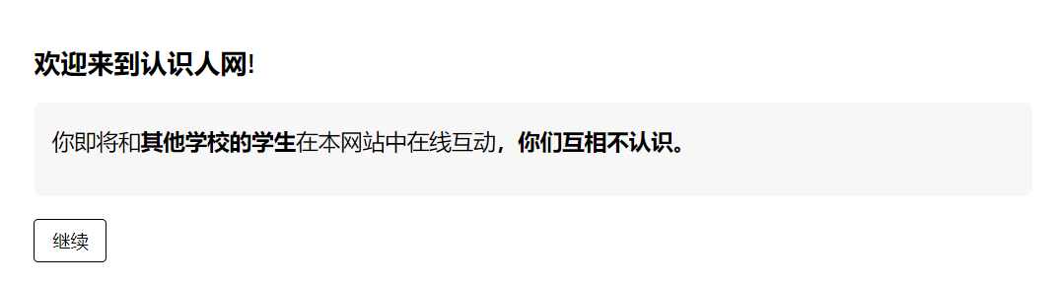
Welcome to the Meet People website!
You are about to interact online with students from other schools on this website. You do not know each other.
Continue

# Page 2 beginning and ending interfaces
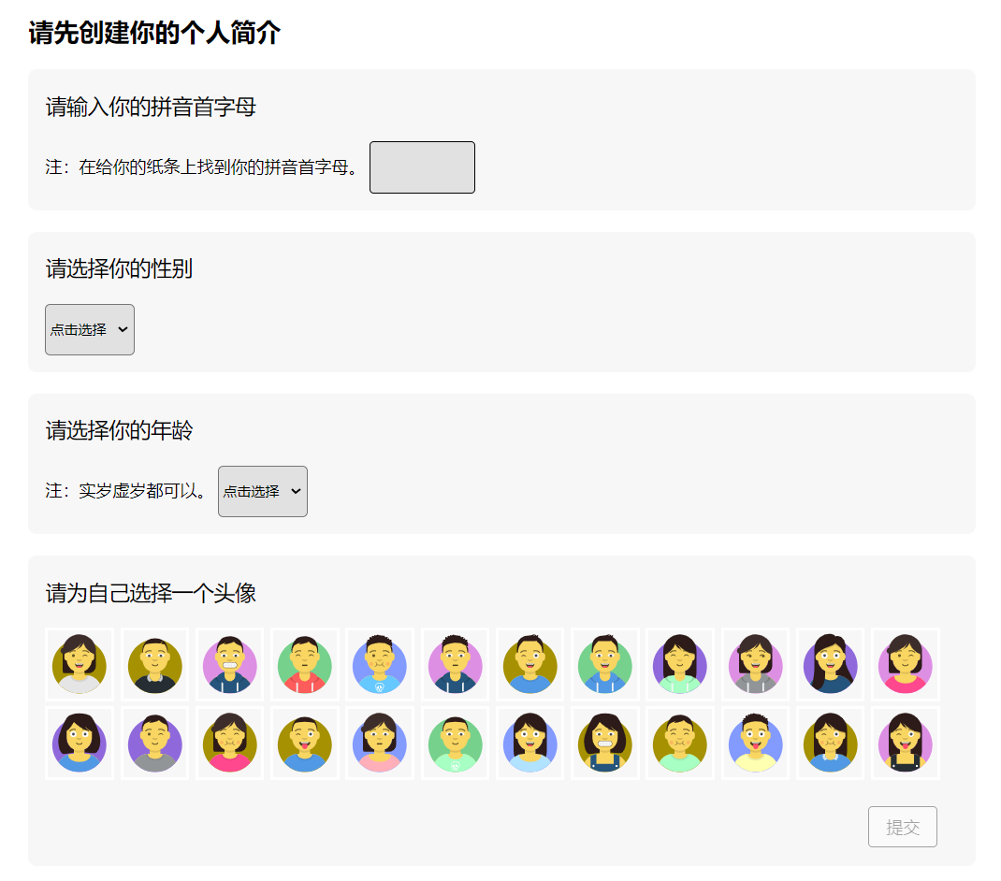
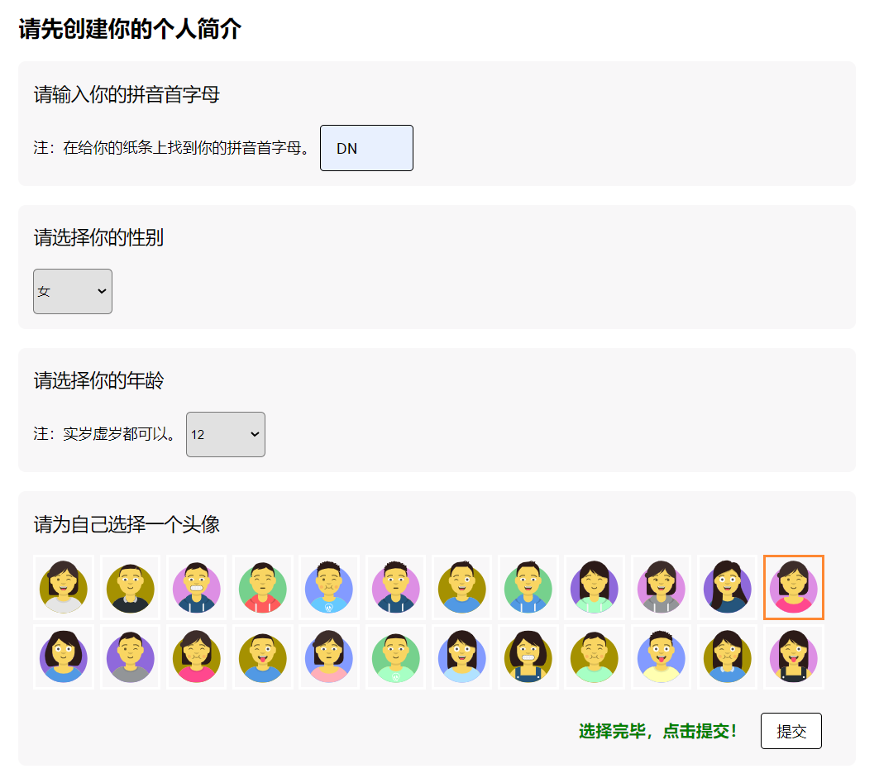
Please create your profile first
Please enter your initials
Please select your gender
Please select your age
Please choose an avatar for yourself
Selected. Click submit!
Submit

# Page 3 beginning and ending interfaces
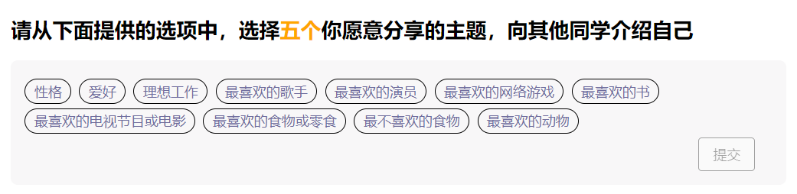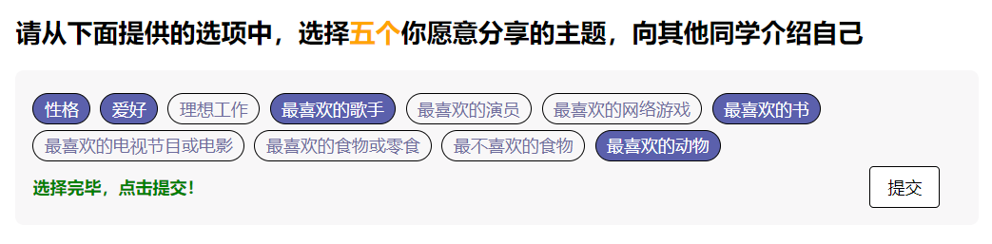
Please select five topics you would like to share from the options provided below to introduce yourself to other students
Personality. Hobbies. Dream job. Favorite singer. Favorite actor. Favorite online game. Favorite book. Favorite TV show or movie. Favorite food or snack. Least favorite food. Favorite animal.
Selected. Click submit!
Submit

# Page 4 beginning and ending interfaces

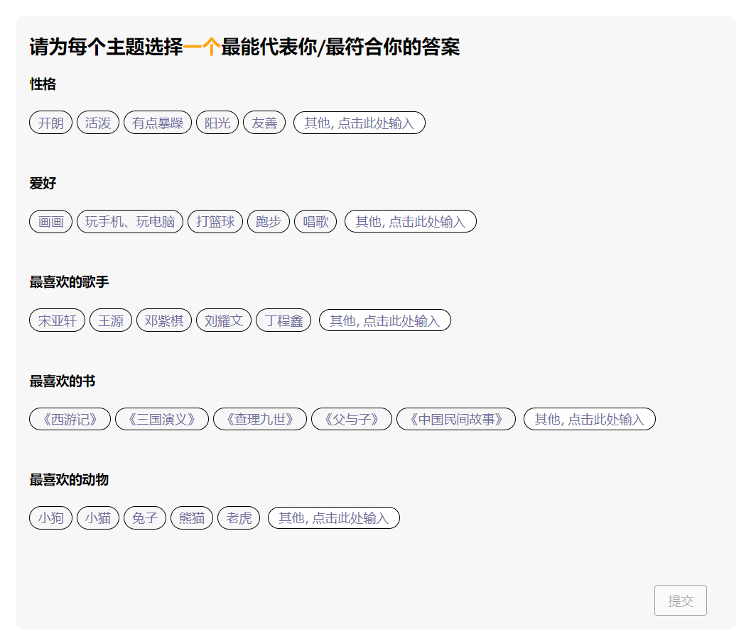

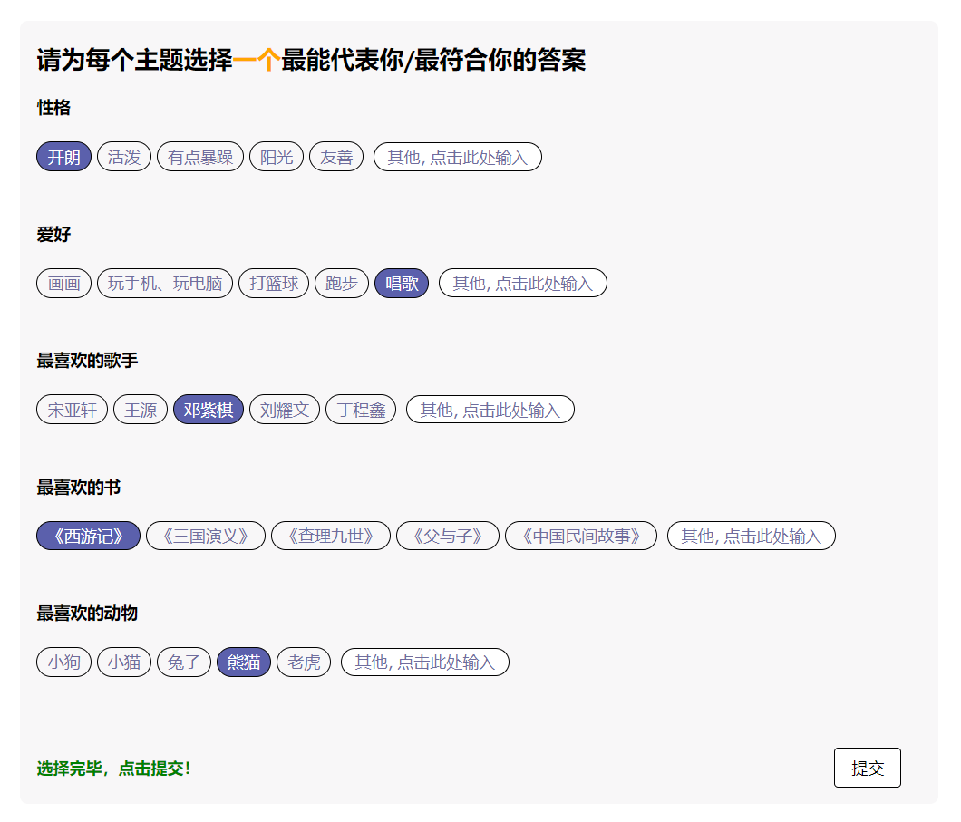
Please choose the answer for each topic that best represents you/applies to you
Personality
Cheerful. Lively. A bit grumpy. Sunny. Friendly. Others, clickto enter

Hobby
Drawing. Playing on mobile phone or computer. Playing basketball. Running. Singing. Others, click here to enter
…
Selected. Click submit!
Submit

Receiving Task Instructions (English translations in italicized font text)

# Page 5 beginning and ending interfaces

Note. Task instructions were provided in audio, and played automatically upon entering this page. See the manuscript for the precise text of audio instructions.

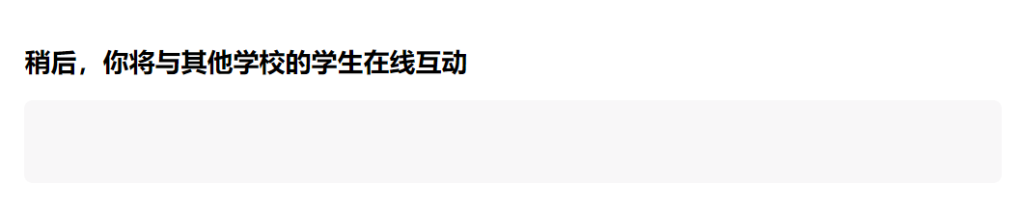
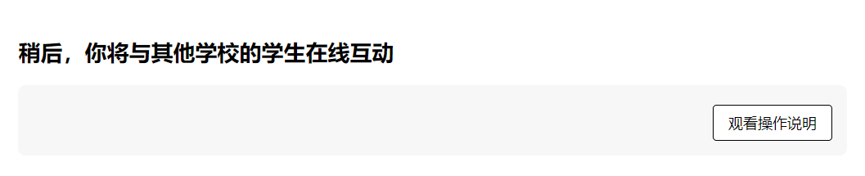
Later, you will interact online with students from other schools
View instructions

Following the Website Tour (Videos in OSF)

# Page 6 beginning and ending interfaces
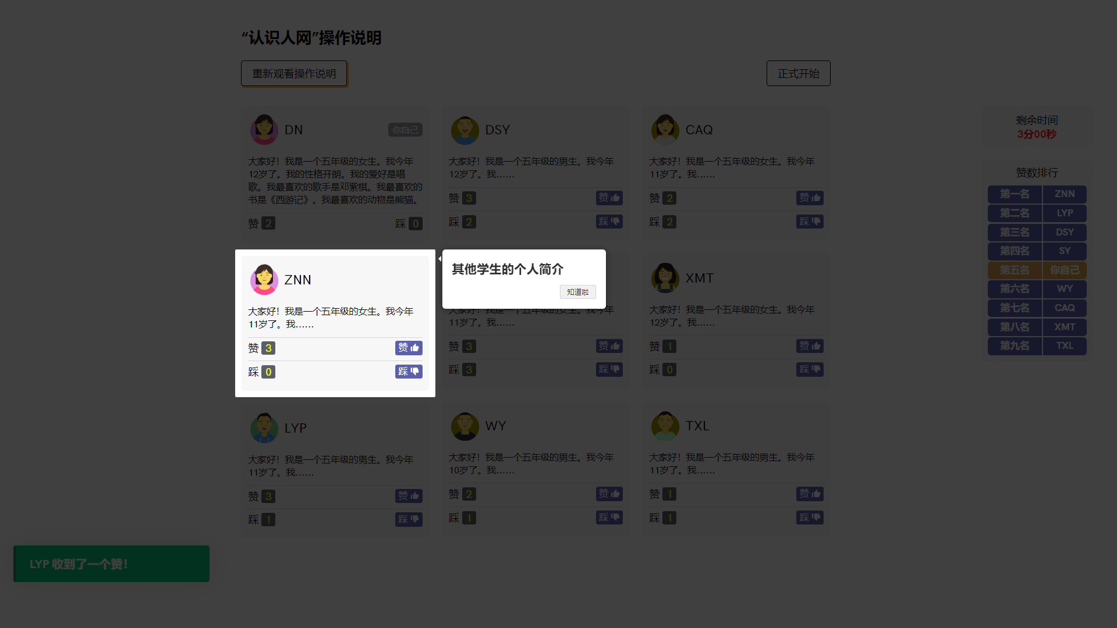
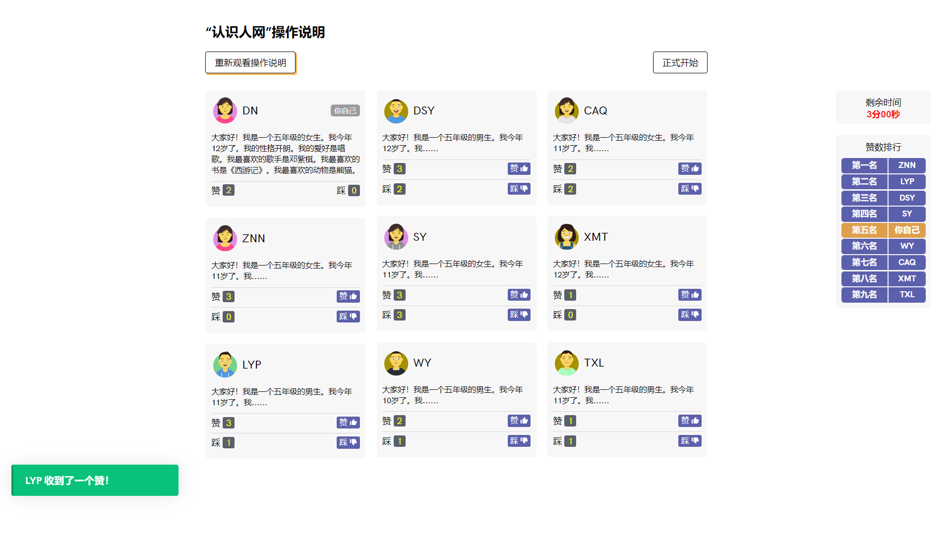
Note. We have summarized the text for each facet in bullet points below.
Acceptance and Rejection conditions:
- Other students' profiles
- If you like his/her profile, click the "Like👍" button
- If you don't like his/her profile, click the "Dislike 👎" button
- Your profile, visible to other students
- The number of "likes" and "dislikes" you received
- Notifications of the received likes and dislikes of you and other students
- You have three minutes to like and dislike other students’ profiles
- The ranking of all students' likes; your ranking is highlighted in orange
- Click this button to view the instructions again
- Click this button to start officially
Neutral condition:
- Other students' profiles
- If you like his/her profile, click the "Like👍" button
- If you don't like his/her profile, click the "Dislike 👎" button
- Your profile, only visible to yourself
- Other students cannot see your profile and cannot give you “Likes” or “Dislikes”
- Notifications of the received likes and dislikes of other students
- You have three minutes to like and dislike other students’ profiles
- The ranking of other students’ likes
- Click this button to view the instructions again
- Click this button to start officially

# Page 7 beginning and ending interfaces

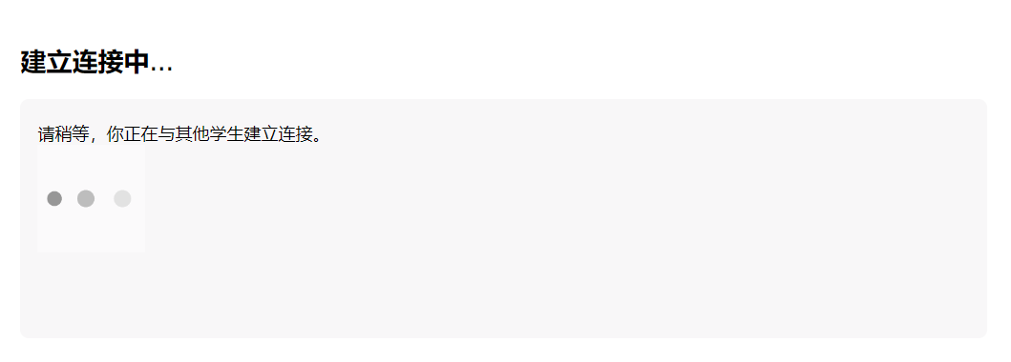
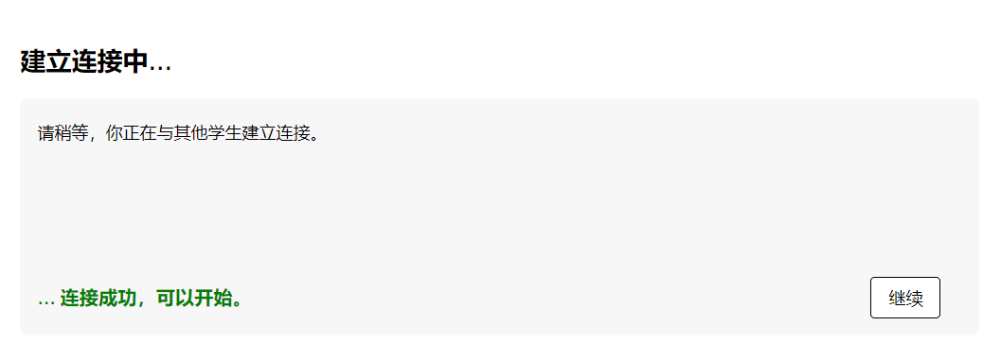
Establishing connection...
Please wait while you are connecting with other students.

... The connection is successful and you can start.
Continue

Having a 3-minute interaction with unknown peers (Videos in OSF)
In the acceptance condition, participants received 6 Likes (at 11, 35, 81, 101, 132, 151 seconds) and no Dislikes. In the rejection condition, participants received 1 Like and 5 Dislikes, occurring in the sequence of Dislike, Like, followed by four Dislikes (at 11, 35, 81, 101, 132, 151 seconds). Below, we have provided an outlined chronology showing the Likes and Dislikes that participants received over time with corresponding screenshots.

Acceptance condition

1 Like & 0 Dislikes,  11 sec past | 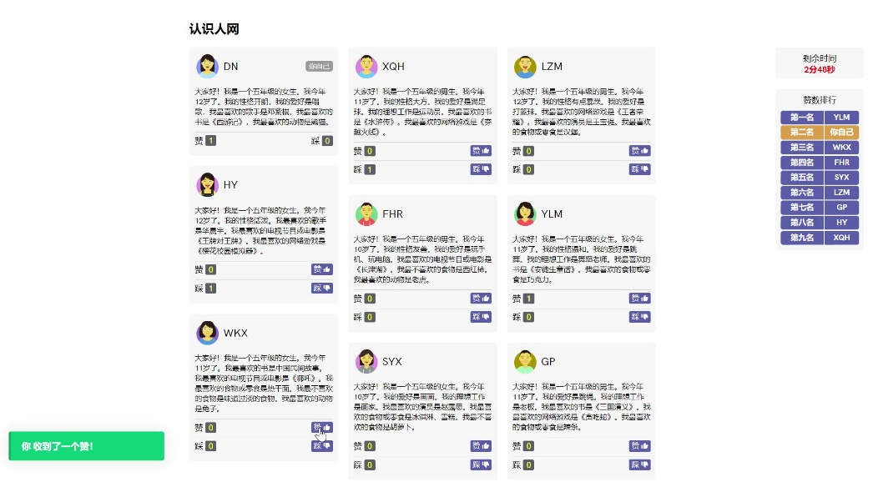
2 Likes & 0 Dislikes,  35 sec past | 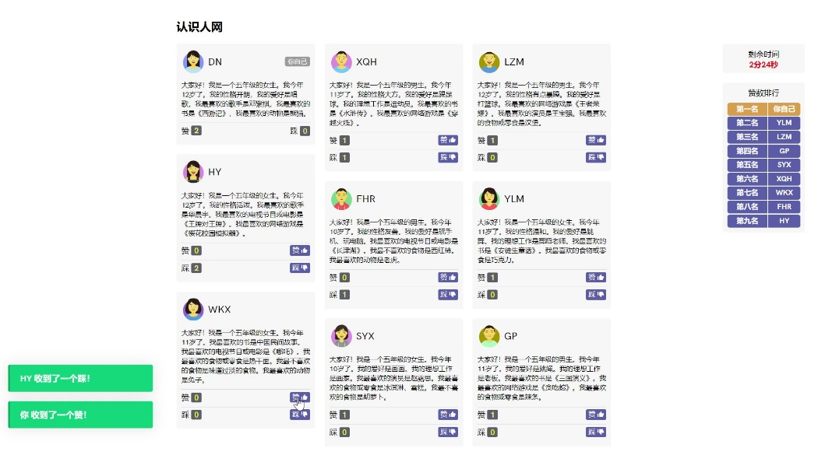
4 Likes & 0 Dislikes,  1 min 41sec past | 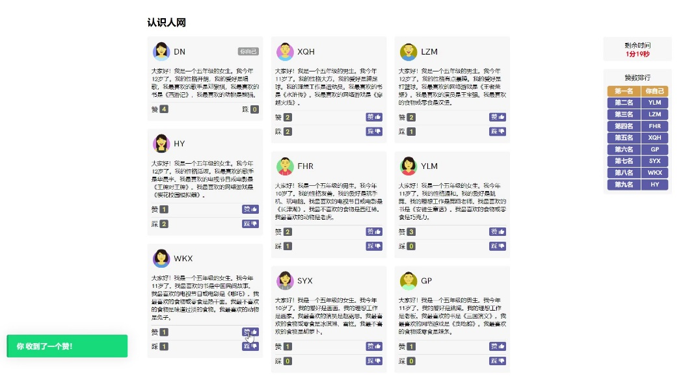
6 Likes & 0 Dislikes,  2 min 31 sec past | 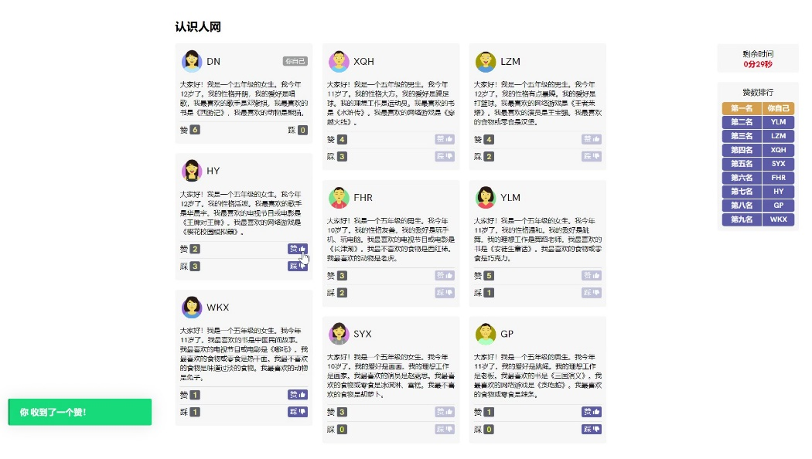
“Time is up! Click the button below to see your results” | 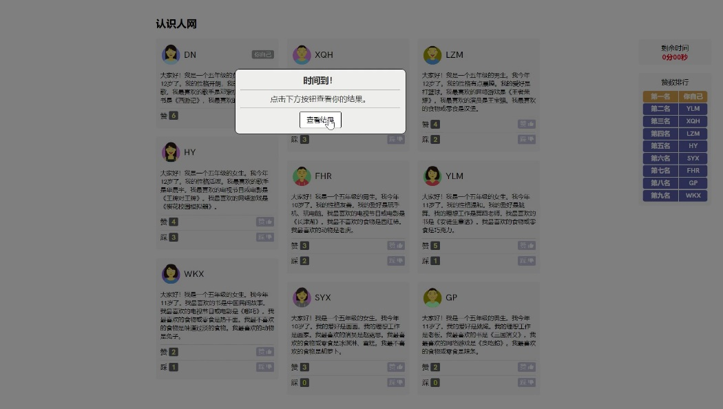
The 'Final Result' pop-up provides a recap, showing that participants received 6 Likes and 0 Dislikes | 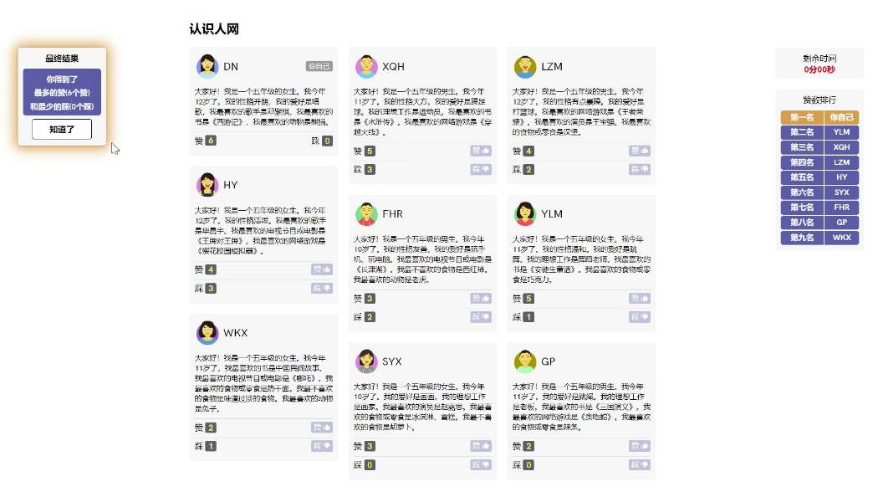

Neutral condition

11 sec past | 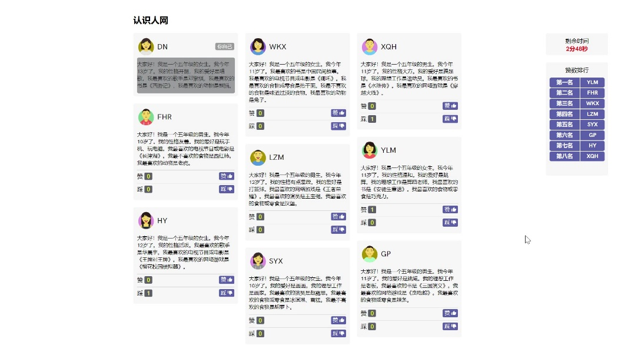
2 min 31 sec past | 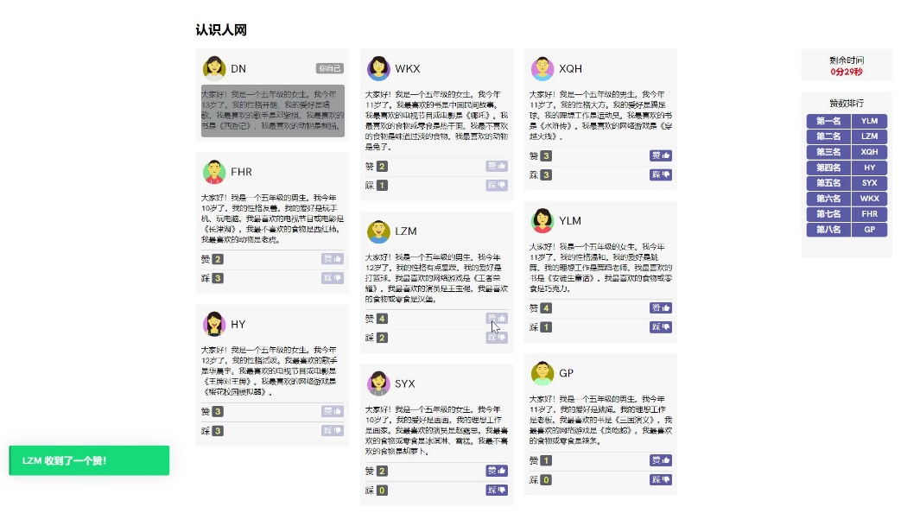
“Time is up! Click the button below to see your results” | 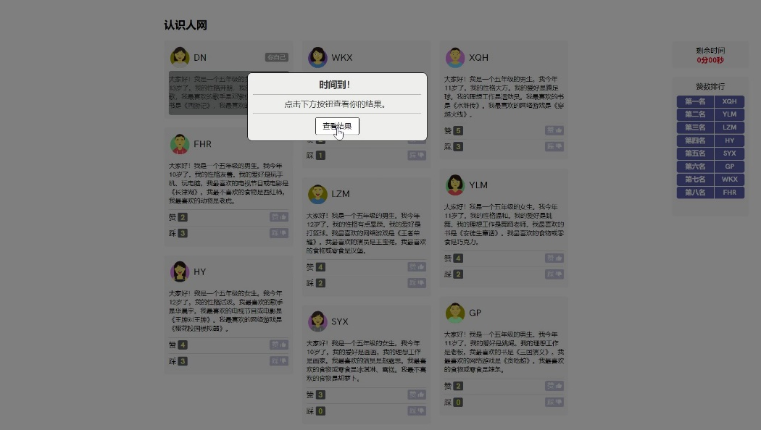
The 'Final Result' pop-up provides a recap, showing that participants gave out 6 Likes and 2 Dislikes | 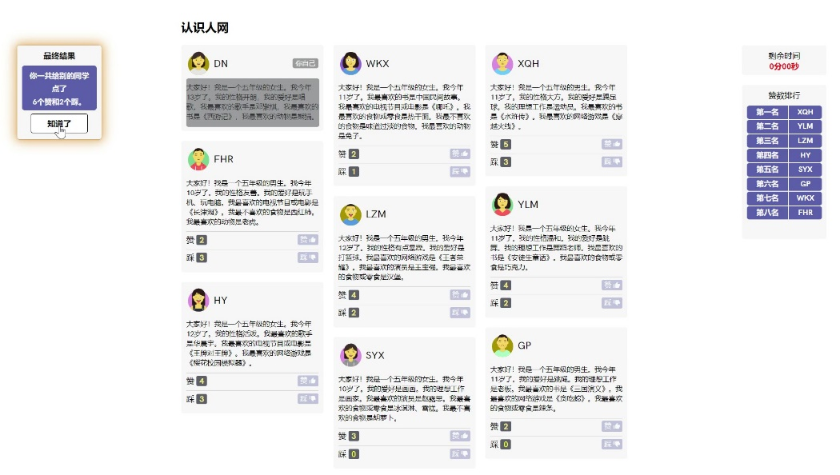

Rejection condition

0 Like & 1 Dislikes,  11 sec past | 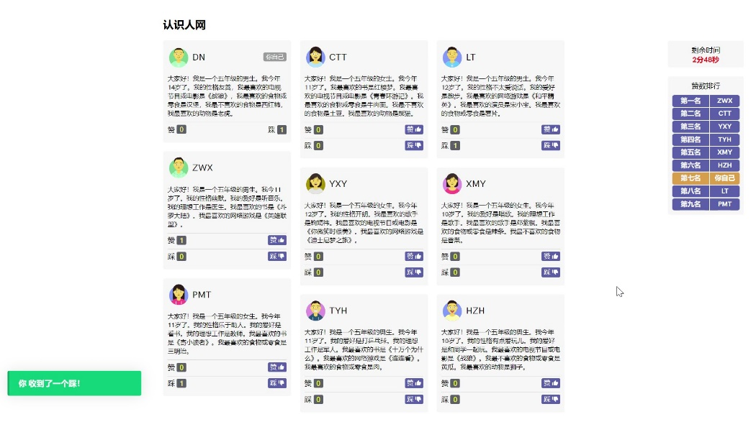
1 Likes & 1 Dislikes,  35 sec past | 
1 Like & 3 Dislikes,  1 min 41sec past | 
1 Like & 5 Dislikes,  2 min 31 sec past | 
“Time is up! Click the button below to see your results” | 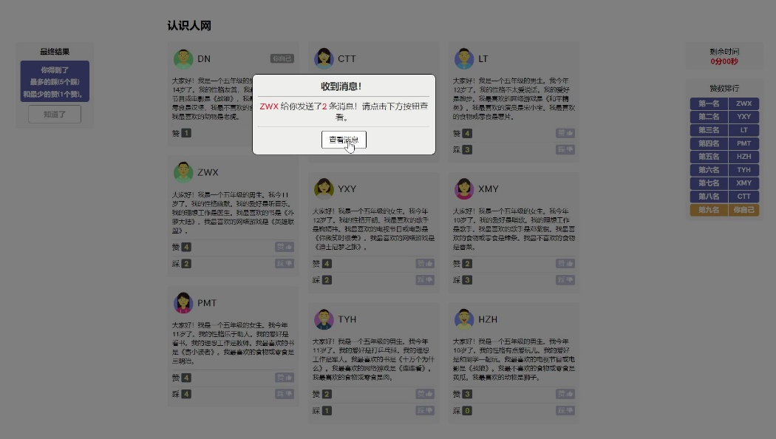
The 'Final Result' pop-up provides a recap, showing that participants received 5 Dislikes and 1 Like | 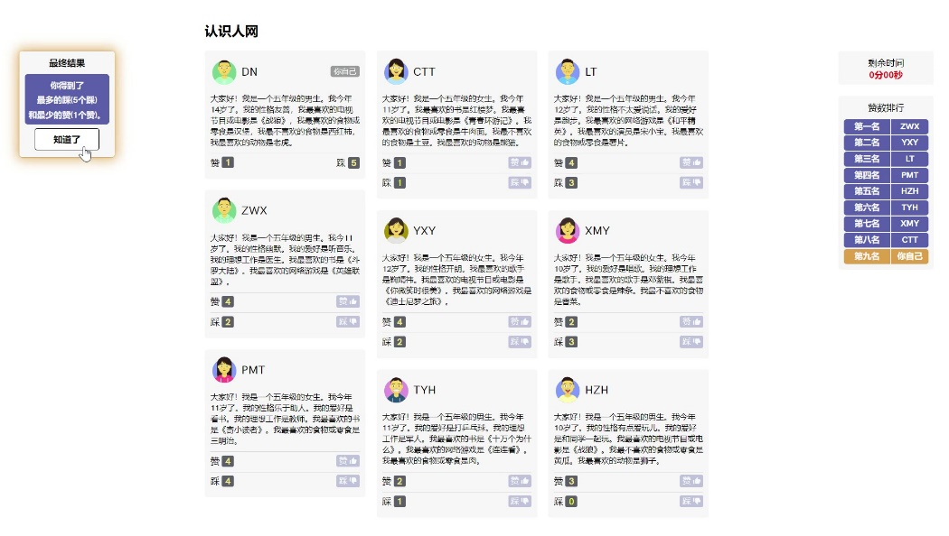

Receiving Peer Feedback (Videos in OSF)

Acceptance condition
The “Message Received!” pop-up | 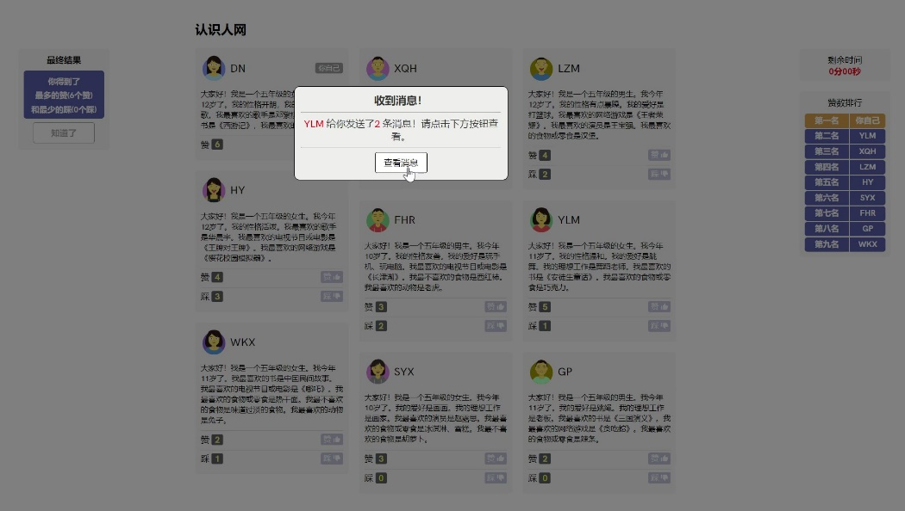
Message from the most liked and least disliked gender-matched peer | 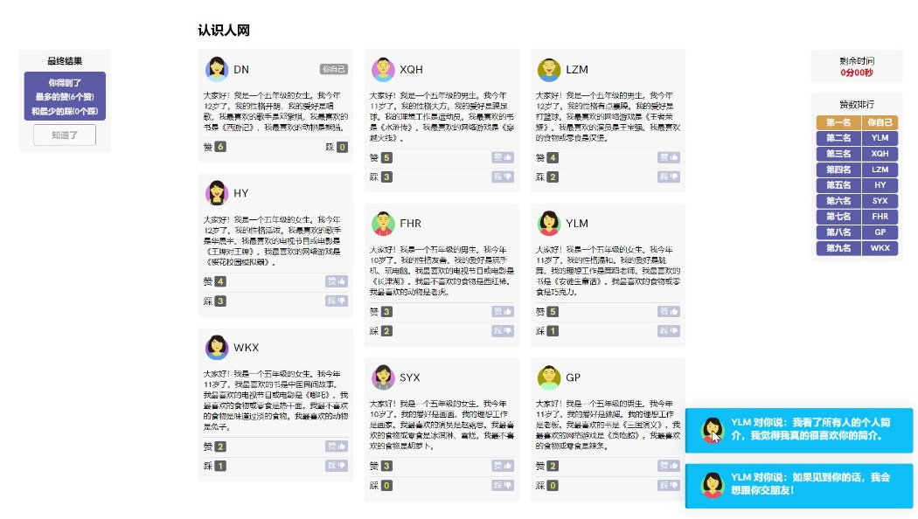

Neutral condition
The “Message Received!” pop-up | 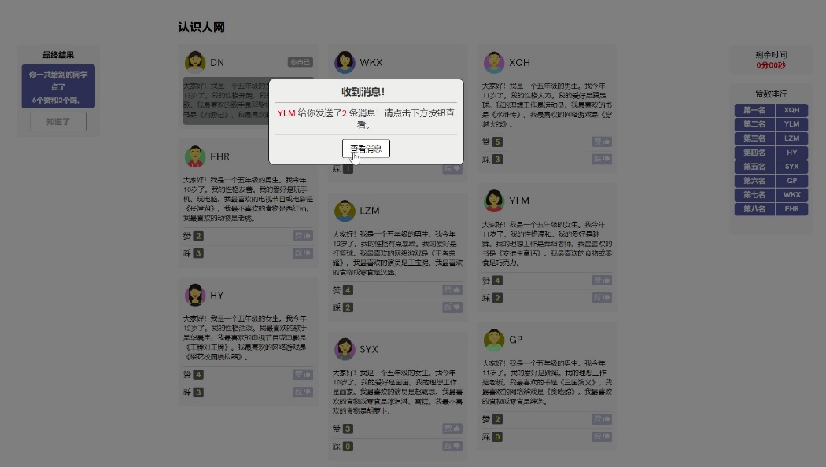
Message from the most liked and least disliked gender-matched peer | 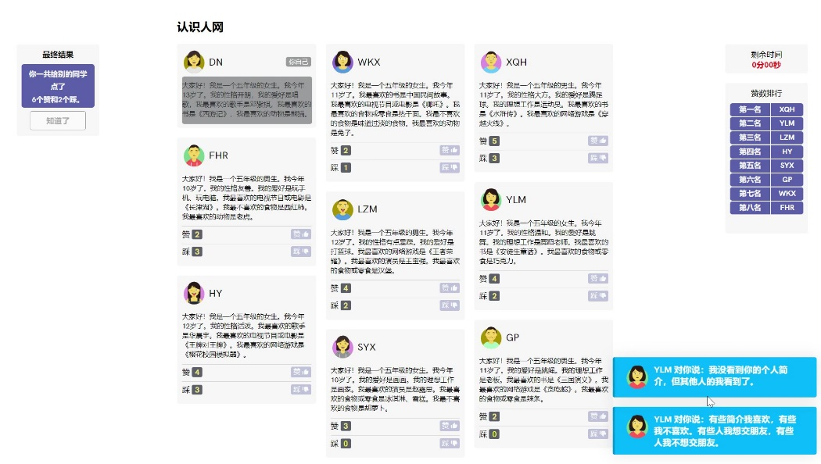

Rejection condition
The “Message Received!” pop-up
Message from the most liked and least disliked gender-matched peer | 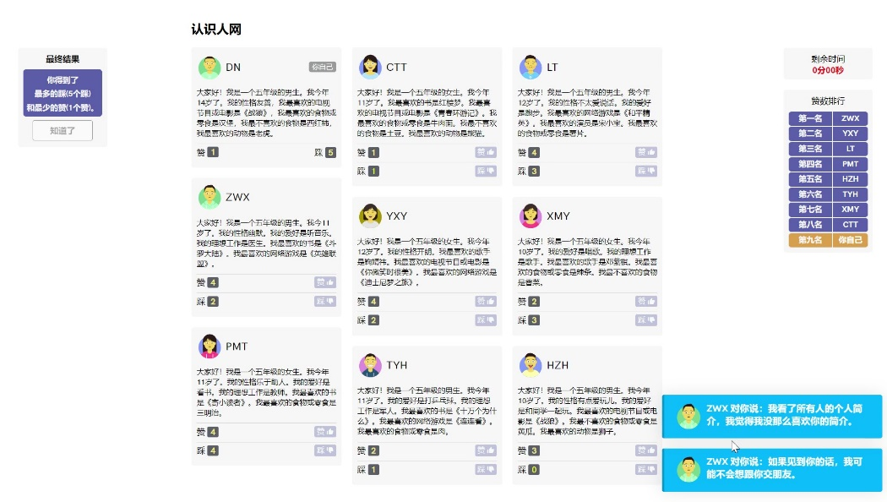

Distribution and Timing of Preprogrammed Likes and Dislikes For Simulated Peers

Profile Version 1:
If the participant is a girl
Name | #Like | #Dislike | Gender | Liked at (seconds) | Disliked at (seconds)
YLM | 4 | 1 | girl | 9, 39, 69, 109 | 130
XQH | 4 | 3 | boy | 30, 80, 105, 155 | 5, 55, 135
LZM | 3 | 2 | boy | 20, 82, 140 | 50, 110
HY | 3 | 3 | girl | 67, 107, 167 | 7, 37, 137
SYH | 2 | 0 | girl | 33, 123
FHR | 2 | 2 | boy | 62, 95 | 17, 142
GP | 1 | 0 | boy | 25
WKX | 1 | 1 | girl | 49 | 99

If the participant is a boy
Name | #Like | #Dislike | Gender | Liked at (seconds) | Disliked at (seconds)
XQH | 4 | 1 | boy | 9, 39, 69, 109 | 130
YLM | 4 | 3 | girl | 30, 80, 105, 155 | 5, 55, 135
HY | 3 | 2 | girl | 20, 82, 140 | 50, 110
LZM | 3 | 3 | boy | 67, 107, 167 | 7, 37, 137
FHR | 2 | 0 | boy | 33, 123
SYH | 2 | 2 | girl | 62, 95 | 17, 142
WKX | 1 | 0 | girl | 25
GP | 1 | 1 | boy | 49 | 99

Profile version 2:
If the participant is a girl
Name | #Like | #Dislike | Gender | Liked at (seconds) | Disliked at (seconds)
PMT | 4 | 1 | girl | 9, 39, 69, 109 | 130
ZWX | 4 | 3 | boy | 30, 80, 105, 155 | 5, 55, 135
LT | 3 | 2 | boy | 20, 82, 140 | 50, 110
YXY | 3 | 3 | girl | 67, 107, 167 | 7, 37, 137
XMY | 2 | 0 | girl | 33, 123
HZH | 2 | 2 | boy | 62, 95 | 17, 142
TYH | 1 | 0 | boy | 25
WKX | 1 | 1 | girl | 49 | 99

If the participant is a boy
Name | #Like | #Dislike | Gender | Liked at (seconds) | Disliked at (seconds)
ZWX | 4 | 1 | boy | 9, 39, 69, 109 | 130
PMT | 4 | 3 | girl | 30, 80, 105, 155 | 5, 55, 135
YXY | 3 | 2 | girl | 20, 82, 140 | 50, 110
LT | 3 | 3 | boy | 67, 107, 167 | 7, 37, 137
HZH | 2 | 0 | boy | 33, 123
XMY | 2 | 2 | girl | 62, 95 | 17, 142
CTT | 1 | 0 | girl | 25
TYH | 1 | 1 | boy | 49 | 99

References
Benjamini, Y., & Hochberg, Y. (1995). Controlling the False Discovery Rate: A Practical and Powerful Approach to Multiple Testing. Journal of the Royal Statistical Society: Series B (Methodological), 57(1), 289–300. https://doi.org/10.1111/j.2517-6161.1995.tb02031.x
Hox, J., van de Schoot, R., & Matthijsse, S. (2012). How few countries will do? Comparative survey analysis from a Bayesian perspective. Survey Research Methods, 6, 87–93.
Kaplan, D., & Depaoli, S. (2012). Bayesian structural equation modeling. In R. Hoyle (Ed.), Handbook of structural equation modeling (pp. 650–673). New York, NY: Guilford Press.
Lee, H. Y., Jamieson, J. P., Reis, H. T., Beevers, C. G., Josephs, R. A., Mullarkey, M. C., O’Brien, J. M., & Yeager, D. S. (2020). Getting Fewer “Likes” Than Others on Social Media Elicits Emotional Distress Among Victimized Adolescents. Child Development, 91(6), 2141–2159. https://doi.org/10.1111/cdev.13422
Lutz, S., & Schneider, F. M. (2021). Is receiving Dislikes in social media still better than being ignored? The effects of ostracism and rejection on need threat and coping responses online. Media Psychology, 24(6), 741–765. https://doi.org/10.1080/15213269.2020.1799409
Muthén, B., & Asparouhov, T. (2012). Bayesian structural equation modeling: A more flexible representation of substantive theory. Psychological Methods, 17, 313–335. doi:10.1037/a0026802
Timeo, S., Riva, P., & Paladino, M. P. (2020). Being liked or not being liked: A study on social‐media exclusion in a preadolescent population. Journal of Adolescence, 80(1), 173–181. https://doi.org/10.1016/j.adolescence.2020.02.010
van de Schoot, R., Veen, D., Smeets, L., Winter, S. D., & Depaoli, S. (2020). A tutorial on using the WAMBS checklist to avoid the misuse of Bayesian statistics. Small Sample Size Solutions: A Guide for Applied Researchers and Practitioners; van de Schoot, R., Miocevic, M., Eds, 30-49.
Wolf, W., Levordashka, A., Ruff, J. R., Kraaijeveld, S., Lueckmann, J.-M., & Williams, K. D. (2015). Ostracism Online: A social media ostracism paradigm. Behavior Research Methods, 47(2), 361–373. https://doi.org/10.3758/s13428-014-0475-x

