ESM- Figure 1a
Dual Change Score Model of the Development of Negative Affect and Conduct Problems
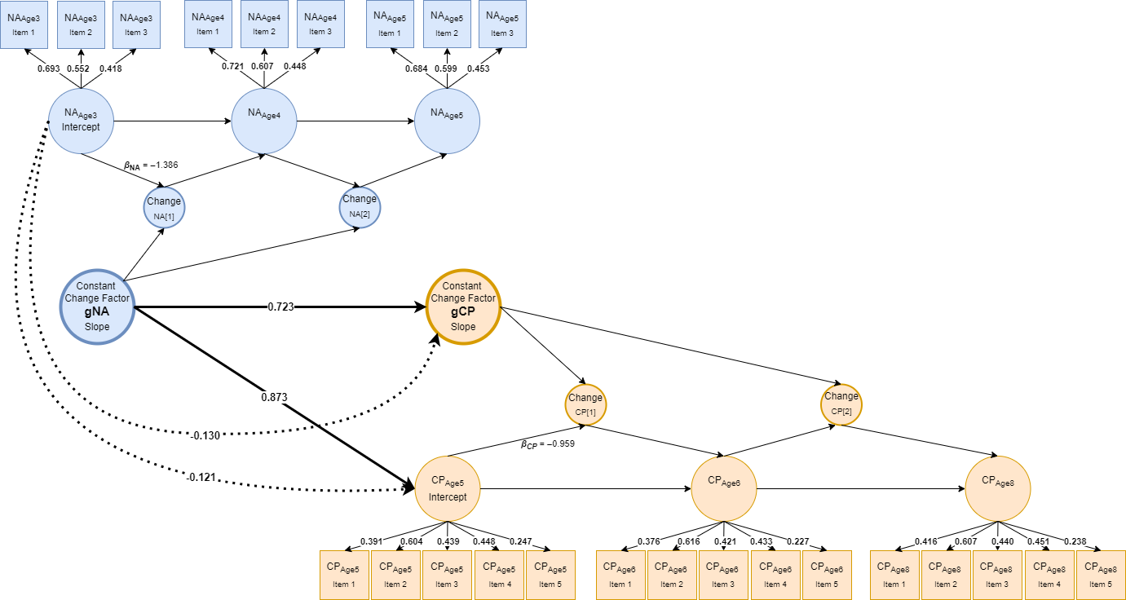
Model Fit:
RMSEA = .039 [.037–.041]
CFI = .904
SRMR = .059
R²(CP_{Age5}/gCP) = .610/.392
Note. Squares represent observed indicators and circles represent latent variables. Constant Change Factor (gNA, gCP) represents the overall rate of change across intervals. Autoproportion parameters (β_{NA}, β_{CP}) capture proportional, level-dependent change and were constrained to equality across adjacent intervals to represent constant proportional dynamics; the same β value applies to both autoregressive paths within each construct, for visual clarity, only one of the two autoregressive paths is displayed. The variances of the latent change factors were likewise constrained to equality; their loadings on the Constant Change Factor were fixed to 1 for model identification. Bold lines indicate statistically significant paths (p <= .001); dotted lines indicate nonsignificant paths; reported coefficients are standardized estimates. For clarity, estimates for regression paths from Change to Constant Change Factors are not shown, as these coefficients were fixed 1; NA = Negative Affect (abbreviated Children’s Behavior Questionnaire); CP = Conduct Problems (Strengths and Difficulties Questionnaire).

ESM- Figure 1b
Dual Change Score Model of the Development of Surgency and Conduct Problems
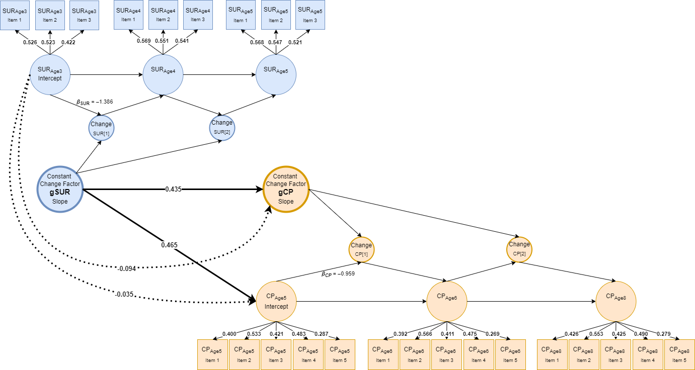
Model Fit:
RMSEA = .029 [.026–.031]
CFI = .947
SRMR = .035
R²(CP_{Age5}/gCP) = .189/.127
Note. Squares represent observed indicators and circles represent latent variables. Constant Change Factor (gSUR, gCP) represents the overall rate of change across intervals. Autoproportion parameters (β_{SUR}, β_{CP}) capture proportional, level-dependent change and were constrained to equality across adjacent intervals to represent constant proportional dynamics; the same β value applies to both autoregressive paths within each construct, for visual clarity, only one of the two autoregressive paths is displayed. The variances of the latent change factors were likewise constrained to equality; their loadings on the Constant Change Factor were fixed to 1 for model identification. Bold lines indicate statistically significant paths (p <= .001); dotted lines indicate nonsignificant paths; reported coefficients are standardized estimates. For clarity, estimates for regression paths from Change to Constant Change Factors are not shown, as these coefficients were fixed 1; SUR = Surgency (abbreviated Children’s Behavior Questionnaire); CP = Conduct Problems (Strengths and Difficulties Questionnaire).

ESM- Figure 1c
Dual Change Score Model of the Development of Negative Affect and ADHD Symptoms
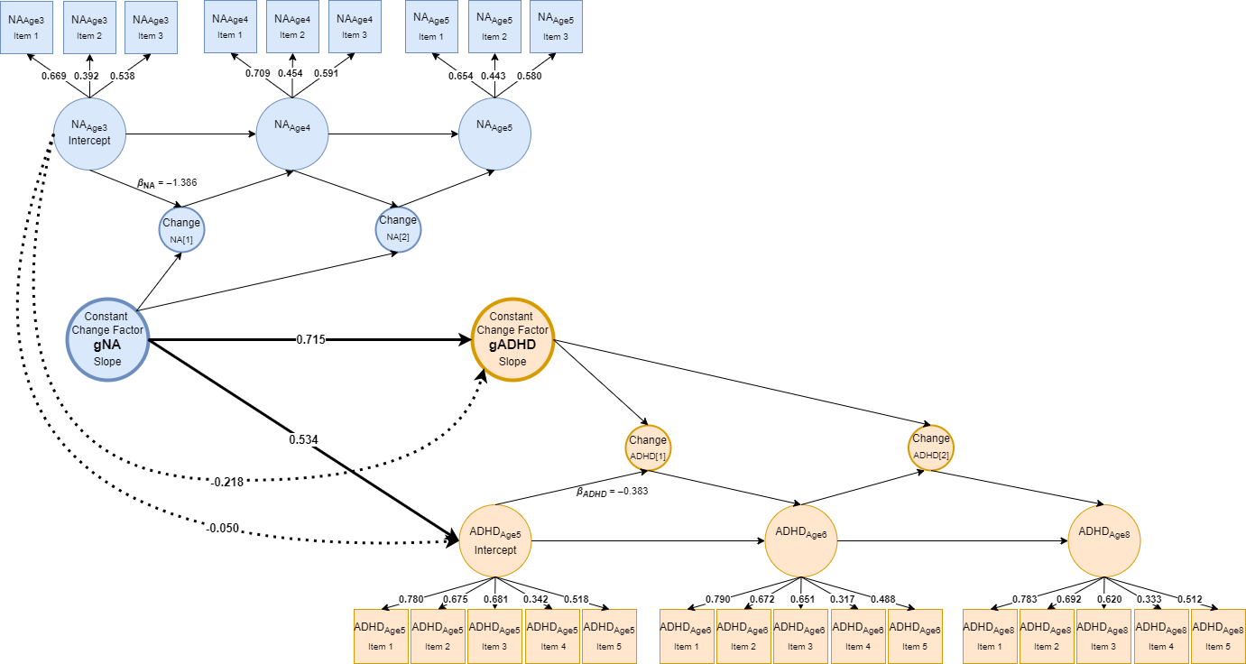
Model Fit:
RMSEA = .039 [.037–.042]
CFI = .934
SRMR = .044
R²(ADHD_{Age5}/gADHD) = .243/.300
Note. Squares represent observed indicators and circles represent latent variables. Constant Change Factor (gNA, gADHD) represents the overall rate of change across intervals. Autoproportion parameters (β_{NA}, β_{ADHD}) capture proportional, level-dependent change and were constrained to equality across adjacent intervals to represent constant proportional dynamics; the same β value applies to both autoregressive paths within each construct, for visual clarity, only one of the two autoregressive paths is displayed. The variances of the latent change factors were likewise constrained to equality; their loadings on the Constant Change Factor were fixed to 1 for model identification. Bold lines indicate statistically significant paths (p <= .001); dotted lines indicate nonsignificant paths; reported coefficients are standardized estimates. For clarity, estimates for regression paths from Change to Constant Change Factors are not shown, as these coefficients were fixed 1; NA = Negative Affect (abbreviated Children’s Behavior Questionnaire); ADHD = Attention-Deficit/Hyperactivity Disorder symptoms (Strengths and Difficulties Questionnaire).

ESM- Figure 1d
Dual Change Score Model of the Development of Surgency and ADHD Symptoms
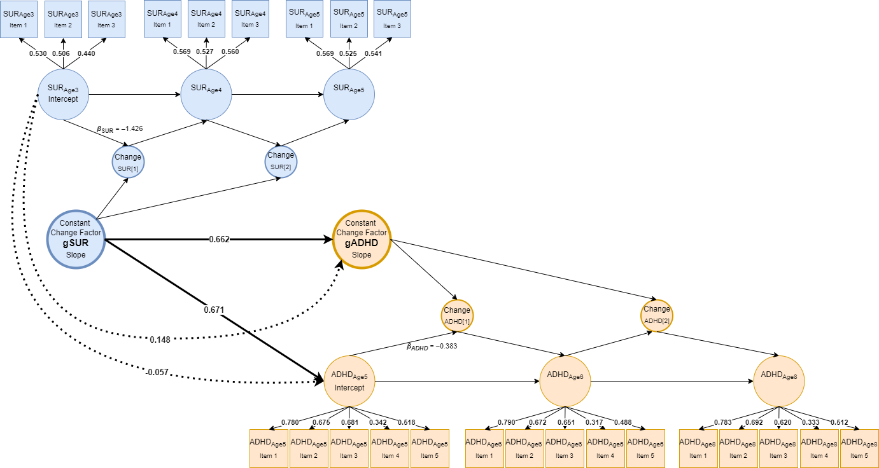
Model Fit:
RMSEA = .038 [.036–.040]
CFI = .942
SRMR = .044
R²(ADHD_{Age5}/gADHD) = .387/.290
Note. Squares represent observed indicators and circles represent latent variables. Constant Change Factor (gSUR, gADHD) represents the overall rate of change across intervals. Autoproportion parameters (β_{SUR}, β_{ADHD}) capture proportional, level-dependent change and were constrained to equality across adjacent intervals to represent constant proportional dynamics; the same β value applies to both autoregressive paths within each construct, for visual clarity, only one of the two autoregressive paths is displayed. The variances of the latent change factors were likewise constrained to equality; their loadings on the Constant Change Factor were fixed to 1 for model identification. Bold lines indicate statistically significant paths (p <= .001); dotted lines indicate nonsignificant paths; reported coefficients are standardized estimates. For clarity, estimates for regression paths from Change to Constant Change Factors are not shown, as these coefficients were fixed 1; SUR = Surgency (abbreviated Children’s Behavior Questionnaire); ADHD = Attention-Deficit/Hyperactivity Disorder symptoms (Strengths and Difficulties Questionnaire).

ESM-Figure 2
Model-Implied Associations of Increase in Reactive Temperament and Externalizing Symptoms ate Age 5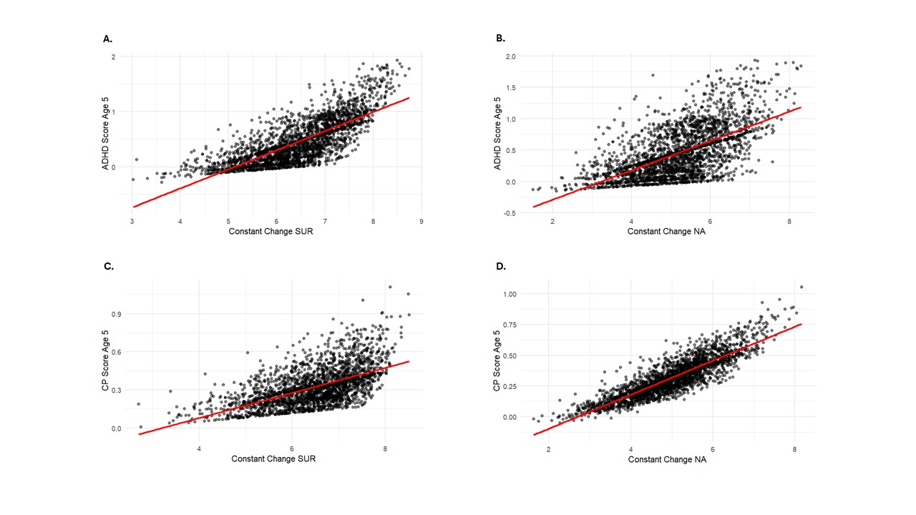
Note. NA = Negative Affectivity; SUR = Surgency; ADHD = Attention-Deficit/Hyperactivity Disorder symptoms; CP = Conduct Problems.
Note. NA = Negative Affectivity; SUR = Surgency; ADHD = Attention-Deficit/Hyperactivity Disorder symptoms; CP = Conduct Problems.

ESM-Figure 3
Model-Implied Associations of Increase in Reactive Temperament and Externalizing Symptoms Change Score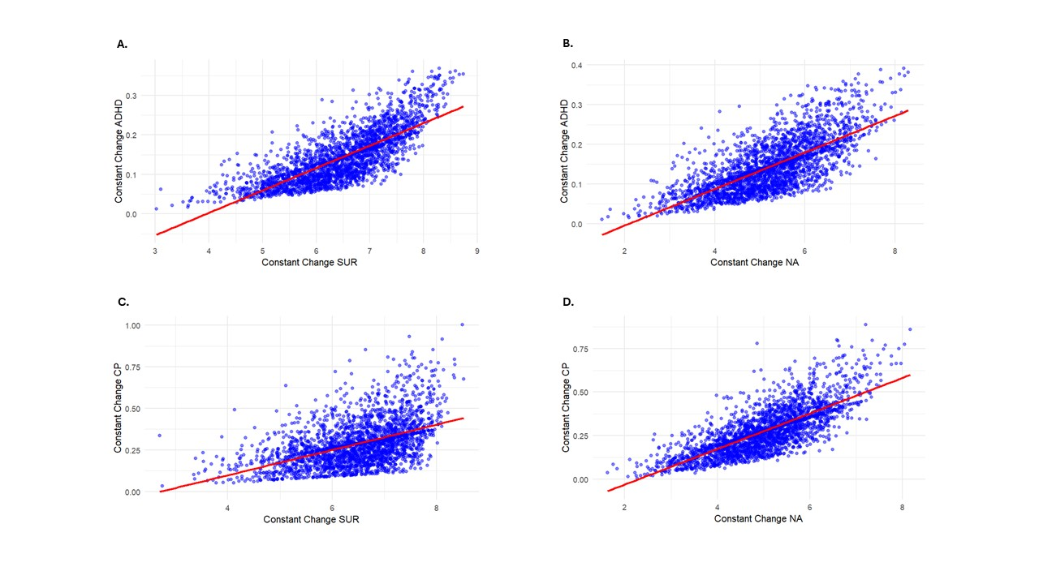
ESM-Figure 4
Predicted Trajectories in Reactive Temperament and Externalizing Symptoms 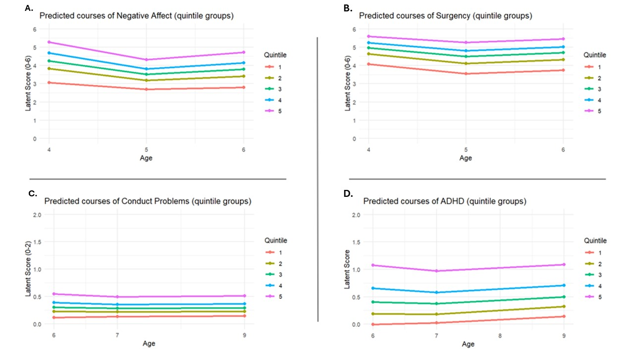
Note. NA = Negative Affectivity; SUR = Surgency; ADHD = Attention-Deficit/Hyperactivity Disorder symptoms; CP = Conduct Problems.

ESM-Table 1

Means and latent correlations among study variables
Variable | M | 1 | 2 | 3 | 4 | 5 | 6 | 7 | 8
1. NA_{Age3} | 4.177 | —
2. gNA | 5.193 | .83 *** | —
3. SUR_{Age3} | 4.900 | .60 *** | .58 *** | —
4. gSUR | 6.468 | .55 *** | .62 *** | .83 *** | —
5. ADHD_{Age5} | 0.457 | .45 *** | .49 *** | .56 *** | .62 *** | —
6. gADHD | 0.142 | .39 *** | .53 *** | .48 *** | .53 *** | .72 *** | —
7. CP_{Age5} | 0.324 | .68 *** | .78 *** | .39 *** | .43 *** | .72 *** | .68 *** | —
8. gCD | 0.288 | .62 *** | .62 *** | .35 *** | .35 *** | .62 *** | .72 *** | .72 *** | —
Note. ADHD = Attention Deficit Hyperactivity Disorder; CP = Conduct Problems; NA = Negative Affectivity; SUR = Surgency; gX = Constant Change Factor/Slope; All values are standardized latent parameters (from Mplus TECH4 output); Intercepts represent latent baseline levels; slopes indicate latent change factors; p < .001 = ***.
ESM-Table 2
Associations of Reactive Temperament (Age 3) and Externalizing Symptoms (Age 5 and Change)
Relationship | Estimate | SE (Est./SE) | p-value
NA and CP
NA_{Age3} → CP_{Age3} | 0.783 | 0.028 (27.512) | 0.000
NA_{Age3} → gCP | 0.615 | 0.034 (17.863) | 0.000
Goodness-of-fit: | χ² (242) = 1201.149, RMSEA = 0.039, CFI = 0.904, SRMR = 0.059 R²_{CP AGE 5/gCP} = 0.612/0.378
SUR and CP
SUR_{Age3} → CP_{Age3} | 0.425 | 0.037 (11.577) | 0.000
SUR_{Age3} → gCP | 0.336 | 0.036 (9.317) | 0.000
Goodness-of-fit: | χ² (246) = 787.156, RMSEA = 0.029, CFI = 0.946, SRMR = 0.036 R²_{CP AGE 5/gCP} = 0.181/0.113
NA and ADHD
NA_{Age3} → ADHD_{Age3} | 0.483 | 0.027 (17.825) | 0.000
NA_{Age3} → gADHD | 0.497 | 0.065 (7.645) | 0.000
Goodness-of-fit: | χ² (240) = 1269.076, RMSEA = 0.040, CFI = 0.930, SRMR = 0.046 R²_{ADHD AGE 5/gADHD} = 0.233/0.247
SUR and ADHD
SUR_{Age3} → ADHD_{Age3} | 0.616 | 0.026 (23.671) | 0.000
SUR_{Age3} → gADHD | 0.519 | 0.067 (7.619) | 0.000
Goodness-of-fit: | χ² (244) = 1189.314, RMSEA = 0.038, CFI = 0.939, SRMR = 0.045 R²_{ADHD AGE 5/gADHD} = 0.380/0.269
Note. ADHD = Attention Deficit Hyperactivity Disorder; CP = Conduct Problems; NA = Negative Affect; SUR = Surgency; gX = Constant Change Factor/Slope; RMSEA = Root Mean Square Error of Approximation; CFI = Comparative Fit Index; SRMR = Standardized Root Mean Square Residual; χ² (df) = Chi-square statistic (degrees of freedom); R² = coefficient of determination.

ESM-Table 3
Associations of Reactive Temperament (Age 5) and Externalizing Symptoms (Age 5 and Change)
Relationship | Estimate | SE (Est./SE) | p-value
NA and CP
NA_{Age5} → CP_{Age5} | 0.803 | 0.026 (30.760) | 0.000
NA_{Age5} → gCP | 0.626 | 0.033 (18.798) | 0.000
Goodness-of-fit: | χ² (242) = 1201.149, RMSEA = 0.039, CFI = 0.904, SRMR = 0.059 R²_{CP AGE 5/gCP} = 0.644/0.392
SUR and CP
SUR_{Age5} → CP_{Age5} | 0.434 | 0.035 (12.379) | 0.000
SUR_{Age5} → gCP | 0.348 | 0.035 (9.908) | 0.000
Goodness-of-fit: | χ² (244) = 768.369, RMSEA = 0.029, CFI = 0.947, SRMR = 0.035 R²_{CP AGE 5/gCP} = 0.189/0.121
NA and ADHD
NA_{Age5} → ADHD_{Age5} | 0.502 | 0.025 (19.727) | 0.000
NA_{Age5} → gADHD | 0.523 | 0.064 (8.161) | 0.000
Goodness-of-fit: | χ² (238) = 1214.633, RMSEA = 0.039, CFI = 0.934, SRMR = 0.044 R²_{ADHD AGE 5/gADHD} = 0.252/0.274
SUR and ADHD
SUR_{Age5} → ADHD_{Age5} | 0.611 | 0.025 (24.632) | 0.000
SUR_{Age5} → gADHD | 0.527 | 0.067 (7.882) | 0.000
Goodness-of-fit: | χ² (242) = 1145.547, RMSEA = 0.038, CFI = 0.942, SRMR = 0.044 R²_{ADHD AGE 5/gADHD} = 0.373/0.278
Note. ADHD = Attention Deficit Hyperactivity Disorder; CP = Conduct Problems; NA = Negative Affect; SUR = Surgency; gX = Constant Change Factor/Slope; RMSEA = Root Mean Square Error of Approximation; CFI = Comparative Fit Index; SRMR = Standardized Root Mean Square Residual; χ² (df) = Chi-square statistic (degrees of freedom); R² = coefficient of determination.

