Figure S1. Diagnostic plots of the association between anxiety and BAS. BAS = behavioral activation system.
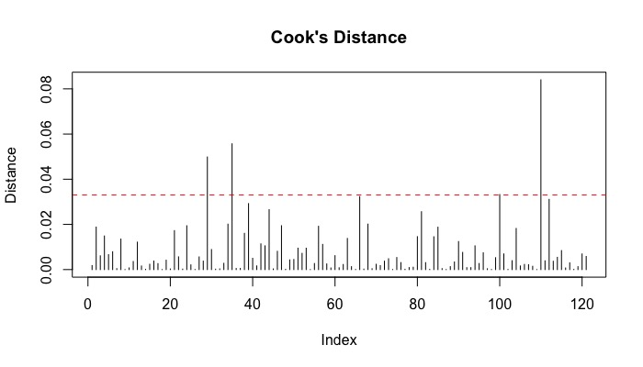
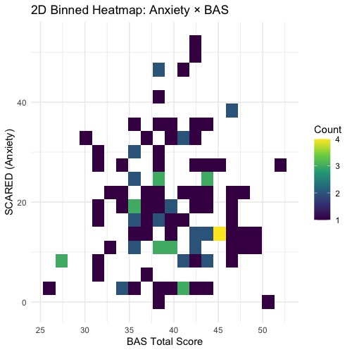
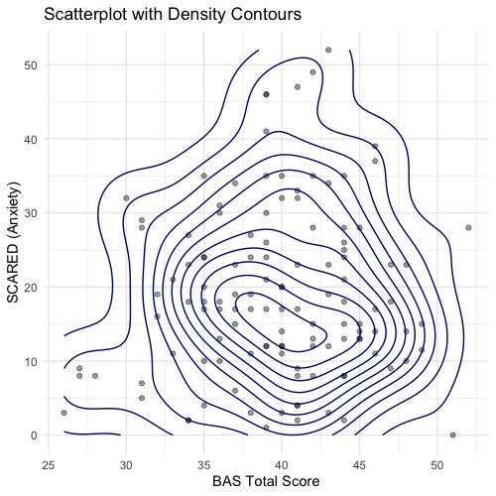
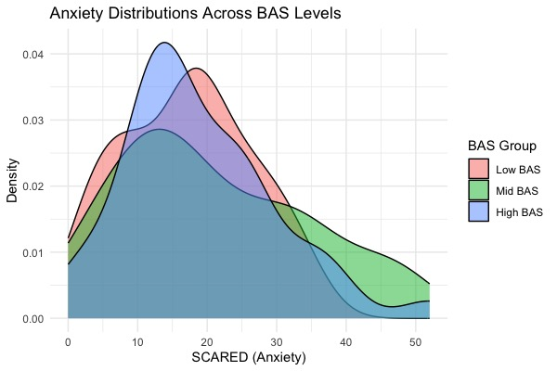
Table S1. VS activation model results. VS = ventral striatum; BAS = behavioral activation system.
 | VS Activation
Predictors | Estimates | CI | p
(Intercept) | -0.02 | -0.12 – 0.07 | 0.645
Condition (Risky vs. Cautious) | 0.12 | 0.06 – 0.19 | <0.001
Anxiety | 0.04 | -0.04 – 0.11 | 0.303
BAS | 0.04 | -0.03 – 0.12 | 0.283
Age | -0.01 | -0.08 – 0.06 | 0.784
Sex (1=female) | -0.06 | -0.20 – 0.08 | 0.383
Mean Relative Motion | -0.02 | -0.08 – 0.05 | 0.603
Condition*Anxiety | -0.08 | -0.15 – -0.02 | 0.012
Condition*BAS | -0.13 | -0.20 – -0.06 | <0.001
Anxiety*BAS | 0.07 | -0.02 – 0.15 | 0.113
Condition*Anxiety*BAS | -0.10 | -0.17 – -0.03 | 0.006
Random Effects
σ² | 0.89
τ₀₀ _{Subject} | 0.11
ICC | 0.11
N _{Subject} | 121
Observations | 3847
Marginal R² / Conditional R² | 0.013 / 0.119

Table S2. Amygdala activation model results. BAS = behavioral activation system
 | Amygdala Activation
Predictors | Estimates | CI | p
(Intercept) | -0.09 | -0.19 – 0.01 | 0.081
Condition (Risky vs. Cautious) | 0.10 | 0.03 – 0.16 | 0.004
Anxiety | -0.01 | -0.09 – 0.06 | 0.768
BAS | 0.01 | -0.07 – 0.09 | 0.804
Age | -0.03 | -0.10 – 0.04 | 0.461
Sex (1=female) | 0.09 | -0.05 – 0.24 | 0.198
Mean Relative Motion | -0.07 | -0.14 – -0.01 | 0.029
Condition*Anxiety | 0.05 | -0.02 – 0.11 | 0.162
Condition*BAS | -0.02 | -0.09 – 0.05 | 0.508
Anxiety*BAS | -0.04 | -0.12 – 0.05 | 0.408
Condition*Anxiety*BAS | 0.10 | 0.03 – 0.17 | 0.005
Random Effects
σ² | 0.87
τ₀₀ _{Subject} | 0.12
ICC | 0.12
N _{Subject} | 121
Observations | 3847
Marginal R² / Conditional R² | 0.015 / 0.131

Table S3. dACC activation model results. dACC = dorsal anterior cingulate; BAS = behavioral activation system.
 | dACC Activation
Predictors | Estimates | CI | p
(Intercept) | 0.03 | -0.07 – 0.13 | 0.578
Condition (Risky vs. Cautious) | -0.08 | -0.14 – -0.01 | 0.023
Anxiety | -0.11 | -0.19 – -0.03 | 0.006
BAS | -0.03 | -0.11 – 0.06 | 0.537
Age | 0.03 | -0.05 – 0.10 | 0.491
Sex (1=female) | -0.02 | -0.17 – 0.13 | 0.827
Mean Relative Motion | -0.08 | -0.15 – -0.01 | 0.029
Condition*Anxiety | 0.08 | 0.01 – 0.14 | 0.026
Condition*BAS | 0.03 | -0.03 – 0.10 | 0.305
Anxiety*BAS | 0.07 | -0.02 – 0.16 | 0.148
Condition*Anxiety*BAS | 0.03 | -0.04 – 0.10 | 0.347
Random Effects
σ² | 0.86
τ₀₀ _{Subject} | 0.13
ICC | 0.13
N _{Subject} | 121
Observations | 3847
Marginal R² / Conditional R² | 0.021 / 0.149

Table S4. Task-based VS-dACC connectivity model results. VS = ventral striatum; dACC = dorsal anterior cingulate; BAS = behavioral activation system. NOTE: The interaction between Condition and BAS survived multiple comparison correction after non-significant interactions were removed from the model (b=-.30, p=.014).
 | VS-dACC Connectivity
Predictors | Estimates | CI | p
(Intercept) | -0.04 | -0.26 – 0.18 | 0.704
Condition (Risky vs. Cautious) | 0.03 | -0.21 – 0.27 | 0.812
Anxiety | 0.04 | -0.15 – 0.22 | 0.702
BAS | 0.04 | -0.15 – 0.23 | 0.685
Age | -0.07 | -0.20 – 0.07 | 0.341
Sex (1=female) | 0.06 | -0.22 – 0.34 | 0.671
Mean Relative Motion | -0.00 | -0.14 – 0.13 | 0.954
Condition*Anxiety | -0.07 | -0.32 – 0.17 | 0.547
Condition*BAS | -0.29 | -0.55 – -0.03 | 0.027
Anxiety*BAS | -0.00 | -0.21 – 0.20 | 0.971
Condition*Anxiety*BAS | 0.03 | -0.24 – 0.31 | 0.811
Random Effects
σ² | 0.92
τ₀₀ _{Subject} | 0.08
ICC | 0.08
N _{Subject} | 121
Observations | 242
Marginal R² / Conditional R² | 0.042 / 0.120

Table S5. Task-based amygdala-dACC connectivity model results. dACC = dorsal anterior cingulate; BAS = behavioral activation system. NOTE: The association between anxiety and amygdala-dACC connectivity was significant after non-significant interactions were removed from the model (b=.17, p=.01).
 | Amygdala-dACC Connectivity
Predictors | Estimates | CI | p
(Intercept) | 0.08 | -0.13 – 0.29 | 0.463
Condition (Risky vs. Cautious) | 0.06 | -0.19 – 0.30 | 0.655
Anxiety | 0.13 | -0.05 – 0.31 | 0.154
BAS | 0.06 | -0.13 – 0.25 | 0.520
Age | -0.07 | -0.20 – 0.07 | 0.328
Sex (1=female) | -0.24 | -0.50 – 0.03 | 0.086
Mean Relative Motion | -0.15 | -0.28 – -0.02 | 0.028
Condition*Anxiety | 0.09 | -0.15 – 0.34 | 0.443
Condition*BAS | -0.26 | -0.52 – -0.01 | 0.045
Anxiety*BAS | -0.07 | -0.27 – 0.13 | 0.478
Condition*Anxiety*BAS | 0.04 | -0.23 – 0.32 | 0.748
Random Effects
σ² | 0.91
τ₀₀ _{Subject} | 0.06
ICC | 0.06
N _{Subject} | 121
Observations | 242
Marginal R² / Conditional R² | 0.075 / 0.129

Table S6. Resting-state VS-dACC connectivity model results. VS = ventral striatum; dACC = dorsal anterior cingulate; BAS = behavioral activation system.
 | VS-dACC Connectivity
Predictors | Estimates | CI | p
(Intercept) | 0.16 | -0.08 – 0.41 | 0.188
Anxiety | -0.01 | -0.19 – 0.16 | 0.884
BAS | 0.23 | 0.05 – 0.41 | 0.012
Age | -0.07 | -0.25 – 0.11 | 0.456
Sex (1=female) | -0.34 | -0.70 – 0.02 | 0.060
Mean Relative Motion | 0.04 | -0.14 – 0.22 | 0.649
Anxiety*BAS | 0.02 | -0.17 – 0.21 | 0.803
Observations | 124
R² / R² adjusted | 0.098 / 0.051

Table S7. Resting-state amygdala-dACC connectivity model results. dACC = dorsal anterior cingulate; BAS = behavioral activation system.
 | Amygdala-dACC Connectivity
Predictors | Estimates | CI | p
(Intercept) | 0.17 | -0.08 – 0.42 | 0.178
Anxiety | -0.04 | -0.22 – 0.14 | 0.680
BAS | 0.07 | -0.11 – 0.26 | 0.434
Age | -0.16 | -0.34 – 0.02 | 0.077
Sex (1=female) | -0.35 | -0.70 – 0.01 | 0.059
Mean Relative Motion | 0.07 | -0.11 – 0.26 | 0.421
Anxiety*BAS | -0.04 | -0.23 – 0.15 | 0.686
Observations | 124
R² / R² adjusted | 0.082 / 0.035

Table S8. VS dissimilarity model results. VS = ventral striatum; BAS = behavioral activation system.
 | VS Dissimilarity
Predictors | Estimates | CI | p
(Intercept) | -0.10 | -0.34 – 0.14 | 0.390
Anxiety | 0.24 | 0.06 – 0.42 | 0.010
BAS | 0.04 | -0.14 – 0.23 | 0.651
Age | -0.11 | -0.29 – 0.07 | 0.235
Sex (1=female) | 0.25 | -0.12 – 0.62 | 0.179
Mean Relative Motion | 0.06 | -0.13 – 0.24 | 0.547
Anxiety*BAS | -0.08 | -0.28 – 0.12 | 0.445
Observations | 121
R² / R² adjusted | 0.097 / 0.049

Figure S2. Anxiety is associated with more dissimilarity in VS connectivity patterns when making Risky versus Cautious choices. Adolescents with higher anxiety show more neural differentiation in whole-brain striatal connectivity patterns between Risky vs. Cautious choices, suggesting that striatal connectivity may encode different aspects of decision situations depending on youth anxiety. VS = ventral striatum; BAS = behavioral activation system.

