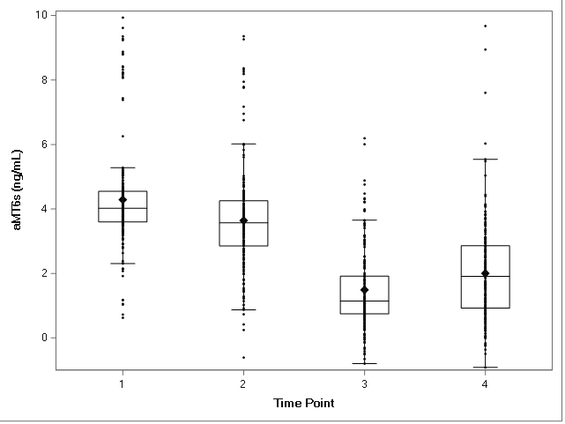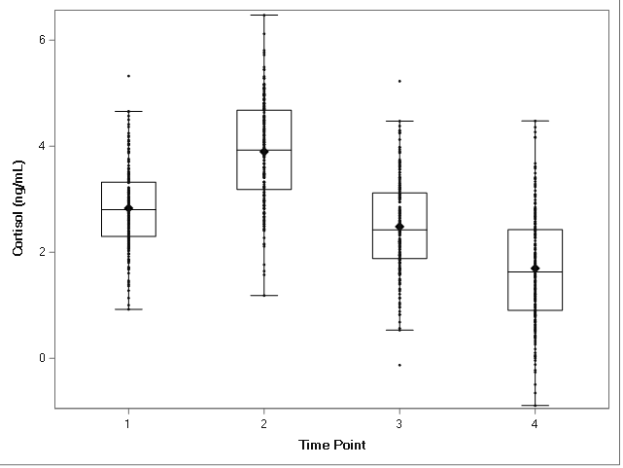

Supp. Fig. 1. Average Cortisol/aMT6s Values by Time Point. Horizontal lines across each box denote median values; diamonds denote mean values. Error bars reflect confidence intervals. For the daily time points, (1) was immediately upon waking, (2) was 30 minutes after waking, (3) was before dinner, and (4) was before bed.

