Figure S1
Average momentary loneliness by age groups from 12 to 21
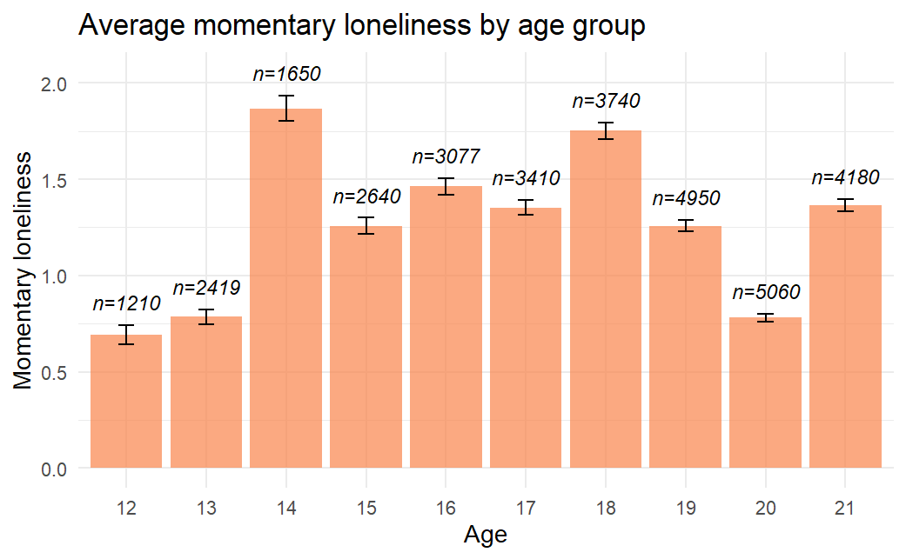
Table S1
Key Standardized Coefficients from Multilevel Structural Equation Models Predicting Loneliness from Separate Maladaptive Personality Trait Domains in Hypotheses Set 2
 | NA |  | DET |  | ANT |  | DIS |  | PSY |  | ANA
H2a+H2b (moment)
Within | β | CI | β | CI | β | CI | β | CI | β | CI | β | CI
alone→lonely (H1a) | 0.19 | -0.13; 0.49 | 0.50 | 0.26; 0.73 | 0.57 | 0.32; 0.78 | 0.54 | 0.25; 0.78 | 0.58 | 0.32; 0.79 | 0.70 | 0.38; 0.94
variability lonely | 0.93 | 0.89; 0.94 | 0.93 | 0.89; 0.94 | 0.93 | 0.89; 0.94 | 0.93 | 0.89; 0.94 | 0.93 | 0.89; 0.94 | 0.93 | 0.89; 0.94
Between
PID→lonely (H2a) | 0.33 | 0.19; 0.44 | 0.26 | 0.15; 0.37 | 0.31 | 0.21; 0.42 | 0.19 | 0.09; 0.31 | 0.20 | 0.10; 0.31 | 0.11 | -0.00; 0.24
PID→alone | 0.02 | -0.09; 0.13 | 0.12 | 0.01; 0.23 | 0.09 | -0.02; 0.21 | 0.09 | -0.03; 0.19 | 0.08 | -0.03; 0.18 | 0.03 | -0.08; 0.13
PID→variability lonely (H2b) | 0.35 | 0.24; 0.46 | 0.20 | 0.11; 0.32 | 0.28 | 0.17; 0.39 | 0.20 | 0.10; 0.32 | 0.22 | 0.12; 0.34 | 0.08 | -0.03; 0.20
lonely<->variability lonely | 0.52 | 0.43; 0.60 | 0.55 | 0.46; 0.63 | 0.54 | 0.45; 0.62 | 0.55 | 0.47; 0.63 | 0.55 | 0.46; 0.63 | 0.57 | 0.48; 0.64
alone<->variability lonely | 0.09 | -0.02; 0.20 | 0.07 | -0.04; 0.18 | 0.07 | -0.04; 0.18 | 0.07 | -0.04; 0.19 | 0.07 | -0.04; 0.19 | 0.09 | -0.02; 0.20
H2c+H2d (daily)
Within | β | CI | β | CI | β | CI | β | CI | β | CI | β | CI
alone→lonely (H1b) | 0.76 | -0.98; 1.52 | 0.30 | -0.71; 1.16 | 0.51 | -0.83; 1.42 | 0.24 | -1.12; 1.32 | 0.45 | -0.71; 1.31 | 0.60 | -0.54; 1.44
variability lonely | 0.96 | 0.88; 0.98 | 0.96 | 0.88; 0.98 | 0.96 | 0.88; 0.98 | 0.97 | 0.96; 0.98 | 0.97 | 0.97; 0.98 | 0.97 | 0.88; 0.98
Between
PID→lonely (H2c) | 0.42 | 0.30; 0.53 | 0.29 | 0.17; 0.42 | 0.29 | 0.17; 0.42 | 0.26 | 0.14; 0.38 | 0.37 | 0.26; 0.48 | 0.13 | 0.01; 0.26
PID→alone | 0.02 | -0.10; 0.14 | 0.12 | 0.01; 0.23 | 0.09 | -0.02; 0.21 | 0.10 | -0.01; 0.22 | 0.09 | -0.02; 0.20 | 0.03 | -0.08; 0.14
PID→variability lonely (H2d) | 0.36 | 0.24; 0.46 | 0.26 | 0.14; 0.37 | 0.25 | 0.13; 0.36 | 0.22 | 0.10; 0.33 | 0.27 | 0.16; 0.37 | 0.09 | -0.03; 0.21
lonely<->variability lonely | 0.66 | 0.57; 0.73 | 0.68 | 0.60; 0.74 | 0.68 | 0.60; 0.74 | 0.67 | 0.60; 0.74 | 0.67 | 0.59; 0.73 | 0.69 | 0.61; 0.75
alone<->variability lonely | 0.09 | -0.02; 0.21 | 0.07 | -0.05; 0.18 | 0.08 | -0.04; 0.19 | 0.07 | -0.04; 0.19 | 0.07 | -0.04; 0.19 | 0.09 | -0.03; 0.20
Note. N = 294 (between), N = 29,984 (within); PID = maladaptive personality traits assessed via PID-5BF+; NA = domain negative affect; DET = domain detachment; ANT = domain antagonism; DIS = domain disinhibition; PSY = domain psychoticism; ANA = domain Anankastia.

Table S2
Key Standardized Coefficients from Multilevel Structural Equation Models Predicting Loneliness from Separate Maladaptive Personality Trait Domains in Hypotheses Set 3
 | NA |  | DET |  | ANT |  | DIS |  | PSY |  | ANA
H3a (moment)
Within | β | CI | β | CI | β | CI | β | CI | β | CI | β | CI
alone→lonely (H1a) | 0.07 | -0.16; 0.42 | 0.44 | 0.24; 0.70 | 0.48 | 0.27; 0.67 | 0.41 | 0.17; 0.66 | 0.50 | 0.31; 0.73 | 0.70 | 0.44; 0.97
Between
PID→H1a (H3a) | 0.22 | 0.06; 0.33 | 0.04 | -0.11; 0.15 | 0.02 | -0.14; 0.14 | 0.05 | -0.08; 0.17 | -0.00 | -0.14; 0.10 | -0.12 | -0.26; 0.01
PID→lonely (H2a) | 0.32 | 0.21; 0.41 | 0.23 | 0.11; 0.32 | 0.29 | 0.19; 0.39 | 0.20 | 0.08; 0.29 | 0.19 | 0.08; 0.28 | 0.09 | -0.05; 0.19
PID→alone | 0.01 | -0.10; 0.15 | 0.12 | 0.02; 0.22 | 0.10 | -0.01; 0.21 | 0.09 | -0.02; 0.21 | 0.08 | -0.02; 0.20 | 0.03 | -0.08; 0.16
alone<->lonely (H1c) | -0.01 | -0.13; 0.09 | -0.04 | -0.15; 0.07 | -0.03 | -0.14; 0.07 | -0.03 | -0.14; 0.08 | -0.02 | -0.13; 0.08 | -0.01 | -0.12; 0.09
H3b (daily)
Within
alone→lonely (H1b) | 0.72 | 0.10; 1.43 | 0.76 | 0.30; 1.15 | 0.89 | 0.45; 1.50 | 0.91 | 0.28; 1.65 | 1.24 | 0.69; 2.04 | 1.23 | 0.63; 1.70
Between
PID→H1b (H3b) | 0.10 | -0.23; 0.43 | 0.03 | -0.28; 0.24 | -0.13 | -0.45; 0.18 | 0.02 | -0.32; 0.25 | -0.32 | -0.72; 0.01 | -0.27 | -0.54; 0.03
PID→lonely (H2c) | 0.42 | 0.31; 0.51 | 0.27 | 0.17; 0.38 | 0.29 | 0.18; 0.40 | 0.36 | 0.14; 0.37 | 0.32 | 0.20; 0.43 | 0.13 | 0.01; 0.24
PID→alone | 0.03 | -0.09; 0.14 | 0.13 | 0.00; 0.24 | 0.10 | -0.10; 0.15 | 0.10 | -0.01; 0.21 | 0.09 | -0.03; 0.19 | 0.03 | -0.09; 0.14
alone<->lonely (H1c) | 0.05 | -0.07; 0.17 | 0.02 | -0.11; 0.14 | 0.03 | -0.10; 0.15 | 0.03 | -0.09; 0.15 | 0.03 | -0.10; 0.15 | 0.05 | -0.08; 0.17
Note. N = 294 (between), N = 29,984 (within); PID = maladaptive personality traits assessed via PID-5BF+; NA = domain negative affect; DET = domain detachment; ANT = domain antagonism; DIS = domain disinhibition; PSY = domain psychoticism; ANA = domain Anankastia.

Table S3
Key Standardized Coefficients from Multilevel Structural Equation Models Predicting Loneliness from Separate Maladaptive Personality Trait Domains in Exploratory Set B
 | NA |  | DET |  | ANT |  | DIS |  | PSY |  | ANA
 | β | CI | β | CI | β | CI | β | CI | β | CI | β | CI
Within
sa | -0.96 | -1.42; -0.47 | -0.86 | -1.27; -0.47 | -0.92 | -1.32; -0.56 | -0.83 | -1.28; -0.40 | -0.83 | -1.25; -0.46 | -1.07 | -1.48; -0.60
sb | -0.54 | -0.89; -0.17 | -0.90 | -1.16; -0.60 | -0.67 | -0.95; -0.40 | -0.79 | -1.12; 0.44 | -0.69 | -0.98; -0.39 | -0.69 | -1.00; -0.37
sc | 0.06 | -0.59; 0.73 | 0.20 | -0.20; 0.73 | 0.44 | 0.02; 0.97 | 0.39 | -0.14; 0.95 | 0.68 | 0.21; 1.16 | 0.53 | 0.00; 1.23
indirect effect (ψab) | 0.26 | -0.13; 0.67 | 0.48 | 0.11; 0.84 | 0.36 | 0.01; 0.71 | 0.37 | -0.02; 0.79 | 0.31 | -0.03; 0.65 | 0.45 | 0.03; 0.89
cross-level interaction (moderation)
PID→sa | 0.00 | -0.29; 0.18 | -0.09 | -0.28; 0.12 | -0.03 | -0.23; 0.18 | -0.08 | -0.28; 0.12 | -0.10 | -0.30; 0.09 | 0.07 | -0.13; 0.24
PID→sb | -0.17 | -0.33; -0.10 | 0.03 | -0.11; 0.19 | -0.16 | -0.31; -0.01 | -0.03 | -0.18; 0.12 | -0.13 | -0.28; 0.02 | -0.10 | -0.24; 0.05
PID→sc | 0.15 | -0.17; 0.44 | 0.10 | -0.20; 0.33 | -0.13 | -0.39; 0.13 | -0.04 | -0.33; 0.24 | -0.29 | -0.60; -0.04 | -0.13 | -0.53; 0.12
Note. N = 294 (between), N = 29,984 (within); PID = maladaptive personality traits assessed via PID-5BF+; NA = domain negative affect; DET = domain detachment; ANT = domain antagonism; DIS = domain disinhibition; PSY = domain psychoticism; ANA = domain Anankastia.

