List of Items Contributing to trauma exposure
(1) “A car accident in which your child or another person in the car was hurt bad enough to require medical attention”,
(2) “Another significant accident for which your child needed specialized and intensive medical treatment”,
(3) “Witnessed or caught in a fire that caused significant property damage or personal injury”,
(4) “Witnessed or caught in a natural disaster that caused significant property damage or personal injury”,
(5) “Witnessed or present during an act of terrorism (e.g., Boston marathon bombing)”,
(6) “Witnessed death or mass destruction in a war zone”,
(7) “Witnessed someone shot or stabbed in the community”,
(8) “Shot, stabbed, or beaten brutally by a non-family member”,
(9) “Shot, stabbed, or beaten brutally by a grown up in the home”,
(10) “Beaten to the point of having bruises by a grown up in the home”,
(11) “A non-family member threatened to kill your child”,
(12) “A family member threatened to kill your child”,
(13) “Witness the grownups in the home push, shove or hit one another”,
(14) “A grown up in the home touched your child in his or her privates, had your child touch their privates, or did other sexual things to your child”,
(15) “An adult outside your family touched your child in his or her privates, had your child touch their privates or did other sexual things to your child”,
(16) “A peer forced your child to do something sexually”, and
(17) “Learned about the sudden unexpected death of a loved one”. Response items for each item were 0 (no) or 1 (yes).

Figure S1
Equation 1: Model equation of effects of neighbourhood and household disadvantage on pubertal development. Y and age are time-varying variables. The (1 | Subject) term represents the random effect of the intercept in each subject. The e represents the normally distributed residual error term. Age, trauma and BMI served as fixed effects, where β denotes the parameter estimates for both the main effects and their interactions.

Figure S2
Pearson correlation of variables measured for females.
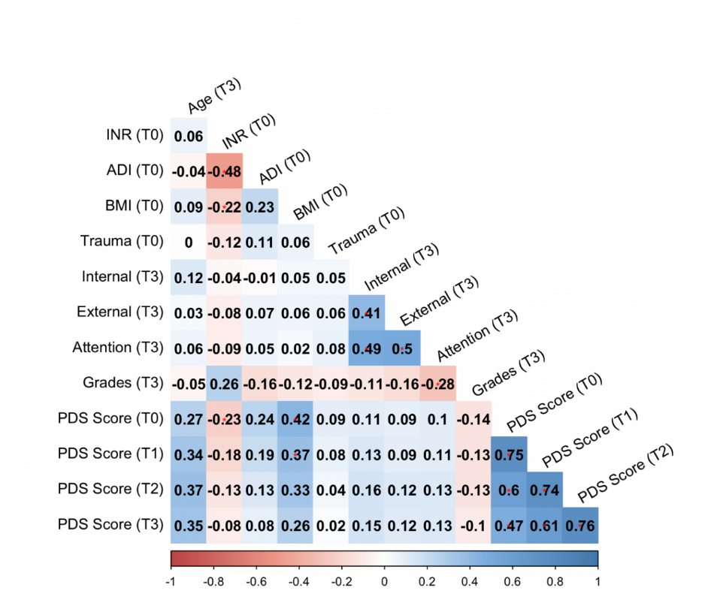
Note: *: Indicates significance at the .05 level (i.e., p < .05); **: Indicates significance at the .01 level (i.e., p < .01); ***: Indicates significance at the .001 level (i.e., p < .001).
Abbreviations: ADI = Area Deprivation Index; PDS = Pubertal Development Scale; BMI = Body Mass Index
Figure S3
Pearson correlation of variables measured for males.
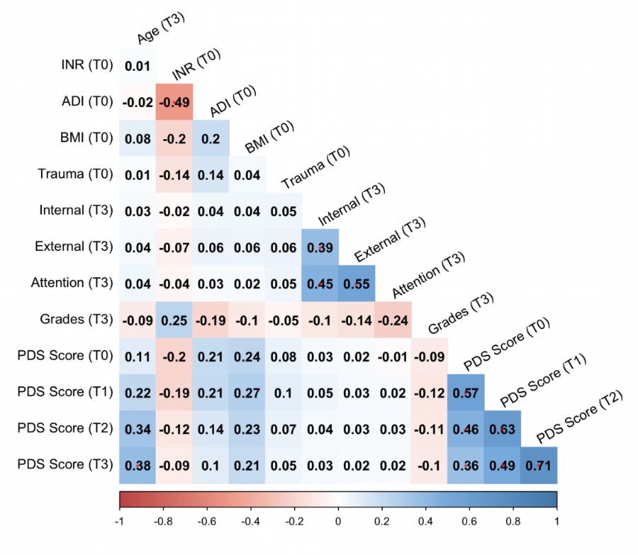
Note: *: Indicates significance at the .05 level (i.e., p < .05); **: Indicates significance at the .01 level (i.e., p < .01); ***: Indicates significance at the .001 level (i.e., p < .001).
Abbreviations: ADI = Area Deprivation Index; PDS = Pubertal Development Scale; BMI = Body Mass Index
Table S1
Linear Mixed Model of Pubertal Development for ADI and INR by Gender adjusting for the interaction term of INR, ADI, Trauma, and BMI and age, as well as the random effect of family ID and participant ID
 | Females |  |  |  |  | Males
Fixed Effects | β | SE | t | p |  | β | SE | t | p
(Intercept) | -0.38 | 0.01 | -33.26 | < .001 |  | -0.87 | 0.02 | -40.84 | < .001
INR | -0.08 | 0.01 | -6.50 | < .001 |  | -0.06 | 0.02 | -4.69 | < .001
ADI | 0.10 | 0.01 | 7.01 | < .001 |  | 0.08 | 0.01 | 6.32 | < .001
Age | 0.04 | < 0.01 | 156.05 | < .001 |  | 0.03 | < 0.01 | 100.69 | < .001
Trauma | 0.05 | 0.01 | 4.00 | < .001 |  | 0.02 | < 0.01 | 2.67 | 0.010
BMI | 0.22 | 0.01 | 21.43 | < .001 |  | 0.08 | 0.01 | 14.96 | < .001
INR: Age | < 0.01 | < 0.01 | 4.12 | < .001 |  | < 0.01 | < 0.01 | 2.97 | .004
ADI: Age | -0.002 | < 0.01 | -5.53 | < .001 |  | 0.0003 | < 0.01 | 0.02 | .985
Trauma: Age | < -0.01 | < 0.01 | -2.60 | .009 |  | < 0.01 | < 0.01 | 0.35 | .715
BMI: Age | < -0.01 | < 0.01 | -4.73 | < 0.001 |  | < 0.01 | < 0.01 | 8.29 | < 0.001
Note: INR = Income-to-Needs Ratio; ADI = Area Deprivation Index; BMI = Body Mass Index. All p-values readjusted using false discovery rate.

Table S2
Linear Mixed Model of Pubertal Development for ADI and INR by Gender adjusting for the interaction term of INR and ADI and age, as well as the random effect of family ID and participant ID

 | Female |  |  |  | Male
Fixed Effects | b | SE | t | p | b | SE | t | p
Intercept | -0.380 | 0.012 | -32.158 | < .001 | -0.867 | 0.024 | -36.784 | < .001
INR | -0.121 | 0.013 | -9.031 | < .001 | -0.066 | 0.011 | -6.009 | < .001
Age | 0.044 | < .001 | 158.570 | < .001 | 0.028 | < .001 | 102.507 | < .001
ADI | 0.129 | 0.014 | 9.352 | < .001 | 0.099 | 0.013 | 7.778 | < .001
INR:Age | 0.001 | < .001 | 4.311 | < .001 | 0.001 | < .001 | 2.827 | 0.005
ADI:Age | -0.002 | < .001 | -5.626 | < .001 | < .001 | < .001 | 0.045 | 0.964
Note: INR = Income-to-Needs Ratio; ADI = Area Deprivation Index; BMI = Body Mass Index.

Table S3
Linear Mixed Model of Pubertal Development for ADI and INR by Gender adjusting for the interaction term of INR, ADI, and Trauma and age, as well as the random effect of family ID and participant ID
 | female |  |  |  | male
Fixed Effects | b | SE | t | p | b | SE | t | p
Intercept | -0.386 | 0.012 | -32.310 | < .001 | -0.866 | 0.024 | -36.486 | < .001
INR | -0.114 | 0.014 | -8.446 | < .001 | -0.066 | 0.011 | -5.911 | < .001
Age | 0.044 | < .001 | 156.498 | < .001 | 0.028 | < .001 | 100.907 | < .001
ADI | 0.130 | 0.014 | 9.309 | < .001 | 0.096 | 0.013 | 7.408 | < .001
Trauma | 0.055 | 0.012 | 4.549 | < .001 | 0.021 | 0.009 | 2.371 | 0.018
INR:Age | 0.001 | < .001 | 4.029 | < .001 | 0.001 | < .001 | 3.207 | 0.001
ADI:Age | -0.002 | < .001 | -5.416 | < .001 | < .001 | < .001 | 0.104 | 0.917
Trauma:Age | -0.001 | < .001 | -2.756 | 0.006 | < .001 | < .001 | 0.473 | 0.637
Note: INR = Income-to-Needs Ratio; ADI = Area Deprivation Index; BMI = Body Mass Index.

Table S4
Linear Mixed Model of Pubertal Development for ADI and INR by Gender adjusting for the interaction term of INR, ADI, and BMI and age, as well as the random effect of family ID and participant ID
 | female |  |  |  | male
Fixed Effects | b | SE | t | p | b | SE | t | p
Intercept | -0.372 | 0.011 | -33.051 | < .001 | -0.867 | 0.021 | -41.515 | < .001
INR | -0.086 | 0.013 | -6.675 | < .001 | -0.059 | 0.011 | -5.453 | < .001
Age | 0.044 | < .001 | 158.182 | < .001 | 0.028 | < .001 | 102.749 | < .001
ADI | 0.093 | 0.013 | 7.039 | < .001 | 0.084 | 0.013 | 6.711 | < .001
BMI | 0.244 | 0.011 | 21.463 | < .001 | 0.080 | 0.010 | 7.829 | < .001
INR:Age | 0.001 | < .001 | 3.655 | < .001 | 0.001 | < .001 | 3.752 | < .001
ADI:Age | -0.002 | < .001 | -5.097 | < .001 | < .001 | < .001 | -1.037 | 0.300
BMI:Age | -0.001 | < .001 | -4.898 | < .001 | 0.003 | < .001 | 8.703 | < .001
Note: INR = Income-to-Needs Ratio; ADI = Area Deprivation Index; BMI = Body Mass Index.

Table S5
Results of analysis examining puberty as a mediator in the association between SES and mental health/academic outcomes for females.
 |  | Internalizing |  |  | Externalizing |  |  | Attention |  |  |  | Grades
Path Analysis |  | β | SE [95% CI] |  | β | SE [95% CI] |  | β | SE [95% CI] |  | β |  |  | SE [95% CI]
Household Disadvantage
Direct path
c path |  | -0.057** | 0.019 [-0.094, -0.020] |  | -0.066*** | 0.019 [-0.103, -0.028] |  | -0.077*** | 0.019 [-0.117, -0.040] |  |  | 0.230*** | 0.018 [0.194, 0.264]
Indirect path
a1 path (INR → PDS Slope) |  | 0.037 | 0.019 [0.002, 0.075] |  | 0.037 | 0.019 [-0.002, 0.075] |  | 0.037 | 0.019 [0.002, 0.075] |  |  | 0.037 | 0.019 [0.002, 0.075]
a2 path (INR → PDS Intercept) |  | -0.080*** | 0.017 [-0.115 -0.046] |  | -0.081*** | 0.017 [-0.115, -0.046] |  | -0.081*** | 0.017 [-0.115, -0.046] |  |  | -0.081*** | 0.017 [-0.115, -0.046]
b1 path (PDS Slope → Outcome) |  | 0.116*** | 0.018 [0.081, 0.152] |  | 0.106*** | 0.018 [0.071, 0.142] |  | 0.112*** | 0.019 [0.074, 0.148] |  |  | -0.050** | 0.016 [-0.081, -0.019]
b2 path (PDS Intercept → Outcome) |  | 0.099*** | 0.020 [0.060, 0.140] |  | 0.085*** | 0.020 [0.047, 0.123] |  | 0.111*** | 0.021 [0.070, 0.153] |  |  | -0.057** | 0.019 [-0.093, -0.019]
a1*b1 path |  | 0.004 | 0.002 [< 0.001, 0.009] |  | 0.004 | 0.004 [< 0.001, 0.008] |  | 0.004 | 0.002 [< 0.001, 0.009] |  |  | -0.002 | 0.001 [-0.005, < -0.001]
a2*b2 path |  | -0.008** | 0.002 [-0.013, -0.024] |  | -0.007** | 0.002 [-0.012, -0.003] |  | -0.009** | 0.003 [-0.014, -0.004] |  |  | 0.005* | 0.002 [0.001, 0.009]
Total Effect |  | -0.060** | 0.019 [-0.097, -0.024] |  | -0.068* | 0.019 [-0.105, -0.031] |  | -0.082* | 0.020 [-0.121, -0.045] |  |  | 0.232*** | 0.018 [0.197, 0.267]
Neighbourhood Disadvantage
Direct path
c path |  | -0.052** | 0.020 [-0.091, -0.014] |  | 0.021 | 0.020 [-0.016, 0.060] |  | 0.010 | 0.020 [-0.029, 0.049] |  |  | -0.034 | 0.021 [-0.074, 0.007]
Indirect path
a1 path (ADI → PDS Slope) |  | -0.063** | 0.020 [-0.100, -0.024] |  | -0.063** | 0.020 [-0.100, -0.024] |  | -0.063** | 0.020 [-0.100, -0.024] |  |  | -0.063** | 0.020 [-0.100, -0.024]
a2 path (ADI → PDS Intercept) |  | 0.111*** | 0.018 [0.075, 0.1465] |  | 0.111*** | 0.018 [0.075, 0.146] |  | 0.111*** | 0.018 [0.075, 0.146] |  |  | 0.111*** | 0.018 [0.75, 0.146]
b1 path (PDS Slope → Outcome) |  | 0.116*** | 0.018 [0.081, 0.152] |  | 0.107*** | 0.018 [0.071, 0.142] |  | 0.112* | 0.019 [0.074, 0.149] |  |  | -0.050** | 0.016 [-0.081, -0.019]
b2 path (PDS Intercept → Outcome) |  | 0.099*** | 0.020 [0.060, 0.140] |  | 0.086*** | 0.020 [0.047, 0.124] |  | 0.111*** | 0.021 [0.1070 0.153] |  |  | -0.057*** | 0.019 [-0.093, -0.019]
a1*b1 path |  | -0.007** | 0.002 [-0.013, -0.002] |  | -0.007** | 0.002 [-0.012, -0.002] |  | -0.007** | 0.003 [-0.012, -0.003] |  |  | 0.003* | 0.002 [0.001, 0.007]
a2*b2 path |  | 0.011** | 0.003 [0.006, 0.017] |  | 0.009** | 0.003 [0.005, 0.015] |  | 0.012** | 0.003 [0.007, 0.019] |  |  | -0.006* | -0.006 [-0.011, -0.020]
Total Effect |  | -0.052* | 0.019 [-0.091, -0.014] |  | 0.023 | 0.020 [-0.016, 0.060] |  | 0.015 | 0.020 [-0.023, 0.054] |  |  | -0.037* | -0.037 [-0.077, - 0.004]
Notes: Independent variables: income-to-needs ratio (INR) and area deprivation index (ADI). Dependent variables: mental health (internalizing, externalizing, and attention problems) and school grades. Mediators: pubertal developmental scale (PDS) scores at baseline and PDS scores over time (extracted intercepts and slopes). 1 = slope pathway, 2 = intercept pathway, β = standardized coefficient, SE = standard error, CI = confidence interval. P-values for indirect effects (a1*b1 and a2*b2) were readjusted using false discovery rate. Bold indicates significance at the p < .05 level, uncorrected. * indicates significance at the .01 level for indirect effects (i.e., p_{FDR} < .05); ** indicates significance at the .01 level (i.e., p_{FDR} < .01); *** indicates significance at the .001 level (i.e., p_{FDR} < .001).
Table S6
Results of analysis examining puberty as a mediator in the association between SES and mental health/academic outcomes for males.
 |  | Internalizing |  |  | Externalizing |  |  | Attention |  |  | Grades
Path Analysis |  | β | SE [95% CI] |  | β | SE [95% CI] |  | β | SE [95% CI] |  |  | β | SE [95% CI]
Household Disadvantage
Direct path
c path |  | 0.012 | 0.017 [-0.020, 0.047] |  | -0.021* | 0.018 [-0.058, 0.014] |  | -0.017 | 0.018 [-0.053, 0.019] |  | 0.108*** |  | 0.014 [0.080, 0.136]
Indirect path
a1 path (INR → PDS Slope) |  | -0.007 | 0.017 [-0.040,0.026] |  | -0.013 | 0.017 [-0.046, 0.021] |  | -0.009 | 0.017 [-0.042, 0.025] |  | -0.002 |  | 0.018 [ -0.037, 0.032]
a2 path (INR → PDS Intercept) |  | -0.109*** | 0.017 [-0.141, -0.075] |  | -0.108*** | 0.017[-0.140, -0.074] |  | -0.107*** | 0.017 [-0.140, -0.073] |  | -0.103*** |  | 0.017 [-0.136, -0.069]
b1 path (PDS Slope → Outcome) |  | 0.007 | 0.017 [-0.027, 0.041] |  | 0.030 | 0.018 [-0.004, 0.065] |  | 0.026 | 0.018 [-0.008, 0.061] |  | -0.002 |  | 0.014 [ -0.031, 0.026]
b2 path (PDS Intercept → Outcome) |  | 0.034 | 0.017 [0.000, 0.067] |  | -0.022 | 0.018 [-0.058, 0.013] |  | -0.034 | 0.019[-0.071, 0.002] |  | -0.028 |  | 0.016[-0.059, 0.005]
a1*b1 path |  | < 0.001 | < 0.001[-0.001, 0.000] |  | < 0.001 | 0.001[-0.002, 0.000] |  | < 0.001 | 0.001[-0.002, 0.001] |  | < -0.001 |  | < 0.001[0.000, 0.001]
a2*b2 path |  | -0.004 | 0.002[-0.008, 0.000] |  | 0.002 | 0.002[-0.001, 0.007] |  | 0.004 | 0.002[< -0.001, 0.008] |  | 0.003 |  | 0.002[< -0.001, 0.007]
Total Effect |  | 0.009 | 0.002 [-0.024, 0.044] |  | -0.019 | 0.018[-0.055, 0.017] |  | -0.017 | 0.018[-0.053, 0.019] |  | 0.111*** |  | 0.014 [0.082, 0.140]
Neighbourhood Disadvantage
Direct path
c path |  | 0.034 | 0.019 [-0.002, 0.070] |  | 0.035 | 0.020 [- 0.004, 0.074] |  | 0.014 | 0.020 [-0.026, 0.051] |  | -0.096*** |  |  | 0.020 [-0.135, -0.057]
Indirect path
a path (ADI → PDS Intercept)) |  | 0.125*** | 0.019 [0.088, 0.161] |  | 0.125*** | 0.019 [0.089, 0.161] |  | 0.125*** | 0.19 [0.089, 0.161] |  | 0.125*** |  |  | 0.019 [0.089, 0.161]
b path (PDS Intercept → Outcome) |  | 0.027 | 0.017 [-0.006, 0.061] |  | -0.022 | 0.018 [-0.058, 0.013] |  | -0.030 | 0.018 [-0.066, 0.006] |  | -0.037 |  |  | 0.017 [-0.071, -0.002]
a1*b1 path |  | 0.003 | 0.002 [-0.001, 0.008] |  | -0.003 | 0.002[-0.008, 0.002] |  | -0.004 | 0.002[-0.009, 0.001] |  | -0.005 |  |  | 0.002[-0.009, < -0.001]
Total Effect |  | 0.038* | 0.018 [0.001, 0.074] |  | 0.033 | 0.020 [-0.007, 0.071] |  | 0.010 | 0.019 [-0.030, 0.047] |  | -0.096*** |  |  | 0.020 [ -0.135, -0.058]
Notes: Independent variables: income-to-needs ratio (INR) and area deprivation index (ADI). Dependent variables: mental health (internalizing, externalizing, and attention problems) and school grades. Mediators: pubertal developmental scale (PDS) scores at baseline and PDS scores over time (extracted intercepts and slopes). 1 = slope pathway, 2 = intercept pathway, β = standardized coefficient, SE = standard error, CI = confidence interval. P-values for indirect effects (a1*b1 and a2*b2) were readjusted using false discovery rate. Bold indicates significance at the p < .05 level, uncorrected. * indicates significance at the .01 level for indirect effects (i.e., p_{FDR} < .05); ** indicates significance at the .01 level (i.e., p_{FDR} < .01); *** indicates significance at the .001 level (i.e., p_{FDR} < .001).
Table S7 sensitivity
Results of sensitivity analysis examining puberty as a mediator in the association between SES and mental health/academic outcomes for females, accounting for prior mental and academic outcomes
 |  | Internalizing |  |  | Externalizing |  |  | Attention |  |  |  | Grades
Path Analysis |  | β | SE [95% CI] |  | β | SE [95% CI] |  | β | SE [95% CI] |  | β |  |  | SE [95% CI]
Household Disadvantage
Direct path
c path |  | -0.045* | 0.018 [-0.081, -0.008] |  | -0.044* | 0.018 [-0.081, -0.009] |  | -0.066** | 0.019[-0.105, -0.029] |  |  | 0.126*** | 0.016 [0.096, 0.158]
Indirect path
a2 path (INR → PDS Intercept) |  | -0.078*** | 0.017 [-0.113 -0.044] |  | -0.078*** | 0.017 [-0.111, -0.043] |  | -0.080*** | 0.017 [-0.114, -0.046] |  |  | -0.073*** | 0.017 [-0.108, -0.037]
b2 path (PDS Intercept → Outcome) |  | 0.097*** | 0.019 [0.059, 0.134] |  | 0.078*** | 0.019 [0.040, 0.116] |  | 0.109*** | 0.021 [0.069, 0.150] |  |  | -0.038* | 0.016 [-0.070, -0.005]
a2*b2 path |  | -0.008** | 0.002 [-0.013, -0.004] |  | -0.006** | 0.002[-0.011, -0.003] |  | -0.009*** | 0.003 [-0.015, -0.005] |  |  | 0.003*** | 0.001 [0.000, 0.006]
Total Effect |  | -0.048** | 0.019 [-0.085, -0.011] |  | -0.046* | 0.018 [-0.083, -0.010] |  | -0.070*** | 0.019 [-0.109, -0.033] |  |  | 0.128*** | 0.016 [0.098, 0.159]
Neighbourhood Disadvantage
Direct path
c path |  | -0.051** | 0.019 [-0.088, -0.014] |  | 0.012 | 0.019 [-0.024, 0.051] |  | 0.003 | 0.019 [-0.035, 0.039] |  |  | -0.016 | 0.018 [-0.051, 0.019]
Indirect path
a1 path (ADI → PDS Slope) |  | -0.064** | 0.020 [-0.102, -0.025] |  | -0.063*** | 0.020 [-0.102, -0.025] |  | -0.064*** | 0.020 [-0.102, -0.026] |  |  | -0.065** | 0.020 [-0.103, -0.025]
a2 path (ADI → PDS Intercept) |  | 0.111*** | 0.018 [0.077, 0.149] |  | 0.110*** | 0.018 [0.076, 0.147] |  | 0.111*** | 0.018 [0.077, 0.149] |  |  | 0.109*** | 0.019 [0.073, 0.146]
b1 path (PDS Slope → Outcome) |  | 0.118*** | 0.018 [0.082, 0.153] |  | 0.105*** | 0.018 [0.071, 0.140] |  | 0.109*** | 0.018 [0.072, 0.144] |  |  | -0.035** | 0.014 [-0.062, -0.008]
b2 path (PDS Intercept → Outcome) |  | 0.097*** | 0.019 [0.059, 0.134] |  | 0.078*** | 0.019 [0.040, 0.116] |  | 0.109*** | 0.021 [0.069, 0.150] |  |  | -0.038* | 0.017 [-0.070, -0.005]
a1*b1 path |  | -0.008** | 0.003 [-0.013, -0.003] |  | -0.007** | 0.002 [-0.012, -0.003] |  | -0.007** | 0.002 [-0.013, -0.003] |  |  | 0.002 | 0.001 [0.000, 0.005]
a2*b2 path |  | 0.011*** | 0.003 [0.006, 0.017] |  | 0.009*** | 0.003 [0.004, 0.014] |  | 0.012*** | 0.003 [0.007, 0.019] |  |  | -0.004* | 0.002 [-0.009, -0.001]
Total Effect |  | -0.048 | 0.019 [-0.085, -0.011] |  | 0.014 | 0.019 [-0.023, 0.052] |  | 0.008 | 0.019 [-0.030, 0.046] |  |  | -0.018 | 0.017 [-0.053, 0.016]
Notes: Independent variables: income-to-needs ratio (INR) and area deprivation index (ADI). Dependent variables: mental health (internalizing, externalizing, and attention problems) and school grades. Mediators: pubertal developmental scale (PDS) scores at baseline and PDS scores over time (extracted intercepts and slopes). 1 = slope pathway, 2 = intercept pathway, β = standardized coefficient, SE = standard error, CI = confidence interval. * indicates significance at the .01 level for indirect effects (i.e., p < .05); ** indicates significance at the .01 level (i.e., p< .01); *** indicates significance at the .001 level (i.e., p < .001).

