Supplement C – Sex Differences
Hyperreactivity
The pattern of results for invariance testing of the IBQ-SS hyperreactivity subscale was similar to the full sample across both sexes, so the metric model was used to measure sensory hyperreactivity (see Tables C.1 and C.2).
Table C.1. Invariance testing scaled fit statistics compared to a baseline, unconstrained model.
 | χ² (df) | Robust CFI | Robust TLI | AIC
Males
Configural | 387.403 (159) | 0.72 | 0.66 | 9275.844
Metric | 394.802 (169) | 0.72 | 0.69 | 9262.597
Scalar | 425.068 (179) | 0.70 | 0.68 | 9271.969
Residual | 440.196 (189) | 0.69 | 0.69 | 9271.872
Females
Configural | 277.214 (159) | 0.78 | 0.74 | 7939.214
Metric | 280.111 (169) | 0.79 | 0.77 | 7924.948
Scalar | 308.452 (179) | 0.76 | 0.74 | 7934.501
Residual | 321.840 (189) | 0.75 | 0.75 | 7933.024
CFI = Comparative Fit Index; TLI = Tucker-Lewis Index; AIC = Aikake Information Criterion
Criteria for adequate fit: CFI ≥ 0.9; TLI ≥ 0.9

Table C.2. Pairwise ANOVA results for test of χ² differences across models.
 | χ² Difference (p)
 | Males | Females
Configural vs. Metric | 6.77 (.75) | 4.64 (.91)
Metric vs. Scalar | 30.83 (.001) | 29.13 (.001)
Scalar vs. Residual | 16.37 (.09) | 14.04 (.17)

Cross-lagged panel models (CLPMs) demonstrated better fit in females than males (see Table C.3). In males (n = 130), no cross-lagged effects were observed between infant sensory hyperreactivity and maternal sensitivity nor intrusiveness. Additionally, intrusiveness at 6 months demonstrated only a small autoregressive association with intrusiveness at 12 months, and this did not meet criteria for statistical significance. Refer to Figure C.1 for the CLPM results in males.
In females (n = 114), the cross-lagged negative association between maternal sensitivity at 6 months and infant hyperreactivity at 12 months was moderately strong. The overall pattern of results in females mirrored the full sample. See Figure C.2 for CLPM results in females.
The CLPM analyses split by sex were underpowered; however, the larger effect sizes observed in females compared to males suggests a potentially more important role for maternal sensitivity and intrusiveness in predicting infant sensory hyperreactivity for female infants. These results should be replicated in larger samples with adequate power to detect effects.
Table C.3. CLPM fit indices across sensory hyperreactivity models.
 | Males |  | Females
 | Sensitivity | Intrusiveness | Sensitivity | Intrusiveness
χ² (df) | 438.538 (205) | 439.044 (205) | 332.35 (205) | 329.507 (205)
Robust CFI | 0.72 | 0.72 | 0.78 | 0.79
Robust TLI | 0.69 | 0.69 | 0.75 | 0.76
RMSEA | 0.092 | 0.092 | 0.073 | 0.072
SRMR | 0.110 | 0.108 | 0.100 | 0.099
CFI = Comparative Fit Index; TLI = Tucker-Lewis Index
Criteria for adequate fit: RMSEA ≤ 0.06; SRMR ≤ 0.08; CFI ≥ 0.9; TLI ≥ 0.9

Figure C.1. CLPM results for sensory hyperreactivity in males (n = 130).
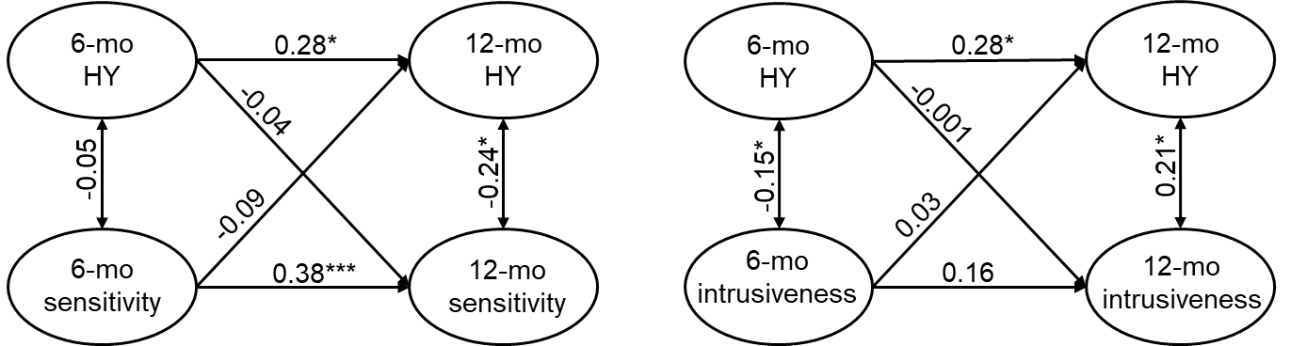
HY = hyperreactivity

Figure C.2. CLPM results for sensory hyperreactivity in females (n = 114).
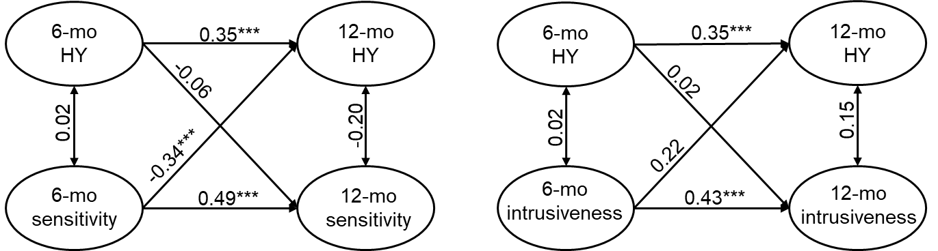
HY = hyperreactivity
Hyporeactivity
The invariance testing results for hyporeactivity were similar to the full sample (Table C.4), with one exception: the configural model demonstrated slightly better fit than the metric model according to the $χ^{2}$ test of difference in females (Table C.5). However, the metric model was still used to maintain consistency in analyses across sexes.
Table C.4. Invariance testing scaled fit statistics compared to a baseline, unconstrained model for sensory hyporeactivity.
 | χ² (df) | Robust CFI | Robust TLI | AIC
Males
Configural | 438.158 (239) | 0.82 | 0.79 | 10699.892
Metric | 455.773 (251) | 0.71 | 0.79 | 10692.312
Scalar | 548.192 (263) | 0.74 | 0.72 | 10763.661
Residual | 565.199 (275) | 0.74 | 0.73 | 10754.733
Females
Configural | 405.184 (239) | 0.84 | 0.82 | 9379.613
Metric | 427.558 (251) | 0.83 | 0.82 | 9376.742
Scalar | 484.084 (263) | 0.80 | 0.79 | 9410.034
Residual | 542.712 (275) | 0.75 | 0.75 | 9447.472
CFI = Comparative Fit Index; TLI = Tucker-Lewis Index; AIC = Aikake Information Criterion
Criteria for adequate fit: CFI ≥ 0.9; TLI ≥ 0.9

Table C.5. Pairwise ANOVA results for test of χ² differences across hyporeactivity models.
 | χ² Difference (p)
 | Males | Females
Configural vs. Metric | 17.14 (.14) | 22.60 (.03)
Metric vs. Scalar | 100.66 (<.001) | 58.70 (<.001)
Scalar vs. Residual | 16.04 (.19) | 57.56 (.12)

Sensory hyporeactivity models demonstrated better fit in females than males (Table C.6). Similar results were observed in both males and females, and patterns mirrored those observed in the full sample (see Figures C.3 and C.4). Due to smaller sample sizes, the autoregressive effects between hyporeactivity at 6 months and maternal sensitivity at 12 months did not reach the threshold for statistical significance but were similar in size to the effects observed in the full sample.
Table C.6. CLPM fit indices across hyporeactivity models.
 | Males |  | Females
 | Sensitivity | Intrusiveness | Sensitivity | Intrusiveness
χ² (df) | 533.792 (295) | 556.524 (295) | 489.827 (295) | 485.847 (295)
Robust CFI | 0.79 | 0.77 | 0.82 | 0.83
Robust TLI | 0.77 | 0.75 | 0.81 | 0.81
RMSEA | 0.077 | 0.081 | 0.075 | 0.074
SRMR | 0.128 | 0.128 | 0.093 | 0.091
CFI = Comparative Fit Index; TLI = Tucker-Lewis Index
Criteria for adequate fit: RMSEA ≤ 0.06; SRMR ≤ 0.08; CFI ≥ 0.9; TLI ≥ 0.9
Figure C.3. CLPM results for sensory hyporeactivity in males (n = 102).
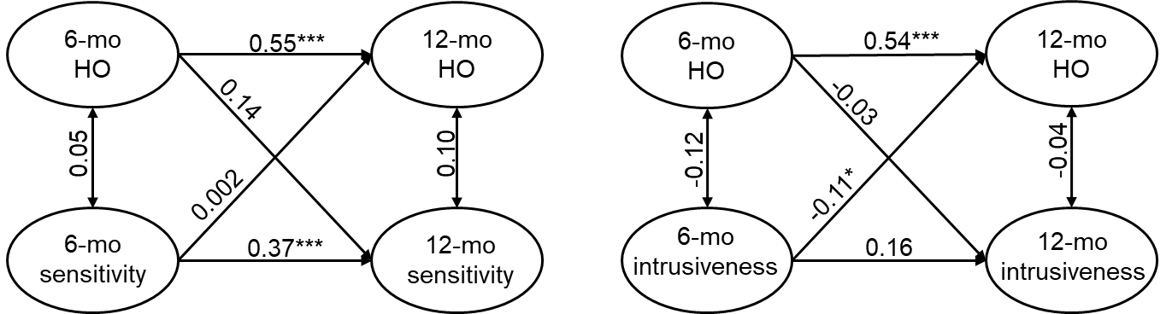
HO = hyporeactivity
Figure C.4. CLPM results for sensory hyporeactivity in males (n = 89).
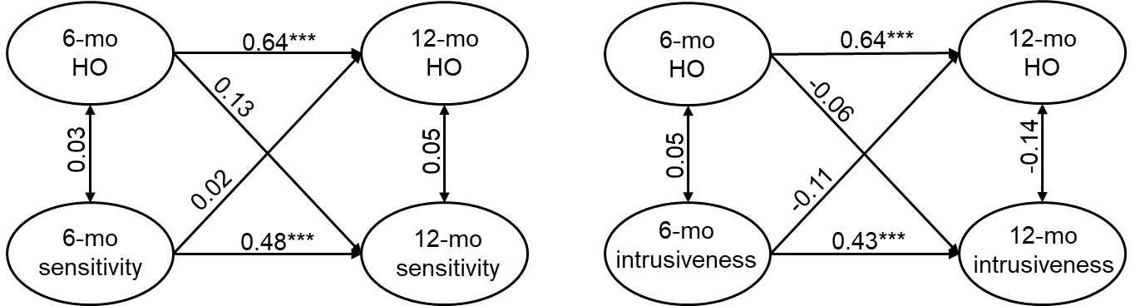
HO = hyporeactivity

