Supplement B – Additional Statistical Results
Demographic Correlations with Variables of Interest
Table B.1. Correlations between demographic variables and variables of interest at 6 and 12 months.
 | Birthweight | Income to Need Ratio |  | Sex
6-month Hyperreactivity | -.13 | -.18** | -.09
12-month Hyperreactivity | -.04 | -.23*** | -.11
6-month Hyporeactivity | .12 | .16* | -.10
12-month Hyporeactivity | .11 | .08 | .01
6-month Sensitivity | .09 | .15* | .06
12-month Sensitivity | .05 | .29*** | .06
6-month Intrusiveness | -.00 | -.16* | .04
12-month Intrusiveness | -.03 | -.23*** | .03
*p < .05
**p < .01
***p < .001
Note: The hyporeactivity subscale is equivalent to the original IBQ-R Perceptual Sensitivity subscale, reverse scored.
Mental Health and Neurodevelopmental Conditions within the Sample
Maternal mental health, especially depression, is known to influence maternal sensitivity and intrusiveness. Additionally, early signs of neurodevelopmental conditions, such as autism and attention deficit/hyperactivity disorder (ADHD), increase the likelihood of atypical sensory reactivity. Thus, it is important to consider the prevalence of mental health and neurodevelopmental conditions within the study sample. Data collection for these conditions is ongoing; therefore, data on some conditions is currently incomplete. For later diagnosis of autism (n = 7 of 188 with available data) and ADHD (n = 10 of 188 with available data), parents reported on whether or not their child had received a professional diagnosis by age eight years in half of the sample, and adolescents reported on their own diagnosis at age 16-18 years in the other half of the sample. For family history of autism (n = 13 of 94 with available data) and ADHD (n = 21 of 121 with available data), parents reported on whether the child had biological relatives with these diagnoses at child age 7-10 years. Data on maternal depression, defined as either a lifetime major depressive episode or a positive screening result on the Edinburgh Postnatal Depression Scale (cutoff of 13) at 2-3 months postpartum, was available for the full sample (n = 34 met criteria for depression).
Invariance Testing
As recommended by Mackinnon and colleagues (2022), we conducted invariance testing using the lavaan package in RStudio (Rosseel, 2012) to establish the underlying latent structure of the sensory reactivity variables included in the cross-lagged panel models (CLPM) to ensure comparability of measurement across waves of data collection. We tested for invariance separately within the hyperreactivity and reverse-scored perceptual sensitivity (termed hyporeactivity) subscales by fitting four iterations of increasingly restrictive factor models to both waves of data then conducting ANOVAs for pairwise comparison of χ² differences across models. We applied the constraints from the best-fitting and most parsimonious model to the underlying factor structure for the sensory reactivity variables in the CLPM.
The least restrictive factor model is the configural model, in which factor loadings, item intercepts, and error are free to vary over waves. The metric model constrains factor loadings to equality across waves. The scalar model employs the same constraints as the metric model in addition to constraining intercepts to be equal across time. Finally, the residual model maintains constraints from the scalar model and constrains error terms to be equal across time. For both hyporeactivity and hyperreactivity, the configural and metric models demonstrated similar fit and outperformed the scalar and residual models. The metric model was selected as it is more parsimonious than the configural model. Refer to Table B.2 for fit statistics (compared to a baseline, unconstrained model) and Table B.3 for model comparison for both hypo- and hyperreactivity.
Table B.2. Invariance testing scaled fit statistics compared to a baseline, unconstrained model.
 | χ² (df) | Robust CFI | Robust TLI | AIC
Hyporeactivity
Configural | 595.070 (239) | 0.84 | 0.81 | 21714.256
Metric | 604.655 (251) | 0.84 | 0.82 | 21697.879
Scalar | 779.330 (263) | 0.75 | 0.74 | 21861.633
Residual | 823.253(275) | 0.75 | 0.75 | 21882.284
Hyperreactivity
Configural | 437.195 (159) | 0.76 | 0.72 | 17168.435
Metric | 440.720 (169) | 0.77 | 0.74 | 17151.216
Scalar | 483.496 (179) | 0.75 | 0.73 | 17175.807
Residual | 504.142 (189) | 0.74 | 0.73 | 17183.906
CFI = Comparative Fit Index; TLI = Tucker-Lewis Index; AIC = Aikake Information Criterion
Criteria for adequate fit: RMSEA ≤ 0.06; SRMR ≤ 0.08; CFI ≥ 0.9; TLI ≥ 0.9

Table B.3. Pairwise ANOVA results for test of χ² differences across models.
 | χ² Difference (p)
 | Hyporeactivity | Hyperreactivity
Configural vs. Metric | 8.24 (.77) | 2.57 (.99)
Metric vs. Scalar | 188.30 (<.001) | 44.89 (<.001)
Scalar vs. Residual | 44.65 (<.001) | 21.51 (.02)

Cross-Lagged Panel Modeling Using the Metric Model
Figure B.1 illustrates complete path diagrams of the hypo- and hyperreactivity CLPMs. Only maternal sensitivity path diagrams are shown, as the underlying factor structures were maintained across sensitivity and intrusiveness models. Table B.4 contains fit indices across all four cross-lagged panel models.
Table B.4. CLPM fit indices across models.
 | Hyperreactivity |  | Hyporeactivity
 | Sensitivity | Intrusiveness | Sensitivity | Intrusiveness
χ² (df) | 488.853 (205) | 480.849 (205) | 684.840 (295) | 689.305 (295)
CFI | 0.78 | 0.77 | 0.83 | 0.83
TLI | 0.75 | 0.75 | 0.81 | 0.81
RMSEA | 0.074 | 0.073 | 0.073 | 0.073
SRMR | 0.093 | 0.091 | 0.084 | 0.083

Figure B.1. Path diagrams of CLPM with underlying metric model factor structures for hypo- and hyperreactivity.
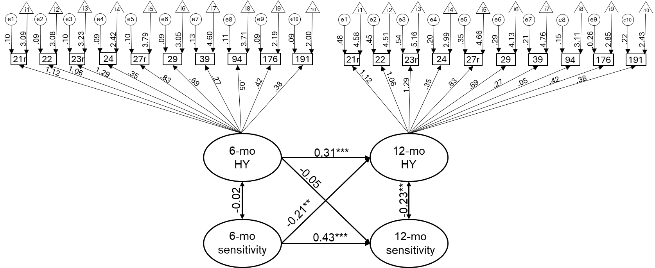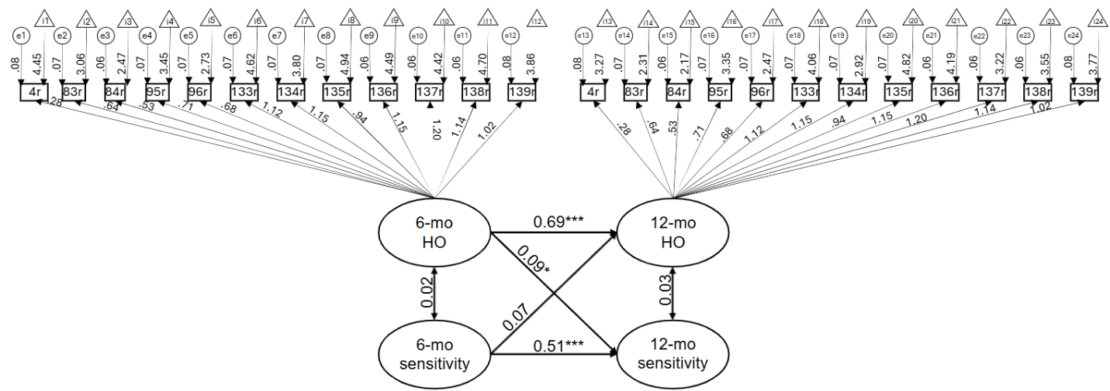

References
Mackinnon, S., Curtis, R., & O'Connor, R. (2022). A tutorial in longitudinal measurement invariance and cross-lagged panel models using lavaan. Meta-Psychology, 6. https://doi.org/10.15626/MP.2020.2595
Rosseel, Y. (2012). lavaan: An R Package for Structural Equation Modeling. Journal of Statistical Software, 48(2), 1–36. https://doi.org/10.18637/jss.v048.i02

