Supplement

Internal consistency of eye tracking measures
Table S1. Cronbach’s α for eye tracking measures by stimulus set and time point
 | Emotion
Measure | All (Composite measure) | Angry | Fearful | Happy
Scanpath distribution
T1
set 1 | 0.84 | 0.64 | 0.6 | 0.76
set 2 | 0.75 | 0.39 | 0.79 | 0.75
T2
set 1 | 0.97 | 0.80 | 0.8 | 0.89
set 2 | 0.95 | 0.64 | 0.84 | 0.77
Eye-Mouth Index (EMI)
T1
set 1 | 0.97 | 0.91 | 0.87 | 0.83
set 2 | 0.88 | 0.79 | 0.85 | 0.86
T2
set 1 | 0.86 | 0.86 | 0.69 | 0.90
set 2 | 0.93 | 0.89 | 0.62 | 0.73
Pupil dilation response
T1
set 1 | <0 | <0 | <0 | <0
set 2 | 0.33 | 0.42 | <0 | <0
T2
set 1 | <0 | 0.37 | <0 | <0
set 2 | <0 | 0.27 | <0 | <0

Development of eye tracking measures over the course of the experiment
The development of eye tracking measures over the course of the experiment was examined using hierarchical linear mixed effects models with trial number as fixed effect and random effect specified for participant. Sattertwaithe adjusted degrees of freedom were used. No effect of trial number was found for scanpath dispersion at either time point (T1: t (1155.79) = 0.40, p = 0.690, T2: t (905.62) = -0.47, p = 0.635) or EMI at T1 (t (11162.21) = -0.48, p = 0.64). However, EMI at T2 decreased over the course of the experiment (t (916.91) = 3.47, p = 0.001). Pupil dilation responses decreased during the course of the experiment at both time points (T1: t = 9.76, p < 0.0001; T2: t = 11.006, p < 0.0001). These effects are illustrated in Figure S1.

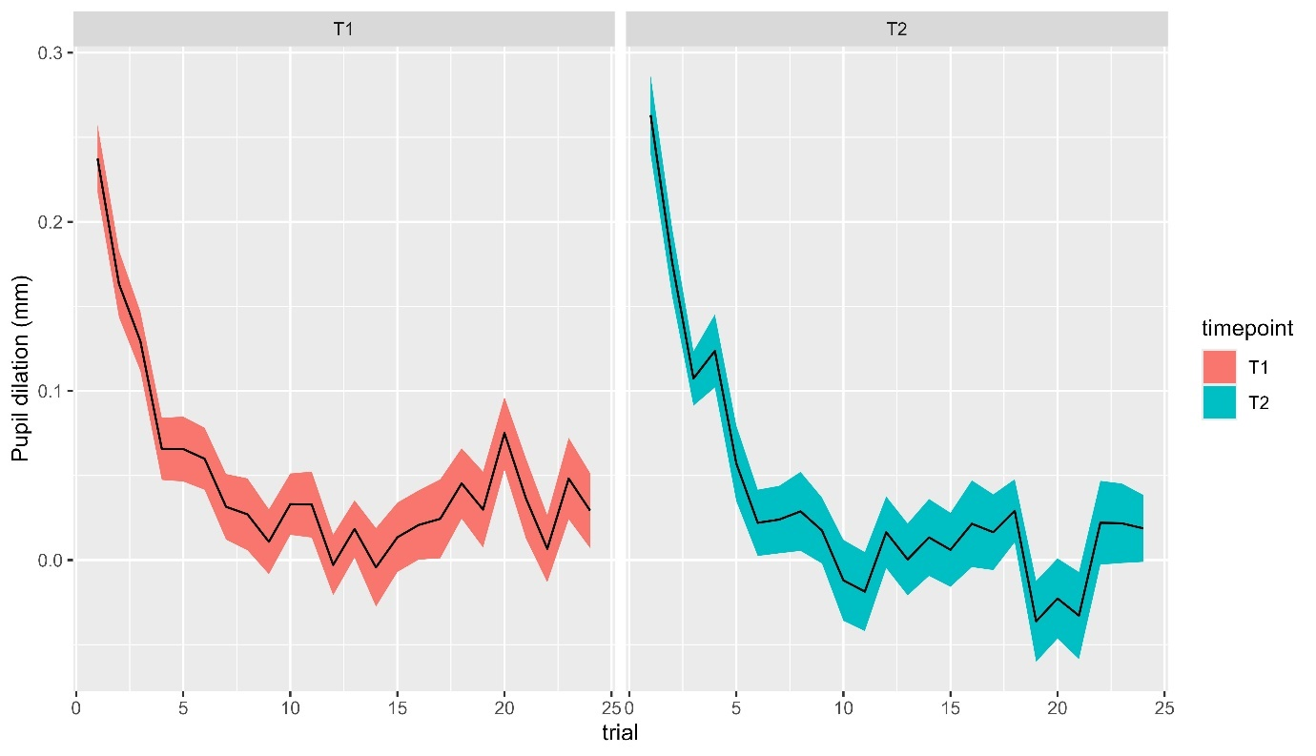
Figure S1. Mean pupil dilation by trial at T1 and T2. The colored area covers the mean +/- 1 standard error.

Does scanpath distribution at T1 predict change in LSAS?
Table S2 shows results of GLMM with LSAS as response variable and timepoint (LSAS measurements 1-5), treatment arm, age, and gender as predictors run separately for the three emotional expressions with the inclusion of the eye-mouth index as covariate.

Table S2. Results from linear mixed effects models examining the change in LSAS over time with the eye-mouth index included as covariate
 | b | SE | t | df | p
Timepoint | 4.21 | 4.7 | 0.9 | 35.98 | 0.376
Treatment arm | -7.38 | 6.62 | -1.12 | 49.6 | 0.270
Scanpath_{T1} | 25.65 | 16.2 | 1.58 | 45.2 | 0.120
Age | 1.61 | 1.4 | 1.15 | 49.6 | 0.256
Gender | -2.49 | 7.14 | -0.35 | 49.86 | 0.729
Eye-Mouth Index | 0.22 | 0.27 | 0.79 | 49.42 | 0.435
Timepoint x Treatment  Arm | 4.84 | 1.33 | 3.64 | 48.26 | <0.001***
Timepoint x Scanpath_{T1} | -8.52 | 3.62 | -2.35 | 36.08 | 0.024*
Random effects
Intercept (SD)
  20.89
Slope (SD) | 3.39

LSAS: Leibowitz social anxiety scale; Scanpath_{T1}: Scanpath distribution at T1; * p <.05; *** p <.001

Table S3 shows results of GLMM with LSAS as response variable and scanpath distribution at T1, timepoint (LSAS measurements 1-5), treatment arm, age, and gender as predictors run separately for the three emotional expressions.

Table S3. Results from linear mixed effects models examining the change in LSAS over time by emotion.
 | b | SE | T | df | p
Angry
Timepoint | 0.37 | 4.56 | 0.08 | 24.66 | 0.935
Treatment arm | -8.86 | 6.54 | -1.36 | 47.89 | 0.182
Scanpath_{T1} | 19.77 | 15.54 | 1.27 | 30.05 | 0.213
Age | 1.77 | 1.39 | 1.28 | 49.07 | 0.207
Gender | -3.11 | 7.1 | -0.44 | 49.36 | 0.663
Timepoint x Treatment Arm | 4.98 | 1.4 | 3.55 | 45.62 | 0.001***
Timepoint x Scanpath_{T1} | -5.56 | 3.56 | -1.56 | 24.2 | 0.132
Random effects
Intercept (SD) | 21.28
Slope (SD) | 3.62
Fearful
Timepoint | 2.52 | 5.29 | 0.48 | 25.58 | 0.638
Treatment arm | -9.55 | 6.54 | -1.46 | 49.89 | 0.15
Scanpath dispersion_{T1} | 13.34 | 16.77 | 0.8 | 41.84 | 0.431
Age | 1.87 | 1.39 | 1.35 | 49.94 | 0.185
Gender | -2.9 | 7.1 | -0.41 | 50.02 | 0.684
Timepoint x Treatment Arm | 5.27 | 1.4 | 3.75 | 46.48 | 0.001***
Timepoint x Scanpath_{T1} | -7.28 | 4.19 | -1.74 | 25.14 | 0.095
Random effects
Intercept (SD) | 21.36
Slope (SD) | 3.54
Happy
Timepoint | 0.58 | 5.01 | 0.12 | 21.8 | 0.908
Treatment arm | -9.31 | 6.43 | -1.45 | 49.56 | 0.154
Scanpath_{T1} | 19.26 | 16.59 | 1.16 | 30.91 | 0.255
Age | 1.7 | 1.39 | 1.22 | 49.14 | 0.229
Gender | -3.13 | 7.06 | -0.44 | 49.85 | 0.66
Timepoint x Treatment Arm | 5.12 | 1.36 | 3.77 | 47.89 | 0.001***
Timepoint x Scanpath_{T1} | -5.84 | 3.95 | -1.48 | 21.89 | 0.153
Random effects
Intercept (SD) | 22.21
Slope (SD) | 3.85

LSAS: Leibowitz social anxiety scale, Scanpath_{T1}: Scanpath distribution at T1; *** p <.001

Table S4 shows results of GLMM with LSAS as response variable and timepoint (LSAS measurements 1-5), treatment arm, age, and gender. The analysis was conducted separately for parent- and child-rated LSAS scores.

Table S4. Results from linear mixed effects models examining the change in parent- and child-rated LSAS over time.
LSAS-P | b | SE | t | df | p
Timepoint | 4.53 | 5.68 | 0.8 | 28.91 | 0.431
Treatment arm | -12.61 | 6.95 | -1.81 | 48.84 | 0.076
Scanpath_{T1} | 28.44 | 16.97 | 1.68 | 45.52 | 0.101
Age | 0.48 | 1.59 | 0.3 | 47.7 | 0.764
Gender | -1.91 | 8.09 | -0.24 | 48.77 | 0.815
Timepoint x Treatment Arm | 5.48 | 1.59 | 3.45 | 43.65 | 0.001**
Timepoint x Scanpath_{T1} | -9.5 | 4.44 | -2.14 | 27.93 | 0.041*
Random effects
Intercept (SD) | 21.91
Slope (SD) | 3.52
LSAS-C
Timepoint | 3.9 | 5.8 | 0.67 | 37.51 | 0.506
Treatment arm | -4.81 | 7.02 | -0.69 | 49.6 | 0.496
Scanpath_{T1} | 26.89 | 17.1 | 1.57 | 47.09 | 0.123
Age | 2.52 | 1.37 | 1.84 | 48.73 | 0.072
Gender | -6.23 | 7.16 | -0.87 | 46.95 | 0.389
Timepoint x Treatment Arm | 3.99 | 1.71 | 2.33 | 47.13 | 0.024*
Timepoint x Scanpath_{T1} | -7.57 | 4.45 | -1.7 | 38.38 | 0.097
Random effects
Intercept (SD) | 22.67
Slope (SD) | 4.44

LSAS-P: Leibowitz social anxiety scale, parent-rated; LSAS-C: Leibowitz social anxiety scale, child-rated; Scanpath_{T1}: Scanpath distribution at T1; * p <.05; ** p <.01

Does scanpath distribution to angry, fearful, and happy faces change from T1 to T2?
Table S5. Results from linear mixed effects models examining the change in scanpath distribution from T1 to T2 with the eye-mouth index included as covariate.

 | b | SE | t | df | p
Timepoint | 0.01 | 0.01 | 0.85 | 41.59 | 0.402
Treatment arm | -0.02 | 0.06 | -0.34 | 46.72 | 0.737
Age | 0.01 | 0.01 | 0.61 | 45.81 | 0.548
Gender | -0.09 | 0.06 | -1.42 | 43.9 | 0.161
Eye-Mouth Index | 0 | 0 | -0.96 | 39.07 | 0.343
Timepoint x  Treatment arm | -0.01 | 0.02 | -0.64 | 33.31 | 0.526
Random effects
Intercept (SD) | 0.11

Table S6. Results from linear mixed effects models examining the change in scanpath distribution from T1 to T2 for angry, fearful, and happy faces
 | B | SE | t | df | P
Angry
Timepoint | 0.02 | 0.02 | 0.9 | 31.52 | 0.375
Treatment arm | 0.01 | 0.1 | 0.1 | 21.35 | 0.924
Age | 0.01 | 0.02 | 0.4 | 28.17 | 0.692
Gender | -0.05 | 0.09 | -0.58 | 31.5 | 0.563
Timepoint x Treatment arm | -0.02 | 0.03 | -0.69 | 24.93 | 0.498
Random effects
Intercept (SD) | 0.01
Fearful
Timepoint | 0.02 | 0.02 | 1.35 | 22.17 | 0.190
Treatment arm | 0.06 | 0.07 | 0.81 | 31.06 | 0.422
Age | 0 | 0.01 | 0.34 | 40.06 | 0.735
Gender | -0.07 | 0.06 | -1.04 | 41.95 | 0.306
Timepoint x Treatment  arm | -0.03 | 0.02 | -1.57 | 28.37 | 0.127
Random effects
Intercept (SD) | 0.11
Happy
Timepoint | 0.02 | 0.02 | 0.8 | 28.95 | 0.431
Treatment arm | 0.01 | 0.1 | 0.1 | 26.33 | 0.922
Age | 0.01 | 0.02 | 0.37 | 24.59 | 0.717
Gender | -0.06 | 0.09 | -0.62 | 31.14 | 0.537
Timepoint x Treatment  arm | -0.02 | 0.03 | -0.71 | 25.28 | 0.483
Random effects
Intercept (SD) | 0.09

Does change in scanpath distribution from T1 to T2 predict change in LSAS?
Table S7. Results from linear mixed effects models examining the association between LSAS and change in scanpath distribution from T1 to T2 with change in eye-mouth index included as covariate.
 | B | SE | t | df | p
ΔScanpath | 6.26 | 17.13 | 0.37 | 29.84 | 0.717
Timepoint | -6.7 | 1.06 | -6.33 | 48.41 | <0.001***
Age | 1.89 | 1.4 | 1.35 | 49.7 | 0.183
Gender | -2.55 | 7.26 | -0.35 | 48.54 | 0.727
Treatment arm | -8.92 | 6.72 | -1.33 | 49.21 | 0.190
ΔEMI | 0.1 | 0.43 | 0.24 | 29.75 | 0.814
ΔScanpath x  Timepoint | -4.19 | 3.22 | -1.3 | 36.61 | 0.202
Treatment arm x  Timepoint | 5.17 | 1.39 | 3.71 | 48.51 | <0.001***
Random effects
Intercept (SD) | 21.4
Slope (SD) | 3.63

ΔScanpath: Change in scanpath distribution from T1 to T2 (difference score); ΔEMI: Change in eye-mouth index from T1 to T2 (difference score); *** p <.001

Table S8. Results from linear mixed effects models examining the association between parent- and self-rated LSAS and change in scanpath distribution from T1 to T2.

 | b | SE | T | df | p
LSAS-P
ΔScanpath | 8.88 | 16.35 | 0.54 | 36.37 | 0.59
Timepoint | -7.53 | 1.27 | -5.91 | 43.32 | 0
Age | 0.85 | 1.6 | 0.53 | 49 | 0.598
Gender | -2.27 | 8.26 | -0.27 | 48.47 | 0.785
Treatment arm | -13.29 | 7.12 | -1.87 | 49.34 | 0.068
ΔScanpath x  Timepoint | -4.07 | 3.66 | -1.11 | 36.66 | 0.273
Treatment arm x  Timepoint | 5.70 | 1.65 | 3.45 | 44.98 | <.001***
Random effects
Intercept (SD) | 22.46
Slope (SD) | 3.84
LSAS-C
ΔScanpath | 11.77 | 17.76 | 0.66 | 29.03 | 0.513
Timepoint | -5.74 | 1.32 | -4.34 | 48.31 | <.001***
Age | 2.56 | 1.38 | 1.85 | 48.28 | 0.07
Gender | -6.82 | 7.22 | -0.94 | 46.46 | 0.35
Treatment arm | -5.46 | 7.17 | -0.76 | 49.41 | 0.45
ΔScanpath x  Timepoint | -3.9 | 3.95 | -0.99 | 37.37 | 0.33
Treatment arm x  Timepoint | 4.2 | 1.75 | 2.39 | 47.38 | 0.021*
Random effects
Intercept (SD) | 23.04
Slope (SD) | 4.60

LSAS-P: Leibowitz social anxiety scale, parent-rated; LSAS-C: Leibowitz social anxiety scale, child-rated ΔScanpath: Change in scanpath distribution from T1 to T2; * p <.05; *** p <.001

Table S9. Results from linear mixed effects models examining the association between LSAS and change in scanpath distribution from T1 to T2. Analyses conducted separately for angry, fearful, and happy faces
 | b | SE | T | df | P
Angry
ΔScanpath | 0.57 | 12.44 | 0.05 | 32.74 | 0.964
Timepoint | -6.61 | 1.09 | -6.06 | 47.74 | <0.001***
Age | 1.91 | 1.39 | 1.37 | 49.59 | 0.175
Gender | -2.62 | 7.11 | -0.37 | 49.8 | 0.714
Treatment arm | -8.9 | 6.61 | -1.35 | 49.44 | 0.184
ΔScanpath x  Timepoint | -1.32 | 2.59 | -0.51 | 35.64 | 0.612
Treatment arm x  Timepoint | 5.03 | 1.42 | 3.53 | 47.98 | 0.001**
Random effects
Intercept (SD) | 21.45
Slope (SD) | 3.72
Fearful
ΔScanpath | -0.67 | 15.95 | -0.04 | 36.09 | 0.967
Timepoint | -6.64 | 1.15 | -5.76 | 44.37 | <0.001***
Age | 1.88 | 1.39 | 1.35 | 49.86 | 0.182
Gender | -2.35 | 7.32 | -0.32 | 49.14 | 0.75
Treatment arm | -8.85 | 6.79 | -1.3 | 49.06 | 0.199
ΔScanpath x  Timepoint | -1.88 | 3.43 | -0.55 | 34.85 | 0.587
Treatment arm x  Timepoint | 5.15 | 1.51 | 3.4 | 45.21 | 0.001**
Random effects
Intercept (SD) | 21.50
Slope (SD) | 3.79
Happy
ΔScanpath | 8.1 | 15.83 | 0.51 | 18.97 | 0.615
Timepoint | -5.97 | 1.42 | -4.21 | 46.68 | <0.001***
Age | 2.5 | 1.38 | 1.8 | 48.12 | 0.078
Gender | -6.6 | 7.3 | -0.9 | 44.63 | 0.371
Treatment arm | -5.59 | 7.38 | -0.76 | 47.52 | 0.453
ΔScanpath x  Timepoint | -3.75 | 3.8 | -0.99 | 21.56 | 0.335
Treatment arm x  Timepoint | 4.51 | 1.94 | 2.33 | 41.94 | 0.025*
Random effects
Intercept (SD) | 21.37
Slope (SD) | 3.46
ΔScanpath: Change in scanpath distribution from T1 to T2; * p <.05; *** p <.001

