Supplemental Table 1. List of Youth Risk Behavior Survey items, original scoring, and transformations in the current study to assess adversity and health risk behavior variables
Variable |  | Question | Original Scoring | Transformations
Early Life Adversity
Threat
 | Witnessed community violence | Have you ever seen someone get physically attacked, beaten, stabbed, or shot in your neighborhood? | Binary (yes/no) | -
 | Physically forced intercourse | Have you ever been physically forced to have sexual intercourse when you did not want to? | Binary (yes/no) | -
 | Sexual abuse | Has an adult or person at least 5 years older than you ever made you do sexual things that you did not want to do? (Count such things as kissing, touching, or being made to have sexual intercourse.) | Binary (yes/no) | -
 | Physical abuse | During your life, how often has a parent or other adult in your home hit, beat, kicked, or physically hurt you in any way? | 5-point Likert scale from 1 (never) to 5 (always) | -
 | Emotional abuse | During your life, how often has a parent or other adult in your home insulted you or put you down? | 5-point Likert scale from 1 (never) to 5 (always) | -
 | Witnessed domestic violence | During your life, how often have your parents or other adults in your home slapped, hit, kicked, punched, or beat each other up? | 5-point Likert scale from 1 (never) to 5 (always) | -
Deprivation
 | Housing instability | During the past 30 days, where did you usually sleep? | 8-point nominal scale: 1) In my parent's or guardian's home, 2) In the home of a friend, family member, or other person because I had to leave my home or my parent or guardian cannot afford housing, 3) In a shelter or emergency housing, 4) In a motel or hotel, 5) In a car, park, campground, or other public place, 6) I do not have a usual place to sleep, 7) Somewhere else | Binary: in parent or guardian's home (0), other (1)
 | Physical neglect | During your life, how often has there been an adult in your household who tried hard to make sure your basic needs were met, such as looking after your safety and making sure you had clean clothes and enough to eat? | 5-point Likert scale from 1 (never) to 5 (always) | Reverse coded (lower scores = higher neglect/deprivation)
 | Parent substance use | Have you ever lived with a parent or guardian who was having a problem with alcohol or drug use? | Binary (yes/no)
 | Parent mental illness | Have you ever lived with a parent or guardian who had severe depression, anxiety, or another mental illness, or was suicidal? | Binary (yes/no)
 | Parent incarceration | Have you ever been separated from a parent or guardian because they went to jail, prison, or a detention center? | Binary (yes/no)
 | Parent monitoring | How often do your parents or other adults in your family know where you are going or with whom you will be? | 5-point Likert scale from 1 (never) to 5 (always) | Reverse coded (less monitoring = increased deprivation)
Health Risk Behaviors
Risky Driving
 | Drinking and driving (passenger) | During the past 30 days, how many times did you ride in a car or other vehicle driven by someone who had been drinking alcohol? | 5-point scale from 1 (0 times) to 5 (6 or more times) | -
 | Drinking and driving (driver) | During the past 30 days, how many times did you drive a car or other vehicle when you had been drinking alcohol? | 6-point scale from 1 (did not drive in past month), 2 (0 times) to 6 (6 or more times) | 5-point scale from 0 (I did not drive in past month or 0 times) to 5 (6 or more times)
 | Texting and driving | During the past 30 days, on how many days did you text or e-mail while driving a car or other vehicle? | 8-point scale from 1 (did not drive in past month), 2 (0 times) to 8 (all 30 days) | 7-point scale from 0 (I did not drive in past month or 0 times) to 7 (all 30 days)
Weapon Carrying
 | Weapon carrying on school property | During the past 30 days, on how many days did you carry a weapon such as a gun, knife, or club on school property? | 5-point scale from 1 (0 days) to 5 (6 or more days) | -
 | Gun carrying in past year | During the past 12 months, on how many days did you carry a gun? (Do not count the days when you carried a gun only for hunting or for a sport, such as target shooting.) | 5-point scale from 1 (0 days) to 5 (6 or more days) | -
Violence
 | Physical fights | During the past 12 months, how many times were you in a physical fight? | 8-point scale from 1 (0 times) to 8 (12 or more times) | -
 | Physical fights on school property | During the past 12 months, how many times were you in a physical fight on school property? | 8-point scale from 1 (0 times) to 8 (12 or more times) | -
Suicidal Behavior
 | Suicide attempts | During the past 12 months, how many times did you actually attempt suicide? | 5-point scale from 1 (0 times) to 5 (6 or more times)
 | Injurious attempt | If you attempted suicide during the past 12 months, did any attempt result in an injury, poisoning, or overdose that had to be treated by a doctor or nurse? | Nominal scale: 1 (I did not attempt suicide during past 12 months), 2 (Yes), 3 (No) | Binary: (0) No/I did not attempt suicide, (1) yes
Smoking
 | Age of first use | How old were you when you first smoked a cigarette, even one or two puffs? | 7-point scale from 1 (never), 2 (8 years or younger) to 7 (17 years or older) | Scores 2-7 reverse coded (younger age of first use = higher risk)
 | Cigarette use (frequency) | During the past 30 days, on how many days did you smoke cigarettes? | 7-point scale from 1 (0 days) to 7 (all 30 days) | -
 | Cigarette use (amount) | During the past 30 days, on the days you smoked, how many cigarettes did you smoke per day? | 7-point scale from 1 (Did not smoke) to 7 (>20 per day) | -
 | Electronic vapor product use (frequency) | During the past 30 days, on how many days did you use an electronic vapor product? | 7-point scale from 1 (0 days) to 7 (all 30 days) | -
 | Tobacco product use (frequency) | During the past 30 days, on how many days did you use chewing tobacco, snuff, dip, snus, or dissolvable tobacco products, such as Copenhagen, Grizzly, Skoal, Camel Snus, or Velo Nicotine Lozenges? (Do not count any electronic vapor products.) | 7-point scale from 1 (0 days) to 7 (all 30 days) | -
 | Cigar use (frequency) | During the past 30 days, on how many days did you smoke cigars, cigarillos, or little cigars, such as Swisher Sweets, Middleton's (including Black & Mild), or Backwoods? | 7-point scale from 1 (0 days) to 7 (all 30 days) | -
Alcohol
 | Age of first use | How old were you when you had your first drink of alcohol other than a few sips? | 7-point scale from 1 (never), 2 (8 years or younger) to 7 (17 years or older) | Scores 2-7 reverse coded (younger age of first use = higher risk)
 | Alcohol use (frequency) | During the past 30 days, on how many days did you have at least one drink of alcohol? | 7-point scale from 1 (0 days) to 7 (all 30 days) | -
 | Binge drinking (frequency) | During the past 30 days, on how many days did you have 4 or more drinks of alcohol in a row, that is, within a couple of hours (if you are female) or 5 or more drinks of alcohol in a row, that is, within a couple of hours (if you are male)? | 7-point scale from 1 (0 days) to 7 (20 or more days) | -
 | Binge drinking (amount) | During the past 30 days, what is the largest number of alcoholic drinks you had in a row, that is, within a couple of hours? | 8-point scale from 1 (did not drink) to 8 (10 or more drinks) | -
Marijuana
 | Marijuana use (frequency) | During your life, how many times have you used marijuana? | 7-point scale from 1 (0 times) to 7 (100 or more times) | -
 | Age of first use | How old were you when you tried marijuana for the first time? | 7-point scale from 1 (never), 2 (8 years or younger) to 7 (17 years or older) | Scores 2-7 reverse coded (younger age of first use = higher risk)
Illicit Drug Use
 | Prescription pain medicine abuse | During your life, how many times have you taken prescription pain medicine without a doctor's prescription or differently than how a doctor told you to use it? | 6-point scale from 1 (0 times) to 6 (40 or more times) | -
 | Cocaine | During your life, how many times have you used any form of cocaine, including powder, crack, or freebase? | 6-point scale from 1 (0 times) to 6 (40 or more times) | -
 | Inhalant | During your life, how many times have you sniffed glue, breathed the contents of aerosol spray cans, or inhaled any paints or sprays to get high? | 6-point scale from 1 (0 times) to 6 (40 or more times) | -
 | Heroin | During your life, how many times have you used heroin (also called smack, junk, or China White)? | 6-point scale from 1 (0 times) to 6 (40 or more times) | -
 | Methamphetamine | During your life, how many times have you used methamphetamines (also called speed, crystal meth, crank, ice, or meth)? | 6-point scale from 1 (0 times) to 6 (40 or more times) | -
 | Ecstasy | During your life, how many times have you used ecstasy (also called MDMA or Molly)? | 6-point scale from 1 (0 times) to 6 (40 or more times) | -
 | Hallucinogenic | During your life, how many times have you used hallucinogenic drugs, suchacid, PCP, angel dust, mescaline, or mushrooms? | 6-point scale from 1 (0 times) to 6 (40 or more times) | -
Sexual Behaviors
 | Age of first sexual intercourse | How old were you when you had sexual intercourse for the first time? | 8-point scale from 1 (never), 2 (11 years or younger) to 8 (17 or older) | Scores 2-8 reverse coded (earlier age of first intercourse = higher risk)
 | Number of sexual partners | During your life, with how many people have you had sexual intercourse? | 7-point scale from 1 (never), 2 (1 person) to 7 (6 or more people)
 | Substance use | Did you drink alcohol or use drugs before you had sexual intercourse the last time? | 1) I have never had sexual intercourse, 2) Yes, 3) No | Binary: (0) No/I have never had intercourse, (1) Yes
 | Pregnancy prevention | The last time you had sexual intercourse with an opposite-sex partner, what one method did you or your partner use to prevent pregnancy? | 8-point nominal scale: 1) I have never had sexual intercourse with an opposite-sex partner, 2) No method was used to prevent pregnancy, 3) Birth control pills (not including emergency contraception), 4) Condoms, 5) an IUD, 6) A shot, patch, or birth control ring, 7) Withdrawal or some other method, 8) Not sure | Binary: Some method used (0), no method used (1)
Physical Health
 | Soda consumption | During the past 7 days, how many times did you drink a can, bottle, or glass of soda or pop, such as Coke, Pepsi, or Sprite? (Do not count diet soda or diet pop.) | 7-point scale from 1 (none) to 7 (4 or more per day) | -
 | Physical activity | During the past 7 days, on how many days were you physically active for a total of at least 60 minutes per day? | 8-point scale from 1 (0 days) to 8 (7 days) | Reverse coded (less activity = higher risk)
 | Hours of sleep | On an average school night, how many hours of sleep do you get? | 7-point scale from 1 (4 or less) to 7 (10 or more) | Reverse coded (less sleep = higher risk)
 | Obesity | N/A. BMI calculation completed by YRBS based on youth-reported weight, age, gender items. | Binary: Yes (>= 95th percentile for BMI), No (<95th percentile) | -

Supplemental Table 2. Frequencies of adversity exposures and health risk behavior engagement among youth included in the sample (N = 7691)
Adversity type |  |  |  |  |  | N (%)
Threat
Witnessed community violence |  |  |  |  |  | 1817 (24)
Physically forced intercourse |  |  |  |  |  | 673 (9)
Sexual abuse |  |  |  |  |  | 602 (8)
Emotional abuse
 |  | Never |  |  |  | 2948 (38)
 |  | Rarely |  |  |  | 1930 (25)
 |  | Sometimes |  |  |  | 1810 (24)
 |  | Often |  |  |  | 701 (9)
 |  | Always |  |  |  | 302 (4)
Physical abuse
 |  | Never |  |  |  | 5184 (67)
 |  | Rarely |  |  |  | 1572 (20)
 |  | Sometimes |  |  |  | 747 (10)
 |  | Often |  |  |  | 136 (2)
 |  | Always |  |  |  | 52 (.68)
Witnessed intimate partner violence
 |  | Never |  |  |  | 6049 (79)
 |  | Rarely |  |  |  | 938 (12)
 |  | Sometimes |  |  |  | 534 (7)
 |  | Often |  |  |  | 131 (2)
 |  | Always |  |  |  | 39 (.5)
Deprivation
Physical neglect
 |  | Never |  |  |  | 5906 (77)
 |  | Rarely |  |  |  | 919 (12)
 |  | Sometimes |  |  |  | 318 (4)
 |  | Often |  |  |  | 178 (2)
 |  | Always |  |  |  | 370 (5)
Unstable housing |  |  |  |  |  | 255 (3)
Parent substance use |  |  |  |  |  | 2266 (29)
Parent mental illness |  |  |  |  |  | 2526 (33)
Parent incarceration or separation |  |  |  |  |  | 1375 (18)
Parental monitoring
 |  | Never |  |  |  | 150 (2)
 |  | Rarely |  |  |  | 609 (8)
 |  | Sometimes |  |  |  | 288 (4)
 |  | Often |  |  |  | 2797 (36)
 |  | Always |  |  |  | 3847 (50)
HRB Category |  |  |  |  | N (%)
Risky Driving Behaviors
Drinking and driving (passenger)
 | 0 times |  |  |  | 6644 (86)
 | 1 time |  |  |  | 430 (6)
 | 2 or 3 times |  |  |  | 321 (4)
 | 4 or 5 times |  |  |  | 76 (1)
 | 6 or more times |  |  |  | 220 (3)
Drinking and driving (driver)
 | 0 times |  |  |  | 7553 (98)
 | 1 time |  |  |  | 74 (1)
 | 2 or 3 times |  |  |  | 41 (1)
 | 4 or 5 times |  |  |  | 7 (<1)
 | 6 or more times |  |  |  | 16 (<1)
Texting and driving
 | 0 times |  |  |  | 6208 (81)
 | 1 or 2 days |  |  |  | 459 (6)
 | 3 to 5 days |  |  |  | 237 (3)
 | 6 to 9 days |  |  |  | 131 (2)
 | 10 to 19 days |  |  |  | 146 (2)
 | 20 to 29 days |  |  |  | 134 (2)
 | All 30 days |  |  |  | 376 (5)
Weapon-Carrying
On school property (past month)
 | 0 days |  |  |  | 7400 (96)
 | 1 day |  |  |  | 55 (1)
 | 2 or 3 days |  |  |  | 58 (1)
 | 4 or 5 days |  |  |  | 28 (<1)
 | 6 or more days |  |  |  | 150 (2)
Gun carrying (past year)
 | 0 days |  |  |  | 7448 (97)
 | 1 day |  |  |  | 85 (1)
 | 2 or 3 days |  |  |  | 56 (1)
 | 4 or 5 days |  |  |  | 24 (<1)
 | 6 or more days |  |  |  | 78 (1)
Violent Behavior
Number of physical fights (past year)
 | 0 times |  |  |  | 6337 (82)
 | 1 time |  |  |  | 676 (9)
 | 2 or 3 times |  |  |  | 422 (6)
 | 4 or 5 times |  |  |  | 134 (2)
 | 6 or 7 times |  |  |  | 34 (<1)
 | 8 or 9 times |  |  |  | 14 (<1)
 | 10 or 11 times |  |  |  | 10 (<1)
 | 12 or more times |  |  |  | 64 (1)
Number of physical fights at school (past year)
 | 0 times |  |  |  | 7185 (93)
 | 1 time |  |  |  | 361 (5)
 | 2 or 3 times |  |  |  | 101 (1)
 | 4 or 5 times |  |  |  | 23 (<1)
 | 6 or 7 times |  |  |  | 7 (<1)
 | 8 or 9 times |  |  |  | 2 (<1)
 | 10 or 11 times |  |  |  | 2 (<1)
 | 12 or more times |  |  |  | 10 (<1)
Suicidal Behaviors
Number of suicide attempts (past year)
 | 0 |  |  |  | 6975 (91)
 | 1 |  |  |  | 412 (5)
 | 2 or 3 |  |  |  | 243 (3)
 | 4 or 5 |  |  |  | 26 (<1)
 | 6 or more |  |  |  | 35 (<1)
Injurious attempt |  |  |  |  | 155 (2)
Sexual
Age of first sexual intercourse
 | Never |  |  |  | 5165 (67)
 | 17 years or older |  |  |  | 344 (5)
 | 16 years |  |  |  | 647 (8)
 | 15 years |  |  |  | 656 (9)
 | 14 years |  |  |  | 462 (6)
 | 13 years |  |  |  | 215 (3)
 | 12 years |  |  |  | 78 (1)
 | 11 years or younger |  |  |  | 124 (2)
Number of sexual partners
 | 0 |  |  |  | 5165 (67)
 | 1 |  |  |  | 1236 (16)
 | 2 |  |  |  | 526 (7)
 | 3 |  |  |  | 284 (4)
 | 4 |  |  |  | 162 (2)
 | 5 |  |  |  | 99 (1)
 | 6 or more |  |  |  | 219 (3)
Substance use during last intercourse |  |  |  |  | 377 (5)
No method of protection used during last intercourse |  |  |  |  | 304 (4)
Alcohol
Age of first use
 | Never |  |  |  | 4225 (55)
 | 17 or older |  |  |  | 294 (4)
 | 15 - 16 |  |  |  | 1132 (15)
 | 13 - 14 |  |  |  | 1050 (14)
 | 11-12 |  |  |  | 414 (5)
 | 9 - 10 |  |  |  | 225 (3)
 | 8 or younger |  |  |  | 351 (5)
Alcohol use (frequency)
 | 0 days |  |  |  | 6234 (81)
 | 1 or 2 |  |  |  | 862 (11)
 | 3 to 5 |  |  |  | 288 (4)
 | 6 to 9 |  |  |  | 164 (2)
 | 10 to 19 |  |  |  | 96 (1)
 | 20 to 29 |  |  |  | 22 (<1)
 | All 30 days |  |  |  | 25 (<1)
Binge drinking (frequency)
 | 0 days |  |  |  | 6997 (91)
 | 1 day |  |  |  | 218 (3)
 | 2 days |  |  |  | 177 (2)
 | 3 to 5 days |  |  |  | 172 (2)
 | 6 to 9 days |  |  |  | 73 (1)
 | 10 to 19 days |  |  |  | 31 (<1)
 | 20 or more |  |  |  | 23 (<1)
Binge drinking (total amount)
 | None |  |  |  | 6234 (81)
 | 1 or 2 |  |  |  | 658 (9)
 | 3 drinks |  |  |  | 92 (1)
 | 4 drinks |  |  |  | 103 (1)
 | 5 drinks |  |  |  | 152 (2)
 | 6 or 7 drinks |  |  |  | 182 (2)
 | 8 or 9 drinks |  |  |  | 96 (1)
 | 10 or more drinks |  |  |  | 174 (2)
Smoking
Age of first use
 | Never |  |  |  | 6430 (84)
 | 17 or older |  |  |  | 100 (1)
 | 15 - 16 |  |  |  | 314 (4)
 | 13 - 14 |  |  |  | 355 (5)
 | 11-12 |  |  |  | 218 (3)
 | 9 - 10 |  |  |  | 117 (2)
 | 8 or younger |  |  |  | 157 (2)
Cigarette use (frequency)
 | 0 days |  |  |  | 7404 (96)
 | 1 or 2 |  |  |  | 142 (2)
 | 3 to 5 |  |  |  | 55 (1)
 | 6 to 9 |  |  |  | 26 (<1)
 | 10 to 19 |  |  |  | 21 (<1)
 | 20 to 29 |  |  |  | 9 (<1)
 | All 30 days |  |  |  | 34 (<1)
Cigarette use (amount)
 | None |  |  |  | 7404 (96)
 | <1 per day |  |  |  | 128 (2)
 | 1 per day |  |  |  | 75 (1)
 | 2 to 5 per day |  |  |  | 63 (1)
 | 6 to 10 per day |  |  |  | 7 (<1)
 | 11 to 20 per day |  |  |  | 2 (<1)
 | >20 per day |  |  |  | 12 (<1)
Electronic vapor product use
 | Never |  |  |  | 6430 (84)
 | 17 or older |  |  |  | 100 (1)
 | 15 - 16 |  |  |  | 314 (4)
 | 13 - 14 |  |  |  | 355 (5)
 | 11-12 |  |  |  | 218 (3)
 | 9 - 10 |  |  |  | 117 (2)
 | 8 or younger |  |  |  | 157 (2)
Tobacco product use (frequency)
 | 0 days |  |  |  | 7553 (98)
 | 1 or 2 |  |  |  | 61 (1)
 | 3 to 5 |  |  |  | 21 (<1)
 | 6 to 9 |  |  |  | 12 (<1)
 | 10 to 19 |  |  |  | 11 (<1)
 | 20 to 29 |  |  |  | 3 (<1)
 | All 30 days |  |  |  | 30 (<1)
Cigar use (frequency)
 | 0 days |  |  |  | 7366 (96)
 | 1 or 2 |  |  |  | 165 (2)
 | 3 to 5 |  |  |  | 64 (1)
 | 6 to 9 |  |  |  | 26 (<1)
 | 10 to 19 |  |  |  | 22 (<1)
 | 20 to 29 |  |  |  | 7 (<1)
 | All 30 days |  |  |  | 41 (1)
Marijuana
Marijuana use (frequency)
 | 0 times |  |  |  | 5278 (69)
 | 1 or 2 times |  |  |  | 621 (8)
 | 3 to 9 times |  |  |  | 508 (7)
 | 10 to 19 times |  |  |  | 267 (4)
 | 20 to 39 times |  |  |  | 209 (3)
 | 40 to 99 times |  |  |  | 192 (3)
 | 100 or more times |  |  |  | 616 (8)
Age of first use
 | Never |  |  |  | 5278 (69)
 | 17 years or older |  |  |  | 226 (3)
 | 15 or 16 years |  |  |  | 898 (12)
 | 13 or 14 years |  |  |  | 871 (11)
 | 11 or 12 years |  |  |  | 296 (4)
 | 9 or 10 years |  |  |  | 62 (1)
 | 8 years or younger |  |  |  | 60 (1)
Illicit Drug Use (Lifetime)
Prescription pain medicine abuse
 | 0 times |  |  |  | 6833 (89)
 | 1 or 2 |  |  |  | 455 (6)
 | 3 to 9 |  |  |  | 197 (3)
 | 10 to 19 |  |  |  | 71 (1)
 | 20 to 39 |  |  |  | 44 (1)
 | 40 or more |  |  |  | 91 (1)
Cocaine
 | 0 times |  |  |  | 7569 (98)
 | 1 or 2 |  |  |  | 60 (1)
 | 3 to 9 |  |  |  | 16 (<1)
 | 10 to 19 |  |  |  | 9 (<1)
 | 20 to 39 |  |  |  | 4 (<1)
 | 40 or more |  |  |  | 33 (<1)
Inhalant
 | 0 times |  |  |  | 7296 (95)
 | 1 or 2 |  |  |  | 234 (3)
 | 3 to 9 |  |  |  | 77 (<1)
 | 10 to 19 |  |  |  | 30 (<1)
 | 20 to 39 |  |  |  | 14 (<1)
 | 40 or more |  |  |  | 40 (1)
Heroin
 | 0 times |  |  |  | 7646 (99)
 | 1 or 2 |  |  |  | 21 (<1)
 | 3 to 9 |  |  |  | 3 (<1)
 | 10 to 19 |  |  |  | 4 (<1)
 | 20 to 39 |  |  |  | 1 (<1)
 | 40 or more |  |  |  | 16 (<1)
Methamphetamine
 | 0 times |  |  |  | 7624 (99)
 | 1 or 2 |  |  |  | 33 (<1)
 | 3 to 9 |  |  |  | 7 (<1)
 | 10 to 19 |  |  |  | 5 (<1)
 | 20 to 39 |  |  |  | 2 (<1)
 | 40 or more |  |  |  | 20 (<1)
Ecstasy
 | 0 times |  |  |  | 7539 (98)
 | 1 or 2 |  |  |  | 91 (1)
 | 3 to 9 |  |  |  | 20 (<1)
 | 10 to 19 |  |  |  | 16 (<1)
 | 20 to 39 |  |  |  | 6 (<1)
 | 40 or more |  |  |  | 19 (<1)
Hallucinogenic use (lifetime)
 | 0 times |  |  |  | 7271 (95)
 | 1 or 2 |  |  |  | 223 (3)
 | 3 to 9 |  |  |  | 117 (2)
 | 10 to 19 |  |  |  | 36 (<1)
 | 20 to 39 |  |  |  | 16 (<1)
 | 40 or more |  |  |  | 28 (<1)
Physical Health
Soda consumption (past week)
 | None |  |  |  | 2079 (27)
 | 1-3 times |  |  |  | 3081 (40)
 | 4-6 times |  |  |  | 1181 (15)
 | 1x per day |  |  |  | 601 (8)
 | 2x per day |  |  |  | 412 (5)
 | 3x per day |  |  |  | 134 (2)
 | 4 or more per day |  |  |  | 203 (3)
Physical activity (past week)
 | 0 days |  |  |  | 2074 (27)
 | 1 day |  |  |  | 599 (8)
 | 2 days |  |  |  | 1138 (15)
 | 3 days |  |  |  | 766 (10)
 | 4 days |  |  |  | 852 (11)
 | 5 days |  |  |  | 686 (9)
 | 6 days |  |  |  | 532 (7)
 | 7 days |  |  |  | 1044 (14)
Average hours of sleep
 | 8 or more hours |  |  |  | 1719 (22)
 | 7 |  |  |  | 2177 (28)
 | 6 |  |  |  | 1969 (26)
 | 5 |  |  |  | 1132 (15)
 | 4 or less |  |  |  | 694 (9)
Obesity |  |  |  |  | 1343 (17)

Supplemental Figure 1.
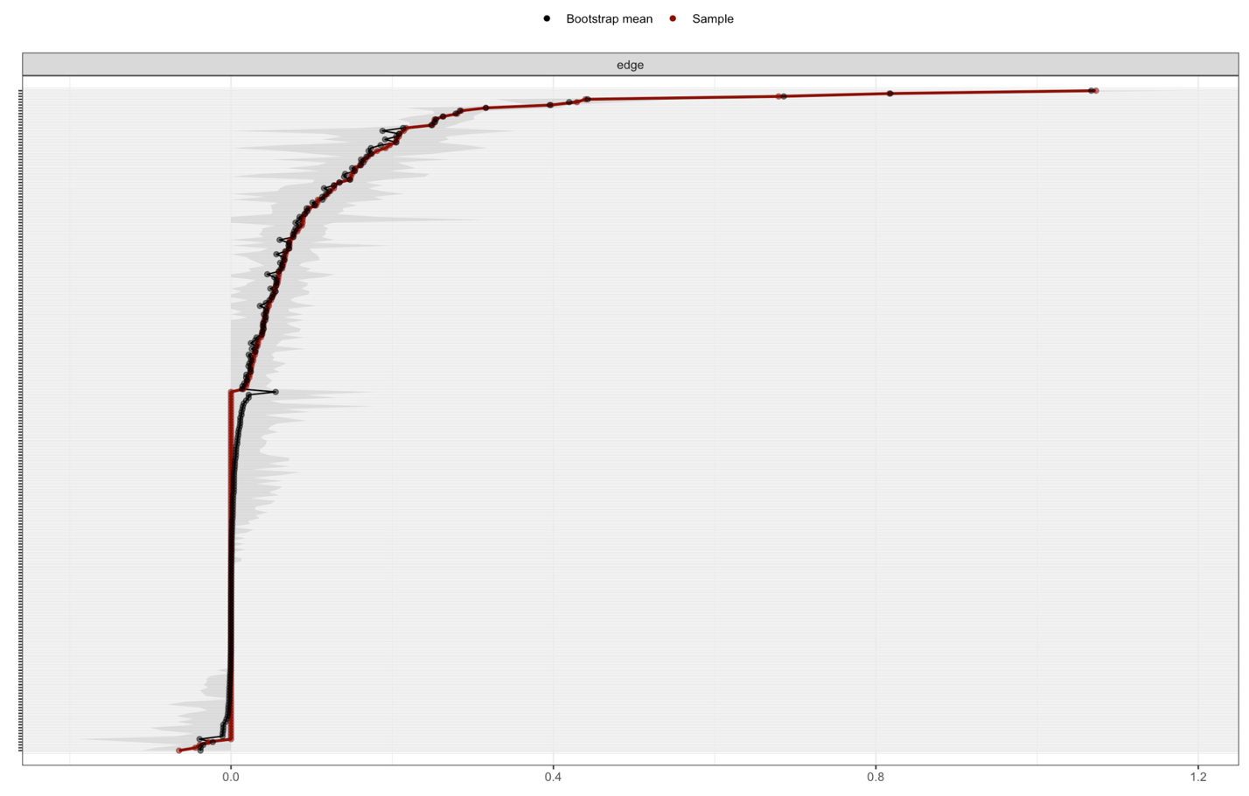
Supplemental Figure 1. Bootstrapped 95% confidence intervals of estimated edge-weights for the network of adversities and HRBs in Figure 1 to examine the stability of identified edge-weights. The red line indicates values from the observed network and the gray area reflects the bootstrapped 95% confidence intervals using 1000 bootstrap samples. Wider confidence intervals indicate less stable edge weights. Horizontal lines plotted on the Y axis represent each edge of the network, ordered from the highest edge-weight to lowest edge weight. Labels were removed from the Y axis for readability.

Supplemental Figure 2.
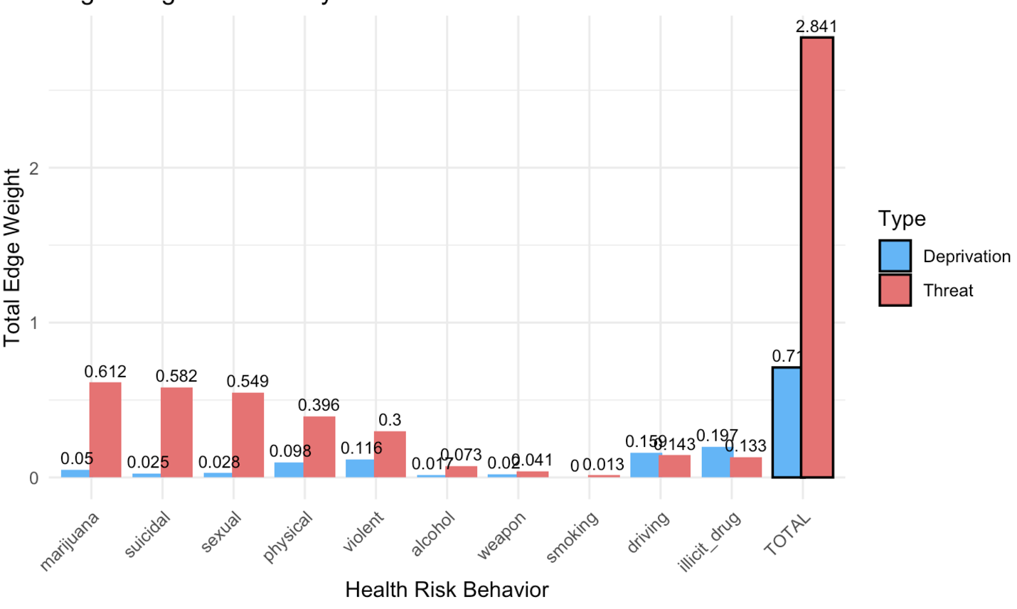
Supplemental Figure 2. Box plot displaying results from sensitivity analysis comparing the strength of associations for threat and deprivation across each type of health risk behavior, with parental mental illness, substance use, and incarceration included as indicators of threat (versus deprivation in our main analyses). Differences in the strength of associations are based on edge weights extracted from the network modeled in Figure 1. The strength of associations for each dimension with HRBs is plotted on the Y axis as total edge weight. Total edge weights were calculated as the sum of edge weights from all individual adversities within each dimension for each HRB category.

