Supplementary Material

To further evaluate the robustness and theoretical interpretation of the three-way interaction between mindful parenting, child negative affect, and frontal alpha asymmetry (FAA), we conducted two complementary sensitivity analyses: (1) the Proportion of Interaction (PoI) and (2) a person-oriented cluster analysis.

1. Proportion of Interaction (PoI) Following Roisman et al. (2012), we calculated the PoI to assess the nature of the observed interaction. The PoI quantifies the proportion of the area between regression lines—bounded by ±2 SD of mindful parenting—that lies on the positive side of the crossover point (where the slopes intersect). A PoI of ~0.50 reflects Differential Susceptibility, with equal sensitivity to positive and negative environments. Values near 0.00 indicate Diathesis-Stress (vulnerability to adverse conditions only), while values near 1.00 suggest Vantage Sensitivity (benefit from positive contexts only; Del Giudice, 2017; Roisman et al., 2012). In our analysis, the slope for high mindful parenting was B = −10.59 and for low parenting B = −6.22, yielding a PoI of 0.63. Although slightly above the classic differential susceptibility range (0.40–0.60), this value suggests that children with high negative affect and greater left-sided FAA showed stronger benefits under high mindful parenting than adverse outcomes under low parenting. See Supplementary Figure S1.

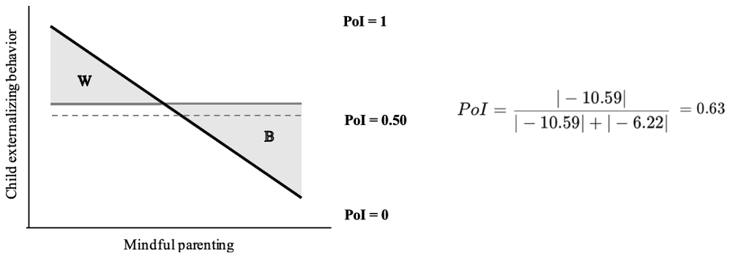
Supplementary Figure S1. Interaction shape and the Proportion of Interaction (PoI) index for 0.63. The dashed line represents the ideal threshold for Differential Susceptibility (PoI = 0.50). If the dashed line were positioned at a PoI value of 0, it would indicate Vantage Sensitivity, suggesting benefits only in positive environments without increased risk in adverse conditions. Conversely, if the dashed line were at a PoI value of 1.0, it would indicate a Diathesis-Stress pattern, suggesting vulnerability to negative environments without corresponding benefits form positive ones. The PoI index, calculated as $\frac{B}{B+W}$ , reflects the ratio of improved outcomes (B = better) for children with high negative affect and left-sided frontal alpha asymmetry (FAA) relative to the total sum of improved (B) and harmful outcomes (W = worse). In this context, improved outcomes are characterized by lower levels of externalizing behavior under high mindful parenting, while harmful outcomes reflect higher levels of externalizing behavior under low mindful parenting.

2. Person-Oriented Cluster Analysis To further explore individual variation in neuro-affective sensitivity, we conducted a K-means cluster analysis based on FAA and negative affect, using a person-oriented approach (Bergman & Magnusson, 1997). This method highlights distinct patterns of individual differences, rather than group averages. Children were grouped based on FAA lateralization (left- vs. right-sided) and levels of negative affect (high vs. low), resulting in four distinct clusters. Notably, children with high negative affect and left-sided FAA exhibited clear environmental sensitivity: they showed lower externalizing behavior under high mindful parenting, but elevated levels under low parenting. In contrast, children in other clusters (e.g., low negative affect or right-sided FAA) displayed more stable outcomes across parenting levels. See Supplementary Figure S2.

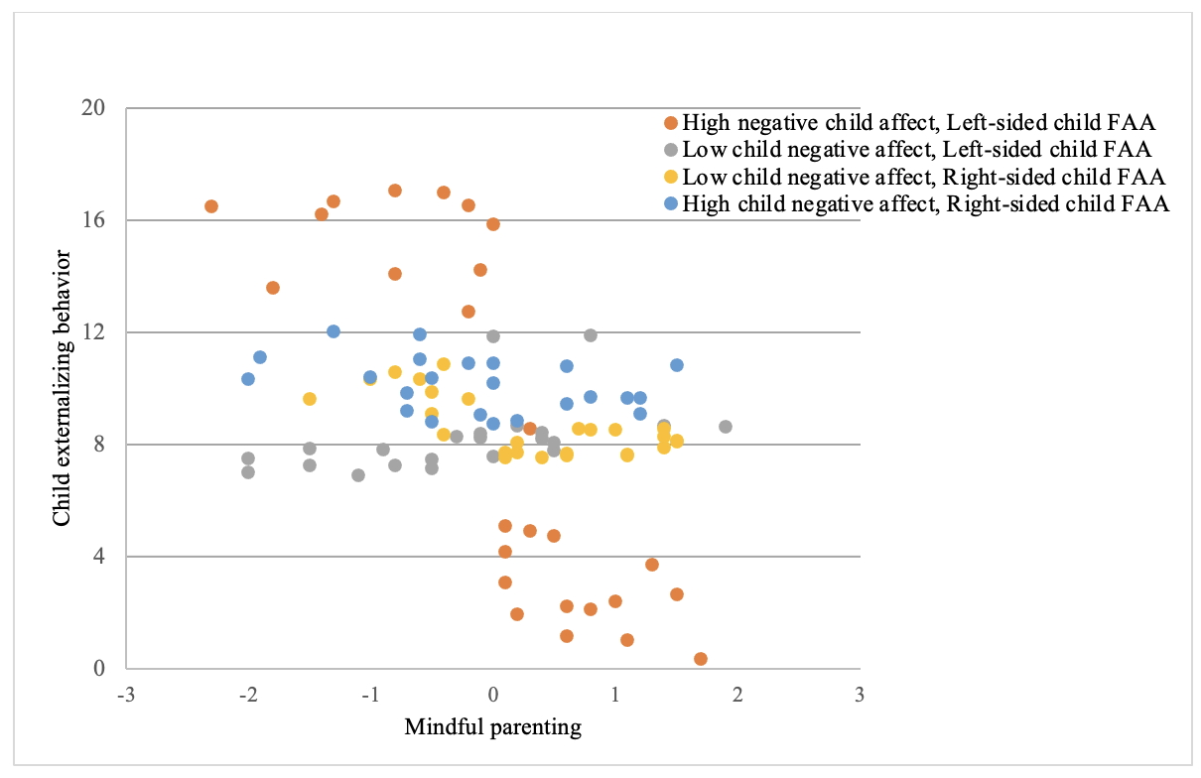
Supplementary Figure S2. Clustering of child externalizing behavior based on mindful parenting (Z-scores), child negative affect (Z-scores), and left- versus right-sided frontal alpha asymmetry (Z-scores) using K-means clustering. The clustering was performed to group participants based on these characteristics, providing insight into how different neuro-affective profiles of individual children relate to mindful parenting and child externalizing behavior. Note. Groupings were created solely to improve clarity and interpretability, without affecting statistical outcomes

