**Supplemental Materials**

**Figure S1**

*Flow Chart Diagram of Participants in the Study*

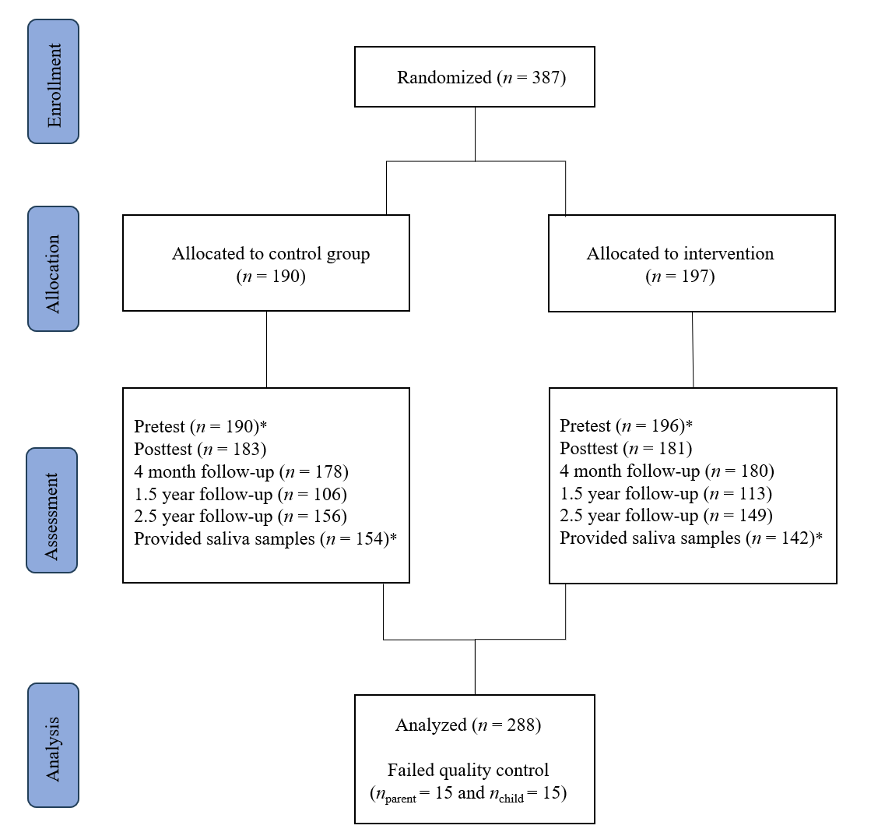

*Note.* * = assessments included in the current study

**Table S1**

*Families With Both Polygenic Scores Versus Families Without Polygenic Scores*

|  |  |  |  |  |  |  |
| --- | --- | --- | --- | --- | --- | --- |
|  | Families with PGS  *N* = 288 | | Families without PGS  *N* = 98 | |  |  |
|  | *N* | % | *N* | % | χ2 | *p* |
| Birth country childa | 279 | 97.21 | 95 | 96.93 | 0.00 | .999 |
| Birth country fathera | 261 | 90.63 | 77 | 78.57 | 8.68 | .003 |
| Birth country mothera | 269 | 90.63 | 78 | 79.59 | 13.87 | < .001 |
| Child sex (Girls) | 138 | 47.92 | 36 | 38.71 | 2.05 | .153 |
| Participating parent (Mothers) | 265 | 92.01 | 90 | 91.84 | 0.00 | .999 |
|  |  |  |  |  |  |  |
|  | *M* | *SD* | *M* | *SD* | *t* | *p* |
| Child age | 6.26 | 1.31 | 6.47 | 1.37 | 1.36 | .176 |
| Parental age | 38.22 | 4.63 | 37.73 | 5.42 | -0.81 | .419 |
| Harsh parenting | 4.64 | 1.05 | 4.82 | 1.28 | 1.22 | .224 |
| Warm-supportive parenting | 9.69 | 1.15 | 9.75 | 1.14 | 0.43 | .671 |
| Disruptive behavior | 132.53 | 19.27 | 135.56 | 19.14 | 1.35 | .179 |

*Note.* PGS = polygenic score. aDichotomized variable, reporting N and % of participants whose birth country is the Netherlands (vs not the Netherlands);

**Table S2**

*Multiple regression analyses to test potential covariates*

|  |  |  |  |
| --- | --- | --- | --- |
| Effect | β | *se* | *p* |
| Intercept | –0.01 | 0.06 | .861 |
| Parental age | –0.003 | 0.06 | .962 |
| Parental sex | 0.06 | 0.06 | .338 |
| Parental education | –0.02 | 0.06 | .719 |
| Child age | 0.12 | 0.06 | .046 |
| Child sex | –0.24 | 0.06 | <.001 |

*Note.* Outcome variable = disruptive child behavior.

**Gene-environment Interplay in Externalizing Behavior**

***Harsh parenting***

Path coefficients appear in Table S3 and are shown in Figure S3. Model fit was good (χ2 (9)= 8.75, *p* =.461, CFI = 1.00 , TLI = 1.01, RMSEA < .001) and the model explained 11.0% of the variance in disruptive child behavior. Harsh parenting was, as expected, positively associated with disruptive child behavior, suggesting that harsh parents were more likely to have children with higher levels of disruptive behavior. This small association reflects that increase in harsh parenting would lead to an increase in disruptive child behavior, controlling for all other predictors in the model. As expected, parents PGS-EXT was also positively associated with harsh parenting (i.e., passive gene-environment correlation). We also found that parents’ PGS-EXT was directly correlated with children’s PGS-EXT which was, as we would expect based on genetic linkage, around β = .50. Children’s PGS-EXT was also significantly associated with parents’ harsh parenting (evocative gene-environment correlation). Notably, this association was in the opposite direction of what we expected, showing that children with higher PGS-EXT scores tended to have parents that are less harsh.

To assess the genetic nurture of externalizing behavior we assessed whether parents’ PGS-EXT predicted disruptive child behavior, controlling for children’s PGS-EXT. We did not find evidence for this genetic nurture hypothesis. As indirect pathways could still be significant, even in the absence of direct correlations (i.e., complete mediation; Baron & Kenny, 1986), we also assessed the two indirect pathways from parents’ PGS-EXT to disruptive child behavior. However, we also did not find evidence for genetic transmission; children’s PGS-EXT did not mediate the association between parents’ PGS-EXT and children’s disruptive behavior. We did, however, find evidence for a statistical effect of parents PGS-EXT on children’s disruptive behavior that was not transmitted via genetic predisposition, but partially mediated via harsh parenting (i.e., an environmentally mediated effect).

***Warm-supportive Parenting***

Path coefficients of direct and indirect effects of warm-supportive parenting are also depicted in Table S3 and Figure S2. Warm-supportive parenting was significantly associated with more disruptive child behavior. We did not find evidence for a passive gene-environment correlation, which would be indicated by a significant direct relationship between parents’ PGS-EXT and warm-supportive parenting. There was also no evidence for an evocative gene-environment correlation, which would have been indicated by a significant direct relationship between children’s PGS-EXT and warm-supportive parenting. Also warmer and more supportive parenting was not associated with parents' PGS-EXT. Lastly, no evidence was found for an environmentally mediated effect from parents’ PGS-EXT to disruptive child behavior via warm-supportive parenting.

**Table S3**

*Unstandardized and Standardized Direct and Indirect Effects Using the Polygenic Score of Externalizing Behaviors*

|  |  |  |  |  |  |
| --- | --- | --- | --- | --- | --- |
|  | *b* | *SE* | β | 95% CI | |
| *LL* | *UL* |
| Child PGS-EXT |  |  |  |  |  |
| Parental PGS- EXT | **0.51** | **0.05** | **0.51** | **0.41** | **0.60** |
| Harsh parenting |  |  |  |  |  |
| Parental PGS- EXT | **1.51** | **0.62** | **0.18** | **0.03** | **0.33** |
| Child PGS- EXT | -1.19 | 0.62 | -0.14 | -0.29 | 0.000 |
| Warm-supportive parenting |  |  |  |  |  |
| Parental PGS- EXT | 0.34 | 0.58 | 0.04 | -0.09 | 0.17 |
| Child PGS- EXT | 0.46 | 0.63 | 0.05 | -0.09 | 0.20 |
|  |  |  |  |  |  |
| Disruptive child behavior |  |  |  |  |  |
| Child Sex | -8.23 | 1.93 | -0.21 | -0.31 | 0.12 |
| Child Age | 1.32 | 0.68 | 0.09 | -0.001 | 0.18 |
| Parental PGS- EXT | -4.99 | 10.22 | -0.04 | -0.17 | 0.11 |
| Child PGS- EXT | 9.79 | 10.08 | 0.07 | -0.07 | 0.20 |
| Harsh parenting | **3.98** | **0.94** | **0.23** | **0.13** | **0.33** |
| Warm-supportive parenting | **1.61** | **0.80** | **0.10** | **0.003** | **0.19** |
| Genetic transmission via child PGS | 6.01 | 3.01 | 0.04 | -0.04 | 0.10 |
| Environmental mediation via HP | **4.96** | **5.28** | **0.04** | **0.002** | **0.08** |
| Environmental mediation via WSP | 0.54 | 1.09 | 0.004 | -0.01 | 0.02 |
| Covariance |  |  |  |  |  |
| Harsh ~~ warm-supportive parenting | **-0.19** | **0.07** | **-0.15** | **-0.26** | **-0.05** |

*Note.* CI = confidence interval; LL = lower limit; UL = upper limit; PGS-EXT = polygenic score of externalizing behaviors. HP = Harsh parenting; WSP = Warm-supportive parenting; Significant estimates are in bold.

**Figure S2**

*The Estimated Model of Gene Environment Correlation, Genetic Confounding, and Genetic Nurture Using the Polygenic Score of Externalizing Behaviors*

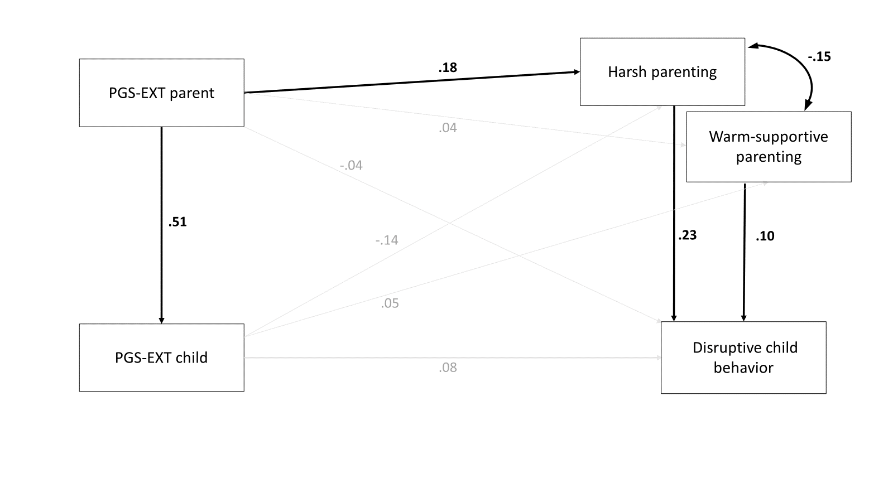

*Note.* Path model testing gene-environment correlation, genetic confounding, and genetic nurture. Each coefficient represents the standardized regression coefficient. Significant estimates are in bold and have bold arrows. PGS-EXT = polygenic score of externalizing behaviors.

**Table S4**

*Unstandardized and Standardized Direct and Indirect Effects Using the Polygenic Score of Externalizing Behaviors for the parent and of Disruptive Behavior for the child*

|  |  |  |  |  |  |
| --- | --- | --- | --- | --- | --- |
|  | *b* | *SE* | β | 95% CI | |
| *LL* | *UL* |
| PGS-DB child |  |  |  |  |  |
| PGS-EXT parent | 0.07 | 0.06 | 0.12 | -0.002 | 0.23 |
| Harsh parenting |  |  |  |  |  |
| PGS-EXT parent | 0.98 | 0.54 | 0.12 | -0.01 | 0.25 |
| PGS-DB child | -0.58 | 0.83 | 0.02 | -0.09 | 0.13 |
| Warm-supportive parenting |  |  |  |  |  |
| PGS-EXT parent | 0.58 | 0.47 | 0.07 | -0.04 | 0.18 |
| PGS-DB child | 0.23 | 0.74 | 0.02 | -0.09 | 0.13 |
| Harsh parenting | **-0.20** | **0.07** | **-0.16** | **-0.26** | **-0.05** |
| Disruptive child behavior |  |  |  |  |  |
| PGS-EXT parent | -0.82 | 7.74 | -0.01 | -0.11 | 0.10 |
| PGS-DB child | **29.06** | **14.59** | **0.13** | **0.004** | **0.25** |
| Harsh parenting | **3.94** | **0.89** | **0.23** | **0.13** | **0.32** |
| Warm-supportive parenting | **1.60** | **0.79** | **0.10** | **0.003** | **0.19** |
| Genetic transmission via PGS child | 2.13 | 1.64 | 0.02 | -0.01 | 0.04 |
| Environmental mediation via HP | 3.87 | 2.38 | 0.03 | -0.01 | 0.06 |
| Environmental mediation via WSP | 0.94 | 0.99 | 0.01 | -0.01 | 0.02 |

*Note.* CI = confidence interval; LL = lower limit; UL = upper limit; PGS-EXT = polygenic score of externalizing behaviors. HP = Harsh parenting; WSP = Warm-supportive parenting; Significant estimates are in bold; Model fit was good (χ2 (9) = 8.35, p = .499, CFI = 1.00, TLI = 1.03, RMSEA < 0.001).