**Table S1**

Demographic and clinical characteristics of the participants

|  |  |
| --- | --- |
| N | 649 |
| Male (%) | 83.05% |
| Age in years (M ± *SD*) | 8.86 ± 1.66 |
| IQ (M ± *SD*) | 104.12 ± 18.03 |
| DSM-IV subtypes (N, %) |  |
| Inattentive | 126 (19.41%) |
| Hyperactive/Impulsive | 26 (4.00%) |
| Combined | 497 (76.58%) |
| Comorbid disorders (N, %) |  |
| No-Comorbid disorders | 555 (85.5%) |
| ODD | 28 (4.20%) |
| LD | 26 (4.01%) |
| Anxiety Disorders | 7 (1.07%) |
| Other | 33 (5.22%) |
| Medication intake (N, %) |  |
| No medication | 424 (65.33%) |
| Concertatm | 134 (20.65%) |
| Atomoxetine | 71 (10.93%) |
| Emotional medication | 20 (3.08%) |
| Suspension or withdrawal | 26 (4.01%) |

*Note.* SD = Standard Deviation; M = Mean; IQ = Intelligence Quotient; ODD = Oppositional Defiant Disorder; LD = Learning Disabilities.

**Table S2**

Demographic and Descriptive Statistics

|  |  |  |  |  |  |  |
| --- | --- | --- | --- | --- | --- | --- |
|  | M (*SD*) | Skew | Kurtosis | Total ADHD | | |
|  | F (*df*) | *η2* | *p* |
| Gender (Boy/Girl) | 539/110 | -- | -- | 6.24 (1, 648) | 0.010 | 0.01* |
| Age (years) | 8.86 (1.66) | 0.28 | -0.82 | 1.43 (5, 642) | 0.013 | 0.20 |
| Medication status(Y/N) | 424/225 | -- | -- | 1.83 (1, 648) | 0.003 | 0.18 |
| Parental education | 3.01 (0.60) | -0.72 | 2.35 | 0.91 (3, 646) | 0.005 | 0.44 |
| Family income | 2.84(0.95) | -0.54 | -0.66 | 1.13 (3, 646) | 0.008 | 0.34 |
| ADHD raw score |  |  |  |  |  |  |
| Inattentive | 17.61 (5.25) | -0.22 | -0.51 | -- | -- | -- |
| Hyperactive/impulsive | 13.08 (6.00) | 0.05 | -0.61 | -- | -- | -- |
| Total score | 41.96 (13.76) | -0.04 | -0.36 | -- | -- | -- |
| BRIEF raw score |  |  |  |  |  |  |
| CRI | 70.73 (12.01) | -0.92 | 3.04 | -- | -- | -- |
| BRI | 53.99 (11.32) | -0/14 | -0.80 | -- | -- | -- |
| Global EF | 124.72 (21.49) | -0.71 | 2.56 | -- | -- | -- |
| Problem behavior |  |  |  |  |  |  |
| Study problem | 2.71 (1.03) | -0.08 | -0.69 | -- | -- | -- |
| Peer problem | 4.06 (1.70) | -0.36 | -0.33 | -- | -- | -- |

*Note.* SD = Standard Deviation; M = Mean; Y = Yes; N = No; EF = Executive Function; CRI = Cognitive Regulation Index; BRI = Behavioral Regulation Index.

\*\**p* < .01, \**p* < 0.05

**Table S3**

Standardized path coefficients for the path model

|  |  |  |  |  |  |  |  |  |  |  |  |  |
| --- | --- | --- | --- | --- | --- | --- | --- | --- | --- | --- | --- | --- |
|  | Study problem | | | Peer problem | | | ADHD-I symptoms | | | ADHD-HI symptoms | | |
|  | *β* | *p* | R2 | *β* | *p* | R2 | *β* | *p* | R2 | *β* | *p* | R2 |
|  |  |  | 0.52 |  |  | 0.20 |  |  | 0.43 |  |  | 0.33 |
| CRI-EF | 0.35 | 0.00 |  | 0.03 | 0.67 |  | 0.65 | 0.00 |  | 0.29 | 0.00 |  |
| BRI-EF | 0.15 | 0.01 |  | 0.04 | 0.42 |  | 0.10 | 0.02 |  | 0.44 | 0.00 |  |
| ADHD-I | 0.19 | 0.01 |  | 0.04 | 0.55 |  |  |  |  |  |  |  |
| ADHD-HI | 0.13 | 0.01 |  | 0.35 | 0.00 |  |  |  |  |  |  |  |
| Gender | 0.02 | 0.56 |  | 0.07 | 0.05 |  | 0.01 | 0.65 |  | 0.27 | 0.00 |  |
| Age | 0.01 | 0.88 |  | 0.01 | 0.41 |  | 0.02 | 0.70 |  | 0.01 | 0.79 |  |

*Note.* EF = Executive Function; CRI = Cognitive Regulation Index = Cool EF; BRI = Behavioral Regulation Index = Hot EF; I = Inattention; HI = Hyperactive/impulsive.

**Table S4**

The latent class probability of 2-LCs, 3-LCs, 4-LCs, 5-LCs models

|  |  |  |  |
| --- | --- | --- | --- |
| Model | Class | Counts | Proportion |
| 2-class | LC1 | 313 | 0.56 |
| LC2 | 242 | 0.44 |
| 3-class | LC1 | 218 | 0.39 |
| LC2 | 205 | 0.37 |
| LC3 | 132 | 0.24 |
| 4-class | **LC1** | **177** | **0.32** |
| **LC2** | **83** | **0.15** |
| **LC3** | **147** | **0.26** |
| **LC4** | **148** | **0.27** |
| 5-class | LC1 | 69 | 0.13 |
| LC2 | 110 | 0.20 |
| LC3 | 74 | 0.13 |
| LC4 | 129 | 0.23 |
| LC5 | 173 | 0.31 |

*Note.* LC = latent class.

**Fig. S1** Fit indices for LCA between 1-5 classes.

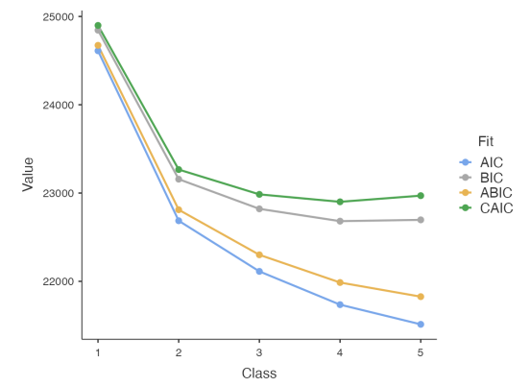

*Note.* LC = Latent Class; AIC = Akaike information criterion; BIC = Bayesian information criterion; ABIC = sample-size adjusted BIC.

**Fig. S2** Forest diagram of exploring the categorical effect of executive function deficits on ADHD group.

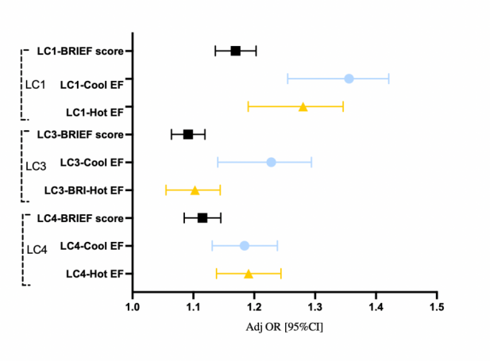

**Table S5**

Demographic and clinical characteristics of the participants.

|  |  |  |  |  |  |  |  |
| --- | --- | --- | --- | --- | --- | --- | --- |
|  | **LC1** | **LC2** | **LC3** | **LC4** | ***F/χ2*** | ***p*** | **Post hoc analysis** |
| **High ADHD** | **Low ADHD** | **Only I** | **Moderate ADHD** |
| N (%) | 177 (31.32%) | 83 (14.69%) | 147 (26.02%) | 158 (27.96%) | -- | -- | -- |
| Male (%) | 150 (84.75%) | 65 (78.31%) | 107 (72.79%) | 135 (85.44%) | 18.87 | 0.00 | LC4 = LC1 > LC2 > LC3 |
| Age in months (M±SD) | 8.92 ± 1.95 | 8.94 ± 1.82 | 9.44 ± 1.98 | 8.69 ± 1.74 | 4.17 | 0.01 | LC3 > LC1 = LC2 = LC4 |
| Parental education (M±SD) | 2.99 ± 0.61 | 3.07 ± 0.58 | 3.01 ± 0.60 | 3.01 ± 0.58 | 0.38 | 0.77 | —— |
| Family income (M±SD) | 2.87 ± 0.99 | 3.01 ± 1.02 | 2.99 ± 0.94 | 2.94 ± 9.95 | 0.55 | 0.65 | —— |
| No Medication (%) | 105 (59.32%) | 65 (78.31%) | 77 (57.38%) | 85 (57.80%) | 2.40 | 0.49 | —— |
| Study problem (M±SD) | 3.41 ± 0.78 | 2.37 ± 0.99 | 2.96 ± 0.98 | 2.55 ± 1.04 | 23.63 | 0.00 | LC1 > LC3 > LC4 = LC2 |
| Symptoms (M±SD) |  |  |  |  |  |  |  |
| Inattentive | 22.78 ± 3.05 | 9.10 ± 2.55 | 17.65 ± 2.95 | 16.26 ± 3.02 | 423.55 | 0.00 | LC1 > LC3 = LC4 > LC2 |
| Hyperactive/impulsive | 18.11 ± 4.18 | 6.18 ± 3.69 | 8.01 ± 2.85 | 13.12 ± 6.09 | 358.76 | 0.00 | LC1 > LC4 > LC3 > LC2 |
| DSM-IV subtypesa (%) |  |  |  |  | 187.74 | 0.00 |  |
| Inattentive | 24 (13.56%) | 19 (22.98%) | 94 (63.95%) | 13 (8.23%) |  |  |  |
| Hyperactive/Iimpulsive | 5 (2.82%) | 3 (3.61%) | 0 (0.00%) | 5 (3.16%) |  |  |  |
| Combined | 147 (83.05%) | 34 (42.96%) | 70 (47.62%) | 123 (77.85%) |  |  |  |

*Note.*M = Mean; SD = Standard Deviation; DSM-IV= Diagnostic and Statistical Manual of Mental Disorders 5th edition; LC = Latent Class; IA = Inattention; HI = Hyperactivity/impulsivity.

a Inattention and hyperactivity/impulsivity symptoms and ADHD diagnostic subtypes were evaluated using the ADHD-RS.

**Table S6**

Executive functions among 4 latent class sub-phenotypes evaluated by BRIEF

|  |  |  |  |  |  |  |  |  |
| --- | --- | --- | --- | --- | --- | --- | --- | --- |
|  | **LC1** | **LC2** | **LC3** | **LC4** | ***F (1,554)*** | ***p*** | ***η2*** | **Post hoc analysis** |
| **High ADHD**  **(N=177)** | **Low ADHD**  **(N=83)** | **Only IA**  **(N=147)** | **Moderate ADHD**  **(N=158)** |
| BRIEF All scorea (M±SD) | 139.57 ± 14.66 | 97.73 ± 21.79 | 120.76 ± 15.65 | 126.90 ± 19.17 | 68.77 | 0.00 | 0.380 | LC1 > LC4 > LC3 > LC2 |
| CRI-Cool EFa (M±SD) | 78.37 ± 7.53 | 54.76 ± 12.31 | 70.71 ± 8.86 | 70.48 ± 10.48 | 116.05 | 0.00 | 0.388 | LC1 > LC4 = LC3 > LC2 |
| BRI-Hot EFa (M±SD) | 61.20 ± 9.45 | 42.98 ± 10.73 | 45.05 ± 8.79 | 56.42 ± 10.35 | 76.64 | 0.00 | 0.295 | LC1 > LC4 > LC3 = LC2 |

*Note.*M = Mean; SD = Standard Deviation; LC = Latent Class; IA = Inattention; CRI = Cognitive Regulation Index; BRI = Behavioral Regulation Index; EF = Executive Function

a ANCOVA with gender, age, no mediation as covariate.