**Supporting Information for**

***Peer Victimization and Adolescent Internalizing and Externalizing Problems: The Longitudinal Between × Within Moderation Role of the FKBP5 Gene***

**Table S1**

The Final RI-CLPM model Controlled for Covariates

|  |  |  |  |  |  |  |  |  |
| --- | --- | --- | --- | --- | --- | --- | --- | --- |
|  | Gender | |  | Age | |  | SES | |
|  | β | *p* |  | β | *p* |  | β | *p* |
| Analyses of RI-CLPMs for internalizing problems and peer victimization | | | | | | | | |
| RI-INT | -0.04 | 0.19 |  | 0.03 | 0.30 |  | 0.03 | 0.26 |
| RI-PV | 0.07 | 0.06 |  | -0.05 | 0.24 |  | 0.07 | 0.05 |
|  |  |  |  |  |  |  |  |  |
| Analyses of RI-CLPMs for internalizing problems and peer victimization | | | | | | | | |
| RI-EXT | 0.13 | 0.01 |  | -0.05 | 0.09 |  | 0.07 | 0.07 |
| RI-PV | 0.08 | 0.05 |  | -0.01 | 0.49 |  | 0.08 | 0.03 |

*Note.* Int = Internalizing problems; Ext = Externalizing problems; PV = Peer victimization.

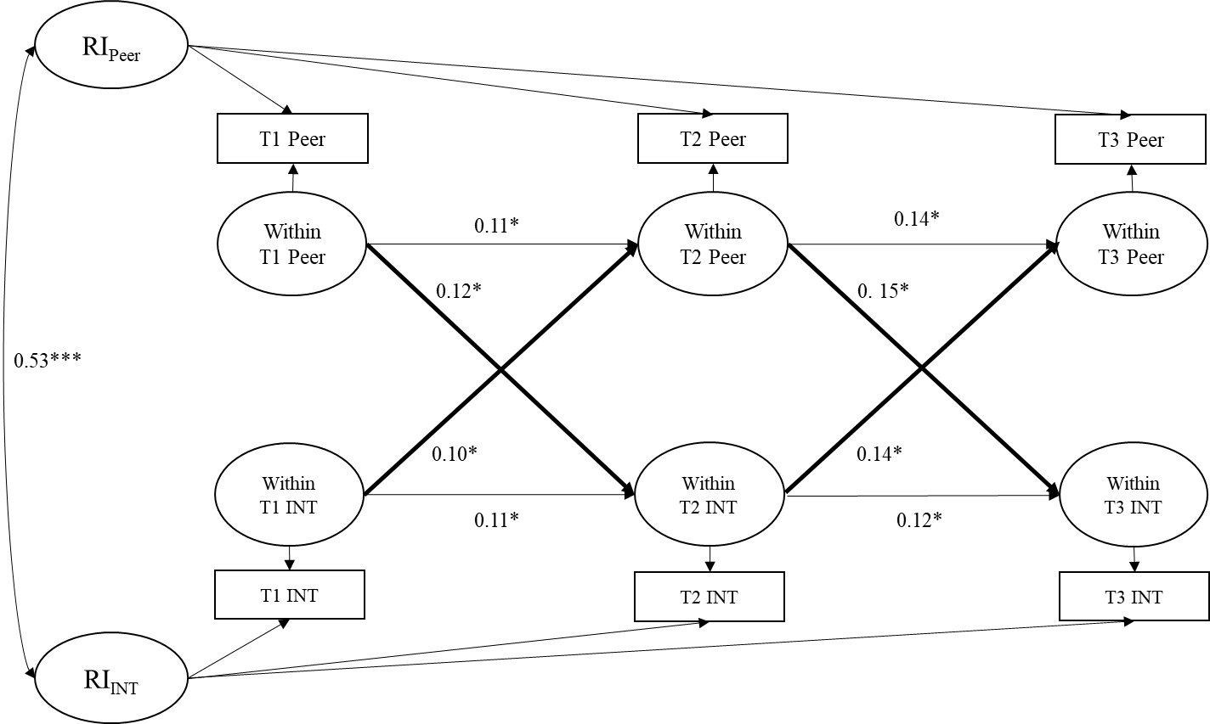

**Fig. S1** The results of the final RI-CLPM model for internalizing problems and peer victimization. Only significant cross-lagged paths are presented as solid lines. Int = Internalizing problems; Peer = Peer victimization.

*\*p <* 0.05; *\*\*p <* 0.01; *\*\*\*p <* 0.001.

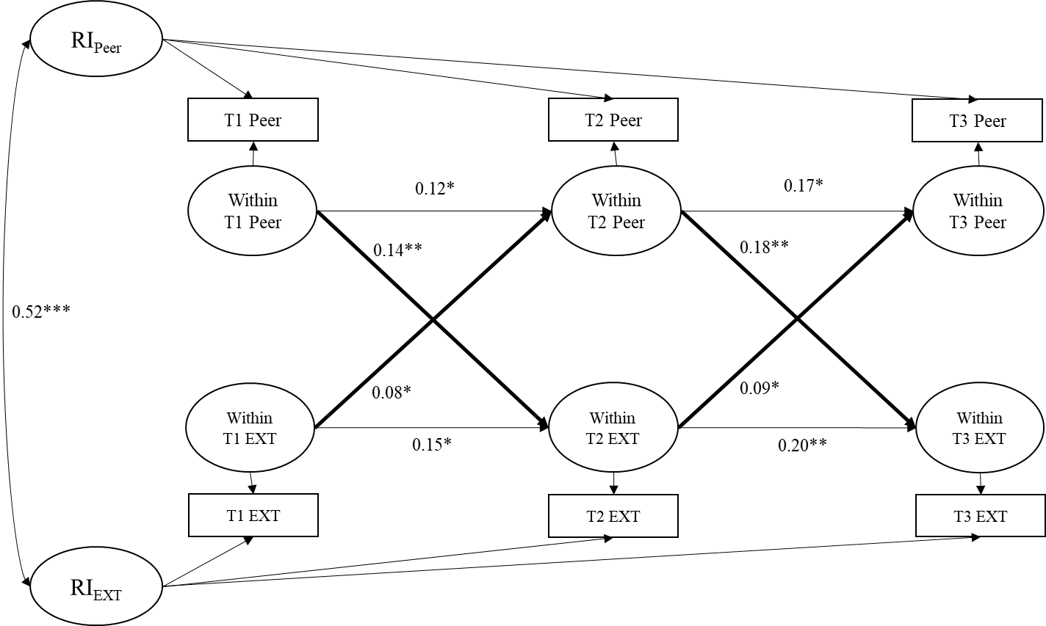

**Fig. S2** The results of the final RI-CLPM model for externalizing problems and peer victimization. Only significant cross-lagged paths are presented as solid lines. Ext = Externalizing problems; Peer = Peer victimization.

*\*p <* 0.05; *\*\*p <* 0.01; *\*\*\*p <* 0.001.