**Supplemental Materials**

**Supplemental Table S1**

*Bivariate correlations among baseline variables*

|  |  |  |  |  |  |  |  |  |  |  |  |  |  |  |
| --- | --- | --- | --- | --- | --- | --- | --- | --- | --- | --- | --- | --- | --- | --- |
|  | 1 | 2 | 3 | 4 | 5 | 6 | 7 | 8 | 9 | 10 | 11 | 12 | 13 | 14 |
| 1. Child Sex | --- |  |  |  |  |  |  |  |  |  |  |  |  |  |
| CG Race/Ethnicity |  |  |  |  |  |  |  |  |  |  |  |  |  |  |
| 2. White | .001 | --- |  |  |  |  |  |  |  |  |  |  |  |  |
| 3. Black | .030 | -.762** | --- |  |  |  |  |  |  |  |  |  |  |  |
| 4. Hispanic | -.019 | -.198** | -.312** | --- |  |  |  |  |  |  |  |  |  |  |
| 5. Other | -.046 | -.165** | -.260** | -.068* | --- |  |  |  |  |  |  |  |  |  |
| 6. CG GED Status | -.027 | .093* | -.046 | -.117** | .044 | --- |  |  |  |  |  |  |  |  |
| 7. CG Marital Status | .022 | .286** | -.318** | .105** | -.017 | .023 | --- |  |  |  |  |  |  |  |
| 8. Poverty Status | -.014 | -.208** | .199** | .023 | -.029 | -.130** | -.285** | --- |  |  |  |  |  |  |
| 9. CG Child Abuse Incidents | -.014 | .182** | -.200** | .017 | .047 | .013 | .067 | -.002 | --- |  |  |  |  |  |
| 10. CG CES-D Total Score | -.046 | -.100** | .125** | -.054 | -.007 | -.085* | -.179** | .156** | .244** | --- |  |  |  |  |
| 11. CTSPC Psych. Aggression | -.025 | -.126** | .175 | -.069 | -.061 | .018 | -.035 | .042 | .099** | .170** | --- |  |  |  |
| 12. CTSPC Phys. Aggression | -.064 | -.180** | .232** | -.075* | -.069 | -.010 | -.031 | .078* | .033 | .172** | .584** | --- |  |  |
| 13. Child Ext. Raw Score | -.054 | .029 | -.008 | -.069* | .039 | .011 | -.022 | .020 | .233** | .298** | .227** | .273** | --- |  |
| 14. Age 14 DBD Symptom Count | -.049 | .173** | -.168** | .023 | -.014 | .027 | .012 | -.071 | .069 | -.010 | .069 | .075 | .194** | --- |

*Note.* For brevity, only variables at study baseline (i.e., child age 4 years) are presented, with the exception of youth’s disruptive behavior disorder diagnosis status, which was collected at child age 14. CG = Caregiver; CES-D = Center for Epidemiologic Studies Depression Scale; Psych. = psychological; Phys. = physical; CTSPC = Conflict Tactics Scale – Parent to Child Version; Ext. = Externalizing Problems; DBD Dx = disruptive behavior disorder diagnosis.

\**p* < .05. \*\**p* < .01.

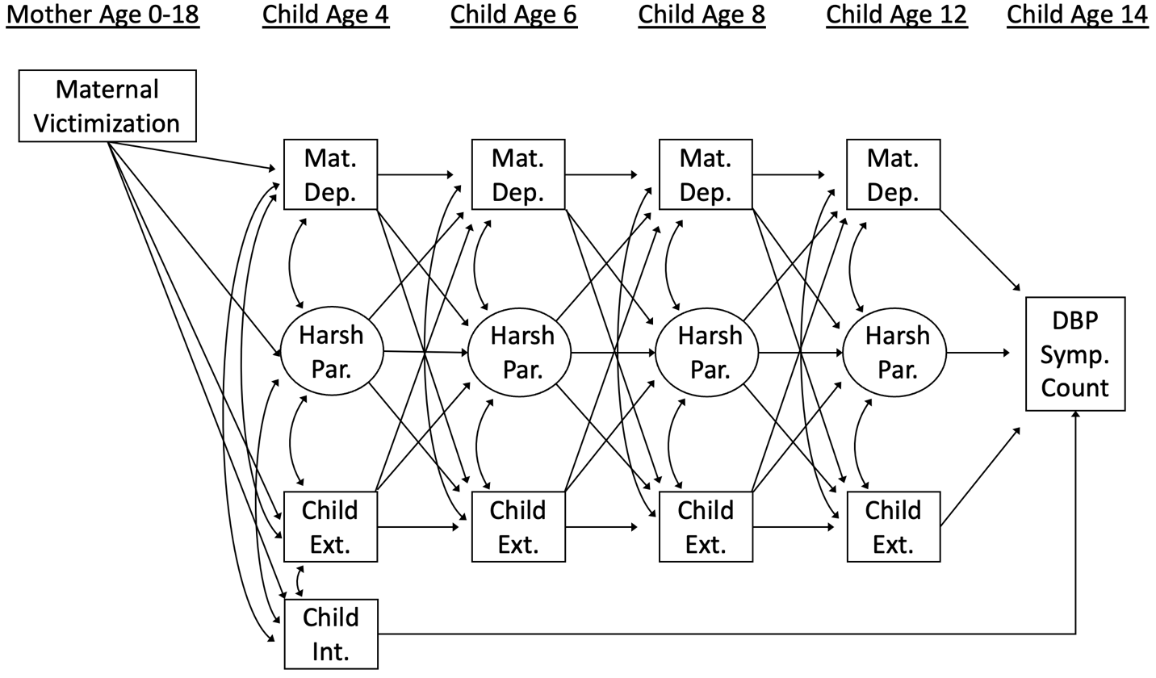**Figure S1a.** Conceptual model depicting traditional cross-lagged panel model

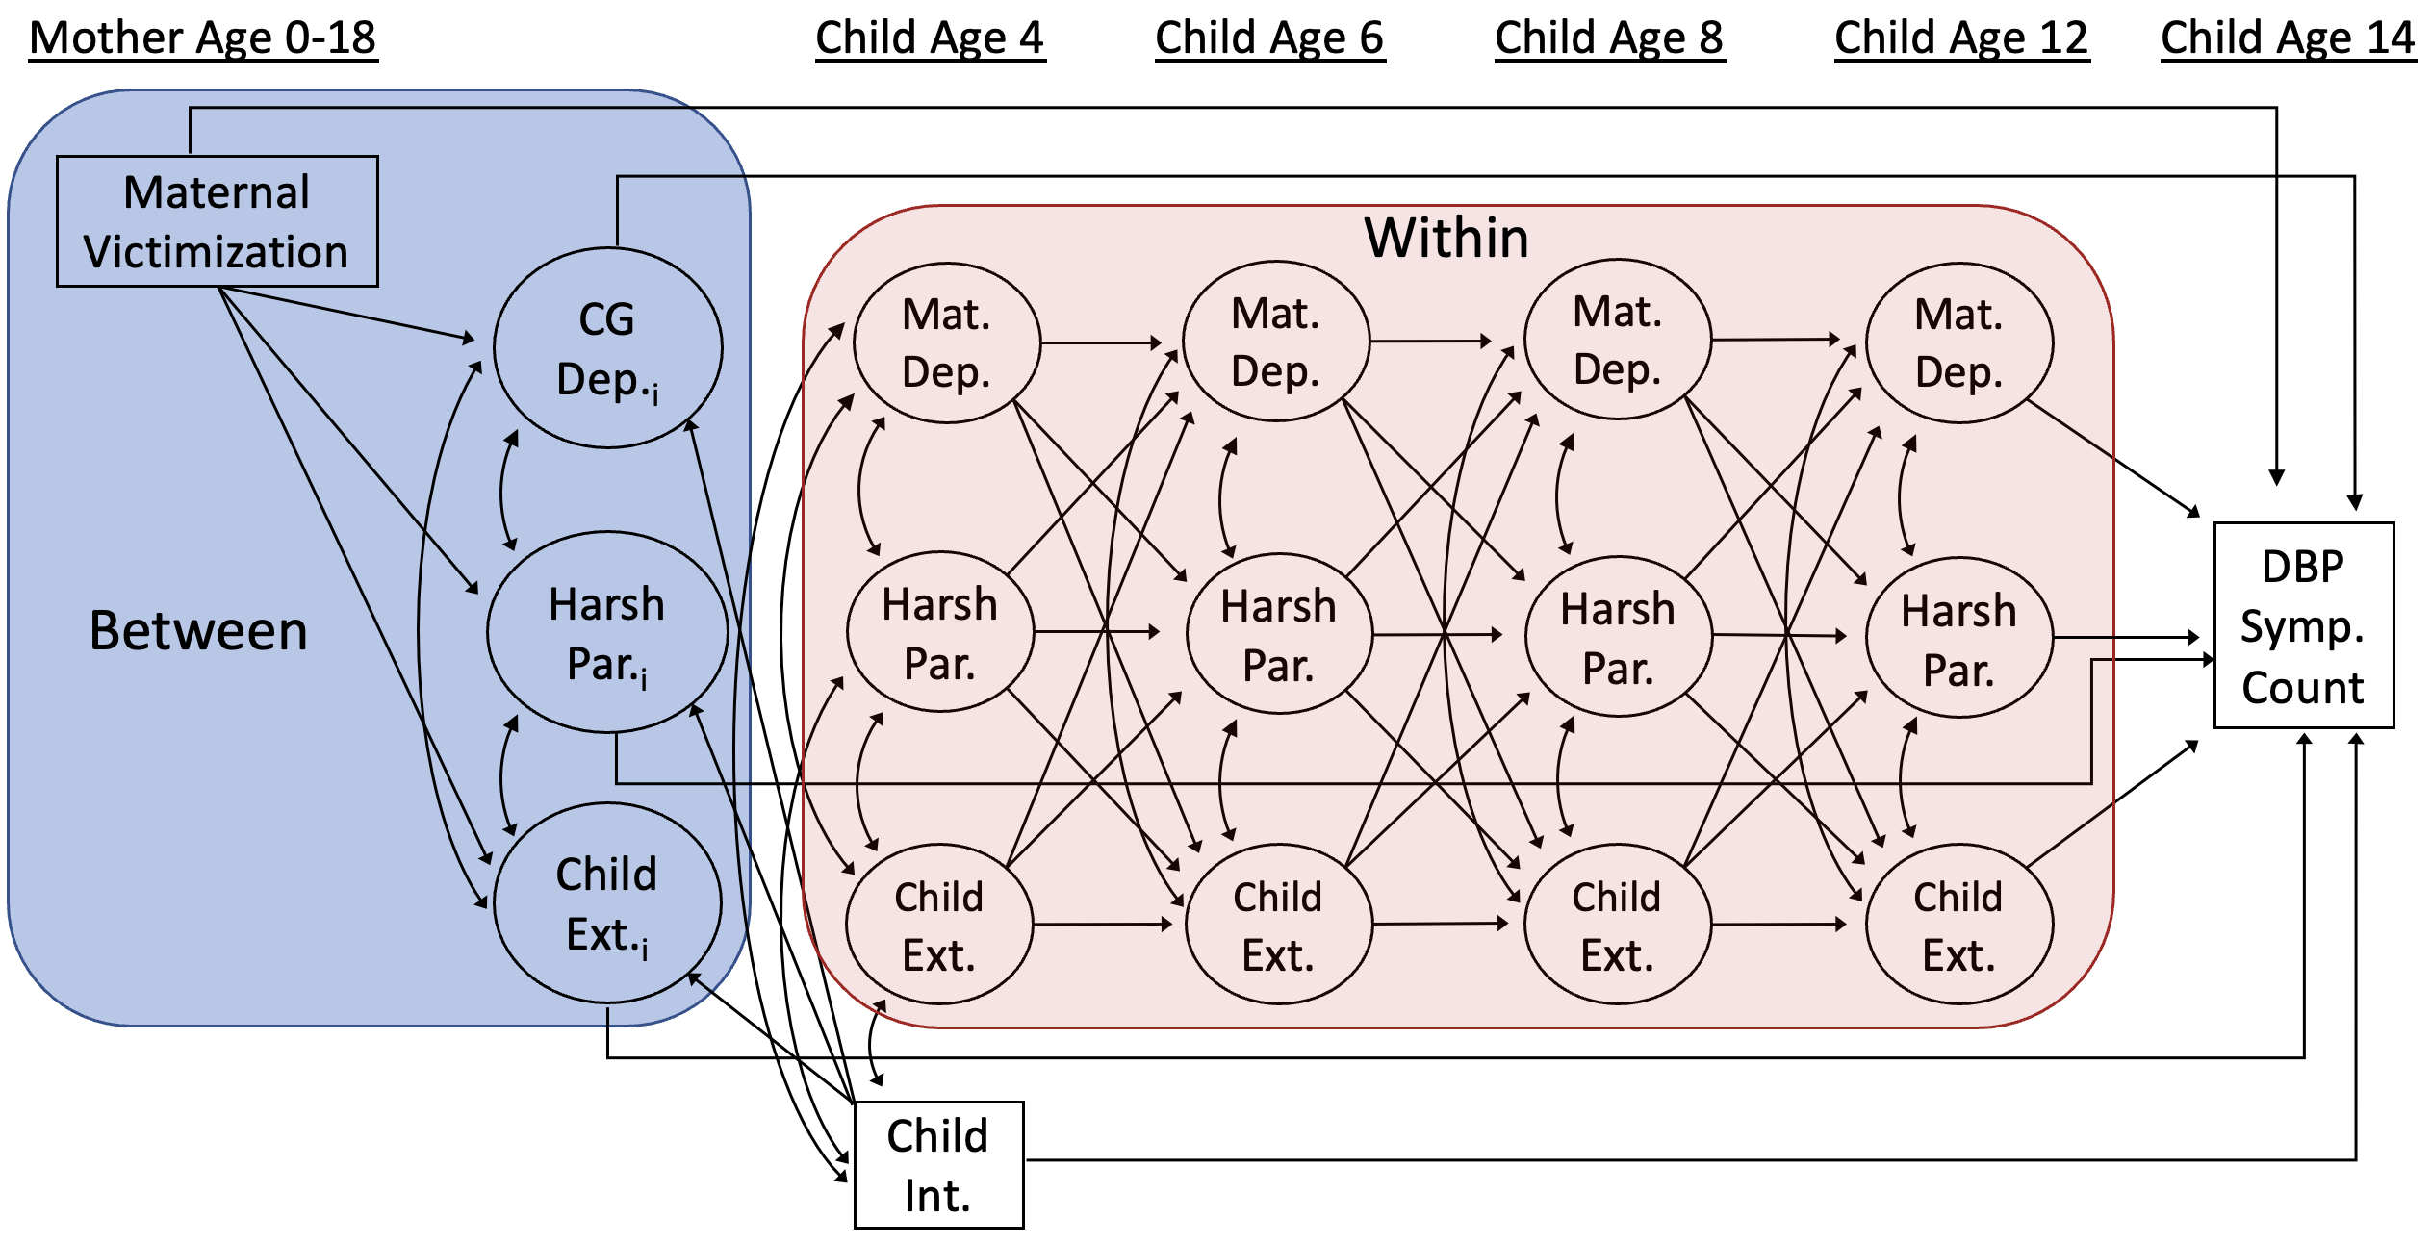**Figure S1b.** Conceptual model depicting random intercept cross-lagged panel model

*Note.* For simplicity, measurement models are not shown. Subscript “i” denotes a random intercept. Mat. = Maternal; Dep. = Depressive Symptoms; Par. = Parenting; Ext. = Externalizing behavior problems; Int. = Internalizing behavior problems; DBP = Disruptive behavior problems; Symp. = Symptom