Supplementary Material

Table S1 | Study 1 (N = 382) Partial Correlations between Self-views and Comparison Tendencies, Controlling for Age and Gender
Table S2 | The Mediator Role of Social and Temporal Comparisons in the Maintenance of Narcissism and Self-Esteem, Controlling for Age and Gender
Table S3 | Study 1 (N = 382) Partial Correlations between Self-views, Comparison Tendencies, and Self Motives Controlling for Other Types of Self Motives
Figure S1 | Individual Mediational Models for Narcissism
Figure S2 | Individual Mediational Models for Self-Esteem
Figure S3 | Mediational Models for Narcissism Controlling for Age and Gender
Figure S4 | Mediational Models for Self-Esteem Controlling for Age and Gender

Table S1
Study 1 (N = 382) Partial Correlations between Self-views and Comparison Tendencies, Controlling for Age and Gender
 | Narcissism | Self-esteem
1. DSOC | .527*** | -.061
2. USOC | .109* | -.527***
3. DTEM | .205*** | -.084
4. UTEM | .170** | -.320***
Note. Age (years) and gender (0 = boys, 1 = girls) were controlled for. DSOC refers to downward social comparisons; USOC refers to upward social comparisons; DTEM refers to downward temporal comparisons; UTEM refers to upward social comparisons. Five adolescents had completely missing data on the variables narcissism, self-esteem, downward social comparisons, and downward temporal comparisons; 19 adolescents had completely missing data on the variables upward social comparisons and upward temporal comparisons.
+p < .10, ***p < .001 (two-tailed).

Table S2
The Mediator Role of Social and Temporal Comparisons in the Maintenance of Narcissism and Self-Esteem, Controlling for Age and Gender

 |  |  |  |  |  | β |  |  | p-value |  | 95% CI
 | Mediator: Downward social comparison
Narcissism at baseline ~
Age |  |  |  |  | 0.055 |  |  | .249 |  | [-0.02 – 0.07]
Gender (Girls) |  |  |  |  | -0.209 |  |  | < .001*** |  | [-0.27 – -0.10]
Downward social comparison ~
Narcissism at baseline (a path) |  |  |  |  | 0.266 |  |  | < .001*** |  | [0.16 – 0.40]
Age |  |  |  |  | 0.056 |  |  | .309 |  | [-0.03 – 0.08]
Gender (Girls) |  |  |  |  | -0.082 |  |  | .146 |  | [-0.180 – 0.04]
Narcissism at follow-up ~
Narcissism at baseline (c path) |  |  |  |  | 0.598 |  |  | < .001*** |  | [0.57 – 0.81]
Downward social comparison (b path) |  |  |  |  | 0.208 |  |  | < .001*** |  | [0.08 – 0.36]
Age |  |  |  |  | 0.077 |  |  | .117 |  | [-0.01 – 0.09]
Gender (Girls) |  |  |  |  | -0.058 |  |  | .264 |  | [-0.16 – 0.05]
Mediation effect (ab) |  |  |  |  | 0.055 |  |  | .006** |  | [0.02 – 0.11]
Total effect |  |  |  |  | 0.654 |  |  | < .001*** |  | [0.63 – 0.87]
 | Mediator: Upward social comparison | β |  |  |  |  | p-value |  |  |  |  | 95% CI
 | Narcissism at baseline ~
 | Age |  |  |  |  | 0.055 |  |  | .236 |  | [-0.02 – 0.07]
 | Gender (Girls) |  |  |  |  | -0.208 |  |  | < .001*** |  | [-0.27 – -0.09]
 | Upward social comparison ~
 | Narcissism at baseline (a path) |  |  |  |  | 0.110 |  |  | .044* |  | [0.01 – 0.22]
 | Age |  |  |  |  | 0.126 |  |  | .026* |  | [0.01 – 0.11]
 | Gender (Girls) |  |  |  |  | 0.132 |  |  | .018* |  | [0.03 – 0.22]
 | Narcissism at follow-up ~
 | Narcissism at baseline (c path) |  |  |  |  | 0.654 |  |  | < .001*** |  | [0.62 – 0.87]
 | Upward social comparison (b path) |  |  |  |  | 0.025 |  |  | .671 |  | [-0.10 – 0.17]
 | Age |  |  |  |  | 0.077 |  |  | .118 |  | [-0.01 – 0.10]
 | Gender (Girls) |  |  |  |  | -0.084 |  |  | .129 |  | [-0.19 – 0.03]
 | Mediation effect (ab) |  |  |  |  | 0.003 |  |  | .719 |  | [-0.01 – 0.02]
 | Total effect |  |  |  |  | 0.657 |  |  | < .001*** |  | [0.63 – 0.88]

Table S2 (continued)
The Mediator Role of Social and Temporal Comparisons in the Maintenance of Narcissism and Self-Esteem, Controlling for Age and Gender

 |  | β | p-value |  | 95% CI
Mediator: Downward temporal comparison
Narcissism at baseline ~
Age |  | 0.055 | .238 |  | [-0.02 – 0.07]
Gender (Girls) |  | -0.209 | < .001*** |  | [-0.27 – -0.10]
Downward temporal comparison ~
Narcissism at baseline (a path) |  | 0.134 | .024* |  | [0.03 – 0.40]
Age |  | -0.108 | .043* |  | [-0.15 – -0.00]
Gender (Girls) |  | -0.089 | .116 |  | [-0.28 – 0.04]
Narcissism at follow-up ~
Narcissism at baseline (c path) |  | 0.641 | < .001*** |  | [0.62 – 0.86]
Downward temporal (b path) |  | 0.121 | .053+ |  | [-0.00 – 0.18]
Age |  | 0.093 | .057+ |  | [0.00 – 0.10]
Gender (Girls) |  | -0.069 | .191 |  | [-0.18 – 0.04]
Mediation effect (ab) |  | 0.016 | .170 |  | [-0.00 – 0.05]
Total effect |  | 0.657 | < .001*** |  | [0.65 – 0.88]
Mediator: Upward temporal comparison |  | β |  | p-value |  | 95% CI
Narcissism at baseline ~
Age |  | 0.055 | .222 |  | [-0.01 – 0.07]
Gender (Girls) |  | -0.208 | < .001*** |  | [-0.27 – -0.09]
Upward temporal comparison ~
Narcissism at baseline (a path) |  | 0.045 | .399 |  | [-0.05 – 0.14]
Age |  | 0.123 | .026* |  | [0.01 – 0.09]
Gender (Girls) |  | 0.165 | .002** |  | [0.05 – 0.22]
Narcissism at follow-up ~
Narcissism at baseline (c path) |  | 0.659 | < .001*** |  | [0.62 – 0.90]
Upward temporal comparison (b path) |  | -0.009 | .882 |  | [-0.15 – 0.17]
Age |  | 0.078 | .127 |  | [-0.01 – 0.10]
Gender (Girls) |  | -0.076 | .180 |  | [-0.19 – 0.04]
Mediation effect (ab) |  | -0.000 | .924 |  | [-0.01 – 0.01]
Total effect |  | 0.659 | < .001*** |  | [0.62 – 0.90]

Table S2 (continued)
The Mediator Role of Social and Temporal Comparisons in the Maintenance of Narcissism and Self-Esteem, Controlling for Age and Gender

 |  | β | p-value |  | 95% CI
Mediator: Downward social comparison
Self-esteem at baseline ~
Age |  | -0.133 | .015* |  | [-0.13 – -0.02]
Gender (Girls) |  | -0.138 | .006** |  | [-0.25 – -0.04]
Downward social comparison ~
Self-esteem at baseline (a path) |  | 0.012 | .834 |  | [-0.09 – 0.12]
Age |  | 0.066 | .248 |  | [-0.02 – 0.09]
Gender (Girls) |  | -0.135 | .015* |  | [-0.23 – -0.03]
Self-esteem at follow-up ~
Self-esteem at baseline (c path) |  | 0.675 | < .001*** |  | [0.64 – 0.86]
Downward social comparison (b path) |  | -0.047 | .423 |  | [-0.20 – 0.09]
Age |  | -0.104 | .055+ |  | [-0.13 – -0.00]
Gender (Girls) |  | -0.064 | .239 |  | [-0.20 – 0.05]
Mediation effect (ab) |  | -0.001 | .891 |  | [-0.01 – 0.01]
Total effect |  | 0.674 | < .001*** |  | [0.64 – 0.86]
Mediator: Upward social comparison |  | β |  | p-value |  | 95% CI
Self-esteem at baseline ~
Age |  | -0.132 | .008** |  | [-0.12 – -0.02]
Gender (Girls) |  | -0.137 | .008** |  | [-0.25 – -0.04]
Upward social comparison ~
Self-esteem at baseline (a path) |  | -0.274 | < .001*** |  | [-0.33 – -0.14]
Age |  | 0.097 | .074+ |  | [-0.00 – 0.09]
Gender (Girls) |  | 0.074 | .157 |  | [-0.03 – 0.15]
Self-esteem at follow-up ~
Self-esteem at baseline (c path) |  | 0.636 | < .001*** |  | [0.60 – 0.82]
Upward social comparison (b path) |  | -0.129 | .035* |  | [-0.34 – -0.02]
Age |  | -0.104 | .054+ |  | [-0.13 – -0.00]
Gender (Girls) |  | -0.044 | .396 |  | [-0.17 – 0.06]
Mediation effect (ab) |  | 0.035 | .063+ |  | [0.00 – 0.09]
Total effect |  | 0.671 | .000*** |  | [0.65 – 0.85]

Table S2 (continued)
The Mediator Role of Social and Temporal Comparisons in the Maintenance of Narcissism and Self-Esteem, Controlling for Age and Gender

 |  | β | p-value |  | 95% CI
Mediator: Downward temporal comparison
Self-esteem at baseline ~
Age |  | -0.133 | .010* |  | [-0.12 – -0.02]
Gender (Girls) |  | -0.138 | .009** |  | [-0.25 – -0.03]
Downward temporal comparison ~
Self-esteem at baseline (a path) |  | 0.111 | .040* |  | [0.00 – 0.30]
Age |  | -0.089 | .095+ |  | [-0.14 – 0.01]
Gender (Girls) |  | -0.102 | .063+ |  | [-0.31 – 0.00]
Self-esteem at follow-up ~
Self-esteem at baseline (c path) |  | 0.680 | < .001*** |  | [0.65 – 0.86]
Downward temporal comparison (b path) |  | -0.047 | .417 |  | [-0.13 – 0.05]
Age |  | -0.111 | .040* |  | [-0.13 – -0.00]
Gender (Girls) |  | -0.060 | .254 |  | [-0.07 – -0.06]
Mediation effect (ab) |  | -0.005 | .493 |  | [-0.03 – 0.01]
Total effect |  | 0.675 | < .001*** |  | [0.64 – -0.86]
Mediator: Upward temporal comparison |  | β |  | p-value |  | 95% CI
Self-esteem at baseline ~
Age |  | -0.133 | .012* |  | [-0.13 – -0.02]
Gender (Girls) |  | -0.138 | .007** |  | [-0.24 – -0.04]
Upward temporal comparison ~
Self-esteem at baseline (a path) |  | -0.241 | < .001*** |  | [-0.26 – -0.11]
Age |  | 0.094 | .079+ |  | [-0.00 – 0.08]
Gender (Girls) |  | 0.125 | .023* |  | [0.01 – 0.18]
Self-esteem at follow-up ~
Self-esteem at baseline (c path) |  | 0.672 | < .001*** |  | [0.62 – 0.86]
Upward temporal comparison (b path) |  | -0.016 | .788 |  | [-0.21 – 0.12]
Age |  | -0.106 | .053+ |  | [-0.13 – -0.00]
Gender (Girls) |  | -0.054 | .283 |  | [-0.17 – 0.06]
Mediation effect (ab) |  | 0.004 | .795 |  | [-0.02 – 0.04]
Total effect |  | 0.676 | < .001*** |  | [0.64 – 0.86]
Note. Bootstrapping with n = 1,000 iterations; Age (years) and gender (0 = boys, 1 = girls); a path = direct effect of self-views at baseline on comparison types; b path = direct effect of comparison types on self-views at follow-up; c path = direct effect of self-views at baseline on self-views at follow-up.

Table S3
Study 1 (N = 362) Partial Correlations between Self-views, Comparison Tendencies, and Self Motives, controlling for Other Types of Self Motives.
 | Self-enhancement motive  (SE) | Self-  assessment motive  (SA) | Self-improvement motive  (SI)
1. Narcissism | .420*** | .064 | .085
2. Self-esteem | -.022 | -.033 | .110*
3. DSOC | .273*** | -.055 | .122*
4. USOC | .162** | -.013 | -.045
5. DTEM | .099+ | .140** | .072
6. UTEM | .108* | -.028 | .061
Note. Pearson correlation tested partial correlations between self-views, comparison types, and self-motives, while controlling for other self-motives. Self-enhancement (SE) motive was measured with two items (i.e., “I want to hear that I am amazing” and “I want to discover that I am really good at something”); self-assessment (SA) motive was measured with two items (i.e., “I want to hear the truth about myself” and “I want to discover who I really am”); and self-improvement (SI) was measured with two items (i.e., “I want to hear that I can keep improving” and “I want to discover that I can keep improving”), all rated on 4-point scales (0 = Not at all true, 3 = Completely true) and averaged per motive. DSOC refers to downward social comparisons; USOC refers to upward social comparisons; DTEM refers to downward temporal comparisons; UTEM refers to upward social comparisons.
+p < .10, ***p < .001 (two-tailed).

Figure S1
Individual Mediational Models for Narcissism
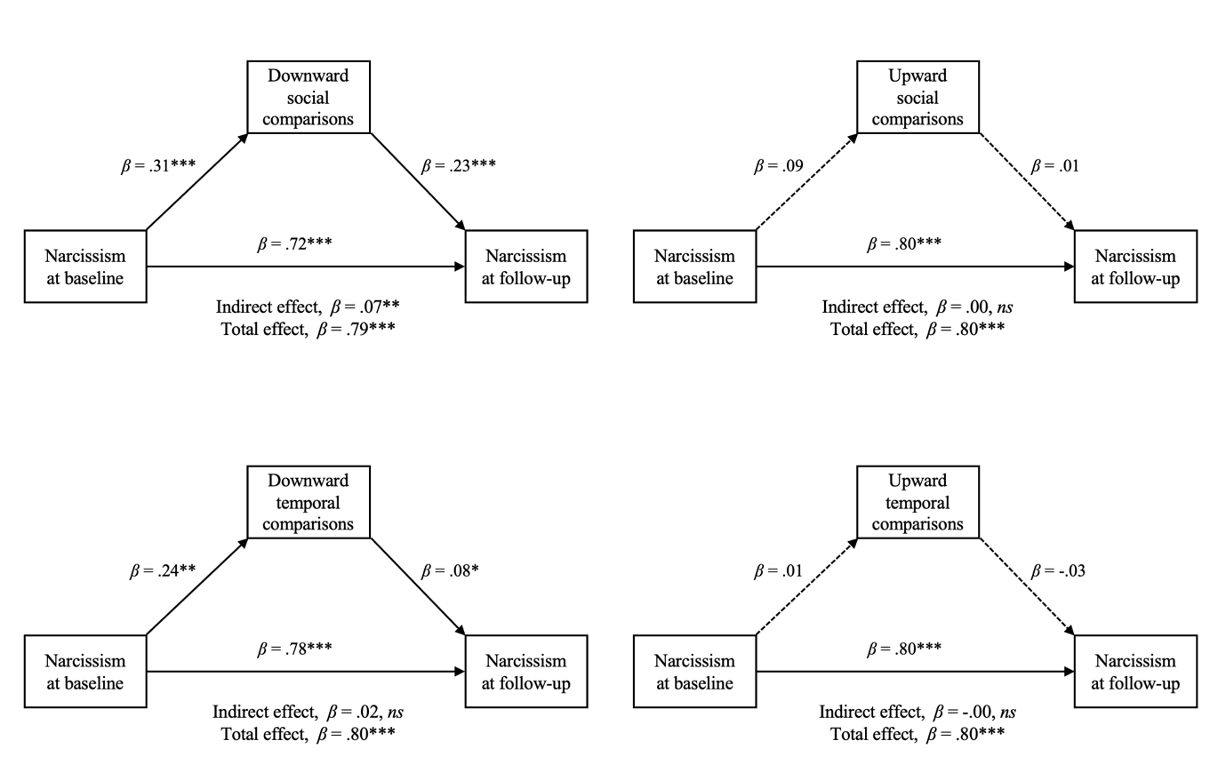
Note. *p < .05, **p < .01, ***p < .001.
Figure S2
Individual Mediational Models for Self-Esteem
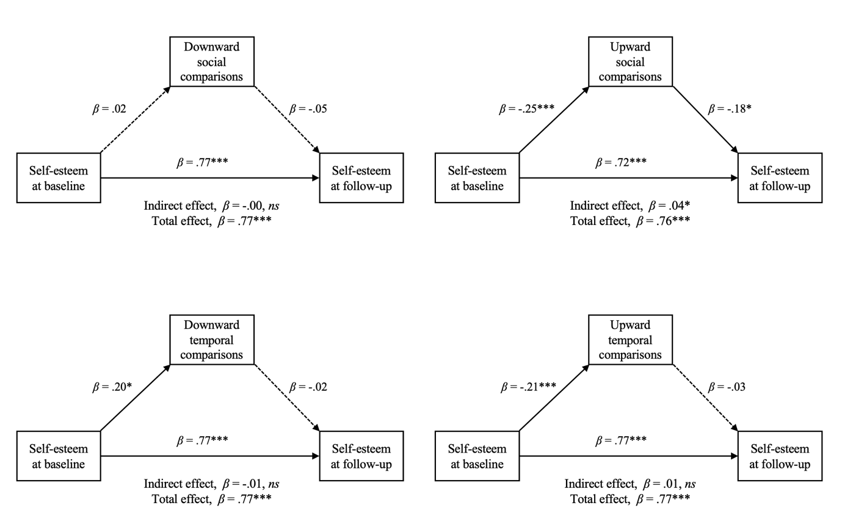

Note. *p < .05, **p < .01, ***p < .001.

Figure S3
Mediational Models for Narcissism Controlling for Age and Gender
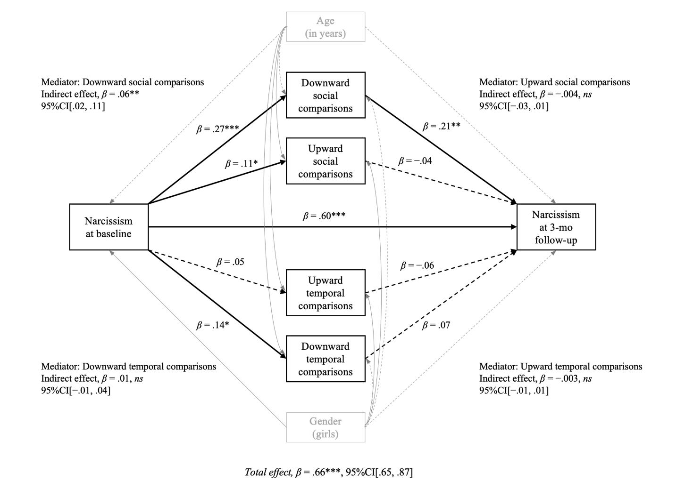
Note. Age (years) and gender (0 = boys, 1 = girls) were controlled for. Regression paths controlling for covariates are denoted with gray color. Solid gray lines indicate significant relationships at p < .05. Dashed gray lines indicate non-significant relationships at p >.10.
*p < .05, **p < .01, ***p < .001.
Figure S4
Mediational Models for Self-Esteem Controlling for Age and Gender
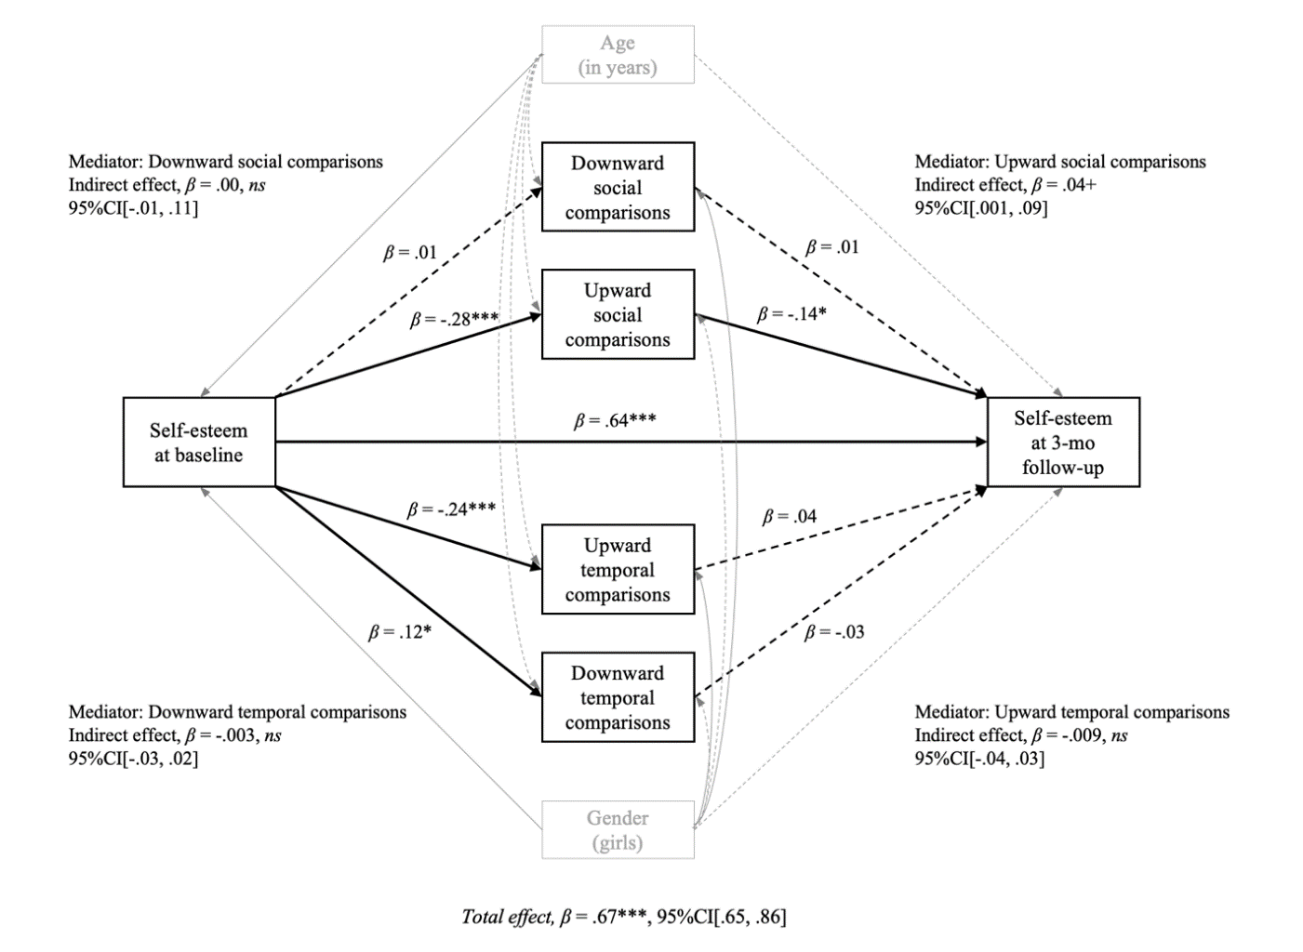
Note. Age (years) and gender (0 = boys, 1 = girls) were controlled for. Regression paths controlling for covariates are denoted with gray color. Solid gray lines indicate significant relationships at p <.05. Dashed gray lines indicate non-significant relationships at p >.10.
+p <.10, *p < .05, **p < .01, ***p < .001.

