Figure 1. Study Inclusion Flow Chart

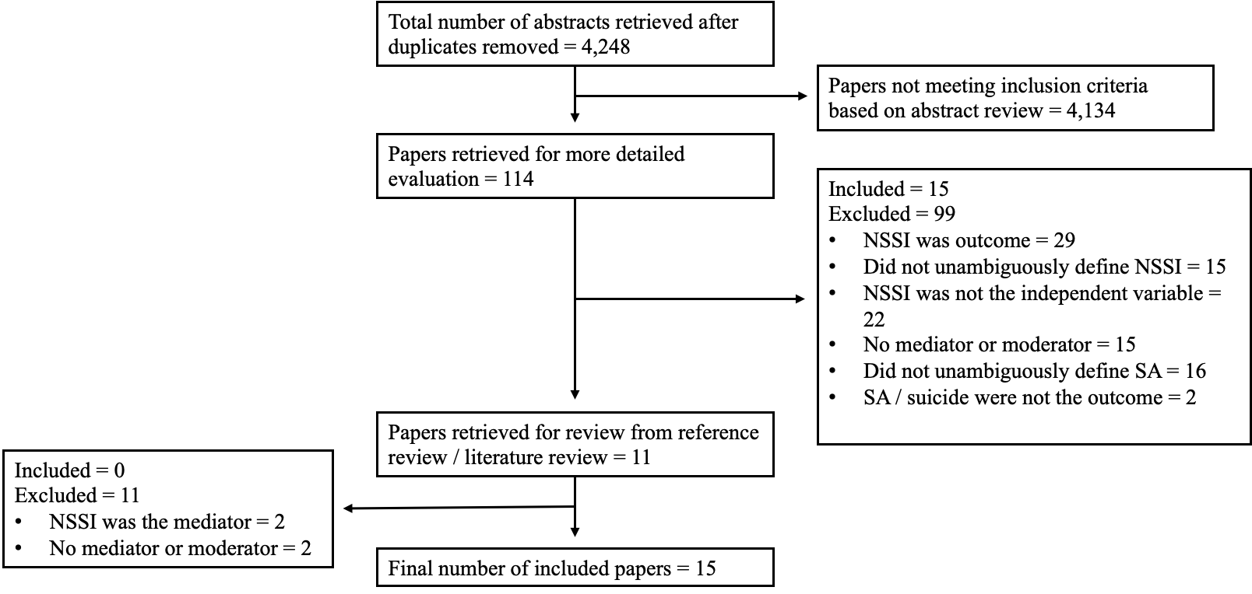

*Note:* Search terms included were: (a) "self-harm" or "non-suicidal self-injury" or "nonsuicidal self-injury" or "NSSI" or "self-injury" or "self-injurious behaviors" or "self-mutilation" or "deliberate self-harm" or "cutting" or "self-cutting" or "self-burning" or "self-poisoning,"; and (b) "suicide" or "self-injury" or "suicidality" or "self-harm" or "suicidal behavior" or "suicide attempt" or "suicide death" or "suicide plan" or "suicide thoughts" or "suicide ideation" or "suicide gesture" or "suicide threat"; and (c) "mediat\*" or "moderat\*" or "interaction" or "path analysis" or "mechanism.” Review completed January 1, 2000 - October 31, 2024.