Supplementary Information

Table S1
Sample Characteristics and Dropout Analysis
Characteristics | Pre-Pandemic Baseline  (N = 102) |  | First  Lockdown  (n = 79) |  | Reopening  (n = 77) |  | Second  Lockdown  (n = 73) |  | Dropout Analysis
 |  |  |  |  |  |  |  |  | t | p
Age | 22.24 (2.76) |  | 22.80 (2.69) |  | 22.96 (2.69) |  | 23.40 (2.64) |  | 1.18 | .240
Gender identity |  |  |  |  |  |  |  |  | 1.74 | .085
Male | 36 (35.3) |  | 26 (32.9) |  | 25 (32.5) |  | 22 (30.1)
Female | 66 (64.7) |  | 53 (67.1) |  | 52 (67.5) |  | 51 (69.9)
Race |  |  |  |  |  |  |  |  | -0.29 | .772
Asian | 18 (17.7) |  | 13 (16.5) |  | 13 (16.9) |  | 13 (17.8)
Black | 4 (3.9) |  | 2 (2.5) |  | 2 (2.6) |  | 2 (2.7)
White | 69 (67.6) |  | 57 (72.2) |  | 55 (71.4) |  | 52 (71.2)
Others | 11 (10.8) |  | 7 (8.8) |  | 7 (9.1) |  | 6 (8.3)
Highest education |  |  |  |  |  |  |  |  | 1.56 | .122
GCSEs | 16 (15.8) |  | 10 (12.7) |  | 9 (11.7) |  | 8 (11.0)
A-Levels | 29 (28.4) |  | 23 (29.1) |  | 23 (29.9) |  | 21 (28.8)
Undergraduate degree | 39 (38.2) |  | 32 (40.5) |  | 32 (41.6) |  | 31 (42.5)
Postgraduate degree | 18 (17.6) |  | 14 (17.7) |  | 13 (16.9) |  | 13 (17.8)
Housing |  |  |  |  |  |  |  |  | 1.35 | .180
Parent(s) | 30 (29.4) |  | 22 (27.8) |  | 21 (27.3) |  | 18 (24.7)
University housing | 33 (32.4) |  | 25 (31.6) |  | 25 (32.5) |  | 25 (34.2)
Rented room | 8 (7.8) |  | 7 (8.9) |  | 7 (9.1) |  | 7 (9.6)
Rented house or flat | 27 (26.5) |  | 21 (26.6) |  | 21 (27.3) |  | 20 (27.4)
Owned a house or flat | 4 (3.9) |  | 4 (5.1) |  | 3 (3.9) |  | 3 (4.1)
Employment |  |  |  |  |  |  |  |  | -0.03 | .976
Full-time | 26 (48.1) |  | 24 (53.3) |  | 22 (51.2) |  | 20 (51.3)
Part-time | 20 (37.0) |  | 15 (33.3) |  | 15 (34.9) |  | 13 (33.3)
Self-employed | 8 (14.8) |  | 6 (13.3) |  | 6 (14.0) |  | 6 (15.4)
Friendship quality | 27.47 (3.55) |  | 28.29 (3.61) |  | 27.73 (3.49) |  | 28.04 (3.72) |  | -0.14 | .885
Childhood adversity
Sexual abuse | 9.60 (22.10) |  | 7.06 (4.65) |  | 6.99 (4.61) |  | 6.85 (4.42) |  | -0.26 | .793
Emotional abuse | 30.15 (24.12) |  | 11.06 (4.91) |  | 10.95 (4.92) |  | 11.03 (4.96) |  | -0.01 | .993
Physical abuse | 7.82 (14.41) |  | 6.54 (2.89) |  | 6.48 (2.82) |  | 6.48 (2.88) |  | -0.48 | .635
Emotional neglect | 36.80 (25.75) |  | 12.58 (5.55) |  | 12.44 (5.55) |  | 12.44 (5.60) |  | 0.25 | .804
Physical neglect | 13.45 (15.24) |  | 7.83 (3.27) |  | 7.74 (3.19) |  | 7.75 (3.20) |  | 0.34 | .734
Negative parenting | 40.68 (23.31) |  | 7.92 (2.93) |  | 7.87 (2.94) |  | 7.82 (2.96) |  | -0.34 | .733
Poor parental involvement | 52.50 (24.55) |  | 9.25 (3.12) |  | 9.16 (3.10) |  | 9.04 (3.02) |  | -1.45 | .149
Corporal punishment | 28.28 (25.86) |  | 6.38 (3.20) |  | 6.36 (3.23) |  | 6.38 (3.21) |  | -0.06 | .956
Paternal abuse | 15.71 (23.86) |  | 7.49 (3.54) |  | 7.47 (3.57) |  | 7.37 (3.55) |  | 0.06 | .951
Maternal abuse | 14.13 (21.13) |  | 7.31 (3.28) |  | 7.25 (3.27) |  | 7.36 (3.33) |  | 1.21 | .228
Paternal overcontrol | 24.57 (25.39) |  | 7.16 (3.21) |  | 7.05 (3.08) |  | 7.03 (3.13) |  | 0.41 | .685
Maternal overcontrol | 32.35 (27.03) |  | 7.86 (3.38) |  | 7.91 (3.40) |  | 8.03 (3.42) |  | 0.71 | .476
Paternal indifference | 20.20 (26.33) |  | 9.77 (4.82) |  | 9.65 (4.83) |  | 9.75 (4.94) |  | 0.37 | .714
Maternal indifference | 13.29 (20.58) |  | 8.56 (3.98) |  | 8.44 (3.91) |  | 8.55 (3.99) |  | 0.67 | .503
Note. Age (in years), friendship quality, and severity of CAs (%) are reported as M (SD). All other characteristics are reported as n (%). Compared to pre-pandemic baseline, sample characteristics did not significantly differ for any of the COVID-19 assessment timepoints. In addition, a dropout analysis was performed using two sample t-tests to compare characteristics between the second lockdown sample and all n = 29 participants that dropped out before then.

Table S2
Missing Questionnaire Data
 | MFQ | RCMAS | CFQ | PSS | CTQ-SF | MOPS | APQ
Pre-Pandemic Baseline (N = 102) | 0 (0%) | 3 (2.94%) | 0 (0%) | 0 (0%) | 5 (4.90%) | 0 (0%) | 6 (5.88%)
First Lockdown (n = 79) | 0 (0%) | 1 (1.27%) | 1 (1.27%) | 0 (0%) | NA | NA | NA
Reopening (n = 77) | 0 (0%) | 5 (6.49%) | 0 (0%) | 0 (0%) | NA | NA | NA
Second Lockdown (n = 73) | 0 (0%) | 2 (2.74%) | 1 (1.37%) | 1 (1.37%) | NA | NA | NA
Note. Missing questionnaire data is reported as n (%). MFQ = Mood and Feelings Questionnaire; RCMAS = Revised Children’s Manifest Anxiety Scale; CFQ = Cambridge Friendship Questionnaire; PSS = Perceived Stress Scale; CTQ-SF = Short-Form of the Childhood Trauma Questionnaire; MOPS = Measure of Parental Style Questionnaire; APQ = Alabama Parenting Questionnaire. NA = Questionnaire data was not assessed at this timepoint.

Table S3
Correlations Between Main Study Variables Across All Assessment Timepoints
 | Variable | 1 | 2 | 3 | 4 | 5 | 6 | 7 | 8 | 9 | 10 | 11 | 12 | 13 | 14 | 15 | 16 | 17 | 18 | 19 | 20 | 21
1. | Childhood adversity | -
2. | Sex | -.02 | -
3. | Age (BL) | .07 | .03 | -
4. | Age (L1) | .08 | .05 | .99 | -
5. | Age (RO) | .09 | .03 | .98 | .99 | -
6. | Age (L2) | .08 | .03 | .99 | .99 | .98 | -
7. | Anxiety (BL) | .04 | .09 | .01 | .04 | .03 | .03 | -
8. | Anxiety (L1) | .26 | .29 | .00 | .02 | .01 | .00 | .62 | -
9. | Anxiety (RO) | .23 | .16 | .05 | .06 | .08 | .05 | .48 | .70 | -
10. | Anxiety (L2) | .28 | .36 | -.06 | -.04 | -.05 | -.04 | .66 | .80 | .68 | -
11. | Depression (BL) | .11 | -.03 | .03 | .07 | .06 | .06 | .85 | .52 | .42 | .58 | -
12. | Depression (L1) | .28 | .19 | -.03 | .01 | .00 | -.01 | .60 | .90 | .67 | .80 | .60 | -
13. | Depression (RO) | .24 | .08 | .02 | .03 | .04 | .02 | .43 | .71 | .91 | .69 | .46 | .77 | -
14. | Depression (L2) | .23 | .18 | -.01 | .01 | .00 | .01 | .61 | .78 | .61 | .90 | .60 | .86 | .73 | -
15. | Friendship quality (BL) | -.31 | .12 | .07 | .07 | .06 | .06 | -.53 | -.30 | -.27 | -.21 | -.54 | -.30 | -.25 | -.17 | -
16. | Friendship quality (L1) | -.35 | .29 | .14 | .15 | .13 | .13 | -.39 | -.32 | -.31 | -.26 | -.40 | -.35 | -.41 | -.33 | .72 | -
17. | Friendship quality (RO) | -.34 | .16 | .24 | .23 | .23 | .22 | -.45 | -.42 | -.54 | -.41 | -.46 | -.44 | -.56 | -.39 | .68 | .77 | -
18. | Friendship quality (L2) | -.38 | .05 | .22 | .22 | .22 | .21 | -.49 | -.44 | -.40 | -.48 | -.47 | -.46 | -.44 | -.43 | .65 | .71 | .82 | -
19. | Perceived stress (L1) | .22 | .38 | -.05 | -.02 | -.04 | -.05 | .53 | .77 | .54 | .62 | .32 | .70 | .46 | .55 | -.31 | -.22 | -.33 | -.34 | -
20. | Perceived stress (RO) | .26 | .24 | -.09 | -.06 | -.07 | -.09 | .42 | .63 | .84 | .70 | .38 | .67 | .82 | .63 | -.22 | -.30 | -.55 | -.46 | .61 | -
21. | Perceived stress (L2) | .26 | .38 | -.09 | -.06 | -.07 | -.08 | .44 | .65 | .61 | .81 | .33 | .70 | .62 | .76 | -.04 | -.15 | -.31 | -.34 | .62 | .70 | -
Note. BL = pre-pandemic baseline (August 2019 to March 2020; N = 102), L1 = first lockdown (April to May 2020; n = 79), RO = reopening (July to August 2020; n = 77), L2 = second lockdown (October to November 2020; n = 73).

C. The Impact of the COVID-19 Pandemic on Mental Health Symptoms
Table S4
Model Fit Statistics for Linear Mixed-Effects Models Predicting (A) Depression and (B) Anxiety Symptoms
Model | AIC | BIC | χ² | df | p
A. Depression Symptoms
1. Time | 636.43 | 658.93
2. Time + Age + Gender | 639.88 | 669.88 | 0.55 | 2 | .759
B. Anxiety Symptoms
1. Time | 692.16 | 714.62
2. Time + Age + Gender | 694.72 | 724.66 | 1.44 | 2 | .486
Note. The best fitting models are highlighted in bold. Random effects for participants have been included in all models. AIC = Akaike information criterion; BIC = Bayesian information criterion.

Table S5
Model Estimates for the Best Fitting Linear Mixed-Effects Models Predicting (A) Depression and (B) Anxiety Symptoms
 | A. Depression Symptoms |  |  |  |  |  | B. Anxiety Symptoms
Fixed Effects | β | SE | 95% CI | t | p |  | β | SE | 95% CI | t | p
Intercept | -0.29 | 0.08 | [-0.46, -0.13] | -3.49 | < .001 |  | -0.13 | 0.10 | [-0.32, 0.06] | -1.34 | .182
First lockdown | 0.30 | 0.08 | [0.14, 0.45] | 3.77 | < .001 |  | 0.20 | 0.08 | [0.04, 0.37] | 2.41 | .017
Reopening | 0.33 | 0.08 | [0.17, 0.49] | 4.15 | < .001 |  | 0.15 | 0.09 | [-0.02, 0.32] | 1.71 | .088
Second lockdown | 0.18 | 0.08 | [0.02, 0.34] | 2.27 | .024 |  | 0.12 | 0.09 | [-0.06, 0.29] | 1.33 | .184
 | Marginal R² = .027; Conditional R² = . 649 |  |  |  |  |  | Marginal R² = .007; Conditional R² = .696
Note. Two linear mixed-effects models predicting (A) depression and (B) anxiety symptomatology as outcomes. Assessment timepoint (dummy-coded: first lockdown, reopening, second lockdown, with pre-pandemic baseline as the reference group) has been added as an independent variable. Random effects for participants have been included in both models. Pre-pandemic baseline = August 2019 to March 2020; First lockdown = April to May 2020; Reopening = July to August 2020; Second lockdown = October to November 2020. β = standardized coefficient; 95% CI = 95% confidence interval. Bold denotes significant effects.

D. The Impact of the COVID-19 Pandemic on Perceived Friendship Quality
Table S6
Model Fit Statistics for Linear Mixed-Effects Models Predicting Perceived Friendship Quality
Model | AIC | BIC | χ² | df | p
1. Time | 740.62 | 763.32
2. Time + Age + Gender | 740.85 | 771.12 | 3.76 | 2 | .152
Note. The best fitting model is highlighted in bold. Random effects for participants have been included in all models. AIC = Akaike information criterion; BIC = Bayesian information criterion.

Table S7
Model Estimates for the Best Fitting Linear Mixed-Effects Models Predicting Perceived Friendship Quality
Fixed Effects | β | SE | 95% CI | t | p
Intercept | -0.10 | 0.10 | [-0.29, 0.10] | -0.98 | .331
First lockdown | 0.21 | 0.08 | [0.04, 0.38] | 2.47 | .014
Reopening | 0.07 | 0.09 | [-0.10, 0.23] | 0.78 | .436
Second lockdown | 0.18 | 0.09 | [0.01, 0.35] | 2.08 | .039
 | Marginal R² = .008; Conditional R² = .709
Note. One linear mixed-effects model predicting perceived friendship quality as the outcome. Assessment timepoint (dummy-coded: first lockdown, reopening, second lockdown, with pre-pandemic baseline as the reference group) has been added as an independent variable. Random effects for participants have been included in both models. β = standardized coefficient; 95% CI = 95% confidence interval. Bold denotes significant effects.

E. The Impact of Childhood Adversity on Perceived Friendship Quality and Mental Health Symptoms Before and During the COVID-19 Pandemic
Table S8
Model Fit Statistics for Linear Mixed-Effects Model Predicting (A) Perceived Friendship Quality,
(B) Depression Symptoms, and (C) Anxiety Symptoms
Model | AIC | BIC | χ² | df | p
A. Friendship Quality
1. Time | 740.62 | 763.32
2. Time + CA | 737.21 | 763.70 | 5.40 | 1 | .020
3. Time + CA + Time:CA | 742.32 | 780.15 | 0.89 | 3 | .827
4. Time + CA + Time:CA + Age + Gender | 740.91 | 786.32 | 5.41 | 2 | .067
B. Depression Symptoms
1. Time | 636.43 | 658.93
2. Time + CA | 634.82 | 661.06 | 3.61 | 1 | .057
3. Time + CA + Time:CA | 636.43 | 673.92 | 4.39 | 3 | .223
4. Time + CA + Time:CA + Age + Gender | 639.37 | 684.37 | 1.06 | 2 | .590
C. Anxiety Symptoms
1. Time | 692.16 | 714.62
2. Time + CA | 692.12 | 718.32 | 2.04 | 1 | .153
3. Time + CA + Time:CA | 690.86 | 728.29 | 7.26 | 3 | .064
4. Time + CA + Time:CA + Age + Gender | 693.02 | 737.94 | 1.84 | 2 | .399
Note. The best fitting model is highlighted in bold. Random effects for participants have been included in all models. AIC = Akaike information criterion; BIC = Bayesian information criterion; CA = childhood adversity (cumulative).

Table S9
Model Estimates for the Best Fitting Linear Mixed-Effects Model Predicting Friendship Quality
Fixed Effects | β | SE | 95% CI | t | p
Intercept | -0.11 | 0.10 | [-0.30, 0.08] | -1.15 | .251
CA | -0.42 | 0.18 | [-0.78, -0.07] | -2.36 | .020
First lockdown | 0.21 | 0.08 | [0.04, 0.38] | 2.49 | .014
Reopening | 0.07 | 0.09 | [-0.10, 0.23] | 0.78 | .436
Second lockdown | 0.18 | 0.09 | [0.01, 0.35] | 2.07 | .039
 | Marginal R² = .053; Conditional R² = .708
Note. A linear mixed-effects model predicting friendship quality as the outcome. Childhood adversity and assessment timepoint (dummy-coded: first lockdown, reopening, second lockdown, with pre-pandemic baseline as the reference group) have been added as independent variables. A random effect for participants has also been included in the model. CA = childhood adversity (cumulative). β = standardized coefficient; 95% CI = 95% confidence interval. Bold denotes significant effects.

Figure S1
Childhood Adversity Effects on Perceived Friendship Quality Across all Assessment Timepoints
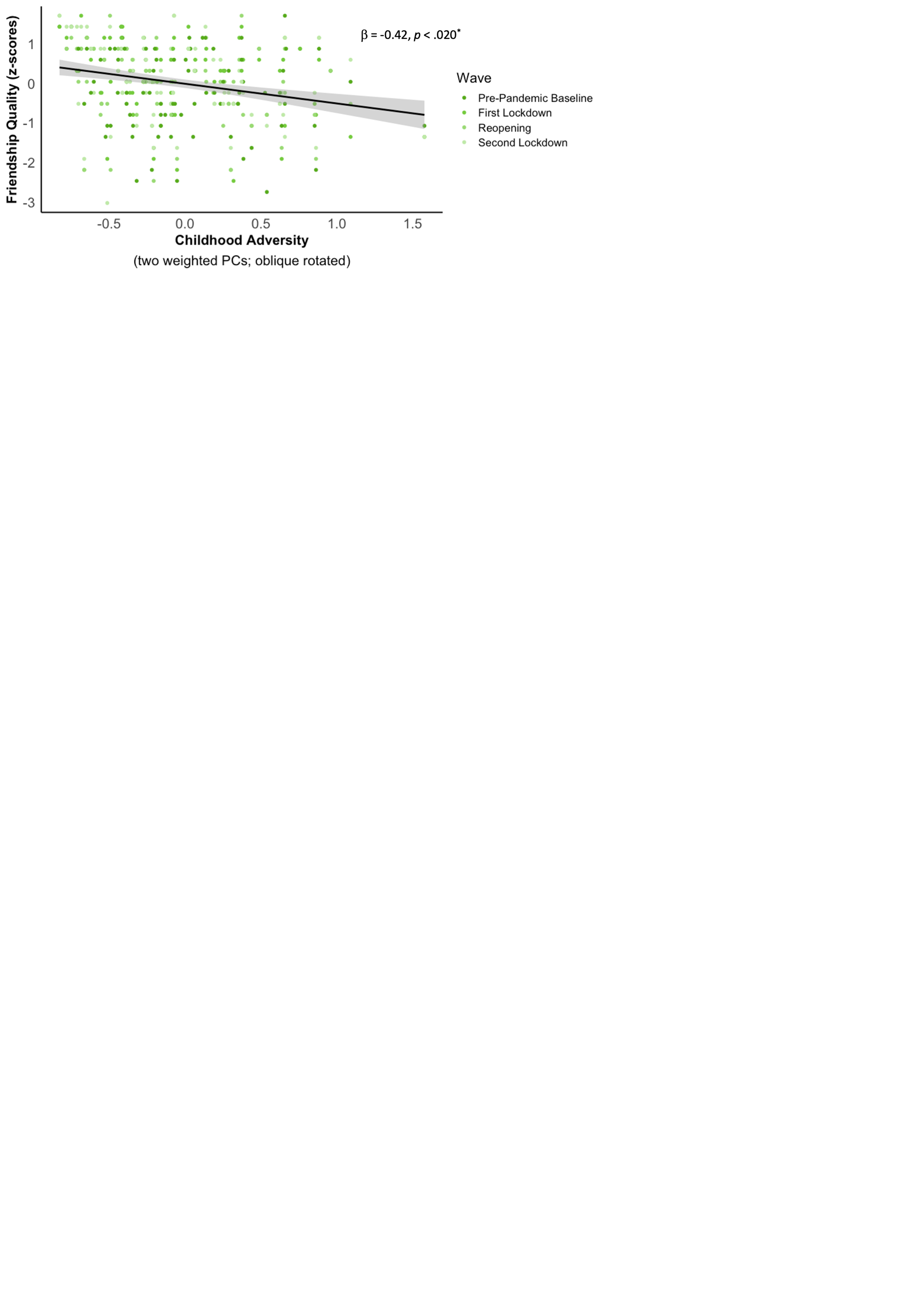
Note. Participants with more severe CA (x-axis) self-reported lower friendship quality (y-axis) across all assessment timepoints. Index scores of CA comprise two weighted and oblique rotated principal components (PCs). Both axes represent standardized scores. The shading of individual data points represents the four different assessment timepoints. The black line shows the best-fitting linear regression line after controlling for all assessment timepoints and the shaded region represents the 95% confidence interval. β = standardized coefficient; *p < .05.

Exploratory: Dimensional Effects of Childhood Adversity
Table S10
Model Fit Statistics for Linear Mixed-Effects Models Predicting Perceived Friendship Quality
Model | AIC | BIC | χ² | df | p
A. Deprivation Dimension
1. Time | 740.62 | 763.32
2. Time + Deprivation | 738.41 | 764.90 | 4.20 | 1 | .040
3. Time + Deprivation + Time:Deprivation | 742.86 | 780.70 | 1.55 | 3 | .671
4. Time + Deprivation + Time:Deprivation + Age + Gender | 741.59 | 786.99 | 5.28 | 2 | .071
B. Threat Dimension
1. Time | 740.62 | 763.32
2. Time + Threat | 739.15 | 765.64 | 3.46 | 1 | .063
3. Time + Threat + Time:Threat | 745.04 | 782.88 | 0.12 | 3 | .990
4. Time + Threat + Time:Threat + Age + Gender | 744.64 | 790.05 | 4.39 | 2 | .111
Note. The best fitting models are highlighted in bold. Random effects for participants have been included in all models. AIC = Akaike information criterion; BIC = Bayesian information criterion.

Table S11
Deprivation Dimension: Model Estimates for the Best Fitting Linear Mixed-Effects Model Predicting Perceived Friendship Quality
Fixed Effects | β | SE | 95% CI | t | p
Intercept | -0.11 | 0.10 | [-0.30, 0.08] | -1.11 | .267
Deprivation | -0.50 | 0.24 | [-0.97, -0.02] | -2.08 | .040
First lockdown | 0.21 | 0.09 | [0.04, 0.38] | 2.49 | .014
Reopening | 0.07 | 0.09 | [-0.10, 0.23] | 0.78 | .436
Second lockdown | 0.18 | 0.09 | [0.01, 0.35] | 2.07 | .040
 | Marginal R² = .043; Conditional R² = .708
Note. A linear mixed-effects model predicting perceived friendship quality as the outcome. Deprivation experiences and assessment timepoint (dummy-coded: first lockdown, reopening, second lockdown, with pre-pandemic baseline as the reference group) have been added as independent variables. A random effect for participants has also been included in the model. β = standardized coefficient; 95% CI = 95% confidence interval. Bold denotes significant effects.

Table S12
Model Fit Statistics for Linear Mixed-Effects Models Predicting Depression Symptoms
Model | AIC | BIC | χ² | df | p
A. Deprivation Dimension
1. Time | 636.43 | 658.93
2. Time + Deprivation | 636.61 | 662.85 | 1.82 | 1 | .177
3. Time + Deprivation + Time:Deprivation | 640.36 | 677.86 | 2.25 | 3 | .523
4. Time + Deprivation + Time:Deprivation + Age + Gender | 643.45 | 688.44 | 0.91 | 2 | .634
B. Threat Dimension
1. Time | 636.43 | 658.93
2. Time + Threat | 633.90 | 660.15 | 4.53 | 1 | .033
3. Time + Threat + Time:Threat | 633.44 | 670.94 | 6.46 | 3 | .091
4. Time + Threat + Time:Threat + Age + Gender | 636.61 | 681.60 | 0.83 | 2 | .660
Note. The best fitting models are highlighted in bold. Random effects for participants have been included in all models. AIC = Akaike information criterion; BIC = Bayesian information criterion.

Table S13
Threat Dimension: Model Estimates for the Best Fitting Linear Mixed-Effects Model Predicting Depression Symptoms
Fixed Effects | β | SE | 95% CI | t | p
Intercept | -0.28 | 0.08 | [-0.45, -0.12] | -3.45 | < .001
Threat | 0.76 | 0.35 | [0.06, 1.46] | 2.15 | .034
First lockdown | 0.30 | 0.08 | [0.14, 0.45] | 3.77 | < .001
Reopening | 0.33 | 0.08 | [0.17, 0.49] | 4.16 | < .001
Second lockdown | 0.18 | 0.08 | [0.02, 0.34] | 2.27 | .024
 | Marginal R² = .006; Conditional R² = .651
Note. A linear mixed-effects model predicting depression symptoms as the outcome. Threat experiences and assessment timepoint (dummy-coded: first lockdown, reopening, second lockdown, with pre-pandemic baseline as the reference group) have been added as independent variables. A random effect for participants has also been included in the model. β = standardized coefficient; 95% CI = 95% confidence interval. Bold denotes significant effects.

Table S14
Model Fit Statistics for Linear Mixed-Effects Models Predicting Anxiety Symptoms
Model | AIC | BIC | χ² | df | p
A. Deprivation Dimension
1. Time | 692.16 | 714.62
2. Time + Deprivation | 693.52 | 719.72 | 0.64 | 1 | .423
3. Time + Deprivation + Time:Deprivation | 694.33 | 731.76 | 5.19 | 3 | .159
4. Time + Deprivation + Time:Deprivation + Age + Gender | 696.59 | 741.51 | 1.74 | 2 | .419
B. Threat Dimension
1. Time | 692.16 | 714.62
2. Time + Threat | 690.20 | 716.40 | 3.96 | 1 | .047
3. Time + Threat + Time:Threat | 689.23 | 726.66 | 6.98 | 3 | .073
4. Time + Threat + Time:Threat + Age + Gender | 691.66 | 736.57 | 1.57 | 2 | .457
Note. The best fitting models are highlighted in bold. Random effects for participants have been included in all models. AIC = Akaike information criterion; BIC = Bayesian information criterion.

Table S15
Threat Dimension: Model Estimates for the Best Fitting Linear Mixed-Effects Model Predicting Anxiety Symptoms
Fixed Effects | β | SE | 95% CI | t | p
Intercept | -0.12 | 0.09 | [-0.31, 0.07] | -1.27 | .205
Threat | 0.84 | 0.42 | [0.01, 1.67] | 2.01 | .048
First lockdown | 0.20 | 0.08 | [0.04, 0.37] | 2.40 | .017
Reopening | 0.15 | 0.09 | [-0.02, 0.32] | 1.71 | .090
Second lockdown | 0.12 | 0.09 | [-0.05, 0.29] | 1.34 | .183
 | Marginal R² = .039; Conditional R² = .697
Note. A linear mixed-effects model predicting anxiety symptoms as the outcome. Threat experiences and assessment timepoint (dummy-coded: first lockdown, reopening, second lockdown, with pre-pandemic baseline as the reference group) have been added as independent variables. A random effect for participants has also been included in the model. β = standardized coefficient; 95% CI = 95% confidence interval. Bold denotes significant effects.

F. Friendship Effects on Mental Health Symptoms Before and During the COVID-19 Pandemic
Table S16
Model Fit Statistics for Linear Mixed-Effects Models Predicting (A) Depression and (B) Anxiety Symptoms
Model | AIC | BIC | χ² | df | p
A. Depression Symptoms
1. Time | 634.00 | 656.46
2. Time + Friendship quality | 592.08 | 618.29 | 43.92 | 1 | < .001
3. Time + Friendship quality + Time:Friendship quality | 589.09 | 626.52 | 9.00 | 3 | .029
4. Time + Friendship quality + Time:Friendship quality  + Age + Gender | 593.08 | 638.00 | 0.000 | 2 | .999
A. Anxiety Symptoms
1. Time | 690.16 | 712.58
2. Time + Friendship quality | 640.07 | 666.23 | 52.09 | 1 | < .001
3. Time + Friendship quality + Time:Friendship quality | 644.15 | 681.51 | 1.93 | 3 | .588
4. Time + Friendship quality + Time:Friendship quality  + Age + Gender | 645.22 | 690.06 | 2.93 | 2 | .231
Note. The best fitting models are highlighted in bold. Random effects for participants have been included in all models. AIC = Akaike information criterion; BIC = Bayesian information criterion.

Table S17
Model Estimates for the Best Fitting Linear Mixed-Effects Model Predicting Depression Symptoms
Fixed Effects | β | SE | 95% CI | t | p
Intercept | -0.31 | 0.07 | [-0.46, -0.16] | -4.11 | < .001
Friendship quality | -0.35 | 0.06 | [-0.48, -0.22] | -5.41 | < .001
First lockdown | 0.34 | 0.07 | [0.19, 0.48] | 4.51 | < .001
Reopening | 0.34 | 0.07 | [0.19, 0.49] | 4.55 | < .001
Second lockdown | 0.23 | 0.07 | [0.08, 0.38] | 2.99 | .003
First lockdown:Friendship quality | 0.11 | 0.08 | [-0.04, 0.26] | 1.44 | .152
Reopening:Friendship quality | -0.10 | 0.08 | [-0.26, 0.06] | -1.27 | .207
Second lockdown:Friendship quality | 0.09 | 0.08 | [-0.06, 0.25] | 1.18 | .238
 | Marginal R² = .189; Conditional R² = .681
Note. A linear mixed-effects model predicting depression symptomatology as the outcome. Perceived friendship quality and assessment timepoint (dummy-coded: first lockdown, reopening, second lockdown, with pre-pandemic baseline as the reference group) have been added as independent variables. A random effect for participants has also been included in the model. β = standardized coefficient; 95% CI = 95% confidence interval. Bold denotes significant effects.

Figure S2
Friendship Effects on Depression Symptoms Across All Assessment Timepoints
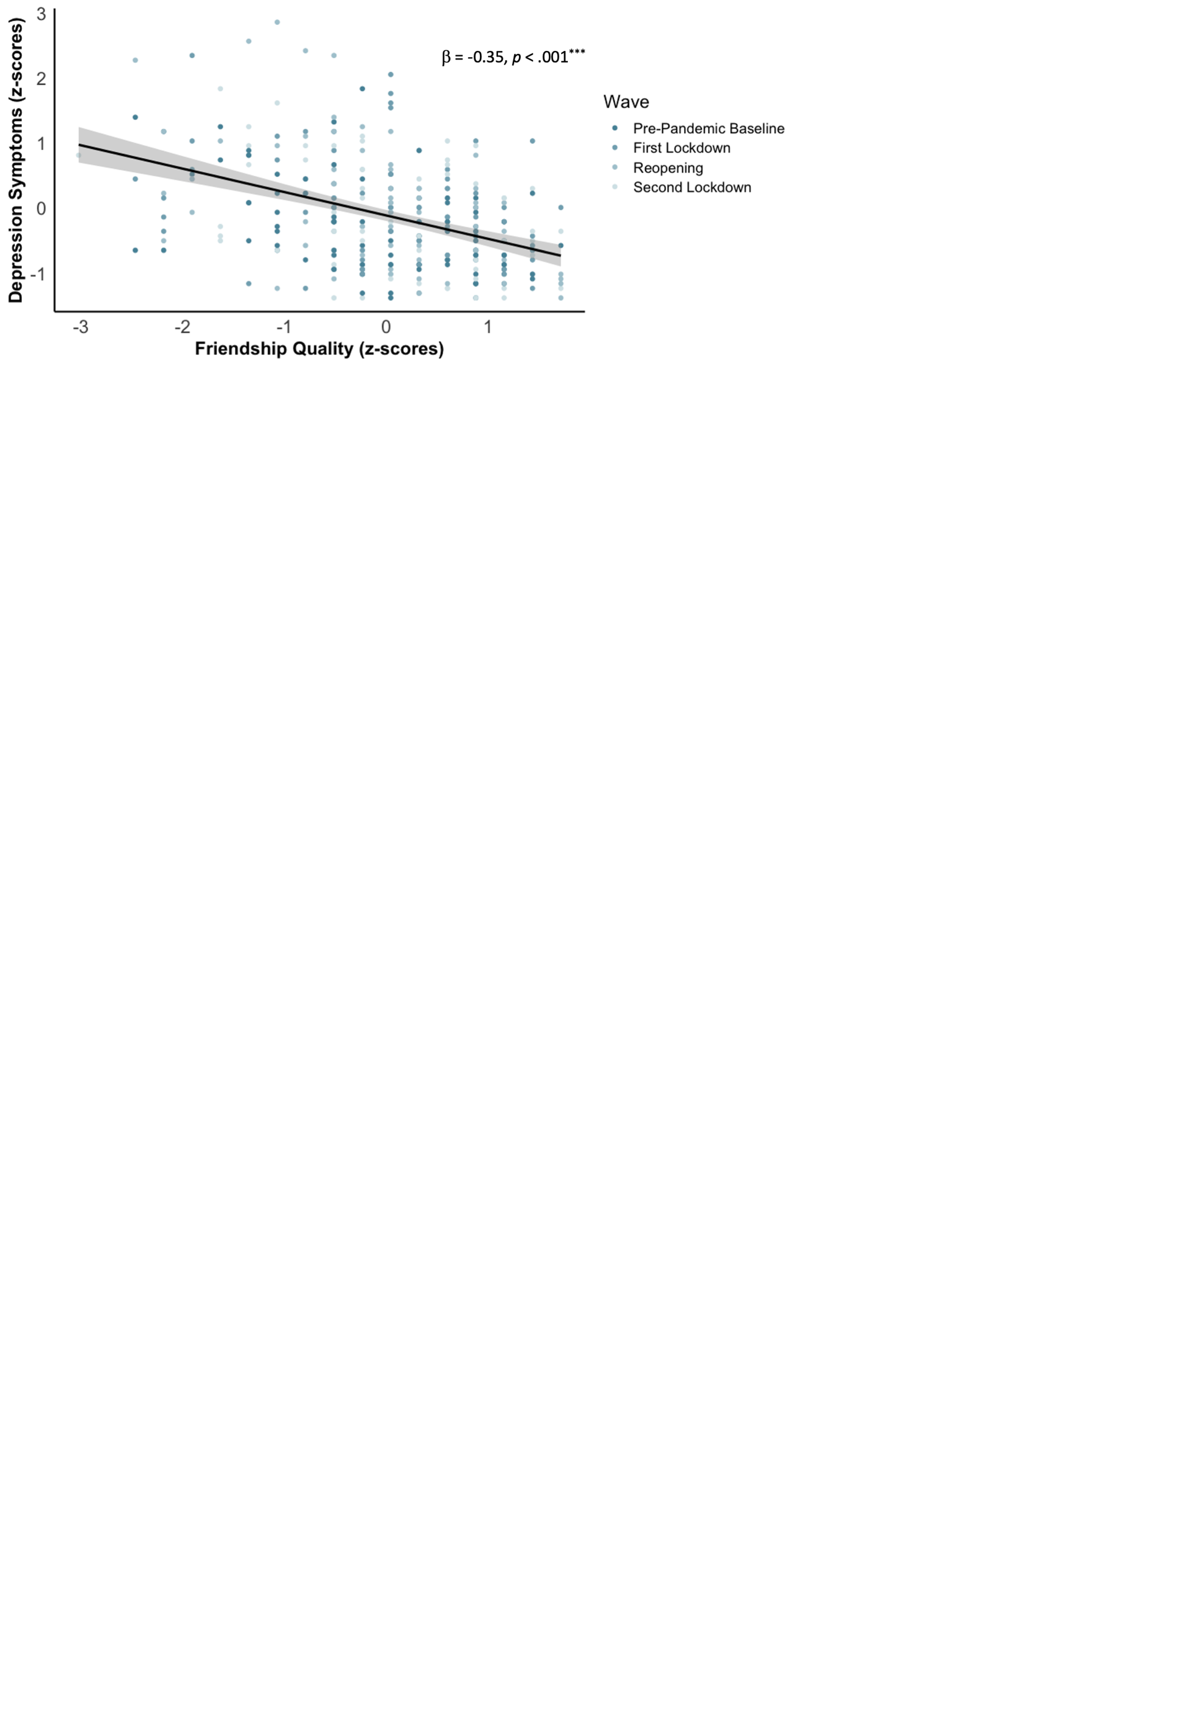
Note. Participants with higher friendship quality (x-axis) reported lower depression symptoms (y-axis) across all assessment timepoints. Both axes represent standardized scores. The shading of individual data points represents the four different assessment timepoints. The black line shows the best-fitting linear regression line after controlling for all assessment timepoints and the shaded region represents the 95% confidence interval. β = standardized coefficient; ***p < .001.

Table S18
Model Estimates for the Best Fitting Linear Mixed-Effects Model Predicting Anxiety Symptoms
Fixed Effects | β | SE | 95% CI | t | p
Intercept | -0.17 | 0.09 | [-0.34, -0.01] | -2.04 | .043
Friendship quality | -0.38 | 0.05 | [-0.48, -0.28] | -7.59 | < .001
First lockdown | 0.29 | 0.08 | [0.13, 0.44] | 3.56 | < .001
Reopening | 0.18 | 0.08 | [0.02, 0.34] | 2.26 | .025
Second lockdown | 0.18 | 0.08 | [0.02, 0.35] | 2.21 | .028
 | Marginal R² = .178; Conditional R² = .714
Note. A linear mixed-effects model predicting anxiety symptomatology as the outcome. Friendship quality and assessment timepoint (dummy-coded: first lockdown, reopening, second lockdown, with pre-pandemic baseline as the reference group) have been added as independent variables. A random effect for participants has also been included in the model. β = standardized coefficient; 95% CI = 95% confidence interval. Bold denotes significant effects.

Figure S3
Friendship Effects on Anxiety Symptoms Before and During the COVID-19 Pandemic
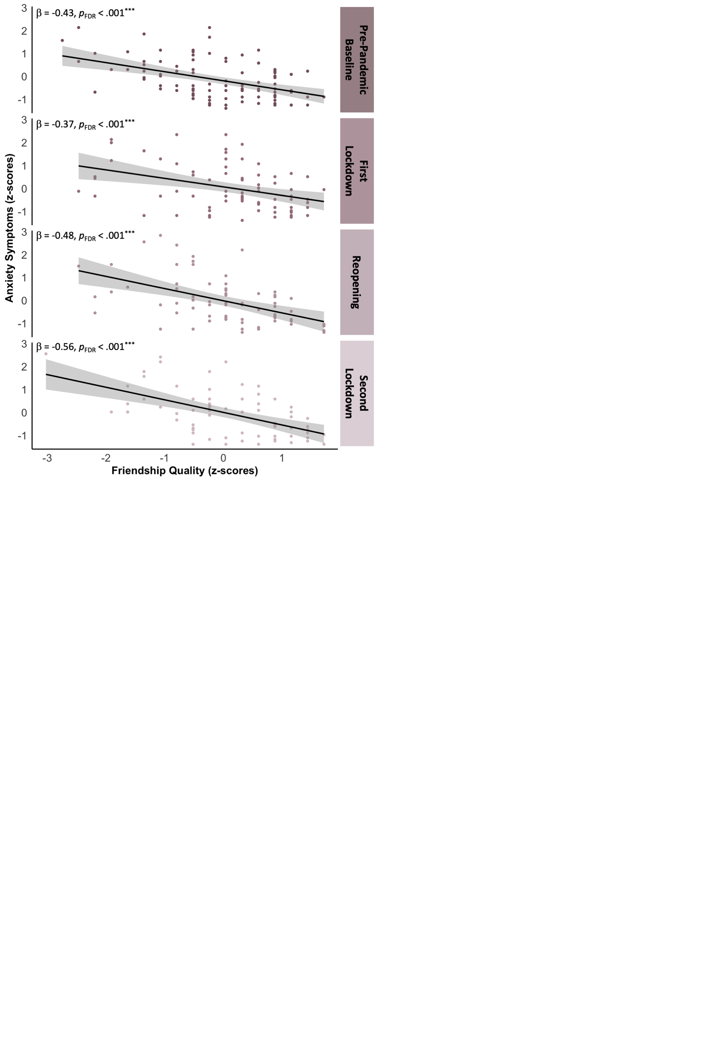
Note. Participants with greater perceived friendship quality (x-axis) self-reported lower levels of anxiety symptoms (y-axis) across all assessment timepoints (ps_{FDR} < .001). Both axes represent standardized score. The black lines show the best-fitting linear regression lines and the shaded regions around them represent the 95% confidence intervals. β = standardized coefficient; ***p_{FDR} < .001.

Figure S4
Friendship Effects on Anxiety Symptoms Across All Assessment Timepoints
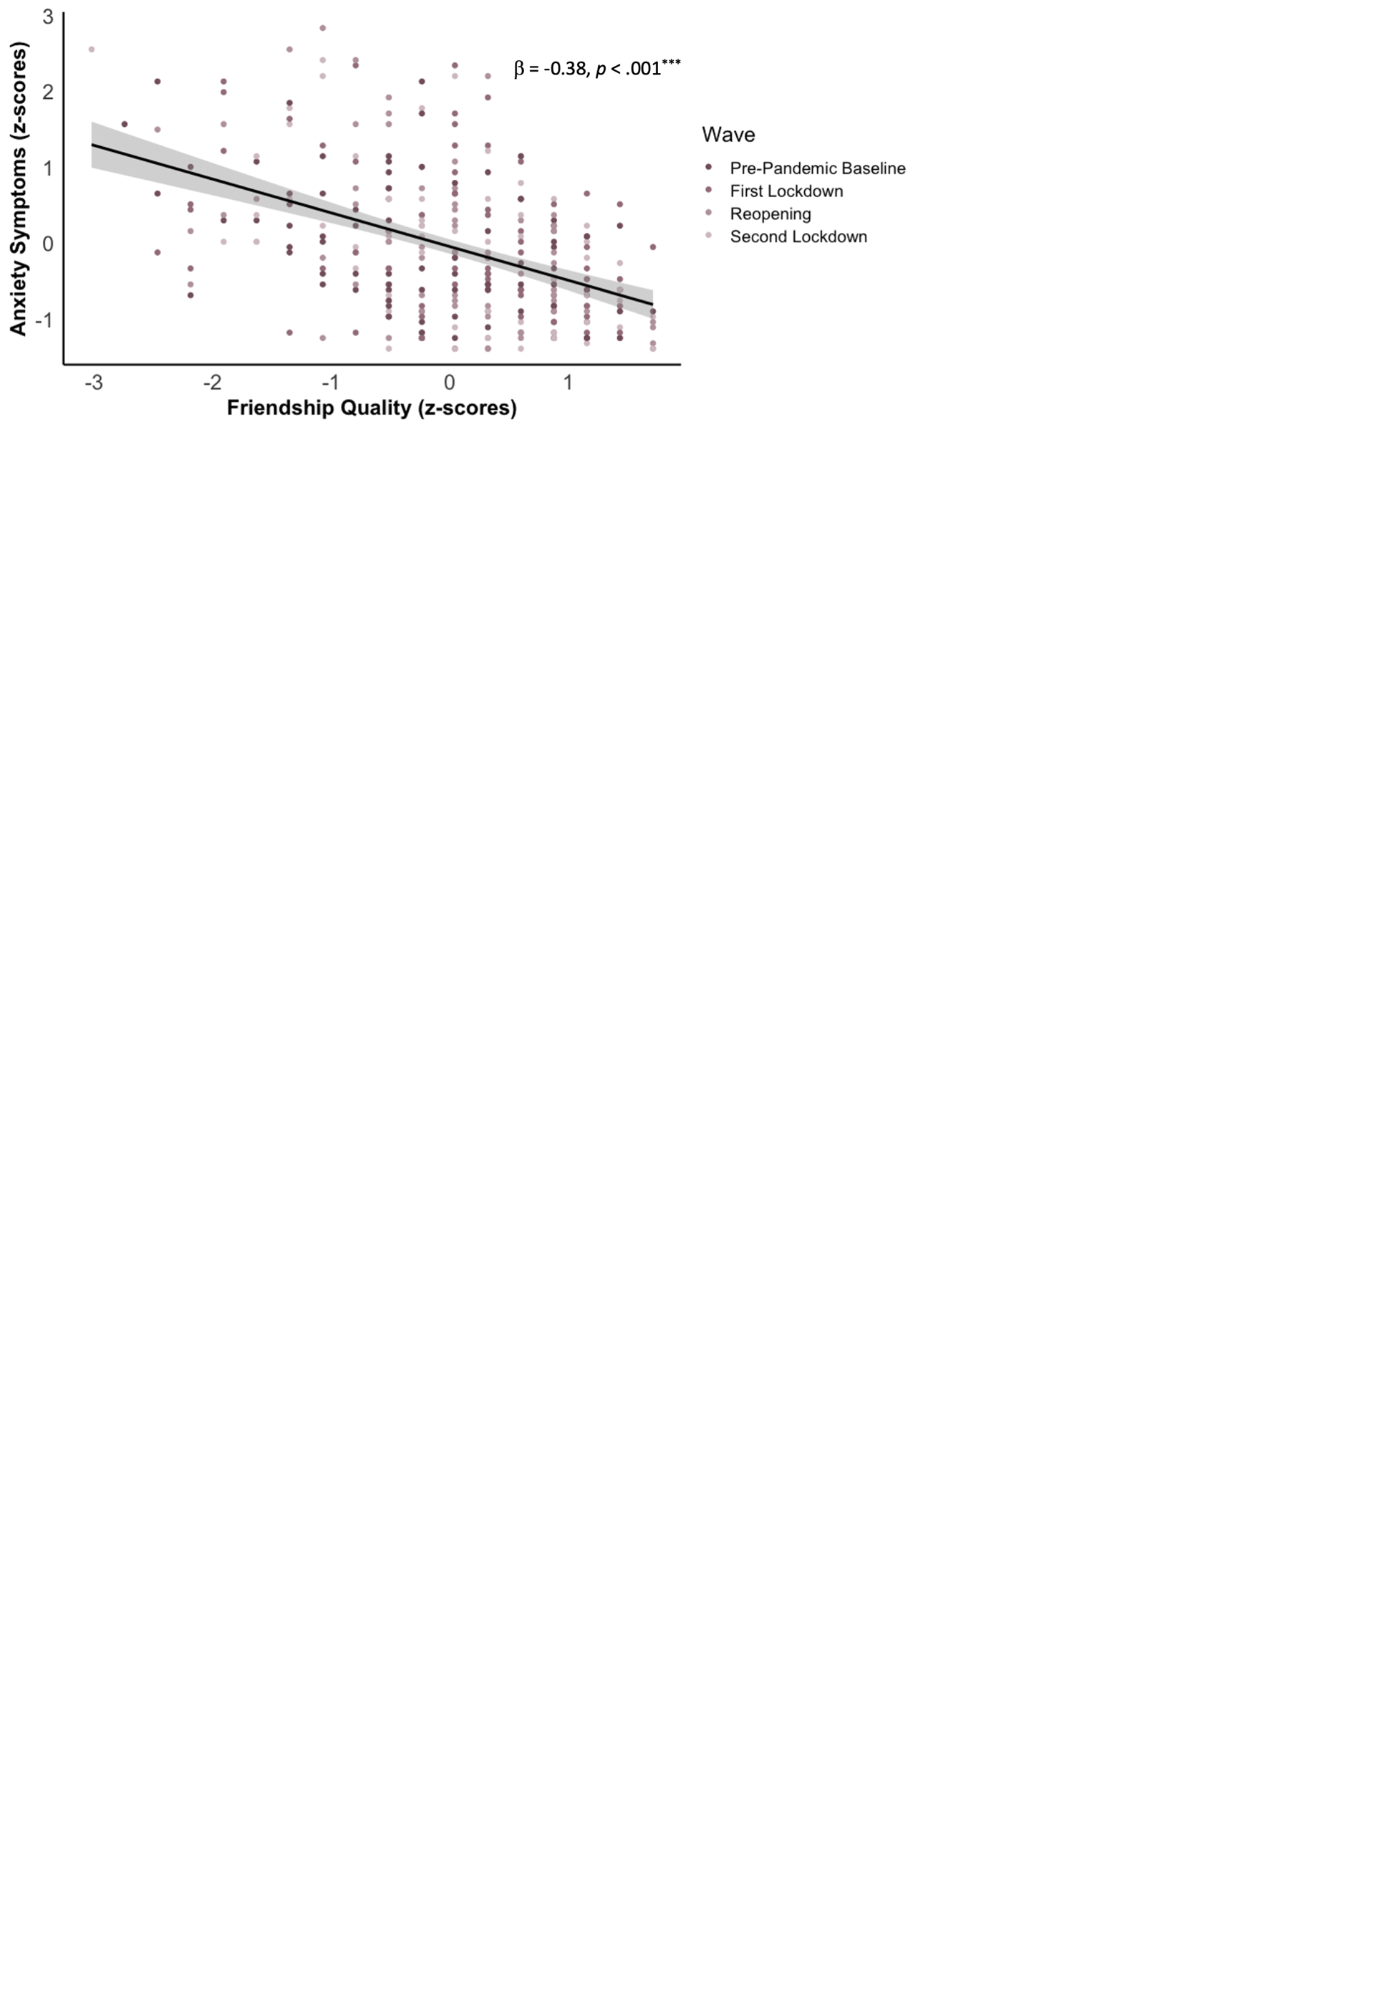
Note. Participants with higher friendship quality (x-axis) reported lower anxiety symptoms (y-axis) across all assessment timepoints. Both axes represent standardized scores. The shading of individual data points represents the four different assessment timepoints. The black line shows the best-fitting linear regression line after controlling for all assessment timepoints and the shaded region represents the 95% confidence interval. β = standardized coefficient; ***p < .001.

G. Exploring the Interplay Between Perceived Friendship Quality and Mental Health Symptoms From Before to During the COVID-19 Pandemic
Bivariate latent change score modeling was utilized to explore the interrelationship between perceived friendship quality and mental health symptomatology from before to during the COVID-19 pandemic (see Figure G1 below). Specifically, five parameters of interest were investigated in each model. First, did perceived friendship quality reported at (A) pre-pandemic baseline, (B) first lockdown, or (C) reopening predict the degree of change in friendship quality (autoregressive parameter) and/or mental health symptoms (coupling parameter). Second, did mental health symptoms at (A) pre-pandemic baseline, (B) first lockdown, or (C) reopening predict the degree of change in mental health symptoms (autoregressive parameter) and/or friendship quality (coupling parameter)? Third, did changes in friendship quality and mental health symptoms co-occur across individuals (correlated change)?

Figure S5
Example of a Bivariate Latent Change Score Model Assessing the Interplay between Perceived Friendship Quality and Depression Symptoms From Pre-Pandemic Baseline to First Lockdown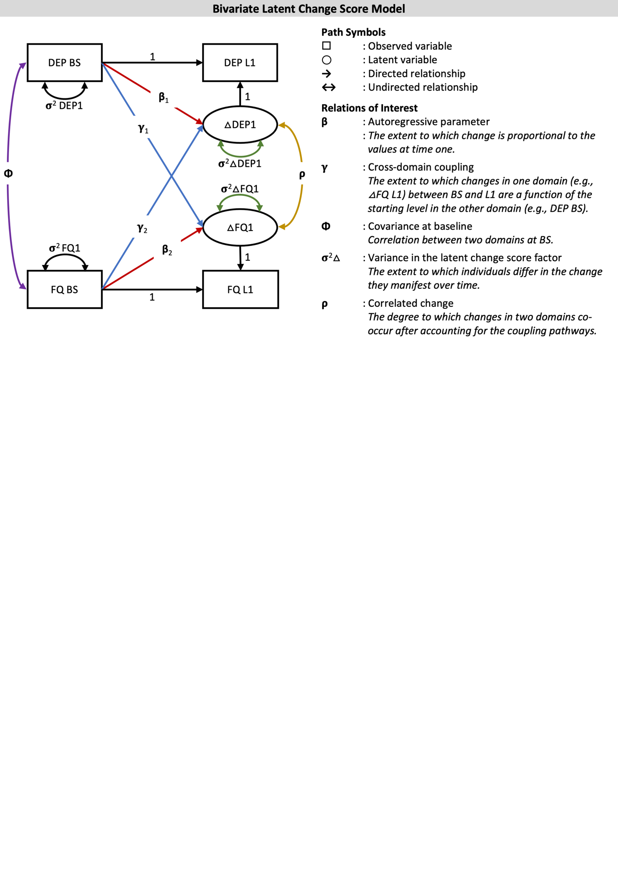
Note. Means are omitted for visual clarity. This visualization and annotation is based on (Kievit et al., 2018). DEP = depression symptom domain, FQ = perceived friendship quality domain, BS = pre-pandemic baseline, L1 = first lockdown.

Table S19
Model Fit Statistics for Bivariate Latent Change Score Models
Domain | χ²₍₆₎ | p | RMSEA | CFI
1. Pre-Pandemic Baseline to First Lockdown
A. Depression symptoms | 114.29 | < .001 | < .001 | 1.00
B. Anxiety symptoms | 121.20 | < .001 | < .001 | 1.00
2. First Lockdown to Reopening
A. Depression symptoms | 144.96 | < .001 | < .001 | 1.00
B. Anxiety symptoms | 138.56 | < .001 | < .001 | 1.00
3. Reopening to Second Lockdown
A. Depression symptoms | 144.96 | < .001 | < .001 | 1.00
B. Anxiety symptoms | 138.56 | < .001 | < .001 | 1.00
Note. Models exploring interrelationships between changes in perceived friendship quality and (A) depression and (B) anxiety symptoms from (1) pre-pandemic baseline to first lockdown, (2) first lockdown to reopening, and (3) reopening to second lockdown. RMSEA = root mean square error of approximation; CFI = comparative fit index.

Table S20
Bivariate Latent Change Score Model Output Assessing the Interplay between Perceived Friendship Quality and (A) Depression and (B) Anxiety Symptoms From Pre-Pandemic Baseline to First Lockdown
Domain |  | Est | SE | z | p
A. Depression Symptoms
1. | DEP_{BS}→ΔDEP₁ (β₁) | -0.22 | 0.13 | -1.64 | .101
2. | DEP_{BS}→ΔFQ₁ (γ₁) | 0.01 | 0.12 | 0.11 | .916
3. | FQ_{BS}→ΔFQ₁ (β₂) | -0.25 | 0.09 | -2.86 | .004
4. | FQ_{BS}→ΔDEP₁ (γ₂) | 0.06 | 0.10 | 0.66 | .512
5. | DEP_{BS}↔FQ_{BS} (φ) | -0.33 | 0.08 | -4.15 | < .001
6. | ΔDEP₁↔ΔFQ₁ (ρ) | -0.15 | 0.06 | -2.72 | .007
7. | σ²DEP₁ | 0.55 | 0.08 | 6.55 | < .001
8. | σ²FQ₁ | 0.93 | 0.12 | 7.79 | < .001
9. | σ²ΔDEP₁ | 0.52 | 0.09 | 6.09 | < .001
10. | σ²ΔFQ₁ | 0.50 | 0.10 | 5.11 | < .001
B. Anxiety Symptoms
1. | ANX_{BS}→ΔANX₁ (β₁) | -0.33 | 0.10 | -3.13 | .002
2. | ANX_{BS}→ΔFQ₁ (γ₁) | 0.01 | 0.10 | 0.11 | .913
3. | FQ_{BS}→ΔFQ₁ (β₂) | -0.29 | 0.09 | -3.29 | .001
4. | FQ_{BS}→ΔANX₁ (γ₂) | -0.04 | 0.11 | -0.35 | .730
5. | ANX_{BS}↔FQ_{BS} (φ) | -0.43 | 0.10 | -4.24 | < .001
6. | ΔANX₁↔ΔFQ₁ (ρ) | -0.11 | 0.05 | -2.19 | .028
7. | σ²ANX₁ | 0.85 | 0.12 | 7.37 | < .001
8. | σ²FQ₁ | 1.00 | 0.13 | 7.66 | < .001
9. | σ²ΔANX₁ | 0.51 | 0.11 | 4.88 | < .001
10. | σ²ΔFQ₁ | 0.50 | 0.10 | 5.13 | < .001
Note. Est = standardized parameter estimates. FQ = perceived friendship quality domain, DEP = depression symptom domain, ANX = anxiety symptom domain, BS = pre-pandemic baseline. β = autoregressive parameter, γ = cross-domain coupling, φ = covariance at pre-pandemic baseline, ρ = correlated change, σ²Δ = variance in the latent change score, → = directed relationship, ↔ = undirected relationship. Bold denotes significant effects.

Table S21
Bivariate Latent Change Score Model Output Assessing the Interplay between Perceived Friendship Quality and (A) Depression and (B) Anxiety Symptoms From First Lockdown to Reopening
Domain |  | Est | SE | z | p
A. Depression Symptoms
1. | DEP_{L1}→ΔDEP₁ (β₁) | -0.33 | 0.09 | -3.57 | < .001
2. | DEP_{L1}→ΔFQ₁ (γ₁) | -0.17 | 0.08 | -2.08 | .037
3. | FQ_{L1}→ΔFQ₁ (β₂) | -0.31 | 0.10 | -3.08 | .002
4. | FQ_{L1}→ΔDEP₁ (γ₂) | -0.16 | 0.07 | -2.30 | .022
5. | DEP_{L1}↔FQ_{L1} (φ) | -0.31 | 0.10 | -2.99 | .003
6. | ΔDEP₁↔ΔFQ₁ (ρ) | -0.13 | 0.04 | -2.99 | .003
7. | σ²DEP₁ | 0.81 | 0.13 | 6.11 | < .001
8. | σ²FQ₁ | 1.00 | 0.17 | 5.88 | < .001
9. | σ²ΔDEP₁ | 0.32 | 0.11 | 2.92 | .003
10. | σ²ΔFQ₁ | 0.44 | 0.09 | 4.84 | < .001
B. Anxiety Symptoms
1. | ANX_{L1}→ΔANX₁ (β₁) | -0.32 | 0.10 | -3.24 | .001
2. | ANX_{L1}→ΔFQ₁ (γ₁) | -0.13 | 0.08 | -1.54 | .123
3. | FQ_{L1}→ΔFQ₁ (β₂) | -0.30 | 0.10 | -2.92 | .003
4. | FQ_{L1}→ΔANX₁ (γ₂) | -0.08 | 0.08 | -0.92 | .360
5. | ANX_{L1}↔FQ_{L1} (φ) | -0.36 | 0.11 | -3.39 | .001
6. | ΔANX₁↔ΔFQ₁ (ρ) | -0.17 | 0.06 | -2.89 | .004
7. | σ²ANX₁ | 0.90 | 0.13 | 6.99 | < .001
8. | σ²FQ₁ | 0.99 | 0.17 | 4.97 | < .001
9. | σ²ΔANX₁ | 0.42 | 0.13 | 3.23 | .001
10. | σ²ΔFQ₁ | 0.43 | 0.09 | 4.97 | < .001
Note. Est = standardized parameter estimates. FQ = perceived friendship quality domain, DEP = depression symptom domain, ANX = anxiety symptom domain, L1 = first lockdown. β = autoregressive parameter, γ = cross-domain coupling, φ = covariance at first lockdown, ρ = correlated change, σ²Δ = variance in the latent change score, → = directed relationship, ↔ = undirected relationship. Bold denotes significant effects.

Table S22
Bivariate Latent Change Score Model Output Assessing the Interplay between Perceived Friendship Quality and (A) Depression and (B) Anxiety Symptoms From Reopening to Second Lockdown
Domain |  | Est | SE | z | p
A. Depression Symptoms
1. | DEP_{RO}→ΔDEP₂ (β₁) | -0.38 | 0.13 | -2.97 | .003
2. | DEP_{RO}→ΔFQ₂ (γ₁) | 0.03 | 0.10 | 0.30 | .764
3. | FQ_{RO}→ΔFQ₂ (β₂) | -0.25 | 0.06 | -3.87 | < .001
4. | FQ_{RO}→ΔDEP₂ (γ₂) | -0.03 | 0.07 | -0.41 | .682
5. | DEP_{RO}↔FQ_{RO} (φ) | -0.48 | 0.11 | -4.31 | < .001
6. | ΔDEP₂↔ΔFQ₂ (ρ) | -0.08 | 0.06 | -1.48 | .140
7. | σ²DEP₂ | 0.78 | 0.15 | 5.39 | < .001
8. | σ²FQ₂ | 1.02 | 0.17 | 6.16 | < .001
9. | σ²ΔDEP₂ | 0.31 | 0.08 | 3.93 | < .001
10. | σ²ΔFQ₂ | 0.41 | 0.11 | 3.68 | < .001
B. Anxiety Symptoms
1. | ANX_{RO}→ΔANX₂ (β₁) | -0.27 | 0.14 | -1.89 | .059
2. | ANX_{RO}→ΔFQ₂ (γ₁) | -0.06 | 0.12 | -0.47 | .642
3. | FQ_{RO}→ΔFQ₂ (β₂) | -0.29 | 0.07 | -4.09 | < .001
4. | FQ_{RO}→ΔANX₂ (γ₂) | -0.02 | 0.07 | -0.29 | .770
5. | ANX_{RO}↔FQ_{RO} (φ) | -0.51 | 0.12 | -4.35 | < .001
6. | ΔANX₂↔ΔFQ₂ (ρ) | -0.20 | 0.09 | -2.35 | .019
7. | σ²ANX₂ | 0.93 | 0.17 | 5.50 | < .001
8. | σ²FQ₂ | 1.00 | 0.16 | 6.22 | < .001
9. | σ²ΔANX₂ | 0.43 | 0.13 | 3.39 | .001
10. | σ²ΔFQ₂ | 0.40 | 0.10 | 3.94 | < .001
Note. Est = standardized parameter estimates. FQ = perceived friendship quality domain, DEP = depression symptom domain, ANX = anxiety symptom domain, RO = reopening. β = autoregressive parameter, γ = cross-domain coupling, φ = covariance at reopening, ρ = correlated change, σ²Δ = variance in the latent change score, → = directed relationship, ↔ = undirected relationship. Bold denotes significant effects.

Figure S6
The Interplay between Perceived Friendship Quality and Anxiety Symptoms from Before to During the COVID-19 Pandemic
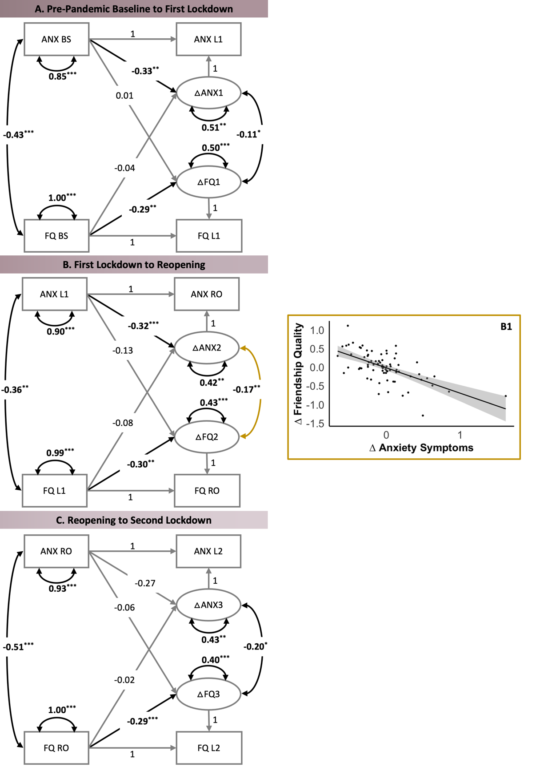
Note. Each path shows standardized parameter estimates. FQ = friendship quality domain, ANX = anxiety symptom domain, BS = pre-pandemic baseline, L1 = first lockdown, RO = reopening, L2 = second lockdown. Δ = latent change score, → = directed relationship, ↔ = undirected relationship. Path in black denote significant effects. B1 = Correlation between change in friendship quality and change in anxiety symptoms from the first lockdown to reopening. *p < .05, **p < .01, ***p < .001.

H. Exploring Perceived Stress as a Potential Mechanism Linking Perceived Friendship Quality with Mental Health Symptoms
Table S23
Model Fit Statistics for Linear Mixed-Effects Models Predicting Perceived Stress
Model | AIC | BIC | χ² | df | p
1. Time | 546.55 | 563.63
2. Time + Age + Gender | 541.80 | 565.71 | 8.75 | 2 | .013
Note. The best fitting model is highlighted in bold. Random effects for participants have been included in all models. AIC = Akaike information criterion; BIC = Bayesian information criterion.

Table S24
Model Estimates for the Best Fitting Linear Mixed-Effects Models Predicting Perceived Stress
Fixed Effects | β | SE | 95% CI | t | p
Intercept | -0.39 | 0.17 | [-0.74, -0.05] | -2.28 | .025
Reopening | -0.07 | 0.09 | [-0.25, 0.12] | -0.73 | .467
Second lockdown | -0.03 | 0.10 | [-0.23, 0.16] | -0.35 | .727
Age | -0.04 | 0.09 | [-0.22, 0.15] | -0.43 | .667
Gender | 0.61 | 0.20 | [0.21, 1.00] | 3.03 | .003
 | Marginal R² = .083; Conditional R² = .656
Note. One linear mixed-effects model predicting perceived stress as the outcome. Assessment timepoint (dummy-coded: reopening, second lockdown, with first lockdown as the reference group) has been added as an independent variable and age and gender identity have been added as covariates. Random effects for participants have also been included. β = standardized coefficient; 95% CI = 95% confidence interval. Bold denotes significant effects.

Figure S7
Perceived Stress During the COVID-19 Pandemic
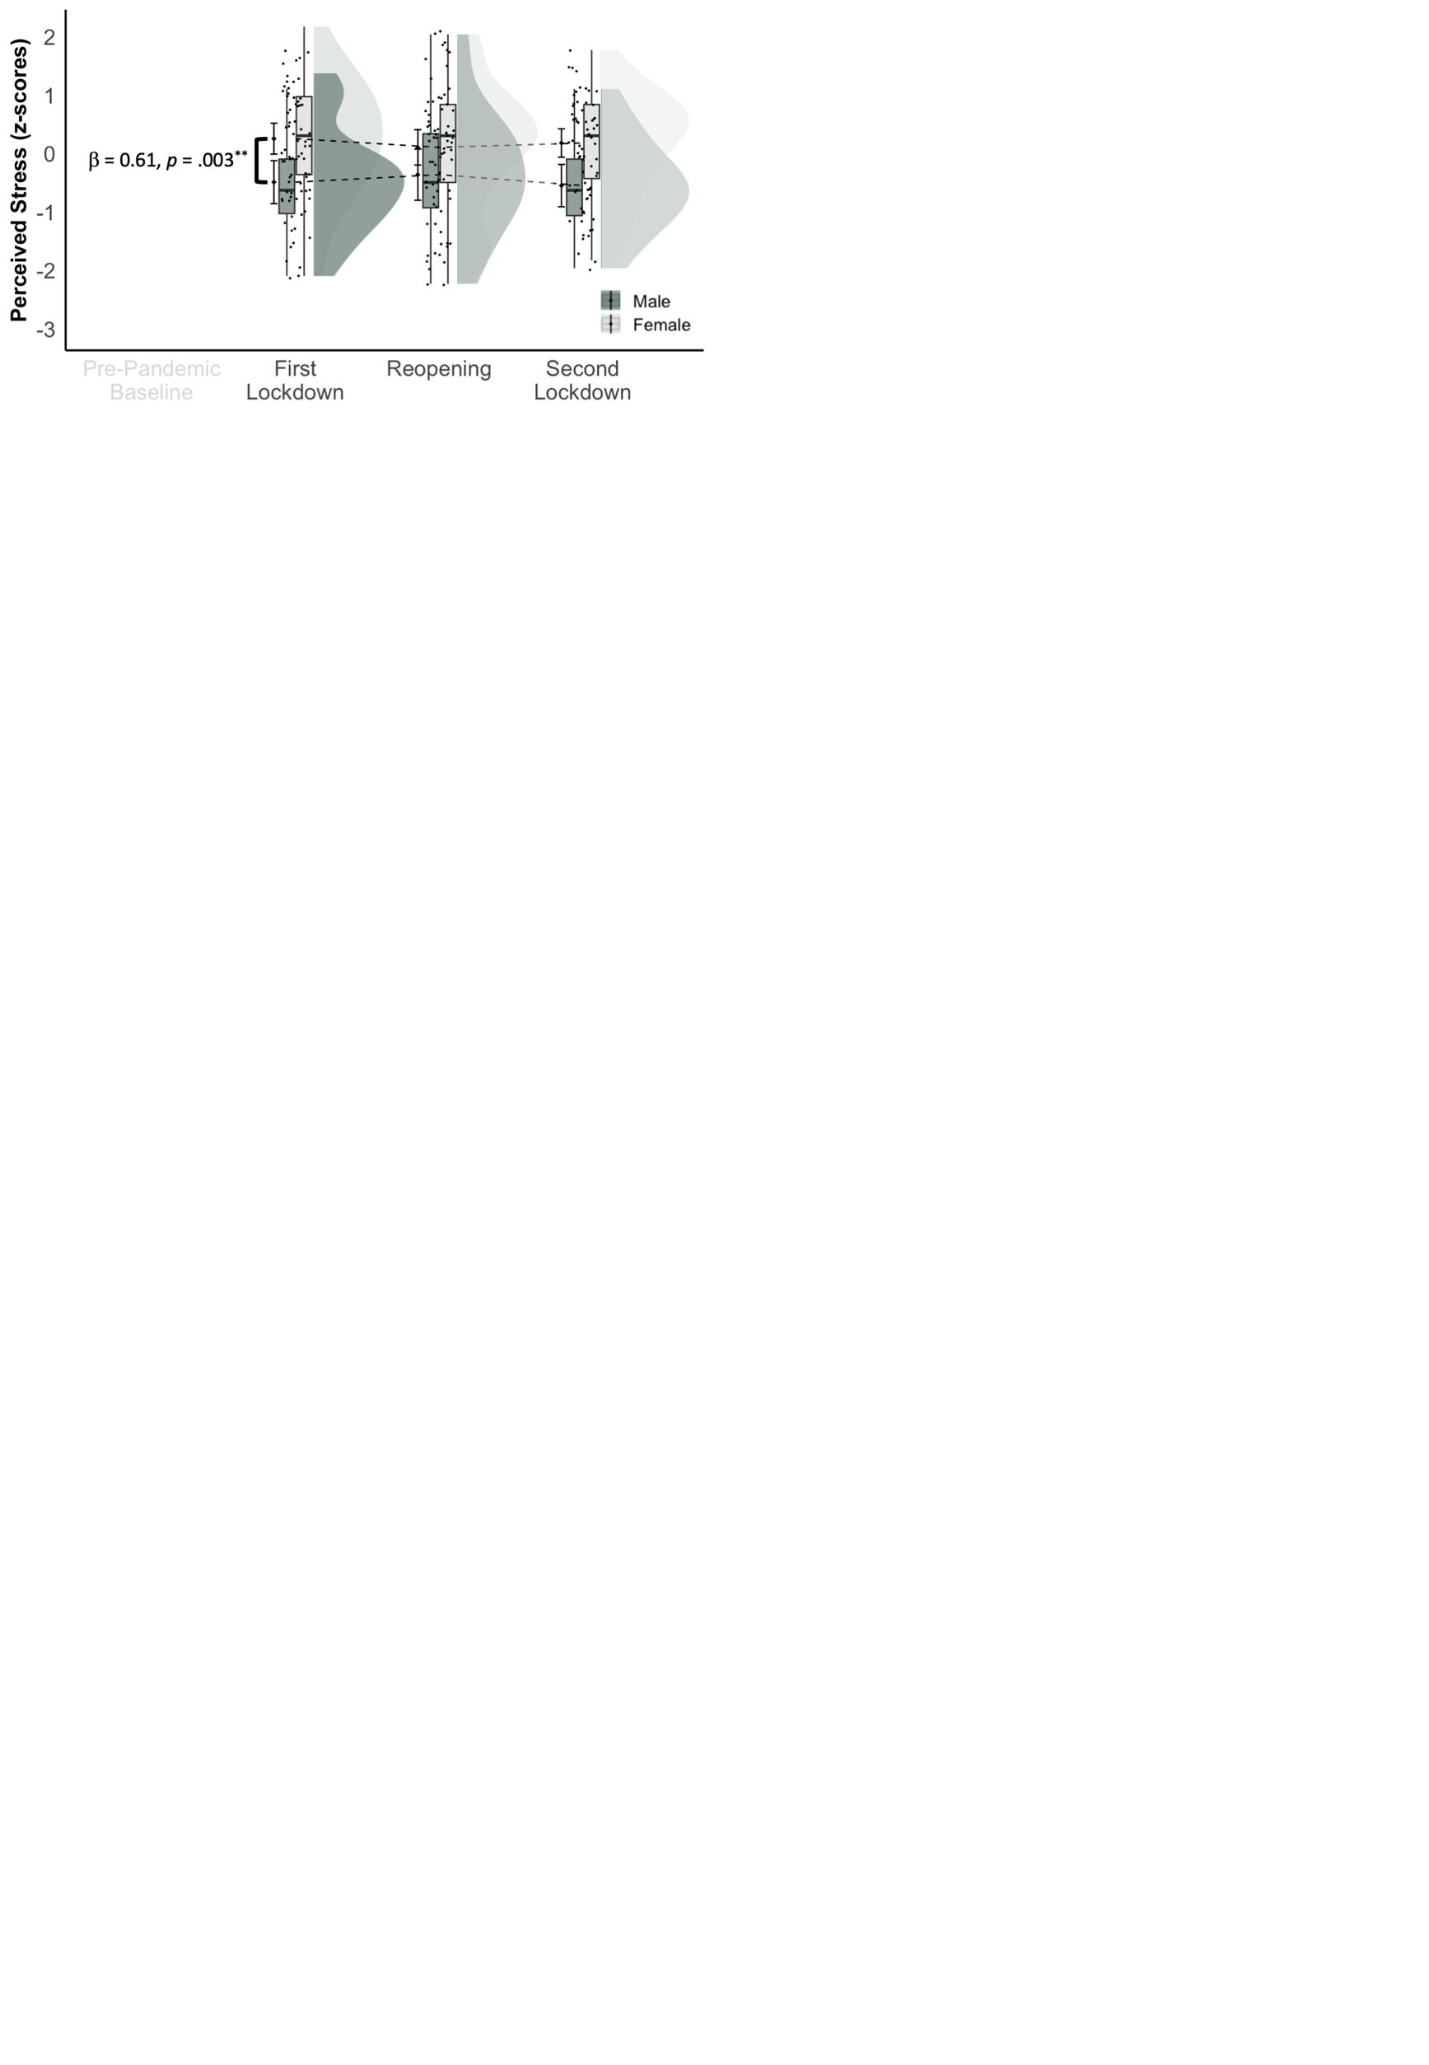
Note. Compared to the first lockdown, participants did not self-report changes in perceived stress. However, participants who identified as female reported significantly elevated levels of perceived stress across all assessment timepoints during the COVID-19 pandemic, compared to participants who identified as male (p = .003). This raincloud plot displays standardized perceived stress scores (y-axis) across all assessment timepoints during the COVID-19 pandemic (x-axis). To emphasize the main effect of time, we first plotted the mean and 95% confidence intervals for each assessment timepoint and connected these with a dashed line. Second, we added box plots showing the median (solid vertical line) and interquartile range. The black dots represent individual raw datapoints. Third, we added violin plots to visualize the probability distribution. **p < .01.

Table S25
Depression Symptoms: Parameter Estimates Mediation Model
 | β | SE | 95% CI | z | p
a path | -0.31 | 0.10 | [-0.50, -0.10] | -2.97 | .003
b path | 0.42 | 0.09 | [0.25, 0.59] | 4.87 | < .001
direct effect (c’) | -0.14 | 0.10 | [-0.34, 0.06] | -1.37 | .172
indirect effect (ab) | -0.13 | 0.05 | [-0.25, -0.05] | -2.57 | .010
Note. β = standardized coefficient; 95% CI = 95% bootstrapped confidence interval. Bold denotes significant effects.

Table S26
Anxiety Symptoms: Parameter Estimates Mediation Model
 | β | SE | 95% CI | z | p
a path | -0.36 | 0.10 | [-0.55, -0.14] | -3.43 | < .001
b path | 0.51 | 0.08 | [0.34, 0.67] | 6.15 | < .001
direct effect (c’) | -0.14 | 0.09 | [-0.31, 0.05] | -1.54 | .123
indirect effect (ab) | -0.18 | 0.06 | [-0.32, -0.08] | -2.99 | .003
Note. β = standardized coefficient; 95% CI = 95% bootstrapped confidence interval. Bold denotes significant effects.

Figure S8
Perceived Stress Mediates the Relationship between Perceived Friendship Quality and Anxiety Symptoms
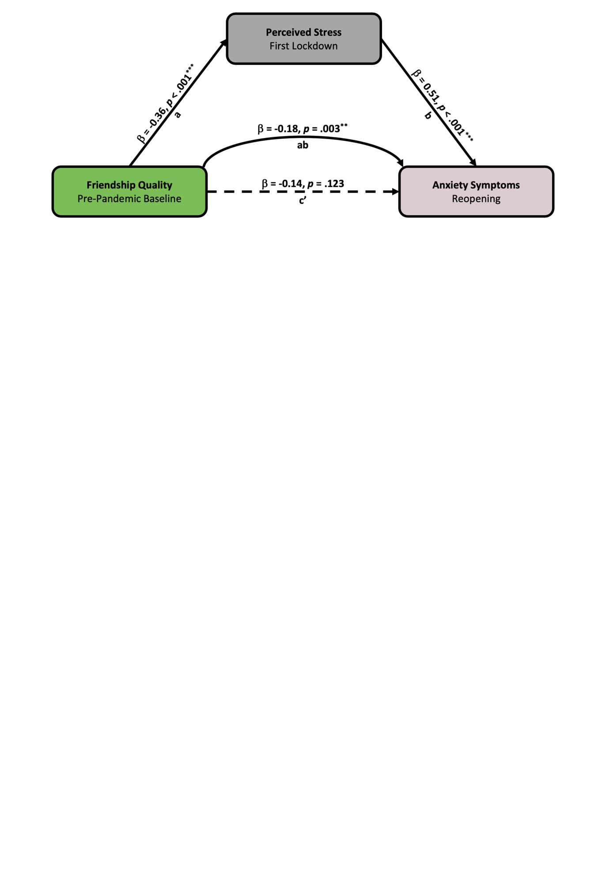
Note. Path a shows the standardized regression coefficient of the relationship between perceived friendship quality during the pre-pandemic baseline and perceived stress during the first lockdown. Path b shows the standardized regression coefficient of the relationship between perceived stress during the first lockdown and anxiety symptoms during reopening, while controlling for gender identity. Paths ab (indirect effect) and c’ (direct effect) show the standardized regression coefficient of the relation between friendship quality during the pre-pandemic baseline and anxiety symptoms during reopening without and while controlling for perceived stress during the first lockdown, respectively. Pre-pandemic baseline = August 2019 to March 2020 (N = 100 after outlier removal); First lockdown = April to May 2020 (n = 77 after outlier removal); Reopening = July to August 2020 (n = 70 after outlier removal). β = standardized coefficient. Dashed line denotes non-significant effect. **p < .01, ***p < .001.

Please note that the mediation effects remained consistent when assessing depression- or anxiety symptoms during the second lockdown. In other words, perceived stress during the first lockdown continued to fully mediate the relationship between pre-pandemic friendship quality and depression symptoms (indirect effect: β = -0.14, SE = 0.05, 95% CI [-0.26, -0.05], p = .009) or anxiety symptoms (indirect effect: β = -0.18, SE = 0.07, 95% CI [-0.34, -0.07], p = .009) during the second lockdown.
I. Monte Carlo Power Analyses
Two post-hoc simulation-based power analyses were performed. First, we used the mixedpower R package (version 0.1.0; (Kumle et al., 2021)) to estimate power in our linear mixed-effects model examining the main effect of friendship quality on depression symptoms before and during the COVID-19 pandemic (Marginal R² = .178; Conditional R² = .668). The following specifications were used to estimate power: fixed effect = 1 (main predictor: perceived friendship quality), simvar = subID (random effect for participants), steps = c(50, 60, 70) (sample sizes we estimated power for), critical_value = 2 (significance threshold for coefficients; α = .05), n_sim = 1000 (number of single simulations used to estimate power). Results of these Monte Carlo simulations indicated that a sample size of N = 70 corresponds to more than 80% power for the main effect. Hence, our smallest available sample size (second lockdown with n = 70 participants after outlier removal) is sufficient to ensure adequate power.
Second, to estimate sample size and power for our sequential mediation model, we followed the recommendations by (Schoemann et al., 2017) and ran Monte Carlo simulations via the Shiny App (available at https://schoemanna.shinyapps.io/mc_power_med/; developed by (Schoemann et al., 2017)). Standardized model parameters have been estimated based on the current dataset. Specifically, we set a = -0.32, b = 0.58, and c’ = -0.32. Moreover, we set N = 73 (reopening sample size after outlier removal), specified the total number of replications (# of Replications = 1,000), the number of draws for computing Monte Carlo confidence intervals (Monte Carlo Draws per Rep = 20,000), a random seed to ensure the exact replicability of the results, and the confidence levels of 95%. This analysis revealed that a sample of N = 73 participants results in 80% power for the indirect effect (ab path).
J. Exploratory: Psychosocial Experiences during the COVID-19 Pandemic
Four items from the COVID-19 Adolescent Symptom and Psychological Experience Questionnaire (CASPE; (Ladouceur, 2020)) were selected to explore self-reported psychosocial experiences at each follow-up assessment timepoint. First, participants were asked about (A) “what event or change has been the most positive” and (B) “[…] most negative” (Figure J1). Second, participants were asked about “[…] how [they] stay connected with friends (Figure J2). Third, participants were asked about “how [they] are coping or dealing with the stress or anxiety related to the COVID-19 outbreak (Figure J3). Although utilized in previous studies (e.g., (Porter et al., 2021), the CASPE has not yet been validated.

Figure S9
Notable (A) Positive and (B) Negative Events or Changes during the COVID-19 Pandemic
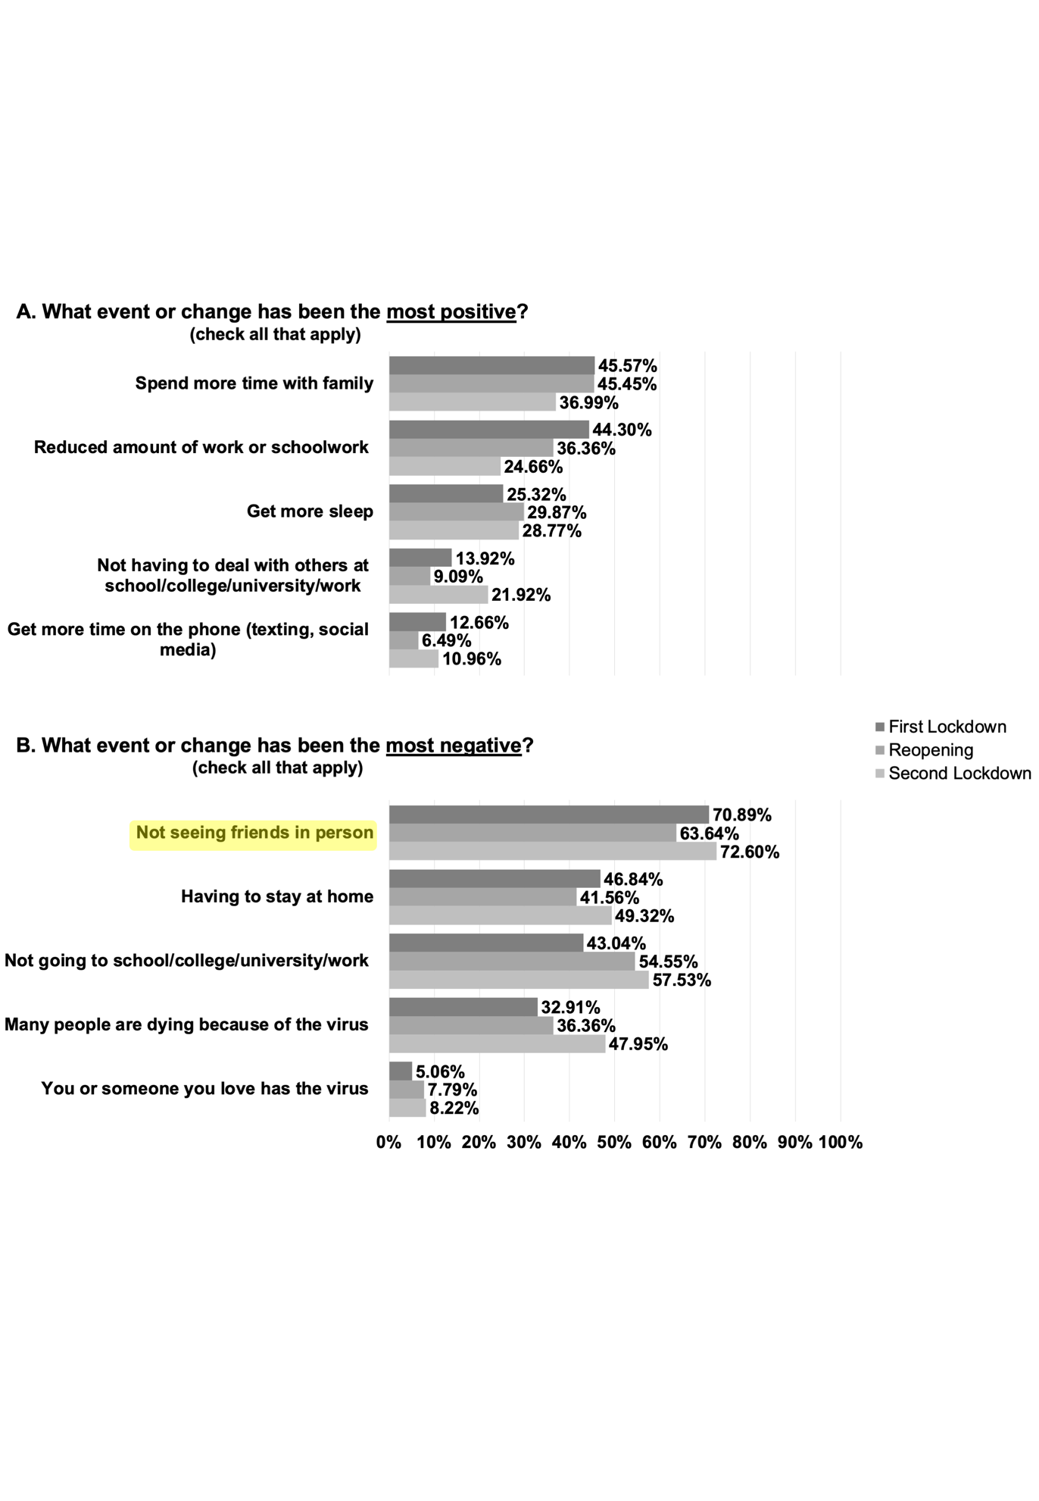
Note. At each assessment timepoint during the COVID-19 pandemic, participants reported (A) the most positive and (B) the most negative events or changes during the COVID-19 pandemic.

Figure S10
Tools Used to Maintain Social Connections with Friends during the COVID-19 Pandemic

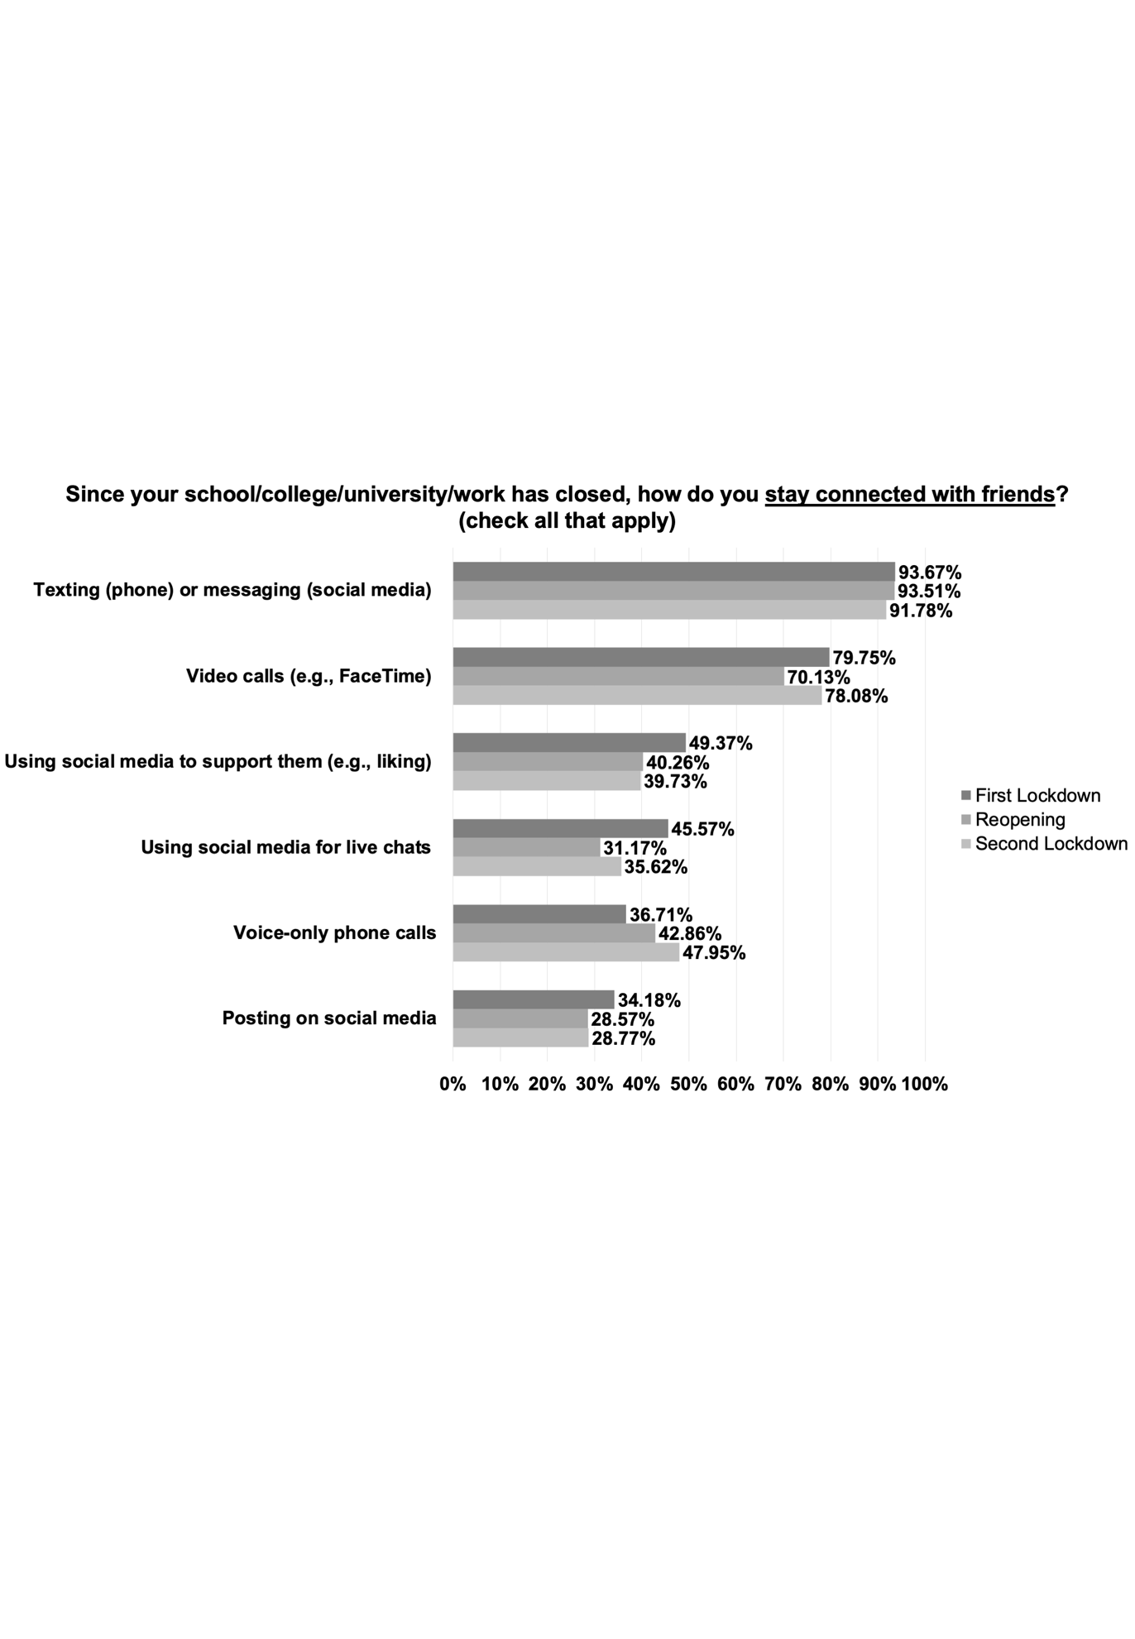
Note. At each assessment timepoint during the COVID-19 pandemic, participants reported all approaches they used to stay connected with friends.

Figure S11
Coping Strategies for Dealing with Pandemic-Related Stress or Anxiety
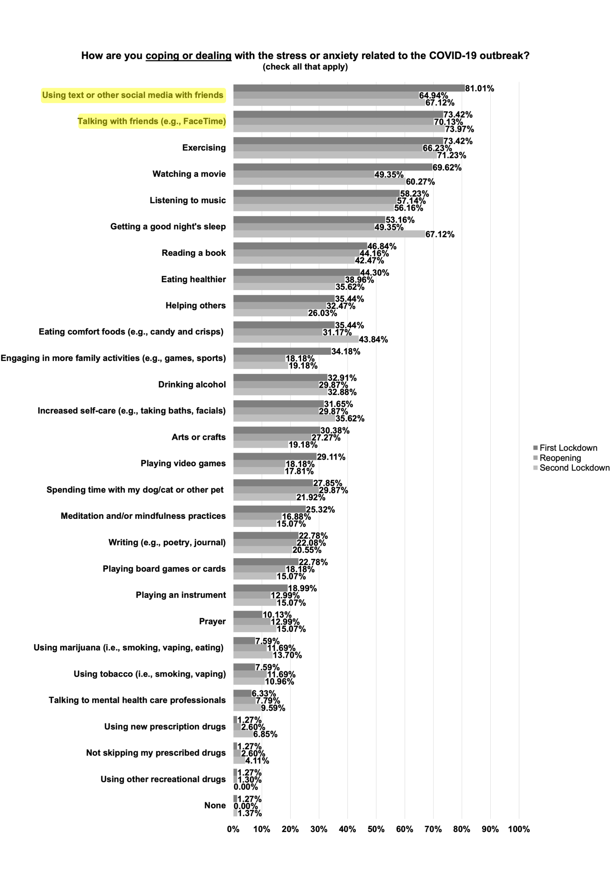
Note. At each assessment timepoint during the COVID-19 pandemic, participants reported approaches to deal with pandemic-related stress or anxiety.
References
Kievit, R. A., Brandmaier, A. M., Ziegler, G., van Harmelen, A.-L., de Mooij, S. M. M., Moutoussis, M., Goodyer, I. M., Bullmore, E., Jones, P. B., Fonagy, P., NSPN Consortium, Lindenberger, U., & Dolan, R. J. (2018). Developmental cognitive neuroscience using latent change score models: A tutorial and applications. Developmental Cognitive Neuroscience, 33, 99–117. https://doi.org/10.1016/j.dcn.2017.11.007
Kumle, L., Võ, M. L.-H., & Draschkow, D. (2021). Estimating power in (generalized) linear mixed models: An open introduction and tutorial in R. Behavior Research Methods, 53(6), 2528–2543. https://doi.org/10.3758/s13428-021-01546-0
Ladouceur, C. D. (2020). COVID-19 adolescent symptom & psychological experience questionnaire. Unpublished Manuscript.
Porter, B. M., Douglas, I. J., Larguinho, T. L., Aristizabal, M., Mitchell, M. E., Roe, M. A., & Church, J. A. (2021). Examination of Pre-pandemic Measures on Youth Well-being During Early Stages of the COVID-19 Pandemic. Biological Psychiatry Global Open Science, 1(4), 252–260. https://doi.org/10.1016/j.bpsgos.2021.08.003
Schoemann, A. M., Boulton, A. J., & Short, S. D. (2017). Determining Power and Sample Size for Simple and Complex Mediation Models. Social Psychological and Personality Science, 8(4), 379–386. https://doi.org/10.1177/1948550617715068

