Appendices

Table A1
The Lab-TAB Episodes Used to Rate Observed Sensitivity
Episode | Description + sensitivity scales
Risk room | The room was filled with novel and ambiguous toys, such as a tunnel, balance beam, staircase, a Halloween mask, black box, … The child was left alone to explore all objects.  ES-scales:  - “Pause to check before exploring a new environment”: Assesses the cautions behaviours, curiosity and interest in approaching a new environment.  - “Cautious and collaborative attitude towards the experimenter”: Assesses how a child interact with a new adult in a collaborative and cautious way.
Tower of Patience | The experimenter and child were building a tower together, alternating each turn. Sometimes the experimenter let the child wait by taking more time to put a block.  ES-scale:  - “Attending to experimenter’s directions”: Assesses whether the child has a reactive attitude in following an experimenter’s directions.
Stranger approach | The child was left alone in an empty room while a male researcher entered the room and spoke to the child in a neutral way, while approaching the child calmly.  ES-scales:  - “Compliance with the experimenter’s request”: Assesses also the reactivity of a child in following the experimenter’s directions (as Scale 3)  - “Fearfulness in response to the stranger’s entrance”: Assesses fearfulness in response to new environments.
Exploring new objects | The child was left alone in a room full of novel and ambiguous toys, such as a cat cage filled with mice, a moving spider, gel balls, a sound making bird, a skull covered with a blanket, …  ES-scale:  - “Hesitancy paired with curiosity”: Assesses similar behaviours as Scale 1 in a new environment.
Pop-up snakes | The child was shown a can of potato chips and was asked to open it. When the child opened the box snakes popped out. The child was asked to surprise his/her mom or dad in the same way.  ES-scale:  - “Positive response/overexcitement”: Assesses positive emotional reactivity in response to a positive experience.
Transparent box | The child was asked to select his/her favourite toy, that toy was locked in a transparent box. The child received a bunch of keys to open the box while the experimenter left the room, but none of the keys fitted the box.  ES scales:  - “Attention to toy’s detailed features”: Assesses the degree of detail a child explores the features of a new toy.  - “Careful perseverance when trying to open the box”: Assesses the degree of persistency in combination with an adequate and respectful approach which is driven by an increased attention to details
Perfect green circles | The child was asked to draw a perfect round circle. Each circle was criticized mildly.  ES-scale:  - “Preference for complying with drawing beautiful circles”: Assesses the appreciation of aesthetics and the commitment of drawing beautiful circles.

Table A2
Standardized Factor Loadings of the One Factor Model of the HSC-RS and The Descriptives of the Items and Total Scale
Items | Highly Sensitive Child | M (SD) | range | Cronbach’s’α | skewness | kurtosis | Age
 | λ |  |  |  |  |  | r
- Pause to check before exploring a new environment | .74*** | 3.65 (1.16) | 1-7 |  | .09 | .45
- Cautious and collaborative attitude towards the experimenter | .68*** | 4.23 (1.38) | 1-7 |  | .01 | -.43
- Attending to experimenter’s directions | .74*** | 3.91 (1.41) | 1-7 |  | .17 | -.19
- Compliance with the experimenter’s request | .55*** | 4.98 (1.85) | 1-7 |  | -.68 | -.72
- Fearfulness in response to the stranger’s entrance | .62*** | 3.87 (1.31) | 1-7 |  | -.01 | -.20
- Hesitancy paired with curiosity | .72*** | 3.72 (1.08) | 1-7 |  | .09 | .59
- Positive response/overexcitement | .36*** | 4.26 (1.7) | 1-7 |  | .03 | -.15
Table A2-continued
- Attention to toy’s detailed features | .63*** | 4.00 (1.23) | 1-7 |  | -.19 | -.16
- Careful perseverance when trying to open the box | .63*** | 3.93 (1.49) | 1-7 |  | .10 | -.43
- Preference for beautiful circles | .67*** | 3.92 (1.46) | 1-7 |  | -.01 | -.54
Total scale |  | 4.04 (0.93) | 1.60-6.90 | .84 | .02 | -.08 | .07
Note.^{.*** p < .001;} λ = factor loadings; r = Pearson’s correlations; N = 541

Figure A1
Latent Profile Analyses Solution with (a) Three Versus (b) Four Classes Of Observer-Rated Sensitivity

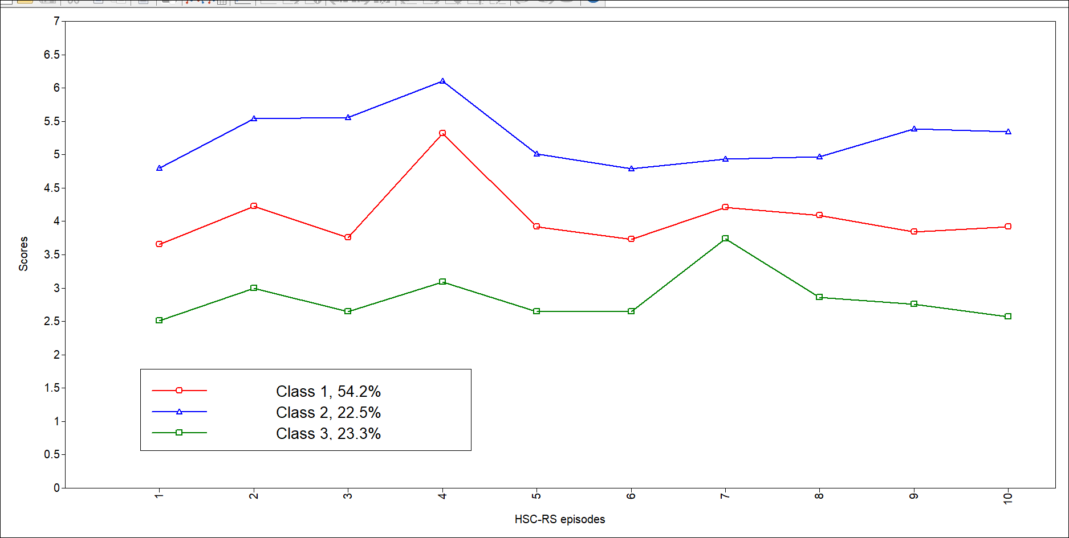
(a)
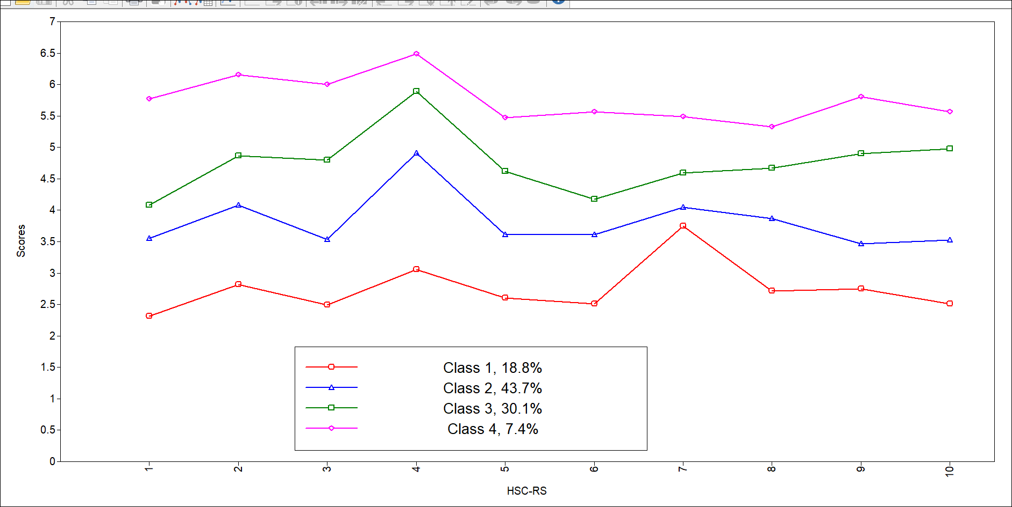
(b)
Note. The x- axis represents each episode (1-10) from the Lab-TAB episodes. The Y-axis represents the observer-rated ES score (1-7).

Table A3
Three Class Solution Based on Latent Profile Analyses on the Items of the HSC-RS
 | Low Sensitive Child | Medium Sensitive Child | High Sensitive Child
 | N = 123 | N =300 | N = 118
 | M (SD) | M (SD) | M (SD)
Pause to check before exploring a new environment | 2.51 (0.87) | 3.65 (0.87) | 4.80 (0.87)
Cautious and collaborative attitude towards the experimenter | 3.00 (1.01) | 4.22 (1.07) | 5.54 (1.07)
Attending to experimenter’s directions | 2.64 (0.99) | 3.76 (0.99) | 5.55 (0.99)
Compliance with the experimenter’s request | 3.09 (1.45) | 5.32 (1.49) | 6.11 (1.49)
Fearfulness in response to the stranger’s entrance | 2.65 (1.03) | 3.92 (1.03) | 5.01 (1.03)
Hesitancy paired with curiosity | 2.65 (0.81) | 3.73 (0.81) | 4.79 (0.81)
Positive response/overexcitement | 3.74 (1.21) | 4.21 (1.20) | 4.94 (1.20)
Attention to toy’s detailed features | 2.86 (0.99) | 4.09 (0.99) | 4.97 (0.99)
Careful perseverance when trying to open the box | 2.76 (1.22) | 3.84 (1.19) | 5.39 (1.19)
Preference for beautiful circles | 2.57 (1.60) | 3.92 (1.12) | 5.34 (1.12)

Table A4
The Descriptive Statistics for the Three Sensitivity Groups: Low Sensitive Child, Medium Sensitive Child, and High Sensitive Child.
Variable | Low  Sensitive  Child |  | Medium Sensitive Child |  | High Sensitive Child |  | (M)ANOVA results
 | N | M (SD) | N | M (SD) | N | M (SD) | F_{(df1, df2)} | p | η_{p}²
Temperament |  |  |  |  |  |  | F_{(10, 1018)} = 31.21 | <.001
Sociability/assertiveness | 122 | 0.52 (0.78) | 277 | 0.14 (0.87) | 117 | -0.86 (0.95) |  | <.001 | .24
Dysphoria | 122 | 0.30 (1.23) | 277 | -0.03 (0.87) | 117 | -0.37 (0.63) |  | <.001 | .06
Fear/inhibition | 122 | -0.22 (0.97) | 277 | -0.02 (0.99) | 117 | 0.25 (0.99) |  | <.001 | .03
Exuberance | 122 | 0.16 (0.95) | 277 | 0.05 (1.03) | 117 | -0.28 (0.96) |  | <.001 | .03
Constraint | 122 | -0.73 (1.15) | 277 | 0.06 (0.82) | 117 | 0.60 (0.68) |  | <.001 | .21
Table A4-continued
Cumulative genetic score | 104 | 0.49 (0.20) |  | 243 | 0.52 (0.21) | 111 | 0.53 (0.19 | F_{(2, 455)} = 1.54 | .215 | .01
Basal cortisol |  |  |  |  |  |  |  | F_{(4, 168)} = .90 | .446
Basal morning cortisol | 22 | 0.52 (0.20) |  | 48 | 0.57 (0.20) | 18 | 0.56 (017) |  | .597 | .01
Basal evening cortisol | 22 | -1.59 (0.30) |  | 48 | -1.45 (0.48) | 18 | -1.62 (0.41) |  | .260 | .03
Cortisol reactivity |  |  |  |  |  |  |  | F_{(4, 240)} = .99 | .996
Cortisol reactivity increase (AUCi) | 37 | 5.00 (0.80) |  | 61 | 4.93 (0.89) | 26 | 5.04 (0.81) |  | .864 | .00
Cortisol reactivity to ground (AUCg) | 37 | 6.12 (0.38) |  | 61 | 6.23 (0.41) | 26 | 6.24 (0.40) |  | .341 | .02
Frontal EEG asymmetry |  |  |  |  |  |  |  | F_{(4, 660)} = .33 | .856
Frontal asymmetry (F4-F3) | 68 | -0.01 (0.13) |  | 183 | -0.02 (0.12) | 83 | 0.01 (0.20) |  | .589 | .00
Frontal asymmetry (F8-F7) | 68 | -0.05 (0.23) |  | 183 | -0.05 (0.23) | 83 | -0.05 (0.24) |  | .996 | .00
Table A4-continued
Partial EEG asymmetry |  |  |  |  |  |  |  | F_{(4, 660)} = 1.12 | .348
Parietal asymmetry (P4-P3) | 68 | 0.02 (0.21) |  | 183 | 0.06 (0.27) | 83 | 0.05 (0.20) |  | .403 | .01
Parietal asymmetry (P8-P7) | 68 | 0.13 (0.26) |  | 183 | 0.10 (0.30) | 83 | 0.15 (0.24) |  | .512 | .00
Note. Low Sensitive Child ; Cortisol variables are log-transformed (ln(X+100))

Table A5
Bivariate and Partial (for the GWAS Data) Correlations Between the Different Predictors Included in the Study.
Variable | 1. | 2. | 3. | 4. | 5. | 6. | 7. | 8. | 9. | 10. | 11. | 12. | 13. | 14.
1.Sociability/assertiveness | -
2.Dysphoria | .11* | -
3.Fear/inhibition | -.16*** | .20*** | -
4.Exuberance | .44*** | -.10* | -.11* | -
5.Constraint | -.12** | -.39*** | .00 | .08 | -
6.Cumulative candidate genetic score | -.01 | .00 | -.02 | -.06 | .03 | -
7.GWAS ADHD | .13** | .02 | -.01 | .08 | -.13* | .02 | -
8.GWAS ASD | .03 | .00 | .01 | .08 | -.05 | .02 | .29*** | -
9.GWAS cognitive performance | -.02 | .06 | -.04 | .00 | .04 | .03 | -.10* | .-.02* | -
10.GWAS depression | -.04 | .09 | .09 | .08 | -.04 | .05 | .06 | .02* | -.02 | -
11.GWAS disinhibition | .03 | .02 | -.09 | -.04 | .02 | .03 | .11* | .07 | -.02 | .09 | -
12.GWAS educational attainment | .01 | -.02 | -.01 | .01 | -.03 | .07 | -.16** | .01 | .37*** | -.08 | -.06 | -
13.GWAS Extraversion | -.03 | .12* | .06 | -.05 | -.12 | -.04 | -.02 | .02 | .04 | .03 | -.04 | .04 | -
14.GWAS anxiety (GAD) | -.05 | .05 | .09 | .02 | -.05 | -.05 | .09 | .06 | -.08 | .13** | .04 | -.09* | .00 | -

Table A5- continued
Variable | 1. | 2. | 3. | 4. | 5. | 6. | 7. | 8. | 9. | 10. | 11. | 12. | 13.
15.GWAS intelligence | -.02 | .08 | -.00 | .03 | .04 | .02 | -.15** | -.03 | .76*** | -.03 | -.03 | .41*** | .06
16. GWAS neuroticism | -.02 | .06 | .02 | -.00 | .02 | -.04 | .17*** | .09 | -.09 | .17*** | -.05 | -.09** | .01
17.Basal morning cortisol | -.03 | .06 | -.06 | -.20 | .14 | .05 | -.07 | -.07 | -.01 | .08 | .17 | .20** | -.15
18.Basal evening cortisol | .05 | .02 | .05 | .16 | .10 | .10 | .06 | .22 | .12 | .18 | .07 | .16 | .04
19.Cortisol reactivity increase (AUCi) | .01 | .11 | .15 | -.03 | .00 | .01 | -.01 | .01 | --.21 | .18 | -.23* | -.16 | .07
20.Cortisol reactivity to ground (AUCg) | -.02 | .03 | .11 | .03 | -.09 | .04 | -.02 | -.01 | -.00 | .02 | -.15 | .10 | .03
21.Frontal asymmetry (F4-F3) | .02 | .00 | .04 | .01 | .01 | -.13* | -.15* | -.13* | .21** | .11 | .01 | .11 | .06
22.Frontal asymmetry (F8-F7) | -.00 | -.02 | -.08 | .01 | .02 | -.13* | -.03 | -.03 | .17*** | .09 | .05 | .15* | .11
23.Parietal asymmetry (P4-P3) | -.04 | .11* | .03 | -.08 | -.08 | -.08 | .05 | -.04 | .04 | .07 | .02 | .02 | -.05
24.Parietal asymmetry (P8-P7) | -.06 | -.16** | -.10 | .02 | .00 | -.05 | -.21** | -.04 | .02 | .07 | -.11 | .07 | -.21

Table A5-continued
Variable. |  |  | 14 | 15 | 16 | 17 | 18 | 19 | 20 | 21 | 22 | 23 | 24
15.GWAS intelligence |  |  | -.09 | -
16. GWAS neuroticism |  |  | .14** | -.11* | -
17.Basal morning cortisol |  |  | -.07 | .08 | .16 | -
18.Basal evening cortisol |  |  | -.25* | -.09 | -.12 | .07 | -
19.Cortisol reactivity increase (AUCi) |  |  | -.01 | -.23* | -.05 | .19 | .19 | -
20.Cortisol reactivity to ground (AUCg) |  |  | -.11 | -.04 | .06 | -.06 | .17 | .60*** | -
21.Frontal asymmetry (F4-F3) |  |  | .07 | .17** | -.03 | -.15 | -.21 | .04 | .07 | -
22.Frontal asymmetry (F8-F7) |  |  | .14* | .07 | .02 | .08 | .03 | -.07 | -.06 | .07 | -
23.Parietal asymmetry (P4-P3) |  |  | .14 | .02 | .02 | .02 | .08 | .08 | .02 | .42*** | .09 | -
24.Parietal asymmetry (P8-P7) |  |  | .04 | .08 | .05 | .11 | .12 | -.05 | -.08 | .16** | .38*** | .09 | -
 | Note. | For the GWAS data, partial correlations were run to control for the first ten PC. For the other variables, bivariate correlations were run.  *** p < .001, ** p < .01, *p < .05.

Table A6
Hierarchical Regression Analysis with Temperamental Traits as Predictors and Gender as a Covariate for Observer-Rated Sensitivity
 | Observer-rated sensitivity (HSC-RS)
 | R² (∆R²) |  |  | B (SE) | β | p
Step 1 | .04 (.04)
Gender |  |  |  | 0.39*** (0.08) | .21 | <.001
Step 2 | .48 (.44)***
Gender |  |  |  | 0.18** (0.06) | .10** | <.001
Sociability/assertiveness |  |  |  | -0.38***(0.04) | -.40*** | <.001
Dysphoria |  |  |  | -0.10**(0.04) | -.11** | .003
Fear/inhibition |  |  |  | 0.10** (0.03) | .11** | .002
Exuberance |  |  |  | 0.02 (0.03) | .03 | .558
Constraint |  |  |  | 0.39*** (0.03) | .42*** | <.001
Note. B (SE) = unstandardized beta and its standard error; β = standardized beta *p < .05; **p < .01; *** p < .001.

Sensitivity Analysis with the Separate Dimensions of Dysphoria
As a sensitivity analysis, we re-ran the analyses with the temperament traits in the prediction of observer-rated ES, but with the subscales, sadness and anger, of dysphoria as separate predictors. The results of the hierarchical regression analyses indicated that the model with gender, and all six temperament traits (i.e., sociability/assertiveness, fear/inhibition, exuberance, constraint, sadness, and anger) (F(6,508) = 71.02, p < .001, $f^{2}=.92$, d =1.92 ) explained 47.2% of the variance in observer-rated sensitivity. Specifically, a significant association with all temperamental traits, except exuberance (β = .02, p = .472) and anger (β = -0.01, p = .870), was found. Higher scores on observer-rated sensitivity were associated with lower sociability/assertiveness (β = - .41, p <.001, d = -0.47), lower sadness (β = -.09, p = .02, d = -0.11), higher fear/inhibition (β = .11, p = .001, d = 0.13), and more constraint (β = .44, p <.001, d = 0.56). VIF scores were all lower than 1.46 indicating no collinearity issues.
Table A7
Hierarchical Regression Analysis with Separate Temperamental Dimensions of Dysphoria
 | Observer-rated sensitivity (HSC-RS)
 | R² (∆R²) | B (SE) | β | p
Step1 | .04 (.04)
Gender |  | 0.39*** (0.08) | .21 | <.001
Step 2 | .48 (.44)***
Gender |  | 0.17*** (0.06) | ..09*** | <.001
Sociability/assertiveness |  | -0.38***(0.04) | -.41*** | <.001
Sadness (dysphoria) |  | -0.29**(0.12) | -.09* | .016
Anger (dysphoria) |  | -0.02 (0.11) | -0.01 | 0.870
Fear/inhibition |  | 0.11** (0.03) | .11*** | <.001
Exuberance |  | 0.02 (0.03) | .03 | .473
Constraint |  | 0.39*** (0.03) | .42*** | <.001
Note. B (SE) = unstandardized beta and its standard error; β = standardized beta *p < .05; **p < .01; *** p < .001.

Table A8
Hierarchical Regression Analysis With the Candidate Gene Polygenic Score as Predictor and Gender as a Covariate for Observer-Rated Sensitivity
 | Observer-rated sensitivity (HSC-RS)
 | R² (∆R²) |  |  | B (SE) |  | β | p
Step 1 | .04 (.04)
Gender |  |  |  | 0.37*** (0.09) |  | .20 | <.001
Step 2 | .05 (.01)°
Gender |  |  |  | 0.39*** (0.09) |  | .21 | <.001
Candidate gene polygenic sensitivity score |  |  |  | 0.39°(0.21) |  | 0.08 | .071
Note. B (SE) = unstandardized beta and its standard error; β = standardized beta. *p < .05; **p < .01; *** p < .001; ° p < 10

Table A9
Hierarchical Regression Analysis with the Individual Candidate Genetic Variants as Predictors and Gender as Covariate for Observer-Rated Sensitivity
 | Observer-rated sensitivity (HSC-RS)
 | R² (∆R²) | B (SE) | β | p
Step 1 | .04 (.05) ***
Gender |  | 0.39*** (0.09) | .21*** | <.001
Step 2 | .06 (.02)
Gender |  | 0.39*** (0.09) | .22***
SLC6A4 SS alleles variant |  | 0. (0.11) | 0.07 | .164
DRD4 7 repeat dominant variant |  | -0.03 (0.09) | -0.02 | .734
DRD2 A1 allele dominant variant |  | 0.14 (0.09) | 0.07 | .134
DAT1 9 repeat dominant variant |  | 0.01 (0.09) | 0.01 | .912
BDNF met allele dominant |  | 0.15 (0.09) | 0.08° | .083
COMT val/val alleles variant |  | -0.06 (0.11) | -0.03 | .588
Note. B (SE) = unstandardized beta and its standard error *p < .05; **p < .01; *** p < .001; ° p < 10

The results of the hierarchical regression analyses indicated that the model with gender, and the individual candidate genes (F(6, 439) = 1.29, p = .26) explained only 6% of variance in observer-rated sensitivity and was not significant.

Table A10
Hierarchical Regression Analysis With the GWAS Polygenic Scores as Predictors and, Gender and the First 10 PCs as Covariates for Observer-Rated Sensitivity
 | Observer-rated sensitivity (HSC-RS)
 | R² (∆R²) |  |  | B (SE) | β | p
Step 1 | .05 (.05) ***
Gender |  |  |  | 0.41*** (0.09) | .23*** | <.001
Step 2 | 0.08 (.03)
Gender |  |  |  | 0.40*** (0.09) | .23*** | <.001
PC1 |  |  |  | 0.85 (1.64) | 0.03 | .603
PC2 |  |  |  | 4.03 (11.32) | 0.02 | .722
PC3 |  |  |  | 1.23 (1.37) | 0.05 | .369
PC4 |  |  |  | 0.96 (1.46) | 0.04 | .509
PC5 |  |  |  | 1.55 (1.26) | 0.06 | .222
PC6 |  |  |  | 2.64* (1.26) | 0.10 | .037
PC7 |  |  |  | 0.98 (1.29) | 0.04 | .452
PC8 |  |  |  | -0.46 (1.28) | -0.03 | .722
PC9 |  |  |  | -0.67 (1.26) | -0.03 | .594
PC10 |  |  |  | 1.57 (1.26) | 0.06 | .214
Step 3 | 0.11 (.03)
Gender |  |  |  | 0.39*** (0.09) | 0.22*** | <.001
PC1 |  |  |  | 0.37 (2.02) | 0.01 | .854
PC2 |  |  |  | 3.36 (11.47) | 0.02 | .770
PC3 |  |  |  | 0.84 (1.43) | 0.03 | .555
PC4 |  |  |  | 0.31 (1.58) | 0.01 | .844
PC5 |  |  |  | 1.77 (1.29) | 0.07 | .170
PC6 |  |  |  | 2.46 (1.27) | 0.10 | .054
PC7 |  |  |  | 0.58 (1.32) | 0.02 | .664
PC8 |  |  |  | -0.62 (1.30) | -0.02 | .630
PC9 |  |  |  | -0.59 (1.27) | -0.02 | .643
PC10 |  |  |  | 1.08 (1.28) | 0.04 | .399
GWAS ADHD |  |  |  | -4873.79 (2025.99) | -0.13* | .017
GWAS ASD |  |  |  | 1546.08 (2400.77) | 0.64 | .520
GWAS cognitive performance |  |  |  | -13643.91 (19071.28) | -0.06 | .475
GWAS depression |  |  |  | -5867.44 (5067.20) | -0.07 | .248
GWAS disinhibition |  |  |  | 13633.19 (14243.61) | 0.05 | .339
GWAS educational attainment |  |  |  | -11721.66 ( 20519.28) | -0.04 | .568
GWAS Extraversion |  |  |  | -5923.56 ( 4467.69) | -0.07 | .186
GWAS anxiety (GAD) |  |  |  | 2341.99 (6387.62) | 0.02 | .714
GWAS intelligence |  |  |  | 24713.66 ( 17038.75) | 0.14 | .148
GWAS neuroticism |  |  |  | 3605.53 ( 4070.33) | 0.05 | .376
Note. B (SE) = unstandardized beta and its standard error; β = standardized beta. PC = primary component; GWAS = Genome wide association study. *p < .05; **p < .01; *** p < .001; ° p < 10

Table A11
Hierarchical Regression Analysis with the GWAS Polygenic Score of ADHD as Predictor and Gender, and the First 10 PCs as Covariates for Observer-Rated Sensitivity
 | R² (∆R²) | B (SE) | β | p
Step 1 | .05 (.05) ***
Gender |  | 0.03 (0.17) | .01 | .878
Level 2 | 0.08 (.03)
Gender |  | 0.40*** (0.09) | .23*** | <.001
PC1 |  | .85 (1.64) | 0.03 | .603
PC2 |  | 4.03 (11.32) | 0.02 | .722
PC3 |  | 1.23 (1.37) | 0.05 | .369
PC4 |  | .96 (1.45) | 0.04 | .509
PC5 |  | 1.55 (1.26) | 0.06 | .222
PC6 |  | 2.64* (1.26) | 0.10 | .037
PC7 |  | .98 (1.30) | 0.04 | .452
PC8 |  | -.454 (1.28) | -0.02 | .722
PC9 |  | -.67 (1.26) | -0.03 | .594
PC10 |  | 1.56 (1.25) | 0.06 | .214
Step 3 | 0.09*(.01)
Gender |  | 0.40*** (0.09) | 0.22*** | <.001
PC1 |  | .56 (1.63) | 0.02 | .853
PC2 |  | 5.06 (11.26) | 0.03 | .774
PC3 |  | .95 (1.36) | 0.04 | .555
PC4 |  | .914 (1.45) | 0.03 | .844
PC5 |  | 1.61 (1.26) | 0.06 | .170
PC6 |  | 2.67 (1.26) | 0.10 | .055
PC7 |  | .78 (1.29) | 0.03 | .664
PC8 |  | -.42 (1.27) | -0.02 | .631
PC9 |  | -.66 (1.25) | -0.03 | .647
PC10 |  | 1.29 (1.25) | 0.05 | .402
GWAS ADHD |  | -4364.25 (1867.62) | -0.12* | .020
Note. B (SE) = unstandardized beta and its standard error; β = standardized beta. As a follow-up analysis we reran the analyses with only GWAS PGS of ADHD at Level 3; PC = primary component; GWAS = Genome wide association study. *p < .05; **p < .01; *** p < .001; ° p < 10

Figure A2
Mean Scores and Variations on Environmental Sensitivity Across the Different Subsamples

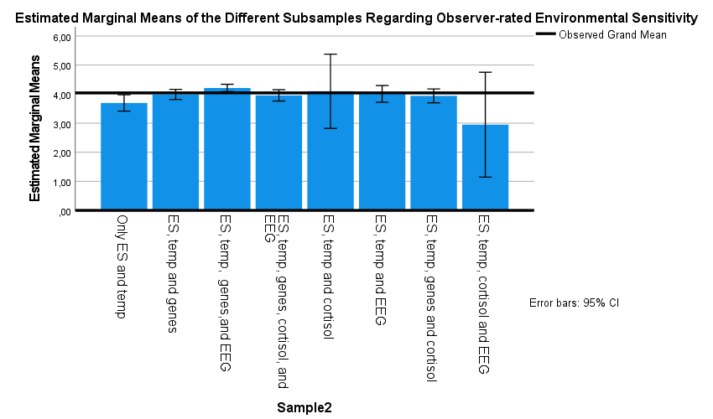
Subsamples

Note. The sample sizes for the different subsamples are: (1) Only ES and temp (n = 41), (2) ES, temperament and genes (n = 107), (3) ES, temperament, genes, and EEG (n = 208), (4) ES, temperament, genes, EEG, and cortisol (n = 86), (5) ES, temperament, and cortisol (n = 2), (6) ES, temperament, and EEG (n = 39), (7) ES, temperament, gene and cortisol (n = 57) (8) ES, temperament, cortisol, and EEG (n = 1).

The Characterisation of Highly Sensitive Children at Multiple Levels of Analysis by Applying the Sensitivity Groups found with the Latent Profile Analyses

Temperament
MANOVAs indicated overall significant differences between the three sensitivity groups F(10, 1018) = 31.21, p < .001, η_{p}² =.235) for the different temperament traits (Figure 1). Only for fear/inhibition and exuberance, there was no significant difference between low sensitive child and medium sensitive child group (p = .178 and p = .822, respectively). In Figure A3 we see an opposite pattern for the low sensitive child group characterised by high sociability/assertiveness, dysphoria, and exuberance and low fear/inhibition, and constraint, versus the high sensitive child group characterised by low sociability/assertiveness, dysphoria, exuberance, and high fear/inhibition and constraint. The medium sensitive child group showed intermediate scores on all temperamental traits with a similar negative score on fear/inhibition.
Figure A3
The Temperamental Profile for the Low, Medium, and High Sensitive Child
Low HSC

Characterisation Based on Candidate Genes
The ANOVA analysis indicated no significant differences between the three sensitivity groups F(2, 455) = 1.54, p = .215, η_{p}² = 0.007) regarding the polygenic score. Plotting the results, we see small differences between the low, medium and high sensitive groups, with increasing polygenic sensitivity scores (Figure S3).
Characterisation Based on Genome-Wide Association Study Polygenic Risk Scores
The MANOVA analysis indicated no significant differences between the three sensitivity groups regarding GWAS PGS (F(16, 778) = .947, p = .658, η_{p}² =.02). When including only the GWAS PGS for ADHD, results showed significant differences between the low and high sensitive group and between the medium and high sensitive group with the highly sensitive group showing the lowest ADHD PGS (F(2) = 3.920, p = .021, η_{p}² =.02; Figure A4).
Figure A4
Differences Between The Low, Medium, and High Sensitivity Group Regarding the GWAS PGS of ADHD
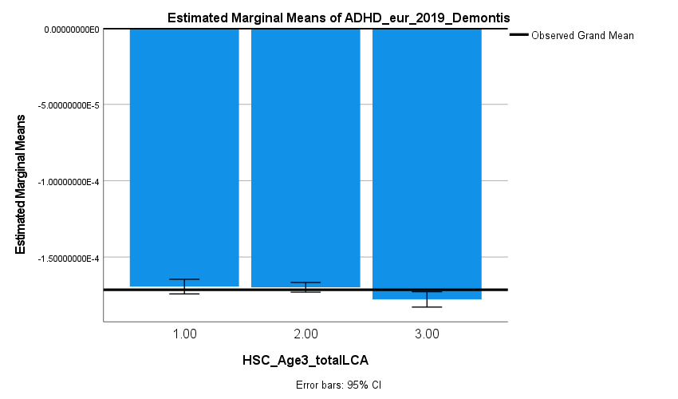

Characterisation Based on Basal Cortisol and Cortisol Reactivity in Response to Stress
The MANOVA analysis indicated no significant differences between the three sensitivity groups regarding basal cortisol F(4, 168) = .90, p = .466, η_{p}² =.02) nor cortisol reactivity F(4, 240) = .99, p = .412 , η_{p}² =.02).
Characterisation Based on Frontal and Parietal EEG Asymmetry
The MANOVA analyses indicated no significant differences between the three sensitivity groups regarding frontal asymmetry F(4, 660) = .33, p = .856, η_{p}² =.002) or parietal asymmetry F(4, 660) = 1.12, p = .348, η_{p}² =.007).

