Supplemental Materials
S.1 Methods
S.1.1 fMRI Emotional Encoding Task
In addition to the 90 images selected for analysis, the task session started and ended with 5 similar dummy images to guard against primacy and recency effects in memory. The last 5 images shown were very positive scenes in order to end the session on a happy note. These 10 total dummy images were not included in the imaging analyses.

S.1.2 fMRI preprocessing: FMRIPrep
Results included in this manuscript come from preprocessing performed using fMRIPrep 20.2.0 (Esteban, Markiewicz, et al. (2018); Esteban, Blair, et al. (2018); RRID:SCR_016216), which is based on Nipype 1.5.1 (Gorgolewski et al. (2011); Gorgolewski et al. (2018); RRID:SCR_002502).

Anatomical data preprocessing
The T1-weighted (T1w) images were corrected for intensity non-uniformity (INU) with N4BiasFieldCorrection (Tustison et al. 2010), distributed with ANTs 2.3.3 (Avants et al. 2008, RRID:SCR_004757), and used as T1w-references throughout the workflow. The T1w-references were then skull-stripped with a Nipype implementation of the antsBrainExtraction.sh workflow (from ANTs), using OASIS30ANTs as target template. Brain tissue segmentation of cerebrospinal fluid (CSF), white-matter (WM) and gray-matter (GM) was performed on brain-extracted T1w using fast (FSL 5.0.9, RRID:SCR_002823, Zhang, Brady, and Smith 2001). Brain surfaces were reconstructed using recon-all (FreeSurfer 6.0.1, RRID:SCR_001847, Dale, Fischl, and Sereno 1999), and the brain mask estimated previously was refined with a custom variation of the method to reconcile ANTs-derived and FreeSurfer-derived segmentations of the cortical gray-matter of Mindboggle (RRID:SCR_002438, Klein et al. 2017). Volume-based spatial normalization to two standard spaces (MNI152NLin2009cAsym, MNI152NLin6Asym) was performed through nonlinear registration with antsRegistration (ANTs 2.3.3), using brain-extracted versions of both T1w reference and the T1w template. The following templates were selected for spatial normalization: ICBM 152 Nonlinear Asymmetrical template version 2009c [Fonov et al. (2009), RRID:SCR_008796; TemplateFlow ID: MNI152NLin2009cAsym], FSL’s MNI ICBM 152 non-linear 6th Generation Asymmetric Average Brain Stereotaxic Registration Model [Evans et al. (2012), RRID:SCR_002823; TemplateFlow ID: MNI152NLin6Asym].

Functional data preprocessing
For each of the BOLD runs found per subject (across all tasks and sessions), the following preprocessing was performed. First, a reference volume and its skull-stripped version were generated using a custom methodology of fMRIPrep. Susceptibility distortion correction (SDC) was omitted. The BOLD reference was then co-registered to the T1w reference using bbregister (FreeSurfer) which implements boundary-based registration (Greve and Fischl 2009). Co-registration was configured with six degrees of freedom. Head-motion parameters with respect to the BOLD reference (transformation matrices, and six corresponding rotation and translation parameters) are estimated before any spatiotemporal filtering using mcflirt (FSL 5.0.9, Jenkinson et al. 2002). BOLD runs were slice-time corrected using 3dTshift from AFNI 20160207 (Cox and Hyde 1997, RRID:SCR_005927). The BOLD time-series (including slice-timing correction when applied) were resampled onto their original, native space by applying the transforms to correct for head-motion. These resampled BOLD time-series will be referred to as preprocessed BOLD in original space, or just preprocessed BOLD. The BOLD time-series were resampled into standard space, generating a preprocessed BOLD run in MNI152NLin2009cAsym space. First, a reference volume and its skull-stripped version were generated using a custom methodology of fMRIPrep. Automatic removal of motion artifacts using independent component analysis (ICA-AROMA, Pruim et al. 2015) was performed on the preprocessed BOLD on MNI space time-series after removal of non-steady state volumes and spatial smoothing with an isotropic, Gaussian kernel of 6mm FWHM (full-width half-maximum). Corresponding “non-aggresively” denoised runs were produced after such smoothing. Additionally, the “aggressive” noise-regressors were collected and placed in the corresponding confounds file. Several confounding time-series were calculated based on the preprocessed BOLD: framewise displacement (FD), DVARS and three region-wise global signals. FD was computed using two formulations following Power (absolute sum of relative motions, Power et al. (2014)) and Jenkinson (relative root mean square displacement between affines, Jenkinson et al. (2002)). FD and DVARS are calculated for each functional run, both using their implementations in Nipype (following the definitions by Power et al. 2014). The three global signals are extracted within the CSF, the WM, and the whole-brain masks. Additionally, a set of physiological regressors were extracted to allow for component-based noise correction (CompCor, Behzadi et al. 2007). Principal components are estimated after high-pass filtering the preprocessed BOLD time-series (using a discrete cosine filter with 128s cut-off) for the two CompCor variants: temporal (tCompCor) and anatomical (aCompCor). tCompCor components are then calculated from the top 2% variable voxels within the brain mask. For aCompCor, three probabilistic masks (CSF, WM and combined CSF+WM) are generated in anatomical space. The implementation differs from that of Behzadi et al. in that instead of eroding the masks by 2 pixels on BOLD space, the aCompCor masks are subtracted a mask of pixels that likely contain a volume fraction of GM. This mask is obtained by dilating a GM mask extracted from the FreeSurfer’s aseg segmentation, and it ensures components are not extracted from voxels containing a minimal fraction of GM. Finally, these masks are resampled into BOLD space and binarized by thresholding at 0.99 (as in the original implementation). Components are also calculated separately within the WM and CSF masks. For each CompCor decomposition, the k components with the largest singular values are retained, such that the retained components’ time series are sufficient to explain 50 percent of variance across the nuisance mask (CSF, WM, combined, or temporal). The remaining components are dropped from consideration. The head-motion estimates calculated in the correction step were also placed within the corresponding confounds file. The confound time series derived from head motion estimates and global signals were expanded with the inclusion of temporal derivatives and quadratic terms for each (Satterthwaite et al. 2013). Frames that exceeded a threshold of 0.5 mm FD or 1.5 standardised DVARS were annotated as motion outliers. All resamplings can be performed with a single interpolation step by composing all the pertinent transformations (i.e. head-motion transform matrices, susceptibility distortion correction when available, and co-registrations to anatomical and output spaces). Gridded (volumetric) resamplings were performed using antsApplyTransforms (ANTs), configured with Lanczos interpolation to minimize the smoothing effects of other kernels (Lanczos 1964). Non-gridded (surface) resamplings were performed using mri_vol2surf (FreeSurfer).

S.1.3 ROI analyses by emotion condition (positive, negative, and neutral)
To confirm the responsivity of the ROIs to affective scene content, we conducted random effects models for each ROI, with the primary predictor being emotion condition (positive, negative, neutral). For bilateral ROIs, hemisphere (left, right) was also included as a second term. For the hippocampus, the division along the longitudinal axis (anterior, posterior) was included as a third term. Next, to test the hypothesis that trauma load would be associated with differences in ROI activity, we performed mixed-effects ANOVAs for each of our ROIs that included TESI-C as a between-subjects factor and emotion condition, as well as hemisphere and anterior/posterior (A/P) when applicable, as within-subject factors.

S.2 Results
S.2.1 Cued recall associations with Age and Sex
Neither age, nor it’s interaction with trauma load (age*TESI-C) correlated with overall cued recall performance or recall for positive, neutral, or negative scenes specifically (ps>0.05, Figure S1A). Girls showed better cued recall performance than boys (Figure S1B; F(1, 52) = 8.69, p < 0.001). Post-hoc tests showed that girls had greater negative (t(43.88) = 3.23, p = 0.01), neutral (t(42.14) = 2.46, p = 0.03), and overall (t(46.87) = 2.91, p = 0.02), but not positive (t(50.4) = 1.95, p = 0.08) recall performance.

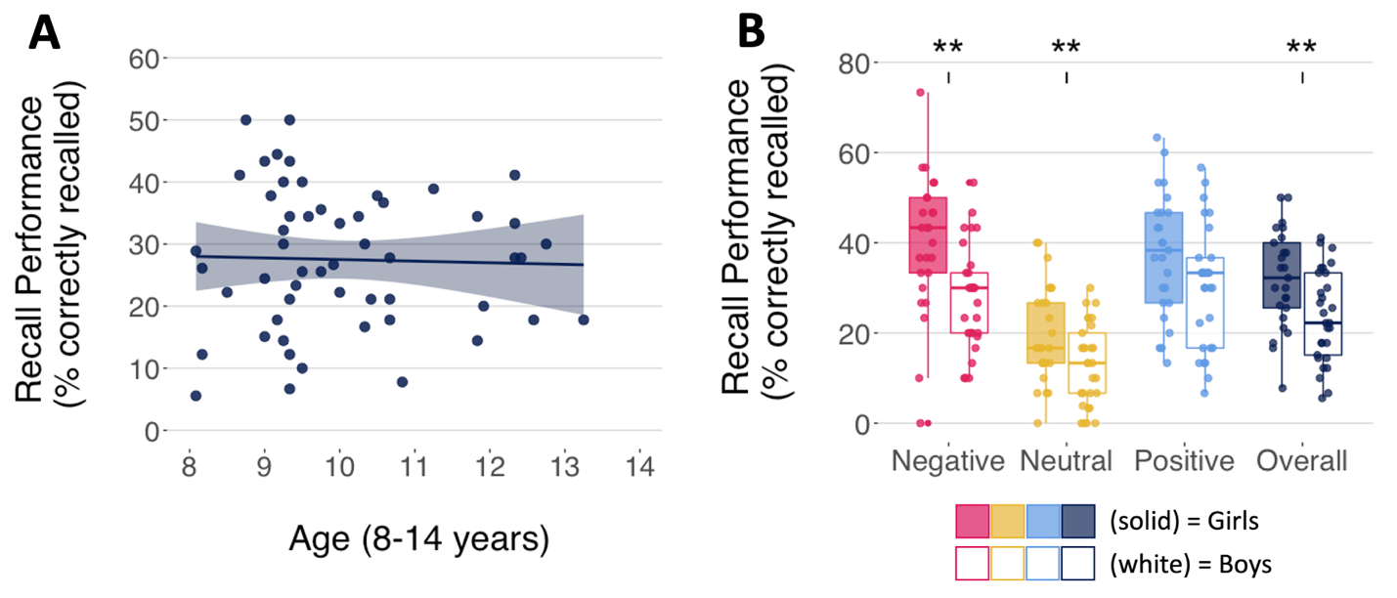

Figure S1. Recall performance by Age or Sex. (A) Negative, neutral, positive, or overall recall performance did not vary by Age. (B) Girls showed greater recall for negative and neutral images as well as overall recall performance compared to boys. There were no significant sex differences for positive image recall. Welch’s t-tests adjusted using Benjamini-Hochberg, ** = p<0.05. Error bars depict standard error.

S.2.2 Effects of emotion on neural activation during scene presentation
In the hippocampus, there was an interaction of emotion*A/P (F(2,110) = 7.95, p=0.001). Post-hoc testing showed a main effect of emotion particularly within the anterior hippocampus (F(2,110)=5.47, p=0.009) and t-tests within this subregion revealed that this was driven by negative images (negative-neutral, t=-2.86, p=0.006; negative-positive, t=-2.19, p=0.03, positive-neutral, p=0.15) (Figure S1).
There were no effects of emotion or interactions with hemisphere for the left amygdala F(2,110)= 0.45, p=0.62), right amygdala F(2, 110)= 0.13, p=0.84), left IPS (F(2, 106) = 1.51, p= 0.22), or right MFG (F(2,110)= 3.14, p= 0.08). Whole-brain responses to positive>neutral and negative>neutral images are shown in Figures S2-3.
Trauma load had no main effect or interaction with emotion condition for any ROI.

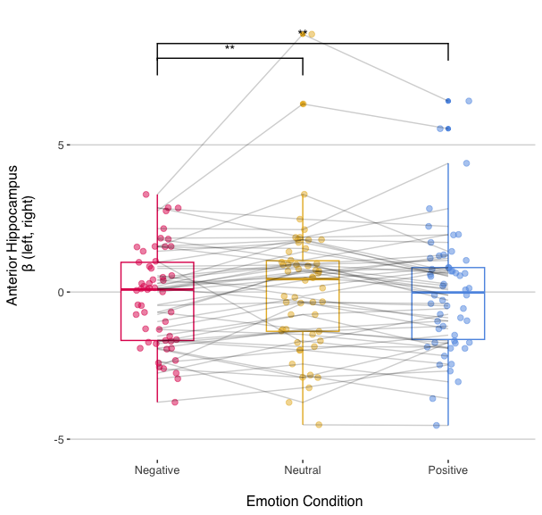
Figure S2. Emotion influences on bilateral anterior hippocampus. Negative images elicited significantly less BOLD activation in the anterior hippocampus compared to positive or neutral images. ** = p<0.05. Error bars depict standard error.

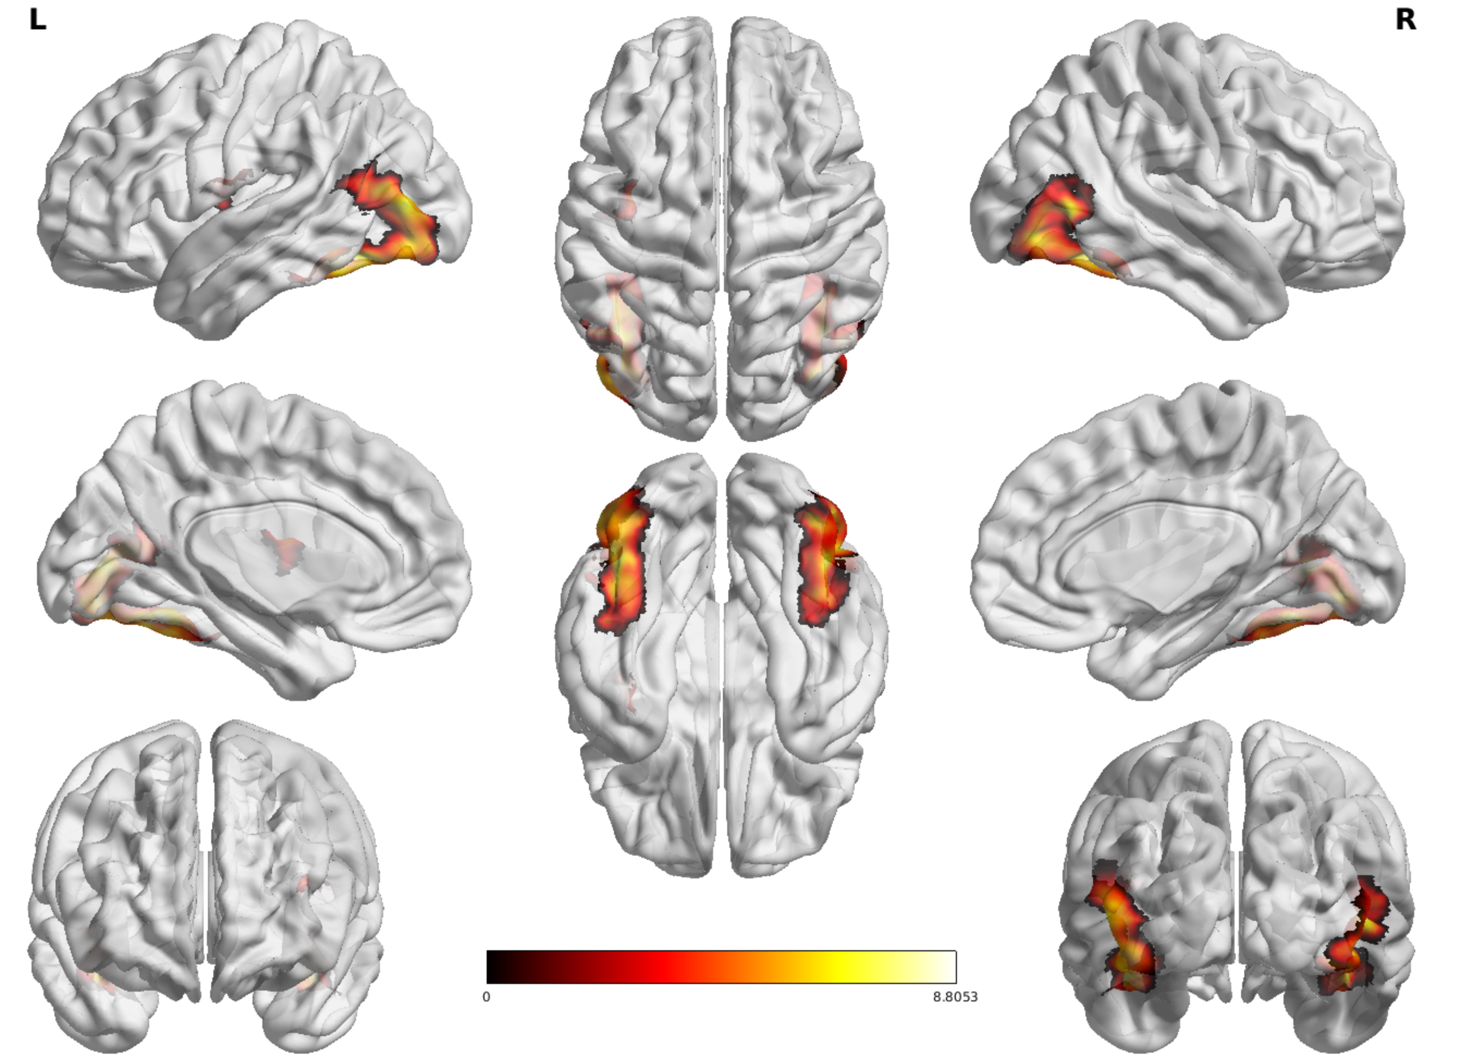

Figure S3. Whole-brain activity for all participants during encoding of positive > neutral scenes.

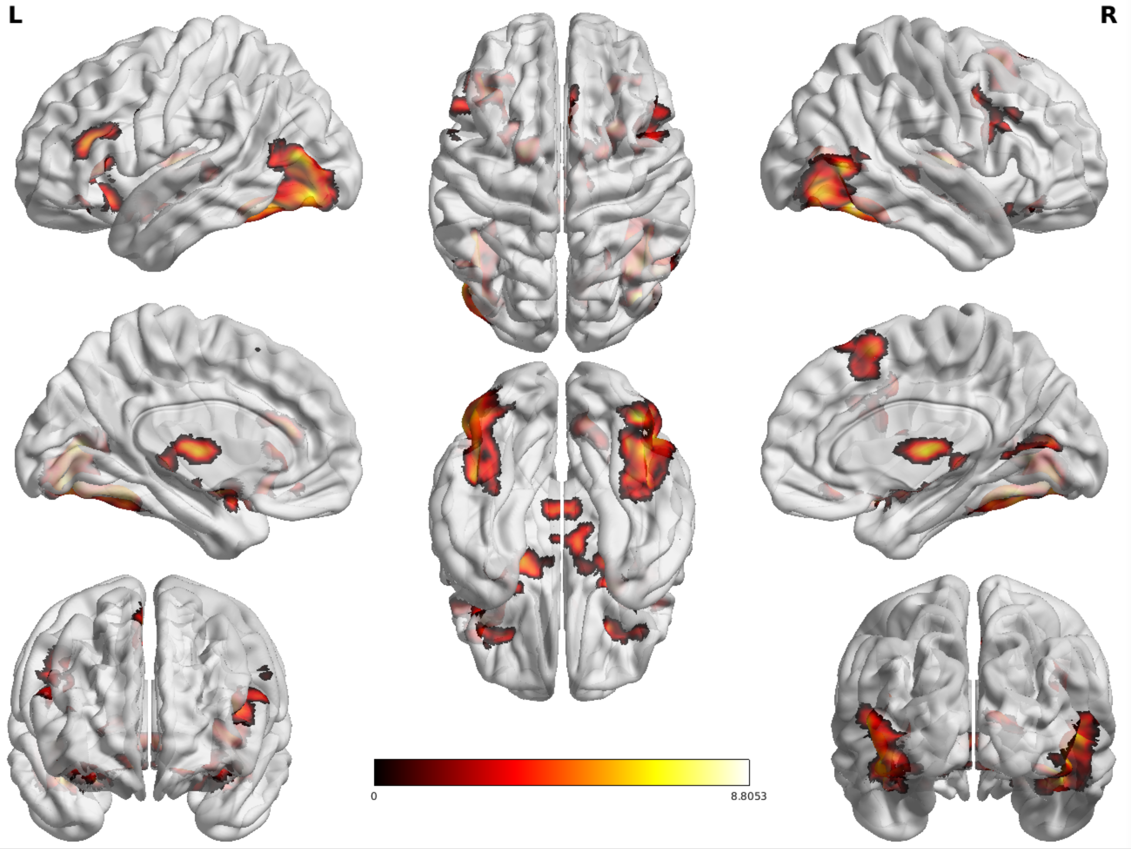

Figure S4. Whole-brain activity for all participants during encoding of negative > neutral scenes.

S.2.3 Expanded clusters for the effects of whole-brain activity during affective scene encoding on recall performance

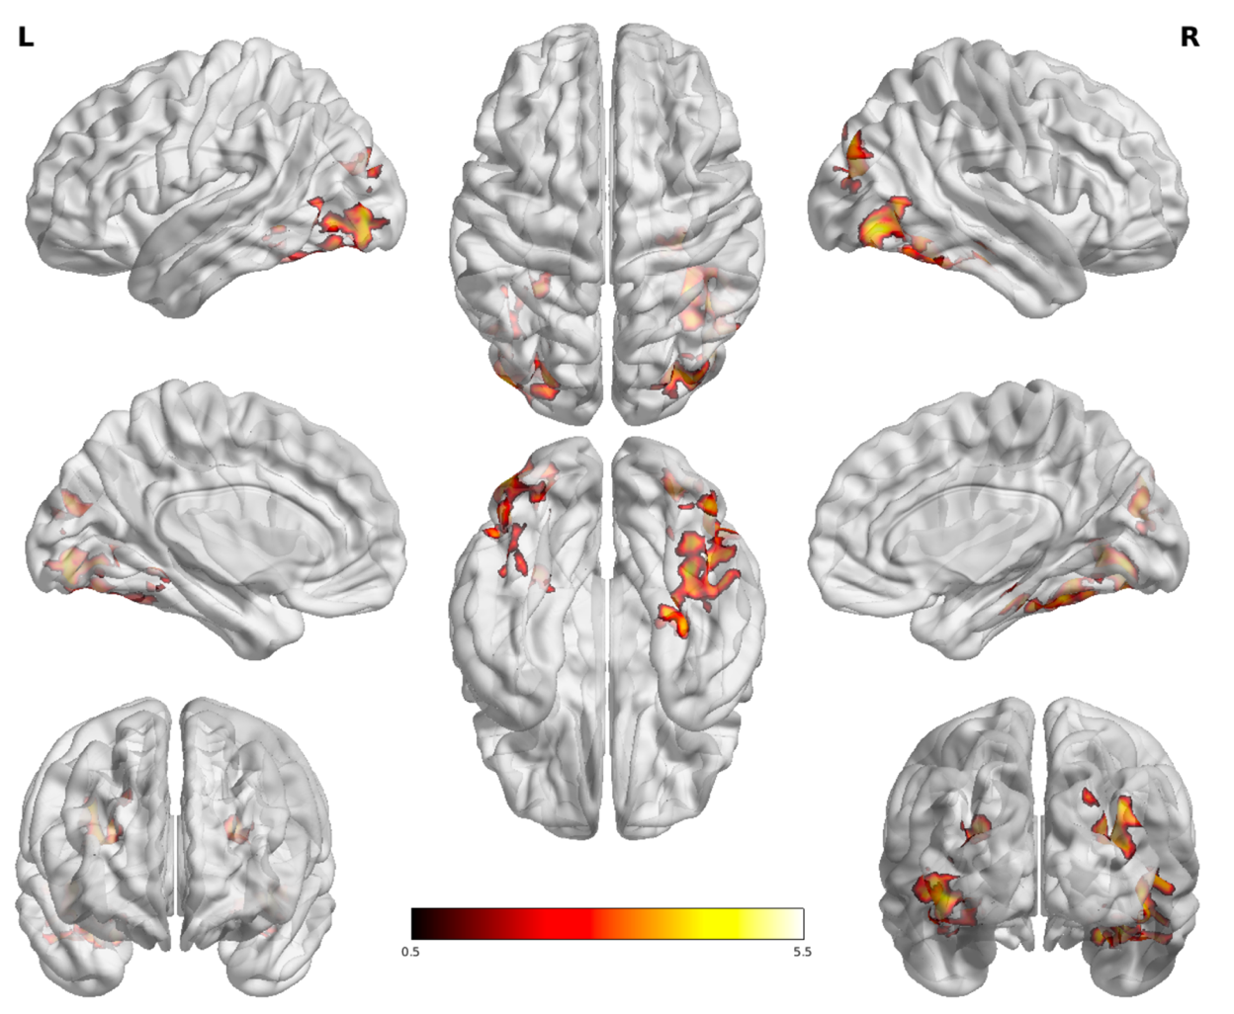
Figure S5. Positive-DM recall correlated positively with whole-brain activation during encoding of positive > neutral scenes in 4 main clusters: the right (x y z: 38, -54, -14; 1563 voxels, z-max=4.62) and left (x y z: -36, -64, -10; 1260 voxels; z-max=4.32) fusiform, as well as the right (x y z: 36, -84, 32; 485 voxels; z-max=3.98) and left (x y z: -26, -84, 24; 213 voxels; z-max=3.63) visual regions.

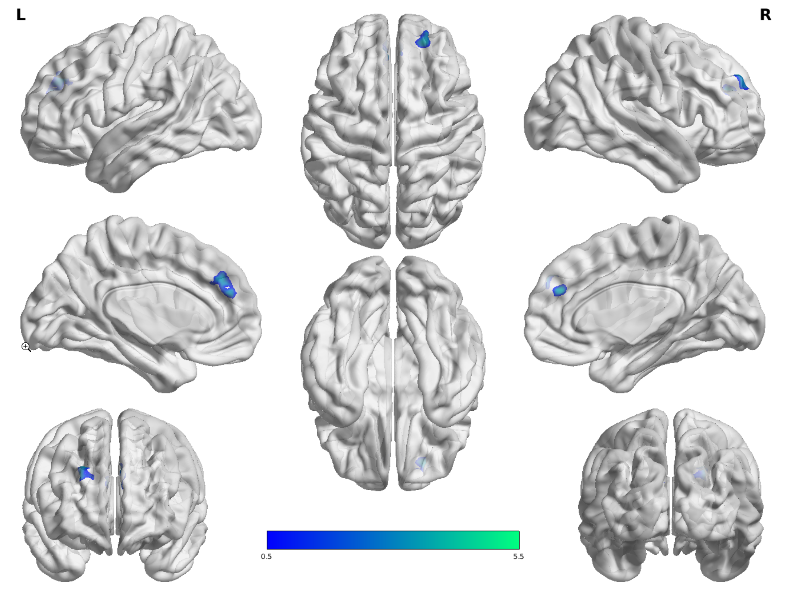
Figure S6. Positive-DM recall negatively correlated with whole-brain activation during encoding of positive > neutral scenes in 1 cluster: the dorsomedial prefrontal cortex (dmPFC; x y z: 0, 42, 26; 390 voxels; z-max=4.28)

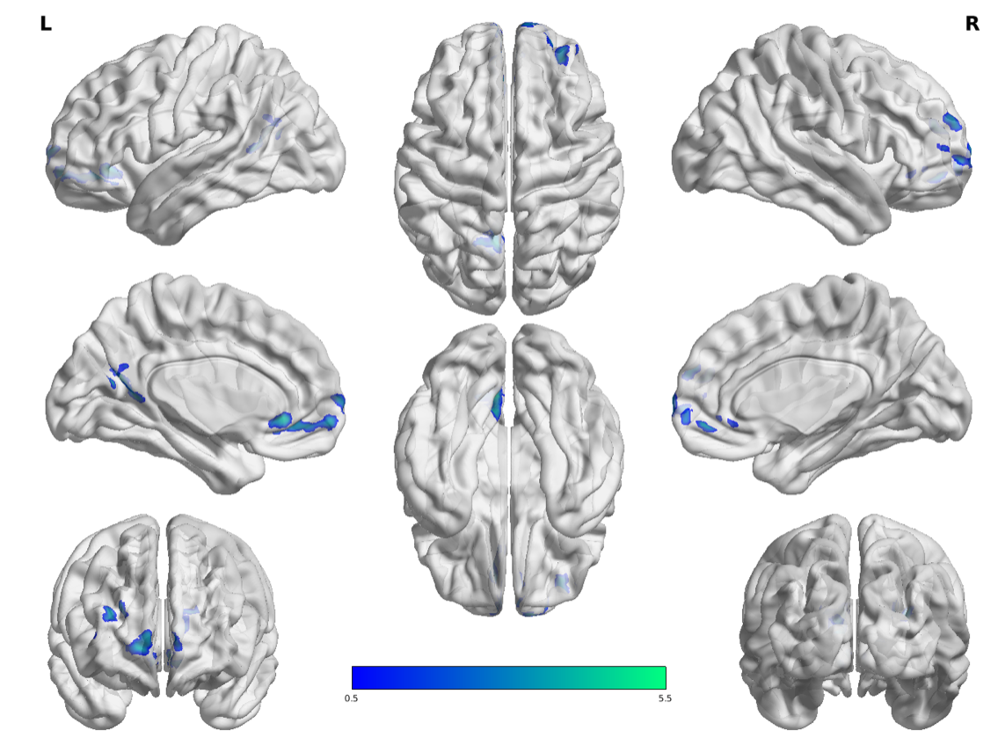
Figure S7. Negative-DM recall negatively correlated with whole-brain activation during encoding of negative > neutral scenes in 3 clusters: subgenual anterior cingulate cortex / ventromedial prefrontal cortex (sgACC / vmPFC; x y z: 4, 48, -6; 617 voxels; z-max=4.94) with some overlap in the left calcarine region (x y z: -8, -64, 18; 242 voxels, z-max=4.32) and right PFC (x y z: 28, 58, 22; 243 voxels; z-max=3.95)

References:
Abraham, Alexandre, Fabian Pedregosa, Michael Eickenberg, Philippe Gervais,
Andreas Mueller, Jean Kossaifi, Alexandre Gramfort, Bertrand Thirion, and Gael Varoquaux. 2014. “Machine Learning for Neuroimaging with Scikit-Learn.” Frontiers in Neuroinformatics 8. https://doi.org/10.3389/fninf.2014.00014.
Avants, B.B., C.L. Epstein, M. Grossman, and J.C. Gee. 2008. “Symmetric
Diffeomorphic Image Registration with Cross-Correlation: Evaluating Automated Labeling of Elderly and Neurodegenerative Brain.” Medical Image Analysis 12 (1): 26–41. https://doi.org/10.1016/j.media.2007.06.004.
Behzadi, Yashar, Khaled Restom, Joy Liau, and Thomas T. Liu. 2007. “A Component
Based Noise Correction Method (CompCor) for BOLD and Perfusion Based fMRI.” NeuroImage 37 (1): 90–101. https://doi.org/10.1016/j.neuroimage.2007.04.042.
Cox, Robert W., and James S. Hyde. 1997. “Software Tools for Analysis and
Visualization of fMRI Data.” NMR in Biomedicine 10 (4-5): 171–78. https://doi.org/10.1002/(SICI)1099-1492(199706/08)10:4/5<171::AID-NBM453>3.0.CO;2-L.
Dale, Anders M., Bruce Fischl, and Martin I. Sereno. 1999. “Cortical Surface-Based
Analysis: I. Segmentation and Surface Reconstruction.” NeuroImage 9 (2): 179–94. https://doi.org/10.1006/nimg.1998.0395.

Esteban, Oscar, Ross Blair, Christopher J. Markiewicz, Shoshana L. Berleant, Craig
Moodie, Feilong Ma, Ayse Ilkay Isik, et al. 2018. “FMRIPrep.” Software. Zenodo. https://doi.org/10.5281/zenodo.852659.
Esteban, Oscar, Christopher Markiewicz, Ross W Blair, Craig Moodie, Ayse Ilkay Isik,
Asier Erramuzpe Aliaga, James Kent, et al. 2018. “fMRIPrep: A Robust Preprocessing Pipeline for Functional MRI.” Nature Methods. https://doi.org/10.1038/s41592-018-0235-4.
Evans, AC, AL Janke, DL Collins, and S Baillet. 2012. “Brain Templates and
Atlases.” NeuroImage 62 (2): 911-22. https://doi.org/10.1016/j.neuroimage.2012.01.024.
Fonov, VS, AC Evans, RC McKinstry, CR Almli, and DL Collins. 2009. “Unbiased
Nonlinear Average Age-Appropriate Brain Templates from Birth to Adulthood.” NeuroImage 47, Supplement 1: S102. https://doi.org/10.1016/S1053-8119(09)70884-5.
Gorgolewski, K., C. D. Burns, C. Madison, D. Clark, Y. O. Halchenko, M. L. Waskom,
and S. Ghosh. 2011. “Nipype: A Flexible, Lightweight and Extensible Neuroimaging Data Processing Framework in Python.” Frontiers in Neuroinformatics 5: 13. https://doi.org/10.3389/fninf.2011.00013.
Gorgolewski, Krzysztof J., Oscar Esteban, Christopher J. Markiewicz, Erik Ziegler,
David Gage Ellis, Michael Philipp Notter, Dorota Jarecka, et al. 2018. “Nipype.” Software. Zenodo. https://doi.org/10.5281/zenodo.596855.
Greve, Douglas N, and Bruce Fischl. 2009. “Accurate and Robust Brain Image
Alignment Using Boundary-Based Registration.” NeuroImage 48 (1): 63–72. https://doi.org/10.1016/j.neuroimage.2009.06.060.
Jenkinson, Mark, Peter Bannister, Michael Brady, and Stephen Smith. 2002. “Improved
Optimization for the Robust and Accurate Linear Registration and Motion Correction of Brain Images.” NeuroImage 17 (2): 825–41. https://doi.org/10.1006/nimg.2002.1132.
Klein, Arno, Satrajit S. Ghosh, Forrest S. Bao, Joachim Giard, Yrjö Häme, Eliezer
Stavsky, Noah Lee, et al. 2017. “Mindboggling Morphometry of Human Brains.” PLOS Computational Biology13 (2): e1005350. https://doi.org/10.1371/journal.pcbi.1005350.
Lanczos, C. 1964. “Evaluation of Noisy Data.” Journal of the Society for Industrial and
Applied Mathematics Series B Numerical Analysis 1 (1): 76–85. https://doi.org/10.1137/0701007.
Power, Jonathan D., Anish Mitra, Timothy O. Laumann, Abraham Z. Snyder, Bradley L.
Schlaggar, and Steven E. Petersen. 2014. “Methods to Detect, Characterize, and Remove Motion Artifact in Resting State fMRI.” NeuroImage 84 (Supplement C): 320–41. https://doi.org/10.1016/j.neuroimage.2013.08.048.
Pruim, Raimon H. R., Maarten Mennes, Daan van Rooij, Alberto Llera, Jan K. Buitelaar,
and Christian F. Beckmann. 2015. “ICA-AROMA: A Robust ICA-Based Strategy for Removing Motion Artifacts from fMRI Data.” NeuroImage 112 (Supplement C): 267–77. https://doi.org/10.1016/j.neuroimage.2015.02.064.
Satterthwaite, Theodore D., Mark A. Elliott, Raphael T. Gerraty, Kosha Ruparel, James
Loughead, Monica E. Calkins, Simon B. Eickhoff, et al. 2013. “An improved framework for confound regression and filtering for control of motion artifact in the preprocessing of resting-state functional connectivity data.” NeuroImage 64 (1): 240–56. https://doi.org/10.1016/j.neuroimage.2012.08.052.
Tustison, N. J., B. B. Avants, P. A. Cook, Y. Zheng, A. Egan, P. A. Yushkevich, and J.
C. Gee. 2010. “N4ITK: Improved N3 Bias Correction.” IEEE Transactions on Medical Imaging 29 (6): 1310–20. https://doi.org/10.1109/TMI.2010.2046908.
Zhang, Y., M. Brady, and S. Smith. 2001. “Segmentation of Brain MR Images Through a
Hidden Markov Random Field Model and the Expectation-Maximization Algorithm.” IEEE Transactions on Medical Imaging 20 (1): 45–57. https://doi.org/10.1109/42.906424.

