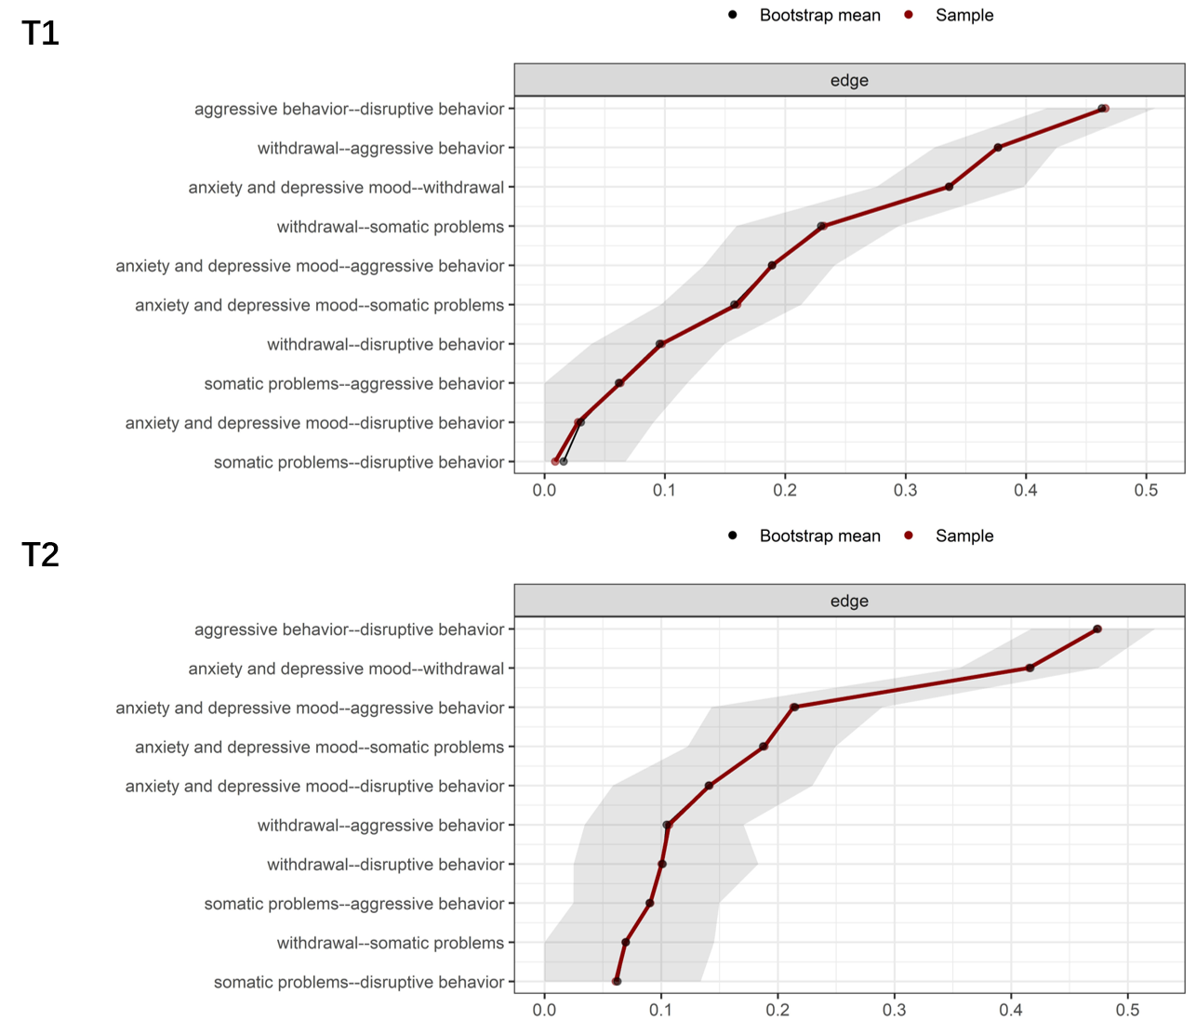

***Figure S1.*** Bootstrapped confidence intervals of estimated edge weights for contemporaneous networks in American preschoolers.

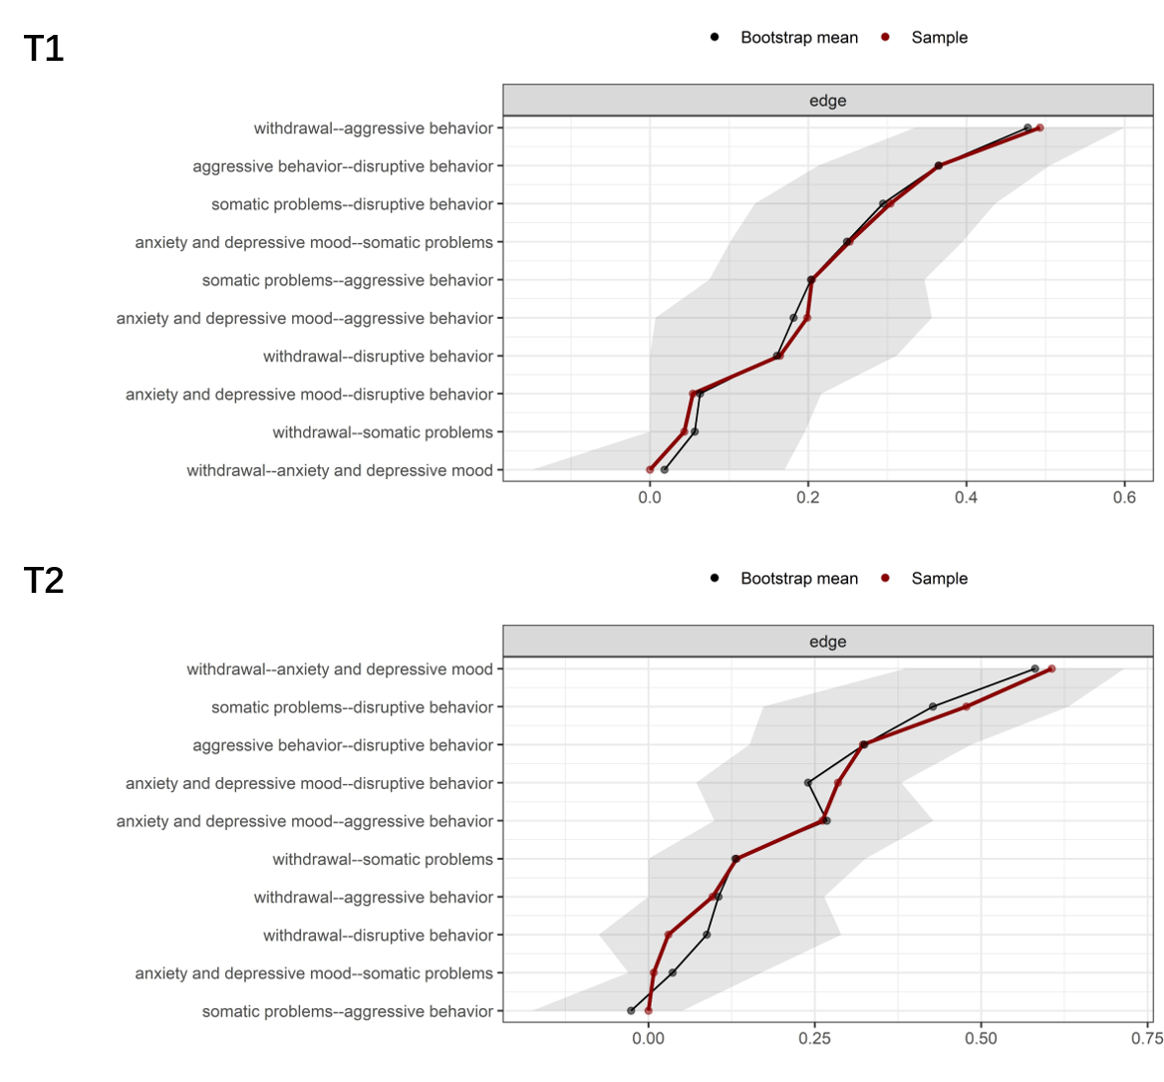

***Figure S2.*** Bootstrapped confidence intervals of estimated edge weights for cross-sectional networks in Chinese preschoolers.

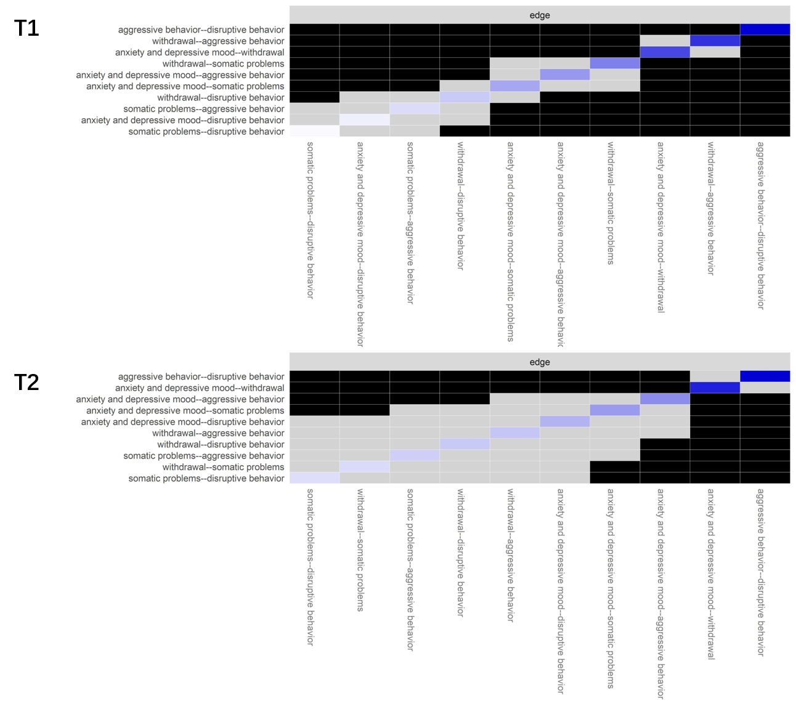

***Figure S3.*** Bootstrapped edge difference tests for cross-sectional networks in American preschoolers. Gray boxes represent edges that are not significantly different from each other, and black boxes represent significantly different edges.

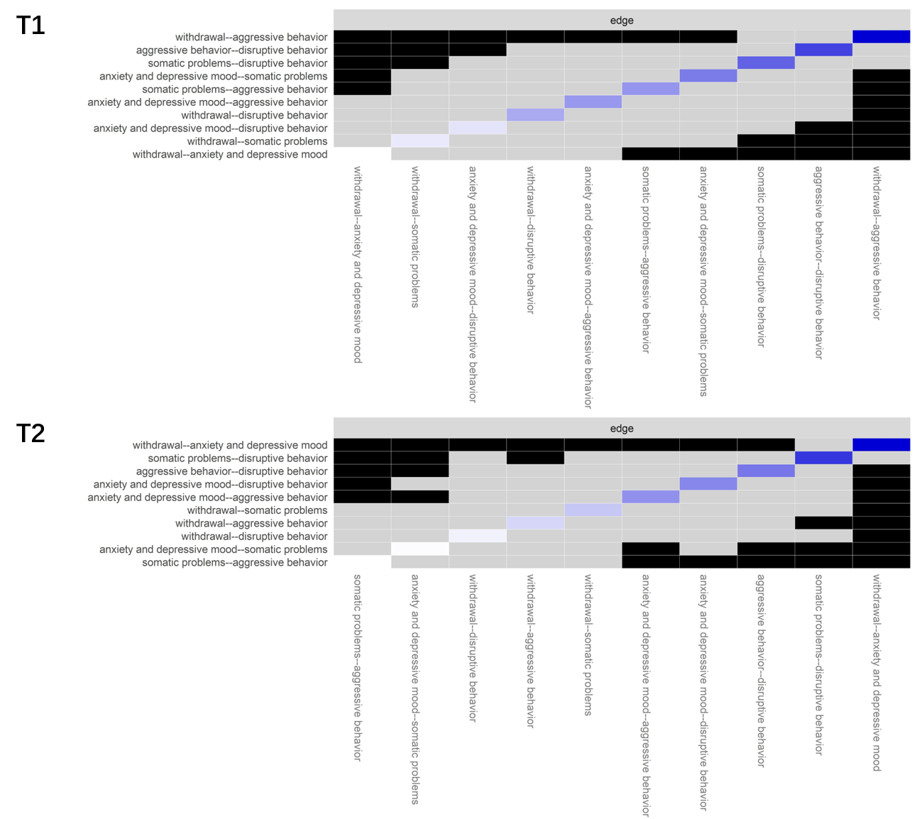

***Figure S4.*** Bootstrapped edge difference tests for cross-sectional networks in Chinese preschoolers. Gray boxes represent edges that are not significantly different from each other, and black boxes represent significantly different edges.

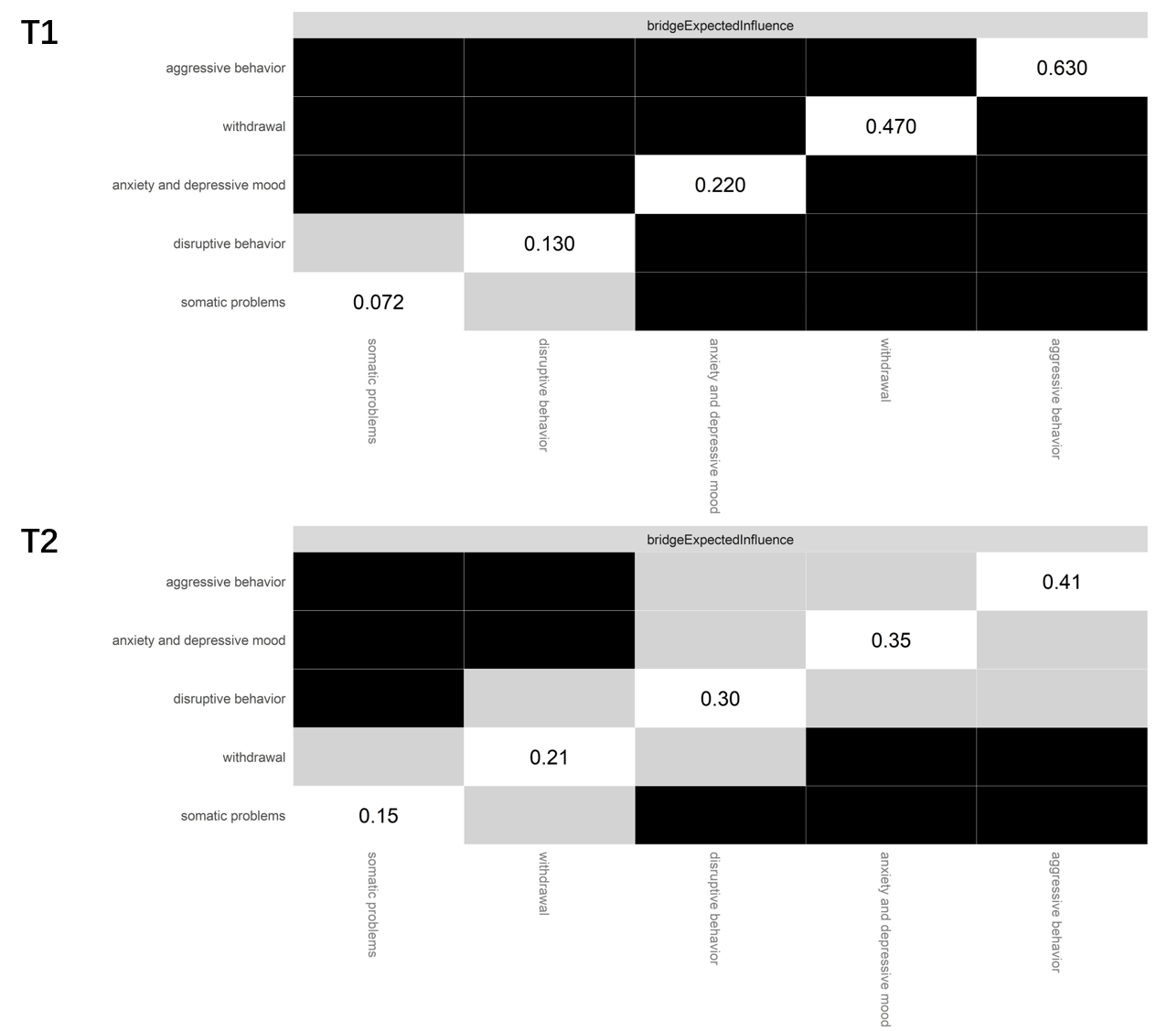

***Figure S5.*** Bootstrapped EI and bEI difference tests for cross-sectional networks in American preschoolers. Gray boxes represent edges that are not significantly different from each other, and black boxes represent significantly different edges.

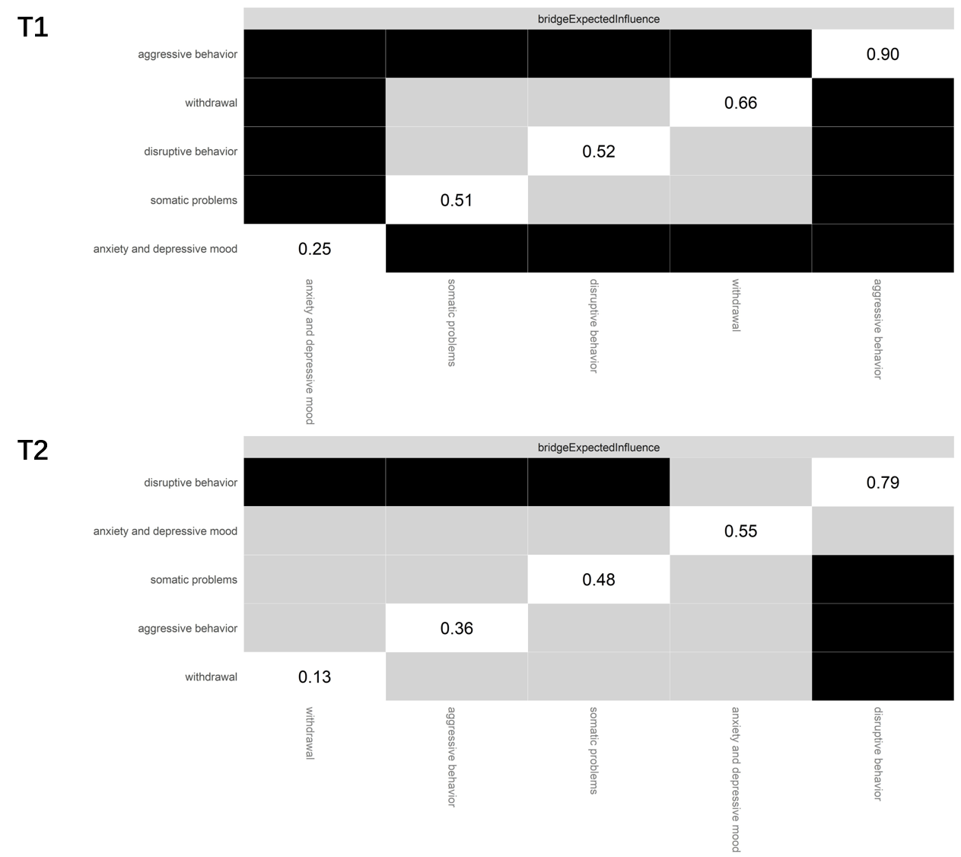

***Figure S6*.** Bootstrapped EI and bEI difference test for cross-sectional networks in Chinese preschoolers. Gray boxes represent edges that are not significantly different from each other, and black boxes represent significantly different edges.

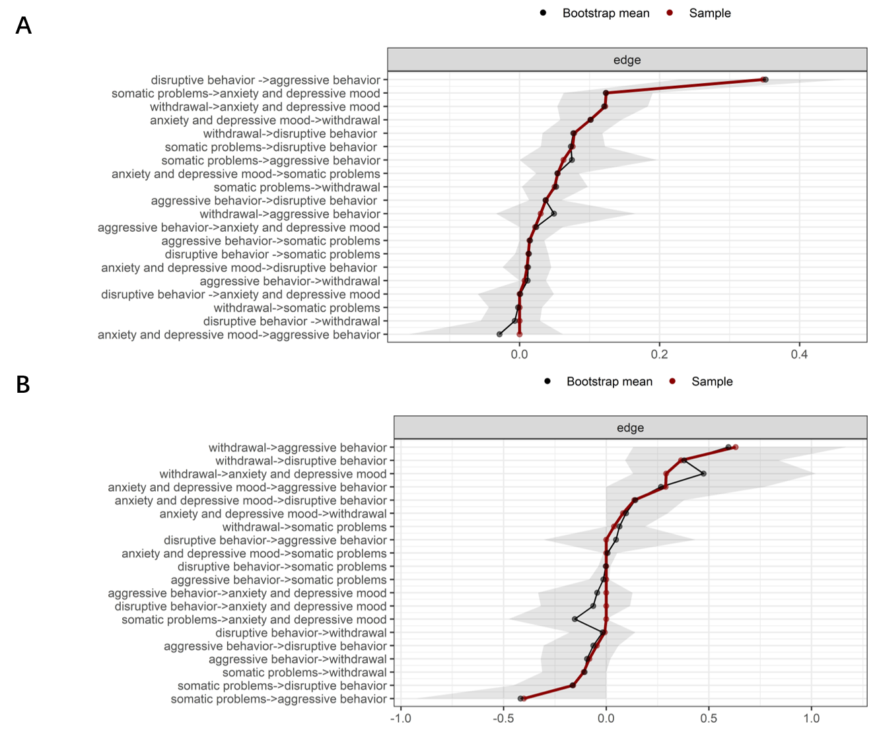

***Figure S7*.** Bootstrapped confidence intervals of estimated edge weights for cross-lagged panel networks in American (panel A) and Chinese (panel B) preschoolers.

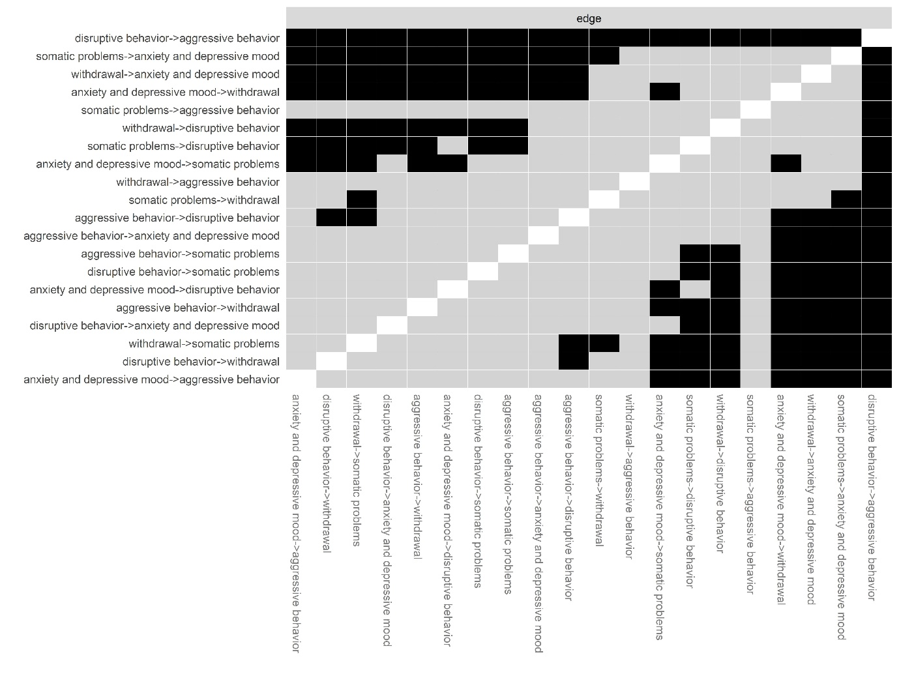

***Figure S8*.** Bootstrapped edge difference tests for cross-lagged panel network in American preschoolers. Gray boxes represent edges that are not significantly different from each other, and black boxes represent significantly different edges.

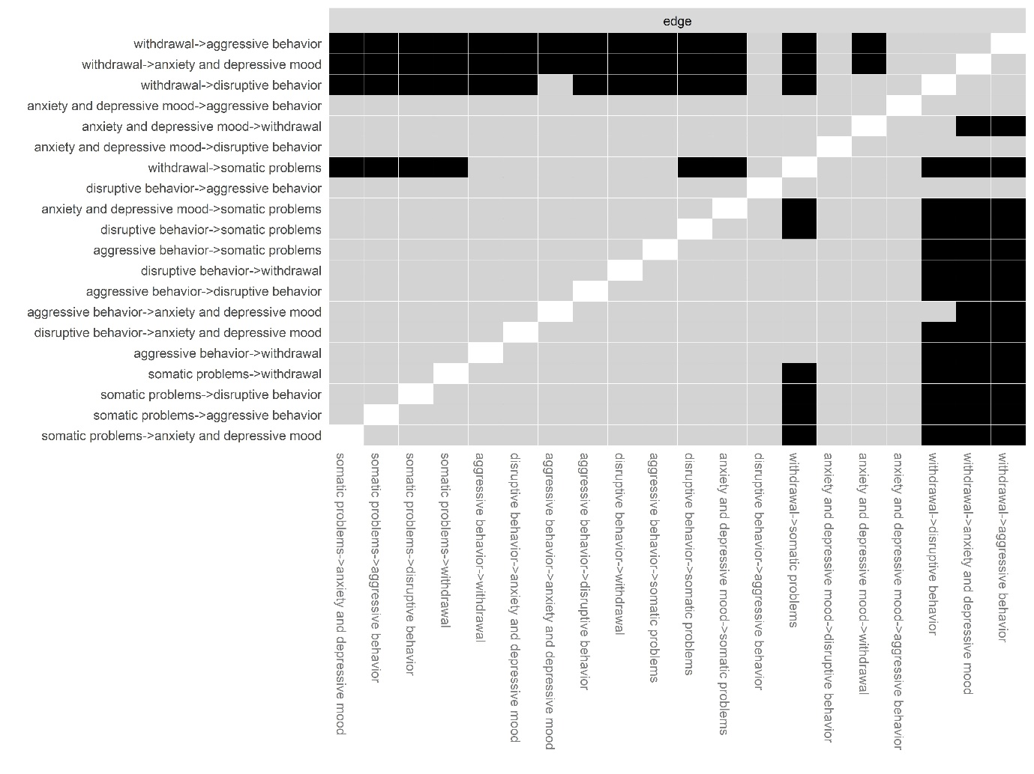

***Figure S9.*** Bootstrapped edge difference tests for cross-lagged panel network in American preschoolers. Gray boxes represent edges that are not significantly different from each other, and black boxes represent significantly different edges.

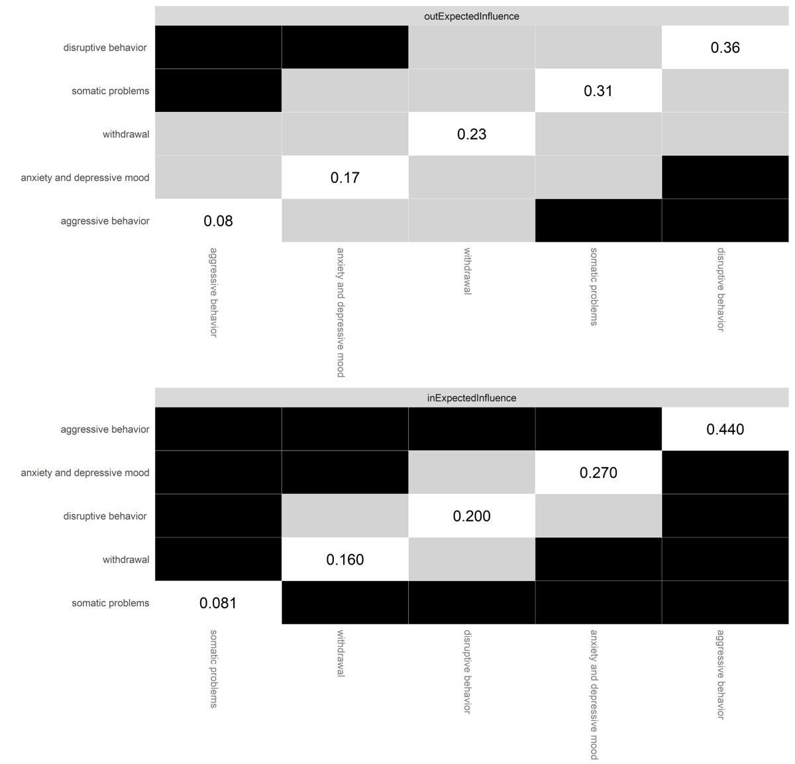

***Figure S10*.** Bootstrapped out-EI and in-EI difference tests for cross-lagged panel network in American preschoolers. Gray boxes represent edges that are not significantly different from each other, and black boxes represent significantly different edges.

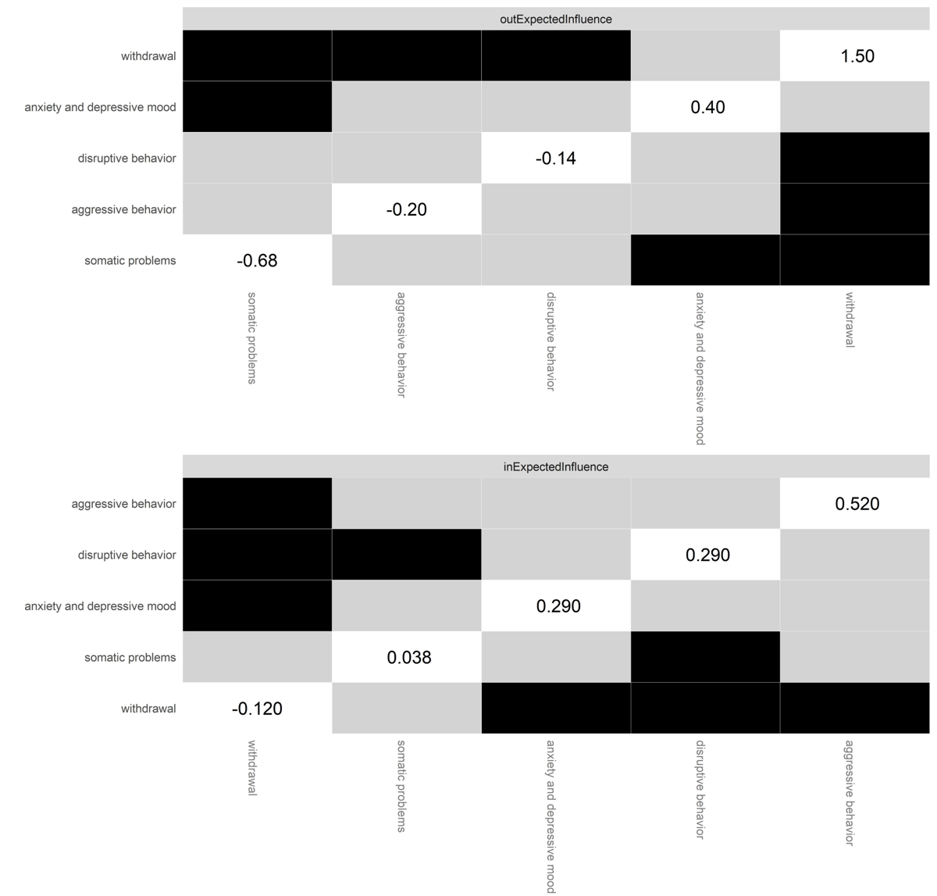***Figure S11.*** Bootstrapped out-EI and in-EI difference tests for cross-lagged panel network in Chinese preschoolers. Gray boxes represent edges that are not significantly different from each other, and black boxes represent significantly different edges.