|  |  |  |  |  |  |  |  |  |  |
| --- | --- | --- | --- | --- | --- | --- | --- | --- | --- |
| Supplementary Table S1  *Attrition Analyses for Cortisol Measurements* | | | | | | | | | |
| **Categorical Variables** | | | | | | | | | |
|  | T1 AUCg | | | T2 AUCg | | | Missing T3 AUCg | | |
|  | Available (n = 105) | Missing  (n = 137) | *X2*, *p*-value | Available  (n = 132) | Missing  (n = 110) | *X2*, *p*-value | Available  (n = 147) | Missing  (n = 95) | *X2*, *p*-value |
| Infant Race/Ethnicity  Non-Hispanic White  Non-White | 73  32 | 97  51 | *X2*= 0.28,  *p* = .597 | 93  39 | 77  44 | *X2*= 1.04,  *p* = .308 | 109  37 | 46  46 | *X2*= 7.94,  *p* = .005 |
| Infant Sex  Male  Female | 50  55 | 77  71 | *X2*= 0.32,  *p* = .573 | 70  62 | 57  64 | *X2*= 0.66,  *p* = .415 | 72  74 | 55  52 | *X2*= 0.04,  *p* = .841 |
| **Continuous Variables** | | | | | | | | | |
|  | T1 AUCg | | | T2 AUCg | | | T3 AUCg | | |
|  | Available  Mean | Missing  Mean | *t*-test, *p*-value | Available  Mean | Missing  Mean | *t*-test, *p*-value | Available  Mean | Missing  Mean | *t*-test, *p*-value |
| Income to Needs Ratio | 3.1 | 3.3 | *t* = -0.6,  *p* = .578 | 3.1 | 3.3 | *t* = -0.8,  *p* = .414 | 3.3 | 3.0 | *t* = 0.8,  *p* = .417 |
| Neighborhood Dangerousness | 4.05 | 3.3 | *t* = 1.0,  *p* = .306 | 3.5 | 3.7 | *t* = -0.3,  *p* = .746 | **2.9** | **4.5** | ***t* = -2.5,**  ***p* = .014** |
| Maternal Age (years) | 29.7 | 29.0 | *t* = 1.2,  *p* = .216 | **30.0** | **28.5** | ***t* = 2.6,**  ***p* = .009** | **30.4** | **27.7** | ***t* = 4.8,**  ***p* < .001** |
| Maternal Prenatal Anxiety | 43.3 | 44.6 | *t* = -0.8  *p* = .425 | 43.3 | 44.9 | *t* = -1.0,  *p* = .330 | 43.0 | 45.6 | *t* = -1.5,  *p* = .116 |
| Maternal Prenatal Depression | **5.1** | **6.2** | ***t* = -2.0,**  ***p* = .044** | 5.3 | 6.2 | *t* = -1.7,  *p* = .087 | 5.5 | 6.1 | *t* = -1.1,  *p* = .261 |
| Maternal Pre-Pregnancy BMI | 27.8 | 27.8 | *t* = 0.0,  *p* = .978 | **26.9** | **28.8** | ***t* = -2.1,**  ***p* = .038** | **27.0** | **29.0** | ***t* = -2.2,**  ***p* = .027** |
| Gravidity | 1.8 | 1.8 | *t* = -0.0  *p* = .972 | 1.7 | 1.9 | *t* = -0.7,  *p* = .463 | 1.7 | 1.9 | *t* = -0.7,  *p* = .480 |
| Maternal WAIS-IV Vocabulary (Raw) | 37.9 | 35.2 | *t* = -1.5  *p* = .131 | 37.5 | 35.1 | *t* = 1.4,  *p* = .173 | **38.5** | **32.9** | ***t* = 3.1,**  ***p* = .002** |
| T1 AUCg | - | - | *-* | 52.6 | 60.6 | *t* = -1.1,  *p* = .271 | 54.3 | 57.5 | *t* = -0.5,  *p* = .603 |
| T2 AUCg | 82.6 | 80.0 | *t* = 0.4,  *p* = .722 | - | - | - | **85.0** | **67.8** | ***t* = 2.4,**  ***p* = .22** |
| T3 AUCg | 92.5 | 92.8 | *t* = -0.2,  *p* = .965 | 89.4 | 100.4 | *t* = -1.3,  *p* = .188 | - | - | - |
| COG 6 mos | 108.6 | 106.0 | *t* = 1.3,  *p* = .200 | 108.1 | 105.9 | *t* = 1.1,  *p* = .275 | 109.2 | 104.0 | ***t* = 2.5,**  ***p* = .012** |
| LAN 6 mos | 100.1 | 100.2 | *t* = -0.0,  *p* = .975 | 103.2 | 100.6 | *t* = 0.4,  *p* = .687 | 101.4 | 98.5 | *t* = 1.5  *p* = .146 |
| COG 12 mos | 102.3 | 101.7 | *t* = 0.3,  *p* = .780 | 103.3 | 100.5 | *t* = 1.3,  *p* = .193 | 103.3 | 99.7 | *t* = 1.6,  *p* = .102 |
| LAN 12 mos | **95.0** | **90.7** | ***t* = 2.5,**  ***p* = .012** | 93.6 | 91.1 | *t* = 1.5,  *p* = .137 | **93.8** | **90.3** | ***t* = 2.0,**  ***p* = .046** |
| COG 24 mos | 100.0 | 97.8 | *t* = 0.9,  *p* = .387 | 98.7 | 98.9 | *t* = -0.1,  *p* = .926 | 100.2 | 96.1 | *t* = 1.5,  *p* = .128 |
| LAN 24 mos | 104.3 | 99.8 | *t* = 1.3,  *p* = .214 | 103.0 | 100.6 | *t* = 0.7,  *p* = .503 | **105.4** | **95.2** | ***t* = 2.7,**  ***p* = .009** |
| *Note*. Significant differences are bolded for clarity. LAN stands for Bayley language, COG stands for Bayley cognitive, AUCg stands for cortisol area under the curve with respect to the ground, and T1-T3 stand for trimester 1 – trimester 3, respectively. | | | | | | | | | |

|  |  |  |  |  |  |  |  |  |  |
| --- | --- | --- | --- | --- | --- | --- | --- | --- | --- |
| Supplementary Table S2  *Attrition Analyses for Bayley Scores* | | | | | | | | | |
| **Categorical Variables** | | | | | | | | | |
|  | 6 Month Bayley | | | 12 Month Bayley | | | 24 Month Bayley | | |
|  | Available (n = 191) | Missing  (n = 62) | *X2*, *p*-value | Available  (n = 170) | Missing  (n = 83) | *X2*, *p*-value | Available  (n = 122) | Missing  (n = 131) | *X2*, *p*-value |
| Infant Race/Ethnicity  Non-Hispanic White  Non-White | 135  56 | 35  27 | *X2*= 3.7,  *p* = .055 | 123  47 | 47  36 | *X2*= 5.6,  *p* = .018 | 99  23 | 71  66 | *X2*= 19.6,  *p* < .001 |
| Infant Sex  Male  Female | 102  89 | 25  37 | *X2*= 2.7,  *p* = .100 | 86  84 | 41  42 | *X2*= 0.0,  *p* = .965 | 62  60 | 65  66 | *X2*= 0.0,  *p* = .948 |
| **Continuous Variables** | | | | | | | | | |
|  | 6 Month Bayley | | | 12 Month Bayley | | | 24 Month Bayley | | |
|  | Available  Mean | Missing  Mean | *t*-test,  *p*-value | Available  Mean | Missing  Mean | *t*-test,  *p*-value | Available  Mean | Missing  Mean | *t*-test,  *p*-value |
| Income to Needs Ratio | 3.3 | 2.7 | *t* = 1.6,  *p* = .112 | **3.4** | **2.6** | ***t* = 2.2,**  ***p* = .032** | **3.6** | **2.7** | ***t* = 2.6,**  ***p* = .009** |
| Neighborhood Dangerousness | **3.2** | **5.1** | ***t* = -2.2,**  ***p* = .034** | 3.3 | 4.4 | *t* = 1.5,  *p* = .137 | **2.5** | **4.7** | *t* = -3.4,  *p* = .001 |
| Maternal Age (years) | 29.4 | 28.6 | *t* = 1.2,  *p* = .244 | 29.7 | 28.4 | *t* = 1.8,  *p* = .071 | **30.0** | **28.6** | ***t* = 2.5,**  ***p* = .012** |
| Maternal Prenatal Anxiety | 44.6 | 42.5 | *t* = 1.1,  *p* = .269 | 44.7 | 42.8 | *t* = 1.1,  *p* = .277 | 44.7 | 43.4 | *t* = -0.8,  *p* = .411 |
| Maternal Prenatal Depression | 5.5 | 6.4 | *t* = -1.3,  *p* = .208 | 5.7 | 5.7 | *t* = 0.1,  *p* = .918 | 5.6 | 5.8 | *t* = -0.4,  *p* = .656 |
| Maternal Pre-Pregnancy BMI | 28.1 | 27.0 | *t* = 1.1,  *p* = .285 | 28.2 | 26.9 | *t* = 1.4,  *p* = .166 | 27.0 | 28.5 | *t* = -1.7,  *p* = .087 |
| Gravidity | 1.8 | 1.9 | *t* = -0.2  *p* = .842 | 1.8 | 1.9 | *t* = -0.5,  *p* = .644 | **1.5** | **2.1** | ***t* = -2.3,**  ***p* = .022** |
| Maternal WAIS-IV Vocabulary (Raw) | 36.6 | 34.8 | *t* = 0.8,  *p* = .413 | 36.6 | 34.4 | *t* = 0.8,  *p* = .415 | **37.4** | **33.8** | *t* = 1.8,  *p* = .076 |
| T1 AUCg | 52.5 | 61.6 | *t* = -1.2  *p* = .233 | 53.5 | 58.2 | *t* = -0.7,  *p* = .490 | 3.9 | 4.0 | *t* = -1.1,  *p* = .271 |
| T2 AUCg | 84.2 | 73.3 | *t* = 1.4,  *p* = .159 | 80.4 | 83.2 | *t* = -0.3,  *p* = .739 | 4.2 | 4.3 | *t* = -1.1,  *p* = .259 |
| T3 AUCg | 92.5 | 92.8 | *t* = -0.0,  *p* = .965 | 93.5 | 90.3 | *t* = 0.4,  *p* = .722 | 4.4 | 4.5 | *t* = -0.2,  *p* = .876 |
| COG 6 mos | - | - | *-* | 107.0 | 106.9 | *t* = 0.1,  *p* = .956 | 108.2 | 105.4 | *t* = 1.4,  *p* = .176 |
| LAN 6 mos | - | - | *-* | 100.1 | 100.5 | *t* = -0.2,  *p* = .871 | 98.6 | 102.2 | *t* = -1.9  *p* = .05 |
| COG 12 mos | 101.8 | 103.1 | *t* = -0.3,  *p* = .780 | **-** | **-** | *t* = 1.31,  *p* = .193 | 103.0 | 99.9 | *t* = 1.3,  *p* = .195 |
| LAN 12 mos | 92.7 | 89.5 | *t* = 1.0,  *p* = .314 | **-** | **-** | *t* = 1.5,  *p* = .137 | 92.8 | 91.7 | *t* = 0.6,  *p* = .556 |
| COG 24 mos | 98.6 | 100.4 | *t* = -0.3,  *p* = .775 | 98.8 | 98.2 | *t* = 0.1,  *p* = .911 | **-** | **-** | **-** |
| LAN 24 mos | 102.3 | 97.5 | *t* = 0.7,  *p* = .434 | 102.6 | 94.8 | *t* = 1.6,  *p* = .131 | **-** | **-** | **-** |
| *Note*. Significant differences are bolded for clarity. LAN stands for Bayley language, COG stands for Bayley cognitive, AUCg stands for cortisol area under the curve with respect to the ground, and T1-T3 stand for trimester 1 – trimester 3, respectively. | | | | | | | | | |

|  |  |  |  |  |
| --- | --- | --- | --- | --- |
| Supplementary Table S3  *Cortisol and Bayley Scores: Moderation by Sex* | | | | |
| Path | Males  *B* (SE), *p*-value | Females  *B* (SE), *p*-value | Constraining Paths to be Equal  *X2*, df, *p*-value |
| T1 AUCg 🡪 COG (6mos) | -0.15 (0.09), *p* = .089 | 0.01 (0.10), *p* = .929 | 1.85, 1, *p* = .173 |
| T2 AUCg 🡪 COG (6mos) | 0.11 (0.06), *p* = .038 | 0.05 (0.04), *p* = .296 | 0.90, 1, *p* = .344 |
| T3 AUCg 🡪 COG (6mos) | 0.00 (0.07), *p* = .974 | -0.03 (0.05), *p* = .567 | 0.16, 1, *p* = .682 |
| T1 AUCg 🡪 LAN (6mos) | -0.07 (0.08), *p* = .395 | -0.10 (0.10), *p* = .291 | 0.11, 1, *p* = .745 |
| T2 AUCg 🡪 LAN (6mos) | 0.03 (0.05), *p* = .555 | 0.02 (0.04), *p* = .647 | 0.02, 1, *p* = .897 |
| T3 AUCg 🡪 LAN (6mos) | -0.02 (0.06), *p* = .682 | -0.02 (0.05), *p* = .755 | 0.01, 1, *p* = .914 |
| T1 AUCg 🡪 COG (12mos) | -0.20 (0.08), *p* = .007 | -0.07 (0.10), *p* = .427 | 1.28, 1, *p* = .258 |
| T2 AUCg 🡪 COG (12mos) | 0.02 (0.05), *p* = .682 | -0.02 (0.06), *p* = .700 | 0.32, 1, *p* = .569 |
| T3 AUCg 🡪 COG (12mos) | 0.04 (0.05), *p* = .444 | 0.05 (0.05), *p* = .310 | 0.02, 1, *p* = .893 |
| T1 AUCg 🡪 LAN (12mos) | -0.18 (0.06), *p* = .002 | -0.07 (0.10), *p* = .461 | 1.08, 1, *p* = .298 |
| T2 AUCg 🡪 LAN (12mos) | -0.03 (0.04), *p* = .385 | -0.06 (0.06), *p* = .373 | 0.12, 1, *p* = .734 |
| T3 AUCg 🡪 LAN (12mos) | -0.02 (0.04), *p* = .626 | -0.02 (0.04), *p* = .609 | 0.00, 1, *p* = .971 |
| T1 AUCg 🡪 COG (24mos) | 0.04 (0.11), *p* = .711 | 0.06 (0.11), *p* = .592 | 0.01, 1, *p* = .904 |
| T2 AUCg 🡪 COG (24mos) | -0.06 (0.09), *p* = .521 | -0.08 (0.07), *p* = .274 | 0.03, 1, *p* = .863 |
| T3 AUCg 🡪 COG (24mos) | -0.01 (0.09), *p* = .903 | 0.01 (0.06), *p* = .844 | 0.05, 1, *p* = .830 |
| T1 AUCg 🡪 LAN (24mos) | 0.22 (0.14), *p* = .109 | 0.11 (0.16), *p* = .517 | 0.36, 1, *p* = .550 |
| T2 AUCg 🡪 LAN (24mos) | -0.11 (0.10), *p* = .308 | -0.17 (0.11), *p* = .104 | 0.23, 1, *p* = .636 |
| T3 AUCg 🡪 LAN (24mos) | -0.05 (0.12), *p* = .685 | 0.13 (0.08), *p* = .110 | 1.66, 1, *p* = .198 |

|  |  |  |  |  |
| --- | --- | --- | --- | --- |
| Supplementary Table S4  *Cortisol and Executive Functioning: Moderation by Sex* | | | | |
| Path | Males  *B* (SE), *p*-value | Females  *B* (SE), *p*-value | Constraining Paths to be Equal  *X2*, df, *p*-value |
| T1 AUCg 🡪 Snack Delay | -0.20 (0.08), *p* = .010 | -0.07 (0.10), *p* = .472 | 1.27, 1, *p* = .259 |
| T2 AUCg 🡪 Snack Delay | -0.02 (0.05), *p* = .715 | -0.10 (0.06), *p* = .126 | 1.87, 1, *p* = .171 |
| T3 AUCg 🡪 Snack Delay | 0.12 (0.06), *p* = .031 | 0.03 (0.05), *p* = .525 | 4.54, 1, *p* = .031 |
| T1 AUCg 🡪 Spin the Pots | -0.00 (0.02), *p* = .890 | -0.01 (0.08), *p* = .478 | 0.12, 1, *p* = .733 |
| T2 AUCg 🡪 Spin the Pots | 0.00 (0.01), *p* = .874 | 0.00 (0.05), *p* = .829 | 0.00, 1, *p* = .979 |
| T3 AUCg 🡪 Spin the Pots | -0.01 (0.01), *p* = .633 | -0.00 (0.06), *p* = .933 | 0.15, 1, *p* = .703 |
| T1 AUCg 🡪 Reverse Categorization | 0.00 (0.04), *p* = .959 | -0.04 (0.04), *p* = .327 | 0.45, 1, *p* = .501 |
| T2 AUCg 🡪 Reverse Categorization | -0.06 (0.02), *p* = .003 | 0.00 (0.02), *p* = .982 | 3.21, 1, *p* = .073 |
| T3 AUCg 🡪 Reverse Categorization | 0.05 (0.03), *p* = .058 | 0.03 (0.02), *p* = .047 | 0.43, 1, *p* = .511 |

|  |  |  |  |  |  |  |
| --- | --- | --- | --- | --- | --- | --- |
| Supplementary Table S5  *Parameter Estimates of the Association between Cortisol AUCg across Pregnancy and Bayley-III Scores Including Bayley Assessments that were Coded to have Significant Threat to Data Integrity* | | | | | | |
| **Autoregressive Paths** | | | | | | |
|  | *B* (SE)  [95% C.I.] |  |  |  |  |  |
| AUCg T1 🡪 AUCg T2 | 0.32 (0.20)  [-0.08, 0.71] |  |  |  |  |  |
| AUCg T1 🡪 AUCg T3 | **0.54, (0.14)**  **[0.28, 0.81]** |  |  |  |  |  |
| AUCg T2 🡪 AUCg T3 | **0.21, (0.08)**  **[0.05, 0.36]** |  |  |  |  |  |
| **Associations with Cognitive Outcomes** | | | | | | |
|  | LAN 6 Months | COG 6 Months | LAN 12 Months | COG 12 Months | LAN 24 Months | COG 24 Months |
|  | *B* (SE)  [95% C.I.] | *B* (SE)  [95% C.I.] | *B* (SE)  [95% C.I.] | *B* (SE)  [95% C.I.] | *B* (SE)  [95% C.I.] | *B* (SE)  [95% C.I.] |
| AUCg T1 | -0.08 (0.08)  [-0.23, 0.06] | -0.08 (0.08)  [-0.24, 0.07] | **-0.15 (0.05)**  **[-0.24, -0.05]** | **-0.16 (0.07)**  **[-0.30, -0.03]** | 0.09 (0.10)  [-0.10, 0.28] | 0.00 (0.07)  [-0.13, 0.14] |
| AUCg T2 | 0.04 (0.03)  [-0.02, 0.10] | **0.09 (0.04)**  **[0.02, 0.16]** | -0.04 (0.03)  [-0.10, 0.02] | -0.00 (0.04)  [-0.08, 0.07] | **-0.15 (0.06)**  **[-0.26, -0.03]** | -0.08 (0.05)  [-0.17, 0.02] |
| AUCg T3 | -0.03 (0.04)  [-0.11, 0.05] | 0.00 (0.04)  [-0.08, 0.08] | -0.02 (0.03)  [-0.08, 0.03] | 0.05 (0.04)  [-0.03, 0.12] | 0.09 (0.05)  [-0.01, 0.20] | 0.05 (0.04)  [-0.03, 0.13] |
| **Residual Correlations** | | | | | | |
|  | LAN 6  Months | COG 6  Months | LAN 12 Months | COG 12 Months | LAN 24 Months | COG 24 Months |
|  | *r* [95% C.I.] | *r* [95% C.I.] | *r* [95% C.I.] | *r* [95% C.I.] | *r* [95% C.I.] | *r* [95% C.I.] |
| COG 6 Months | **.29 [.15, .43]** | - |  |  |  |  |
| LAN 12 Months | **.19 [.02, .37]** | **.39 [.22, .55]** | - |  |  |  |
| COG 12 Months | .04 [-.14, .21] | .**19 [.02, .36]** | **.41 [.27, .55]** | - |  |  |
| LAN 24 Months | .03 [-.18, .23] | .17 [-.04, .37] | **.35 [.16, .54]** | **.20 [.00, .41]** | - |  |
| COG 24 Months | -.07 [-.28, .13] | .18 [-.02, .40] | **.31 [.12, .51]** | **.22 [.02, .43]** | **.61 [.48, .73]** | - |
| *Note*. Beta coefficients are unstandardized. Significant associations are bolded for clarity. Covariates included family income-to-needs ratio, maternal age, maternal depressive symptoms, maternal anxious symptoms, neighborhood dangerousness, gravidity, maternal pre-pregnancy BMI, and infant sex. LAN stands for Bayley language, COG stands for Bayley cognitive, AUCg stands for cortisol area under the curve with respect to the ground, and T1-T3 stand for trimester 1 – trimester 3, respectively. | | | | | | |

|  |  |  |  |
| --- | --- | --- | --- |
| Supplementary Table S6  *Parameter Estimates of the Association between Cortisol AUCg across Pregnancy and Executive Functioning Scores at 24 Months* | | | |
| **Autoregressive Paths** | | | |
|  | *B* (SE) [95% C.I.] |  |  |
| AUCg T1 🡪 AUCg T2 | 0.37 (0.19) [-0.00, 0.73] |  |  |
| AUCg T1 🡪 AUCg T3 | **0.55 (0.13) [0.29, 0.80]** |  |  |
| AUCg T2 🡪 AUCg T3 | **0.18 (0.08) [0.02, 0.34]** |  |  |
| **Associations with Cognitive Outcomes** | | | |
|  | Snack Delay | Spin the Pots | Reverse Categorization |
|  | *B* (SE) [95% C.I.] | *B* (SE) [95% C.I.] | *B* (SE) [95% C.I.] |
| AUCg T1 | -0.11 (0.06) [-0.23, 0.01] | 0.01 (0.01) [-0.02, 0.03] | 0.01 (0.03) [-0.06, 0.07] |
| AUCg T2 | 0.04 (0.04) [-0.04, 0.12] | 0.00 (0.01) [-0.01, 0.02] | -0.02 (0.02) [-0.05, 0.01] |
| AUCg T3 | 0.05 (0.04) [-0.02, 0.13] | -0.00 (0.01) [-0.01, 0.01] | **0.03 (0.01) [0.00, 0.06]** |
| **Residual Correlations** | | | |
|  | Snack Delay | Spin the Pots | Reverse Categorization |
|  | *r* [95% C.I.] | *r* [95% C.I.] | *r* [95% C.I.] |
| Spin the Pots | -.03 [-.22, .17] | - |  |
| Reverse Categorization | .20 [-.02, .42] | -.13 [-.38, .13] | - |
| *Note*. Beta coefficients are unstandardized. Significant associations are bolded for clarity. Covariates included income to needs ratio, maternal age, maternal anxiety, maternal depression, maternal pre-pregnancy BMI, gravidity, infant race, and infant sex. Wake time and post conceptual age were also included as time-varying covariates. LAN stands for Bayley language, COG stands for Bayley cognitive, AUCg stands for cortisol area under the curve with respect to the ground, and T1-T3 stand for trimester 1 – trimester 3, respectively. | | | |

**Supplementary Figure S1**

*Directed Acyclic Graph of Assumed Dependencies Between Prenatal Cortisol Exposure, Neurocognitive Development, and Sociodemographic and Other Prenatal Variables*

*Note*. The primary exposure variable (prenatal cortisol exposure) is highlighted in green, and the primary outcome variable (neurocognitive development) is highlighted in blue and labeled with an I. Unadjusted mediators are depicted in blue. Variables with white circles represent those that, if adjusted for, would allow for identifying the unconfounded effect of prenatal cortisol exposure on neurocognitive development. The figure was made with the program dagitty version 3.1.

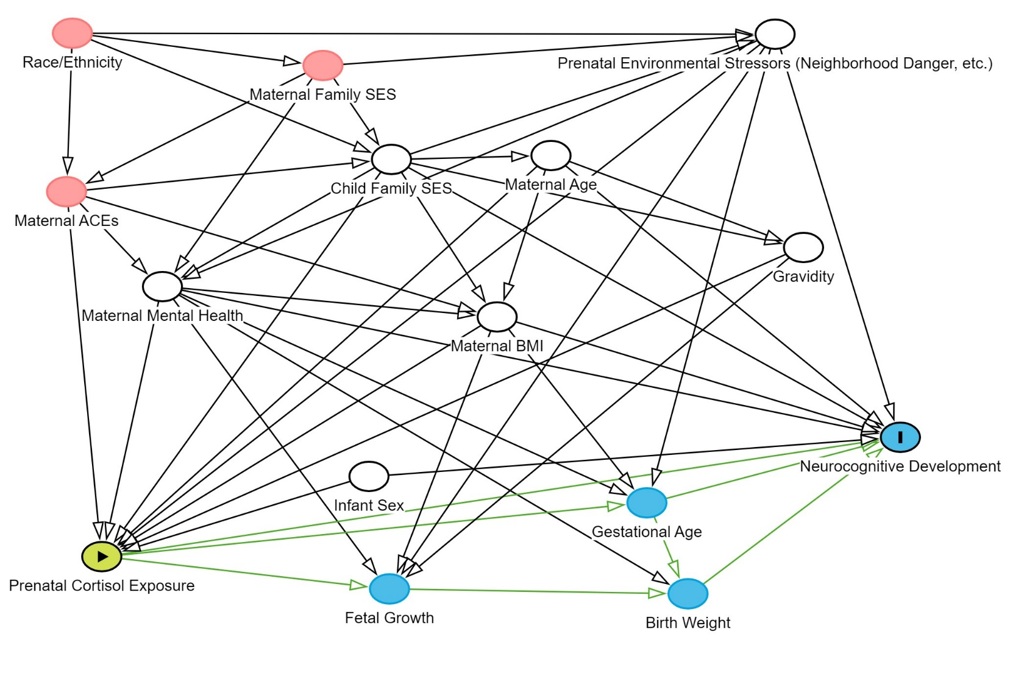

AUCg

Trimester 1

σAUC1

AUCg

Trimester 3

σAUC3

AUCg

Trimester 2

σAUC2

*B1*

*B2*

1

μ1

μ2

μ3

**Supplementary Figure S2**

*Path Diagram of Simplex Model fit to Cortisol AUCg Across Pregnancy*

*B3*

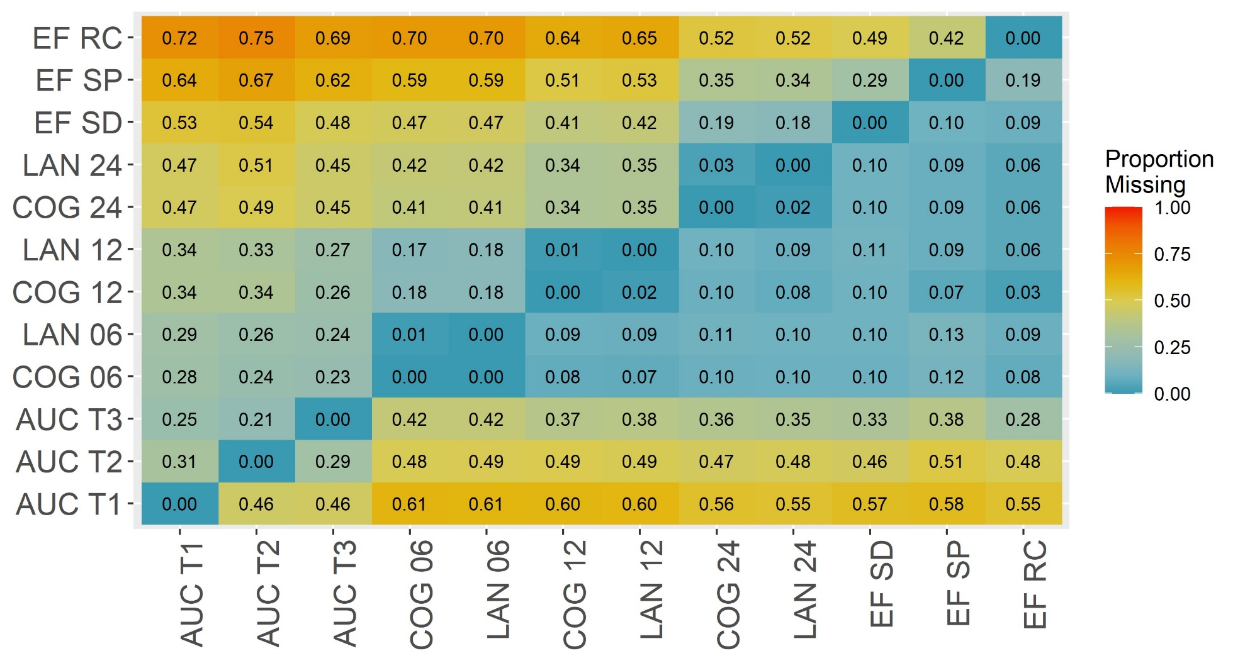

**Supplementary Figure S3**

*Heatmap of The Proportion of Missingness Conditional on Having an Observation for Each Variable*

*Note*. This figure depicts the proportion of missingness on a given variability conditional on having an observed measurement on another variable. For example, the value in row 1, column 1 represents the proportion of missingness on Reverse Categorization at 24 months among individuals with an observed AUC measurement at trimester 1. The values in the plot represent the proportion of missingness. AUC = cortisol AUC, T = trimester, COG = Bayley Cognitive, LAN = Bayley Language, EF = executive functioning, SP = spin the pots, SD = snack delay, RC = reverse categorization.

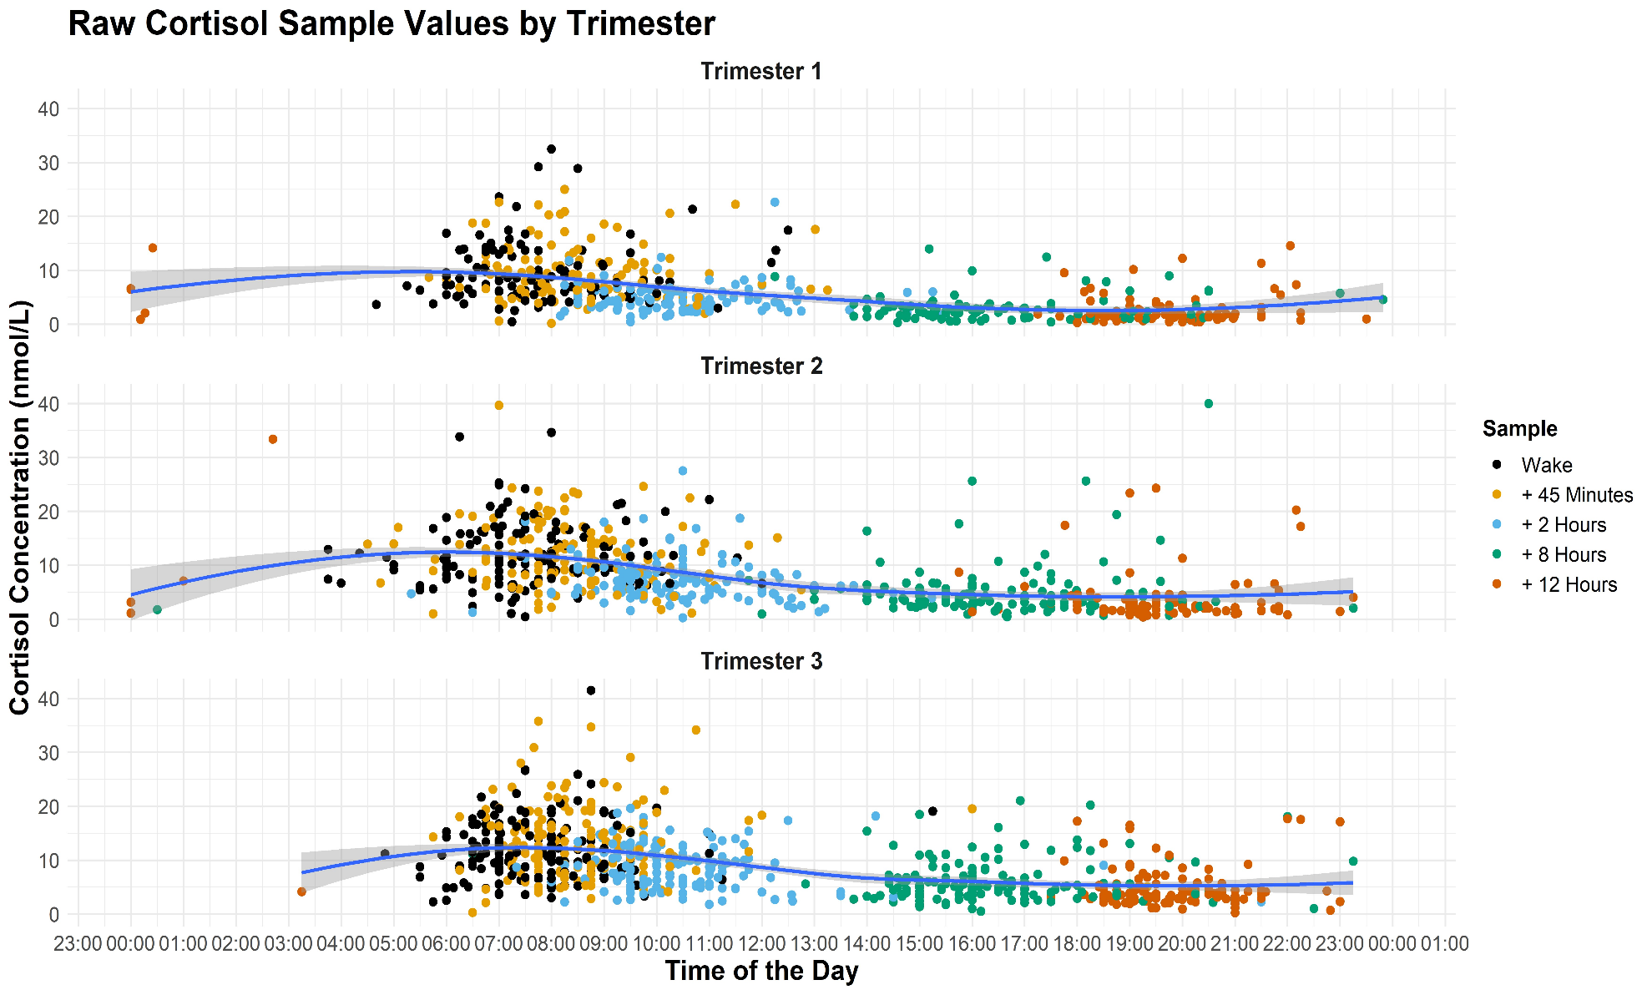

**Supplementary Figure S4**

*Raw Cortisol Measurements at Each Trimester*

*Note*. A loess regression curve is fitted to the raw data at each trimester to depict the mean cortisol concentration trajectory for the sample at each trimester.

**Supplementary Figure S5**

*Bivariate Associations between Cortisol AUCg and Bayley Scores*

