Predicting Autism from Young Infants’ Empathic Responding:
A Prospective Study
Supplementary Material
Order of tasks in visits
- Consent form
- Neutral tasks (2) ^{a,b}
- Distress simulation – experimenter
- Neutral task ^{a,c}
- Laughing infant video
- Additional tasks (2) ª
- Crying infant video
- Additional task ^{a,c}
- Mother-child interactions ª
- Experimenter-child interaction ^{d}
- Distress simulation – mother
- Laughing experimenter
- Mother interview ª
- Questionnaires ª

Notes. ª Tasks not included in the current report.
^{b} In the 9 and 12 months visits, only one neutral task was included.
^{c} Only in the 6 months visit.
^{d} Only in the 9 and 12 months visits.

Table S1: Means (and SDs) of empathic concern and contagious happiness scores by diagnosis group
 |  | Non-ASD |  |  |  |  |  | Atypical Development
 | n | LR  20 | HR-non  11 | HR-mild  17 | GDD  2 | Non-ASD totalª  50 | NR^{b}  48 | ASDª  9 | AD total^{b}  11
a. mean scores across simulations:
6m | EC | .83 (.44) | 1.02 (.38) | .83 (.35) | .25 (.35) | .85 (.41) | .87 (.39) | .48 (.44) | .44 (.42)
 | CH | .94 (.61) | 1.00 (.63) | 1.06 (.62) | 1.50 (.71) | 1.02 (.61) | .99 (.61) | 1.17 (.61) | 1.23 (.61)
9m | EC | .93 (.46) | .75 (.73) | .79 (.49) | .58 (.12) | .83 (.53) | .84 (.54) | .47 (.35) | .49 (.32)
 | CH | .60 (.60) | .99 (.76) | .74 (.47) | .50 (.71) | .73 (.60) | .74 (.61) | .67 (.68) | .64 (.66)
12m | EC | 1.08 (.41) | .95 (.52) | .79 (.39) | .50 (.24) | .93 (.44) | .95 (.44) | .50 (.36) | .50 (.33)
 | CH | .78 (.38) | .95 (.59) | .81 (.53) | 1.00 (.71) | .84 (.49) | .83 (.48) | .83 (.61) | .86 (.60)
b. human simulation scores:
6m | EC | .86 (.53) | 1.07 (.34) | .88 (.43) | .25 (.35) | .89 (.47) | .92 (.46) | .56 (.45) | .50 (.43)
 | CH | .66 (.63) | 1.08 (.67) | .79 (.59) | 1.75 (.35) | .84 (.64) | .80 (.62) | 1.32 (.72) | 1.40 (.67)
9m | EC | 1.13 (.52) | .91 (.81) | .95 (.60) | .63 (.18) | 1.00 (.61) | 1.01 (.62) | .39 (.40) | .43 (.37)
 | CH | .48 (.60) | .75 (.82) | .42 (.45) | .25 (.35) | .51 (.60) | .52 (.61) | .56 (.68) | .50 (.63)
12m | EC | 1.25 (.44) | 1.02 (.68) | .94 (.47) | .63 (.53) | 1.07 (.52) | 1.09 (.52) | .56 (.43) | .57 (.42)
 | CH | .50 (.56) | .64 (.64) | .42 (.49) | 1.25 (.35) | .53 (.56) | .50 (.55) | .56 (.58) | .68 (.60)
c. video scores:
6m | EC | .77 (.45) | 1.02 (.66) | .74 (.44) | .25 (.35) | .79 (.51) | .82 (.50) | .39 (.49) | .36 (.45)
 | CH | 1.20 (.80) | .95 (.82) | 1.33 (.83) | 1.25 (1.77) | 1.19 (.83) | 1.19 (.81) | 1.00 (.87) | 1.05 (.96)
9m | EC | .58 (49) | .45 (.59) | .52 (.49) | .50 (.00) | .53 (.50) | .53 (.51) | .61 (.70) | .59 (.63)
 | CH | .73 (80) | 1.23 (.96) | 1.07 (.63) | .75 (1.06) | .95 (.80) | .96 (.80) | .78 (.91) | .77 (.88)
12m | EC | .75 (.55) | .82 (.56) | .53 (.57) | .25 (.35) | .67 (.56) | .69 (.56) | .44 (.68) | .41 (.63)
 | CH | 1.05 (.72) | 1.27 (.68) | 1.18 (.92) | .75 (1.06) | 1.13 (.78) | 1.15 (.78) | 1.11 (.89) | 1.05 (.88)
Notes. Overall N = 59. Groups with the same letter subscript were compared in the analysis, i.e., constituted the two levels of the dependent measure in the logistic regressions: a = main analysis, b = auxiliary analyses. EC = empathic concern, CH = contagious happiness. LR = low risk; HR-non = high risk-no problems; HR-mild = high risk with minor problems (speech delay or difficulties in emotion or attention regulation); GDD = global developmental delay; ASD = autistic spectrum disorder; Non-ASD total = all four non-ASD groups together (including GDD); NR = normative range, i.e., the non-ASD groups except for GDD; AD = Atypical development (ASD and GDD). For EC the human simulations score is and average of experimenter and mother simulations, for CH the human simulation score is for the experimenter task.

Table S2. Zero order correlations between empathic responses
 |  |  | EC |  |  |  |  |  |  |  |  | CH
 |  |  | Exp. |  |  | Mother |  |  | Video |  |  | Exp. |  |  | Video
Emotion | Task | Age | 6 | 9 | 12 | 6 | 9 | 12 | 6 | 9 | 12 | 6 | 9 | 12 | 6 | 9 | 12
EC | Exp. | 6 | -
 |  | 9 | .24† | -
 |  | 12 | .30* | .39** | -
 | Mother | 6 | .46** | .50** | .21 | -
 |  | 9 | .30* | .59*** | .33* | .34* | -
 |  | 12 | .06 | .12 | .50*** | .08 | .24† | -
 | Video | 6 | .41** | .44** | .27* | .43** | .38** | .04 | -
 |  | 9 | .09 | .54*** | .07 | .36* | .25 | -.08 | .30* | -
 |  | 12 | .02 | .24 | .34** | .17 | .17 | .18 | .16 | .41** | -
CH | Exp. | 6 | .10 | .00 | -.11 | -.03 | -.10 | -.08 | .12 | .09 | .02 | -
 |  | 9 | .08 | .08 | -.01 | -.12 | -.12 | -.01 | .20 | -.09 | -.15 | .28* | -
 |  | 12 | .00 | .14 | .17 | -.06 | -.01 | .23† | -.08 | .01 | .03 | .11 | .38** | -
 | Video | 6 | .03 | -.01 | .08 | -.23 | -.01 | -.01 | -.16 | .03 | -.14 | .24† | .06 | .00 | -
 |  | 9 | .13 | .28* | .09 | .11 | .08 | -.03 | .20 | .03 | .06 | .30* | .45** | .19 | .30* | -
 |  | 12 | .19 | -.01 | .31* | .10 | -.21 | .00 | -.08 | -.00 | .07 | .11 | -.11 | .05 | .11 | .00 | -
Notes. †p < .10, * p < .05, ** p < .01, *** p < .01 (all two-tailed). Overall N = 59. EC = empathic concern, CH = contagious happiness. Exp = experimenter.

Table S3: Fixed effects from the mixed-effects linear model predicting empathic response, without the distressed mother task
Fixed effects | B | S.E. | df | t-value | p-value
Known risk level | -.06 | .06 | 56.30 | -1.12 | .266
Diagnosis | -.15 | .11 | 58.01 | -1.38 | .172
Age | -.02 | .01 | 614.85 | -1.66 | .098
Target | -.04 | .02 | 614.34 | -1.84 | .067
Emotion | .01 | .05 | 614.43 | .33 | .746
Diagnosis X Age | -.01 | .03 | 614.38 | -.41 | .681
Diagnosis X Target | .04 | .07 | 614.52 | .64 | .521
Age X Target | 00 | .01 | 614.49 | .33 | .742
Diagnosis X Emotion | .39 | .13 | 614.72 | 3.05 | .002
Age X Emotion | -.03 | .02 | 614.60 | -1.71 | .088
Target X Emotion | .41 | .05 | 614.65 | 8.94 | < .001
Diagnosis X Age X Target | .04 | .03 | 614.31 | 1.56 | .120
Diagnosis X Age X Emotion | -.02 | .05 | 614.54 | -.43 | .667
Diagnosis X Target X Emotion | -.33 | .13 | 614.77 | -2.55 | .011
Age X Target X Emotion | .04 | .02 | 614.99 | 2.33 | .020
Diagnosis X Age X Target X Emotion | .02 | .05 | 614.61 | .38 | .707
Notes. Known risk level is the sum score of familial risk (0 = low risk, 1 = high risk) and infants gender (0 = girls, 1 = boys). Diagnosis is subsequent ASD diagnosis (0 = non-ASD, 1 = ASD). Age is infants age in empathy assessment (6, 9, and 12 months). Target is the target of empathic response (0 = experimenter, 1 = video stimuli). Emotion is the emotion portrayed by the target (0 = distress, 1 = joy). The analysis included 59 participants and 686 observations.

Table S4: Fixed effects from the mixed-effects linear model predicting empathic response, using atypical diagnosis (ASD or GDD)
Fixed effects | B | S.E. | df | t-value | p-value
Known risk level | -.08 | .05 | 55.89 | -1.46 | .151
Diagnosis | -.16 | .09 | 55.95 | -1.78 | .081
Age | -.01 | .01 | 767.43 | -.71 | .478
Target | -.04 | .02 | 765.87 | -1.86 | .063
Emotion | .06 | .04 | 767.01 | 1.35 | .178
Diagnosis X Age | -.01 | .02 | 767.29 | -.60 | .548
Diagnosis X Target | .02 | .06 | 765.95 | .37 | .710
Age X Target | .00 | .01 | 766.01 | .36 | .723
Diagnosis X Emotion | .47 | .11 | 767.31 | 4.37 | <.001
Age X Emotion | -.05 | .02 | 765.89 | -2.84 | .005
Target X Emotion | .41 | .05 | 766.24 | 9.07 | < .001
Diagnosis X Age X Target | .03 | .02 | 765.81 | 1.43 | .154
Diagnosis X Age X Emotion | -.03 | .04 | 765.80 | -.73 | .465
Diagnosis X Target X Emotion | -.36 | .12 | 766.14 | -3.14 | .002
Age X Target X Emotion | .04 | .02 | 766.61 | 2.34 | .019
Diagnosis X Age X Target X Emotion | .01 | .05 | 766.11 | .17 | .867
Notes. Known risk level is the sum score of familial risk (0 = low risk, 1 = high risk) and infants gender (0 = girls, 1 = boys). Diagnosis is subsequent atypical diagnosis (0 = normative range, 1 = atypical development of ASD or GDD). Age is infants age in empathy assessment (6, 9, and 12 months). Target is the target of empathic response (0 = human simulation of experimenter or mother, 1 = video stimuli). Emotion is the emotion portrayed by the target (0 = distress, 1 = joy). The analysis included 59 participants and 838 observations.
Table S5: Fixed effects from the mixed-effects linear model predicting empathic response, 6 months only
Fixed effects | B | S.E. | df | t-value | p-value
Known risk level | -.02 | .08 | 54.73 | -.22 | .831
Diagnosis | -.11 | .14 | 57.32 | -.79 | .431
Target | .05 | .08 | 215.05 | .72 | .474
Emotion | .23 | .08 | 212.31 | 3.05 | .003
Diagnosis X Target | -.33 | .21 | 215.73 | -1.57 | .118
Diagnosis X Emotion | .62 | .22 | 213.01 | 2.88 | .004
Target X Emotion | .31 | .15 | 213.13 | 2.04 | .043
Diagnosis X Target X Emotion | -.66 | .43 | 212.49 | -1.54 | .125
Notes. Known risk level is the sum score of familial risk (0 = low risk, 1 = high risk) and infants gender (0 = girls, 1 = boys). Diagnosis is subsequent ASD diagnosis (0 = non-ASD, 1 = ASD). Target is the target of empathic response (0 = human simulation of experimenter or mother, 1 = video stimuli). Emotion is the emotion portrayed by the target (0 = distress, 1 = joy). The analysis included 59 participants and 275 observations.

a) | 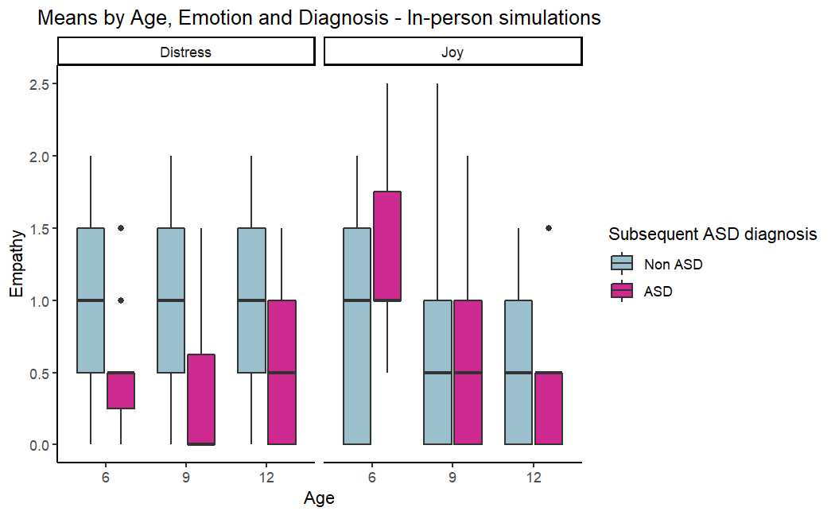
b) | 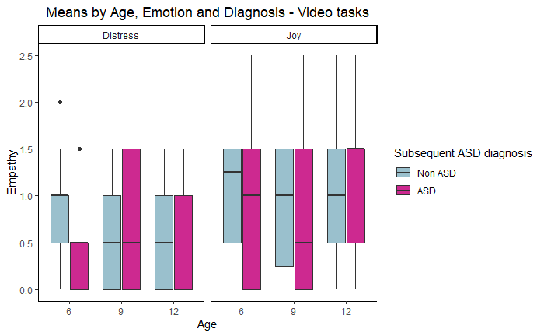
Figure S1. Means of empathic responses by age, emotion, diagnosis group, and target.

