Supplementary Materials

Data Preparation and Preprocessing
Cortisol and Alpha-Amylase Data
At pretest, 14 cortisol values were above three standard deviations from the grand mean: +0 min (n=3), +15 min (n=2), +25 min (n=4), +35 min (n=3), +45 min (n=3), +55 min (n=2). Seven alpha-amylase values were above three standard deviations from the grand mean: +0 min (n=2), +15 min (n=1), +25 min (n=0), +35 min (n=1), +45 min (n=2), +55 min (n=1). In order to successfully normalize positive skew, a fourth root transformation was applied to cortisol and alpha-amylase pretest data as recommended (Felt et al., 2017; Miller & Plessow, 2013). This approach also circumvented the need to winsorize outlier values that might cohesively reflect potential meaningful subgroups of youth that exist at the tail ends of the cortisol and alpha-amylase distributions (Bendezú & Wadsworth, 2018; Bendezú et al., 2022).
Analysis Plan
Exploring Pretest Biological Stress Response Profiles
As the iterative process for identifying the best fitting model using Group Based Trajectory Modeling (GBTM; exploring profiles of unique stress response trajectories in a sample using a single response index such a cortisol) and Multitrajectory Modeling (MTM; exploring profiles of unique stress response trajectories in a sample using multiple response indices simultaneously such as concurrent cortisol and alpha amylase activation) are quite similar, the general process is detailed below for MTM and, where needed, important points of divergence between GBTM and MTM model fitting are further unpacked.
GBTM and MTM utilized the PROC TRAJ procedure (SAS 9.4), with the latter employing the MULTGROUPS option. A nonsignificant Little's (1988) MCAR test, Χ ² (726) = 737.88, p>.25, suggested that our data could be missing at random (MAR) or missing completely at random (MCAR). As such, we proceeded to use Multiple Imputation (MI) to handle missing data in our GBTM and MTM analyses. Ten imputations were performed as recommended (Graham et al., 2007). To specify the best fitting model, polynomial functions were estimated at each model specification step for each identified trajectory. In our cortisol only GBTM modeling, we began by fitting a one-profile model. We then iteratively trimmed the highest order non-significant polynomial estimate from the corresponding cortisol response trajectory equation. After obtaining a solution containing only significant polynomial parameter estimates, we recorded the log Bayes factor approximation [2log_{e}(B₁₀)] (for computational details, see Nagin 2005) for the one-profile solution. The [2log_{e}(B₁₀)] was later used to determine which solution (e.g., one-profile, two-profile) provided the most optimal fit to the data. This initial model specification step was carried out in identical fashion in our alpha amylase only GBTM modeling. This initial step in our MTM model specification process was nearly identical to GBTM, with one notable point of divergence. To fit a one-profile model in MTM model, one trajectory for cortisol and one trajectory for alpha amylase were estimated simultaneously, thus, creating a profile reflective of concurrent cortisol and alpha-amylase responsivity. Non-significant highest order polynomial functions were then trimmed from both trajectory equations until each contained only significant polynomial parameter estimates. We expected quadratic and quartic functions to define cortisol and alpha amylase trajectories.
Next, a more complex two-profile solution was examined for both cortisol only and alpha amylase only GBTM models. All polynomial estimates were reset to the highest-order theoretically informed polynomial function in each trajectory equation, regardless of whether they were nonsignificant in the final one-profile solution. In both GBTM models, the two-profile solution for cortisol only and alpha amylase only were explored, estimating two response trajectories for each biological index (e.g., Low Profile, High Profile). In our MTM models, two concurrent cortisol–alpha amylase trajectory profiles were estimated. Each profile contained one unique cortisol and one unique alpha amylase trajectory (e.g., high cortisol–low alpha amylase; low cortisol–high alpha amylase). Nonsignificant polynomial estimates from each trajectory equation were then trimmed as before until a solution containing only significant polynomial parameter estimates for each identified trajectory was obtained. After recording the [2log_{e}(B₁₀)] for the new two-profile solution, we compared the [2log_{e}(B₁₀)] obtained from the two-profile solution to the one-profile solution. Values equal to or above ten resulting from this comparison provided strong evidence that the more complex solution was a better fit to the data (Nagin, 2005). This process was repeated when testing more complex three- and four-profile solutions.
Given our sample size (N=112) and recommendations from PROC TRAJ procedure developers (N > 100; Nagin, 2005), we limited GBTM and MTM model specification to two-(see main document for further justification) and four-profile solutions, respectively. After the final GBTM and MTM models were specified, we utilized average posterior probability (AvePP_{j} > 0.70), odds of correct classification (OCC_{j} > 5.00), and ratio of the probability of subgroup assignment to the proportion of adolescents assigned to subgroups ([Prob_{j}/Prop_{j}] ≈ 1) as statistical guideposts for evaluating the overall adequacy of the final models. After adequacy evaluation, Wald tests comparing different aspects of the identified trajectories (e.g., intercepts, polynomial estimates) were used to distinguish the profiles. At times, GBTM trajectory distinction analyses can reveal two profiles’ trajectories to be non-significantly different in some aspects (e.g., baseline) and significantly different in others (e.g., reactivity). If and when this occurred, we relied on the differing aspect to label our GBTM profiles.
Results
Profiles of Pretest HPA–SAM Co-Activation
Table S1 displays parameter estimates, adequacy indices, and trajectory distinction analysis results (i.e., differing subscripts) for our MTM analysis of pretest cortisol and alpha-amylase levels. As expected, results obtained from MTM specification supported a four-profile solution (Figure S1): two- to one-profile comparison [2log_{e}(B₁₀)=319.68], three- to two-profile comparison [2log_{e}(B₁₀)=250.38], four- to three-profile comparison [2log_{e}(B₁₀)=64.96]. As per Nagin (2005), a systematic examination of model adequacy indices suggested that the final four-profile solution fit the data well. Our trajectory distinction analyses revealed significant differences that helped characterize the profiles and went on to inform our labeling conventions (Table S1). Two profiles emerged whose HPA-SAM trajectories reflected symmetric co-activation patterns. The Symmetrical HPA–SAM Co-activation No. 1 profile (n=24) displayed trajectories characterized by the lowest cortisol baseline levels in the sample and lack of cortisol reactivity (i.e., linear declining slope). This profile also displayed relatively low alpha-amylase baseline levels and less pronounced alpha-amylase reactivity (i.e., quartic slope). The Symmetrical HPA–SAM Co-activation No. 2 (n=12) profile displayed trajectories characterized by the relatively highest cortisol baseline levels in the sample and relatively more pronounced cortisol reactivity (i.e., quadratic slope). This profile also displayed relatively high alpha-amylase baseline levels and more pronounced alpha-amylase reactivity (i.e., quartic slope). Two profiles emerged whose HPA-SAM trajectories reflected asymmetric co-activation patterns. The Asymmetrical HPA–SAM Co-activation No. 1 (n=30) profile displayed trajectories characterized by relatively low cortisol baseline levels, but also pronounced cortisol reactivity (i.e., quadratic slope). This profile also displayed relatively low alpha-amylase baseline levels and less pronounced alpha-amylase reactivity (i.e., cubic slope). The Asymmetrical HPA–SAM Co-activation No. 2 (n=46) profile displayed trajectories characterized by relatively low cortisol baseline levels and lack of cortisol reactivity (i.e., linear declining slope). This profile also displayed the relatively highest alpha-amylase baseline levels in the sample and more pronounced alpha-amylase reactivity (i.e., quartic slope).
Correlates of Pretest HPA–SAM Co-Activation Profile Membership
There were no significant differences among the four HPA–SAM Co-activation profiles with respect to our primary (youth age, sex) and secondary variables (cohort, pubertal status, medication use, saliva sample timing: child age (F(3,99)=0.85, p>.25), sex (χ²(3)=1.51, p>.25), cohort (χ²(3)=5.30, p=.15), pubertal status (F(3,89)=0.39, p>.25), medication use (χ²(3)=1.51, p>.25), and saliva sample timing (F(3,98)=1.094, p>.25). Child age and sex were retained and controlled for in all MANCOVA analyses. Covariance matrices between youth subgroups were assumed equal for the purposes of MANCOVA (Box’s M=38.34, p>.25).
The association between HPA–SAM profile membership and our focal correlates was significant; Wilk’s Lambda=0.79, F(12,219.89)=0.93, p=.05. A series of Levene’s F tests suggested that the homogeneity of variance assumption was satisfied: stressful life events (F(3,88)=3.71, p=.01), posttraumatic stress (F(3,88)=3.04, p=.03)¹, parent-reported internalizing problems (F(3,88)=1.33, p>.25), parent-reported externalizing problems (F(3,88)=0.41, p>.25). Omnibus tests obtained from our follow-up ANCOVAs revealed significant associations between HPA–SAM profile membership and three of four focal correlates: stressful life events (F(3,86)=2.96, p=.04), posttraumatic stress (F(3,86)=3.13, p=.03), parent-reported internalizing problems (F(3,86)=1.86, p=.14), parent-reported externalizing problems (F(3,88)=2.94, p=.04).
Estimated marginal means, standard errors bars, and the results of Fisher’s LSD tests comparing profile mean estimates are depicted in Figure S2. Relative to those with Symmetric HPA–SAM Co-activation profiles, youth with Asymmetric HPA–SAM Co-activation profiles generally presented with greater parent-reported stress exposure, traumatic stress symptoms, as well as internalizing and externalizing symptoms.

Table S1
Parameter Estimates (Standard Errors) and Model Adequacy Indices for Final HPA–SAM Multitrajectory Modeling Pretest Four-Group Solution
 | Salivary Cortisol |  |  | Salivary Alpha-Amylase |  | AvePP_{j} | OCC_{j} | Prob_{j} | Prop_{j} | Ratio
Symmetrical No.1 (n=24) |  |  |  |  |  | .975 | 208.000 | .229 | .214 | 1.070
Intercept |  |  | 0.458* (0.009) ^{A} |  | 2.747* (0.088) ^{A}
Linear |  |  | -0.001* (0.001) ª |  | 0.088* (0.034)
Quadratic |  |  |  |  | -0.007* (0.003)
Cubic |  |  |  |  | 0.001* (0.001)
Quartic |  |  |  |  | -0.001* (0.001) ª
Symmetrical No.2 (n=12) |  |  |  |  |  | .997 | 1772.44 | .107 | .107 | 1.000
Intercept |  |  | 0.644* (0.016) ^{C} |  | 3.006* (0.120) ^{B}
Linear |  |  | 0.004* (0.001) |  | 0.125* (0.048)
Quadratic |  |  | -0.001* (0.001) ^{b} |  | -0.007* (0.002)
Cubic |  |  |  |  | 0.001† (0.001)
Quartic |  |  |  |  | -0.001† (0.001) ^{b}
Asymmetrical No.1 (n=30)
Intercept |  |  | 0.513* (0.011) ^{B} |  | 2.691* (0.081) ^{A} | .930 | 70.857 | .268 | .268 | 1.000
Linear |  |  | 0.002* (0.001) |  | 0.049* (0.013)
Quadratic |  |  | -0.001* (0.001) ^{b} |  | -0.002* (0.001)
Cubic |  |  |  |  | 0.001* (0.001) ⁻
Asymmetrical No.2 (n=46) |  |  |  |  |  | .966 | 151.529 | .396 | .411 | 0.964
Intercept |  |  | 0.500* (0.007) ^{B} |  | 3.511* (0.065) ^{C}
Linear |  |  | -0.001* (0.001) ª |  | 0.110* (0.025)
Quadratic |  |  |  |  | -0.007* (0.002)
Cubic |  |  |  |  | 0.001* (0.001)
Quartic |  |  |  |  | -0.001* (0.001) ^{b}
Note. AvePP_{j} = Average posterior probability; OCC_{j} = Odds of correct classification; Prob_{j} = Probability of group assignment; Prop_{j} = Proportion of children assigned to each group; Ratio = Ratio of Prob_{j} to Prop_{j}. Upper-case superscripts denote significant differences in intercept estimates within the biological index. Lower-case superscripts denote significant differences in polynomial estimates within the same biological index.
† p < .10. *p < .05.
Figure S1
Actual versus Predicted Salivary Cortisol and Alpha-Amylase Trajectories for Pretest HPA–SAM Multi-Trajectory Modeling Four-Group Solution
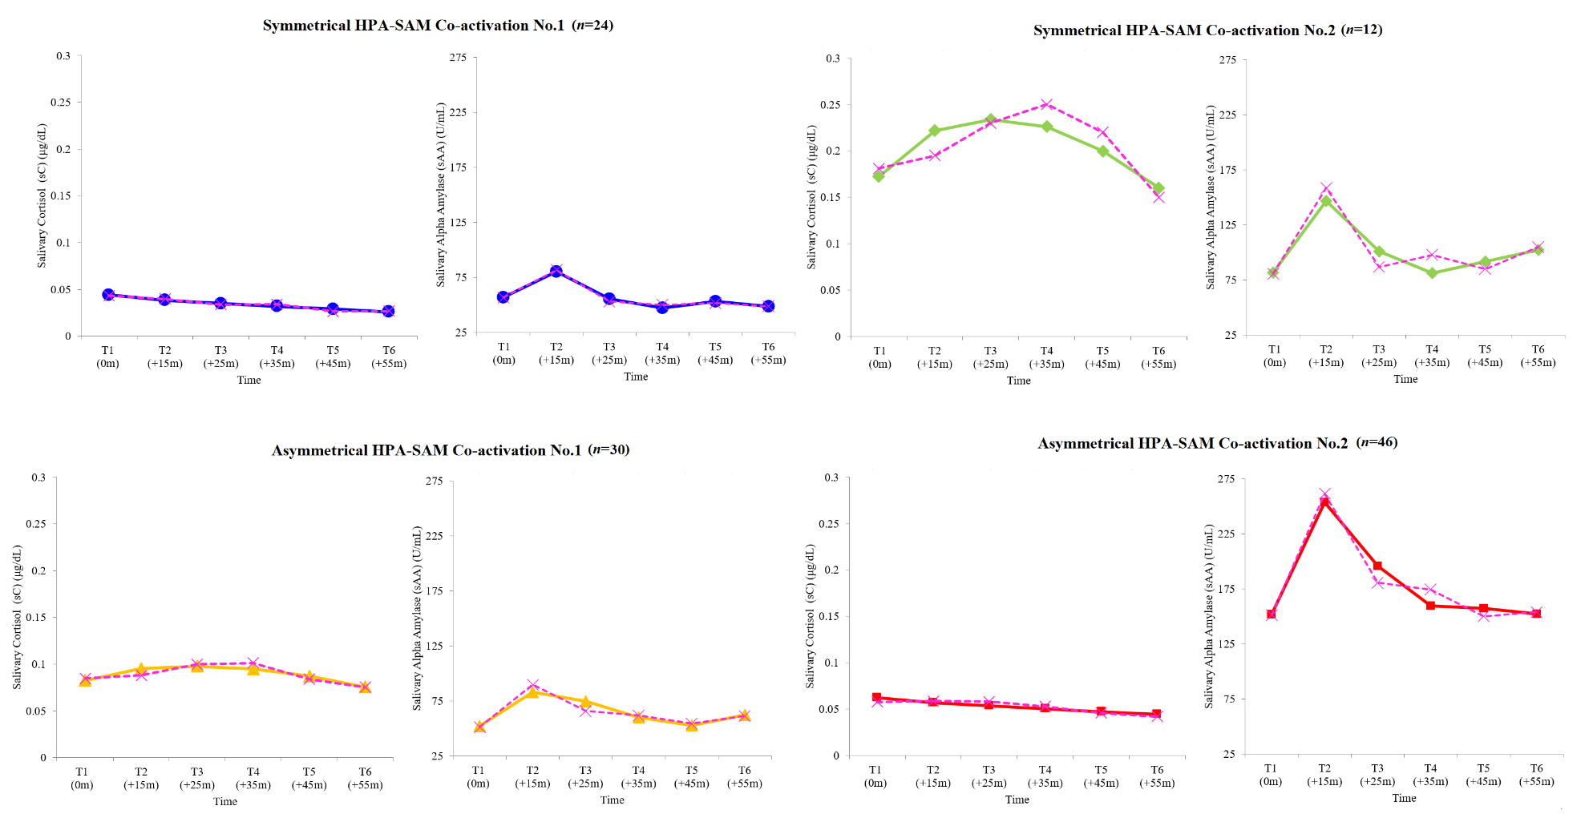
Note. Actual trajectories denoted with dotted lines. Predicted trajectories denoted by solid lines. Reverse transformed values presented for ease of interpretation and cross-study communication. Values in parentheses reflect the number of children assigned to each group.

Figure S2
Plotted Means and Standard Error Bars for Risk and Mental Health Indices for Final HPA–SAM Pretest Four-Group Solution
Note. Differing superscripts denote significant differences between groups.

Following guidelines set forth in Howell (2007), no standard deviation value was four times larger than the smallest standard deviation value, suggesting that follow-up ANCOVAs conducted would be robust to potential violations of the homogeneity of variance assumption.
Omnibus tests in ANOVA frameworks minimize the chance of committing a Type 1 error, with nonsignificant omnibus tests precluding “unnecessary” post-hoc pairwise group comparisons based on the overall pattern of differences across groups (e.g., four co-activation profiles). Yet, omnibus and post-hoc tests do not always converge. Our post-hoc tests revealed significant differences between specific profiles that were ultimately consistent with the pattern of findings that emerged in ANOVA tests of our other focal correlates. For further justification concerning post-hoc pairwise group contrasts following nonsignificant omnibus tests, see Tian et al. (2018).

