Supplemental Figure 1. Bivariate correlations between maternal risk composite variables, observed parenting quality and child externalizing problems
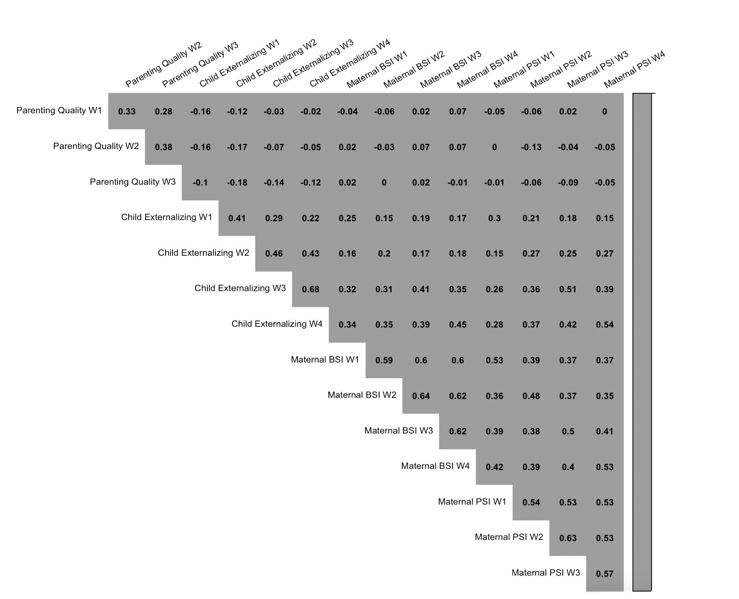
Maternal BSI: Maternal self-reported psychopathology symptoms from the Brief Symptom Inventory.
Maternal PSI: Maternal parenting stress from the Parenting Stress Index.

