Appendix A: Internal Consistency of Minnesota Eating Behavior Survey (MEBS) Scores
Assessment Timepoint | 1  n=688-705 | 2  n=675-683 | 3  n=632-637 | 4  n=681-684 | 5  n=651-661 | 6  n=657-669
Mean Participant Age (years) | 11.70 | 14.77 | 18.28 | 20.99 | 25.26 | 29.13
MEBS Scale Score | McDonald’s Omega
Body Dissatisfaction | .83 | .85 | .85 | .85 | .85 | .85
Weight Preoccupation | .78 | .85 | .82 | .82 | .80 | .80
Compensatory Behaviors | .51 | .61 | .42 | .66 | .50 | .44
Binge Eating | .67 | .69 | .68 | .69 | .72 | .73
Modified Total Score (disordered eating)ª | .82 | .86 | .85 | .85 | .84 | .85
Note. MEBS Modified Total Score = score comprising the total of MEBS Weight Preoccupation, Compensatory Behavior, and Binge Eating subscale scores). A simplified True/False version of the MEBS was administered at timepoint 1, whereas at subsequent timepoints, participants selected one of four responses (Definitely True, Probably True, Probably False, Definitely False). To compute MEBS scores with consistent ranges across timepoints, we collapsed follow-up timepoint responses into two categories (True/False).
ª The Modified Total score, which excludes the Body Dissatisfaction subscale, was used to describe overall disordered eating symptoms (a combination of Weight Preoccupation, Binge Eating, and Compensatory Behaviours), since Body Dissatisfaction was examined separately (as a predictor of disordered eating) in our analyses.
Appendix B: Temporal Stability of Minnesota Eating Behavior Survey (MEBS) Scores
Assessment Timepoint | 1  n=703-711 | 2  n=686 | 3  n=637 | 4  n=685 | 5  n=662 | 6  n=671
 | Body Dissatisfaction
1 | --
2 | .53*** | --
3 | .42*** | .59*** | --
4 | .42*** | .55*** | .65*** | --
5 | .34*** | .47*** | .48*** | .59*** | --
6 | .36*** | .43*** | .46*** | .56*** | .68*** | --
 | Weight Preoccupation
1 | --
2 | .51*** | --
3 | .39*** | .56*** | --
4 | .39*** | .47*** | .60*** | --
5 | .34*** | .42*** | .49*** | .57*** | --
6 | .33*** | .42*** | .49*** | .54*** | .67*** | --
 | Compensatory Behavior
1 | --
2 | .22*** | --
3 | .10* | .23*** | --
4 | .08* | .25*** | .51*** | --
5 | -.01 | .21*** | .27*** | .26*** | --
6 | .15*** | .26*** | .22*** | .34*** | .53*** | --
 | Binge Eating
1 | --
2 | .31*** | --
3 | .20*** | .42*** | --
4 | .17*** | .35*** | .51*** | --
5 | .12** | .23*** | .35*** | .51*** | --
6 | .15*** | .23*** | .35*** | .48*** | .57*** | --
 | Modified Total Score (Disordered Eating)
1 | --
2 | .52*** | --
3 | .36*** | .54*** | --
4 | .35*** | .47*** | .63*** | --
5 | .27*** | .40*** | .47*** | .60*** | --
6 | .31*** | .40*** | .47*** | .54*** | .69*** | --
Note. Pearson’s Product-Moment ccorrelations.

* p < .05. ** p < .01. *** p < .001

Appendix C: Study Results with One Twin Randomly Selected from Each Pair
Table C.1: Results of Growth Curve Models Examining the Impact of Age on BMI and BRS Actual, Ideal, and Actual-Ideal Discrepancy Ratings (One Twin Randomly Selected)
Model | Traditional Regression | Linear with Fixed Slope | Linear with Random Slope | Curvilinear (squared) | Curvilinear (cubed)
 | Estimate (SE) | Estimate (SE) | Estimate (SE) | Estimate (SE) | Estimate (SE)
Body Mass Index | 0.02 (0.00)** | 0.02 (0.00)** | 0.02 (0.00)** | 0.00 (0.00)** | 0.00 (0.00)**
Intercept | 2.76 (0.02)** | 2.77 (0.01)** | 2.77 (0.01)** | 2.28 (0.03)** | 1.82 (0.12)**
Fit Statistics
AIC | ‐781.02 | ‐2001.15 | ‐2056.47 | ‐2304.37 | ‐2316.92
BIC | ‐765.01 | ‐1979.80 | ‐2024.45 | ‐2267.01 | ‐2274.22
Log Likelihood | 393.51 | 1004.58 | 1034.23 | 1159.18 | 1166.46
BRS Actual Rating | 0.05 (0.00)** | 0.05 (0.00)** | 0.05 (0.00)** | 0.00 (0.02) | 0.00 (0.00)**
Intercept | 4.35 (0.09)** | 4.36 (0.08)** | 4.35 (0.07)** | 3.98 (0.22)** | -0.24 (0.86)
Fit Statistics
AIC | 6444.81 | 5632.74 | 5533.37 | 5532.07 | 5508.66
BIC | 6461.64 | 5655.18 | 5567.03 | 5571.36 | 5553.54
Log Likelihood | -3219.40 | -2812.37 | -2760.69 | -2759.03 | -2746.33
BRS Ideal Rating | 0.00 (0.00) | 0.00 (0.00) | 0.00 (0.00) | 0.00 (0.00)* | 0.00 (0.00)**
Intercept | 4.38 (0.07)** | 4.39 (0.06)** | 4.39 (0.07)** | 4.85 (0.20)** | 1.02 (0.80)
Fit Statistics
AIC | 5354.09 | 5085.13 | 5009.55 | 5005.67 | 4983.49
BIC | 5370.92 | 5107.57 | 5043.21 | 5044.94 | 5028.37
Log Likelihood | -2674.05 | -2538.66 | -2498.77 | -2495.84 | -2483.74
BRS A-I Discrepancy | 0.05 (0.00)** | 0.05 (0.00)** | 0.05 (0.00)** | -0.00 (0.00)** | 0.00 (0.00)
Intercept | -0.03 (0.08) | -0.03 (0.07) | -0.03 (0.08) | -0.88 (0.22)** | -1.20 (0.84)
Fit Statistics
AIC | 5936.15 | 5409.53 | 5353.77 | 5338.01 | 5339.86
BIC | 5952.98 | 5431.97 | 5387.42 | 5377.28 | 5384.73
Log Likelihood | -2965.08 | -2700.76 | -2670.88 | -2662.00 | -2661.93
Note. AIC = Akaike Information Criterion; BIC = Bayesian Information Criterion; BMI = body mass index (log of BMI was modelled to ensure normality); BRS = Body Rating Scales (self-report); A-I Discrepancy = Actual-Ideal Discrepancy Score. Curvilinear (squared) = random intercept and random slope (allows for one change in direction of the trajectory across time); Curvilinear (cubed) = random intercept and random slope (allows for two changes in direction of the trajectory across time). Lower AIC and BIC indicate better model fit. The best-fitting models are bolded.
* p = .015, ** p = <.001
Table C.2: Likelihood Ratio Test Results Comparing Growth Curve Model Fit for Impact of Age on Body Image Variables (One Twin Randomly Selected)
Model Comparison | Traditional Regression  &  Linear with Fixed Slope | Linear with Fixed Slope  &  Linear with Random Slope | Linear with Random Slope  &  Curvilinear (squared) | Curvilinear  (squared)  &  Curvilinear  (cubed)
Body Mass Index | 1222.13** | 59.31** | 249.90** | 14.55**
BRS Actual Rating | 814.07** | 103.36** | 3.31 | 25.41**
BRS Ideal Rating | 270.96** | 79.58** | 5.88* | 24.18**
BRS A-I Discrepancy | 528.62** | 59.76** | 17.76** | 0.15
Note. BRS = Body Rating Scales (self-report); BRS A-I Discrepancy = Body Rating Scale Actual-Ideal Discrepancy Score; Curvilinear (squared) = random intercept and random slope (allows for one change in direction of the trajectory across time); Curvilinear (cubed) = random intercept and random slope (allows for two changes in direction of the trajectory across time). Test results suggest that the curvilinear (cubed) model had the best fit for the impact of time on all body image variables except for BRS A-I Discrepancy, where the curvilinear (squared) model had the best fit.
* p = .015, ** p < .001
Appendix D: Histograms Depicting Frequency of Disordered Eating Symptom Variables at Intake
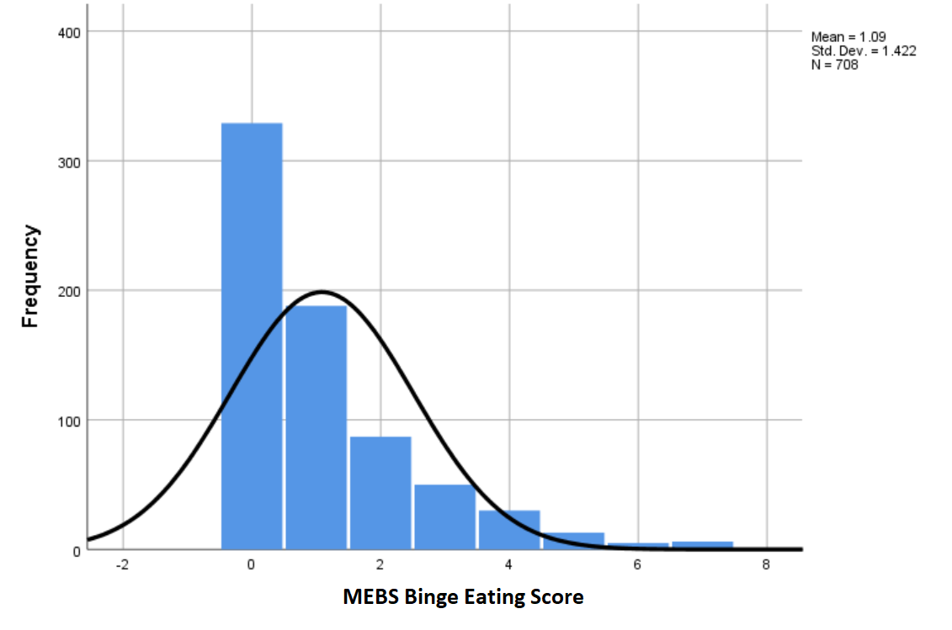

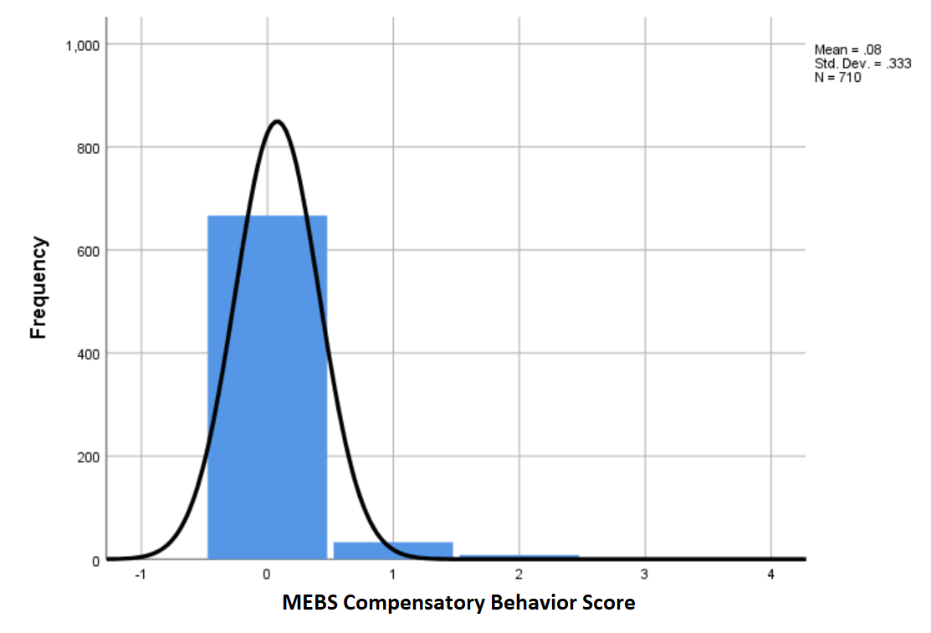

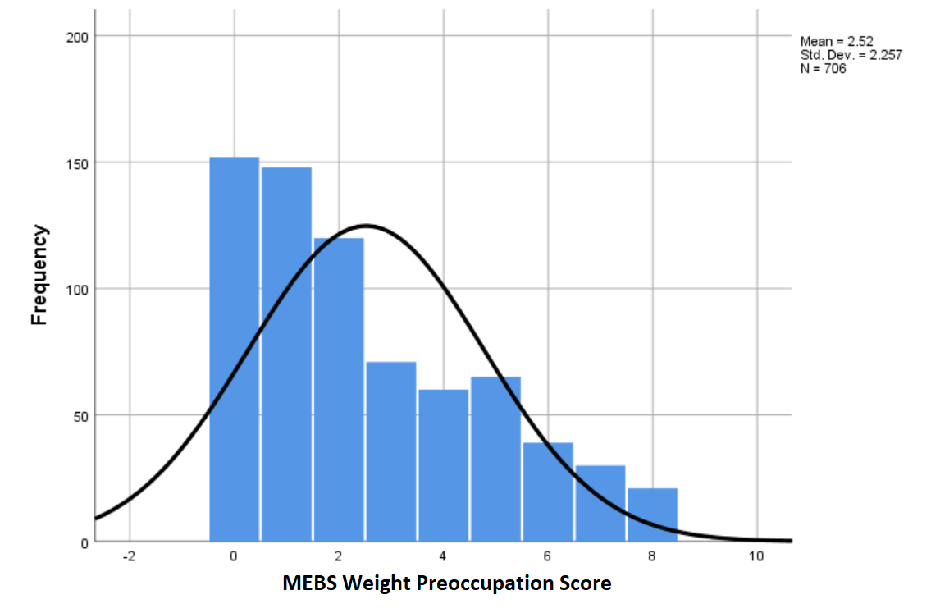

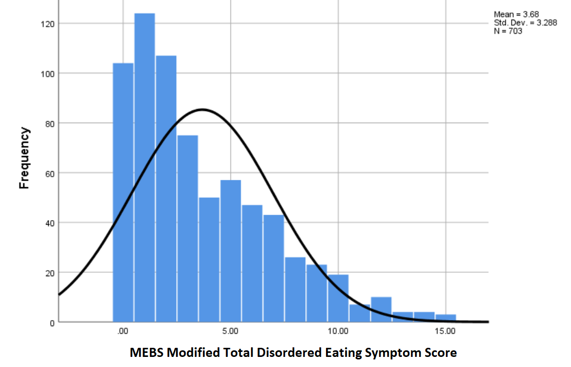

Note. MEBS = Minnesota Eating Behavior Survey; Modified Total Disordered Eating Symptom Score = score comprising total of MEBS Weight Preoccupation, Compensatory Behavior, and Binge Eating subscale scores).
Appendix E: Study Results with One Twin Randomly Selected from Each Pair
Table E.1: Impact of Body Mass Index and Body Image Variables on MEBS Weight Preoccupation Scores from Ages 11 to 29 (One Twin Randomly Selected)
 |  | Model A |  |  | Model B
 |  | Estimate (SE) | p |  | Estimate (SE) | p
Intercept |  | 1.071 (0.11) | <.001 |  | 1.028 (0.10) | <.001
Body Mass Index |  | -0.001 (0.01) | .901 |  | -0.003 (0.01) | .492
MEBS Body Dissatisfaction |  | 0.050 (0.00) | <.001 |  | 0.049 (0.00) | <.001
BRS Actual Rating |  | 0.158 (0.02) | <.001
BRS Ideal Rating |  | -0.178 (0.02) | <.001
BRS A-I Discrepancy Score |  |  |  |  | 0.169 (0.02) | <.001
AIC |  | 5771.71 |  |  | 5770.47
BIC |  | 5814.20 |  |  | 5807.64
Note. AIC = Akaike Information Criterion (lower AIC indicates better model fit); BIC = Bayesian Information Criterion (lower BIC indicates better model fit); BRS = Body Rating Scales (self-report); BRS A-I Discrepancy Score = Body Rating Scale Actual-Ideal Discrepancy Score; MEBS = Minnesota Eating Behavior Survey. The mixed-effects generalized linear models described above consisted of two levels: timepoints (level 1) were nested within participants (level 2). Each model had a gamma distribution and log link. BRS Actual-Ideal Discrepancy scores are calculated using Actual and Ideal scores; because of the significant multicollinearity between them, the effects of these predictors were examined in separate models (Models A and B).
Table E.2: Marginal Effects of Body Image Variables on MEBS Weight Preoccupation from Ages 11 to 29 (One Twin Randomly Selected)
 | Model A |  |  |  | Model B
 | dy/dx | SE | 95% CI |  | dy/dx | SE | 95% CI
BMI | 0.00 | 0.02 | [-0.04, 0.04] |  | -0.01 | 0.01 | [-0.43, 0.02]
MEBS BD | 0.17 | 0.02 | [0.14, 0.20] |  | 0.17 | 0.02 | [0.14, 0.20]
BRS Actual Rating | 0.54 | 0.08 | [0.39, 0.70]
BRS Ideal Rating | -0.61 | 0.07 | [-0.76, -0.47]
BRS A-I Score |  |  |  |  | 0.58 | 0.07 | [0.45, 0.71]
Note. This table illustrates the marginal change in weight preoccupation given a one unit change in each body image variable. Multilevel model analyses showed significant effects of all body image variables, except for BMI, on weight preoccupation (p < .001). BMI = Body Mass Index; BRS = Body Rating Scales (self-report); BRS A-I Score = Body Rating Scale Actual-Ideal Discrepancy Score; MEBS = Minnesota Eating Behavior Survey; MEBS BD= Minnesota Eating Behavior Survey Body Dissatisfaction Score. BRS Actual-Ideal Discrepancy scores are calculated using Actual and Ideal scores; because of the significant multicollinearity between them, the effects of these predictors were examined in separate models (Models A and B).
Table E.3: Impact of Body Mass Index and Body Image Variables on MEBS Compensatory Behavior Scores from Ages 11 to 29 (One Twin Randomly Selected)
 | Model A |  | Model B
 | Estimate (SE) | p | Estimate (SE) | p
Intercept | 0.219 (0.05) | <.001 | 0.206 (0.04) | <.001
Body Mass Index | -0.009 (0.00) | .001 | -0.010 (0.00) | <.001
MEBS Body Dissatisfaction | 0.044 (0.00) | <.001 | 0.044 (0.00) | <.001
BRS Actual Rating | 0.078 (0.01) | <.001
BRS Ideal Rating | -0.084 (0.01) | <.001
BRS A-I Discrepancy Score |  |  | 0.081 (0.01) | <.001
AIC | 993.36 |  | 991.63
BIC | 1035.85 |  | 1028.81
Note. AIC = Akaike Information Criterion (lower AIC indicates better model fit); BIC = Bayesian Information Criterion (lower BIC indicates better model fit); BRS = Body Rating Scales (self-report); BRS A-I Discrepancy Score = Body Rating Scale Actual-Ideal Discrepancy Score; MEBS = Minnesota Eating Behavior Survey. The mixed-effects generalized linear models described above consisted of two levels: timepoints (level 1) were nested within participants (level 2). Each model had a gamma distribution and log link. BRS Actual-Ideal Discrepancy scores are calculated using Actual and Ideal scores; because of the significant multicollinearity between them, the effects of these predictors were examined in separate models (Models A and B).

Table E.4: Marginal Effects of Body Image Variables on MEBS Compensatory Behavior from Ages 11 to 29 (One Twin Randomly Selected)
 | Model A |  |  |  | Model B
 | dy/dx | SE | 95% CI |  | dy/dx | SE | 95% CI
BMI | -0.01 | 0.00 | [-0.02, 0.00] |  | -0.01 | 0.00 | [-0.02, -0.01]
MEBS BD | 0.05 | 0.00 | [0.05, 0.05] |  | 0.05 | 0.00 | [0.05, 0.05]
BRS Actual Rating | 0.09 | 0.01 | [0.07, 0.12]
BRS Ideal Rating | -0.10 | 0.01 | [-0.12, -0.08]
BRS A-I Score |  |  |  |  | 0.10 | 0.01 | [0.08, 0.12]
Note. This table illustrates the marginal change in compensatory behaviour given a one unit change in each body image variable. Multilevel model analyses showed significant effects of all body image variables on compensatory behaviour (p < .001). BMI = Body Mass Index; BRS = Body Rating Scales (self-report); BRS A-I Score = Body Rating Scale Actual-Ideal Discrepancy Score; MEBS = Minnesota Eating Behavior Survey; MEBS BD= Minnesota Eating Behavior Survey Body Dissatisfaction Score. BRS Actual-Ideal Discrepancy scores are calculated using Actual and Ideal scores; because of the significant multicollinearity between them, the effects of these predictors were examined in separate models (Models A and B).
Table E.5: Impact of Body Mass Index and Body Image Variables on MEBS Binge Eating Scores from Ages 11 to 29 (One Twin Randomly Selected)
 | Model A | p | Model B | p
Intercept | 0.550 (0.10) | <.001 | 0.715 (0.09) | <.001
Body Mass Index | -0.017 (0.01) | .001 | -0.008 (0.00) | .078
MEBS Body Dissatisfaction | 0.043 (0.00) | <.001 | 0.043 (0.00) | <.001
BRS Actual Rating | 0.133 (0.02) | <.001
BRS Ideal Rating | -0.059 (0.02) | .003
BRS A-I Discrepancy Score |  |  | 0.093 (0.02) | <.001
AIC | 4173.83 |  | 4183.42
BIC | 4216.32 |  | 4220.59
Note. AIC = Akaike Information Criterion (lower AIC indicates better model fit); BIC = Bayesian Information Criterion (lower BIC indicates better model fit); BRS = Body Rating Scales (self-report); BRS A-I Discrepancy Score = Body Rating Scale Actual-Ideal Discrepancy Score; MEBS = Minnesota Eating Behavior Survey. The mixed-effects generalized linear models described above consisted of two levels: timepoints (level 1) were nested within participants (level 2). Each model had a gamma distribution and log link. BRS Actual-Ideal Discrepancy scores are calculated using Actual and Ideal scores; because of the significant multicollinearity between them, the effects of these predictors were examined in separate models (Models A and B).
Table E.6: Marginal Effects of Body Image Variables on MEBS Binge Eating from Ages 11 to 29 (One Twin Randomly Selected)
 | Model A |  |  |  | Model B
 | dy/dx | SE | 95% CI |  | dy/dx | SE | 95% CI
BMI | -0.04 | 0.01 | [-0.06, -0.01] |  | -0.02 | 0.01 | [-0.03, 0.00]
MEBS BD | 0.09 | 0.01 | [0.08, 0.10] |  | 0.09 | 0.01 | [0.08, 0.10]
BRS Actual Rating | 0.27 | 0.04 | [0.19, 0.36]
BRS Ideal Rating | -0.12 | 0.04 | [-0.20, -0.04]
BRS A-I Score |  |  |  |  | 0.19 | 0.04 | [0.12, 0.26]
Note. This table illustrates the marginal change in binge eating given a one unit change in each body image variable. Multilevel model analyses showed significant effects of all body image variables, except for BMI, on binge eating. BRS = Body Rating Scales (self-report); BRS A-I Score = Body Rating Scale Actual-Ideal Discrepancy Score; MEBS = Minnesota Eating Behavior Survey; MEBS BD= Minnesota Eating Behavior Survey Body Dissatisfaction Score. BRS Actual-Ideal Discrepancy scores are calculated using Actual and Ideal scores; because of the significant multicollinearity between them, the effects of these predictors were examined in separate models (Models A and B).

Table E.7: Impact of Body Mass Index and Body Image Variables on MEBS Modified Overall Disordered Eating Symptom Scores from Ages 11 to 29 (One Twin Randomly Selected)
 | Model A | p | Model B | p
Intercept | 1.417 (0.10) | <.001 | 1.399 (0.09) | <.001
Body Mass Index | -0.016 (0.01) | .003 | -0.017 (0.01) | <.001
MEBS Body Dissatisfaction | 0.164 (0.01) | <.001 | 0.163 (0.01) | <.001
BRS Actual Rating | 0.109 (0.02) | <.001
BRS Ideal Rating | -0.117 (0.02) | <.001
BRS A-I Discrepancy Score |  |  | 0.114 (0.02) | <.001
AIC | 6417.97 |  | 6416.09
BIC | 6460.41 |  | 6453.23
Note. AIC = Akaike Information Criterion (lower AIC indicates better model fit); BIC = Bayesian Information Criterion (lower BIC indicates better model fit); BRS = Body Rating Scales (self-report); BRS A-I Discrepancy Score = Body Rating Scale Actual-Ideal Discrepancy Score; MEBS = Minnesota Eating Behavior Survey. The mixed-effects generalized linear models described above consisted of two levels: timepoints (level 1) were nested within participants (level 2). Each model had a gamma distribution and log link. BRS Actual-Ideal Discrepancy scores are calculated using Actual and Ideal scores; because of the significant multicollinearity between them, the effects of these predictors were examined in separate models (Models A and B).
Table E.8: Marginal Effects of Body Image Variables on MEBS Modified Overall Disordered Eating Symptoms from Ages 11 to 29 (One Twin Randomly Selected)
 |  | Model A |  |  |  | Model B
 | dy/dx | SE | 95% CI |  | dy/dx | SE | 95% CI
BMI | -0.07 | 0.02 | [-0.04, 0.04] |  | -0.07 | 0.02 | [-0.04, 0.02]
MEBS BD | 0.70 | 0.05 | [0.14, 0.20] |  | 0.70 | 0.05 | [0.14, 0.20]
BRS Actual Rating | 0.46 | 0.10 | [0.39, 0.70]
BRS Ideal Rating | -0.50 | 0.09 | [-0.76, -0.47]
BRS A-I Score |  |  |  |  | 0.48 | 0.08 | [0.45, 0.71]
Note. This table illustrates the marginal change in disordered eating symptoms (a combination of weight preoccupation, compensatory behaviour, and binge eating scale scores) given a one unit change in each body image variable. Multilevel model analyses showed significant effects of all body image variables on disordered eating symptoms. BMI = Body Mass Index; BRS = Body Rating Scales (self-report); BRS A-I Score = Body Rating Scale Actual-Ideal Discrepancy Score; MEBS = Minnesota Eating Behavior Survey (self-report); MEBS BD= Minnesota Eating Behavior Survey Body Dissatisfaction Score. BRS Actual-Ideal Discrepancy scores are calculated using Actual and Ideal scores; because of the significant multicollinearity between them, the effects of these predictors were examined in separate models (Models A and B).

Appendix F: Trajectories for Each Tested Growth Model

Figure F.1: Trajectories for Each Tested Growth Curve Model for BMI

Note. BMI = Body Mass Index (log of BMI was modelled to ensure normality); Curvilinear (squared) = model with a random intercept and random slope (allows for one change in direction of the trajectory across time); Curvilinear (cubed) = model with a random intercept and random slope (allows for two changes in direction of the trajectory across time). The number of participants who were 31 years of age or older at the last assessment timepoint was small (n = 12) and thus, trajectories after age 30 should be interpreted with caution.
Figure F.2: Trajectories for Each Tested Growth Curve Model for BRS Actual Rating

Note. BRS = Body Rating Scales (self-report); Curvilinear (squared) = model with a random intercept and random slope (allows for one change in direction of the trajectory across time); Curvilinear (cubed) = model with a random intercept and random slope (allows for two changes in direction of the trajectory across time). The number of participants who were 31 years of age or older at the last assessment timepoint was small (n = 12) and thus, trajectories after age 30 should be interpreted with caution.
Figure F.3: Trajectories for Each Tested Growth Curve Model for BRS Ideal Rating

Note. BRS = Body Rating Scales (self-report); Curvilinear (squared) = model with a random intercept and random slope (allows for one change in direction of the trajectory across time); Curvilinear (cubed) = model with a random intercept and random slope (allows for two changes in direction of the trajectory across time). The number of participants who were 31 years of age or older at the last assessment timepoint was small (n = 12) and thus, trajectories after age 30 should be interpreted with caution.
Figure F.4: Trajectories for Each Tested Growth Curve Model for BRS Actual-Ideal Discrepancy Score

Note. BRS A-I Discrepancy Score = Body Rating Scale Actual-Ideal Discrepancy Score; Curvilinear (squared) = model with a random intercept and random slope (allows for one change in direction of the trajectory across time); Curvilinear (cubed) = model with a random intercept and random slope (allows for two changes in direction of the trajectory across time). The number of participants who were 31 years of age or older at the last assessment timepoint was small (n = 12) and thus, trajectories after age 30 should be interpreted with caution.

